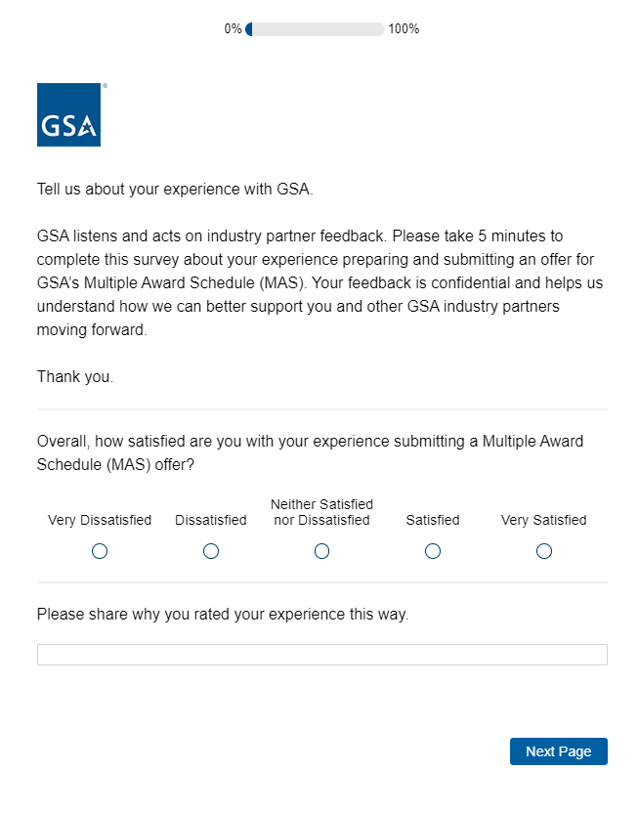
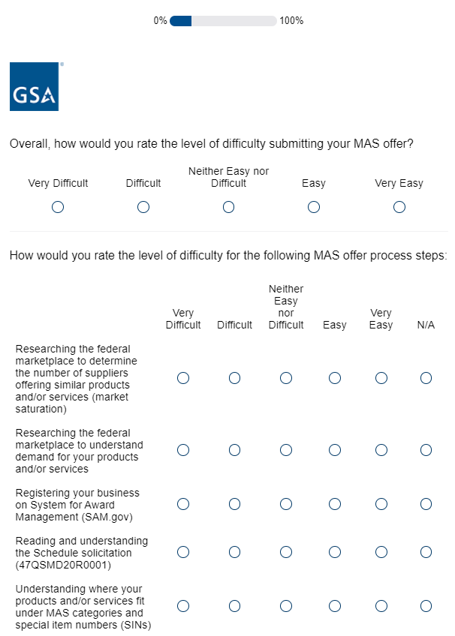
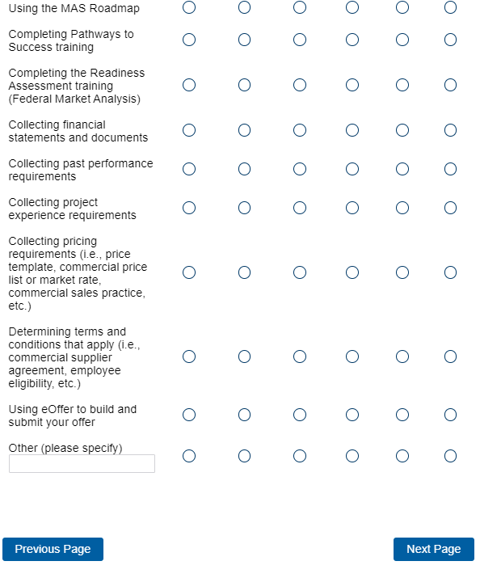
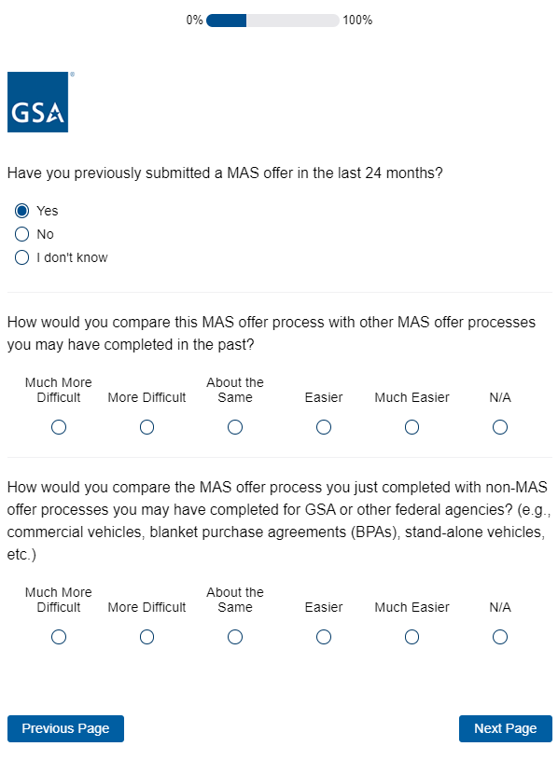
Display Logic: If “Yes” to “Have you previously submitted a MAS offer in the last 24 months?”, show question “How would you compare this MAS offer process with other MAS offer processes you may have completed in the past?”. If “No”, proceed to question “How would you compare the MAS offer process you just completed with non-MAS offer processes you may have completed for GSA or other federal agencies?”.
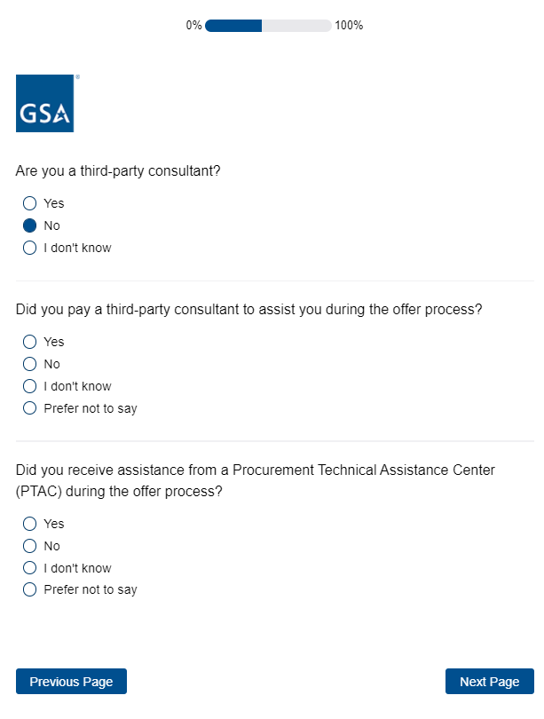
Display logic: If “No” to “Are you a third-party consultant?” display “Did you pay for a third-party consultant to assist you during the offer process?” and “Did you receive assistance from a Procurement Technical Assistance Center (PTAC) during the offer process?”. If “Yes”, proceed to next question.
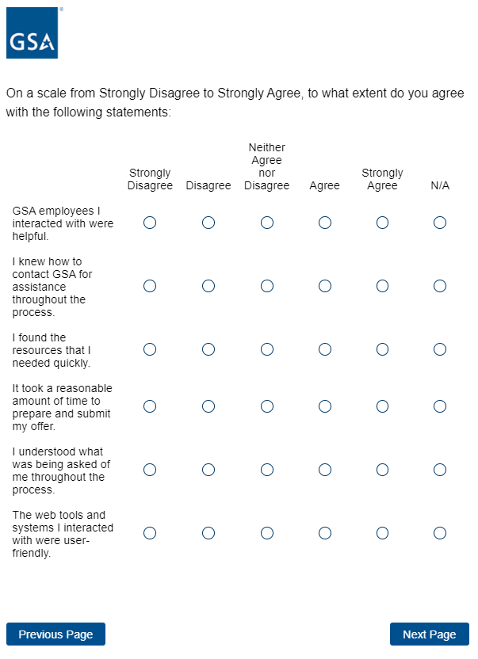
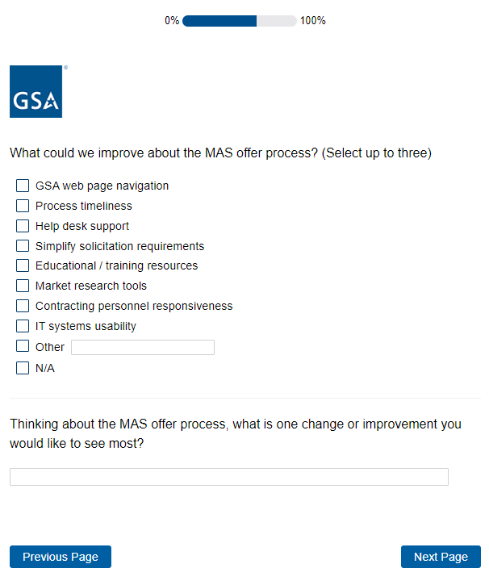
Response restriction: Select up to three responses.
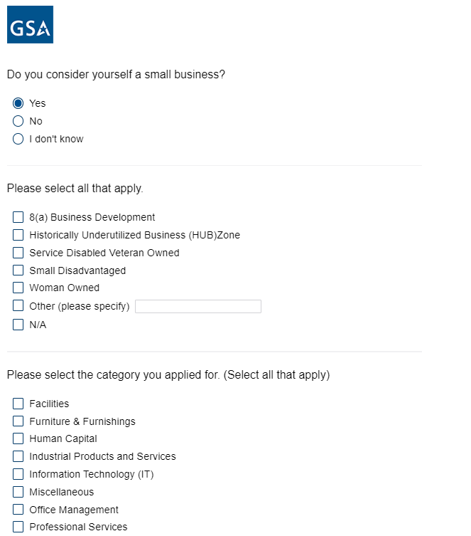
Display logic: If “Yes” to “Do you consider yourself a small business?” then display “Please select all that apply.” If “No” proceed to next question.
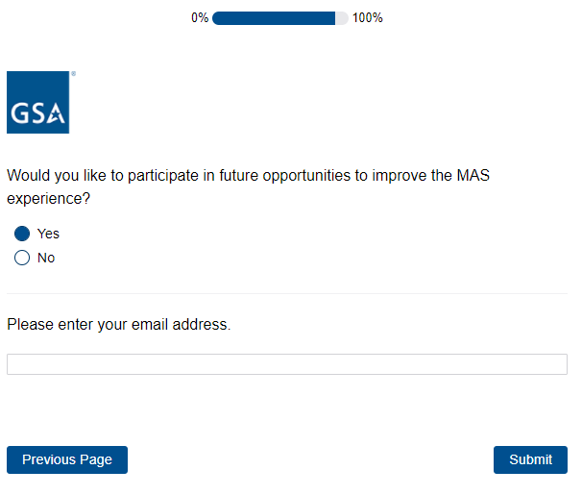
Display logic: If “Yes” to “Would you like to participate in future opportunities to improve the MAS experience?” show “Please enter your email address.” and text field. If “No” proceed to Submit.

