Screenshots of TMSS 2.0 Popover Replacement (7/2022)
Question 1
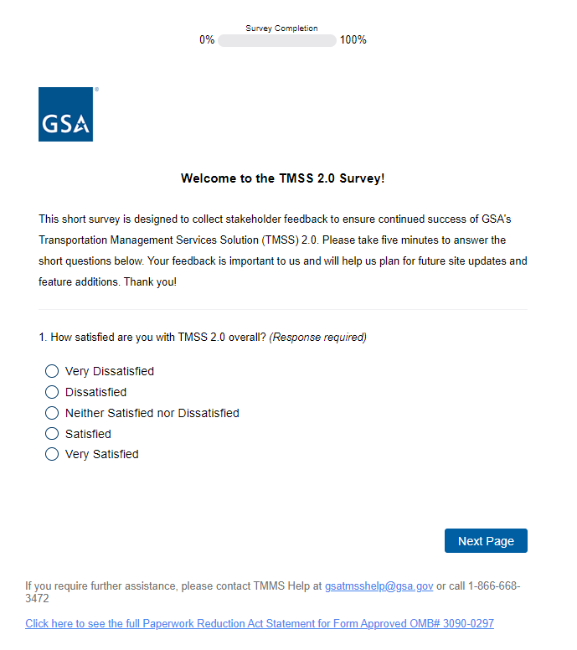

Question 2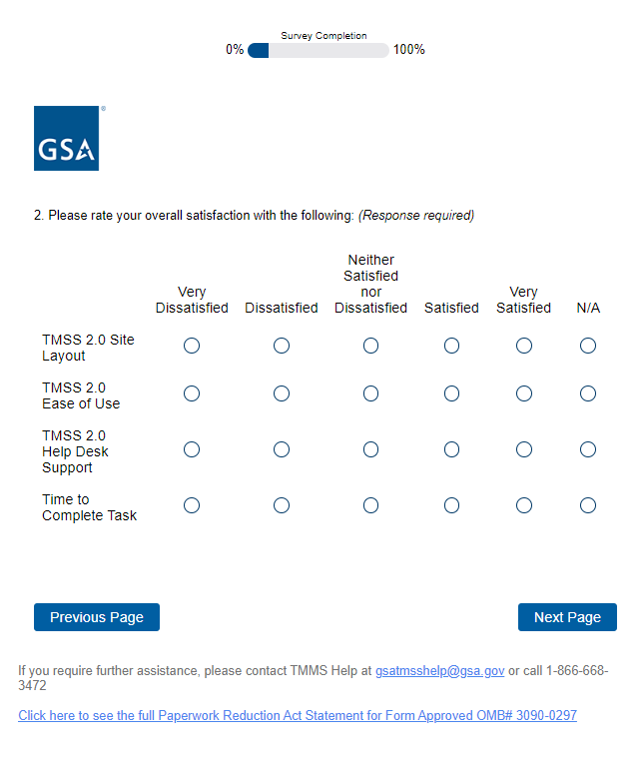
Question 3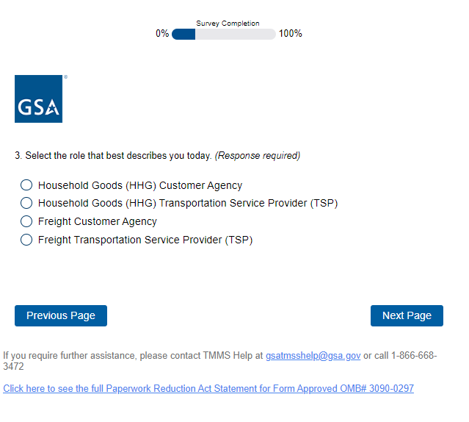

If the first option Household Goods (HHG) Customer Agency is selected in Question 3:
Question 4-1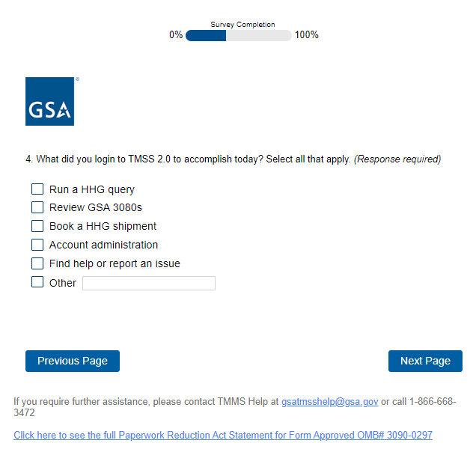

If the second option Household Goods (HHG Transportation Service Provider (TSP) is selected in Question 3:
Question 4-2

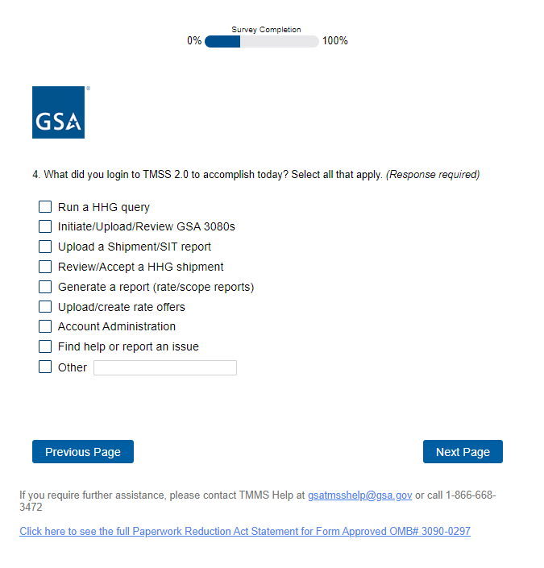

If the third option Freight Customer Agency is selected in Question 3:
Question 4-3
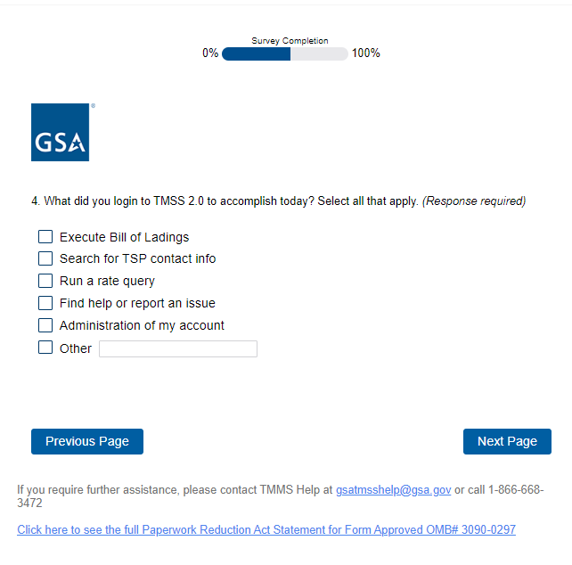

If the fourth option Freight Transportation Service Provider (TSP) is selected in Question 3:
Question 4-4

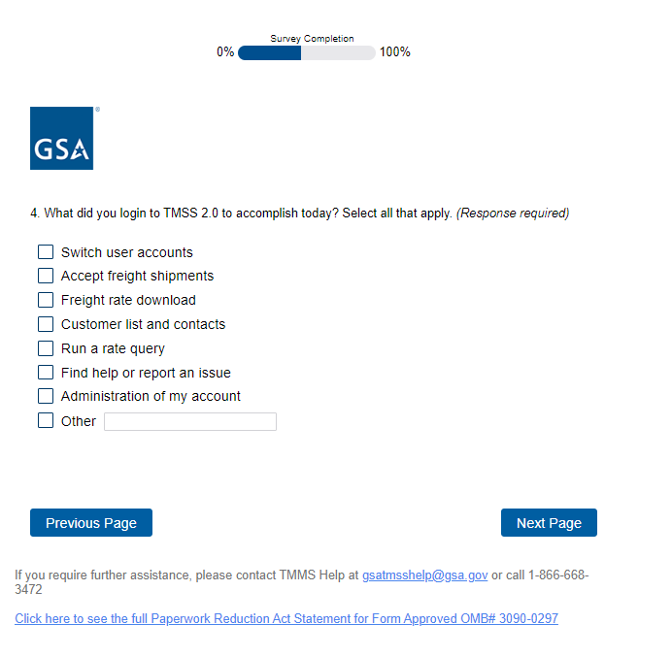
Question 5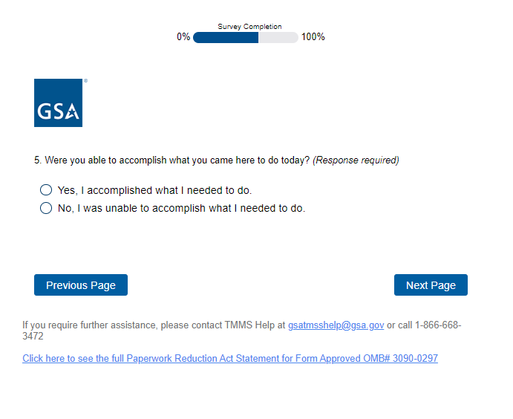
Question 6, 7, 8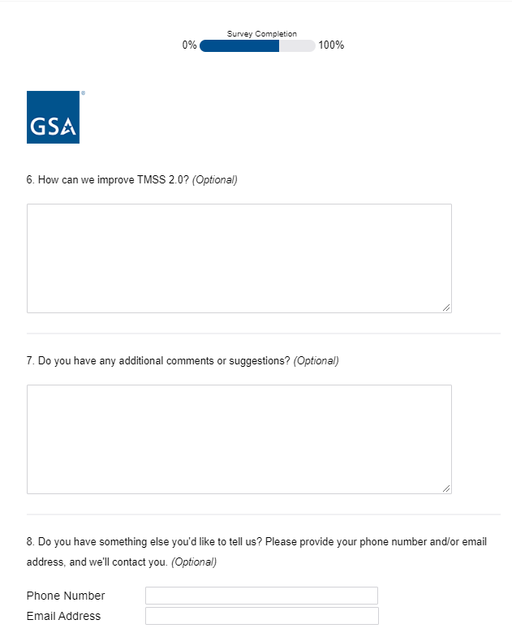

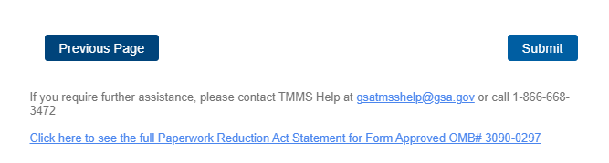

Survey Completion
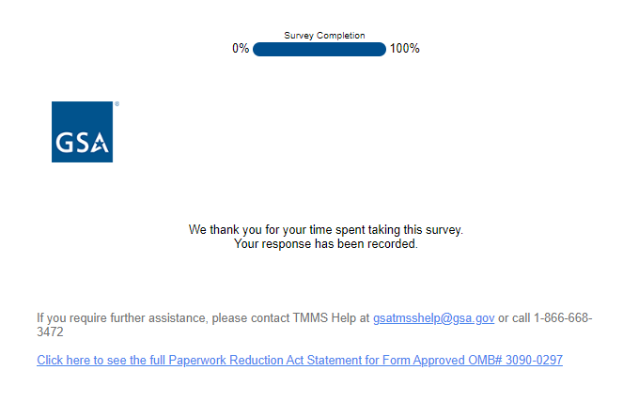

PRA Statement shown when the link in the Footer is clicked: