SCREENSHOTS FOR GENERIC TRAINING SALESFORCE SURVEY
(November 2022)

This is a generic survey that is designed to take you through 3 different survey paths depending on the offices training classes that were offered to the respondents.

Personal Property Management Survey Path Questions
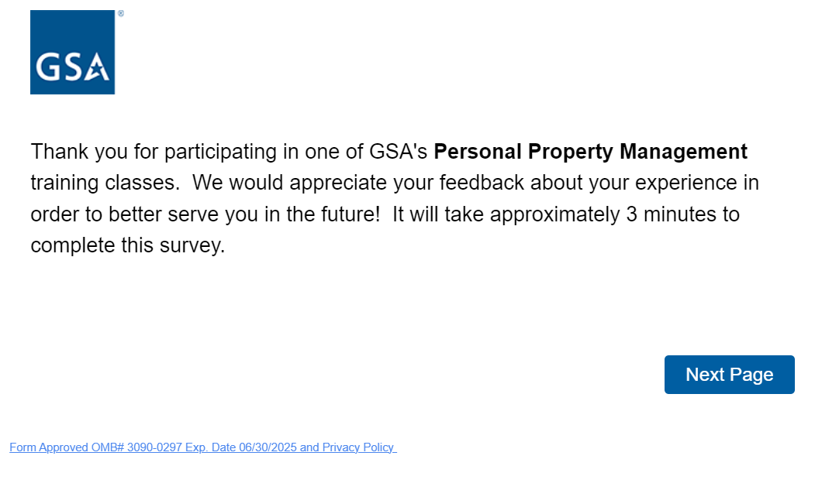
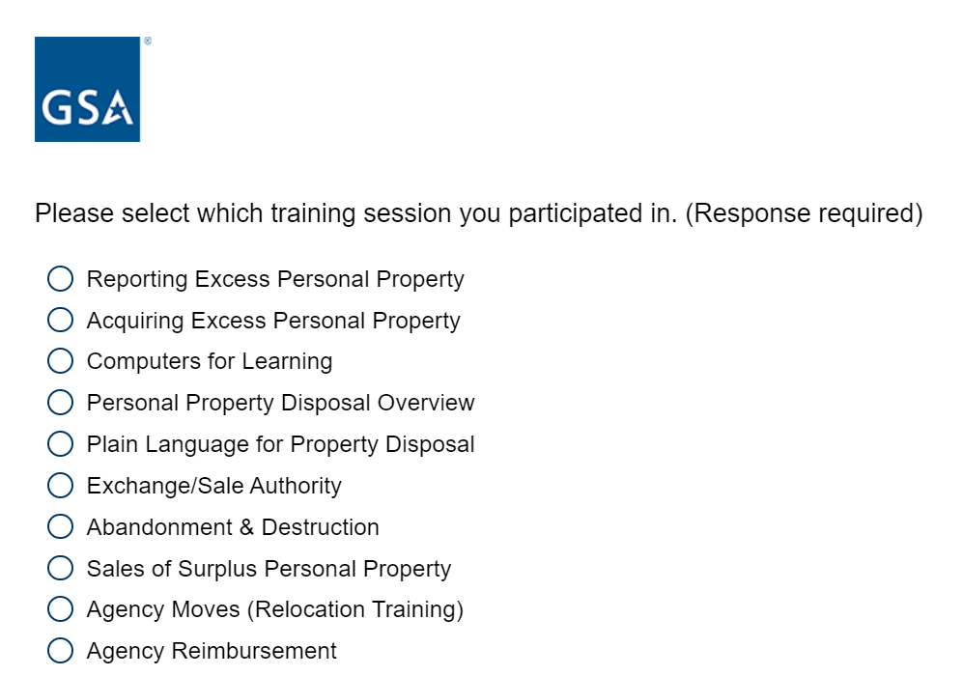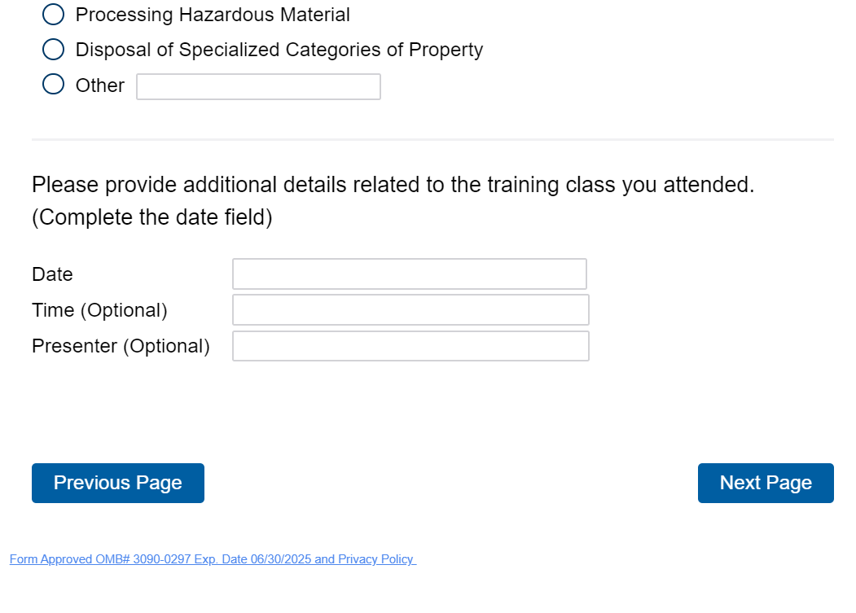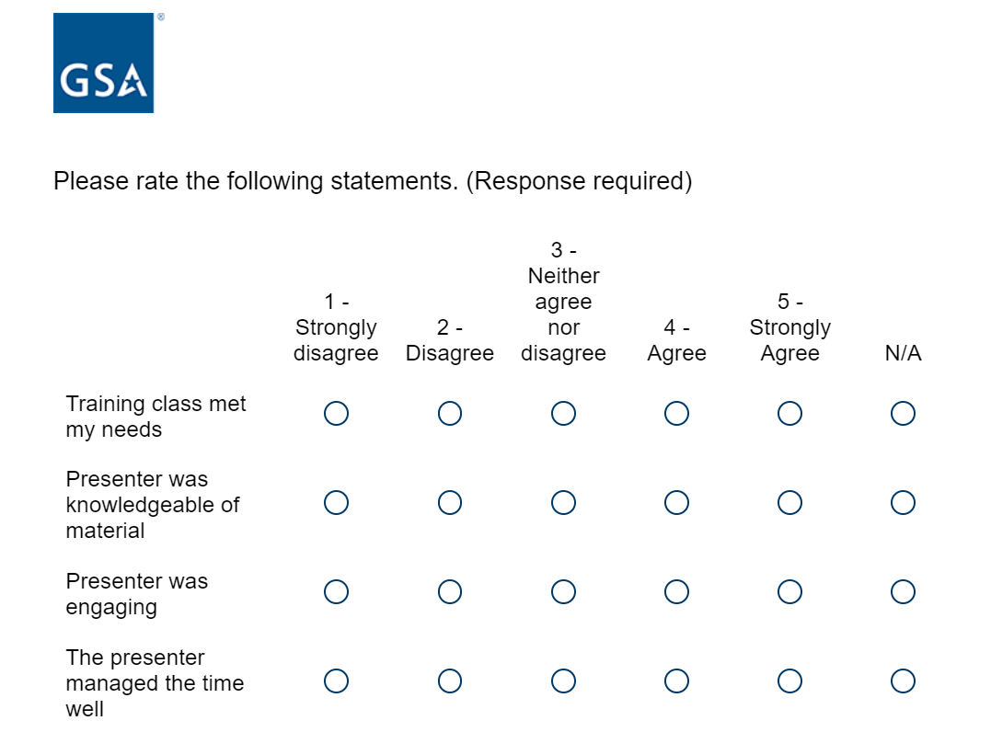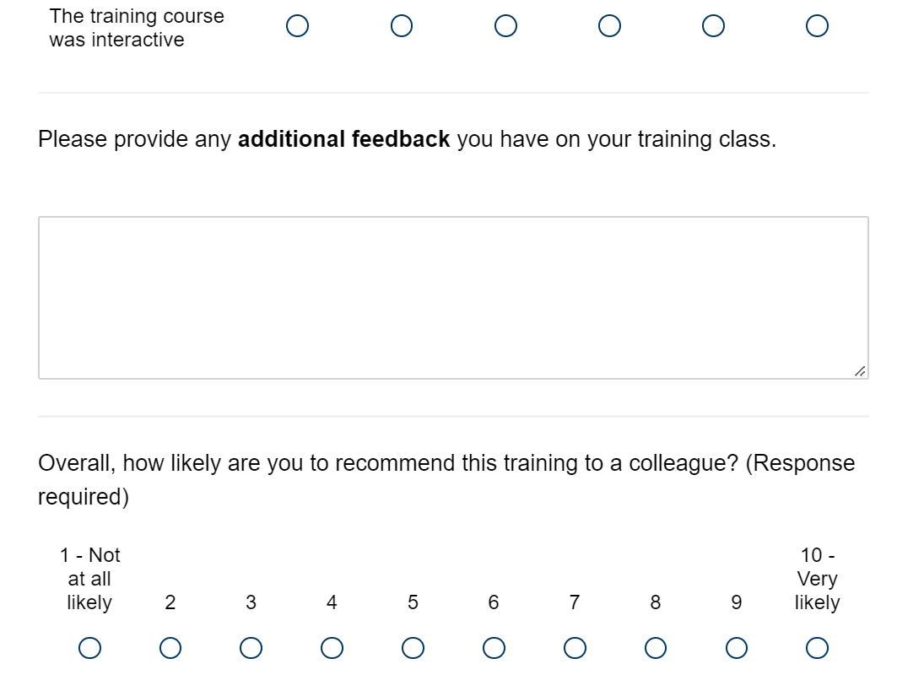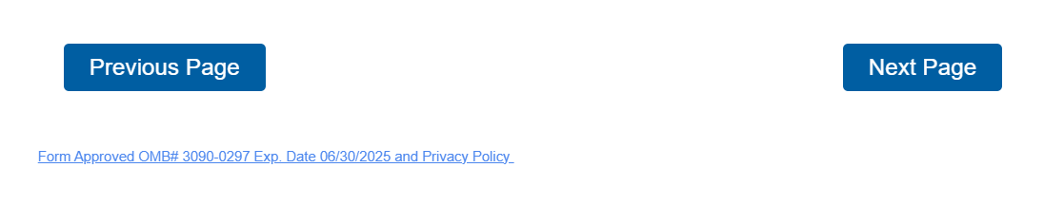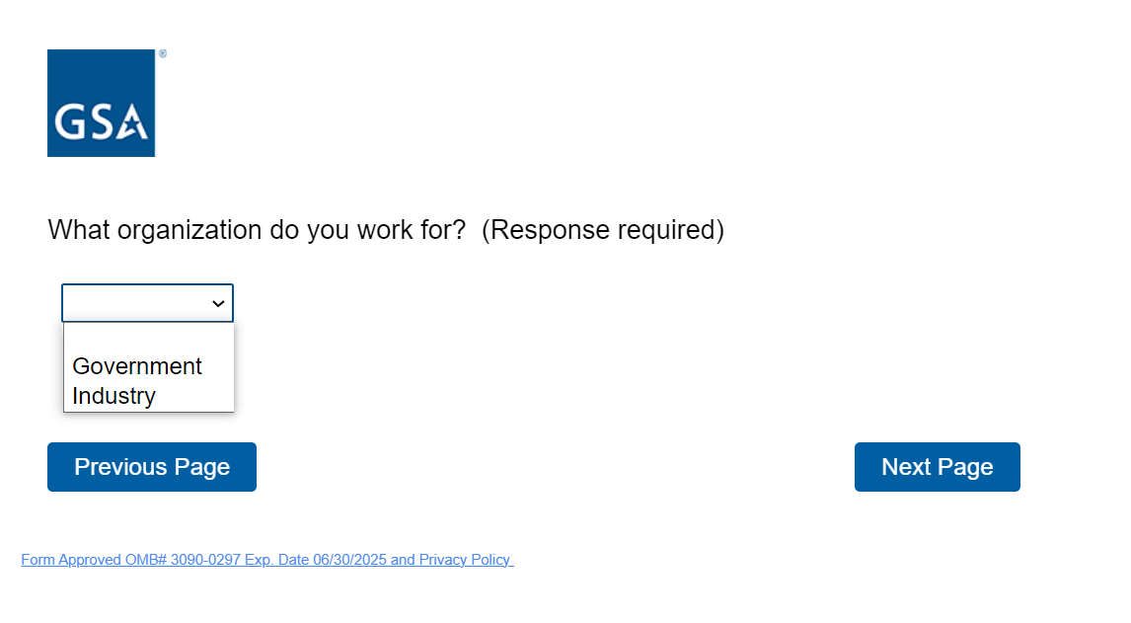
If the respondent selects “Government” from the above question, the below will appear for them to select from the agency and component drop down list. 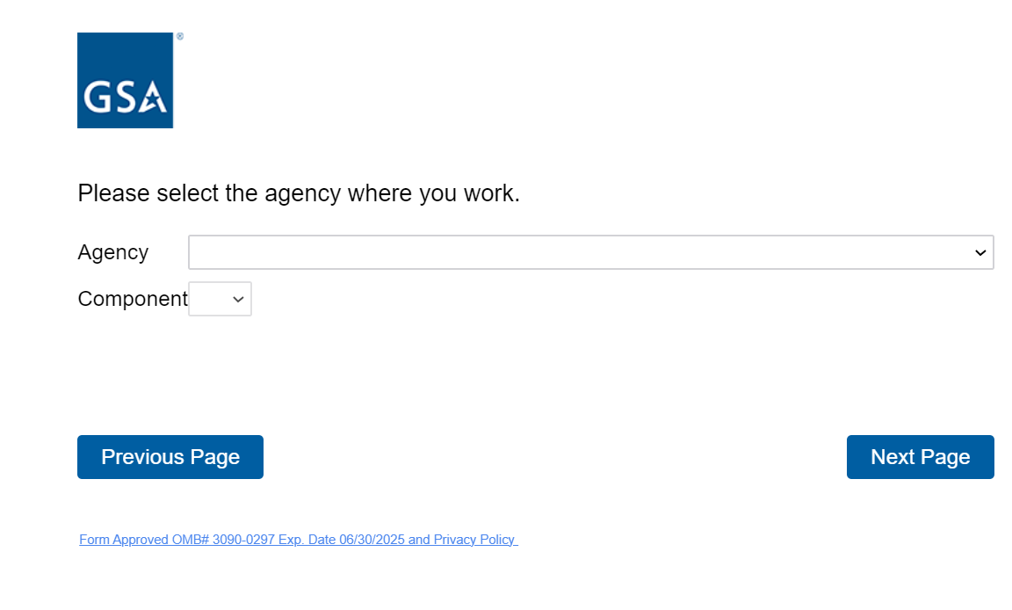

In the drop-down list, if the respondent selects “Other, Other>Other, Local Government, Local Government>Local Government, State Government, State Government>Other, Tribal Government, Tribal Government>Tribal Government”, the below question will appear.
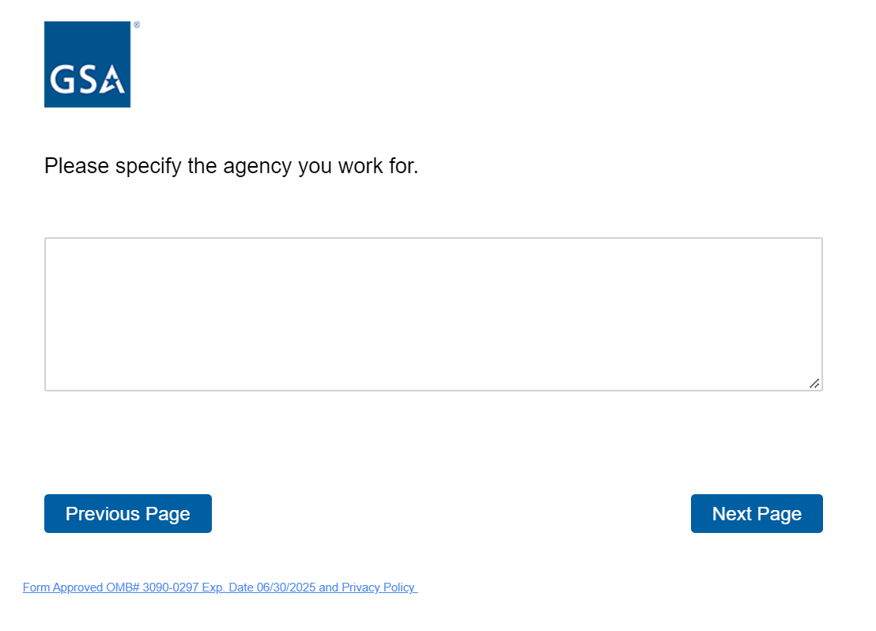

If the respondent selects “Industry”, the below question will appear.
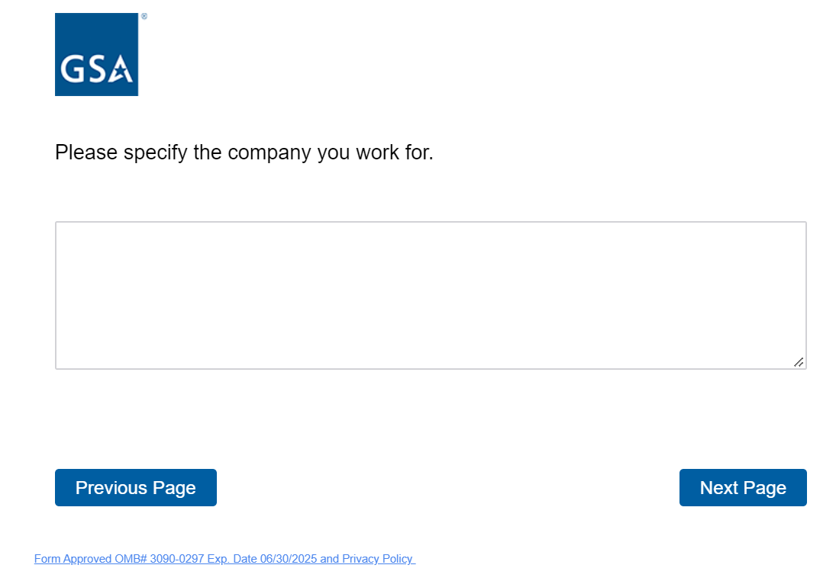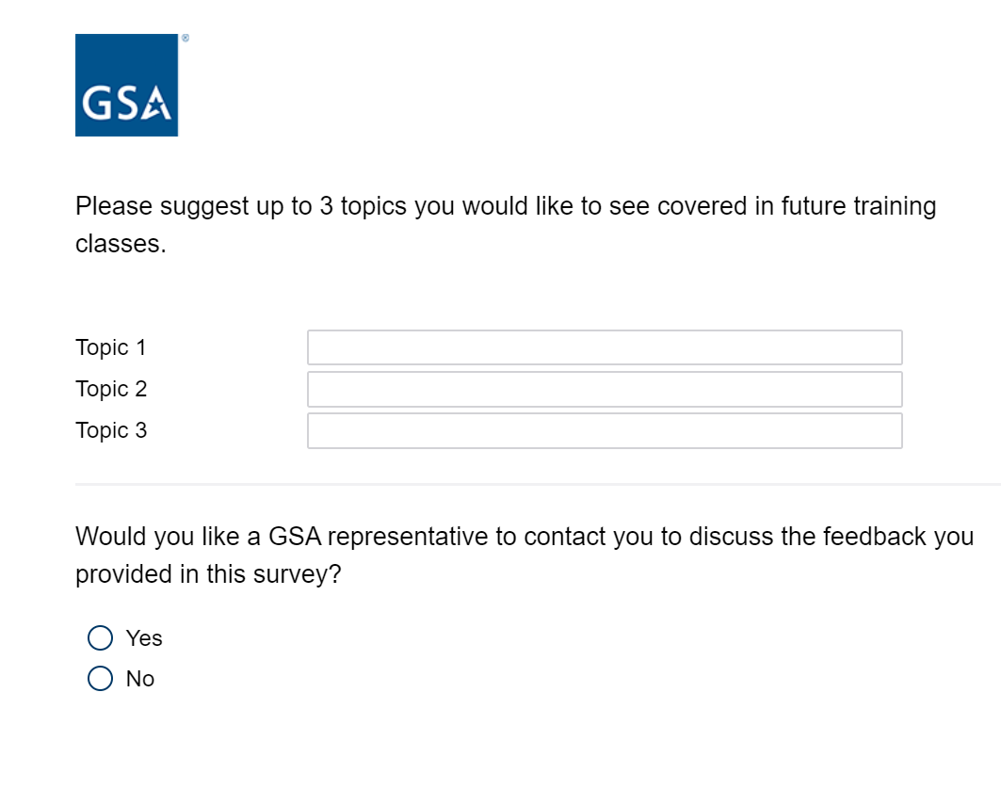
If the respondent selects “yes” to above question, the below question will appear. If the respondent selects “no”, it takes them to the end of the survey and the “Thank you for participating screen will appear”.
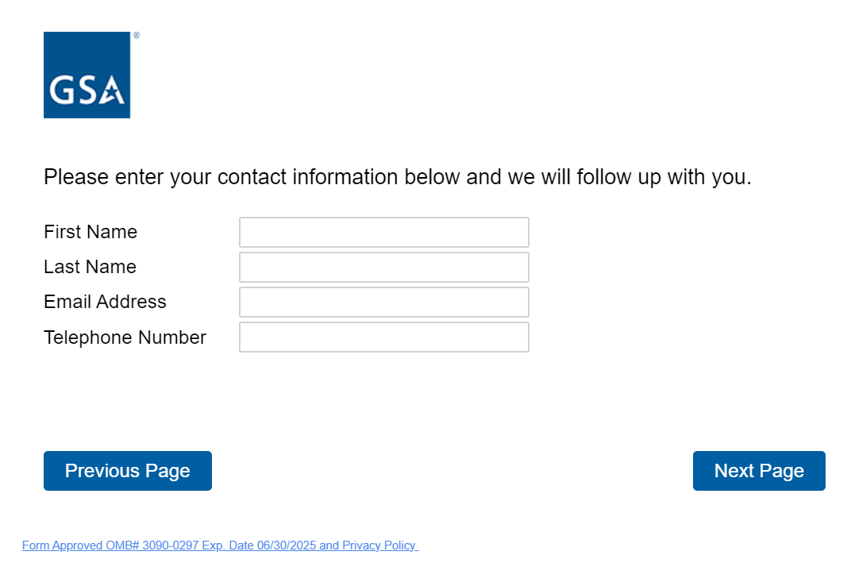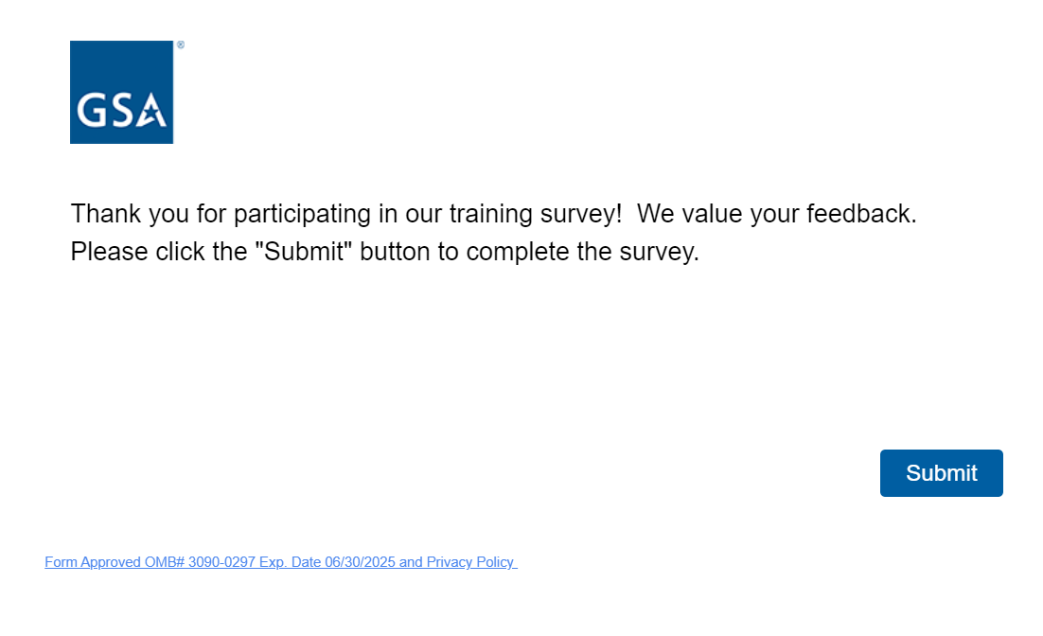

Professional Service Human Capital Survey Path Questions
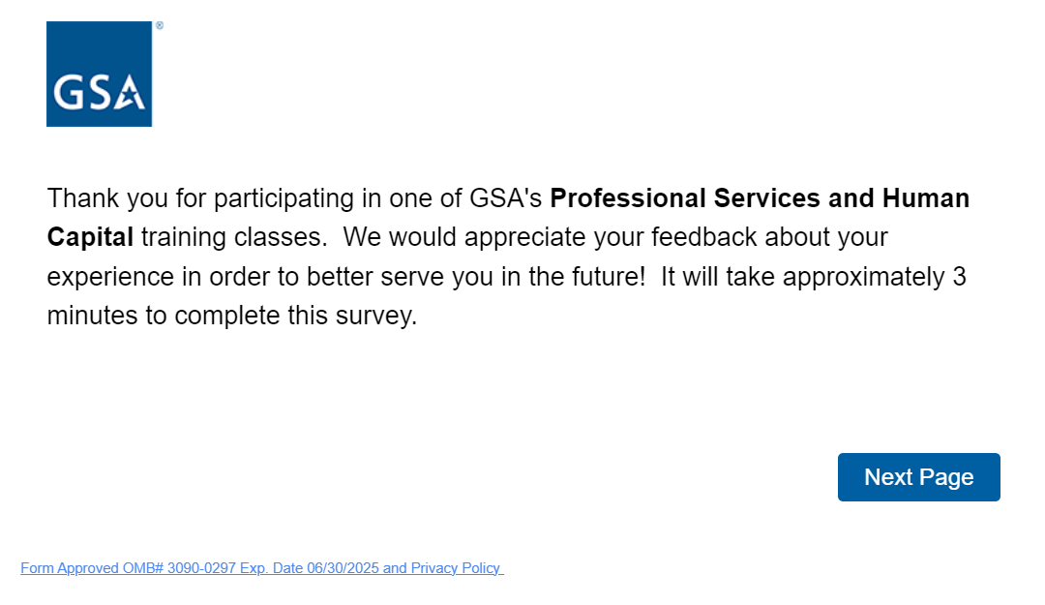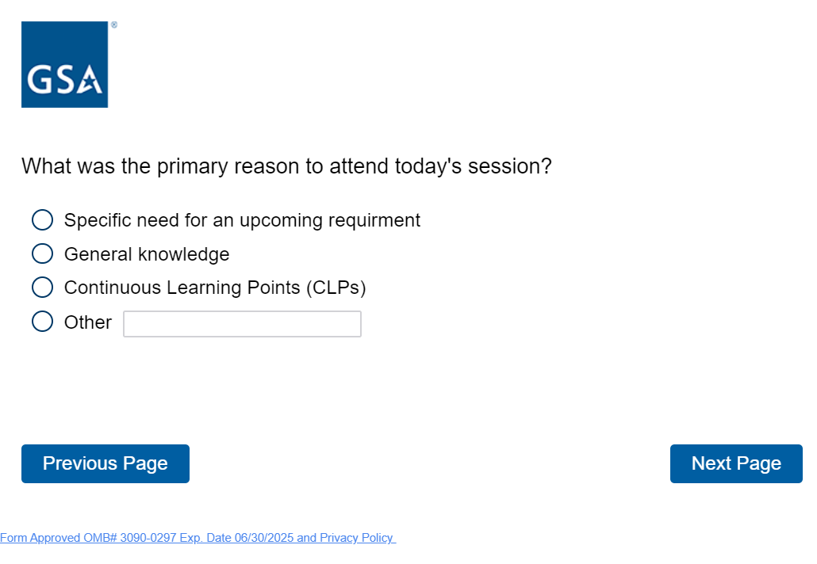 If the respondent selects “Government” from the above question, the below question will appear for them to select from an agency and component drop down list. In the drop-down list, if the respondent selects “Other, Other>Other, Local Government, Local Government>Local Government, State Government, State Government>Other, Tribal Government, Tribal Government>Tribal Government”, the below question will appear. If the respondent selects “Industry”, the below question will appear.
If the respondent selects “yes”, the below question will appear. If the respondent selects “no”, It takes them to the end of the survey and the “Thank you for participating” screen will appear.

Information Technology Category Survey Path Questions 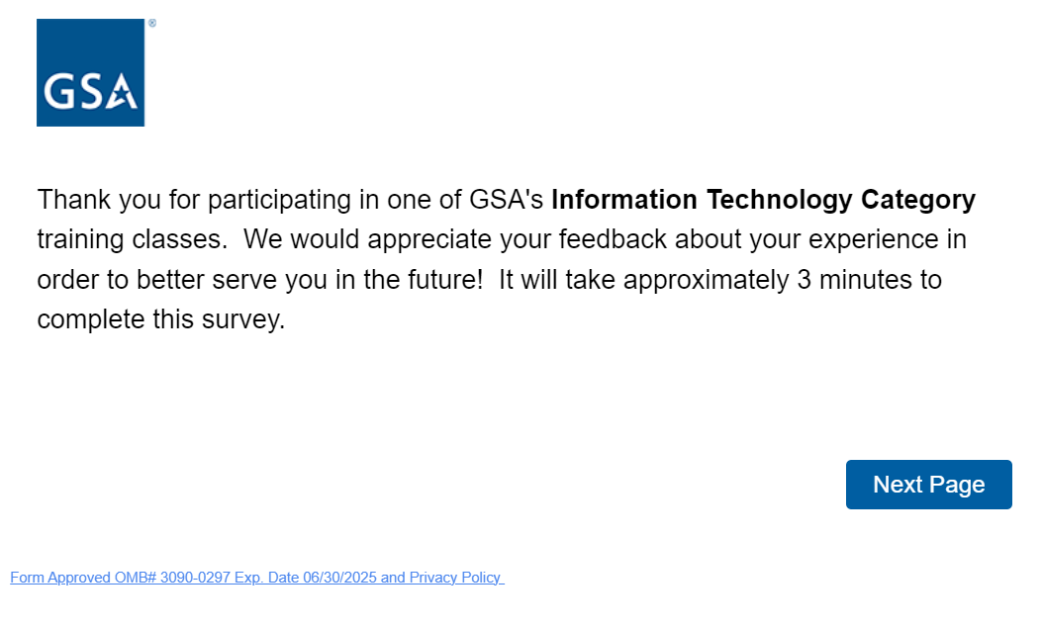 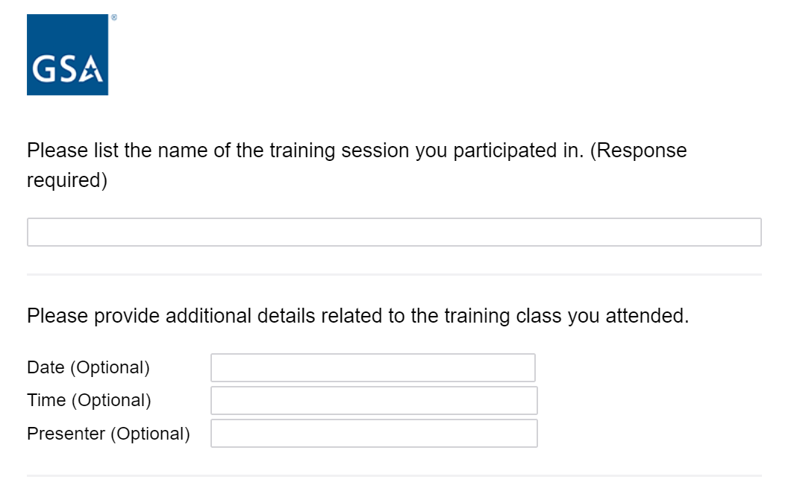
If the respondent selects “Government” from the above question, the below question will appear for them to select from an agency and component drop down list. In the drop-down list, if the respondent selects “Other, Other>Other, Local Government, Local Government>Local Government, State Government, State Government>Other, Tribal Government, Tribal Government>Tribal Government”, the below question will appear. If the respondent selects “Industry”, the below question will appear. 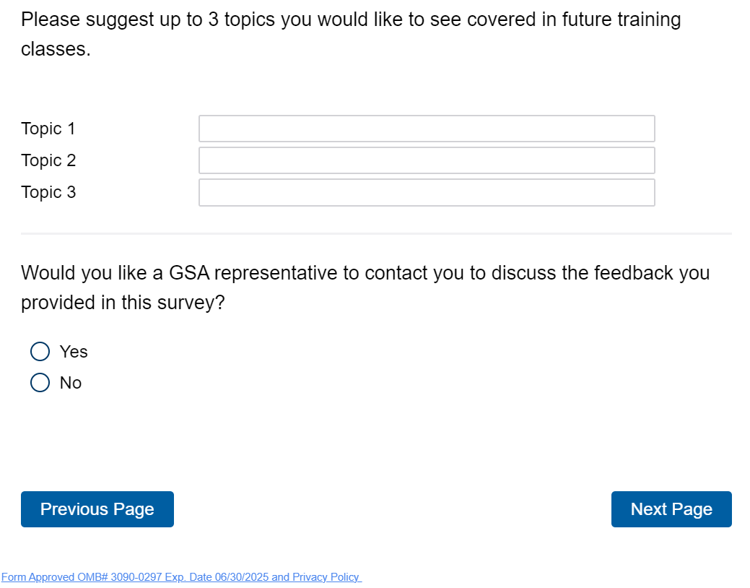

If the respondent selects “yes”, the below question will appear. If the respondent selects “no”, it takes them to the follow-on question.
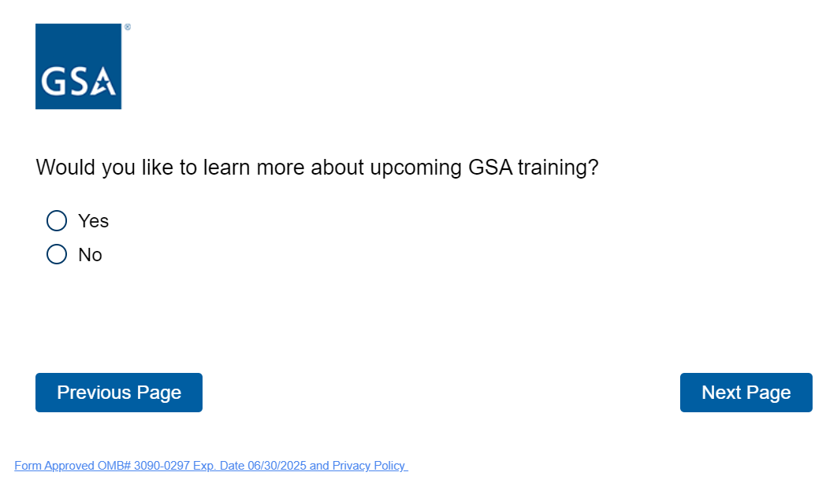
If the respondent selects “yes”, it takes them to the below training website that is updated on a continuous basis: https://www.gsa.gov/about-us/events-and-training/gsa-events
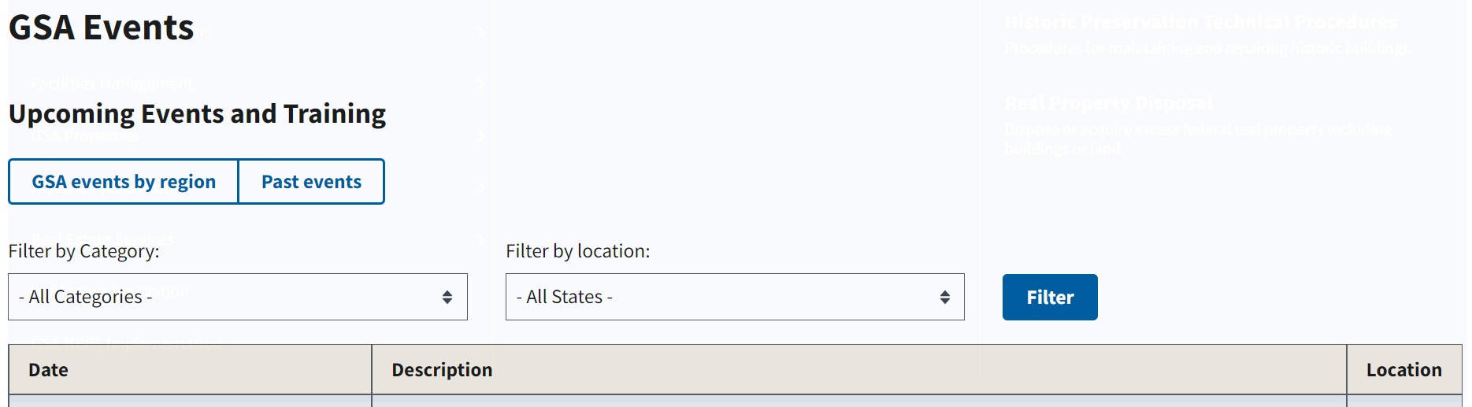

If the respondent selects “no”, it takes them to the end of the survey and the below “Thank you” message will appear.

