**FAST Track 3090-0297**

**GSA Auctions Website Survey (Annual Renewal Dec 2022-Dec 2023)**

**Screen 1**

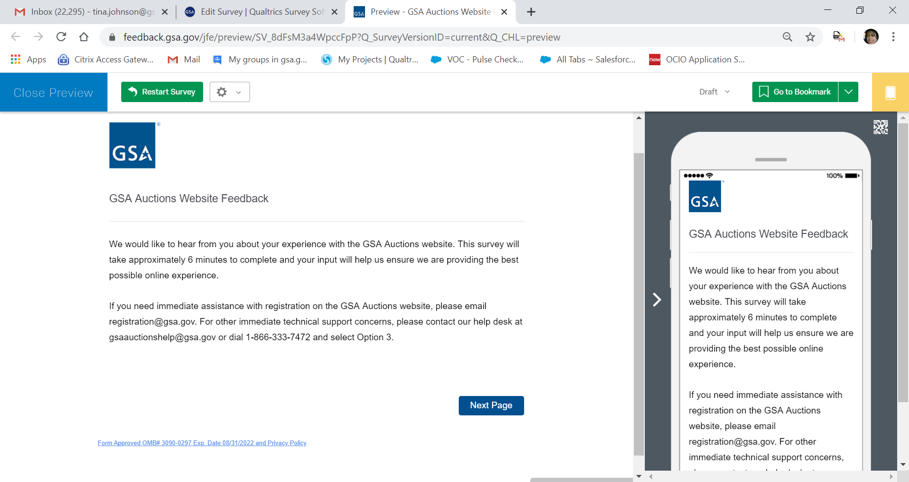

**There is a footer link located at the bottom of most screens that will display the Privacy Policy. If the respondent clicks on the link, titled “Form Apporoved OMB# 3090-3097 Exp. Date 08/31/2022 and Privacy Policy statement will appear. See below text.**

Paperwork Reduction Act Statement

OMB No: 3090-0297

Expires 08/31/2022

This information collection meets the requirements of 44 U.S.C. § 3507, as amended by section 2 of the Paperwork Reduction Act of 1995. You do not need to answer these questions unless we display a valid Office of Management and Budget (OMB) control number. The OMB control number for this collection is 3090-0297. We estimate that it will take 6 minutes to read the instructions, gather the facts, and answer the questions. Send only comments relating to our time estimate, including suggestions for reducing this burden, or any other aspects of this collection of information to: General Services Administration, Regulatory Secretariat Division (MVCB), ATTN: Lois Mandell/IC 3090-0297, 1800 F Street, NW, Washington, DC 20405.

Privacy Act Statement

The information you provide to complete the survey being conducted is collected pursuant to 6 USC § 1523 (b)(1)(A)-(E), the [E-Government Act of 2002 (44 USC § 3501)](https://www.govinfo.gov/content/pkg/PLAW-107publ347/html/PLAW-107publ347.htm), and 40 USC § 501.

The information that you submit is used to improve the user experience on this GSA website. Information will be used by and disclosed to GSA personnel and contractors to process survey results. This survey does not collect any personal information, unless you choose to provide contact information for follow-up, nor can the information you provide be directly tied to you when used for analysis. GSA may collect and use privacy information voluntarily submitted pursuant to its Privacy Act System of Records Notice [GSA/CIO-3](https://www.federalregister.gov/documents/2014/08/12/2014-19071/privacy-act-of-1974-notice-of-an-updated-system-of-records). All records are stored electronically in a secure database in GSA's implementation of Qualtrics, our survey management tool used to conduct this survey.

[You can read more about GSA’s Privacy Policy and use of browser cookies here](https://www.gsa.gov/website-information/website-policies)

**Screen 2**

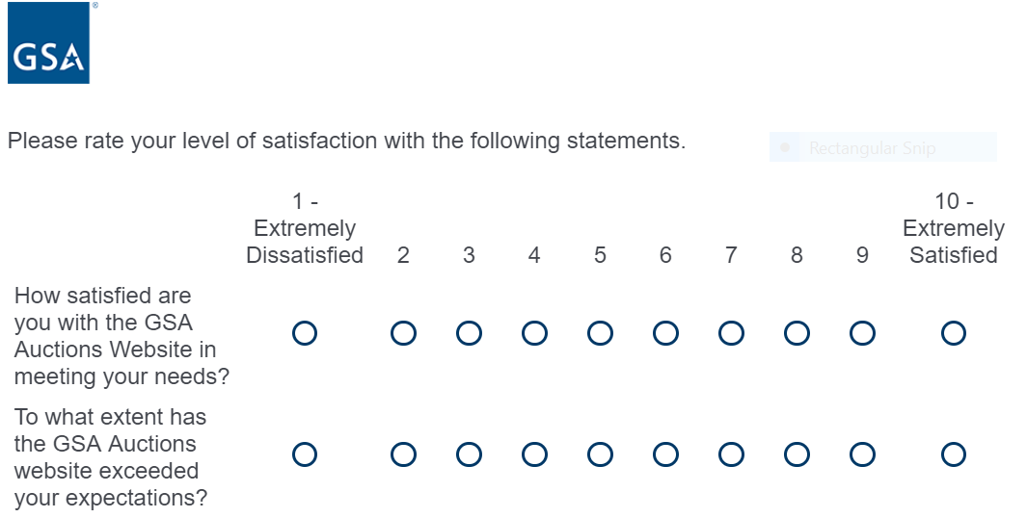

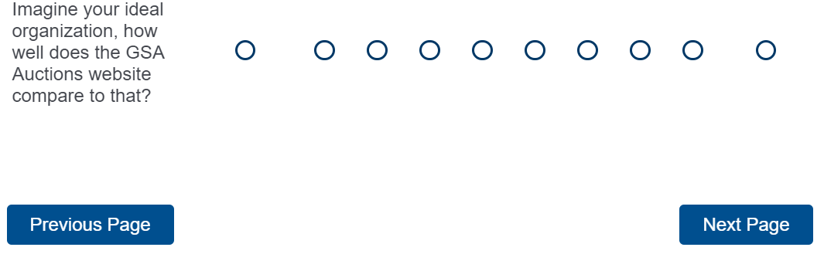

Form Approved OMB# 3090-0297 Exp. Date 08/31/2022 and Privacy Policy

**Screen 3**

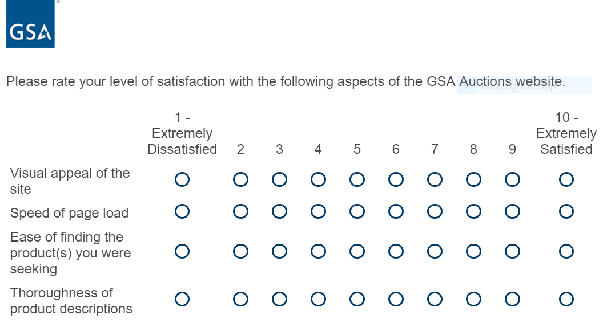

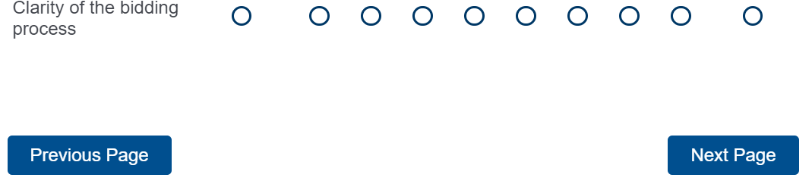

Form Approved OMB# 3090-0297 Exp. Date 08/31/2022 and Privacy Policy

**Screen 4**

**Display this question if respondent did not select a score of 7, 8, 9 or 10 from the scale above for the answer choice titled Thoroughness of product descriptions *OR***

**Display this question if respondent did not select a score of 7, 8, 9, or 10 from the scale above for the answer choice titled Ease of find the product(s) you were seeking**

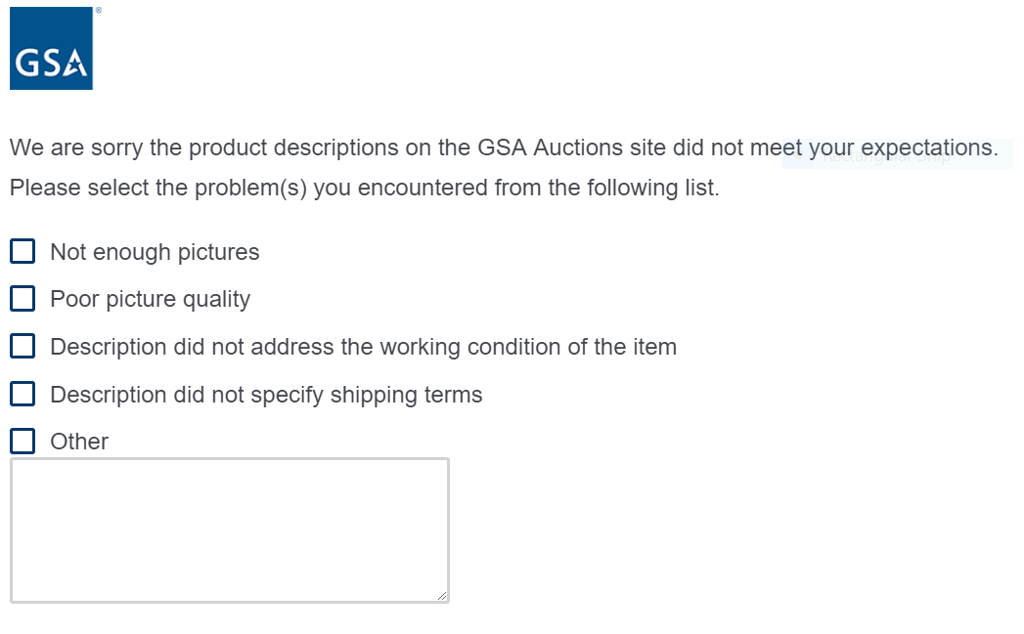



Form Approved OMB# 3090-0297 Exp. Date 08/31/2022 and Privacy Policy

**Screen 5**

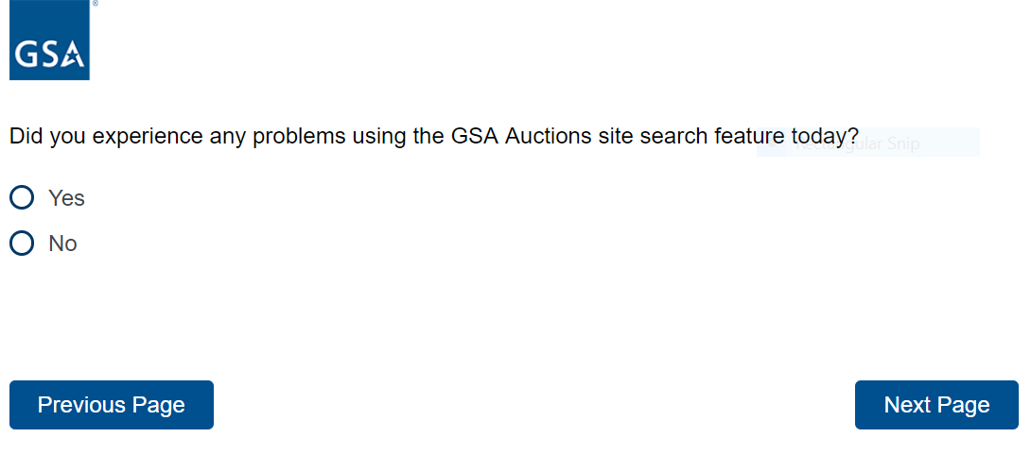

Form Approved OMB# 3090-0297 Exp. Date 08/31/2022 and Privacy Policy

**Screen 6**

**Display this question if respondent selected yes from the above question**

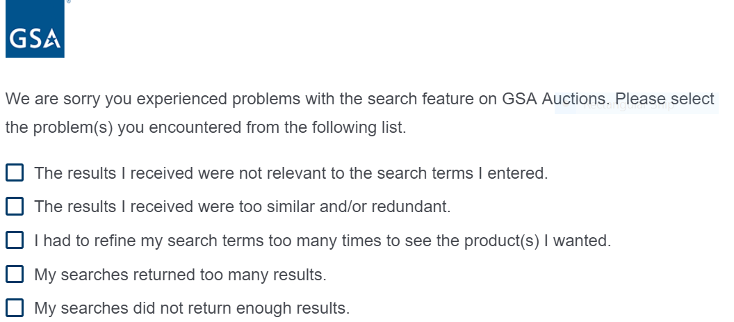

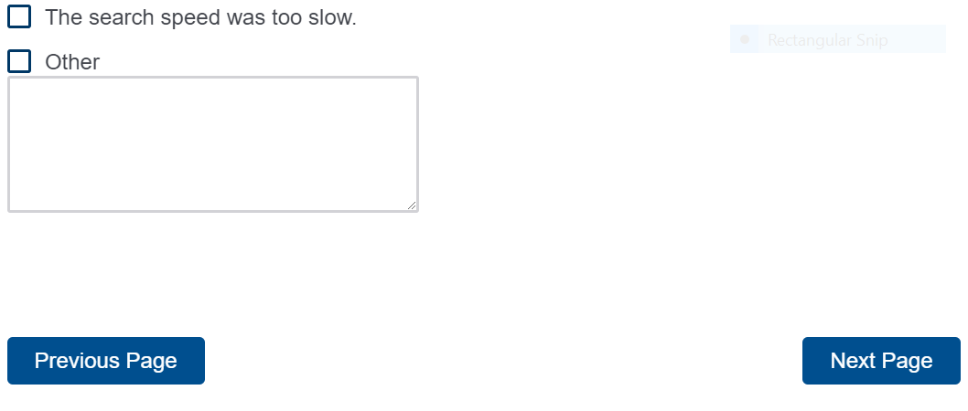

Form Approved OMB# 3090-0297 Exp. Date 08/31/2022 and Privacy Policy

**Screen 7**

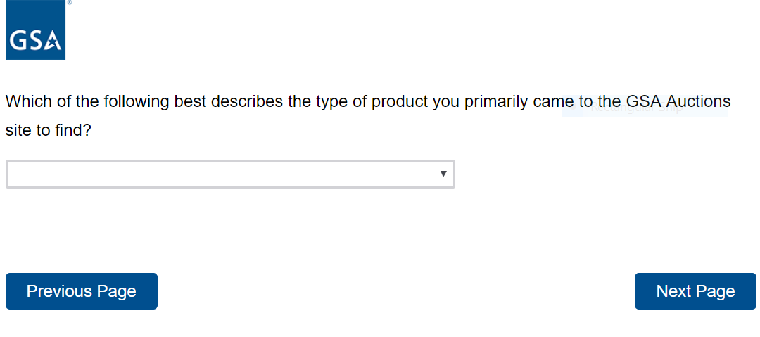

Form Approved OMB# 3090-0297 Exp. Date 08/31/2022 and Privacy Policy

**Respondent selects from the drop down list below:**

I was Not Looking for Anything Specific

Agricultural Equipment and Supplies

Aircraft and Aircraft Parts

Boats and Marine Equipment

Communication Equipment

Computer Equipment and Accessories

Construction Equipment

Electrical and Electronic Equipment

Fire Trucks and Fire Fighting Equipment

Furniture

Hand Tools and Shop Equipment

Household/Personal

Industrial Machinery

Jewelry and Exotic Collectibles

Lab Equipment

Medical, Dental and Veterinary Equipment and Supplies

Motorcycles and Bicycles

NASA Shuttle/Hubble

Office Equipment and Supplies

Photographic Equipment

Real Estate (houses, buildings, land and farms)

Trailers, Tractors and Manufactured Housing

Vehicles and Vehicle Parts

Other

**Screen 8**

**Display this question if the choice “I was Not Looking for Anything Specific” was not selected**

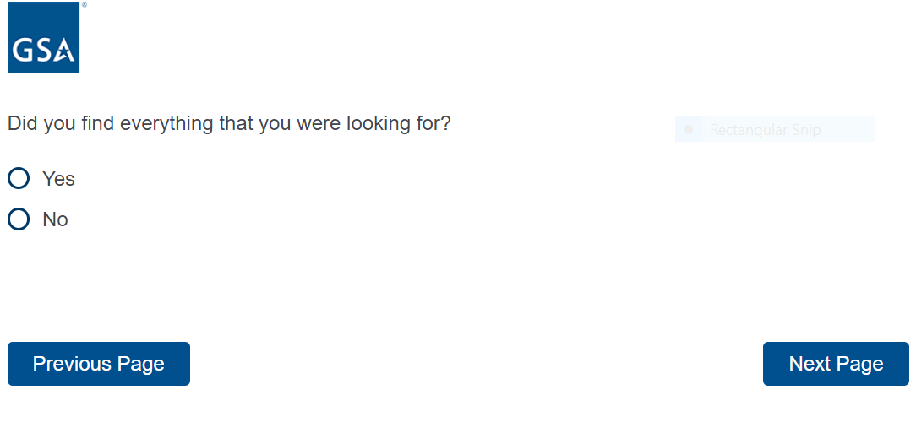

Form Approved OMB# 3090-0297 Exp. Date 08/31/2022 and Privacy Policy

**Screen 9**

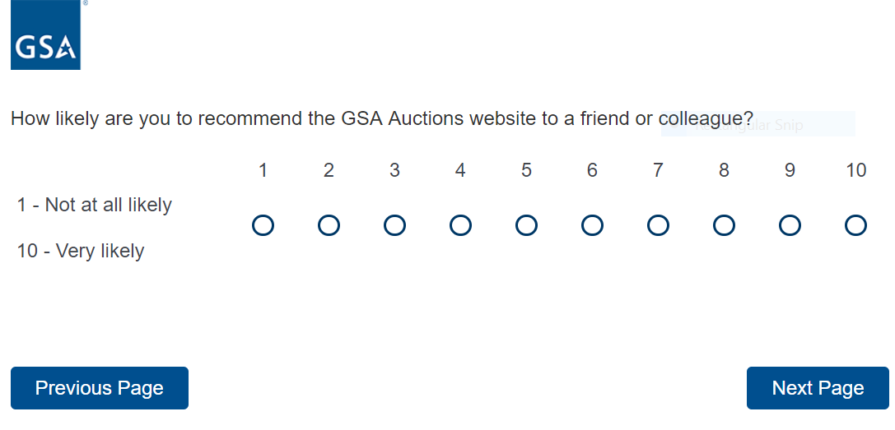

Form Approved OMB# 3090-0297 Exp. Date 08/31/2022 and Privacy Policy

**Screen 10**

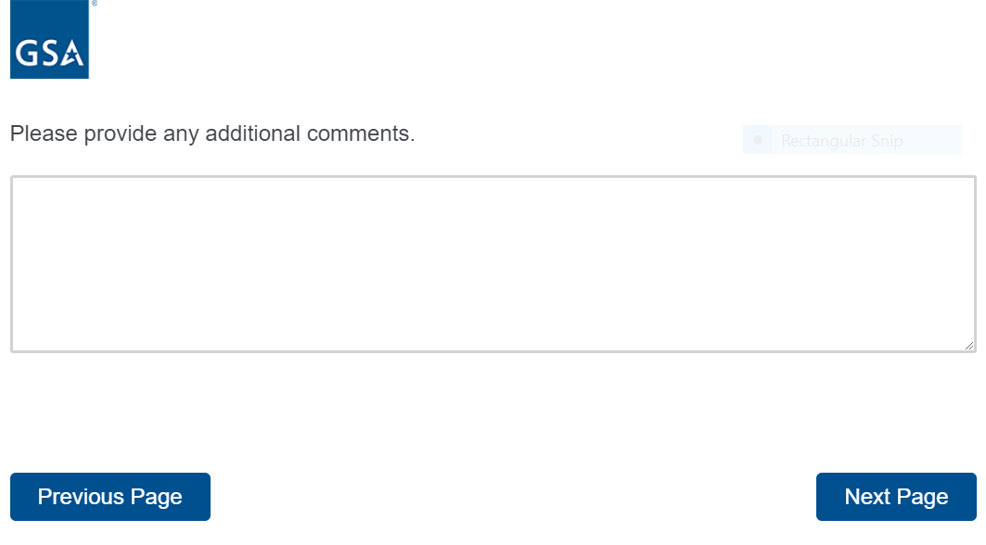

Form Approved OMB# 3090-0297 Exp. Date 08/31/2022 and Privacy Policy

**Screen 11**

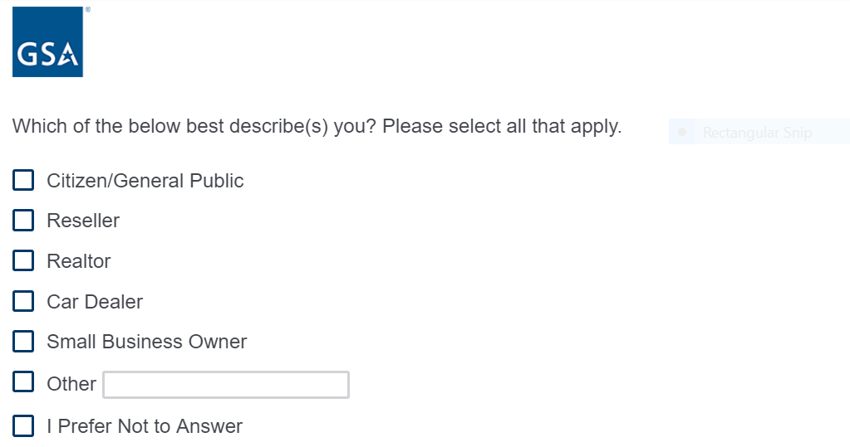

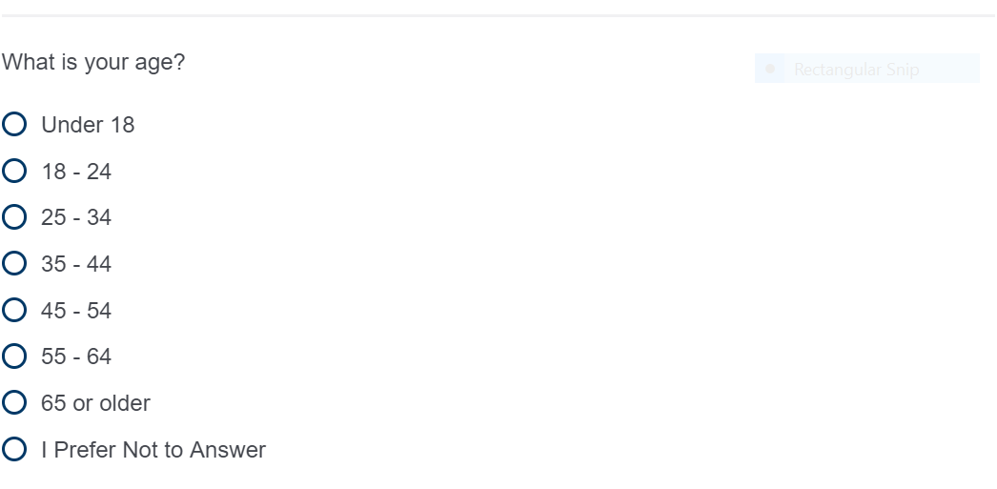



Form Approved OMB# 3090-0297 Exp. Date 08/31/2022 and Privacy Policy

**Screen 12**

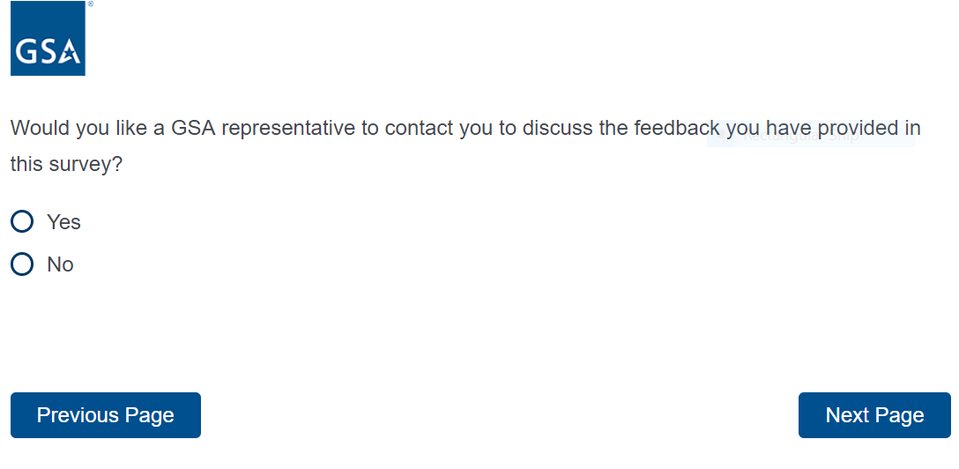

Form Approved OMB# 3090-0297 Exp. Date 08/31/2022 and Privacy Policy

**Screen 13**

**If yes is selected from above, display the following question**

**If no is selected from above, “Thank You” Screen appears**

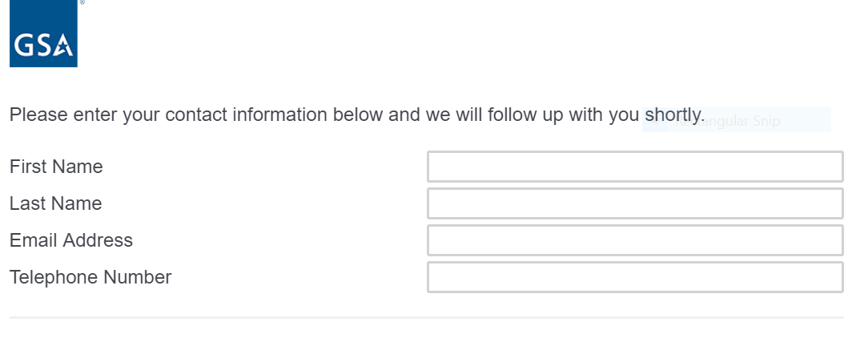

**Screen 14**

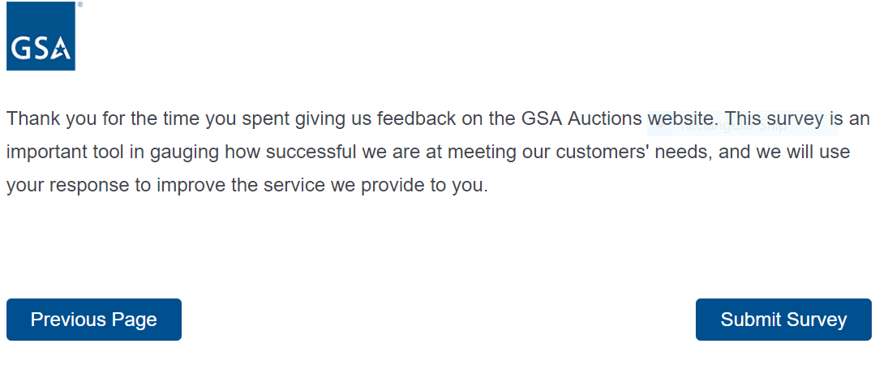

Form Approved OMB# 3090-0297 Exp. Date 08/31/2022 and Privacy Policy