Introduction
The survey outlined in this walkthrough document will collect user feedback on the GSA.gov website. Data collected here will inform our user-centered approach in maintaining and improving our website and digital experience.

Once live, site visitors will be asked to participate in a survey just before they exit the site. 50% of respondents will be asked questions about the overall website (First Option Survey - General), and 50% will be asked to give feedback about the specific page they are on (Second Option Survey - Page-Level).

Users who have ever taken either survey or saw either survey request in the last 10 days will not be asked to complete a survey during their visit.

Throughout this document, asterisks (*) indicate questions respondents must answer to move forward.

First Option Survey (General)
Users will see this prompt when they hover over an exit button (*):

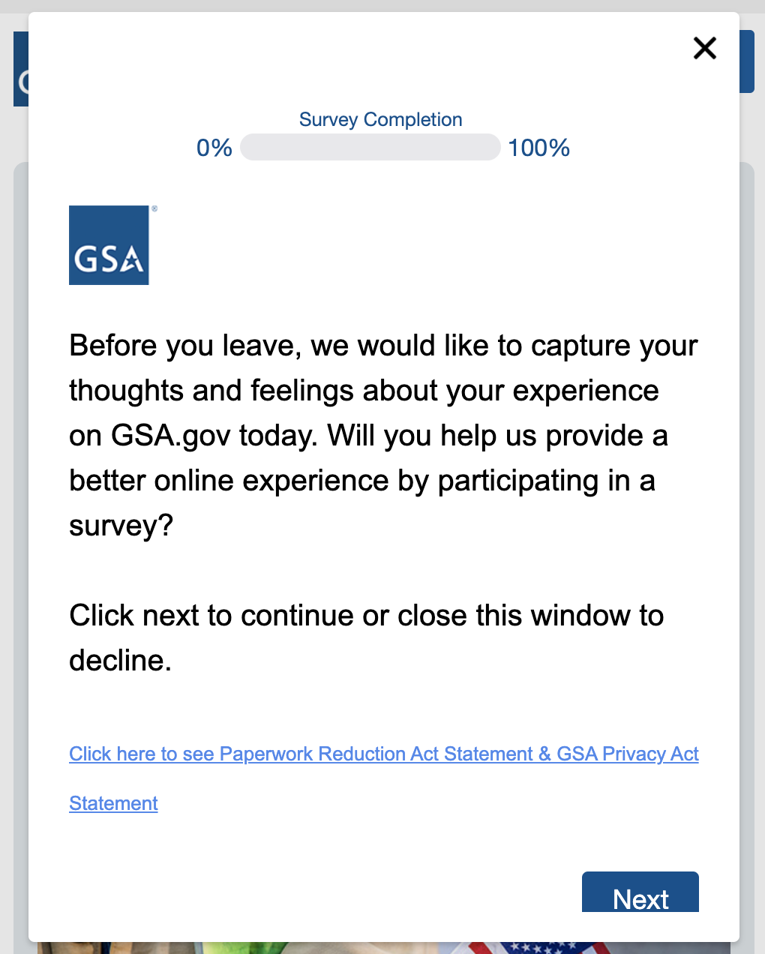
Users who click on the PRA/Privacy link will see this document open in a new window:

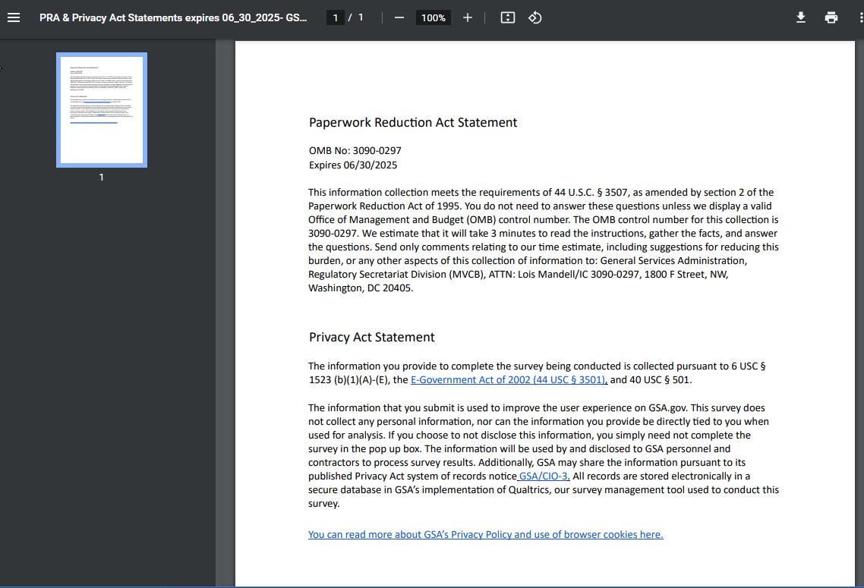

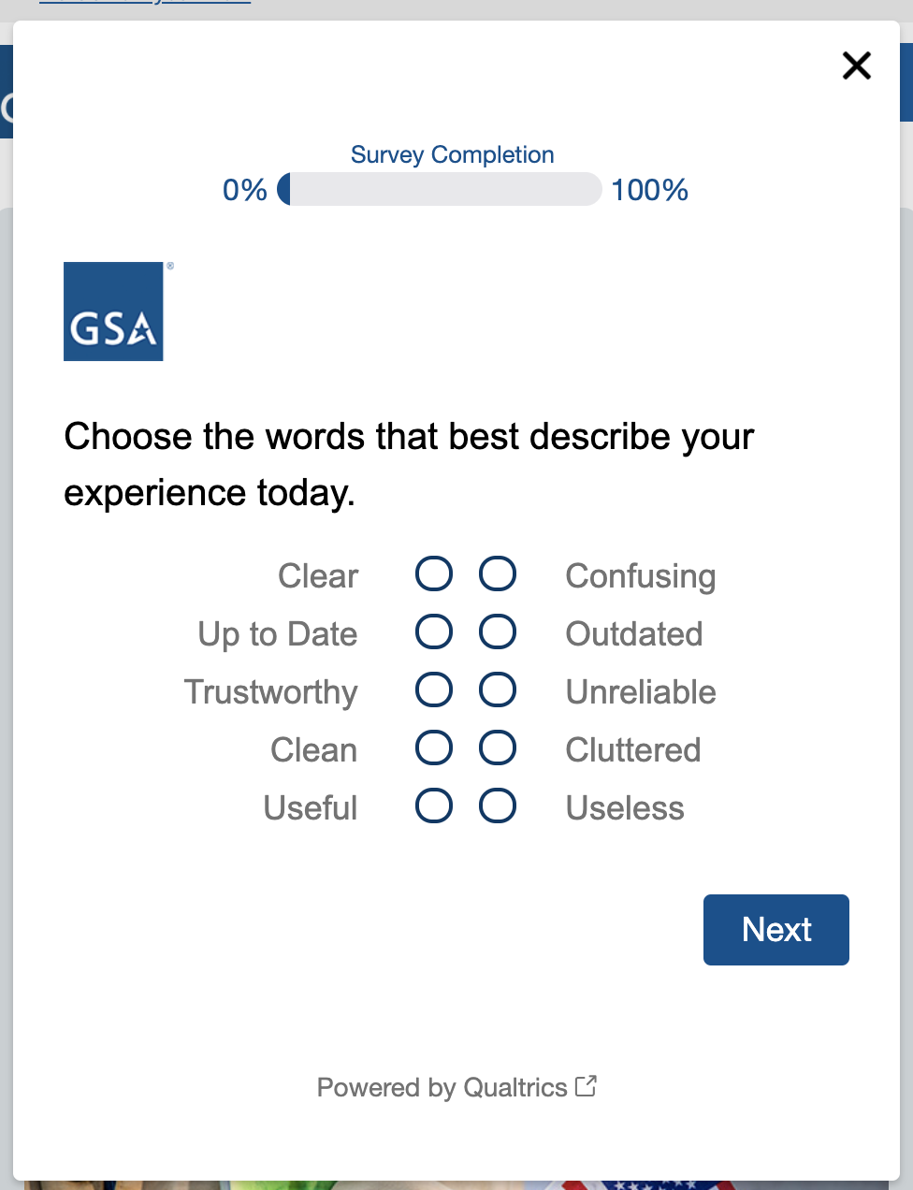
Users who click Next will see the first survey question (*):

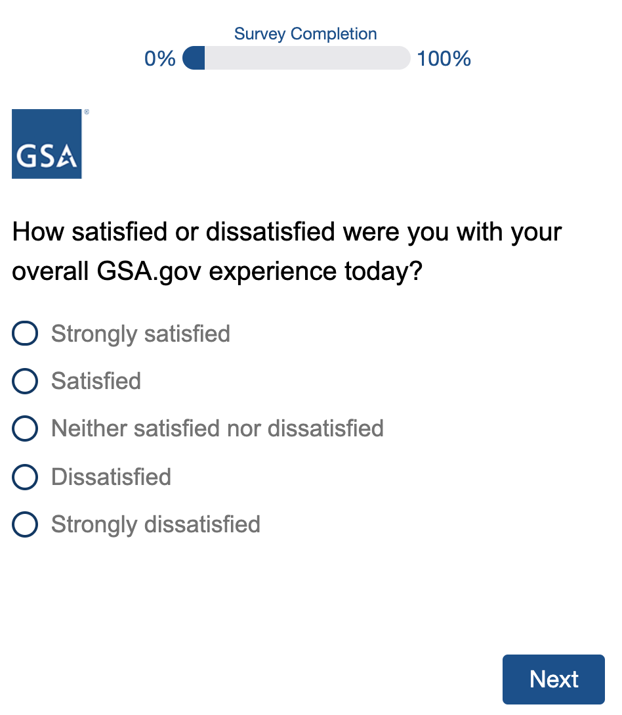
After they respond to the first question, all users will be asked how satisfied they were with their web experience (*):

Then, they will select a primary reason for visiting the site (*):
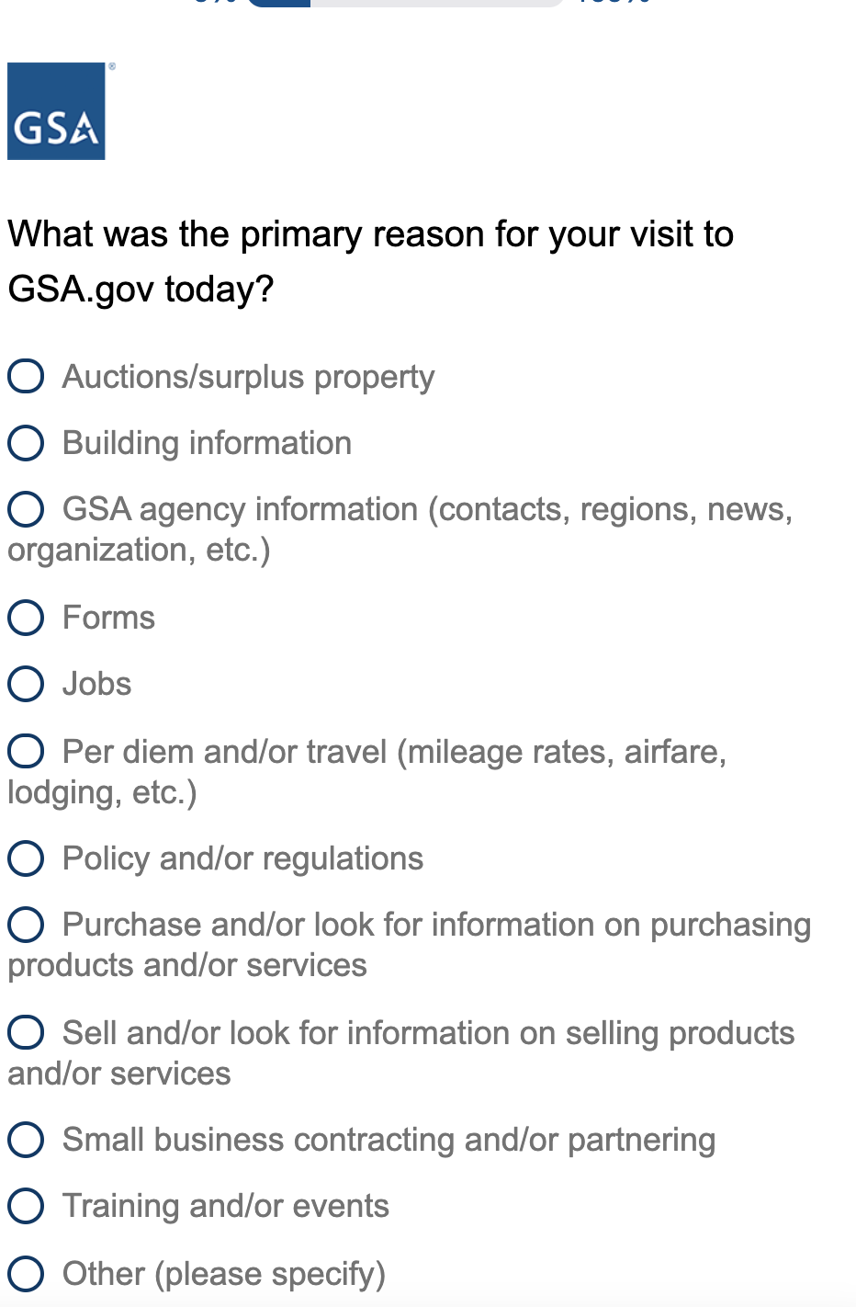

Users who select Other will be prompted to provide their reason in a comment box (*):
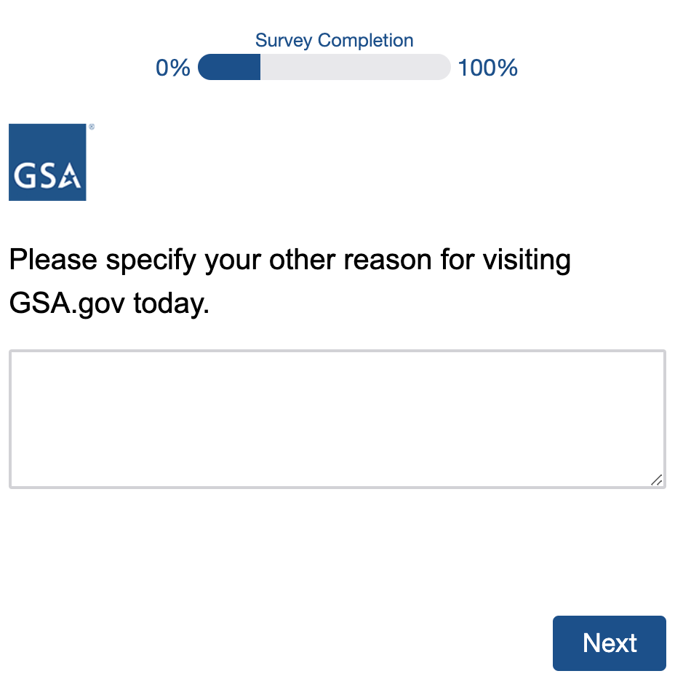

All participants will then be asked if they were able to complete their task on the site (*):
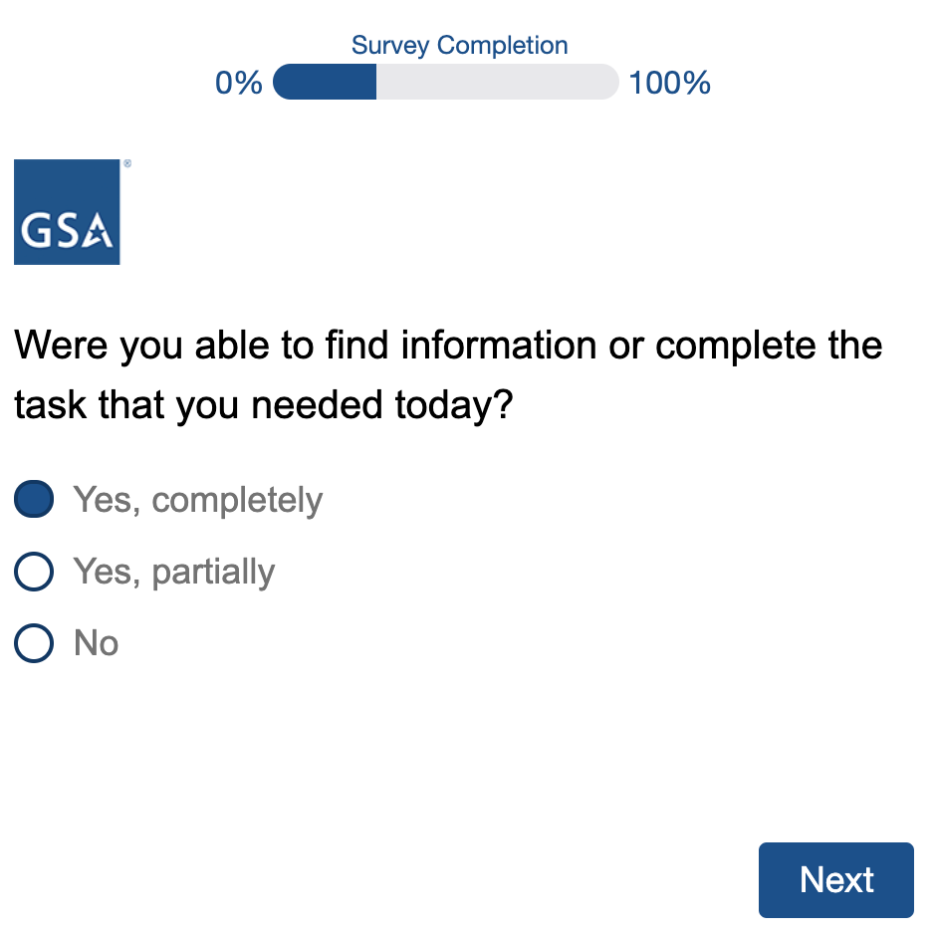

Participants who select Yes, completely or Yes, partially will be asked how much effort it took them to complete their task (*):
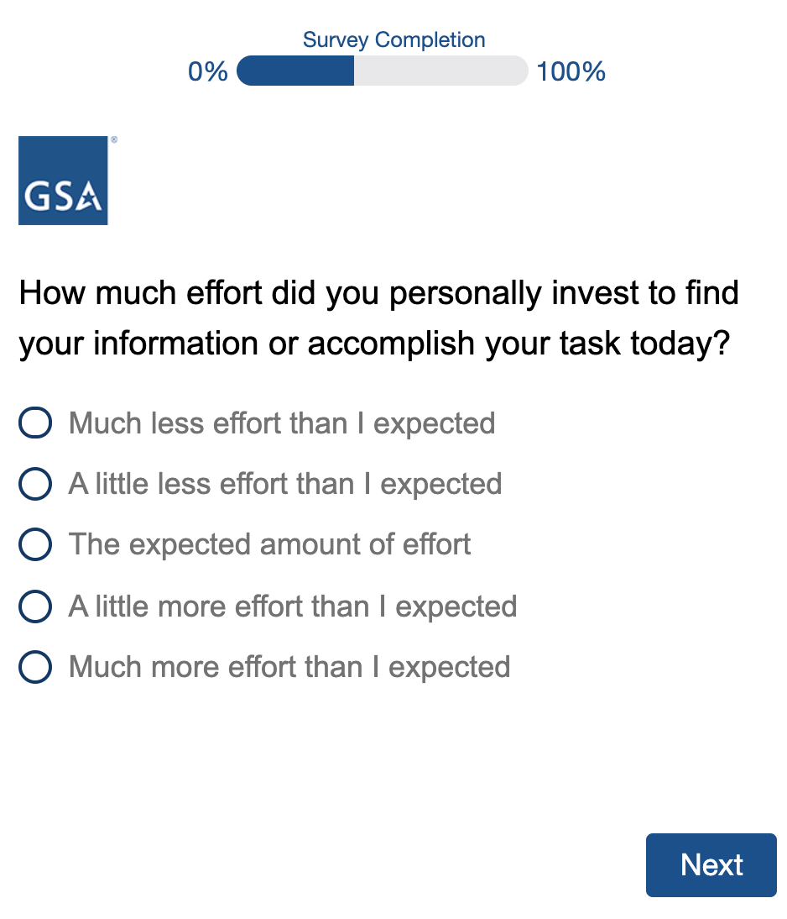

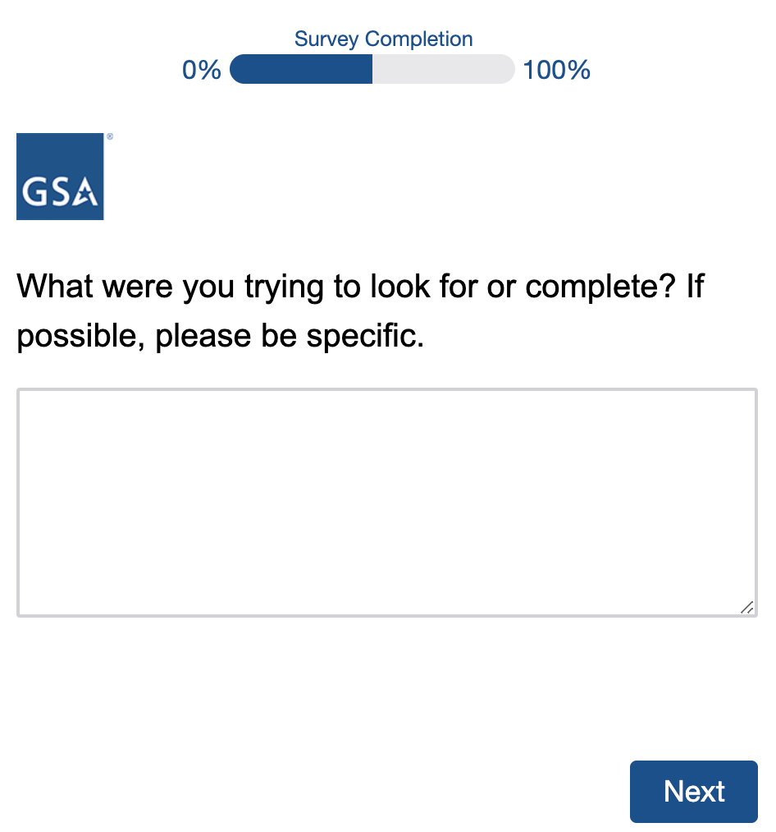
All participants will be asked to describe their task in a comment box (*):

Participants who selected Yes, partially or No when asked if they were able to complete their task will have the opportunity to supply an email address, so GSA staff may follow up with them as deemed necessary:
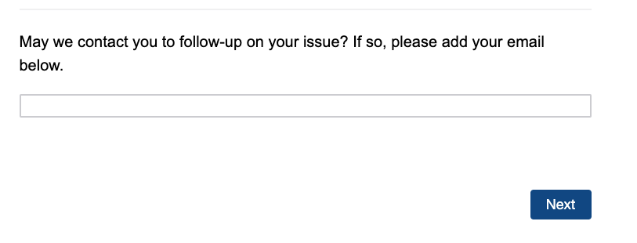
All participants will then be asked to select their role (*):
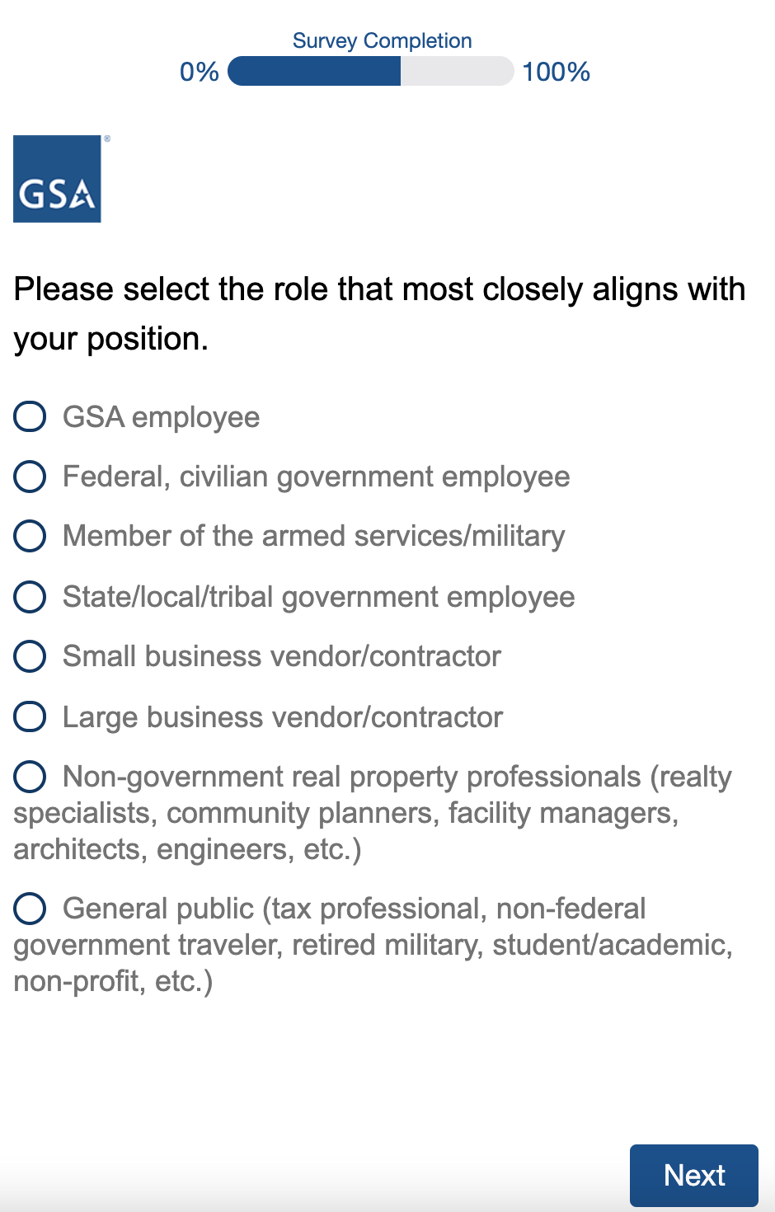

Participants who select Small business vendor/contractor or Large business vendor/contractor will be asked if they currently have a contract (*):
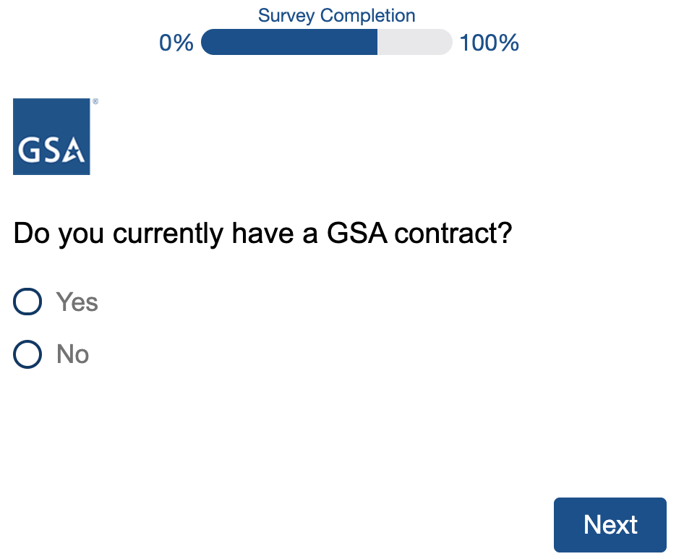

All participants will then be asked to agree or disagree with the following statement (*):
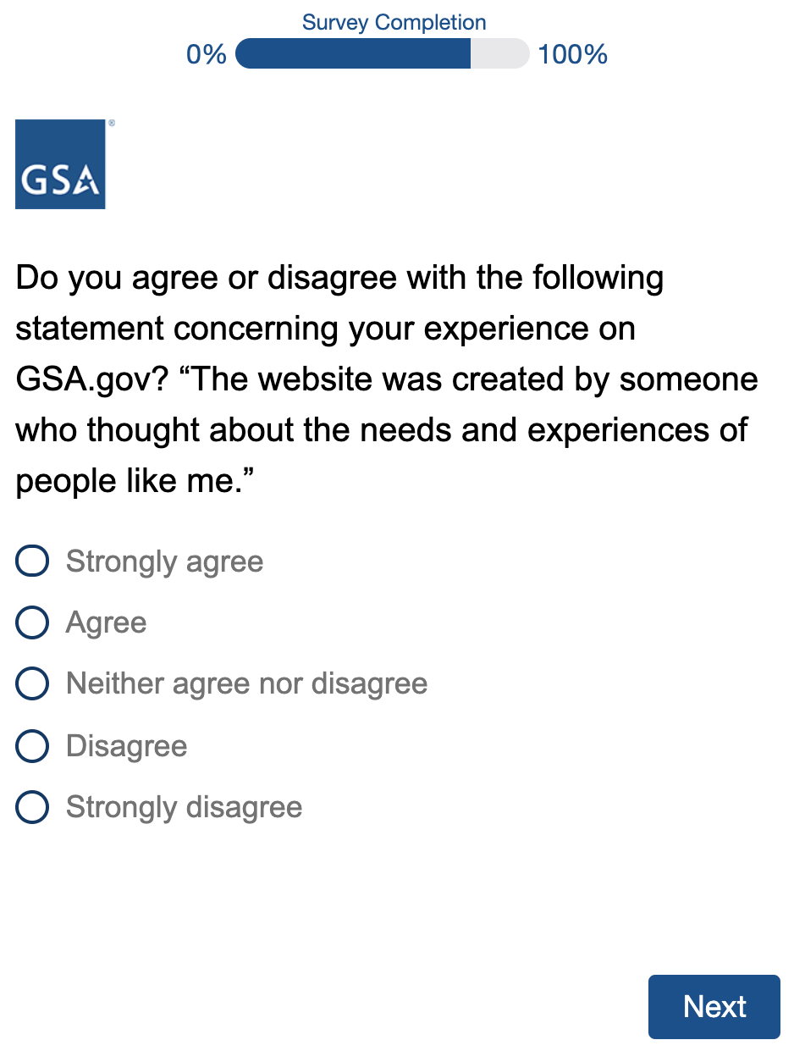

Finally, all participants will have the opportunity leave an open-ended comment about their overall web experience on GSA.gov:

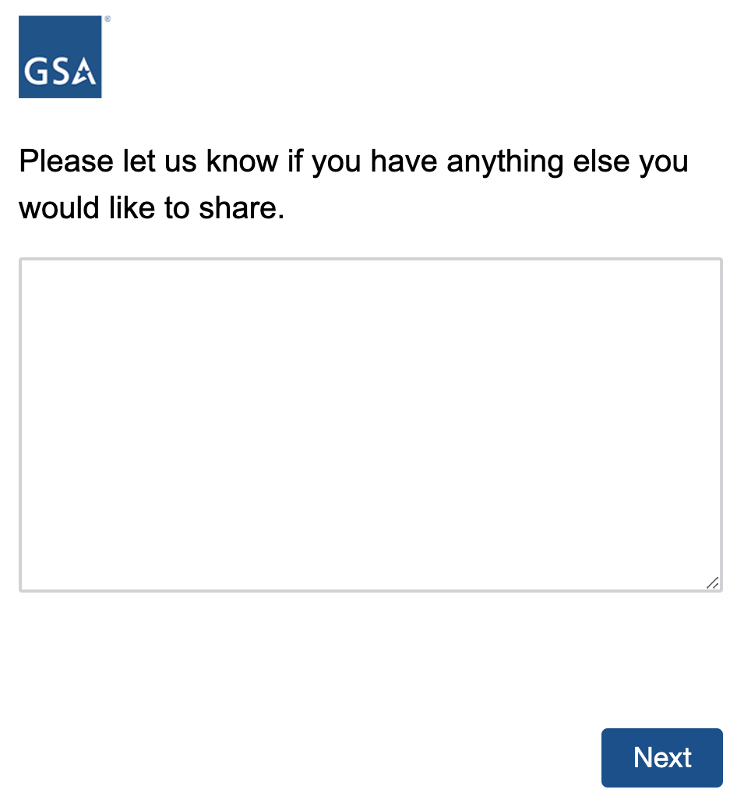

Participants who complete the survey will see this thank you message:
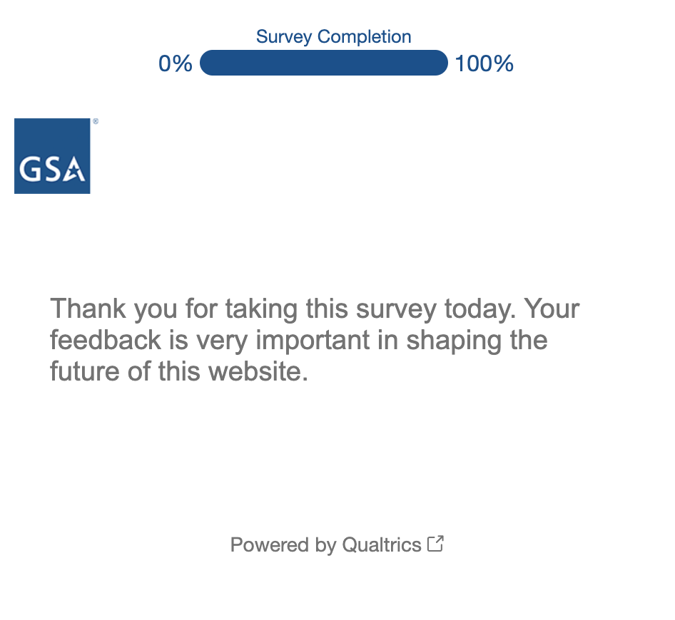

Second Option Survey (Page-Level)
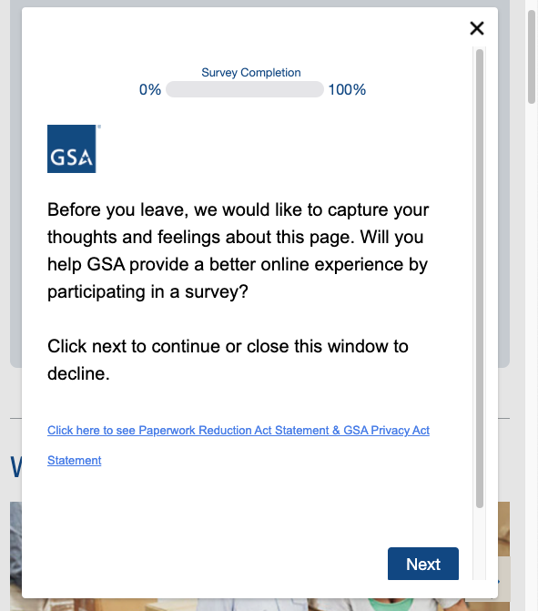
Users who get the page-level survey will see a prompt when they hover over an exit button (*):

Participants who click on the link will see this document in a new window:

All participants who click Next to begin the survey will start with this question (*):
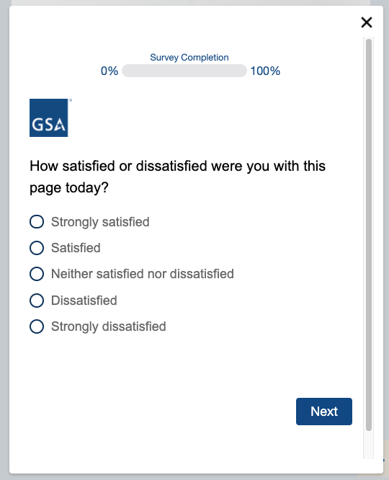

Then, they will then be prompted to agree or disagree with the following statements (*):
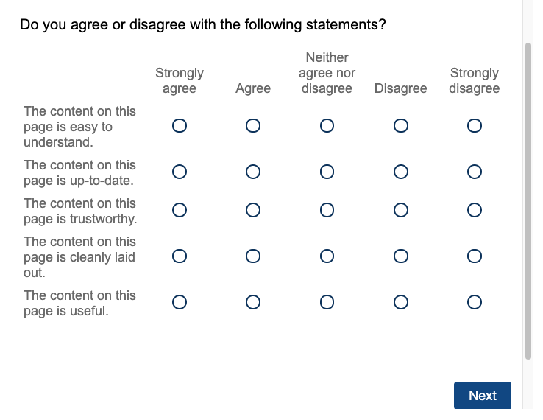

All participants will be asked if they were able to complete their task on the page (*):
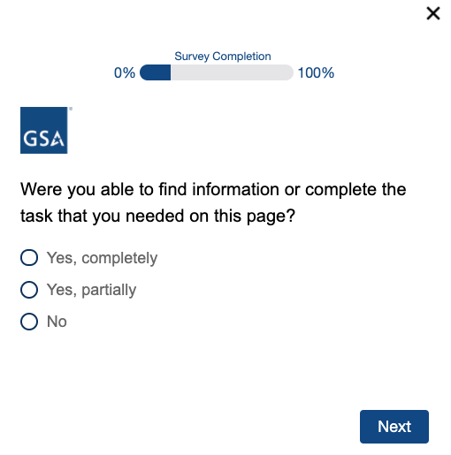

Users who select Yes, completely or Yes, partially will be asked to select their level of effort (*):
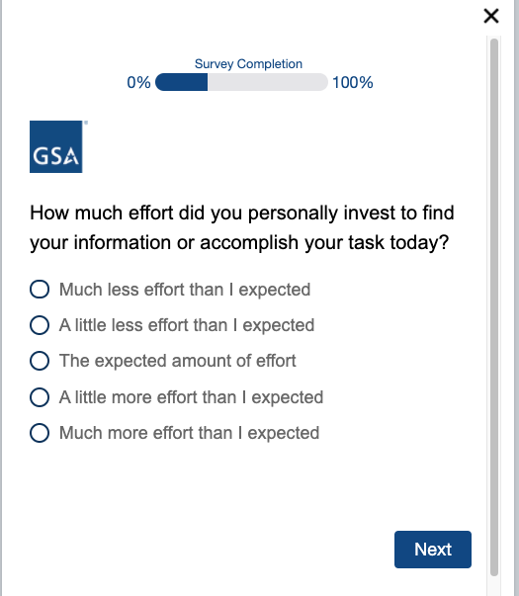

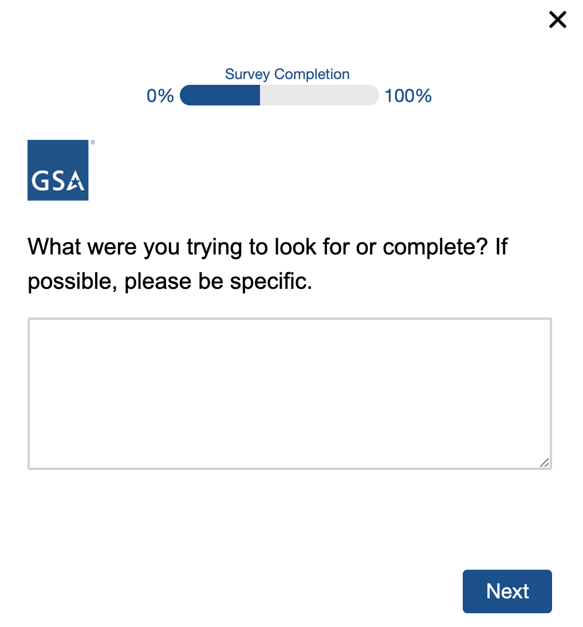
All participants will be asked to specify their task in a comment box (*):

Participants who selected Yes, partially or No when asked if they were able to complete their task will have the opportunity to supply an email address, so GSA staff may follow up with them as deemed necessary:

All participants will be asked to select a primary reason for their visit to the website (*):
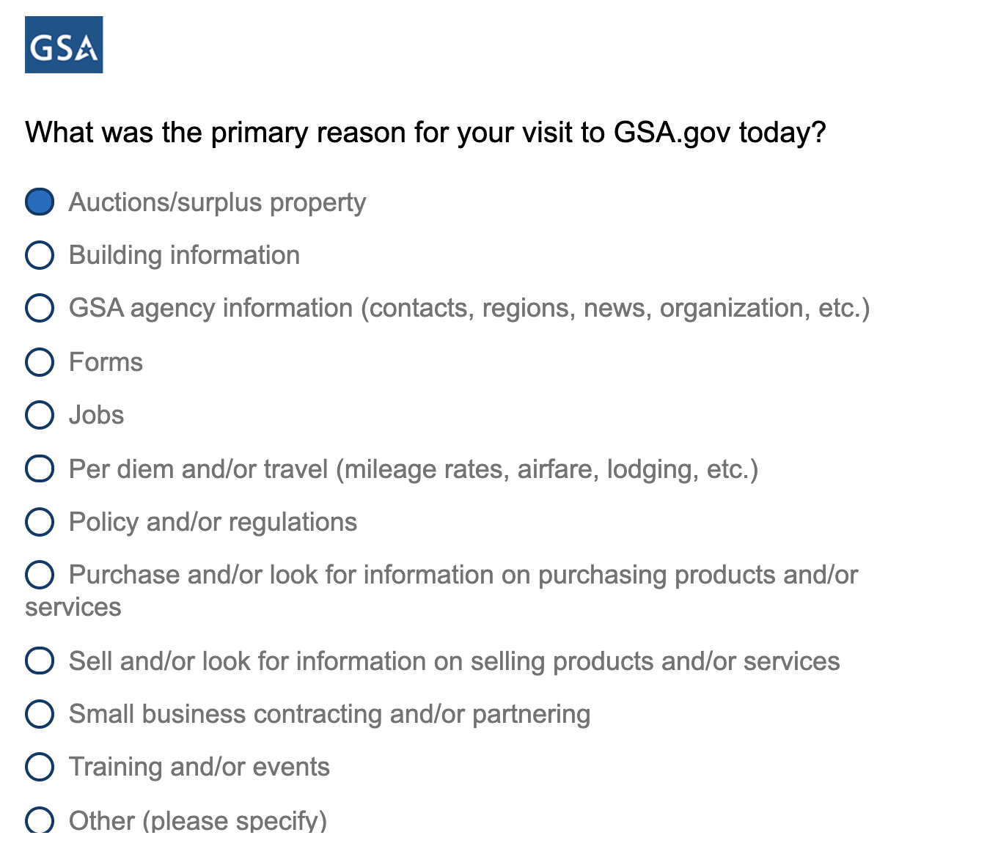

Participants who select Other will be prompted to give their reason in a comment box (*):
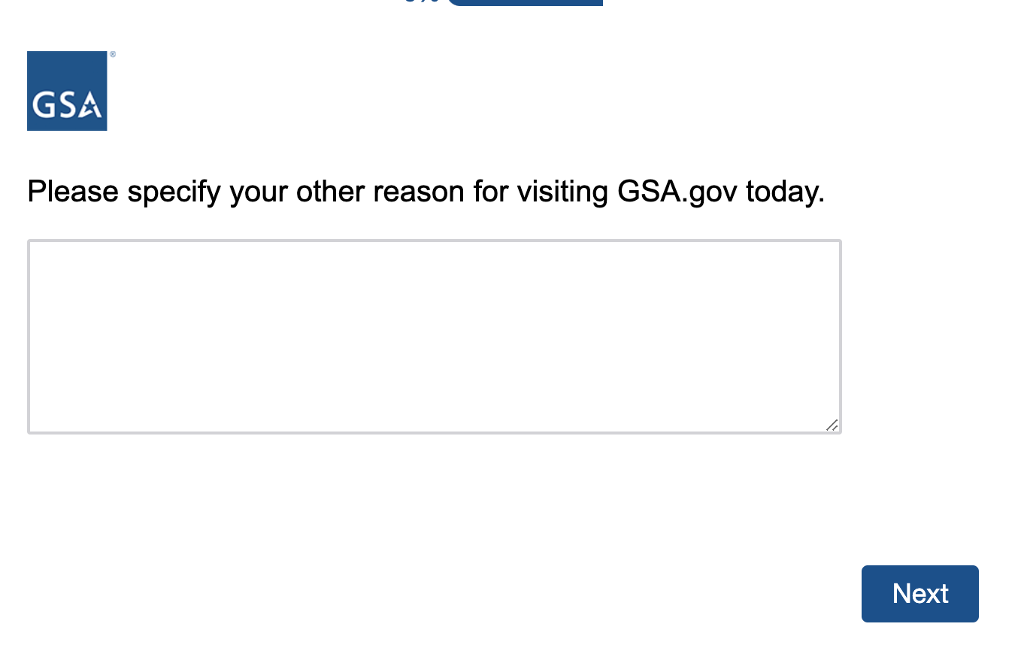
All participants will be asked to select the role that aligns most closely with their position (*):
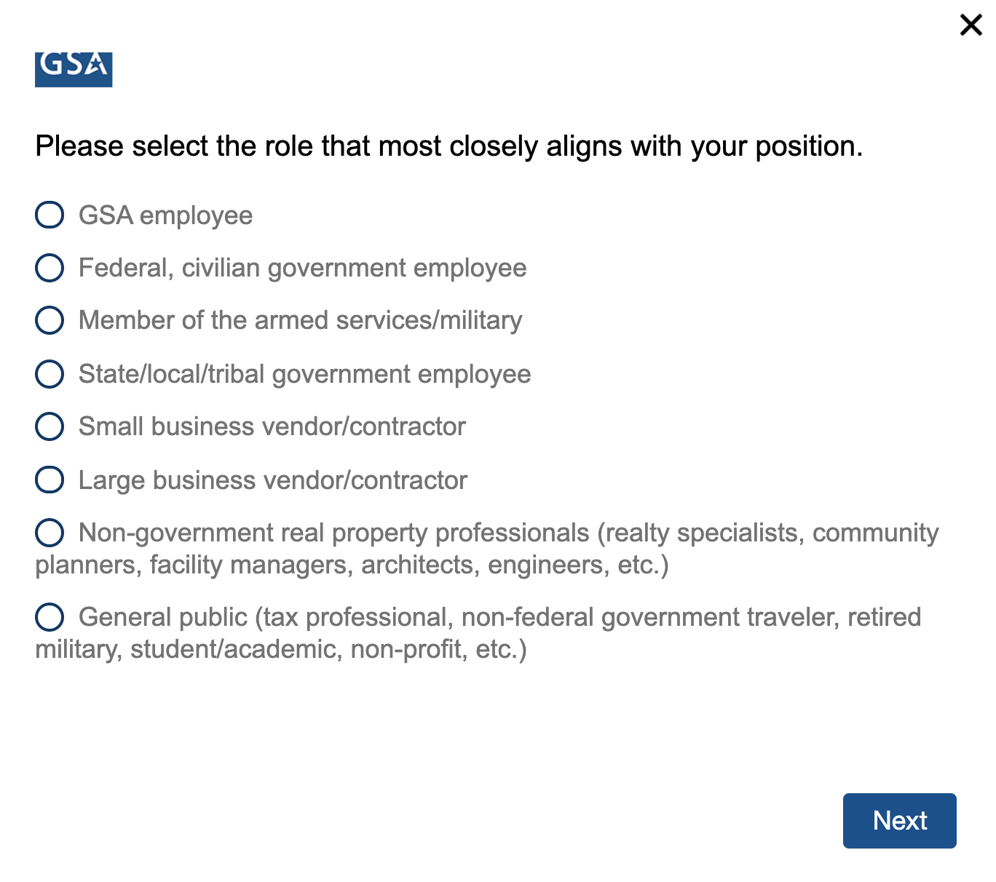
Participants who select Small business vendor/contractor or Large business vendor/contractor will be asked if they currently have a contract (*):
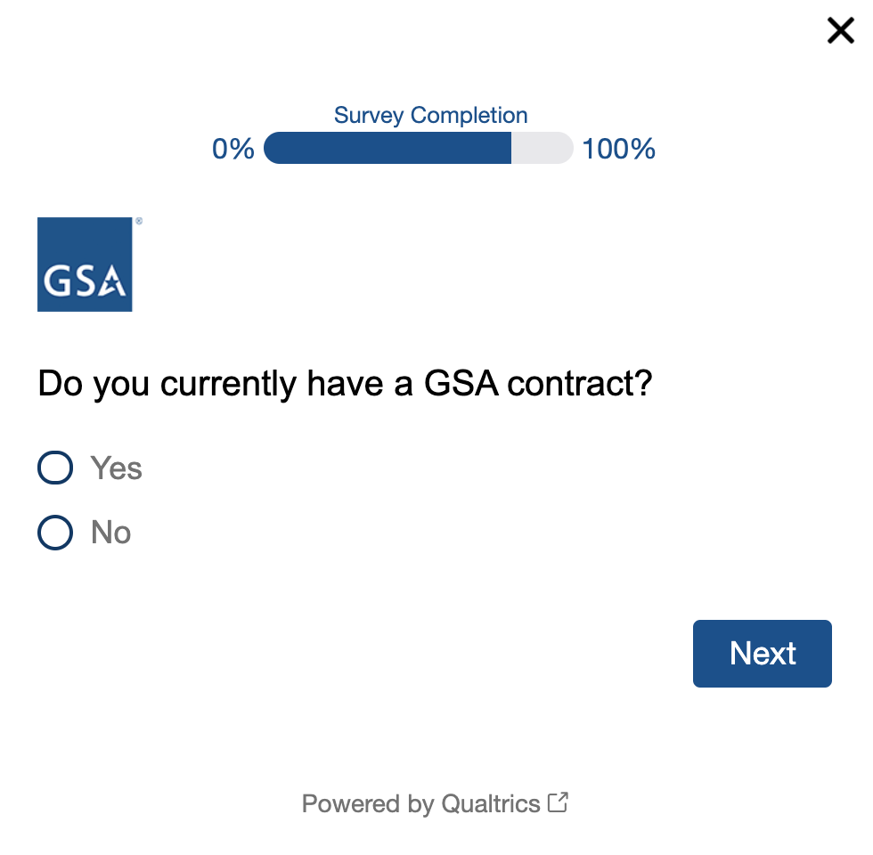

Finally, all participants will have the opportunity to leave an open-ended comment:
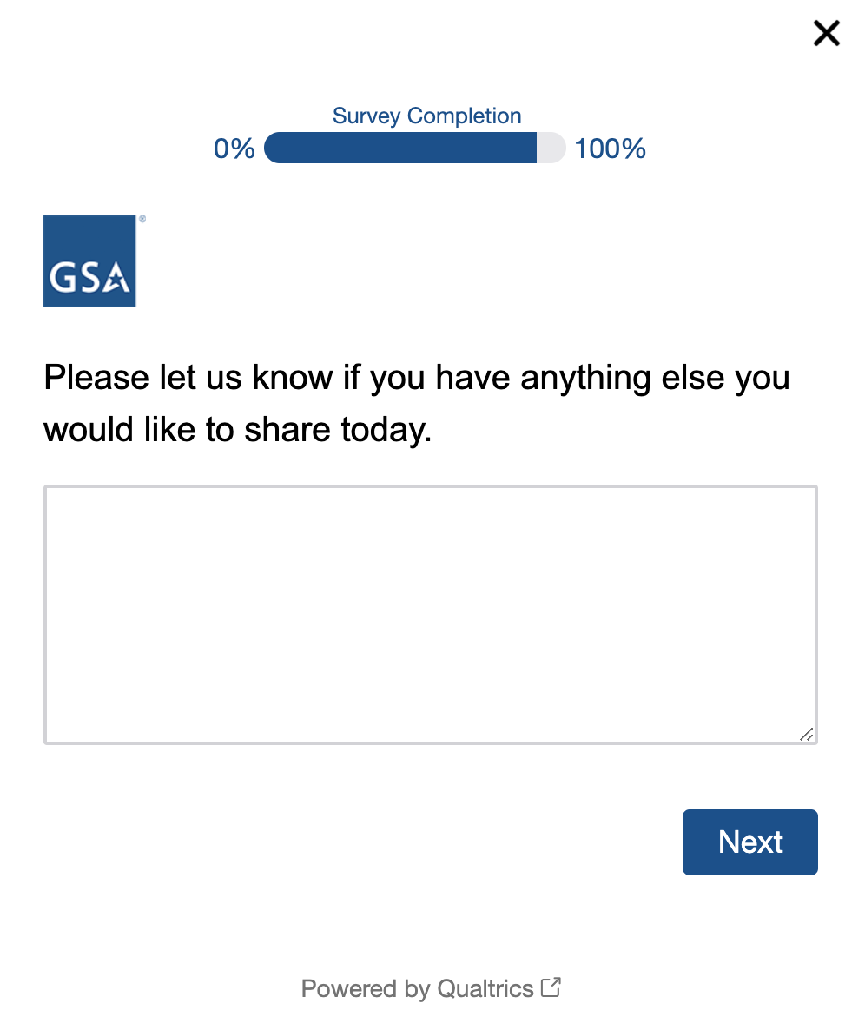

Participants who complete the survey will see this end of survey message:
