FAST Track 3090-0297
Req-24
Screenshots for FAST 2023 Monthly Conference Series

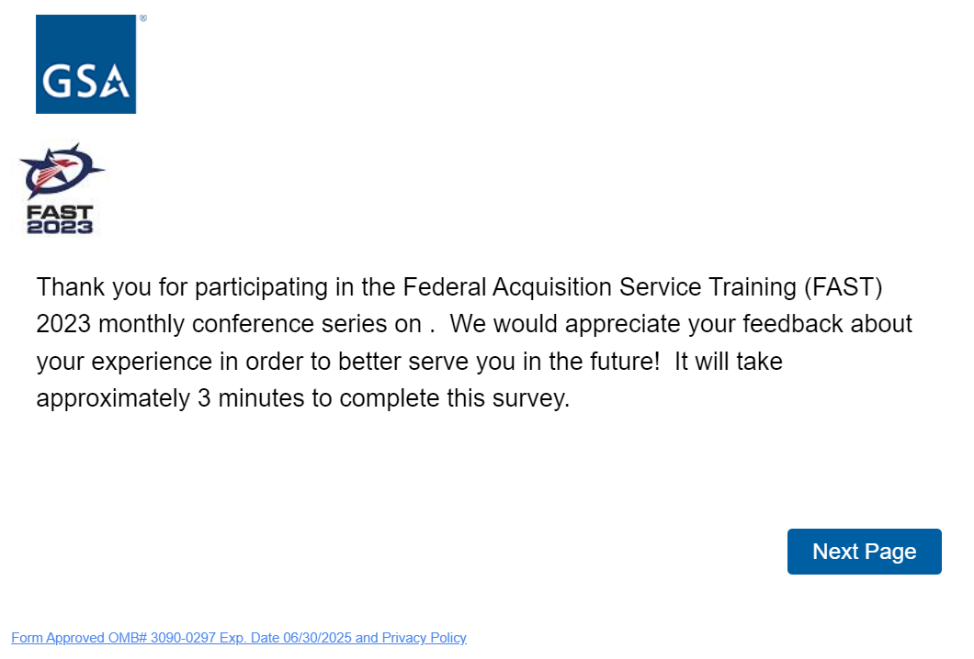

For the above intro statement, it is not an incomplete sentence. We used customized links that will populate the actual name of each training. For example, one of the actual surveys will say, “Thank you for participating in the FAST 2023 monthly conference series on Acquiring Professional Services to Build a Future Ready Workforce. See the complete list of training classes on the next page.
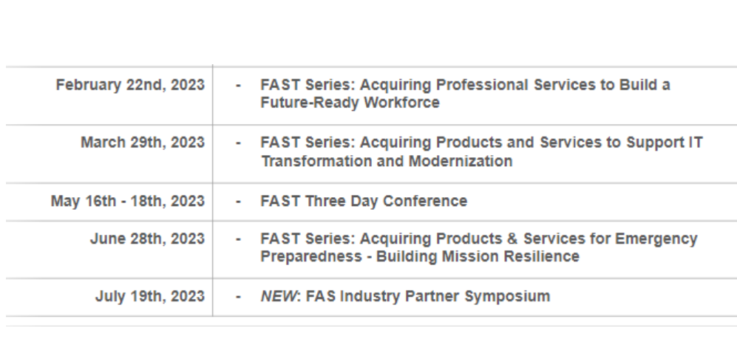
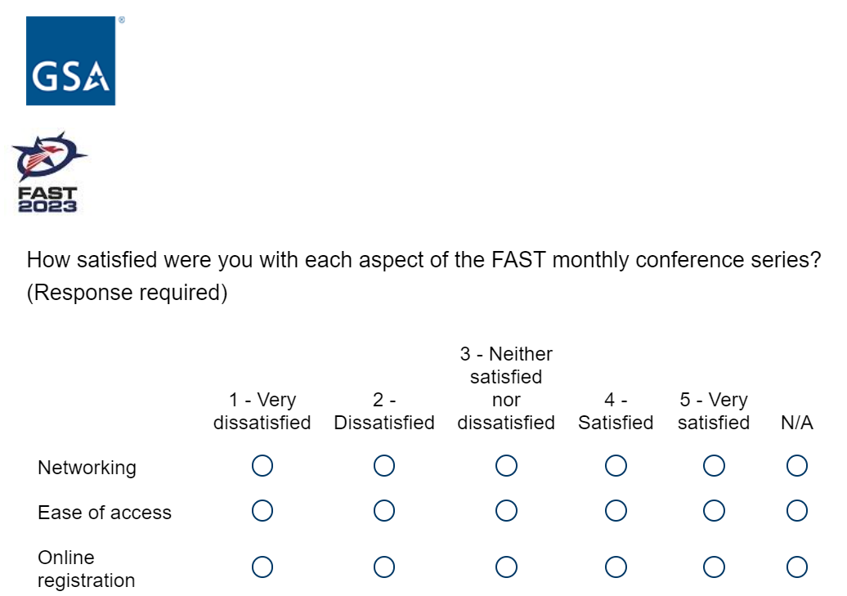
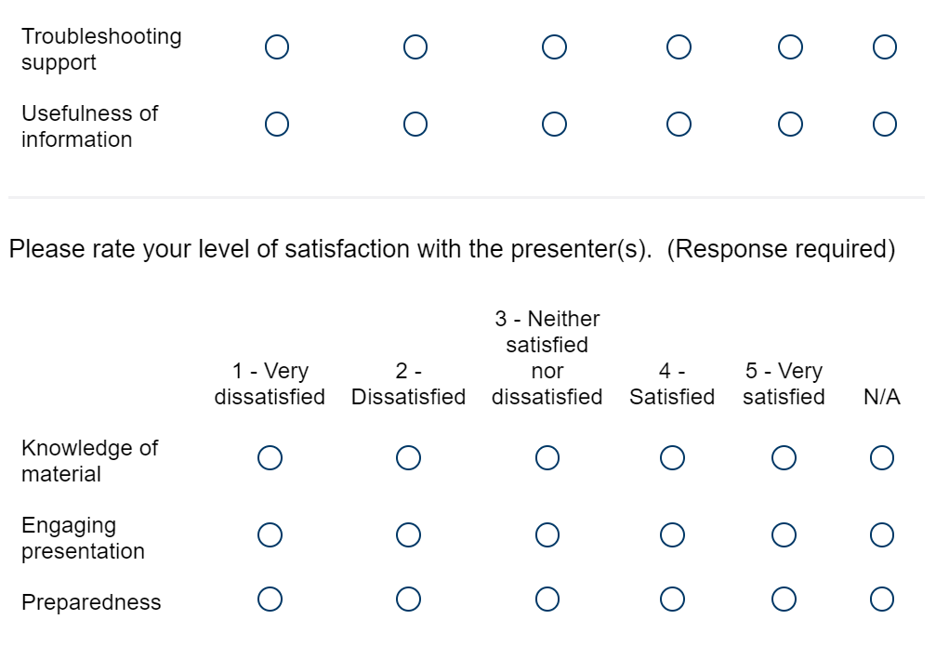
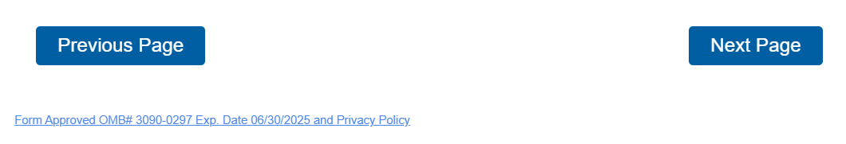
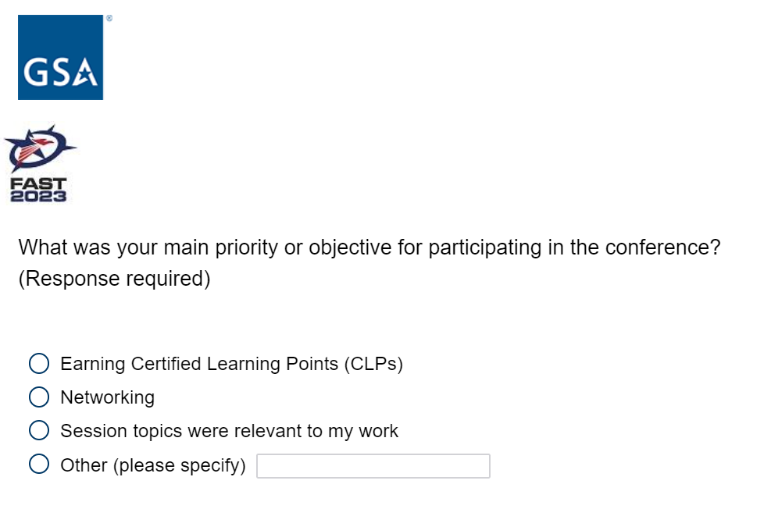
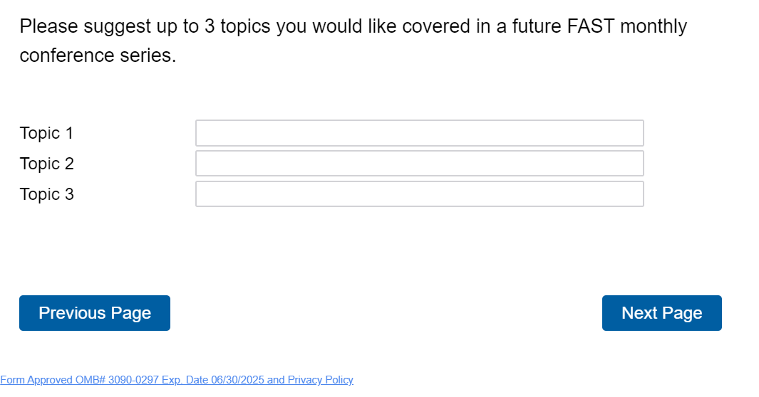
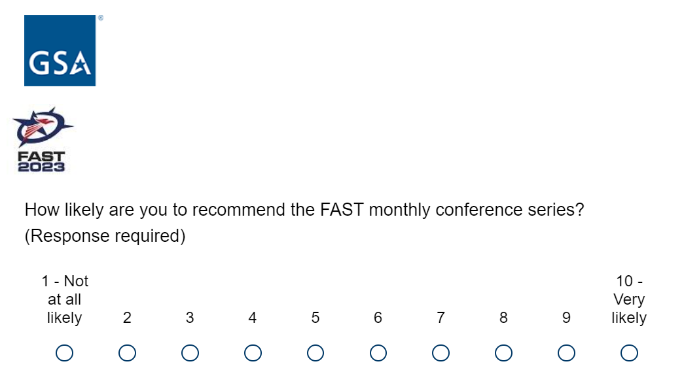

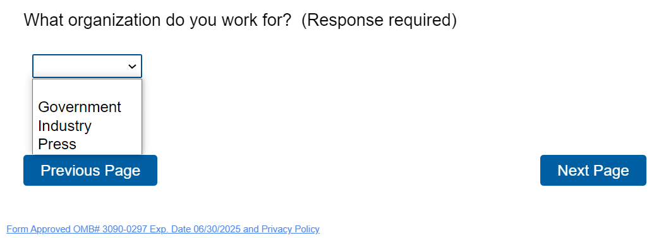

If the respondent selects “Government”, it will bring up a long list of agency names and components for them to choose from

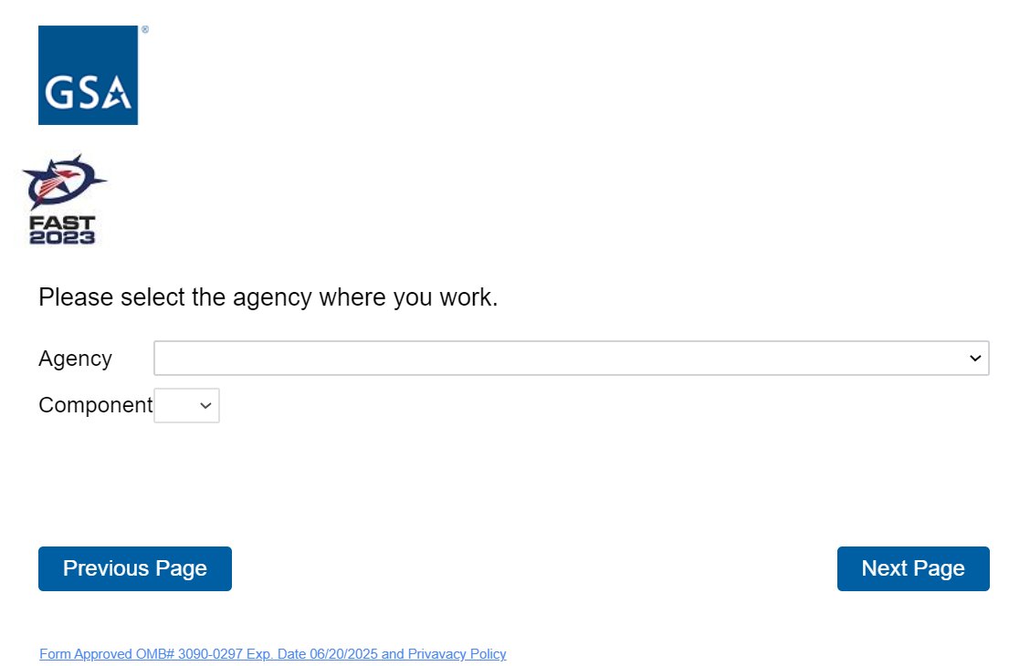
If the respondent selects “Press”, the following question will appear
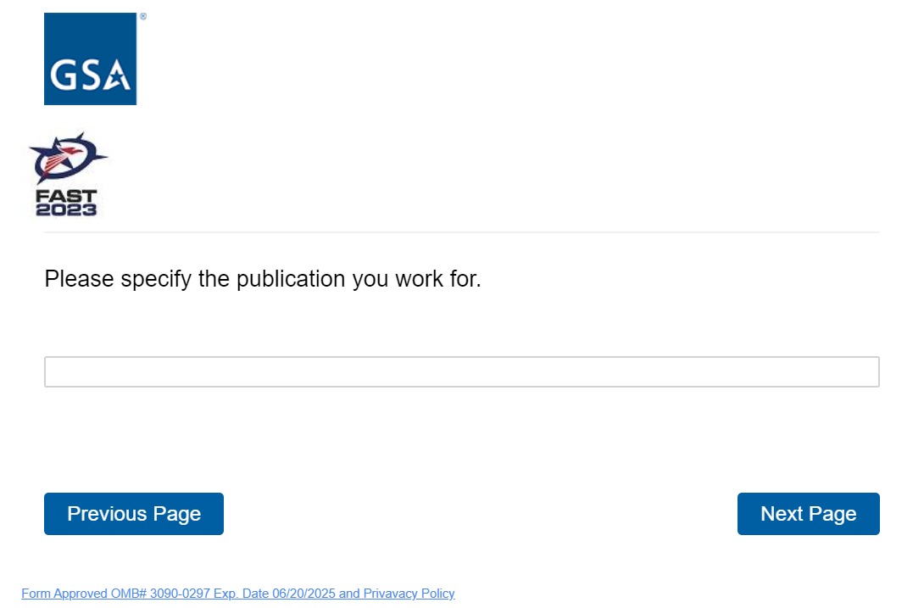
If the respondent selects “Industry”, the following question will appear

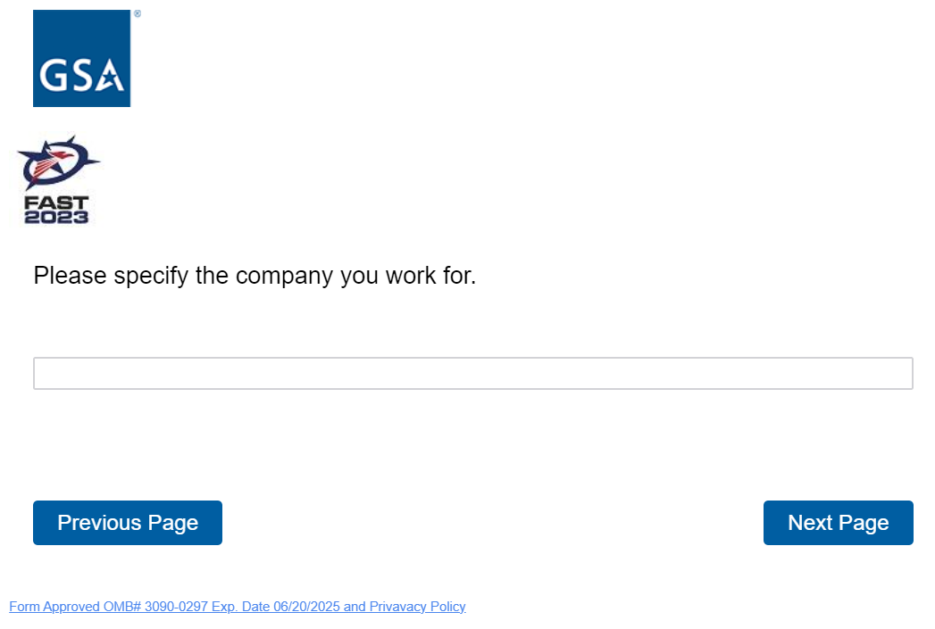

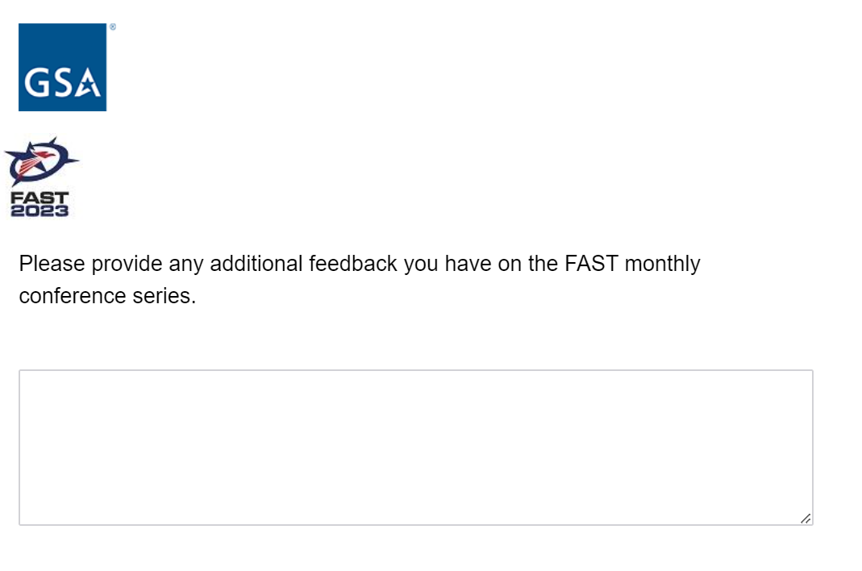
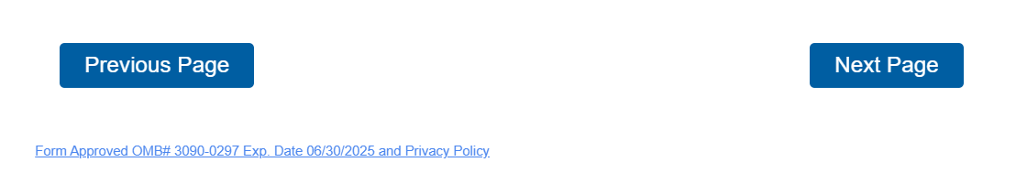
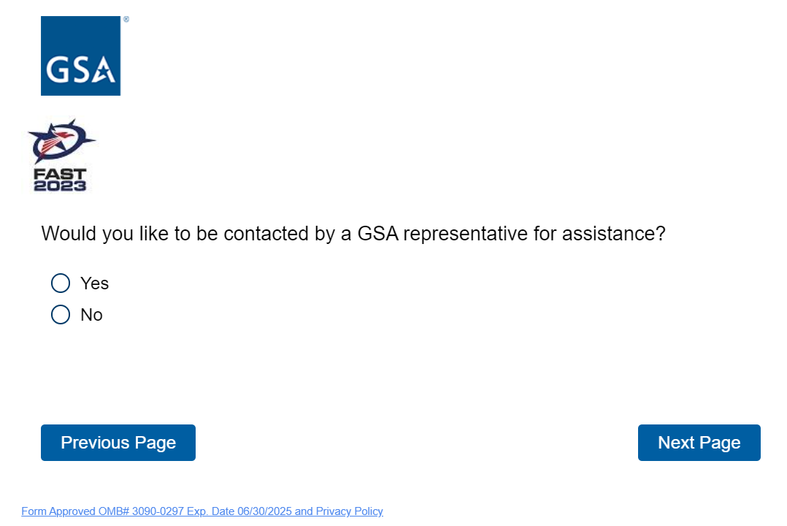

If the respondent selects “yes”, the below question will appear. If the respondent selects “no”, it will skip these 2 questions

