FAST Track 3090-0297

Req-27

Renewal for March 2023 – March 2024

GSA Advantage Website Feedback Survey

# **Screen 1**

This screen is a pop-up that appears when the user has not submitted a survey within the last 30 days and meets the following criteria:

* Demonstrates intent to exit the website
* Visits 5 or more pages
* Spends at least 90 seconds on the website

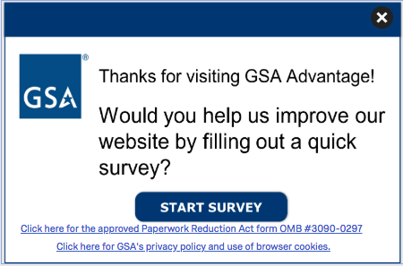

The first link (“Click here to see the full Paperwork Reduction Act statement…”) will open the below pdf in a new tab.

The second link (“Click here to read more about…”) goes to GSA’s Website Privacy and Security Notice webpage.

**Screenshot of GSA’s PRA Statement pdf link**

Paperwork Reduction Act Statement

OMB No: 3090-0297

Expires: 06/30/2025

This information collection meets the requirements of 44 U.S.C. § 3507, as amended by section 2 of the Paperwork Reduction Act of 1995. You do not need to answer these questions unless we display a valid Office of Management and Budget (OMB) control number. The OMB control number for this collection is 3090-0297. We estimate that it will take 3 minute/s to read the instructions, gather the facts, and answer the questions. Send only comments relating to our time estimate, including suggestions for reducing this burden, or any other aspects of this collection of information to: General Services Administration, Regulatory Secretariat Division (MVCB), ATTN: Lois Mandell/IC 3090-0297, 1800 F Street, NW, Washington, DC 20405.

Privacy Act Statement

The information you provide to complete the survey being conducted is collected pursuant to the [E-Government Act of 2002 (44 USC § 3501), and 40 USC § 501](https://www.gpo.gov/fdsys/pkg/PLAW-107publ347/html/PLAW-107publ347.htm).

The information that you submit is used to improve the user experience on GSA.gov. This survey does not collect any personal information, nor can the information you provide be directly tied to you when used for analysis. If you choose to not disclose this information, you simply need not complete the survey in the pop up box. The information will be used by and disclosed to GSA personnel and contractors to process survey results. All records are stored electronically in a secure database in GSA’s implementation of Qualtrics, our survey management tool used to conduct this survey.

[You can read more about GSA’s Privacy Policy and use of browser cookies here](https://www.gsa.gov/website-information/privacy-and-security-notice).

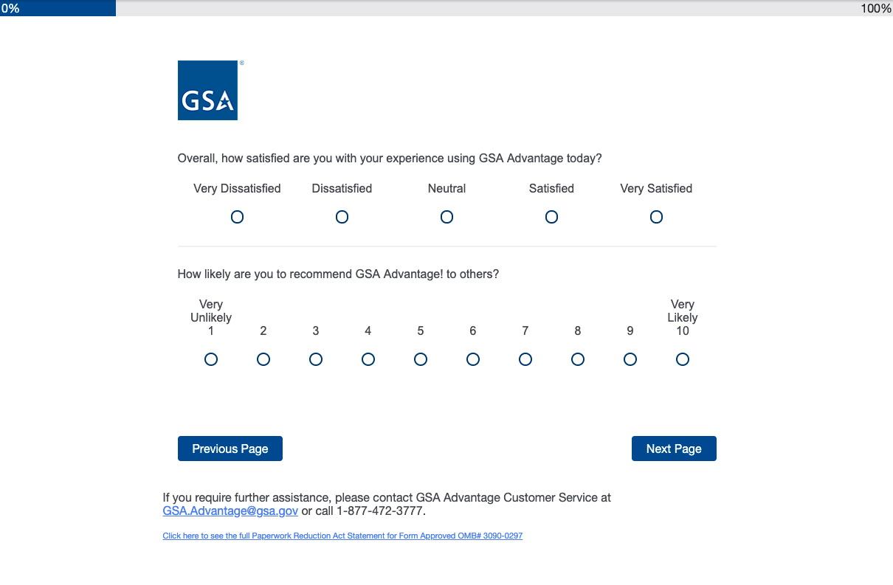

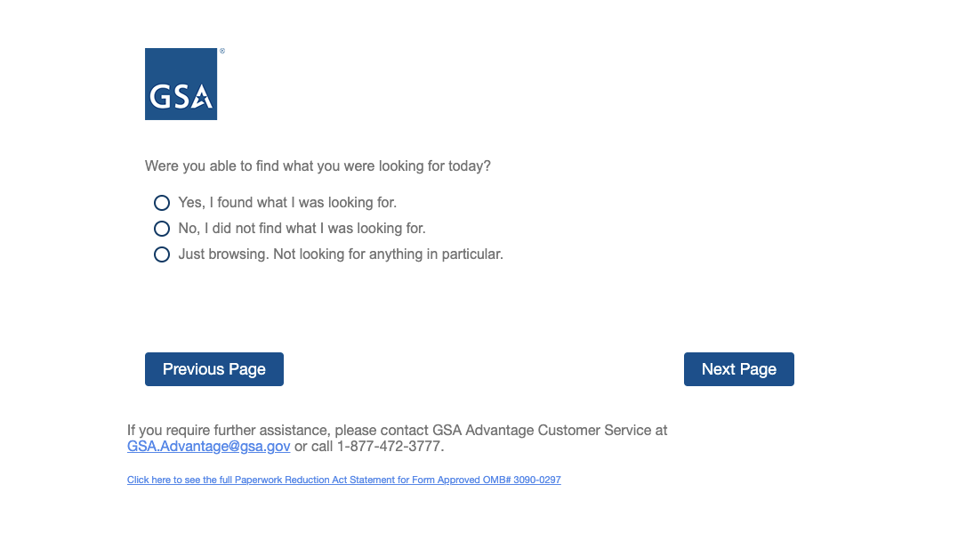

# 

# The following follow-up question is displayed with “No, I did not find what I was looking for.” is selected



 

