2023 Customer Loyalty Survey

On Screens 1, 2, 3, 5, 6, 7a, 7c, 31, and 32, [Program Office] will be replaced by one of the following:
GSA Information Technology Category
GSA Personal Property Management
Multiple Award Schedule (MAS) Human Capital
GSA Global Supply
GSA SmartPay
Multiple Award Schedule (MAS) Professional Services
Data.gov
GSA Fleet
GSA Schedule (excluding IT and Professional Services)

Screen 1
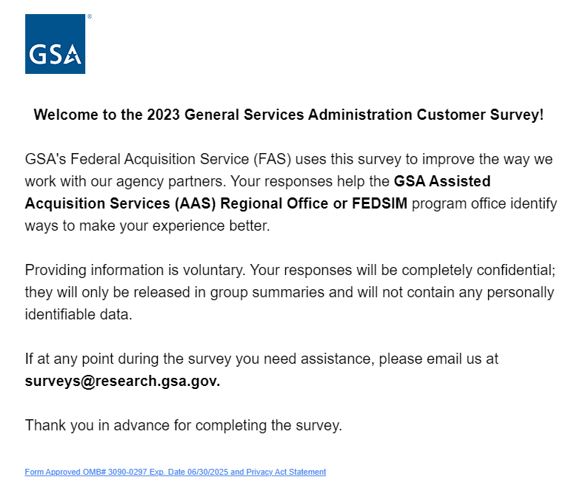
For PRA Review only – Contents of this box will not be displayed to recipients.

Note that this survey depends on embedded data to determine which questions will be displayed to each recipient. Embedded data are commands built into the survey that draw information from the contact list. Survey responses remain confidential.

The embedded data fields that are used in this survey are:
Program Office (GSA office being rated)
Portfolio (Grouping of program offices)

[Program Office Name Inserted Here]

Link at the bottom of the above page goes to a pdf displaying the PRA statement and a GSA Privacy Act Statement. See next page for screenshot.

Screen 1, continued

Screenshot of pdf linked from bottom of first page:
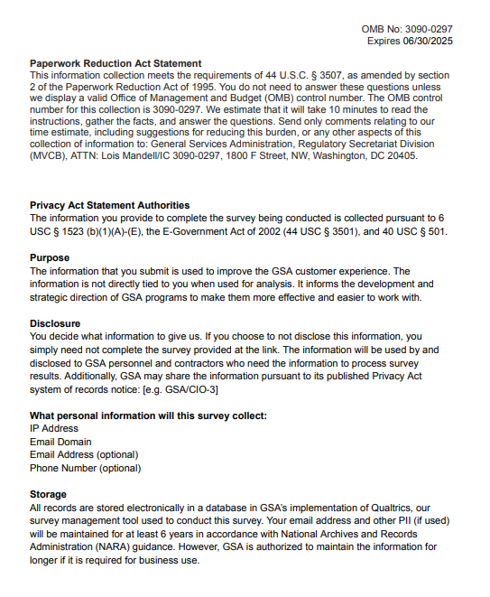

Screen 2a
Display if Program Office=GSA Information Technology Category

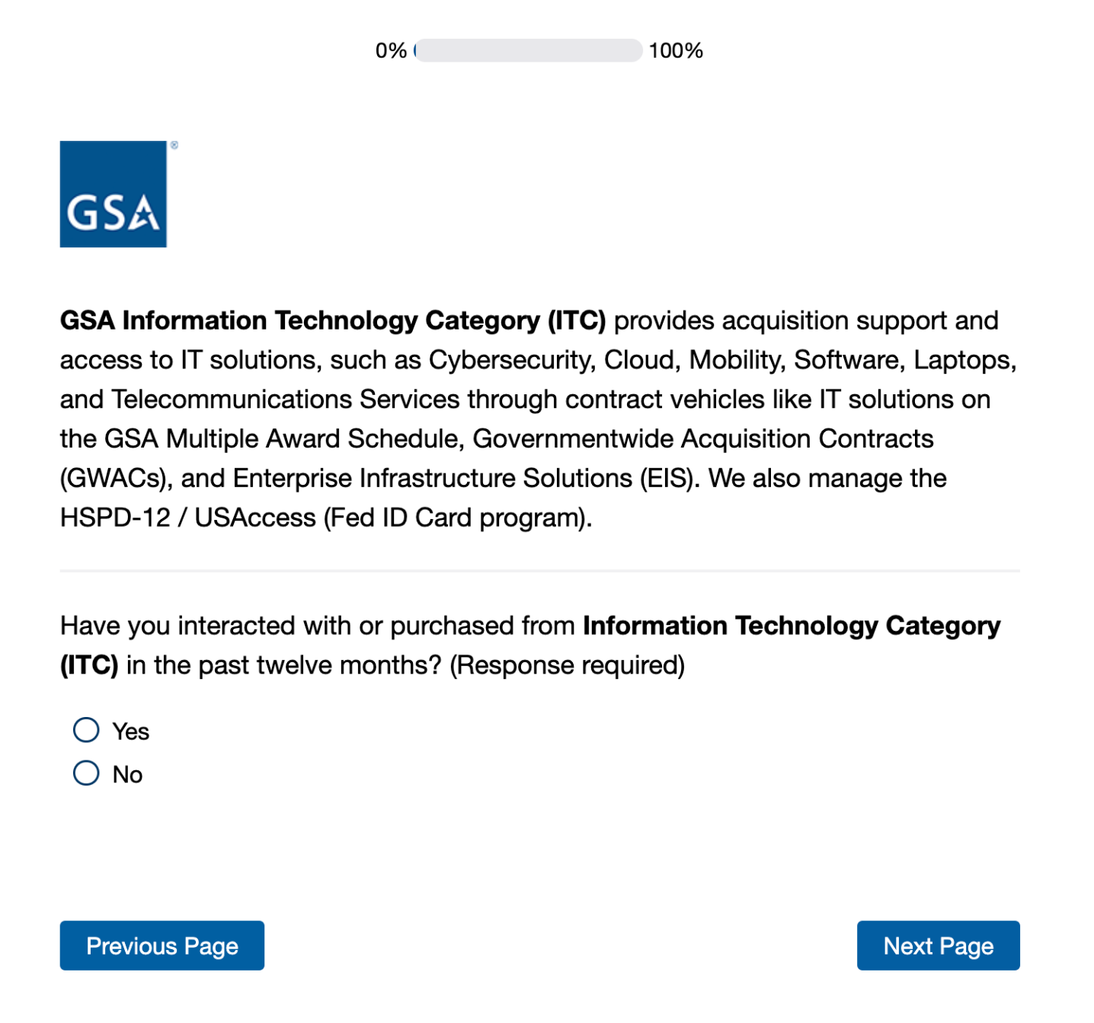
If No is selected, skip to Screen 3a

Screen 2b
Display if Program Office=GSA Personal Property Management
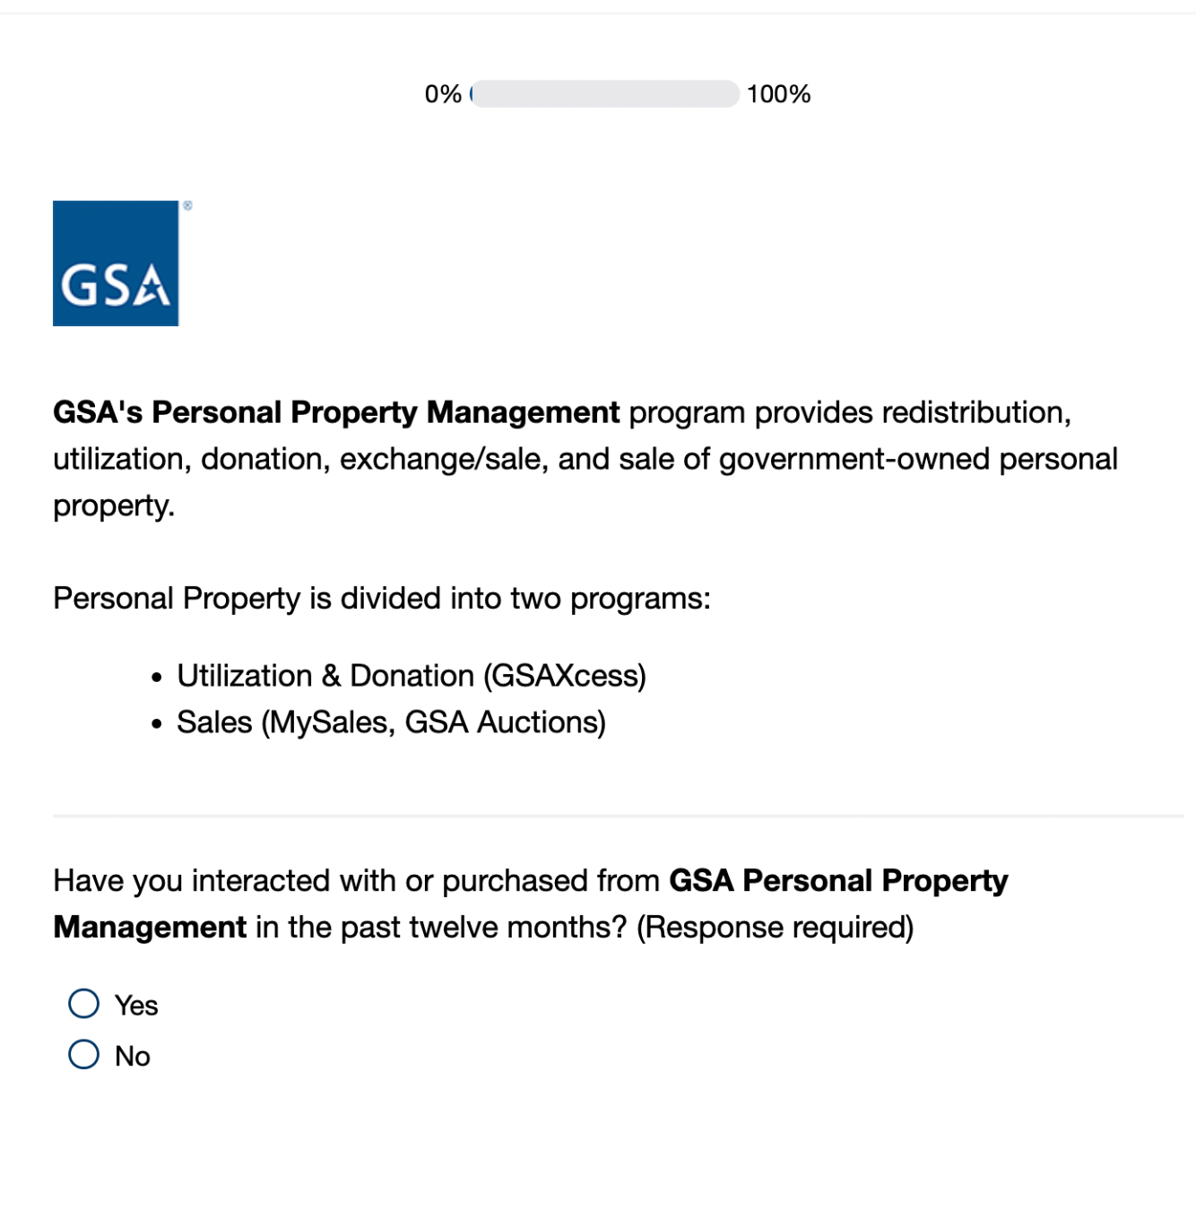
If No is selected, skip to Screen 3a

Screen 2c
Display if Program Office= Professional Services Human Capital (PSHC) MAS
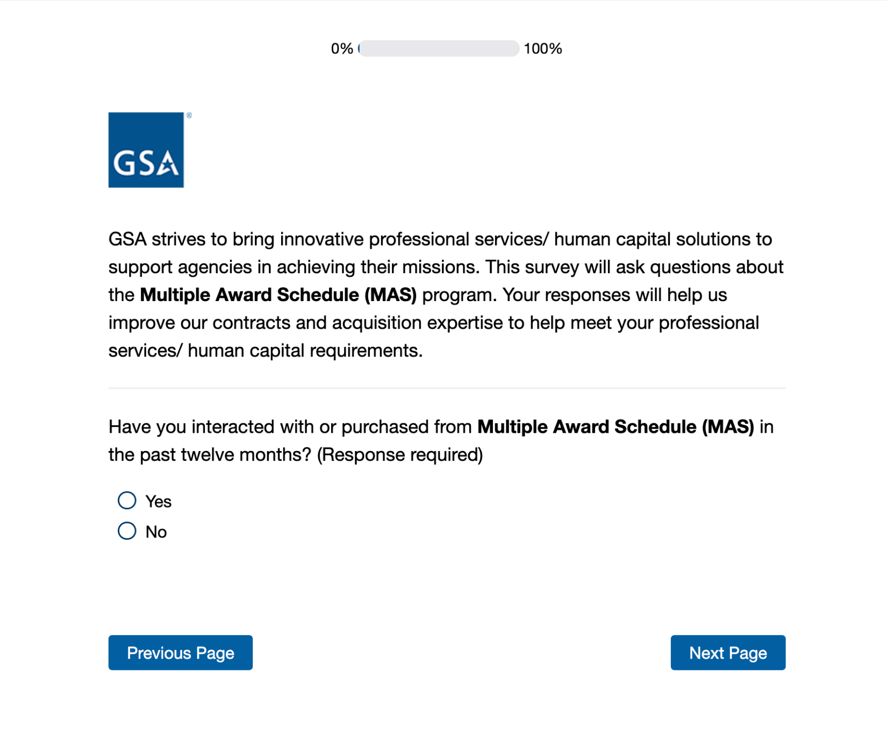
If No is selected, skip to Screen 3b

Screen 2d
Display if Program Office=GSA Global Supply
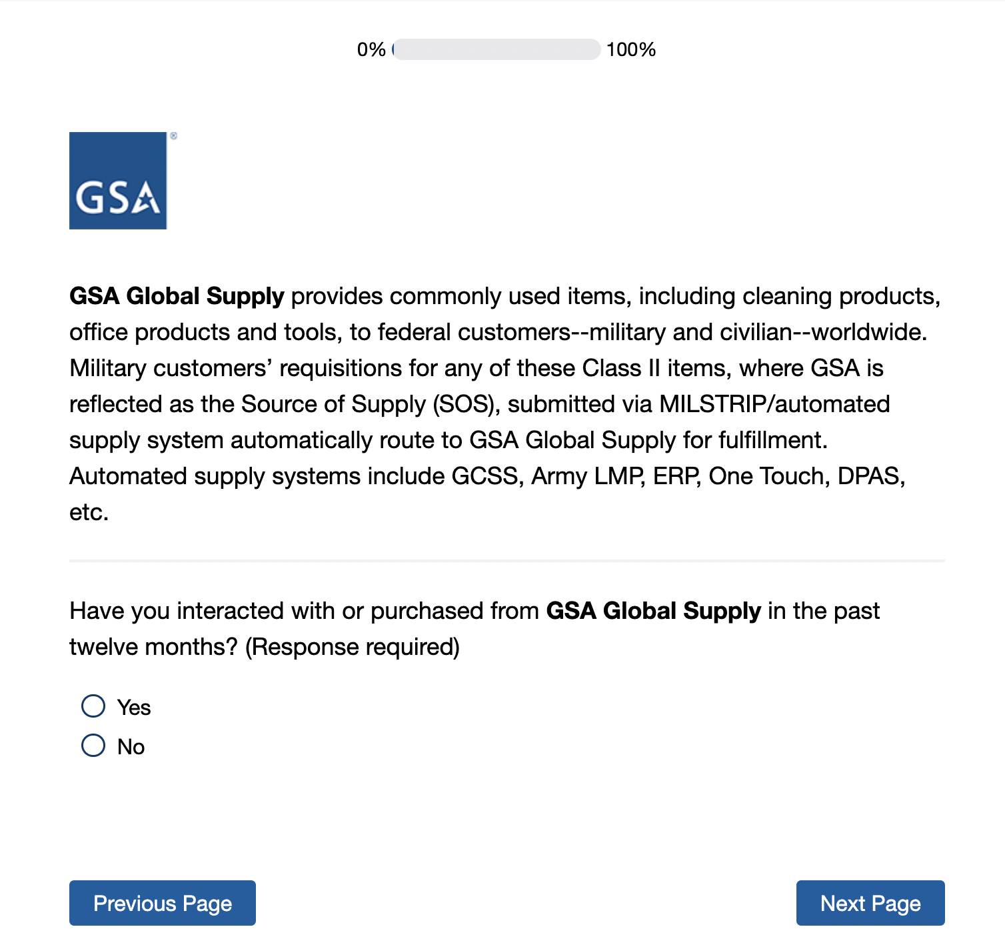

If No is selected, skip to Screen 3a

Screen 2e
Display if Program Office=GSA SmartPay
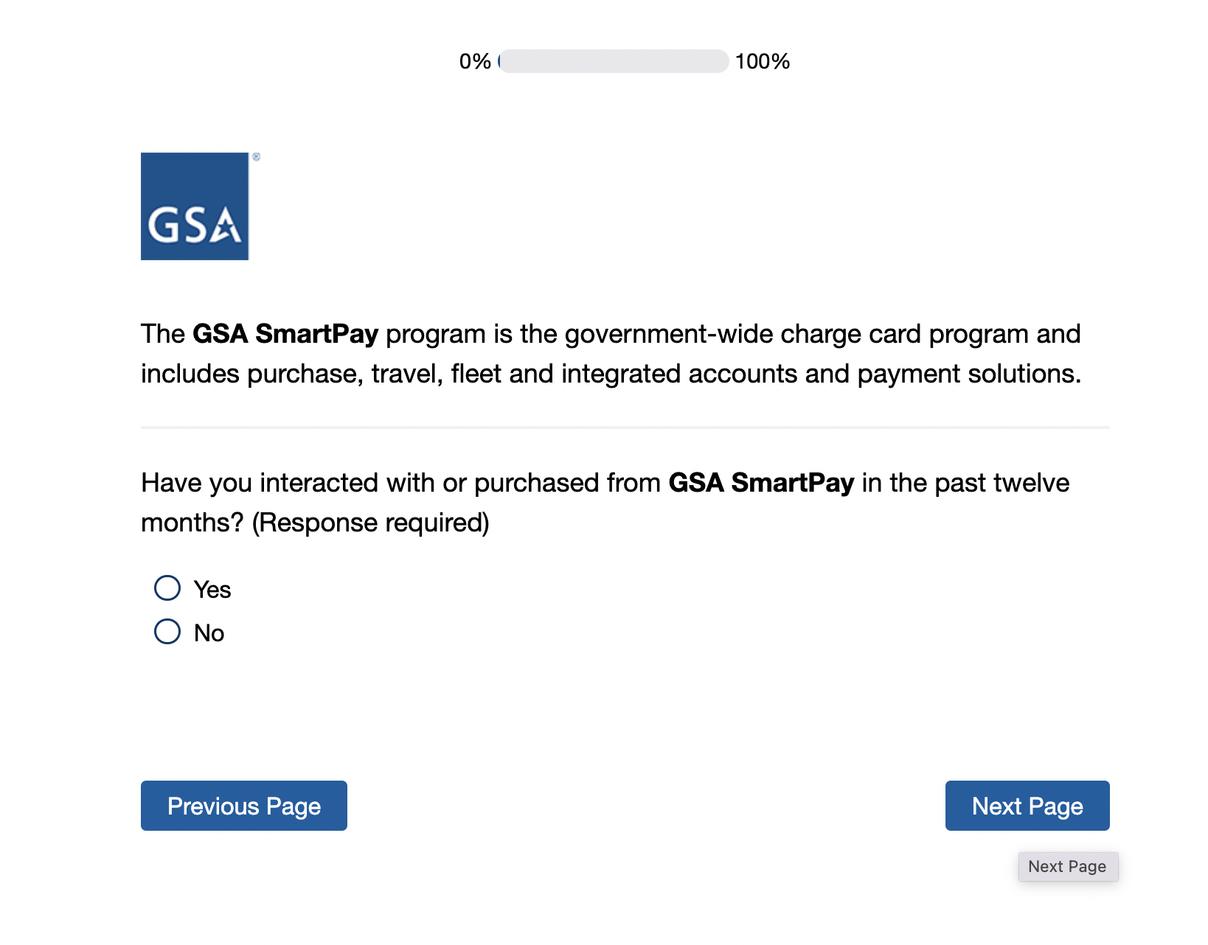
If No is selected, End Survey

If No is selected, skip to Screen 3b

Screen 2g
Display if Program Office=Data.gov
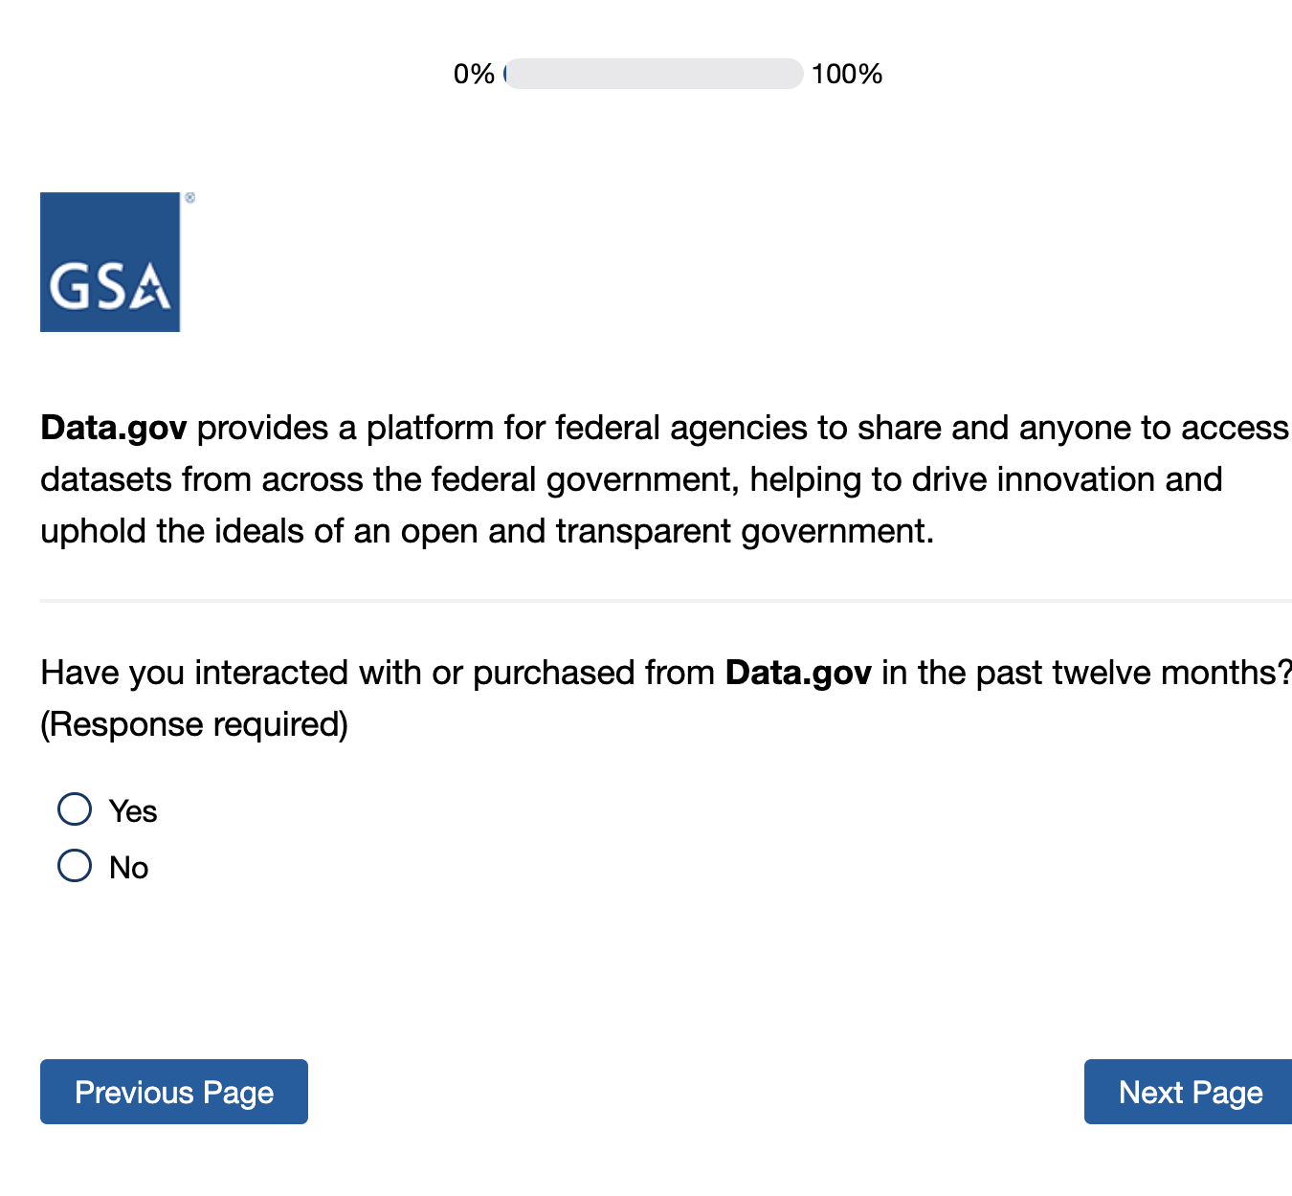
If No is selected, skip to Screen 3a

Screen 2h
Display if Program Office= GSA Fleet
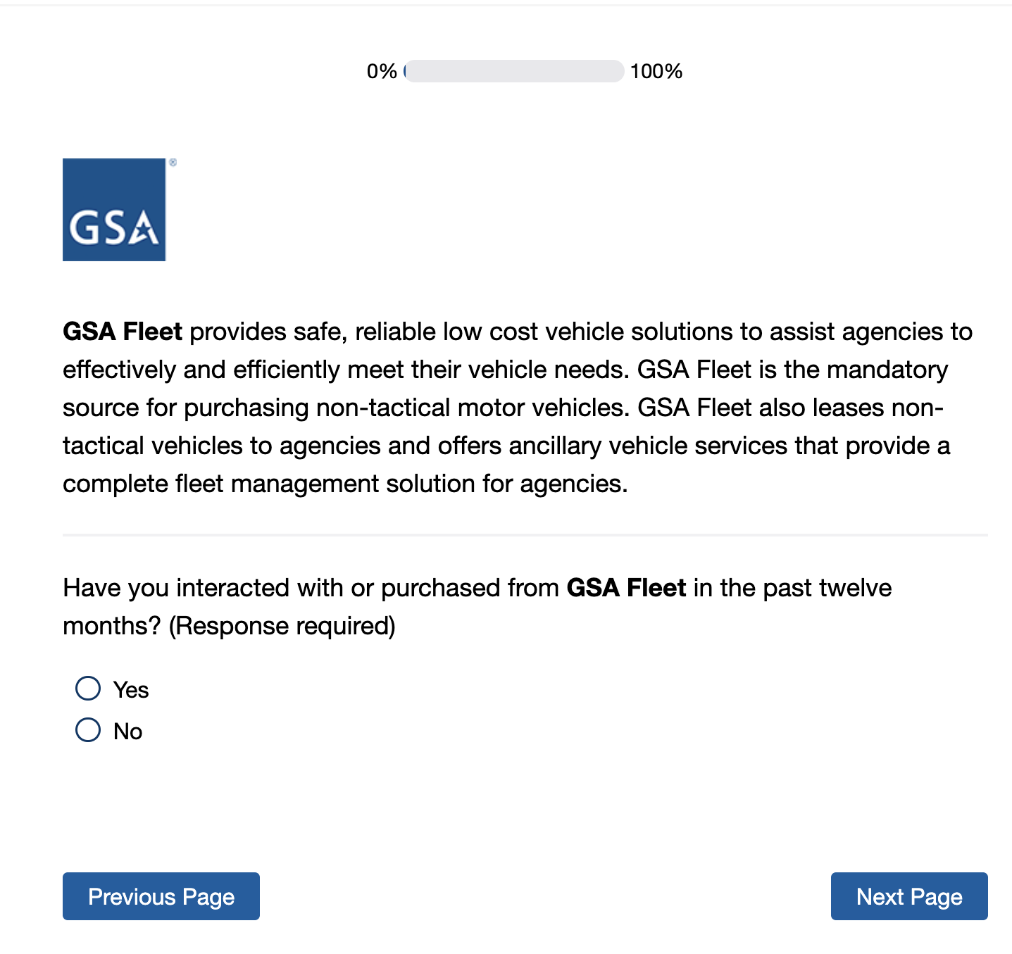
If No is selected, skip to Screen 3a

Screen 2i
Display if Program Office=GSA Schedule (excluding IT and Professional Services)
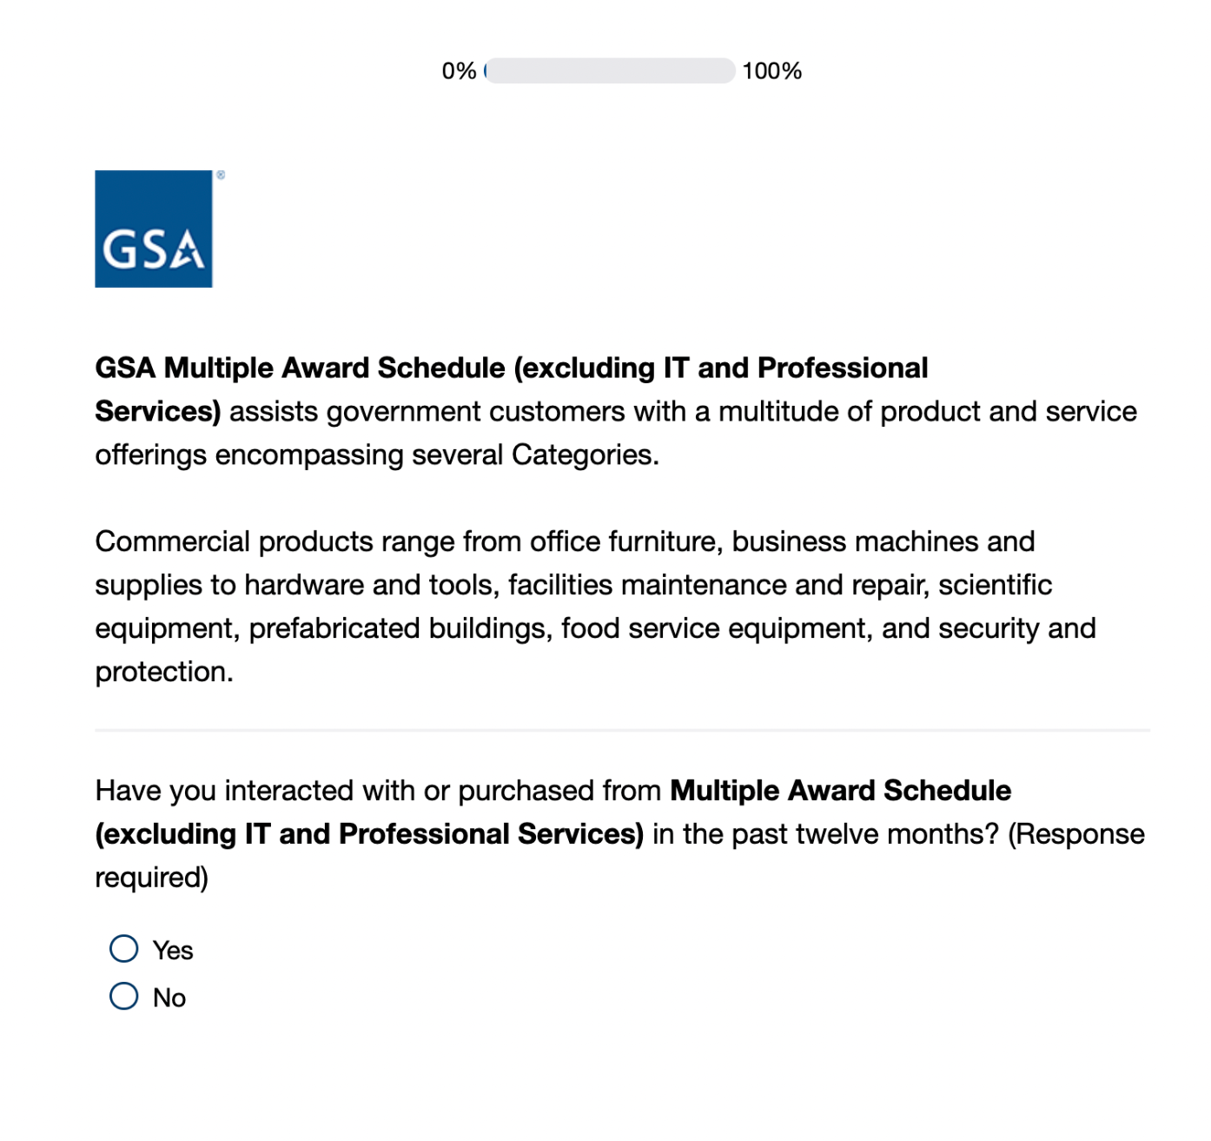
If No is selected, skip to Screen 3

Screen 3a
Display if Program office doesn’t equal GSA Personal Property Management and Program office doesn’t equal Challenge.gov
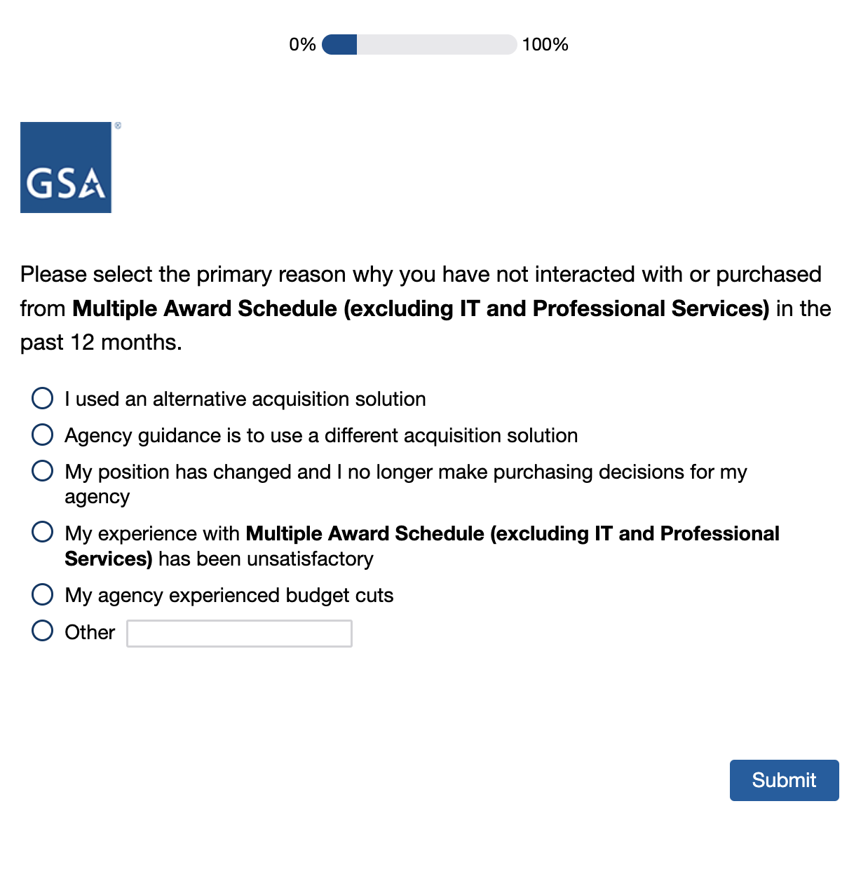
[Program Office Name Inserted Here]

Screen 3b
Display if program office=Challenge.gov
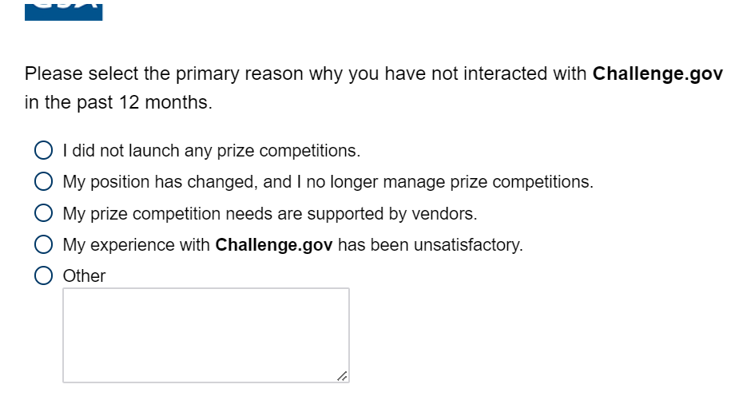
Screen 3c
Display if Program Office= Personal Property Management
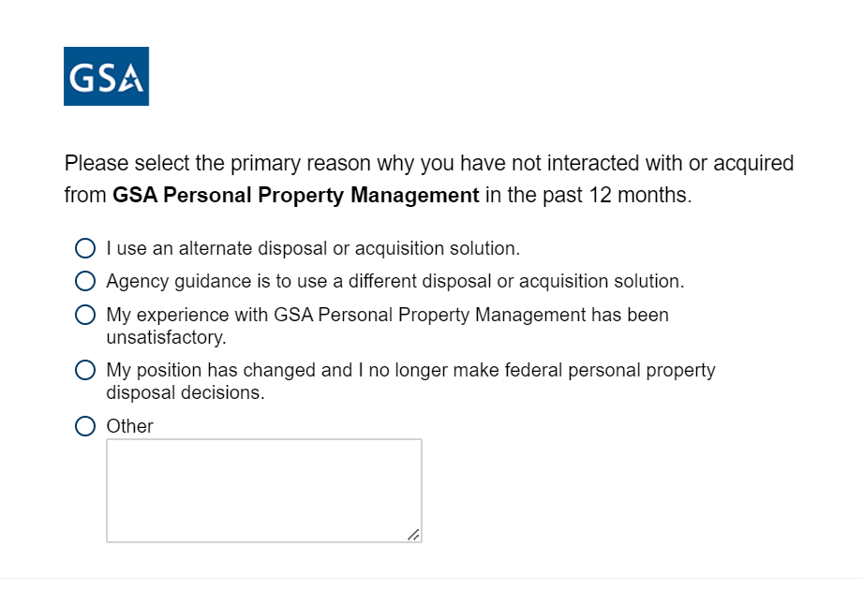
If responses above is ‘I used an alternate disposal or acquisition solution’ or ‘Agency guidance is to use a different disposal or acquisition solution,’ following question appears in same page
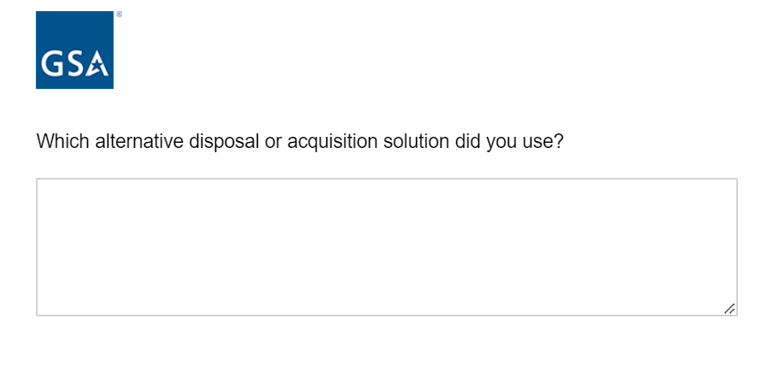
If response to first question in 3a or 3c is ‘I used an alternate disposal or acquisition solution’ or ‘Agency guidance is to use a different disposal or acquisition solution,’ following question appears in same page
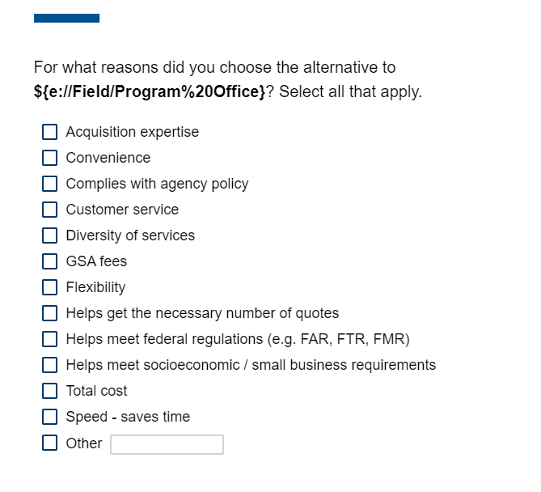
[Program Office Name Inserted Here]
If response to first question on 3a, 3b, or 3c is ‘My experience with… was unsatisfactory,’ the following question displays in the same page
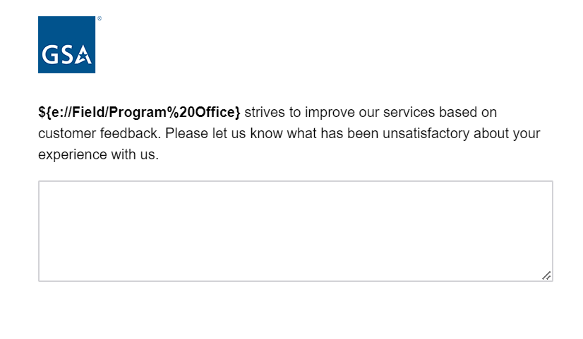
Screen 4a
Display if Program Office= GSA Schedule (excluding ITC and Professional Services)
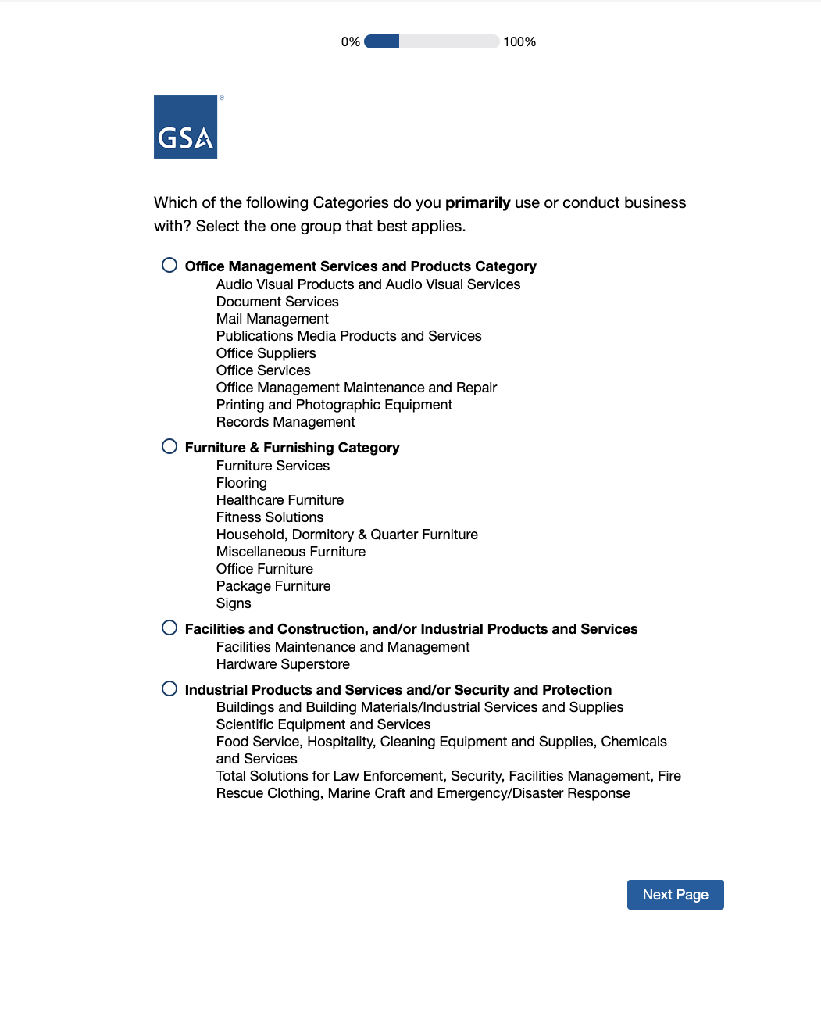
Screen 4b
Display if portfolio=Information Technology Category
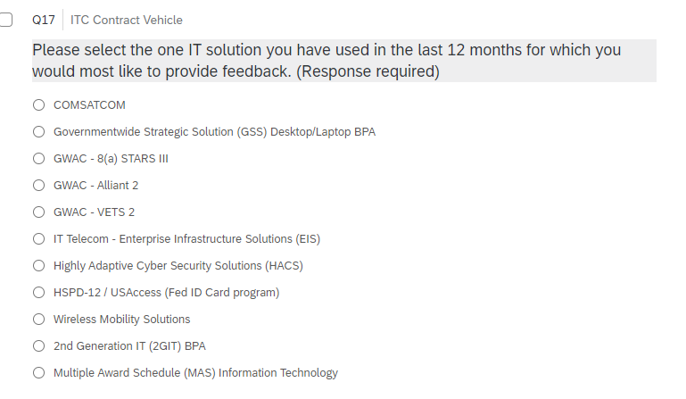
For ITC respondents, the response to the question above becomes the value for ‘Program Office’ for the rest of the survey.

Screen 5
Display to all respondents
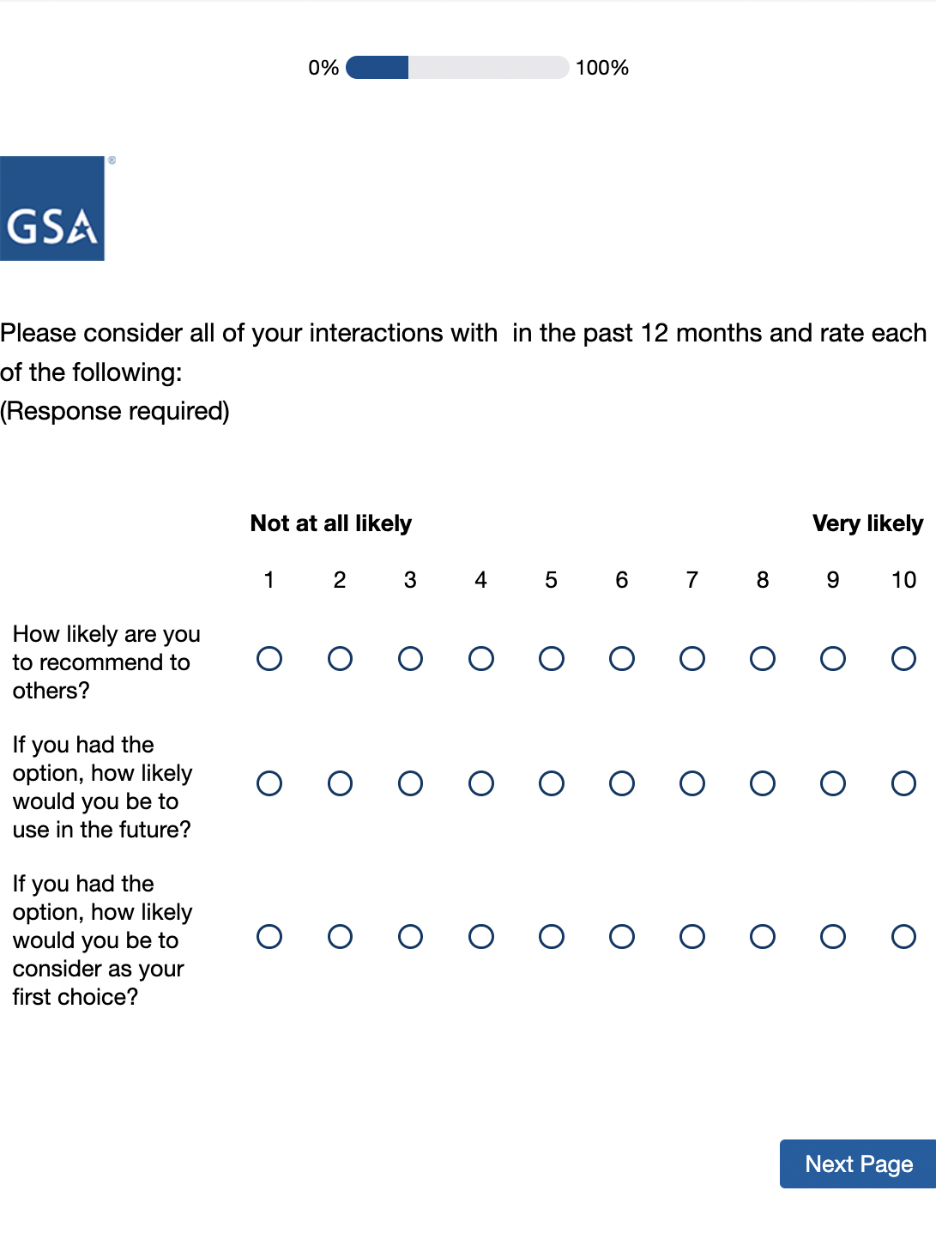
[Program Office Name Inserted Here]

Screen 6
Display to all respondents
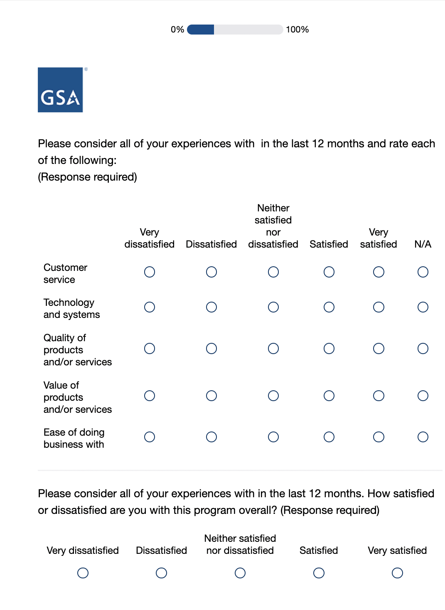

Screen 7
Display if Program Office= GSA Schedule (excluding ITC and Professional Services)
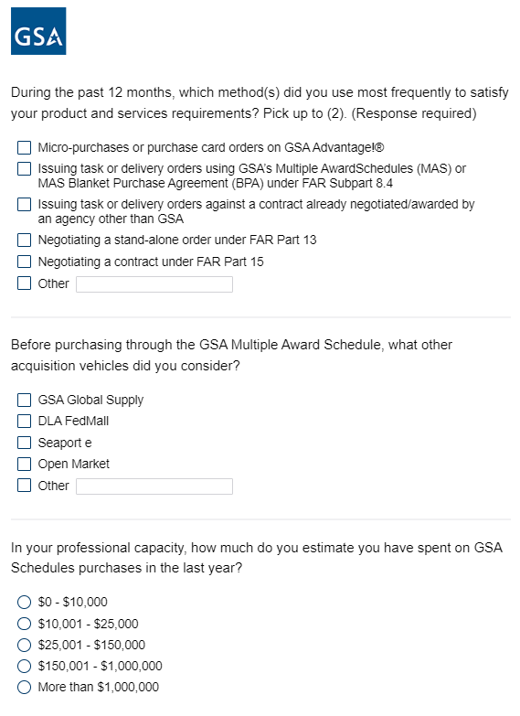
Screen 8
Display if Program Office= GSA Schedule (excluding ITC and Professional Services)
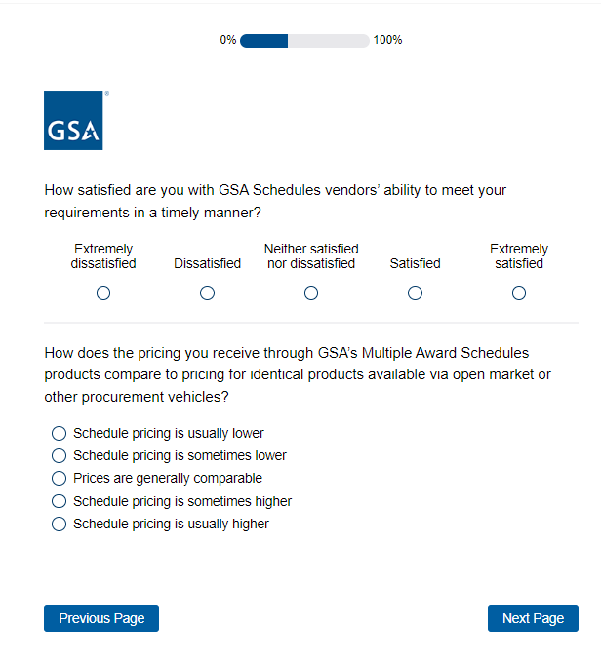
Screen 9
Display if Program Office=GSA Schedule (excluding ITC and Professional Services)
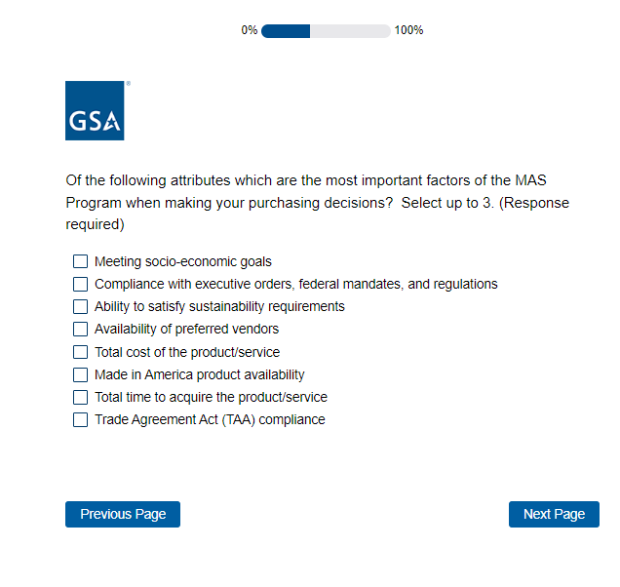
Screen 10
Display if Program Office= GSA Schedule (excluding ITC and Professional Services)
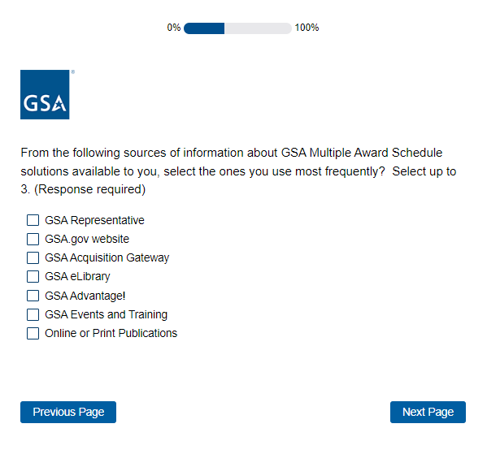
Screen 11
Display if Program Office= GSA Fleet
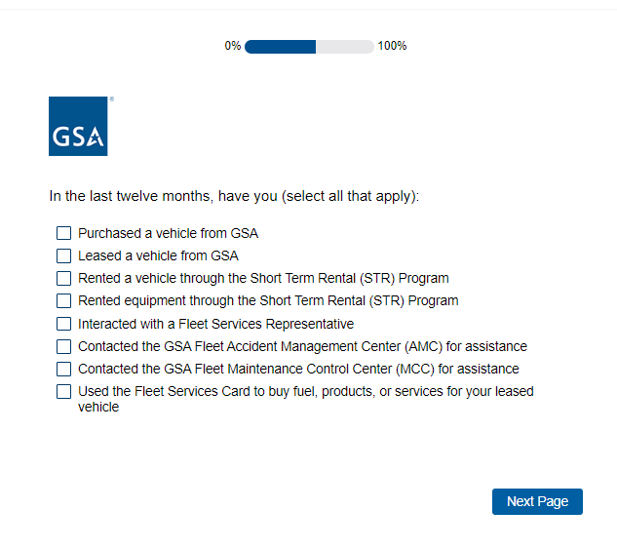
Screen 12
Display if Program Office= GSA Fleet
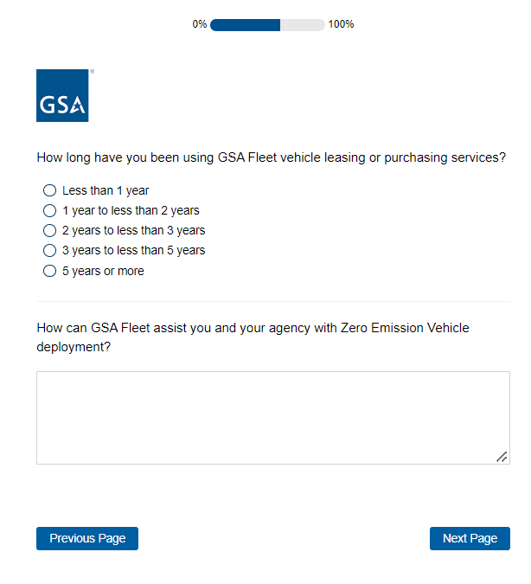
Screen 13
Display if Program Office=Data.gov
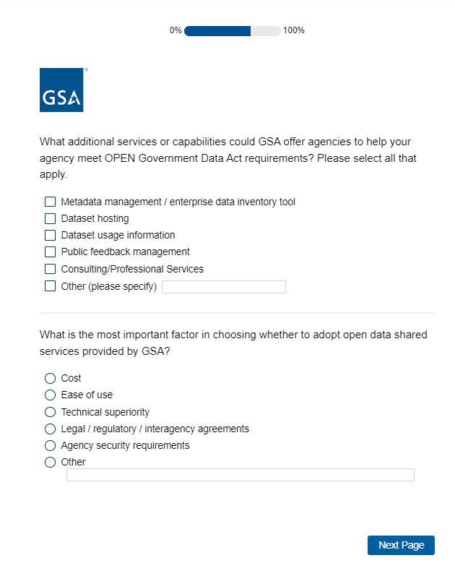
Screen 14
Display if Program Office= Multiple Award Schedule (MAS) Professional Services
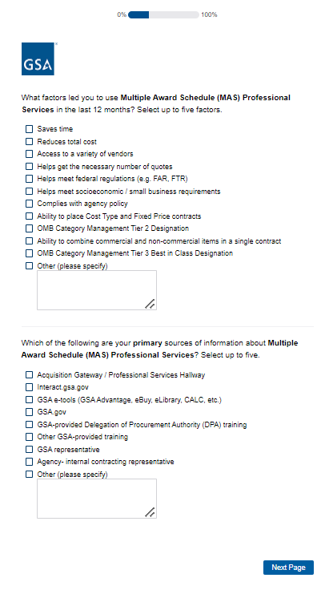
Screen 15
Display if Program Office= Multiple Award Schedule (MAS) Professional Services
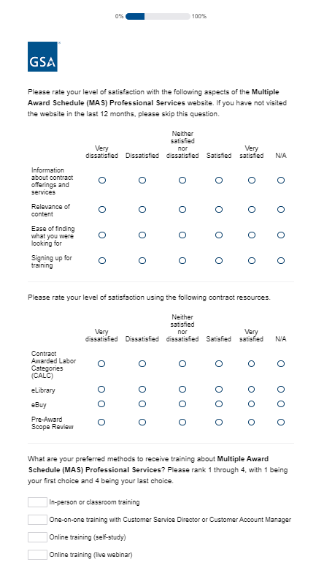
Screen 16
Display if Program Office=GSA SmartPay
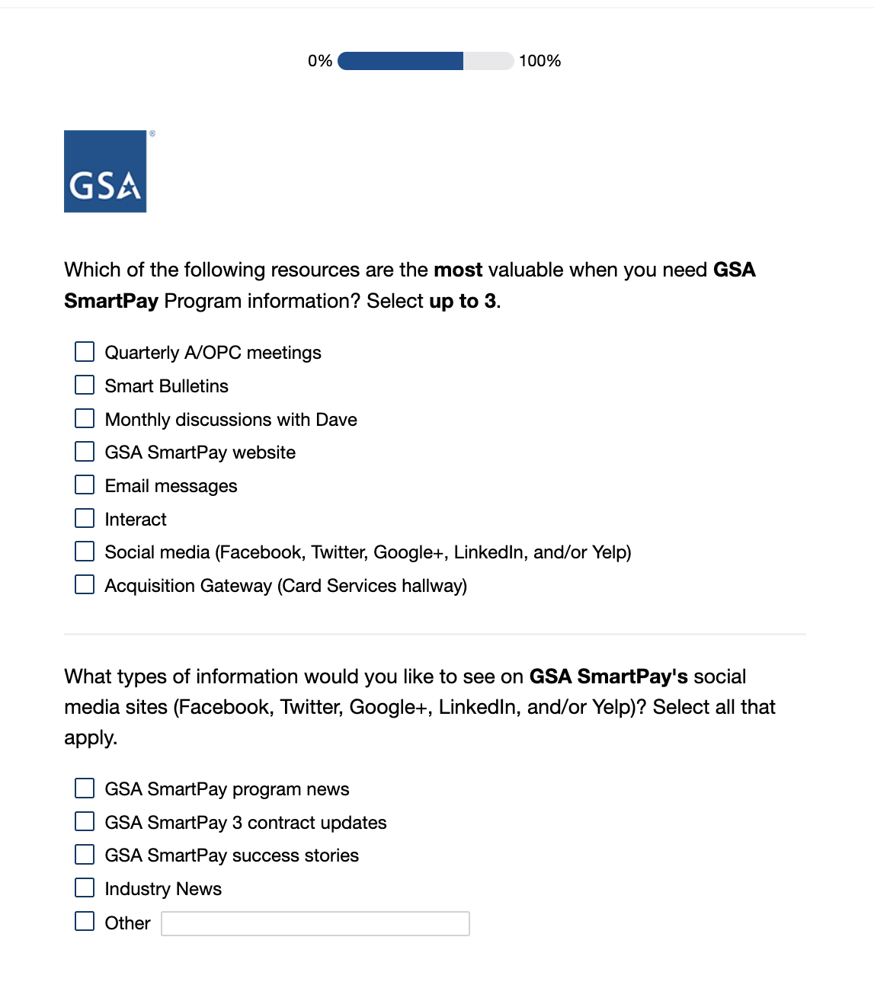
Screen 17
Display if Program Office=GSA SmartPay
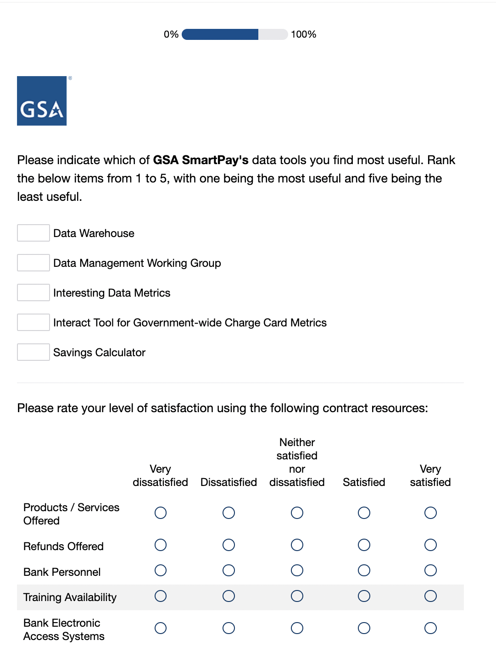

Screen 18
Display if Program Office=GSA SmartPay
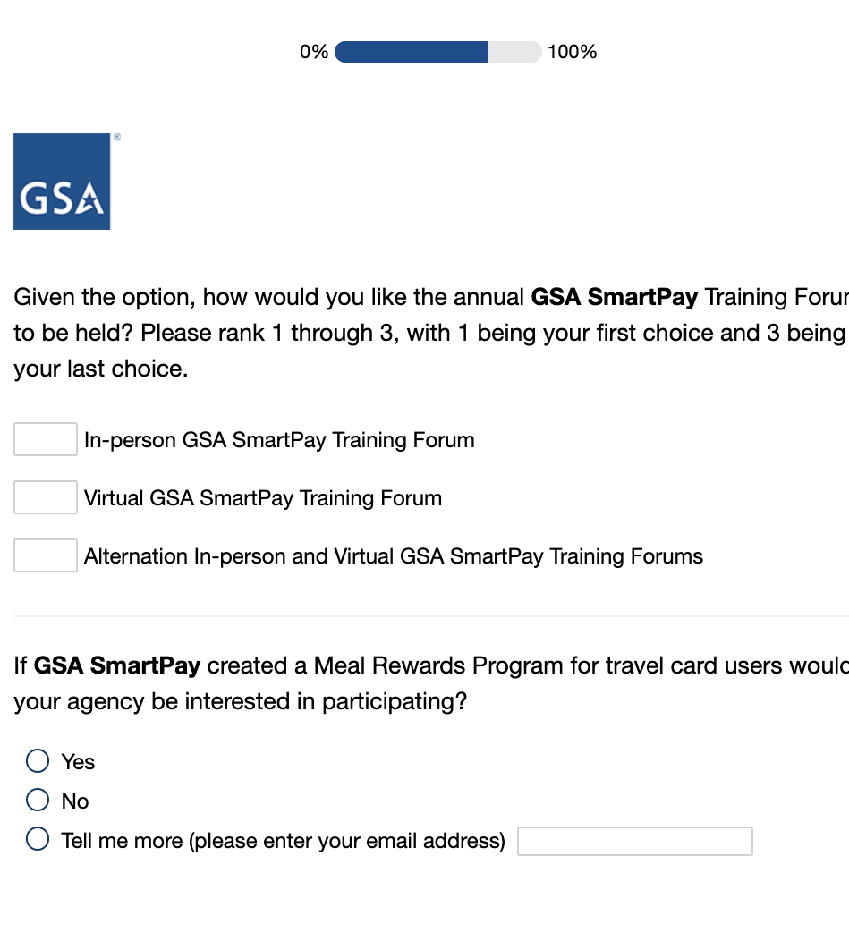
Screen 19
Display if Program Office= GSA Global Supply
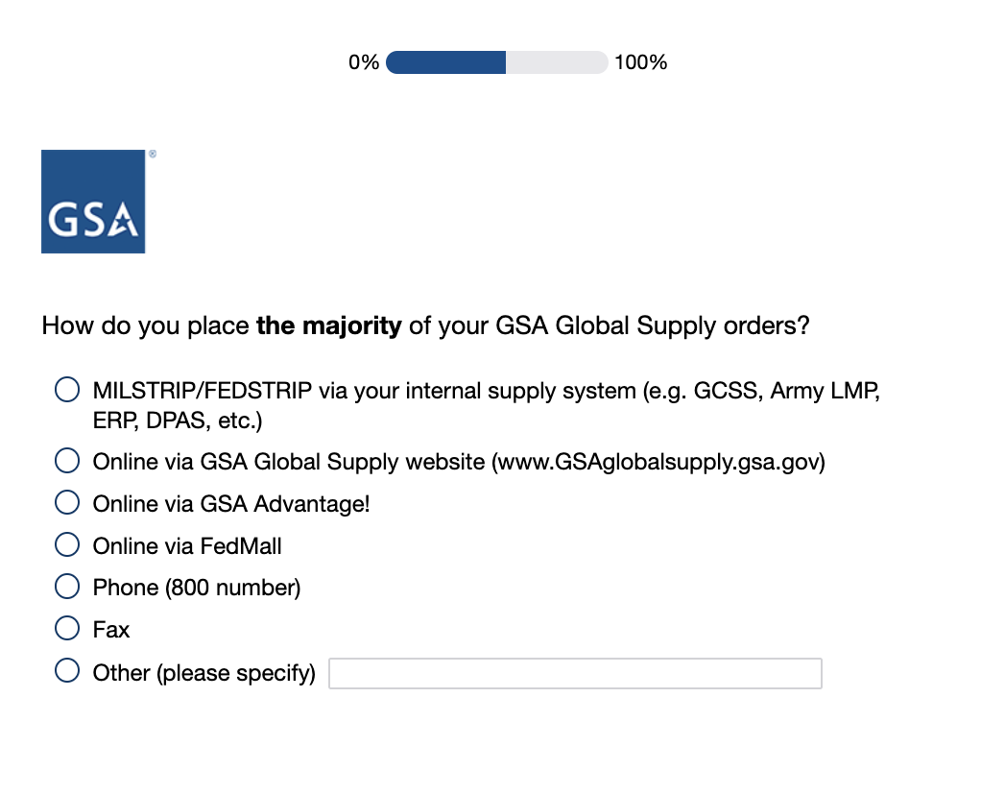
Screen 20
Display if Program Office= GSA Global Supply
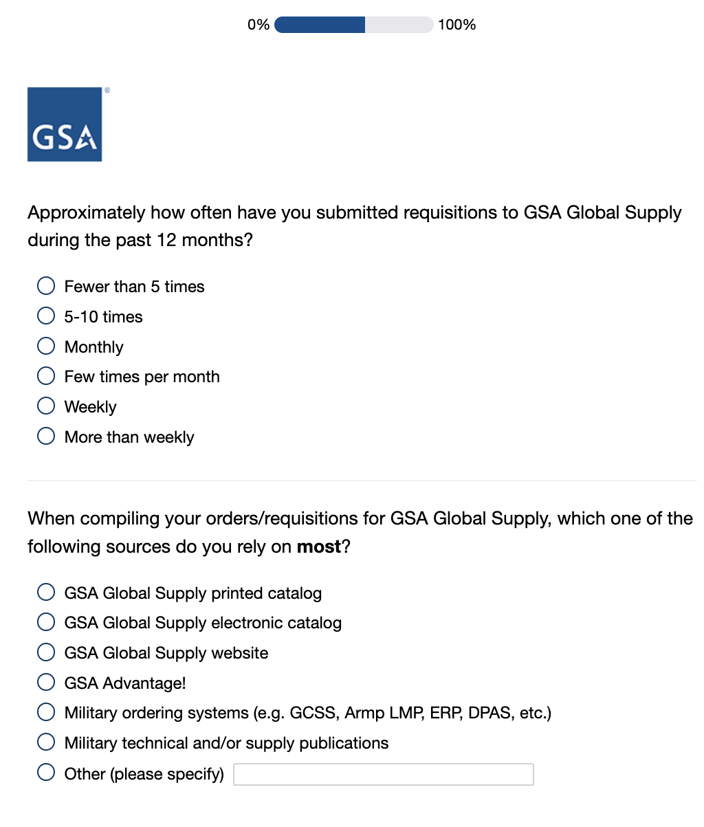
Screen 21
Display if Program Office=GSA Global Supply
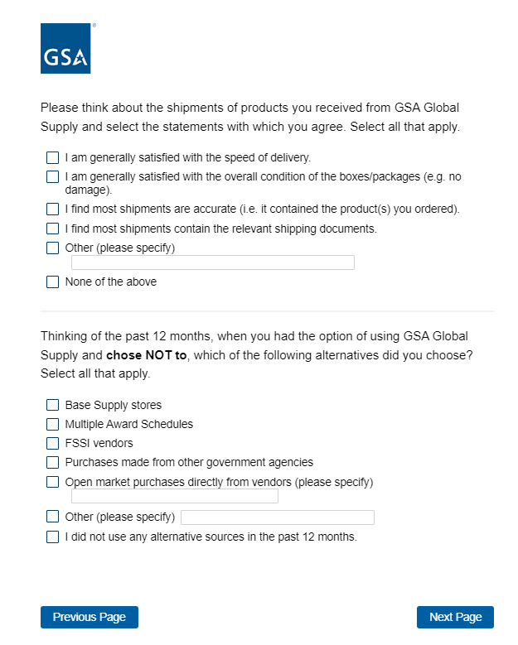
Screen 22
Display if Program Office=GSA Global Supply
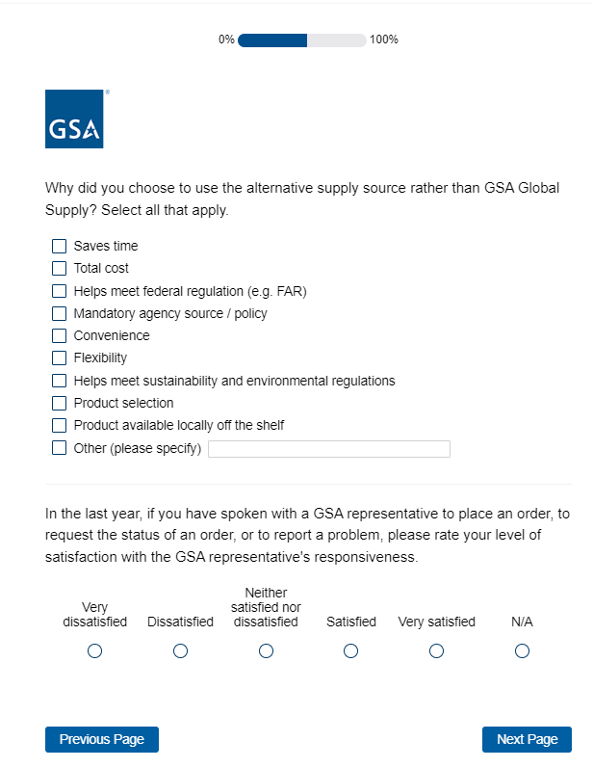

Screen 23
Display if Program Office=Multiple Award Schedule (MAS) Human Capital
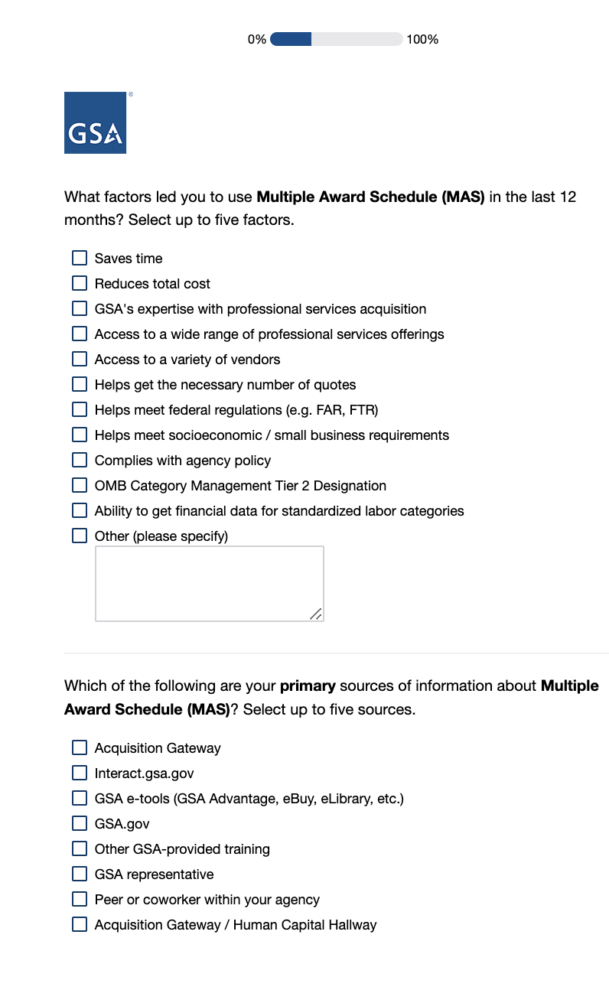

Screen 24
Display if Program Office= Multiple Award Schedule (MAS) Human Capital
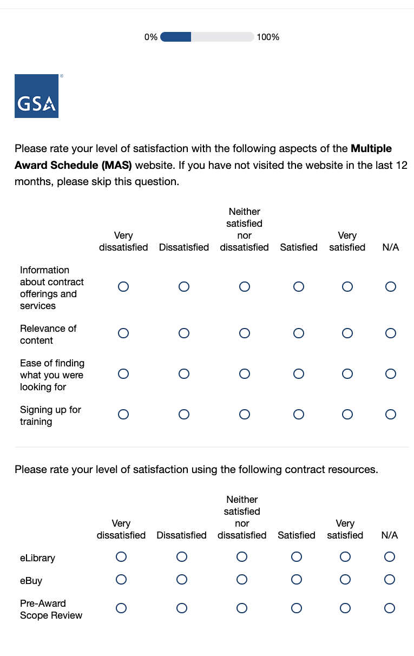
Screen 25
Display if Program Office= GSA Personal Property Management
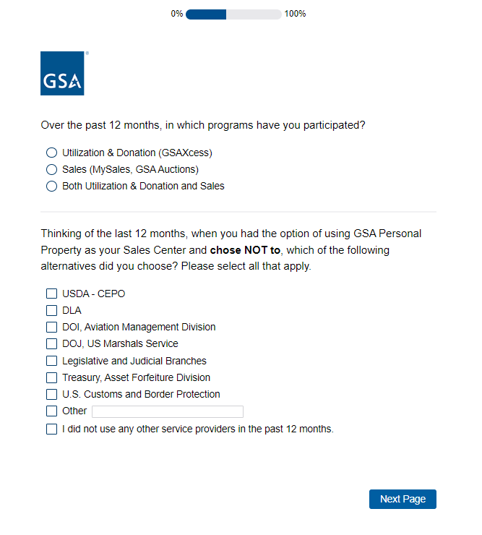
Question only displayed if Agency does not equal SASP

Screen 26a
Display if Program Office=GSA Personal Property Management and Agency doesn’t equal SASP
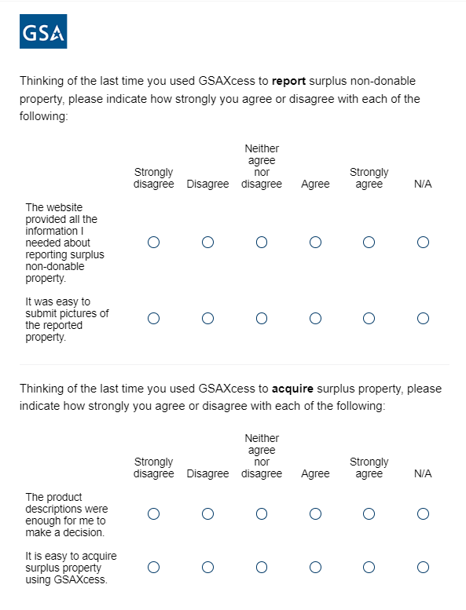
Screen 26b
Display if agency=SASP
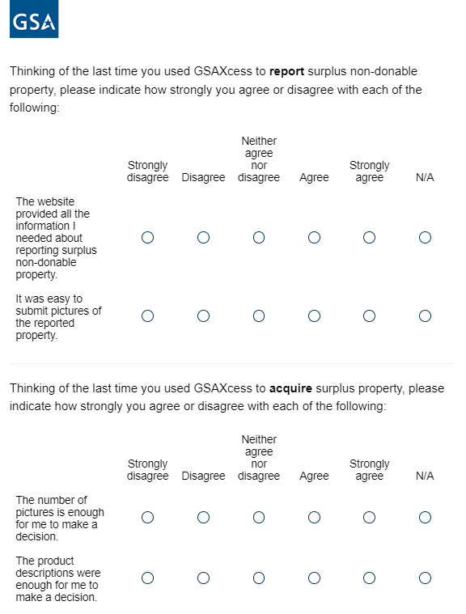

Screen 27
Display if Program Office= GSA Personal Property Management
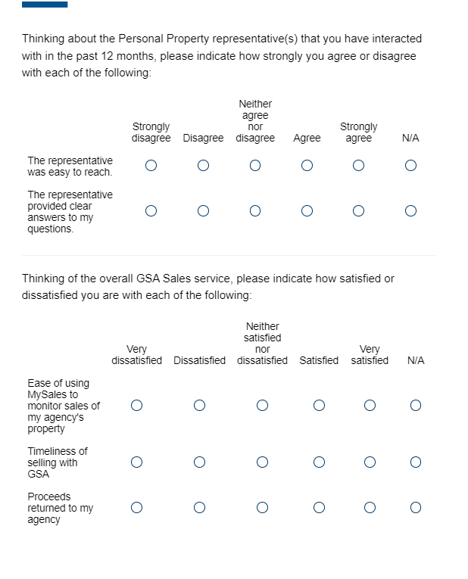
Question only displayed if Agency does not equal SASP

Screen 28
Display if Program Office= GSA Personal Property Management and agency=SASP
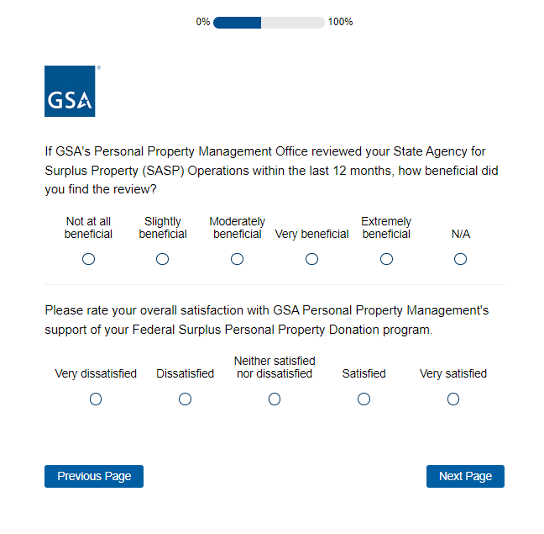
Screen 29
Display to all respondents.
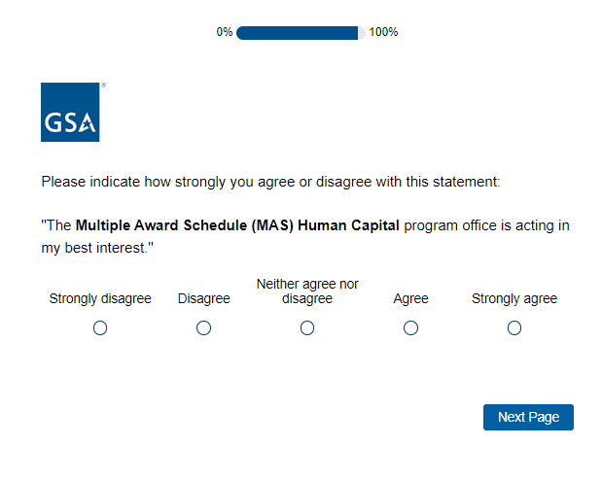
Program office name inserted here
Screen 30
Display to all respondents unless Program Office=MAS Human Capital or MAS Professional Services
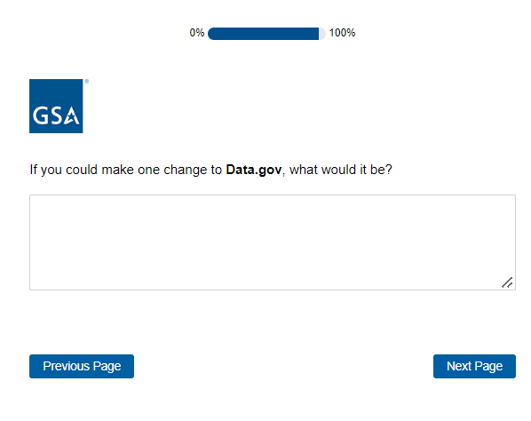
Program office name inserted here
Screen 31
Display if Program Office= MAS Professional Services or MAS Human Capital (vocab changes accordingly)
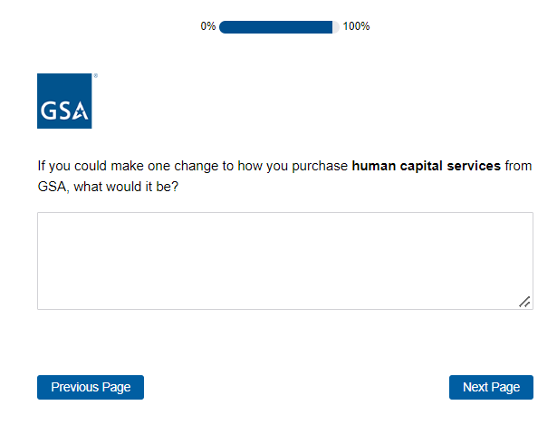
Screen 32
Display to all respondents
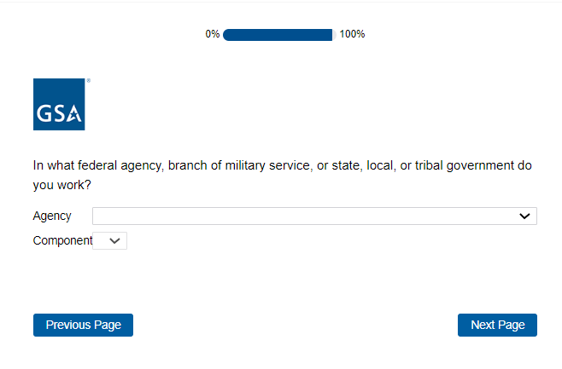

Screen 33
Display to all respondents
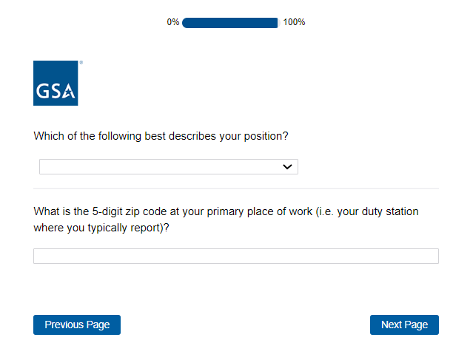

Screen 34
Display to all respondents
