2023 Industry Satisfaction Survey

For PRA Review only – Contents of this box will not be displayed to recipients.

Note that this survey depends on embedded data to determine which questions will be displayed to each recipient. Embedded data are commands built into the survey that draw information from the contact list. Survey responses remain confidential, and personally identifiable information is not collected by the system.

The embedded data fields that are used in this survey are:
GSA Program Office (program being rated)
GSA Portfolio (parent organization of program being rated)
Internal Program (an alternate naming convention used to standardize terminology for the MAS offices)

On Screens 5 and 6, [Program Office] will be replaced by one of the following:
GSA Multiple Award Schedule (MAS)
One Acquisition Solution for Integrated Services (OASIS)
Human Capital and Training Solutions (HCaTS)
GSA Information Technology Category
GSA Fleet
GSA Employee Relocation Resource Center
GSA Center for Travel Management
GSA Transportation Management Program

Screen 1

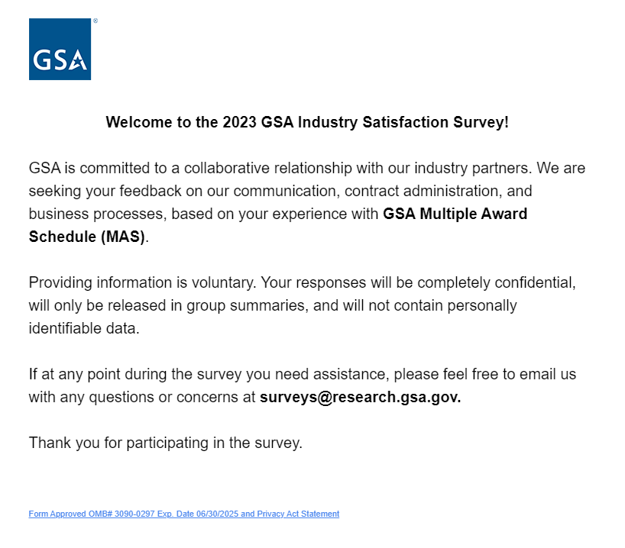
Link at the bottom of above page goes to a pdf displaying the PRA statement and a GSA Privacy Act Statement. See next page for screenshot.
Screen 1, continued

Screenshot of pdf linked from bottom of first page:

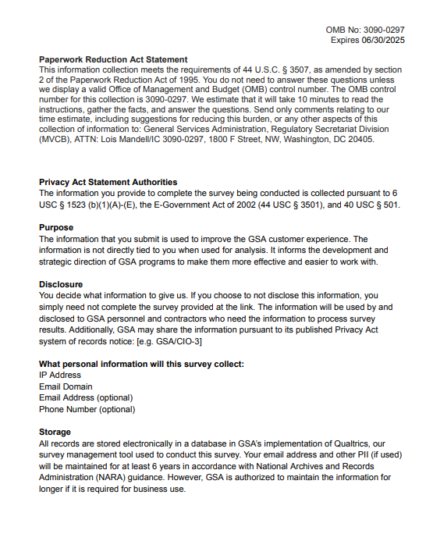
Screen 2a

Display if GSA Portfolio (embedded data) = GSA General Supplies and Services.

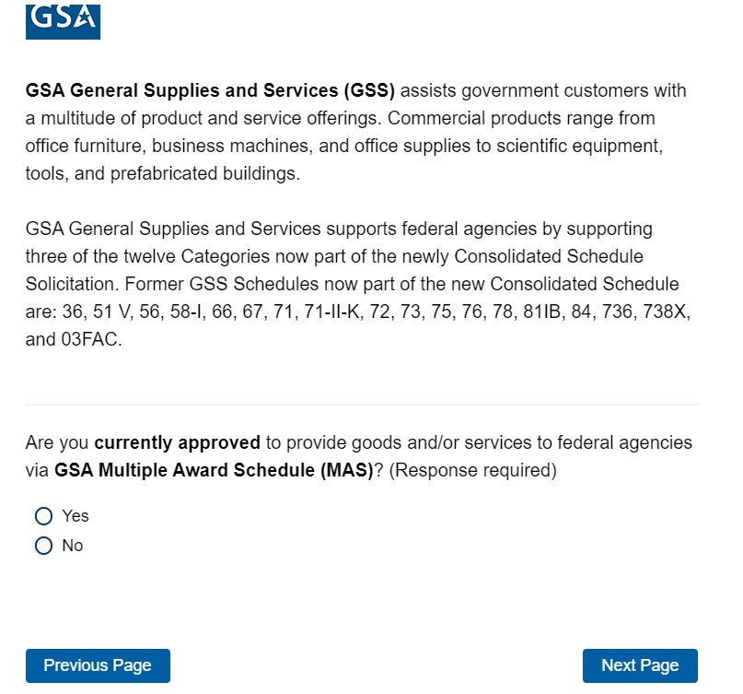

If No, then display Screen 3 and exit survey.
If Yes, skip to Screen 4.

Screen 2b

Display if GSA Program Office (embedded data) = GSA Fleet:
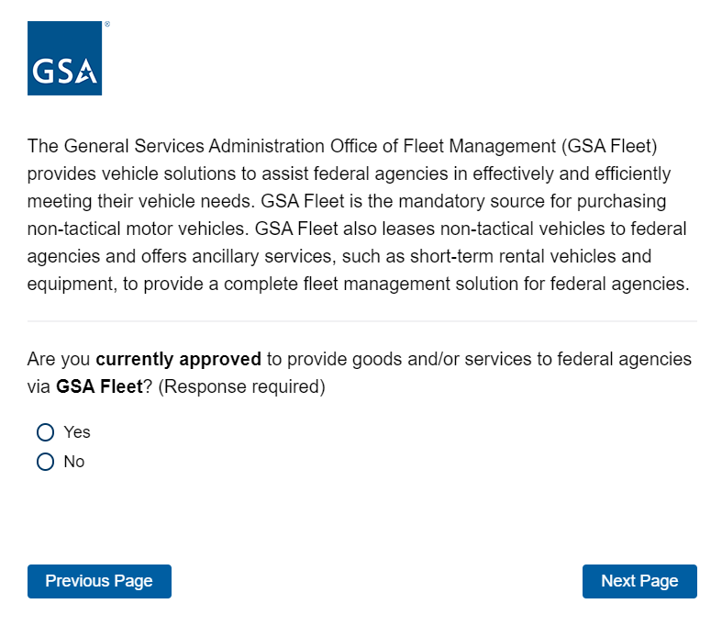
If No, then display Screen 3 and exit survey.
If Yes, skip to Screen 5.

Screen 2c

Display if Portfolio (embedded data) = GSA Information Technology Category:
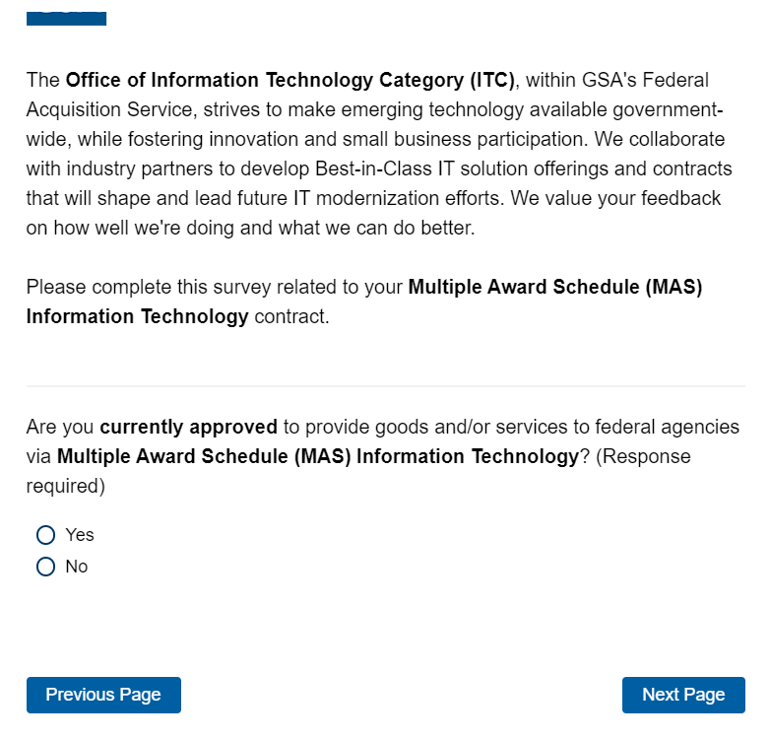
Program Office name inserted here
Program Office name inserted here
If No, then display Screen 3 and exit survey.
If Yes, skip to Screen 5.

Screen 2d

Display if GSA Program Office (embedded data) = GSA Center for Travel Management:

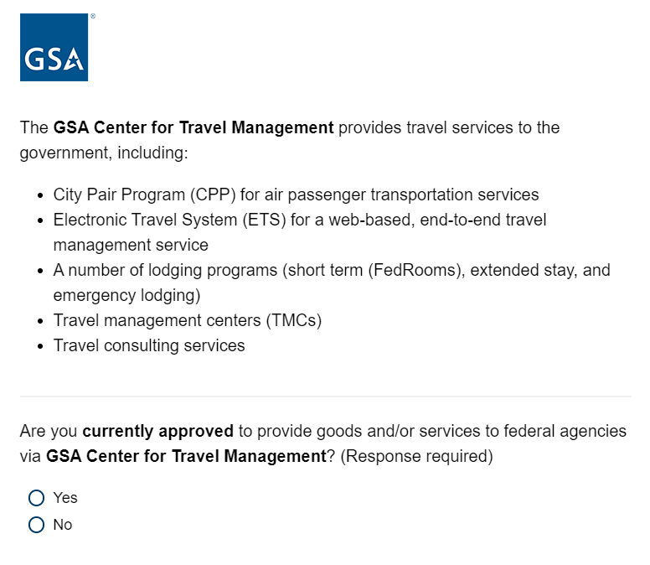
If No, then display Screen 3 and exit survey.
If Yes, skip to Screen 5.

Screen 2e

Display if GSA Program Office (embedded data) = GSA Freight Management Program
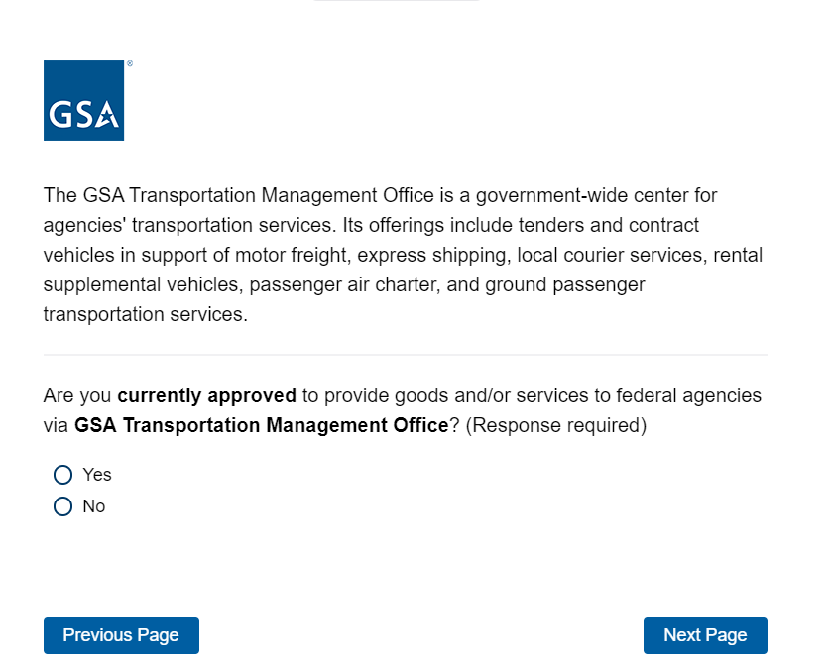
If No, then display Screen 3 and exit survey.
If Yes, skip to Screen 5.

Screen 2f

Display if GSA Program Office (embedded data) = GSA Employee Relocation Resource Center:
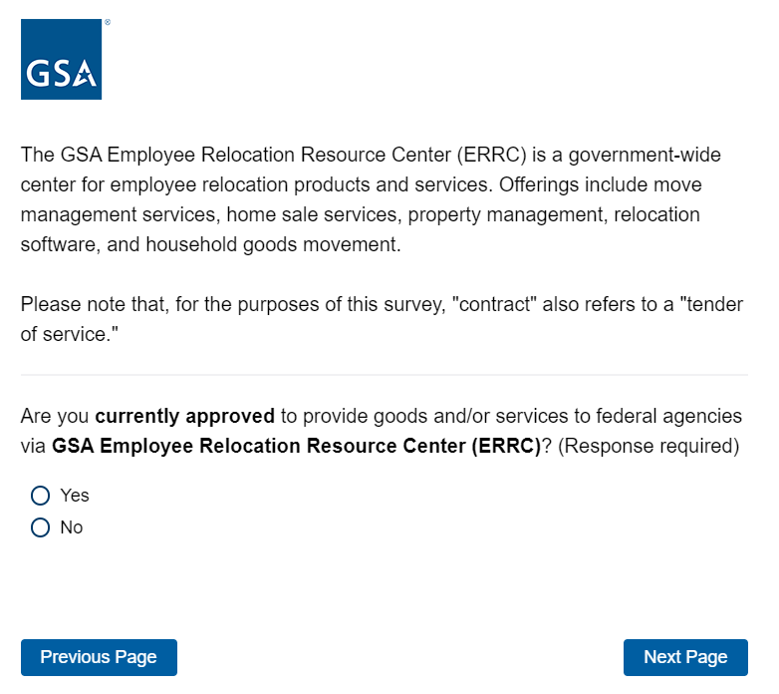
If No, then display Screen 3 and exit survey.
If Yes, skip to Screen 5.
Screen 2g

Display if GSA Program Office (embedded data) = One Acquisition Solution for Integrated Services (OASIS):
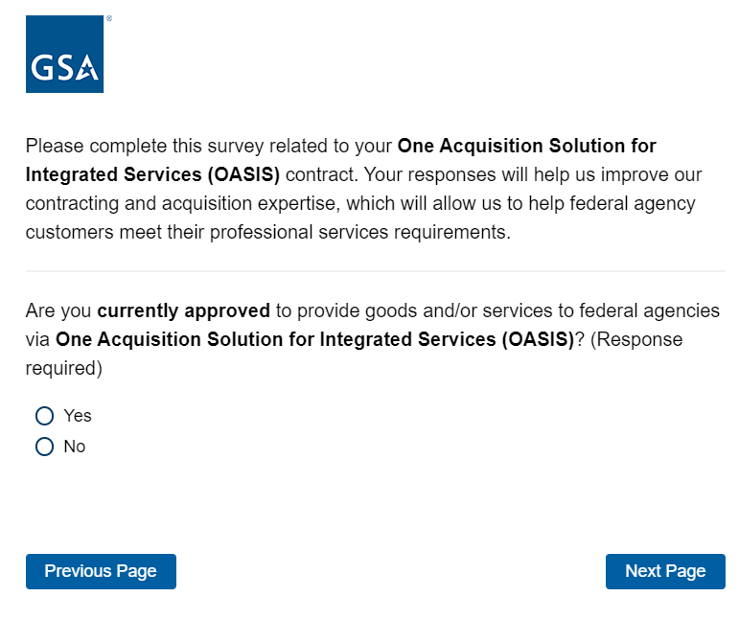
If No, then display Screen 3 and exit survey.
If Yes, skip to Screen 5.

Screen 2h

Display if GSA Portfolio (embedded data) = Professional Services and Program Office= Multiple Award Schedule (MAS)

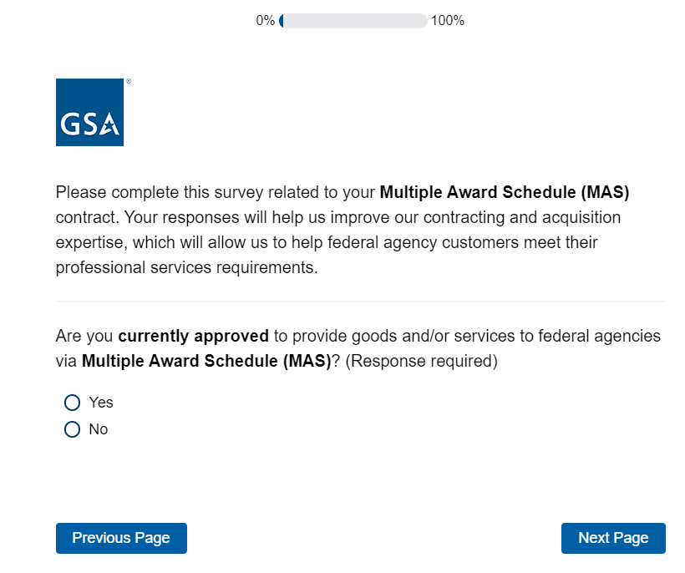
If No, then display Screen 3 and exit survey.
If Yes, skip to Screen 5.

Screen 2i

Display if GSA Program Office (embedded data) = Human Capital and Training Solutions (HCaTS)

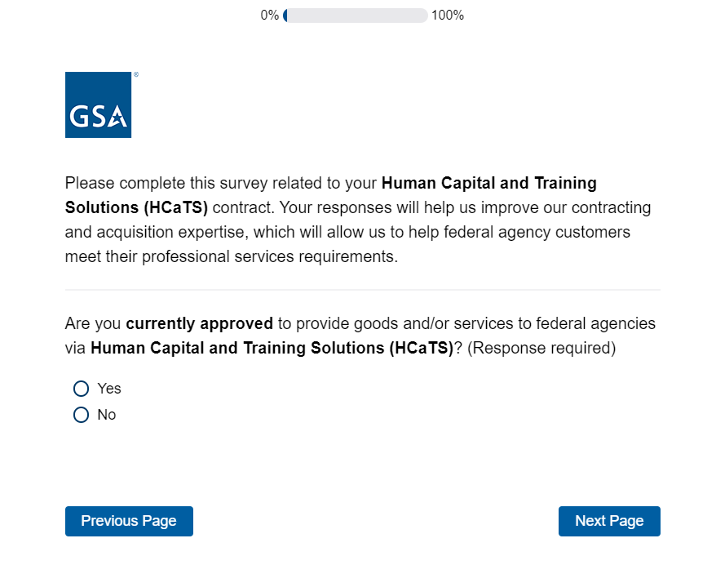

If No, then display Screen 3 and exit survey.
If Yes, skip to Screen 5.

Screen 3

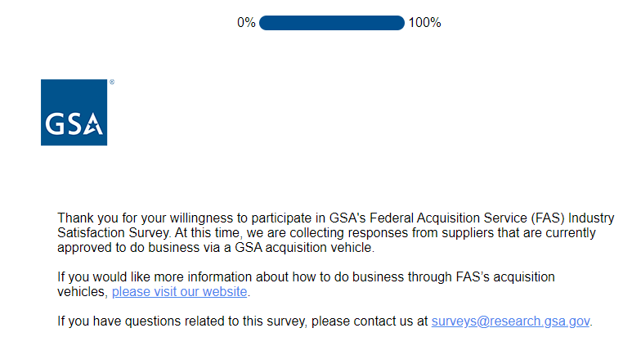

Exit survey (for respondents who select “No” on Screens 2a-i). The above link goes to a page on GSA.gov that provides information on how to do business with GSA.
Screen 4

Display if GSA Portfolio (embedded data) = GSA General Supplies and Services

Proceed to Screen 5.

Screen 5
Display to all respondents

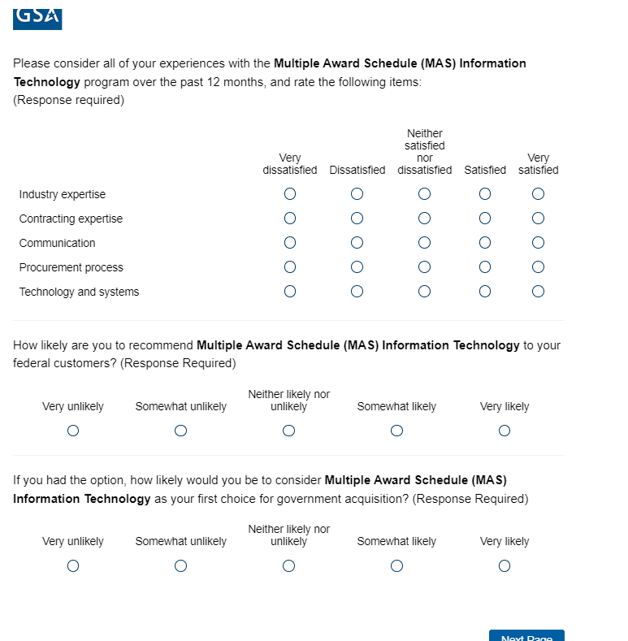
Program Office name inserted here
Program Office name inserted here
Program Office name inserted here

Proceed to Screen 6.
Screen 6

If Portfolio = GSA General Supplies and Services, skip to Screen 7.
If Program Office = GSA Fleet, skip to Screen 10.
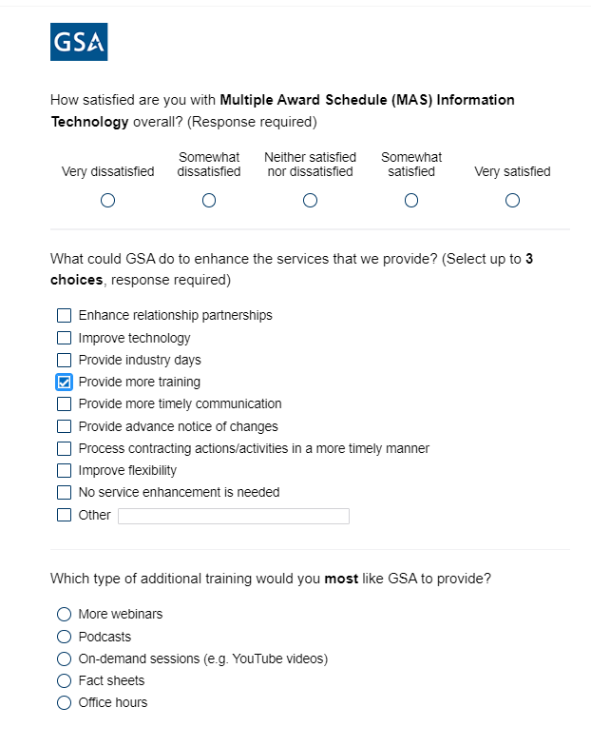
If Program Office = GSA Center for Travel Management, skip to Screen 11.
Display “Which type of additional training would you most like GSA to provide?” if “Provide more training” is selected in previous question.
If Program Office = GSA Transportation Management Program, skip to Screen 13.
If Program Office = GSA Employee Relocation Resource Center, skip to Screen 15.
If Program Office = One Acquisition Solution for Integrated Services (OASIS), skip to Screen 17.
If Portfolio = Professional Services, skip to Screen 20.
If Program Office = Human Capital and Training Solutions (HCaTS), skip to Screen 22.
If Program Office= GSA Information Technology Category, skip to screen
Screen 7

Display if GSA Portfolio (embedded data) = GSA General Supplies and Services,
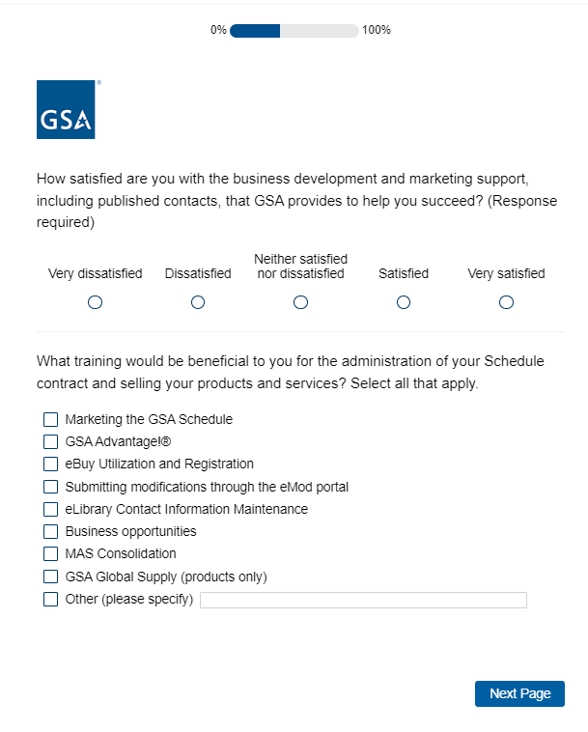

Screen 8

Display if GSA Portfolio (embedded data) = GSA General Supplies and Services

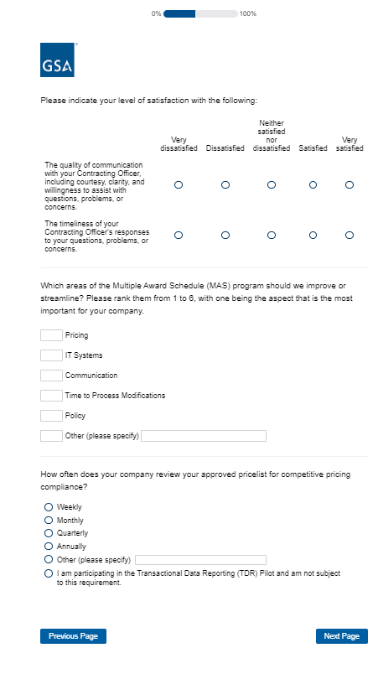

Screen 9

Display if GSA Portfolio (embedded data) = GSA General Supplies and Services
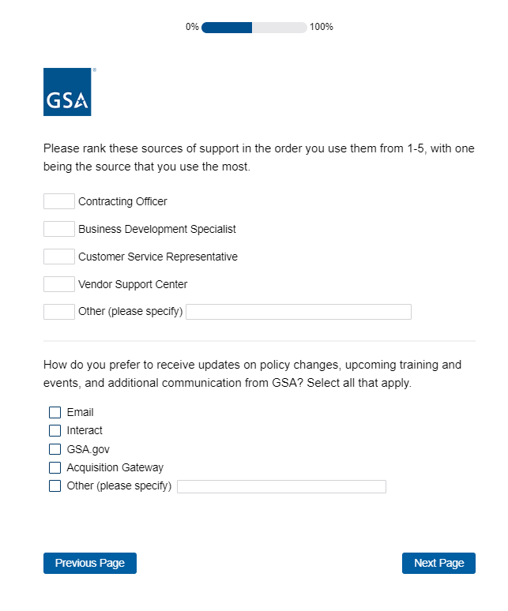

Skip to Screen 29.

Screen 10 (Display if GSA Program Office (embedded data) = GSA Fleet)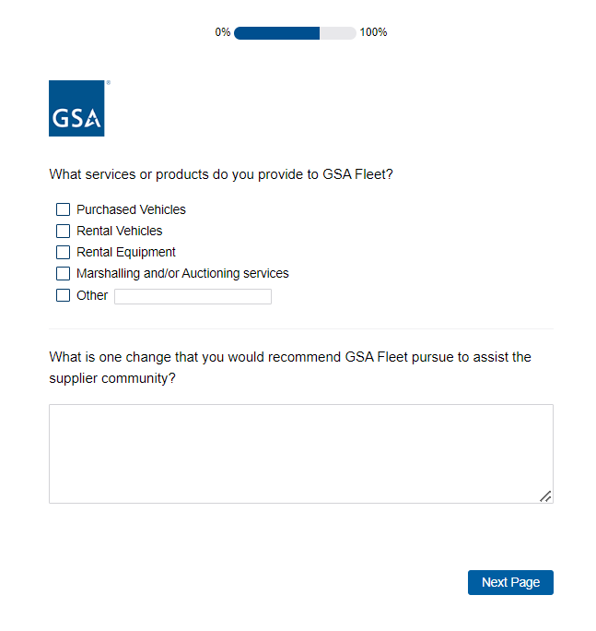

Skip to Screen 32.
Screen 11

Display if GSA Program Office (embedded data) = the GSA Center for Travel Management

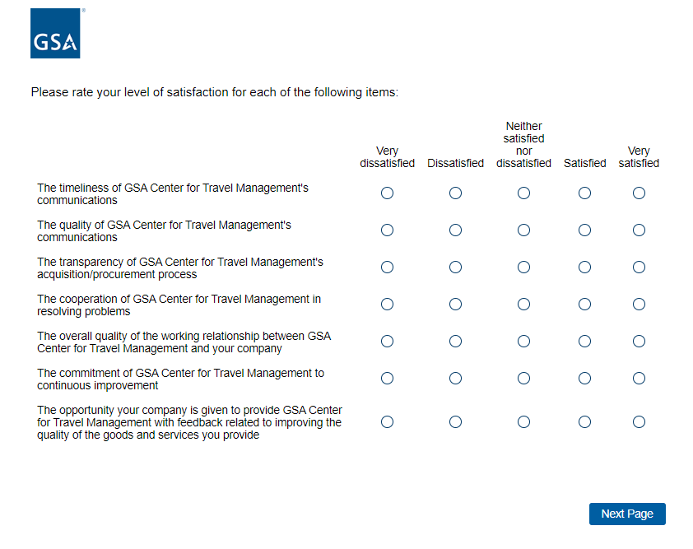

Screen 12

Display if GSA Program Office (embedded data) = the GSA Center for Travel Management

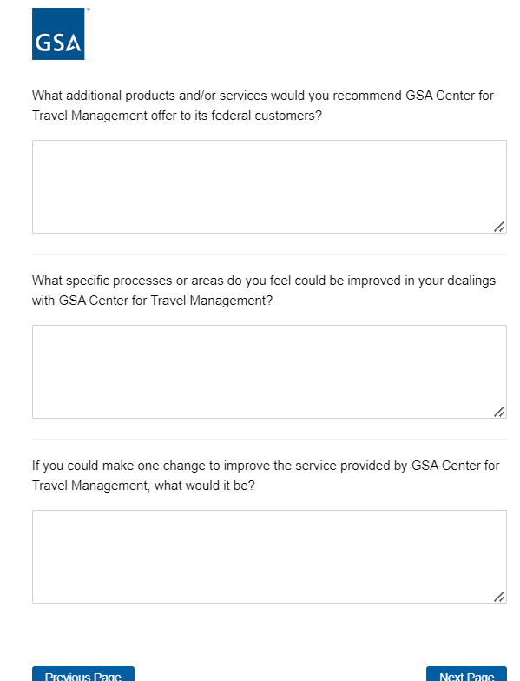

Skip to Screen 32.
Screen 13

Display if GSA Program Office (embedded data) = GSA Transportation Management Program

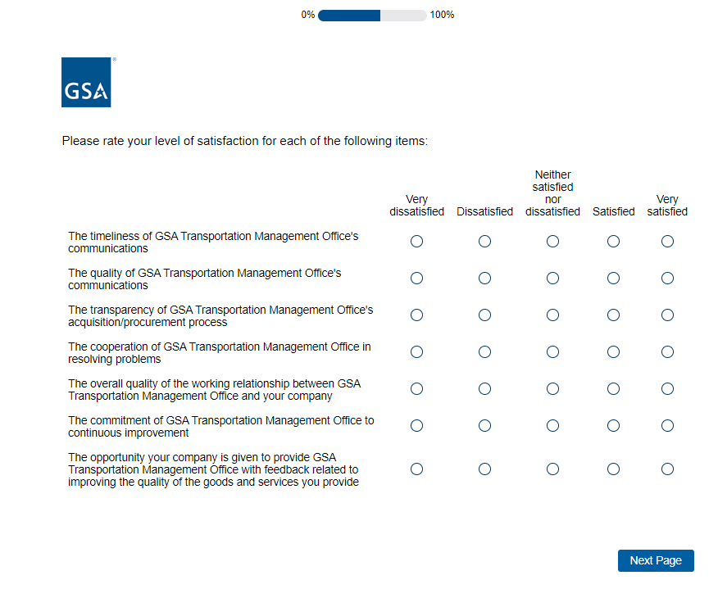

Screen 14

Display if GSA Program Office (embedded data) = GSA Transportation Management Program

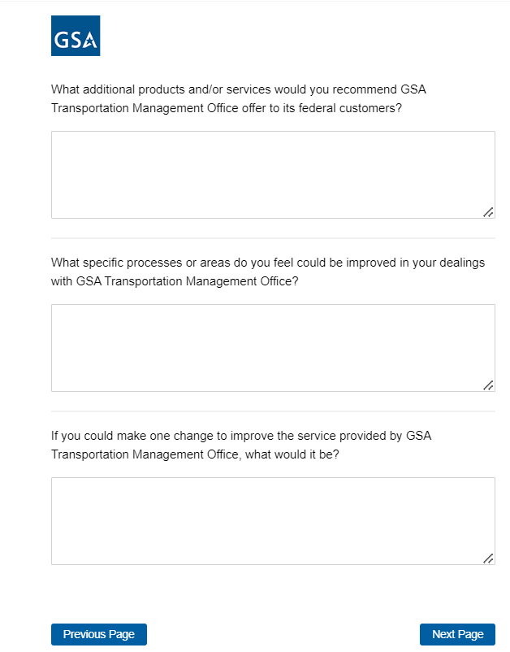

Skip to Screen 32.
Screen 15

Display if GSA Program Office (embedded data) = GSA Employee Relocation Resource Center

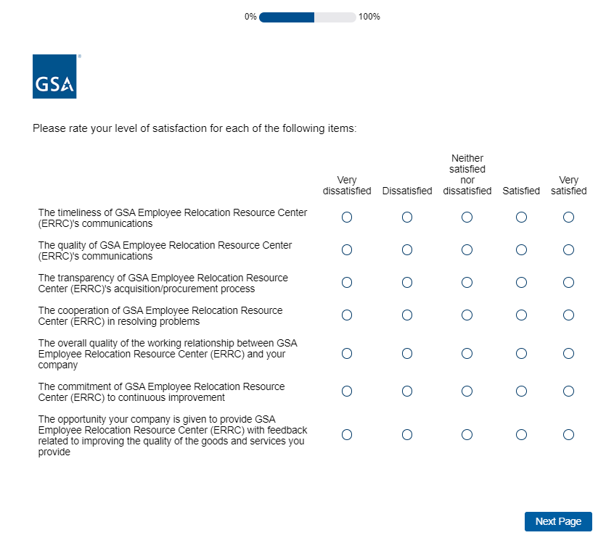

Screen 16

Display if GSA Program Office (embedded data) = GSA Employee Relocation Resource Center

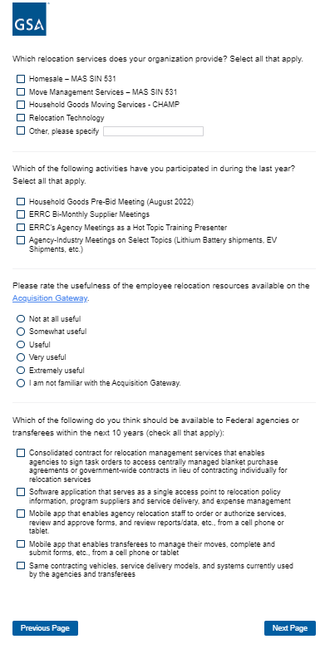

Skip to Screen 29.

Screen 17

Display if GSA Program Office (embedded data) = One Acquisition Solution for Integrated Services (OASIS)

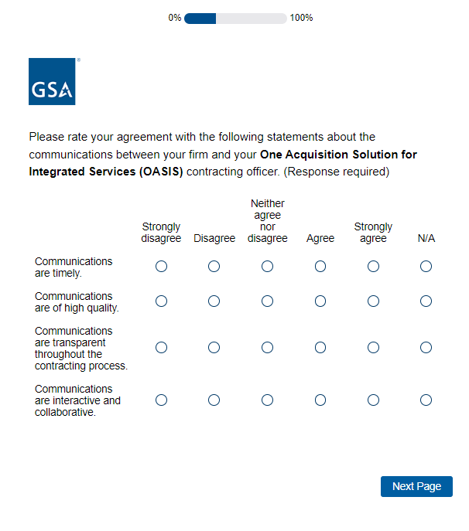

Screen 18

Display if GSA Program Office (embedded data) = One Acquisition Solution for Integrated Services (OASIS)

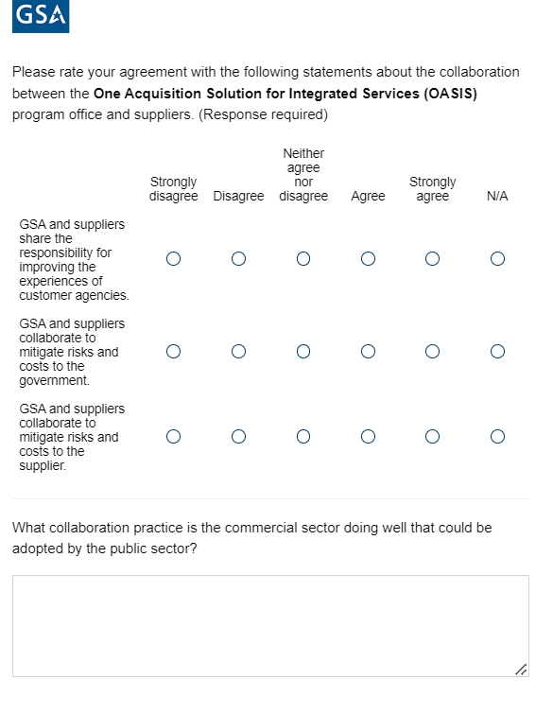

Screen 19

Display if GSA Program Office (embedded data) = One Acquisition Solution for Integrated Services (OASIS)

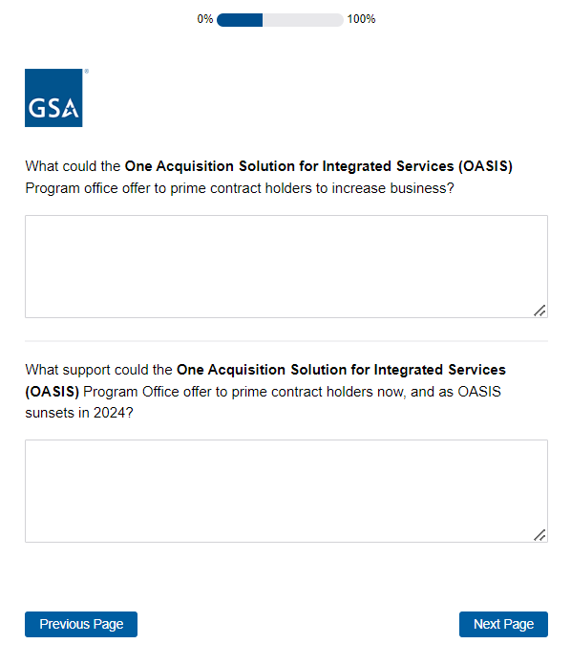
Skip to Screen 32.

Screen 20

Display if GSA Portfolio (embedded data) = Professional Services and Program Office= Multiple Award Schedule (MAS)

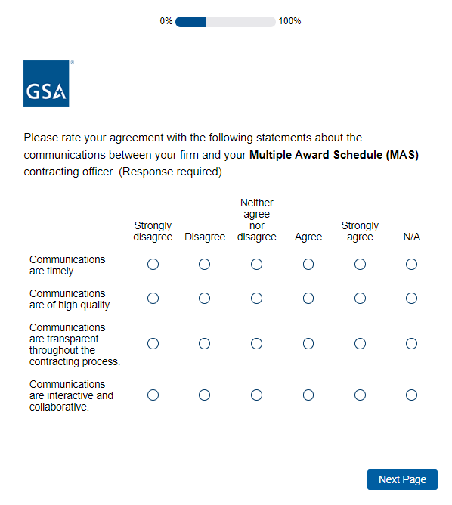

Screen 21

Display if GSA Portfolio (embedded data) = Professional Services

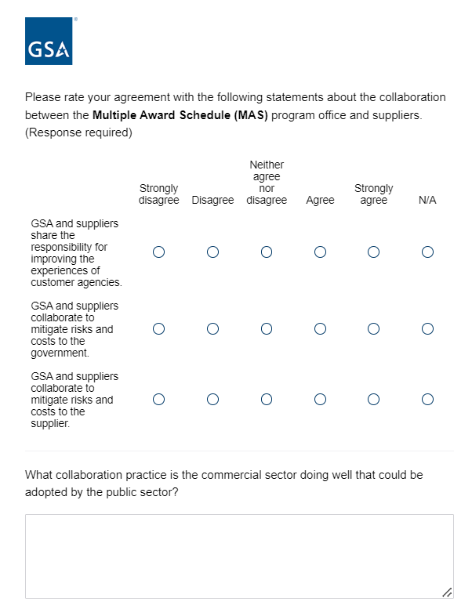
Skip to Screen 29.
Screen 22

Display if GSA Program Office (embedded data) = Human Capital and Training Solutions (HCaTS)

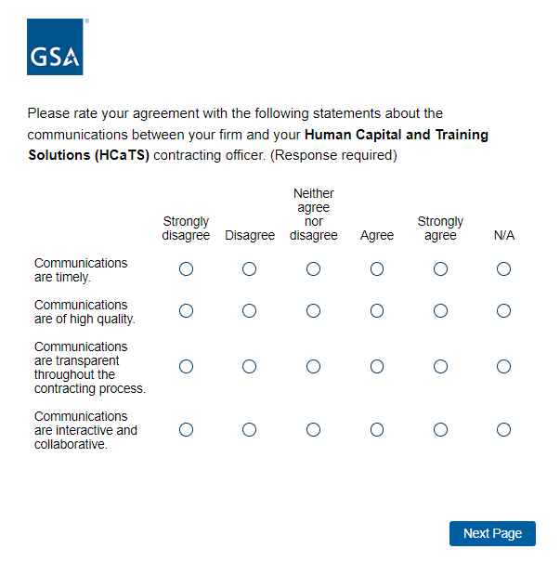

Screen 23

Display if GSA Program Office (embedded data) = Human Capital and Training Solutions (HCaTS)

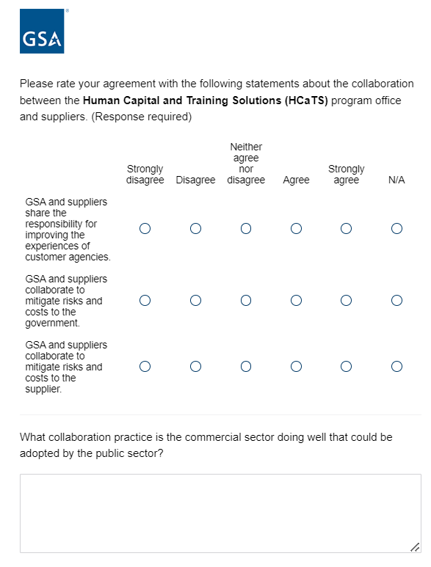

Screen 24

Display if GSA Program Office (embedded data) = Human Capital and Training Solutions (HCaTS)

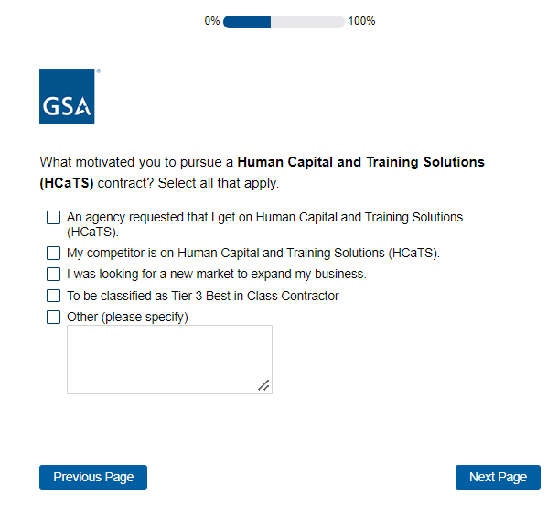
Skip to Screen 32.

Screen 29

Display if GSA Program Office = GSA Multiple Award Schedule (MAS)
Or Program Office= Multiple Award Schedule (excluding IT and Professional Services)
Or if Category = Information Technology
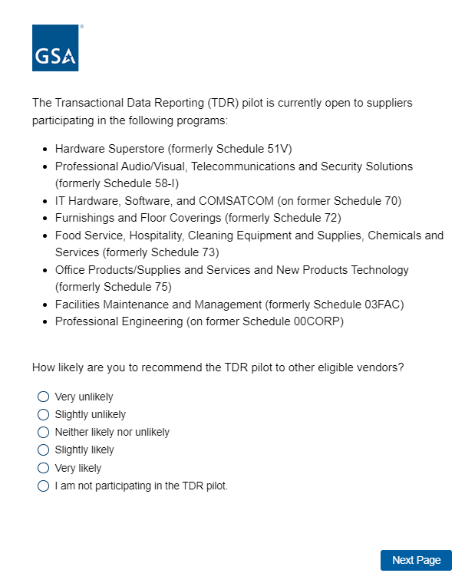

Screen 30

Display if GSA Program Office = GSA Multiple Award Schedule (MAS)
Or if GSA Program Office = GSA Employee Relocation Resource Center
Or if Category = Information Technology
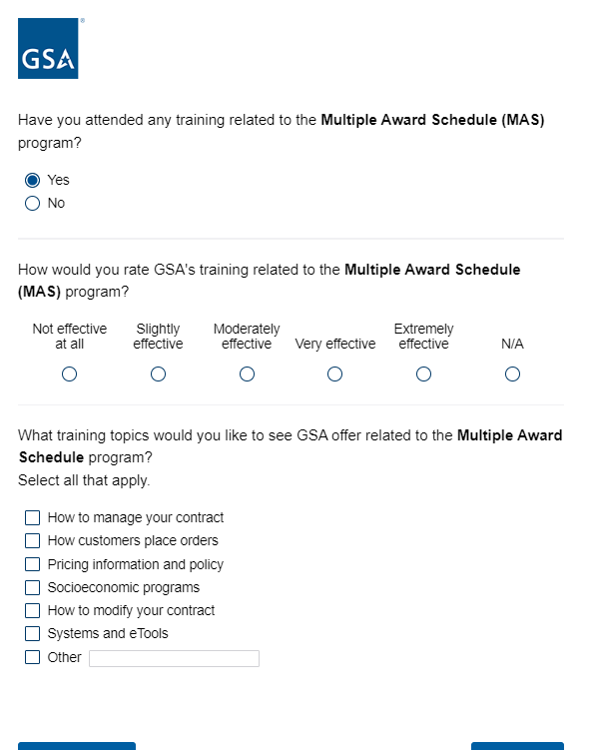
Display if response to previous question is ‘Yes’

Screen 31

Display if GSA Program Office = GSA Multiple Award Schedule (MAS)
Or if GSA Program Office = GSA Employee Relocation Resource Center
Or if Category = Information Technology

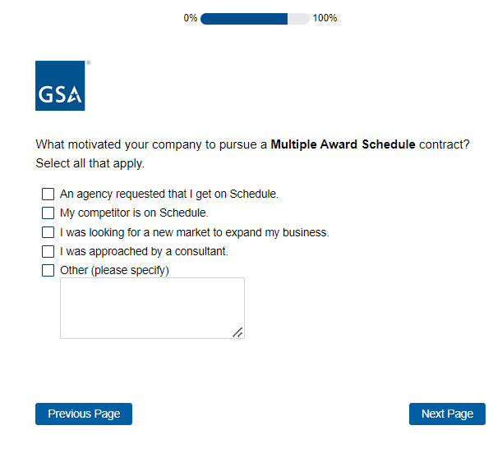

Screen 32
Display if GSA Program Office = GSA Multiple Award Schedule (MAS)
Or if GSA Program Office = GSA Employee Relocation Resource Center
Or if Category = Information Technology
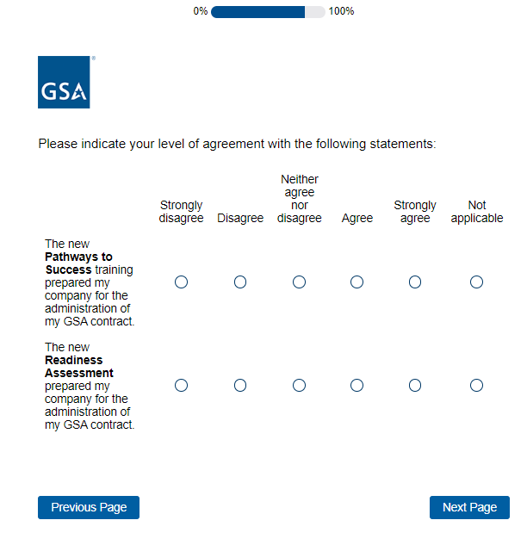

Screen 33a

Display if response to ‘How satisfied are you with Program Office overall?’ is Very Satisfied
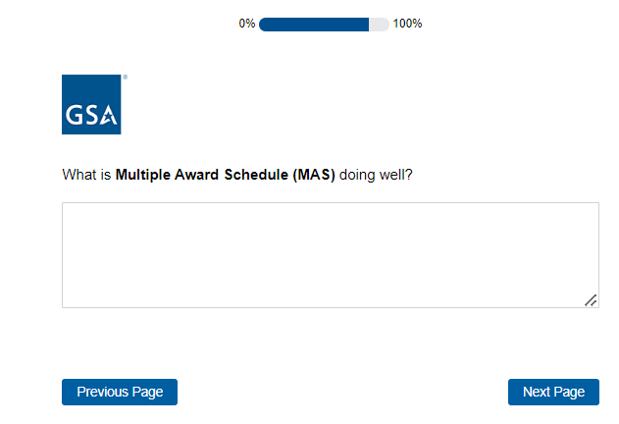
Screen 33b
Display if response to ‘How satisfied are you with Program Office overall?’ is Somewhat Satisfied
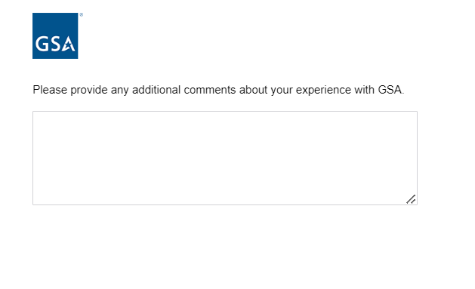

Screen 33c
Display if response to ‘How satisfied are you with Program Office overall?’ is Very dissatisfied, Dissatisfied, or Neither Satisfied nor Satisfied
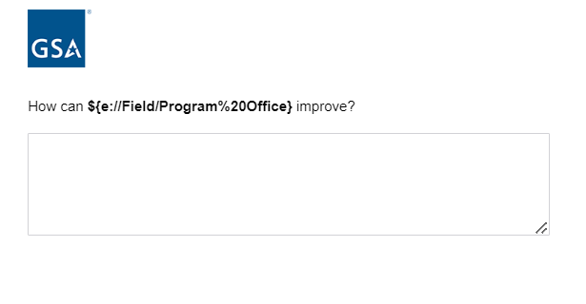
[Program Office Name Inserted Here]

Screen 34

Display to all respondents
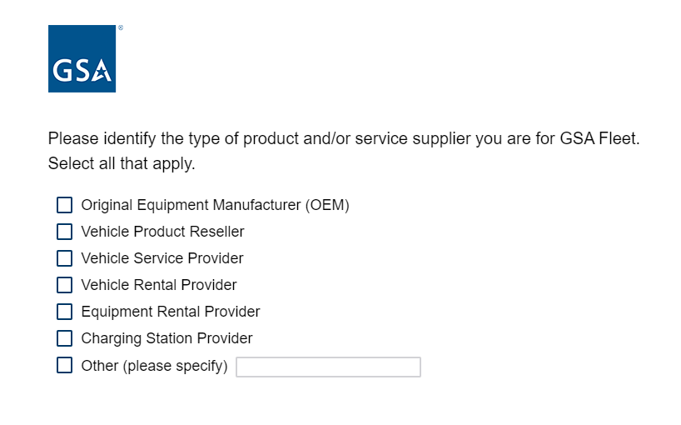This question only appears if program office=GSA Fleet
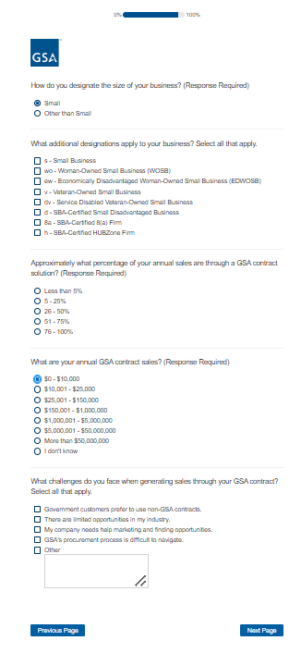
Display if ‘Small’ is selected for previous question
Display if $0-$10,000 or $10,001-$25,000 is selected for previous question

Screen 35
Display to all respondents

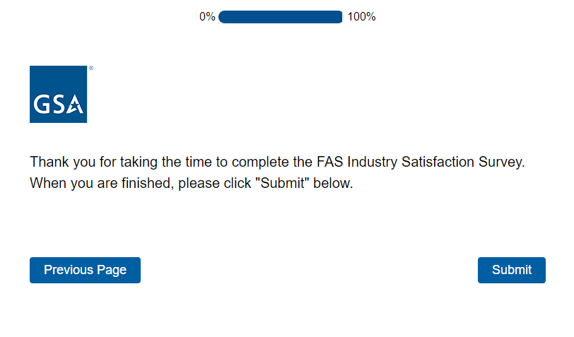

Screen 36
Display to all respondents
