**Challenge.Gov Event Survey Screenshots**

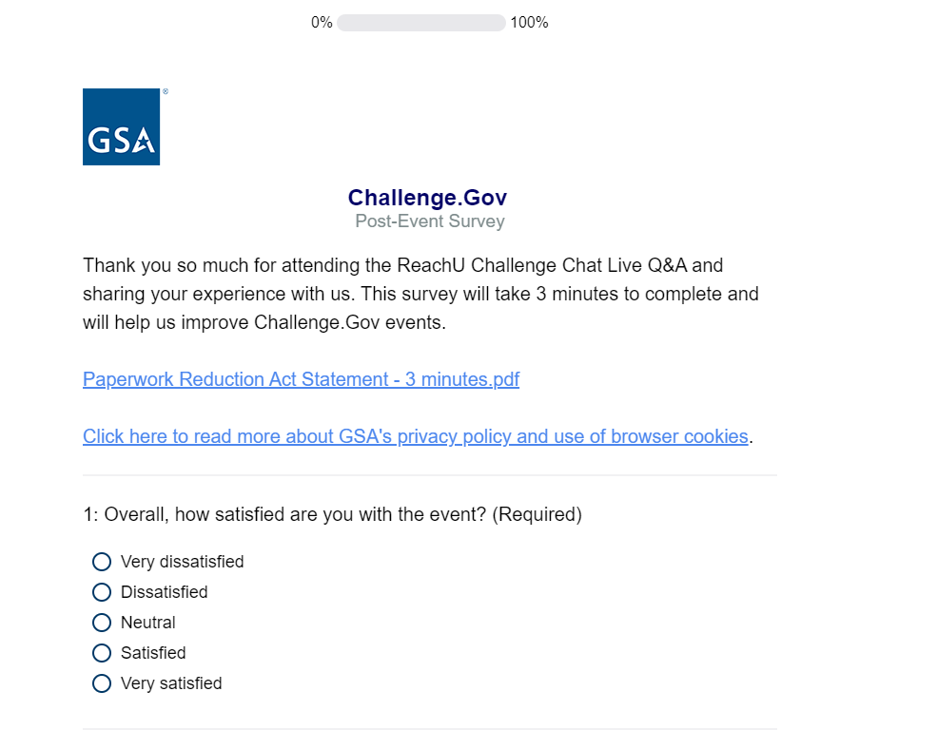

Updated intro text to identify the event.

[Note: Question 1B displays when Very dissatisfied, Dissatisfied, or Neutral are selected]

