**Request for Approval under the “Generic Clearance for the Collection of Routine Customer Feedback” (OMB Control Number: 3090-0297)**

**(Req-)**

**Title: Voluntary Customer Satisfaction Survey for Customers of the USAGov Telephone Government Information Service Who Speak to an Information Specialist**

Upon completion of conversation with an Information Specialist (aka Agent), customers may receive an SMS (text) message to their mobile phone. The message contains a weblink to a webform. Participants submit responses using the webform. The survey is optional.

POC: david.kaufmann@gsa.gov

ENGLISH VERSION

Paperwork Reduction Act Statement:

OMB No: 3090-0297

Expires 06/30/2025

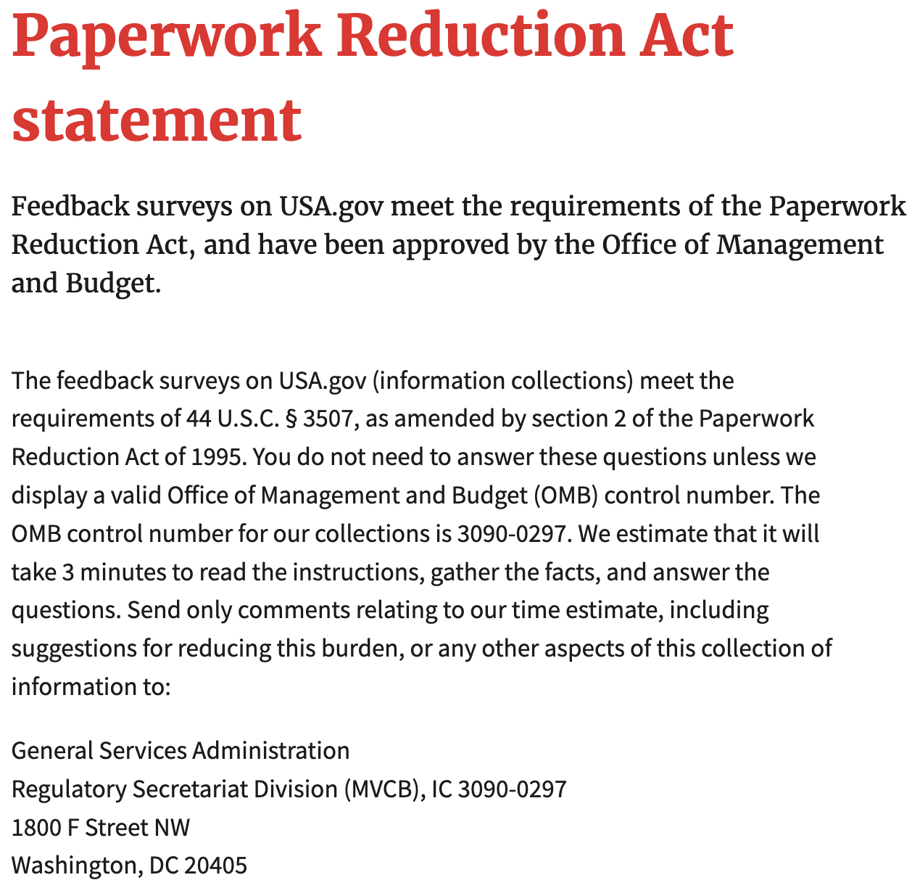

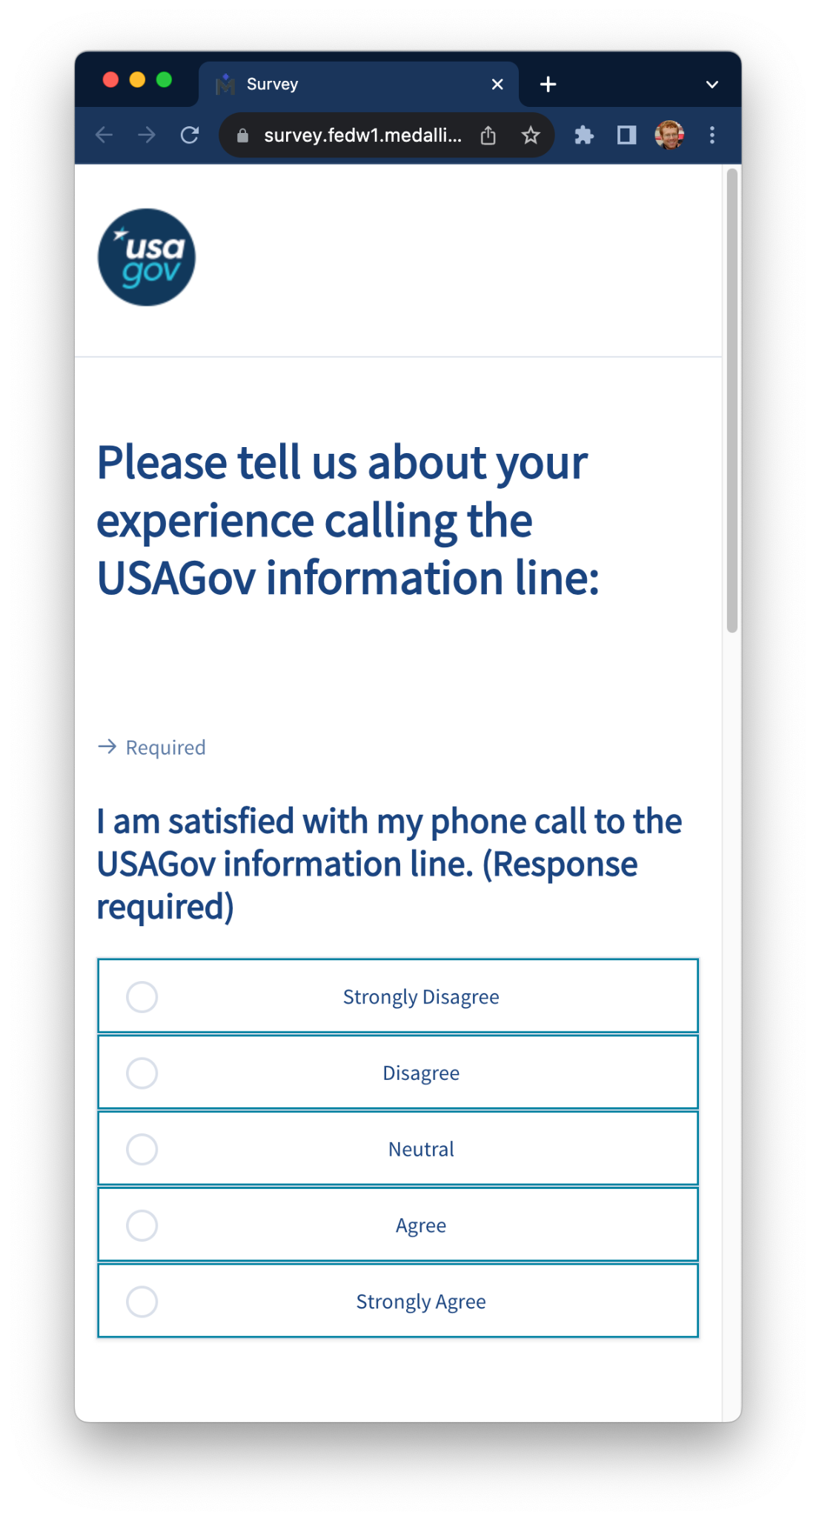

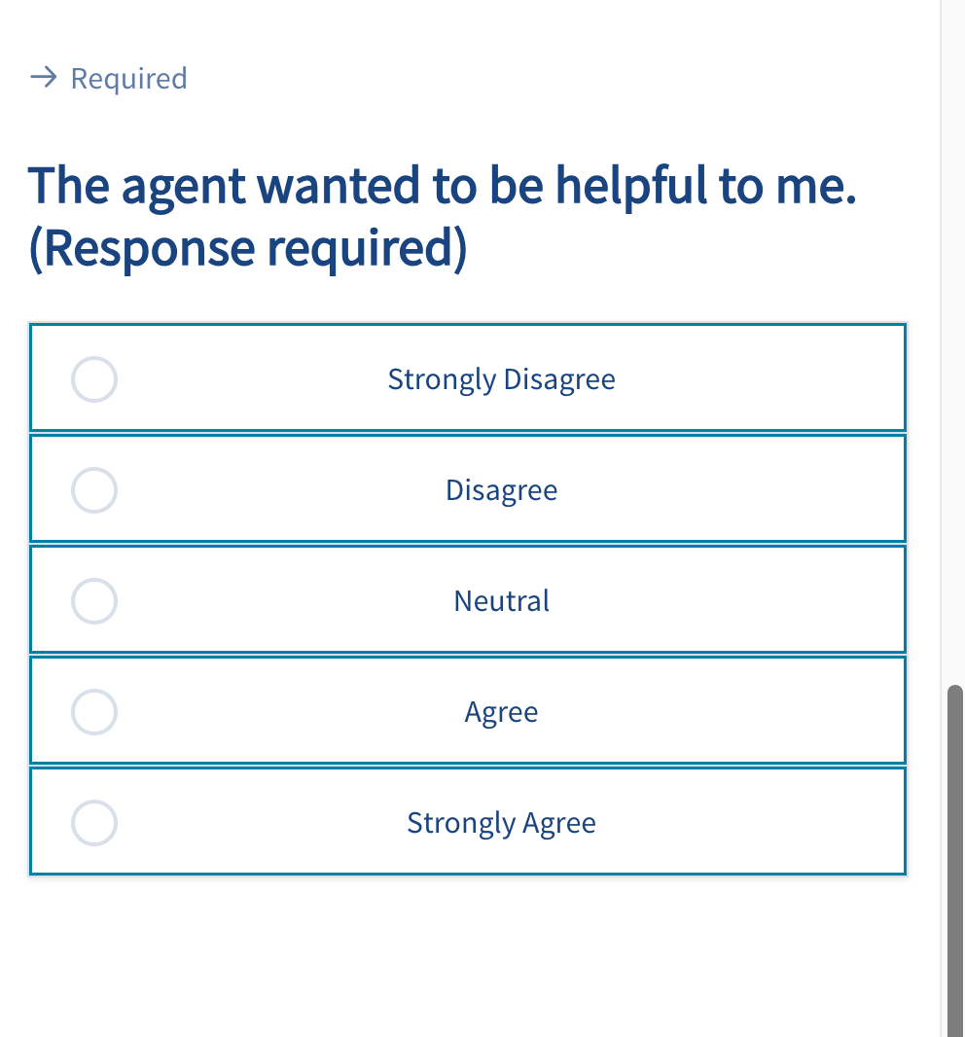

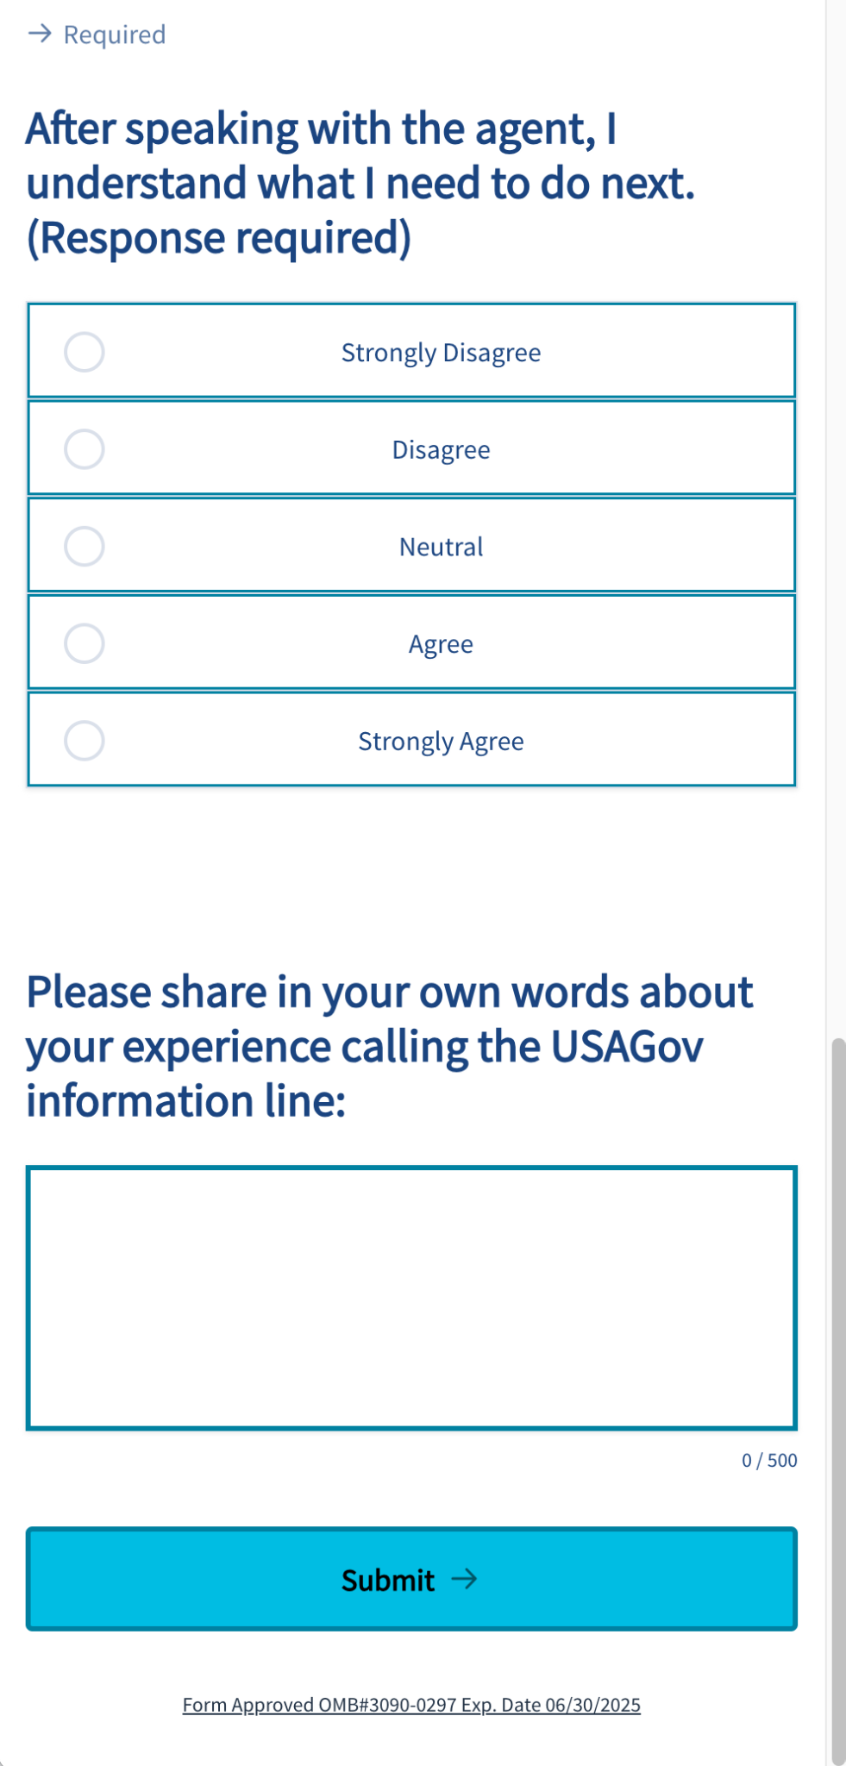

SPANISH VERSION

Paperwork Reduction Act Statement:

OMB No: 3090-0297

Expires 06/30/2025

