**United States Department of Agriculture**

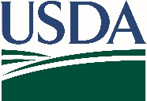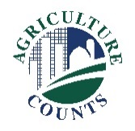

National Agricultural Statistics Service

March 13, 2023

You have been selected to participate in an interview for the June Area survey. Information from this survey are used to develop comprehensive estimates of land uses and agricultural activities across the United States. Data from this survey are a critical foundation for many USDA reports.

Please retain the enclosed aerial photo and county map for your upcoming interview. A NASS representative will contact you by phone or in person to confirm whether the land where you live or operate lies within the red segment boundaries on the map. The representative will also ask questions about agricultural land use on your operation such as total acres operated, grain storage, and livestock inventory. The interview is estimated to take 20 minutes.

The information you provide will be used for statistical purposes only. In accordance with federal law, your responses will be kept confidential, and the data will be available in aggregate form only to ensure that no individual producer or operation can be identified.

Thank you for your participation and support of U.S. agriculture. For more information about NASS surveys, please visit nass.usda.gov/Surveys. If you have any questions, please call us at 888-424-7828.

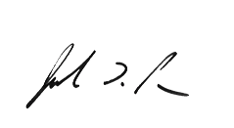

Sincerely,

Joseph L. Parsons

Chair, Agricultural Statistics Board

U.S. Department of Agriculture  
National Agricultural Statistics Service