Non-substantive Change Request
0535-0270 – Hemp Acreage & Production Survey
Hemp Acreage & Production Survey
Questionnaire wording, content, and formatting was determined by the Standards and Survey Development Methodology Branch and approved by the NASS Hemp PDI Survey Team following a review of the data collected in the Hemp Acreage & Production Survey (2022 crop year).
The change to the questionnaire is described below.
There are no planned changes to what will be published for the 2023 crop year survey.
The release for the 2022 crop year is located at https://usda.library.cornell.edu/concern/publications/gf06h2430

Deletion: Section 3 – Operator Characteristics

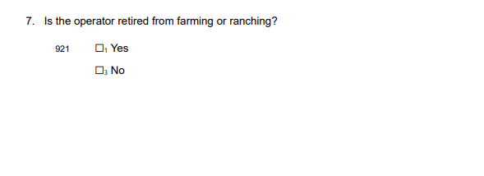
The updated Master Questionnaire has been loaded to ROCIS.
These changes will not impact the current sample size or respondent burden.

