**Appendix V. Site-specific Intervention Design Diagrams**

**This page has been left blank for double-sided copying.**

Appendix V. Figure B1.1.a. Colorado intervention design

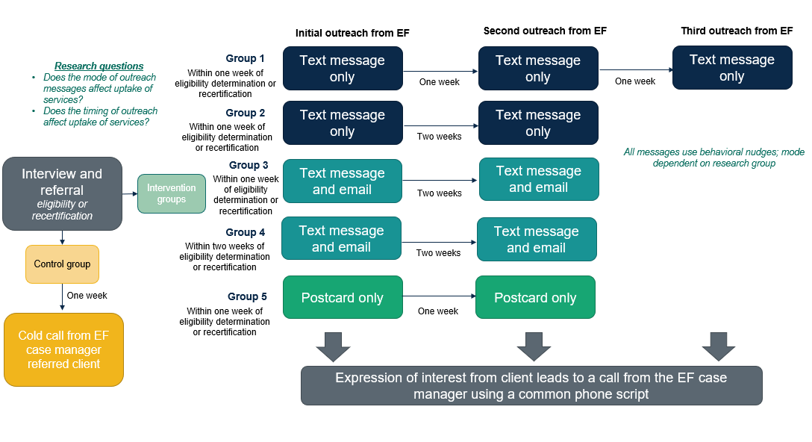

Note: EF = SNAP Employment First program

Appendix V. Figure B1.1.b. Connecticut community colleges intervention design

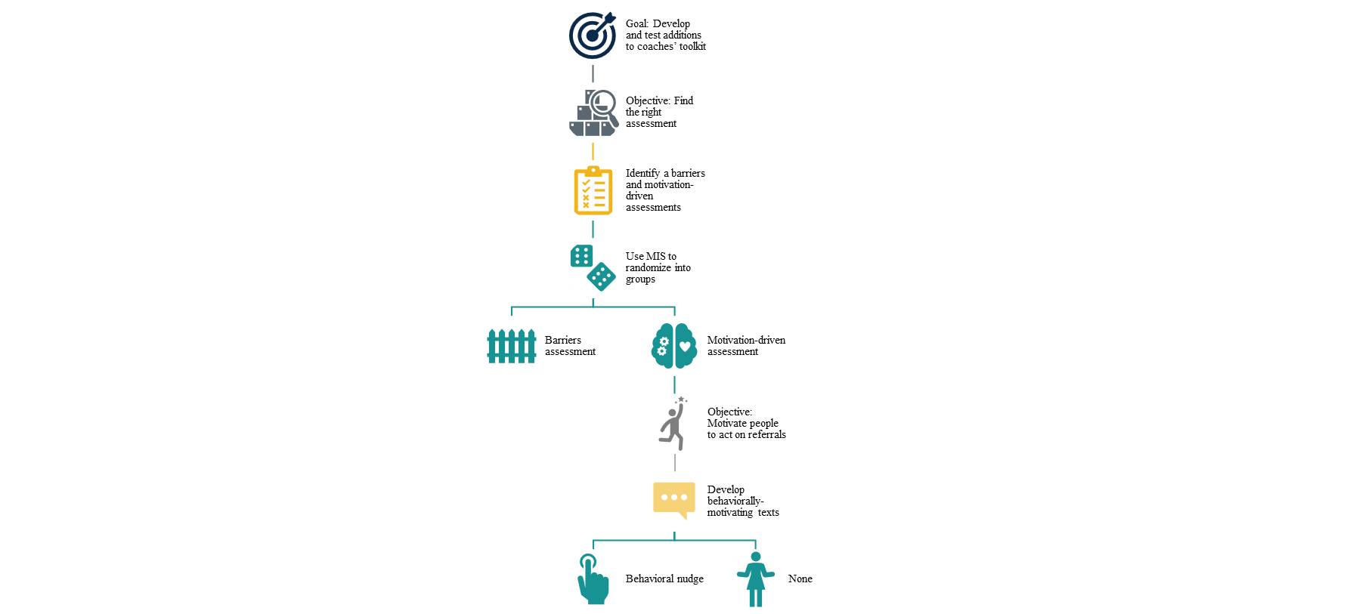

Appendix V. Figure B1.1.c. District of Columbia intervention design

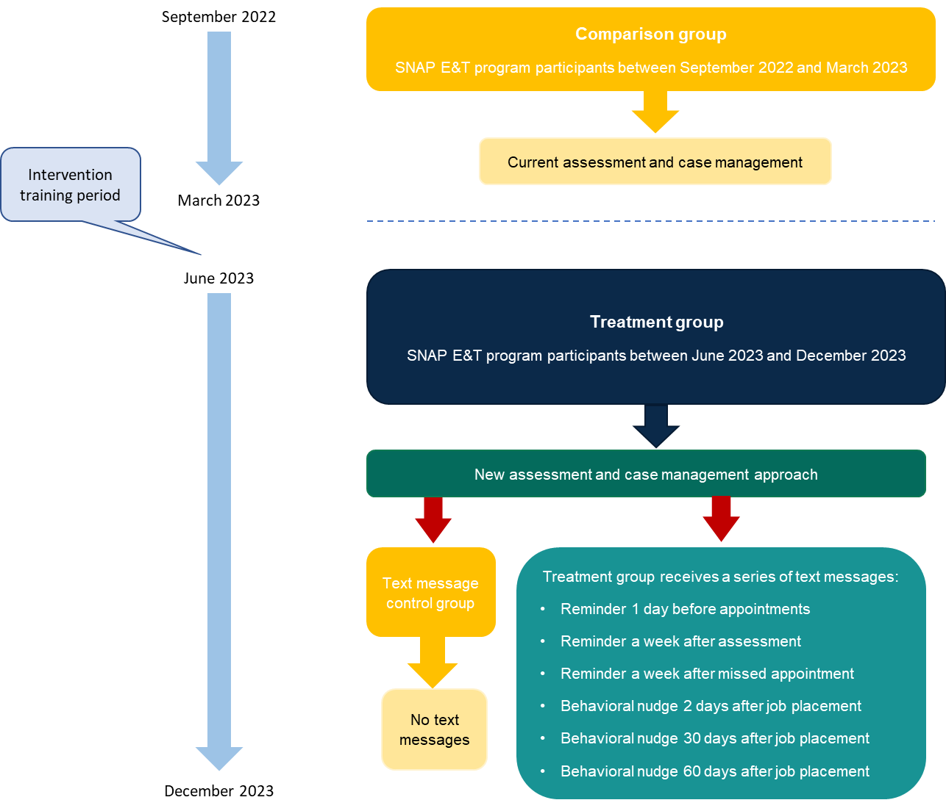

Note: Red arrows indicate points of random assignment

Appendix V. Figure B1.1.d. Kansas intervention design

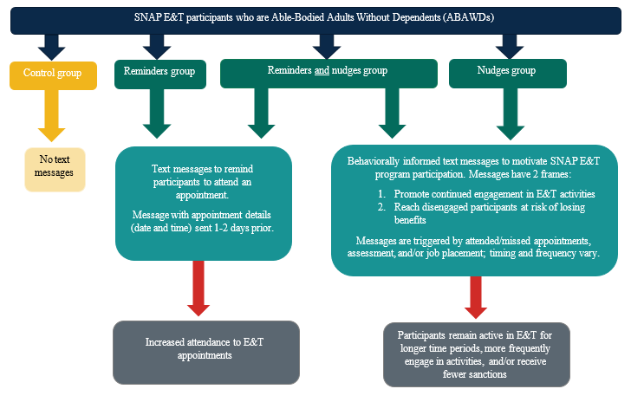

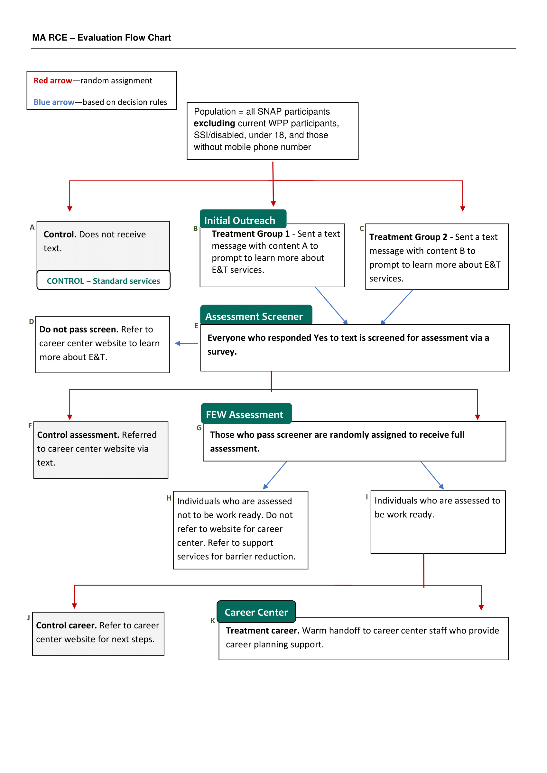Appendix V. Figure B1.1.e. Massachusetts intervention design

Note: RCE = rapid cycle evaluation; WPP = Work Participant Program

**Appendix Q. Figure B1.1.f. Minnesota Hennepin intervention design**

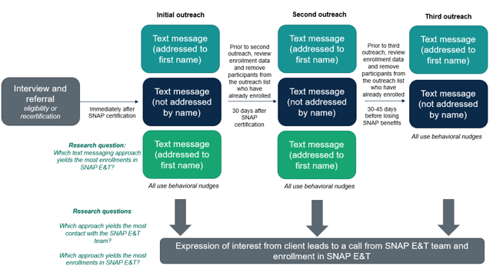

Appendix Q. Figure B1.1.g. Minnesota-Rural intervention design

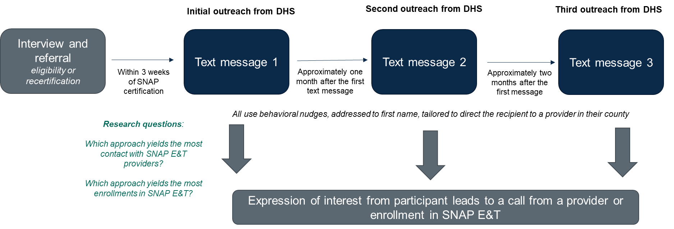

Note: DHS = Minnesota Department of Human Services

Appendix Q. Figure B1.1.h. Rhode Island intervention design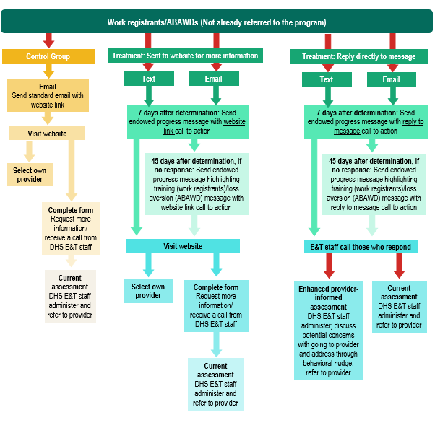

*Notes*: ABAWD = able-bodied adults without dependents; Red arrows represent random assignment. If sample sizes are large enough, the intervention flow chart will apply separately for work registrants and for ABAWDs.