November 2023

TO: Laurel Havas, OMB Desk Officer
Office of Information and Regulatory Affairs
Office of Management and Budget (OMB)

THROUGH: Jamia Franklin, FNS Information Collection Officer
Planning and Regulatory Affairs
Food and Nutrition Service (FNS)

Ruth Brown, OCIO Desk Officer
Information Management Division
Office of the Chief Information Officer (OCIO)

FROM: Caroline Dunn, Senior Analyst
Supplemental Nutrition and Safety Research and Analysis Division
Office of Policy Support
Food and Nutrition Service (FNS)

SUBJECT: Justification for Non-Substantive Change to OMB Control No: 0584-0611 WIC CX Landscape Analysis to adjust questions and slight increase in burden

FNS is requesting a non-substantive change to the previously approved collection, WIC CX (Customer Experience) Landscape Analysis (OMB Control No. 0584-0611, exp. 11/30/2025).

The WIC CX Landscape Analysis will provide FNS with information about how WIC State agencies collect, assess, and use information about the WIC participant experience through a survey of WIC State agencies. The assessment seeks to identify from whom, when, how, and what information is being collected by WIC State agencies; how this information is assessed and used; and what additional assistance WIC State agencies may need to support CX information collection in the future.

The changes are needed to provide additional clarity in the questions, so that we can fully assess how State agencies are collecting information related to that included in Sec. 280 of OMB 2022 A-11 on customer experience efforts. The edits below do not substantially change the information collected, rather focused on reorganizing questions to improve the flow of the survey and updating response options for clarity and to reduce cognitive load. FNS has reviewed the information collection and is making efforts to simplify response options. Below are specific details related to the organization of the survey and the wording of questions:

- USDA updated contact information in the updated introduction (track changes screenshot below):

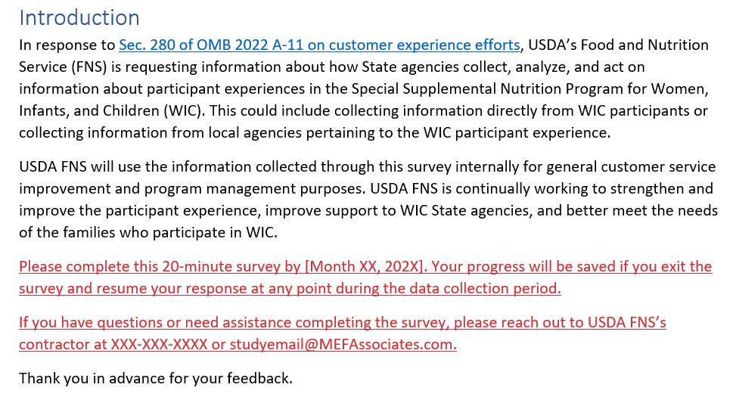

- USDA simplified question 3 response options from open ended to a yes/no selection:

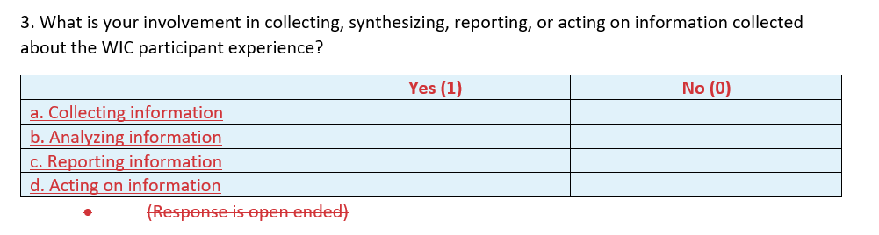

- USDA has updated the question order and made minor, non-substantive, updates to phrasing to improve clarity of questions and response options (see table below):
Former Question Number/Screenshot | New Question Number/Screenshot
Former Question 11  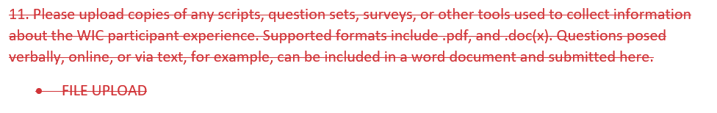 | New Question 4  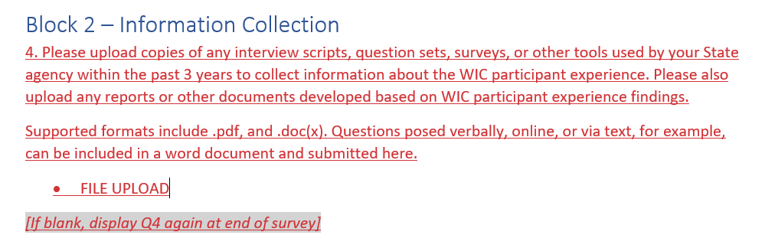
Former Question 6  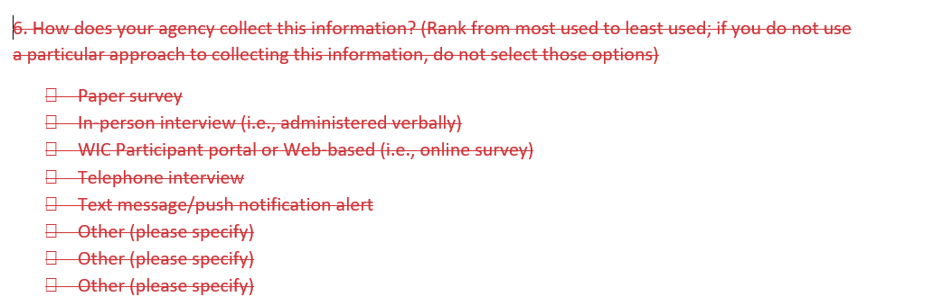 | New Question 8  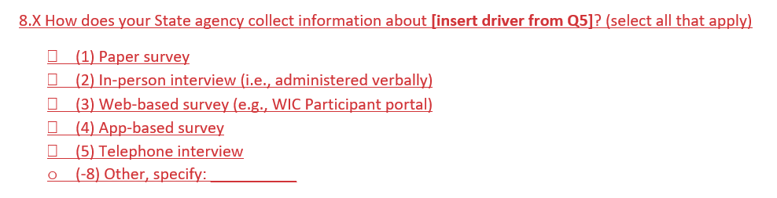
Former Question 5  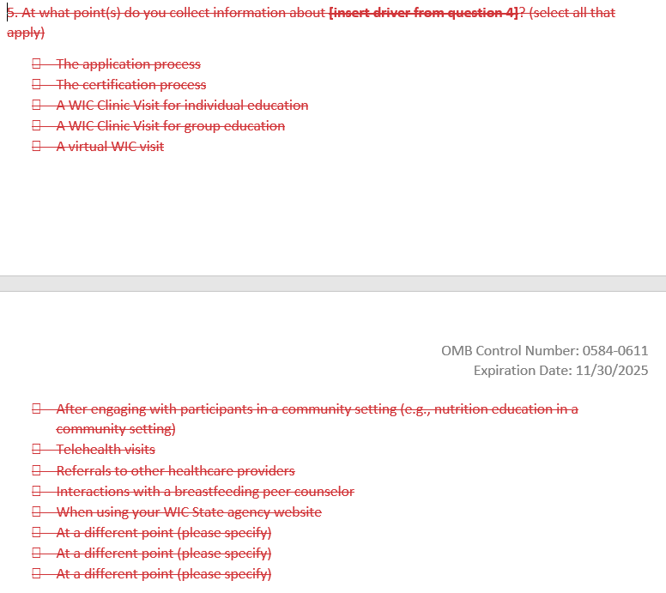 | Updated Question 12  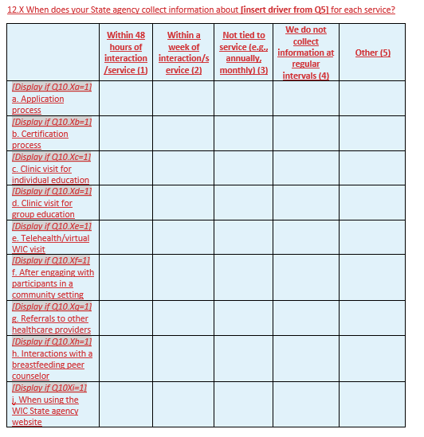
Former Question 9  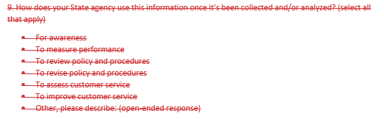 | New Question 16  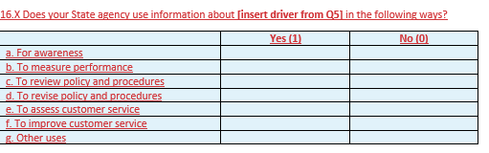
Former Question 8  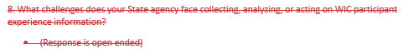 | New Question 19  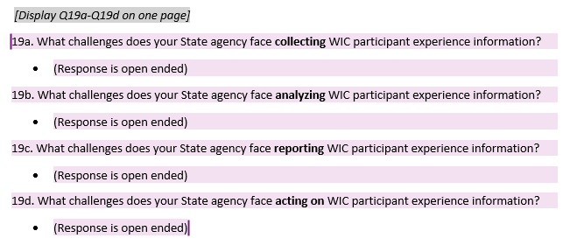

- USDA has updated former question 4 (updated question 5) and simplified/added clarity to response options by reformatting to yes/no/unsure rather than a check all that apply
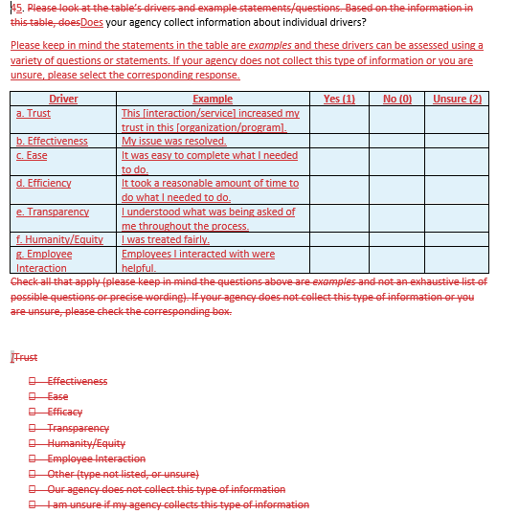

- USDA has added question 6 to better understand how WIC State agencies engage (recruit) individuals to collect information about CX drivers and question 10 to better understand how WIC State agencies collect information about specific key WIC interactions/services (see below):
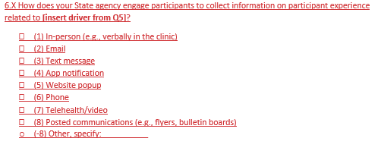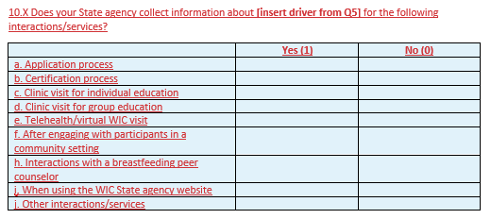

- USDA added a series of simple questions (number 7, 9, 11, 13, 15, 17, and 18 (yes/no response questions)) so that respondents can indicate if they employ a similar approach for multiple drivers from the A11 Section 280 and reduce burden supplying the same response for multiple drivers (format is below, replicated across questions).
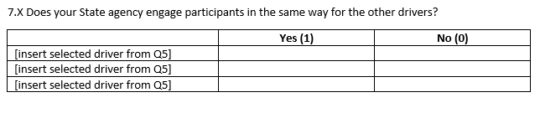
The estimated change in burden is 4.5 hours total (across all 89 WIC State Agency Staff) or 5 minutes per respondent, as shown in the table below. There are an estimated 89 WIC State agency representatives who would have spent 5 minutes (300 seconds) each on the survey. Edits do not impact time needed to read the email to State Agencies.

BURDEN HOURS

Category of Respondent | No. of Respondents | Participation Time | Burden
Original Estimates
WIC State agency staff (WIC State agency representative) (Appendix A) | 89 | 0.25 hours (15 minutes) | 22.25 hours
SNAS-RAD email to State agencies (Appendix C) | 89 | 0.08 hours (5 minutes) | 7.12 hours
Totals | 89 | 0.33 hours | 29.37 hours
Updated Estimates
WIC State agency staff (WIC State agency representative) (Appendix A) | 89 | 0.3 hours (20 minutes) | 26.7 hours
SNAS-RAD email to State agencies (Appendix C) | 89 | 0.08 hours (5 minutes) | 7.12 hours
Totals | 89 | 0.38 hours | 33.8 hours
Difference | N/A | .05 hours (5 minutes) per respondent | 4.5-hour burden increase across all participants

The change will increase the total annualized cost of respondent burden by $169.82 ($1290.57-$1120.75). This reflects the minor change in the time required to respond to the survey updates. No additional federal cost is projected, as changes are non-substantive.

The attached document includes the updated WIC CX Landscape Analysis materials where the requested changes would be made.

If you have any questions regarding this request, please contact Jamia Franklin, FNS Information Collection Clearance Officer for the Food and Nutrition Service, Planning & Regulatory Affairs Office at (703) 305-2403.

Attachments:
Attachment A_WIC CX Landscape Survey_2023 11 21

