ATTACHMENT A-1: Survey (English)
USDA CNPP Brand Health 2023 Baseline

SCREEN 1: LANGUAGE PREFERENCE

- You can take this survey in English or Spanish. Which would you prefer?
Ud. puede completar esta encuesta en Ingles o en Español, cual prefiere?
- English/Ingles
- Español/Spanish
- Neither/Ninguno TERMINATE

SCREEN 2: PRIVACY ACT STATEMENT

Legal Authority: USDA is authorized to collect this information under 42 USC 12651d (b)(13), (14), and (c)(11).
Purpose: This information will be used to inform an awareness campaign to increase familiarity with and eventual interest in participation in USDA programs.
Routine Use: Information may be disclosed for any use permitted under law. Information will only be used in aggregate without personally identifiable information, and is thus not subject to the Privacy Act.

Disclosure: All information collected will be collected privately and only reported anonymously, without any association with your information or personal information. Any information which would permit identification of the individual will be safeguarded and will be used only by persons engaged in and for the purpose of the survey, except as otherwise required by law.
Participation in this research is voluntary and there are no penalties for refusing to answer any question. However, your cooperation in obtaining this much needed information is extremely important in order to ensure the completeness of the results.
To continue, click NEXT.

SCREEN 3: CONSENT FORM

You are being invited to participate in a research study on behalf of the United States Department of Agriculture (USDA) Center of Nutrition Policy and Promotion to inform a National Outreach Campaign. If you agree to take part in this study, you will be asked to complete an online survey. This survey will take you approximately 24 minutes to complete.
You may not directly benefit from this research; however, we hope that your participation in the study may help USDA determine how to best communicate with the general public about specific programs.
You agree to ask questions about the study if you don't understand something. If you have questions once the study is over, you can contact Glynis Donaldson at 703-842-0200.
By clicking “I agree” below, you are indicating that you are at least 18 years old, have read and understood this consent form and agree to participate in this research study. Please print a copy of this page for your records.
I Agree
I Do Not Agree

IF CLICKS ‘I DO NOT AGREE’, TERMINATE. MUST CLICK ‘I AGREE’ TO CONTINUE.

SCREEN 4: OMB BURDEN STATEMENT
OMB BURDEN STATEMENT: Public reporting burden for this collection is estimated to average 24 minutes per submission, including reviewing the screener and privacy act statement, reviewing instructions, gathering and maintaining the data needed, completing the form, and reviewing the collection of information. Comments on the burden or content of this instrument may be sent to U.S. Department of Agriculture, Food and Nutrition Service, Office of Policy Support, 1320 Braddock Place, 5th Floor, Alexandria, VA 22306 ATTN: PRA (0584-0524). You are not required to respond to the collection unless the OMB control number and expiration date are current and valid. (See 5 C.F.R. 1320.5(b)(2)(i).). The OMB control number is 0584-0524 with the expiration date of 02/28/2026.
To continue, click NEXT.

SCREENING: initial questions about respondent demographics

The first few questions are to learn a little bit about you.

- Are you: Mark all that apply.
  - Female
  - Male
  - Transgender, non-binary, or another gender
  - Prefer not to say EXCLUSIVE

- In what year were you born? Please type in the 4-digit year.
________ TERMINATE AFTER 2005 (under 18)

- In which state do you live?
[PULL-DOWN MENU; SET QUOTAS BY 4-WAY REGION OVERALL]
IF (Q04=ALABAMA OR NEBRASKA) AND (Q03=AFTER 2004; under 19 years old), TERMINATE.

- In what type of community do you live?
- Urban, which is inside a city
- Suburban, which is just outside of a city
- Small town or rural, which is farther outside of a city, like in the country

SHOW Q06 & Q07 ON SAME SCREEN
- Are you Hispanic, Latino/Latina, or of Spanish descent?
1 Yes
2 No
3 Prefer not to say

- To be sure we have a representative sample, which of the following categories describes your ethnic background/race? Please select all that apply.
- White/Caucasian
- Black/African American
- Asian
- Native Hawaiian or other Pacific Islander
- American Indian or Alaska Native
- Other
- Prefer not to say EXCLUSIVE

ASK Q08-Q11 AMONG HISPANIC AUDIENCE ONLY; Q06=1
ACCULTURATION WILL BE DETERMINED USING Q08+Q09+Q10
Q08-Q10 USES A POINTS SYSTEM; POINTS ARE LISTED NEXT TO RESPONSES BELOW IN BRACKETS
ACCULTURATION LEVELS ARE AS FOLLOWS:
 | Q08-10 POINTS TOTAL
UNACCULTURATED | 11-15
BI-CULTURAL | 6-10
ACCULTURATED | 1-5

- [ASK HISPANIC AUDIENCE ONLY, Q06=1] What language do you usually speak at home?
[ALTERNATE 1 TO 5 AND 5 TO 1, ANCHOR OTHER]
- Only Spanish [5 POINTS]
- Mostly Spanish [4 POINTS]
- Spanish and English equally [3 POINTS]
- Mostly English [2 POINTS]
- Only English [1 POINT]
- Other [0 POINTS]

- [ASK HISPANIC AUDIENCE ONLY, Q06=1] Thinking of your media habits, including television, the internet, social media, radio, and print newspapers and magazines, would you say you use…
[ALTERNATE 1 TO 5 AND 5 TO 1, ANCHOR OTHER]
- Only Spanish-language media [5 POINTS]
- Mostly Spanish-language media [4 POINTS]
- Spanish- and English-language media equally [3 POINTS]
- Mostly English-language media [2 POINTS]
- Only English-language media [1 POINT]
- Other [0 POINTS]
- [ASK HISPANIC AUDIENCE ONLY, Q06=1] Thinking about your overall cultural identification, would you say you feel…?
ALTERNATE SHOWING 1 TO 5, 5 TO 1
- Much closer to the Hispanic/Latino culture [5 POINTS]
- Somewhat closer to the Hispanic/Latino culture [4 POINTS]
- Equally close to both Hispanic/Latino and U.S. cultures [3 POINTS]
- Somewhat closer to the U.S. culture [2 POINTS]
- Much closer to the U.S. culture [1 POINT]

- [ASK HISPANIC AUDIENCE ONLY, Q06=1] Which of the following locations are you, your family, and/or your ancestors from? Please select all that apply.
- Antigua and Barbuda
- Argentina
- Bahamas
- Barbados
- Belize
- Bolivia
- Chile
- Colombia
- Costa Rica
- Cuba
- Dominica
- Dominican Republic
- Ecuador
- El Salvador
- Grenada
- Guatemala
- Guyana
- Haiti
- Honduras
- Jamaica
- Mexico
- Nicaragua
- Panama
- Paraguay
- Peru
- Puerto Rico
- Saint Lucia
- Saint Vincent and the Grenadines
- Spain
- Suriname
- Trinidad and Tobago
- Uruguay
- United States
- Venezuela
- Other, specify ________

RESUME ASKING ALL

- How many people live with you regularly and make up your “household,” including yourself? Your household is everyone who lives in your home (including children) and shares income and household expenses (bills, food, etc.). Your household may include people who are related to you and people who are not.

_____ Please enter the number of people in your household, including yourself
[NUMERIC 1-99; REQUIRED]

- What was your approximate annual household income for 2022, before taxes, from all sources? This includes salaries, Social Security, pension, interest, and investment earnings.
- Under $30,000
- $30,000 to just below $35,000
- $35,000 to just below $40,000
- $40,000 to just below $45,000
- $45,000 to just below $55,000
- $55,000 to just below $65,000
- $65,000 to just below $75,000
- $75,000 to just below $85,000
- More than $85,000

CODE AS “LOW INCOME” IF MEETS ANY OF THE FOLLOWING REQUIREMENTS:
If Q12=1 and Q13=1
If Q12=2 and Q13 =1, 2
If Q12=3 and Q13 =1, 2, 3
If Q12=4 and Q13 =1, 2, 3, 4
If Q12=5 and Q13 =1, 2, 3, 4, 5
If Q12=6 and Q13 =1, 2, 3, 4, 5, 6
If Q12=7 and Q13 =1, 2, 3, 4, 5, 6, 7
If Q12=8 and Q13 =1, 2, 3, 4, 5, 6, 7, 8
IF DOES NOT FALL INTO THIS DEFINITION, CODE AS MIDDLE/HIGHER INCOME.

BRAND FUNNELS: questions to gauge the brand health of MyPlate and its peer set

Note: Q14-Q18 comprise the brand funnels for MyPlate and its peer set.

- What programs or organizations can you think of that communicate about healthy food choices? PROGRAM 5 OPEN END BOXES. REQUIRED. INCLUDE OPTION FOR “Not sure”

- Thinking specifically about government programs, what government programs can you think of that communicate about healthy food choices? If any of your responses to the previous question are government programs, please provide them again here. PROGRAM 5 OPEN END BOXES. REQUIRED. INCLUDE OPTION FOR “Not sure”

- Now, please indicate if you have ever heard of any of the following.
Please select all that you have heard of.
RANDOMIZE. SPLIT SAMPLE: HALF SEE PROGRAM NAME & LOGO, HALF SEE PROGRAM NAME ALONE

- MyPlate
[ENGLISH VERSION; SHOW IF Q01=1:]
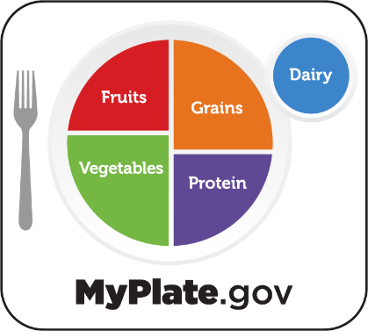

[SPANISH VERSION; SHOW IF Q01=2:]
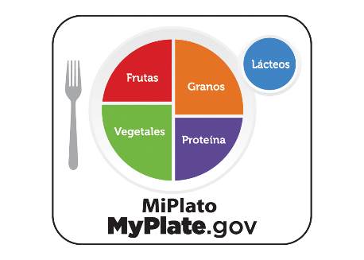

- Text4Baby
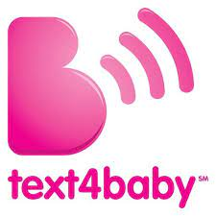

- Fuel Up/Fuel Up to Play60
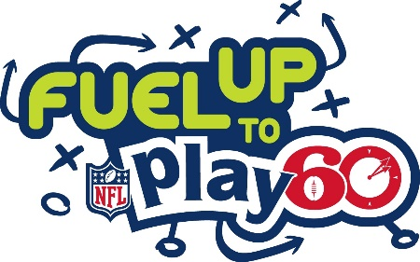

- Move Your Way
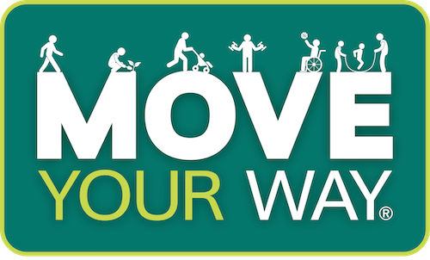

- The Nutrition Facts Label
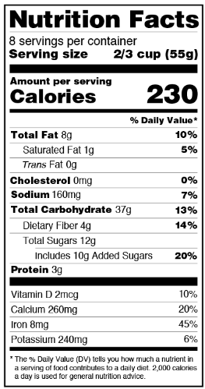

- The Heart Truth/National Red Dress Day
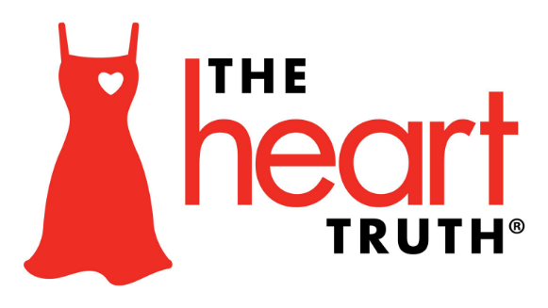

- DASH Eating Plan
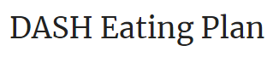

- Let’s Move
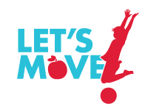

- Team Nutrition
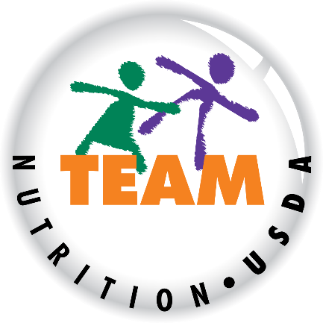

- “SNAP” or the Supplemental Nutritional Assistance Program. It is sometimes referred to and formerly known as “Food Stamps”

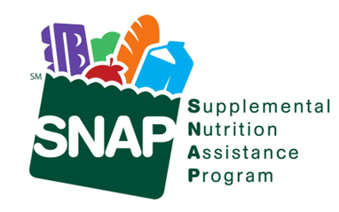

- “WIC” or the Special Supplemental Nutrition Program for Women, Infants, and Children

- None of these EXCLUSIVE; ANCHOR

- How familiar are you with each of the following?
SHOW PROGRAMS AWARE; SELECTED IN Q16
- Very familiar
- Somewhat familiar
- Not too familiar
- Not familiar at all/I only know the name
- Never heard of [PROGRAMMER NOTE: IF BRAND SELECTED IN Q21, FLAG AS CHEATER FOR REVIEW]

- How favorable is your opinion of each of the following?
SHOW PROGRAMS FAMILIAR; SELECTED 1-3 IN Q17
- Very favorable
- Somewhat favorable
- Neutral/no opinion
- Somewhat unfavorable
- Very unfavorable
- Not sure

- Do you currently participate in or get services from any of the following? Select all that apply.
SHOW ORGANIZATIONS FAMILIAR EXCEPT MYPLATE; SELECTED 1-3 IN Q17.
INCLUDE OPTION FOR “None of these”
PROGRAMMING: CODE AUDIENCES
- WIC/SNAP PARTICIPANT: SELECTED WIC OR SNAP IN Q19
- WIC/SNAP ELIGIBLE: (LOW INCOME IN Q12/Q13) AND (DID NOT SELECT WIC OR SNAP IN Q19)
- OTHER: ALL OTHERS

ASK Q20 OF 3 RANDOM PROGRAMS SELECTED 1-3 IN Q17. ALWAYS ASK MYPLATE IF SELECTED 1-3 IN Q17.
- How well do each of the descriptions below describe [INSERT PROGRAM]?
- Describes very well
- Describes somewhat/to some extent
- Neutral/not sure
- Does not describe well
- Does not describe at all

RANDOMIZE
- Accessible
- Convenient
- Easy to use
- Educational
- For someone like me
- Inclusive
- Relevant to my culture
- Trustworthy
- Well-respected
- Helps me stay healthy
- Offers information relevant to my dietary needs
- Helps me find affordable ways to eat healthy
- Useful
- Informative

MYPLATE BRAND: questions to gain insight into sentiments towards the MyPlate brand

SPLIT SAMPLE; ASK IF DID NOT GET MYPLATE LOGO IN Q16
- Before today, had you seen this picture?

[ENGLISH VERSION; SHOW IF Q01=1:]

[SPANISH VERSION; SHOW IF Q01=2:]

  - Yes
  - No
  - Not sure

RESUME ASKING ALL

- What words or phrases would you use to describe this image? Please type in your answers. SHOW MYPLATE LOGO (ENGLISH VERSION IF Q01=1; SPANISH VERSION IF Q01=2). PROGRAM 10 OPEN END BOXES. REQUIRED. INCLUDE OPTION FOR “Not sure”

- [ASK IF SEEN LOGO; Q21=1] And where had you seen this logo before? Select all that apply.
RANDOMIZE
  - At school or as part of a class/seminar
  - Through a government program (e.g., WIC, SNAP, etc.)
  - Through my doctor or another healthcare professional
  - A nutrition app or tool
  - On social media
  - An online advertisement
  - Through a workplace wellness program
  - At my grocery store
  - On food labels
  - On materials my child received from school/at my child’s school
  - Other, specify _______ ANCHOR
  - Not sure EXCLUSIVE; ANCHOR

ASK Q24-Q27 IF FAMILIAR WITH MYPLATE; SELECTED 1-3 IN Q17

- You mentioned you have heard of MyPlate. How likely are you to do each of the following in the next 3 months?
- Very likely
- Somewhat likely
- Neutral/not sure
- Not very likely
- Not likely at all

RANDOMIZE
  - Visit the MyPlate website, MyPlate.gov
  - Follow MyPlate on social media
  - Use MyPlate to find recipes
  - Use MyPlate to seek information about healthy eating
  - Use MyPlate to find affordable ways to eat healthy

- What makes you say you are [Q24a=1,2: likely to visit / Q24a=3: neutral or not sure about visiting / Q24a=4,5: not likely to visit] the MyPlate website in the next 3 months? OPEN END; REQUIRED; CHECK FOR CHEATERS

- Here are some statements about MyPlate. For each, please indicate how convincing it is as a reason to visit the MyPlate website, MyPlate.gov.
- Very convincing
- Somewhat convincing
- Neutral
- Not too convincing
- Not convincing at all
- Not sure

RANDOMIZE
- MyPlate helps people learn how to eat healthy
- MyPlate provides guidance for portion sizes
- MyPlate provides information about the five food groups
- MyPlate offers tips for buying and preparing healthy food on a budget
- MyPlate provides healthy recipes and ideas
- MyPlate has videos and resources that show you how to make healthy changes
- MyPlate helps you find savings on groceries in your area
- MyPlate helps you find ways to make healthy meals for the whole family
- MyPlate offers healthy eating recommendations based on scientific research
- MyPlate is a program offered by the US Department of Agriculture, or USDA
- MyPlate provides tips and ideas for making small changes to be healthier
- MyPlate promotes long-term healthy eating habits
- MyPlate promotes ways to live a longer, more active life
- MyPlate provides information that is relevant to my lifestyle
- MyPlate provides information that is relevant to my culture

- In your opinion, what could MyPlate.gov do to become a more valuable resource for individuals looking to improve what they eat? OPEN END; REQUIRED; INCLUDE OPTION FOR “Not sure”

RESUME ASKING ALL

- In general, how motivated are you to eat healthy foods?
  - Very motivated
  - Somewhat motivated
  - Neither motivated nor unmotivated
  - Not motivated

- In the past year, have you…
  - Yes
  - No
  - Not sure

RANDOMIZE
  - Consulted with a primary care physician/nurse practitioner about your diet
  - Begun a new diet to lose weight
  - Continued a diet to lose or maintain weight
  - Started a new fitness regimen
  - Kept a regular fitness regimen
  - Searched for information about healthy eating
  - Worked toward specific goals to improve your health

- How much do you agree or disagree with each of the following statements?
  - Agree strongly
  - Agree somewhat
  - Neutral
  - Disagree somewhat
  - Disagree strongly
  - Not sure

RANDOMIZE
- It is more expensive to buy healthy foods
- I often eat fast food because it is cheap and easy to get
- I often struggle with craving unhealthy foods
- I no longer buy certain foods because the price has gone up
- My loved ones often prefer to eat unhealthy meals
- It is generally difficult for me to prepare healthy foods
- Food labels are difficult to understand
- I am not always sure what is considered the right amount of food to eat
- I am not always sure how much of each food group to eat at each meal
- It is difficult for me to find healthy foods near me
- I don’t have time to prepare or eat healthy meals

DEMOGRAPHICS: questions about respondent demographics

Now just a few final questions for statistical purposes...

- What is the highest level of education you completed?
- Less than high school
- High school
- Associate’s degree
- Bachelor's degree
- Advanced degree (Masters, PhD, MD, JD, etc.)
- Not sure/Prefer not to say

- What is your marital status? Are you…
  - Married
  - Unmarried but living with partner
  - Single
  - Separated
  - Divorced
  - Widowed
  - Other
  - Prefer not to say

- What is your current employment status?
  - Employed full-time
  - Employed part-time
  - Self-employed
  - Student
  - Homemaker
  - Retired
  - Unemployed, looking for work
  - Other
  - Not sure

- Are you the parent/guardian of any children under age 18?
- Yes
- No
- Prefer not to say

You’ve completed all the questions and your answers have been submitted. You may now close the survey window. Thank you for your participation.

