[BARCODE] [READABLE ID] [MAILNUM] [SEQ]
Resident [DATE]
[ADDRESS]
[CITY], [STATE] [ZIP]

Dear Resident,
Invitation to participate in the U.S. Food and Drug Administration (FDA) sponsored
National Survey on Numerical Claims in Prescription Drug Advertising

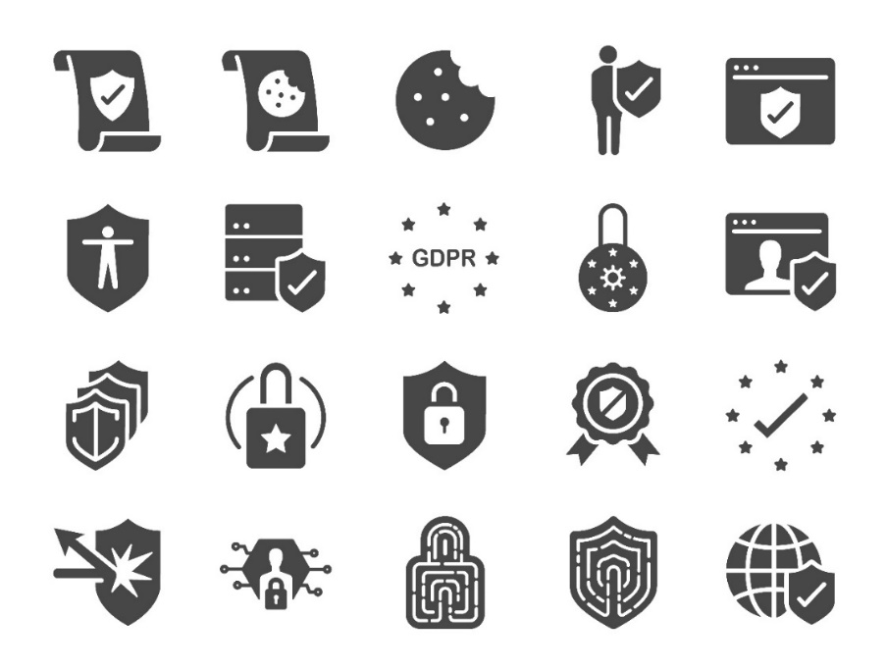 | What is this survey? | This is the last opportunity to participate in the FDA-sponsored survey to assess how adults interpret different claims used in prescription drug advertising. Findings from this study will help to improve claims made about benefits and risks in prescription drug advertising. Understanding these claims can help consumers make better informed decisions about their health.
 | What do I need to do? | Please complete the enclosed survey and return using the postage paid envelope or respond online using the information in the box below.  If you have already completed the survey, thank you. If not, we encourage the adult household member with the next birthday and who is at least 18 years of age to do so as soon as possible. You may need to pass this survey on to them.  We estimate it will take about 20 minutes to complete the survey.  [Included in the post-paid condition: After you have completed and submitted the survey, you will receive an additional $10 as a token of our appreciation.]
 | Who do I contact if I have a question? | If you have any questions about the survey, please call Naomi Yount at Westat, [Insert toll free number] or send an email to [insert project email address] for assistance.

Thank you in advance for participating in this important research study.

Sincerely,

Naomi Yount, Ph.D.
Westat

To Take the Survey Online:
Go to [URL]  Enter your unique access code [PIN] | 

Paperwork Reduction Act Statement: According to the Paperwork Reduction Act of 1995, an agency may not conduct or sponsor and a person is not required to respond to a collection of information unless it displays a valid OMB control number. The valid OMB control number for this information collection is xxxx-xxxx, and the expiration date is xx/xx/xxxx. The time required to complete this information collection is estimated to average 20 minutes per response, including the time for reviewing instructions and completing and reviewing the collection of information. Send comments regarding this burden estimate or any other aspects of this collection of information, including suggestions for reducing burden, to PRAStaff@fda.hhs.gov. This survey is being conducted on behalf of the U.S. Food and Drug Administration.

