Attachment 35. Screenshots of Screener – English

Introduction page (1 of 2):



Introduction page (2 of 2):

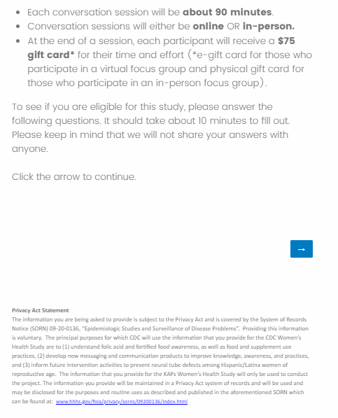

Screenshot of Q1:

Screenshot of Q2:

Screenshot of Q3:

Screenshot of Q4:

Screenshot of Q5:

Screenshot of Q6:

Screenshot of Q7:

Screenshot of Q8 (1 of 2):

Screenshot of Q8 (2 of 2):

Screenshot of Q9:

Screenshot of Q10:

Screenshot of Q11:

Screenshot of Q12:

Screenshot of Q13:

Screenshot of Q14:

Screenshot of Q15:

Screenshot of Q16:

Screenshot of Q17:

Screenshot of Scheduling Questions (1 of 2):

Screenshot of Scheduling Questions (2 of 2):

Screenshot of Contact Information Page (Closing):

