Attachment 36. Screenshots of Screener – Spanish

Página de introducción (1 de 2):

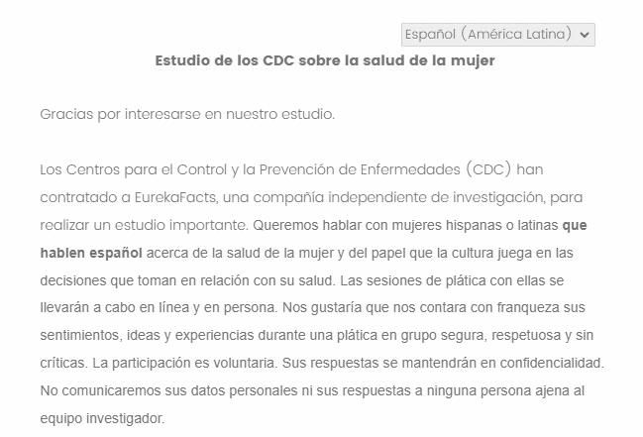

Página de introducción (2 de 2):

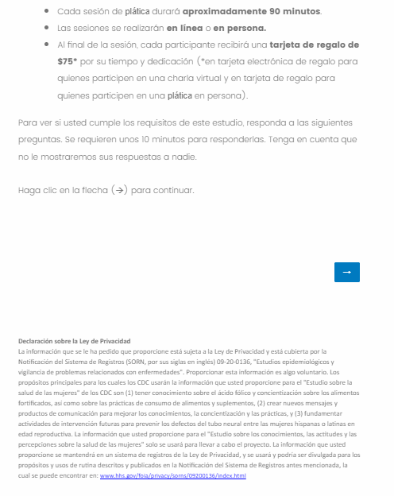

Pantallazo de P1:

Pantallazo de P2:

Pantallazo de P3:

Pantallazo de P4:

Pantallazo de P5:

Pantallazo de P6:

Pantallazo de P7:

Pantallazo de P8 (1 de 2):

Pantallazo de P8 (2 de 2):

Pantallazo de P9:

Pantallazo de P10:

Pantallazo de P11:

Pantallazo de P12:

Pantallazo de P13:

Pantallazo de P14:

Pantallazo de P15:

Pantallazo de P16:

Pantallazo de P17:

Pantallazo de las preguntas de programación (1 de 2):

Pantallazo de las preguntas de programación (2 de 2):

Pantallazo de la página de información de contacto (para finalizar):

