National Intimate Partner and Sexual Violence Survey (NISVS) Redesign
Task 6.1: Pilot Sample Design Methodology and Data Collection Procedures
Contract Number GS00F009DA

April 21, 2021

Table of Contents
Section Page
1 Introduction 1
2 Proposed Design 2
2.1 Address Based Sample 2
2.2 Response Rate Assumptions and Number of Completes 2
2.3 Survey Procedures 2

1. Introduction
The National Intimate Partner and Sexual Violence Survey (NISVS) produces national and state-level data on the prevalence of sexual violence, intimate partner violence (IPV), and stalking. The purpose of this document is to describe the design of the pilot study.
The goal is to complete 200 surveys for the pilot study. The survey will collect data using similar procedures as the NISVS Feasibility Study that used the address-based sample (ABS). Using an address-based sample (ABS), we will mail a request to the household for one individual to complete the survey on the web. Screener non-respondents will be given the option to complete a household roster on paper. Those who do not respond to the extended survey on the web will be followed-up with and given the option to complete the survey over the phone (in-bound CATI) or by web.
The next sections describe the sample design and survey procedures in detail. This document contains the following sections:
- Address Based Sample
- Response Rate Assumptions and Number of Completes
- Survey Procedures

2. Proposed Design
2.1 Address Based Sample
The sampling frame will be drawn from a database of addresses used by MSG to provide random samples of addresses. The MSG database is derived from the Computerized Delivery Sequence File, which is a list of addresses from the United States Postal Service. It is estimated to cover approximately 98 percent of all households in the country. All non-vacant residential addresses in the United States present on the MSG database, including post office (P.O.) boxes, throwbacks (i.e., street addresses for which mail is redirected by the United States Postal Service to a specified P.O. box), and seasonal addresses will be subject to sampling. The sample will be drawn using implicit stratification, with the sample sorted by geography using zip code +4 within the 50 states and Washington DC.
2.2 Response Rate Assumptions and Number of Completes
A total of 815 addresses will be sampled. Based on prior surveys, we anticipate approximately 10 percent of these will be returned by the post office as non-deliverable. Some portion of the remaining sample will be ineligible households (e.g., vacant). We have assumed an initial screening response rate of approximately 48 percent, with approximately 60 percent of those resulting in a completed survey. This will yield approximately 200 completed surveys, for a combined pilot study response rate of approximately 29 percent (0.48 x 0.60=0.29).
2.3 Survey Procedures
The procedures for the selected sample are shown in Figure 1. The first step is to send a letter asking an adult to complete the screening survey on the web (Figure 1 - Box A). Letters will include a unique access code and PIN for each household and the URL to launch the survey. The letter will also include a helpdesk toll free number for any questions about the study. The web screener will ask the individual to answer selected questions about the household. It will then select an individual in the household to be the respondent for the pilot study. If the person selected for the extended interview is the screener respondent, then the individual will be instructed to proceed directly to the extended interview. If the selected extended respondent is not the screener respondent, the screener respondent will be instructed to ask the selected adult to log in to the website and complete the survey.
A reminder postcard (Figure 1 – Box B) will be sent one week after the initial mailing. This will be sent to the entire sample. The text will thank those who have already responded. It will remind those that haven’t responded to do so.
The web version of the NISVS will have one question per page or, in the case of a sequence of similar questions, a grid-type format. The survey will automatically be formatted to the type of device the respondent is using (e.g., mobile phone, tablet, laptop). When logging in to the extended survey, the respondent will be required to change their password. Each screen of the survey will include a link to frequently asked questions, support resources (e.g., hotlines) and contact information for the project.
If the screener is not completed three weeks after the initial mailing, a letter will be sent by express delivery asking the respondent to either fill out the screener on the web or complete a paper version of the screener (Figure 1 – Box C).
Among those households that complete the screener, but the selected respondent has not completed the extended interview, additional follow-up contacts will be attempted. This will be for households that have a completed web screener, but there is no response for the extended survey. It will also be for those who return the paper screener and the home office staff selects a respondent from the household roster (Figure 1 – Box F). A follow-up letter will be sent inviting the selected individual to complete the survey on the web (Figure 1 – Box D). If there is no response, an express letter will be sent to the selected respondent (Figure 1 – Box E) approximately one week later, asking the person to complete the extended survey by web or by an alternative mode (in-bound CATI). Unlike the Feasibility study, the CATI will consist of the interviewer bringing up the web survey to administer the survey.
To provide the incentives for those who complete the survey on the web, an Amazon gift code will be provided at the end of the survey. If respondents complete the survey by phone, the Amazon gift code will be provided verbally.
Several procedures will be used to maintain the privacy of the survey respondents. As with the Feasibility Study, a graduated consent process will be used. The letter and subsequent information provided to respondents will describe the study as being on health and injuries.
For the purposes of the pilot we have not included NRFU since the field period does not allow time for this stage. Depending on exact procedures, this could add another 1-3 months onto the collection period. The small sample size means that the inclusion in the pilot would not gain much in terms of additional completes. There is no reason to believe the NRFU will perform very differently in the Pilot as it did on the feasibility test.
Figure 1: Mailing Sequence for Pilot Study
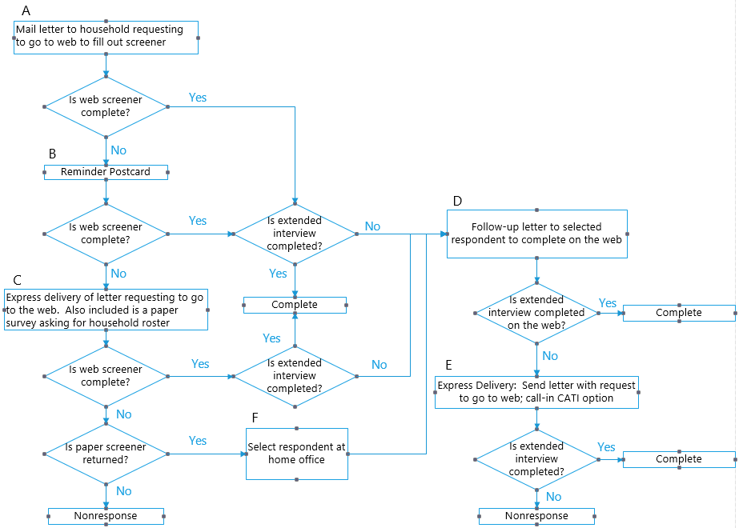

Figure 2: Draft Schedule for Pilot Study

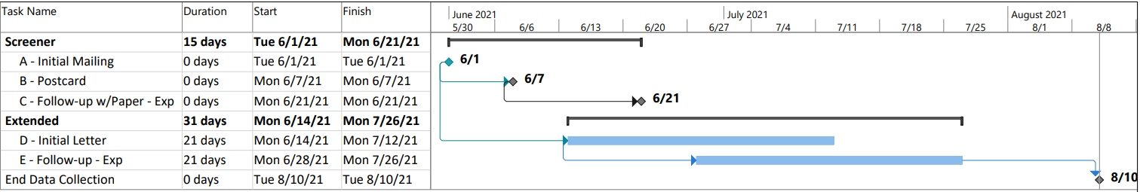

The Feasibility survey had a response rate of 33 percent. As noted below, we are proposing to cut the NRFU portion of the procedure to save time. Without the NRFU, we estimate the response rate will be 29 percent.

