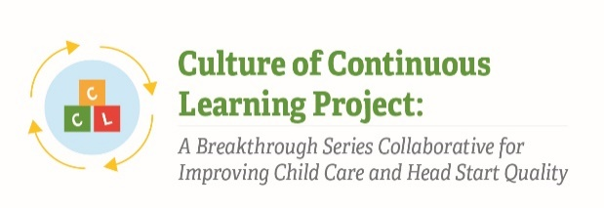

Instrument 2: Pre-Work Assignment: Data Collection Planning Worksheet

Culture of Continuous Learning Project: A Breakthrough Series Collaborative for Improving Child Care and Head Start Quality

Respondents | Time of Data Collection
BSC Teams (Team Data Manager and Senior Team Leader) | Baseline (T1)

Note: Specific metrics in this data collection worksheet are illustrative; different metrics may be included depending on the findings discovered during the implementation process. This data collection worksheet was pulled from CCL Phase I instruments and has been adapted to meet the needs of the current project.

Metrics will be selected based on relevance at time of data collection such that the time to complete the data collection worksheet is no more than 120 minutes.

Purpose
This worksheet is intended to help you think about how you will collect and share the monthly and periodic metrics as part of the Breakthrough Series Collaborative to Support Social and Emotional Learning Practices. We hope that you will find it to be a helpful tool in your planning efforts!
The Paperwork Reduction Act of 1995 (Pub. L. 104-13) Statement: This collection of information is voluntary and will be used to establish a concrete plan for how to collect the metrics data for the BSC. Public reporting burden for this collection of information is estimated to average 120 minutes per response, including the time for reviewing instructions, gathering and maintaining the data needed, and reviewing the collection of information. An agency may not conduct or sponsor, and a person is not required to respond to, a collection of information unless it displays a currently valid OMB control number. The OMB number and expiration date for this collection are OMB #: 0970-XXXX, Exp: XX/XX/XXXX. Send comments regarding this burden estimate or any other aspect of this collection of information, including suggestions for reducing this burden to Kathryn Tout, ktout@childtrends.org or Child Trends, 708 N 1st Suite #333 Minneapolis, MN 55401 Attention: Kathryn Tout

Metric | How will the data be collected? | Who will collect the data? | When will the data be collected? Where will it be collected & stored? | What tools, resources, and supports do we need?
- Child Attendance: Total # of children (including full-time and part-time students) who were absent for any reason (planned, excused, or unexcused) 0, 1, or 2 times during the month

- Teacher Attendance: Total # of teaching staff (including teachers, assistant teachers, paras, etc.), regardless of whether they are full-time or part-time, who were absent 0, 1, or 2 times during the month

- Behaviors that are perceived as challenging: # of times there was a behavioral disruption/behavior perceived as challenging in each classroom each day during a selected week each month (Also note in comments if there are differences by the race of the children who are identified as having behaviors perceived as challenging)
- Children Making Progress as Determined By Social-Emotional Assessment: # of children who have made developmental progress in the social-emotional domain of an approved assessment tool

- Parent Communication: Total # of children about whom parents/caregivers are engaged in two-way conversation with classroom staff member each day
- Caregiver’s confidence at home: # of parents who report that they feel confident and comfortable in promoting their children’s social and emotional competencies and preventing/responding to challenging behaviors at home

7a. Staff Perceptions that the Center is Culturally Responsive: # of staff who report they feel that the center is culturally responsive
7b. Family Perceptions that the Center is Culturally Responsive: # of families who report they feel that the center is culturally responsive
8. Teaching Staff Feeling Comfortable Managing Children’s Behaviors: # of teaching staff who respond that they felt comfortable or confident in promoting pro-social behavior and managing and/or responding to children’s behavior in the classroom in the week prior to the data collection
[Additional metric as defined in the updated collaborative change framework]
[Additional metric as defined in the updated collaborative change framework]

[Additional metric as defined in the updated collaborative change framework]

