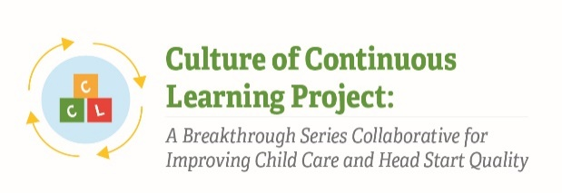

Instrument 3: Plan, Do, Study, Act (PDSA) Form & Tracker

Culture of Continuous Learning Project: A Breakthrough Series Collaborative for Improving Child Care and Head Start Quality
Respondents | Time of Data Collection
BSC Teams (Administrator, Teachers, Other Staff, Parent) | Weekly during Action Period phases

Note: The PDSA Form and Tracker was pulled from CCL Phase I instruments and has been adapted to meet the needs of the current project; we anticipate it will take BSC Teams no longer than 15 minutes to complete.

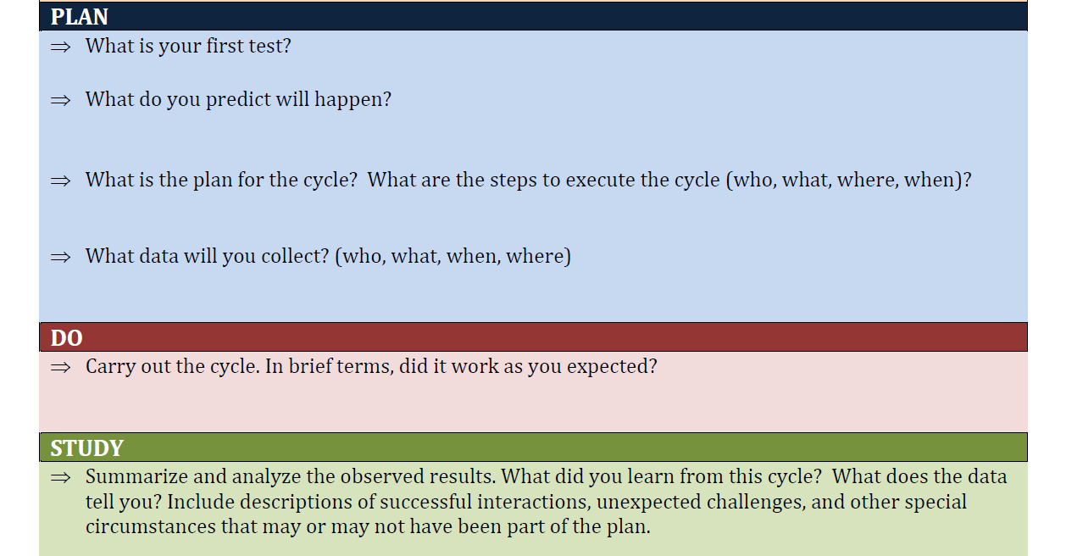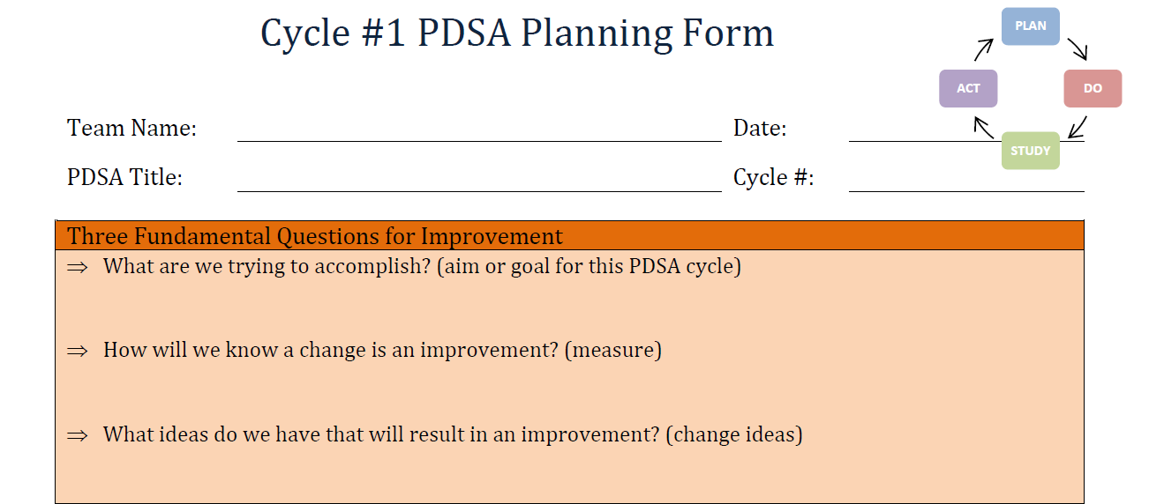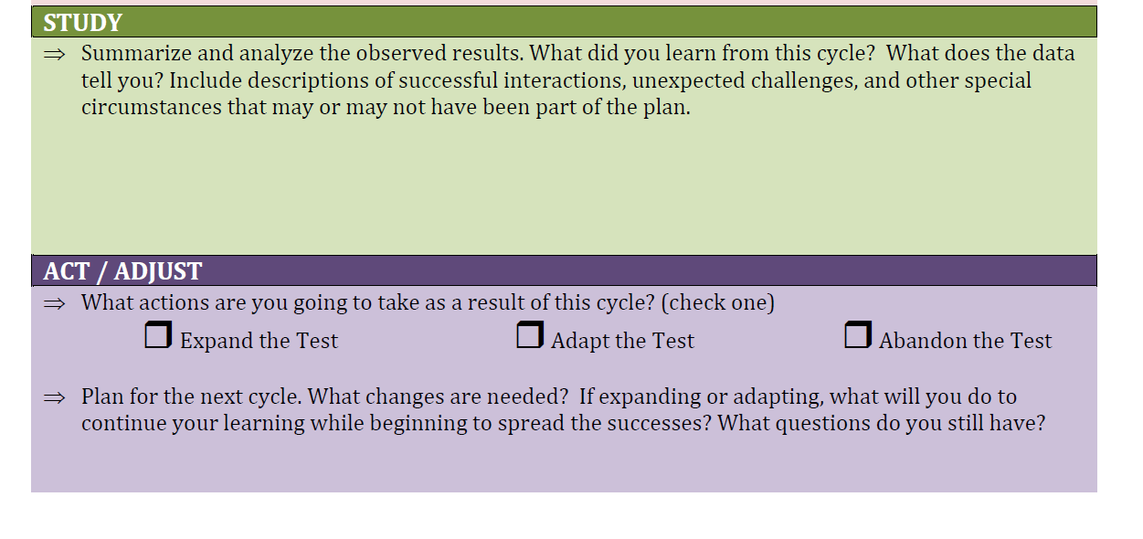
The Paperwork Reduction Act of 1995 (Pub. L. 104-13) Statement: This collection of information is voluntary and will be used to help teams identify and track the specific small changes they choose to examine from the broader set of empirically based practices they are implementing. The form allows them to keep track of the lessons learned from each PDSA cycle. These forms enable teams to monitor how their changes align with the specific goals of participating in the BSC. Guidance for utilizing this form is described in more detail during the Learning Sessions. Public reporting burden for this collection of information is estimated to average 15 minutes per response, including the time for reviewing instructions, gathering and maintaining the data needed, and reviewing the collection of information. An agency may not conduct or sponsor, and a person is not required to respond to, a collection of information unless it displays a currently valid OMB control number. The OMB number and expiration date for this collection are OMB #: 0970-XXXX, Exp: XX/XX/XXXX. Send comments regarding this burden estimate or any other aspect of this collection of information, including suggestions for reducing this burden to Kathryn Tout, ktout@childtrends.org or Child Trends, 708 N 1st Suite #333 Minneapolis, MN 55401 Attention: Kathryn Tout

