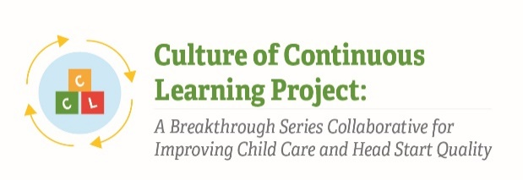

Instrument 5: Implementation Discussion Forum Prompts

Culture of Continuous Learning Project: A Breakthrough Series Collaborative for Improving Child Care and Head Start Quality

Respondents | Time of Data Collection
BSC Teams (Administrator, Teachers, Other Staff, Parent) | Weekly during Action Period phases

Note: Specific prompts in this guide are illustrative; different prompts may be included depending on the findings discovered during the implementation process. This discussion forum guide was pulled from CCL Phase I instruments and has been adapted to meet the needs of the current project.

Prompts will be selected based on relevance at time of data collection such that the time to complete discussion prompts is no more than 15 minutes.

Purpose
An interactive shared Internet site will be developed for teams to use throughout the project as a forum for ongoing sharing of ideas and collaborative problem-solving for improving practices and their organizational capacity. Teams will be encouraged to post comments on the website whenever they have a success to share or a problem they need help solving. The implementation team and faculty will also provide periodic (2 to 4 per month) discussion prompts on the site to encourage interaction and cross-sharing amongst the teams.

Topics of potential prompts include:
- Challenges that the teams may be experiencing related to improvement science, addressing specific drivers, or the overall implementation of the project.
- Successful changes that teams have tested.
- Specific topics of interest related to improvement science and the drivers in order to increase knowledge and skills.
- Resources and tools that the teams or faculty have found to be helpful in their implementation.
- Cross team relationship building questions that build community and encourage teams to get to one another and each other’s centers.

The Paperwork Reduction Act of 1995 (Pub. L. 104-13) Statement: This collection of information is voluntary and will be used to create a forum for ongoing sharing of ideas and collaborative problem-solving for improving practices and organizational capacity. Public reporting burden for this collection of information is estimated to average 15 minutes per response, including the time for reviewing instructions, gathering and maintaining the data needed, and reviewing the collection of information. An agency may not conduct or sponsor, and a person is not required to respond to, a collection of information unless it displays a currently valid OMB control number. The OMB number and expiration date for this collection are OMB #: 0970-XXXX, Exp: XX/XX/XXXX. Send comments regarding this burden estimate or any other aspect of this collection of information, including suggestions for reducing this burden to Kathryn Tout, ktout@childtrends.org or Child Trends, 708 N 1st Suite #333 Minneapolis, MN 55401 Attention: Kathryn Tout

