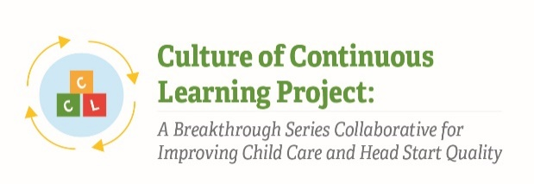
Instrument 8: BSC Overall Feedback Form

Culture of Continuous Learning Project: A Breakthrough Series Collaborative for Improving Child Care and Head Start Quality

Respondents | Time of Data Collection
BSC Team Members (Administrator, Teachers, Other Staff, Parent) | Midpoint (T2)  Post-test (T3)

Note: Specific statements and questions in this self-report are illustrative; different statements and questions may be included depending on the findings discovered during the implementation process. This self-report of BSC activities was pulled from CCL Phase I instruments and has been adapted to meet the needs of the current project.

Statements and questions will be selected based on relevance at time of data collection such that the time to complete the self-report is no more than 15 minutes.

Participation in BSC activities
Part I. Individual Experience
The following are statements about your individual perceptions of and experiences with the Breakthrough Series Collaborative. Please indicate how strongly you agree or disagree with the following statements.
 | Strongly Disagree | Somewhat Disagree | Neutral | Somewhat agree | Strongly Agree | Not Applicable
The goals and priorities my BSC team developed were clear
The goals and priorities my BSC team developed reflected the unique needs and interests of my program/site
The strategies taught as part of the BSC model (for example the “Model for Improvement” and “PDSAs”) helped me to use quality improvement approaches in my program
The BSC helped me understand how to use data to improve my practice
The Learning Sessions I attended provided a consistent and clear quality improvement process.
The Model for Improvement (3 questions) was helpful in providing a consistent and clear quality improvement process.
The Plan-Do-Study-Act cycles were helpful in testing and implementing changes.
The training and coaching my BSC team received from faculty and staff was a source of support
The monthly conference calls I joined supported my quality improvement efforts
The affinity group calls I joined supported my quality improvement efforts
The site visit from faculty and BSC implementers was helpful
Engaging in progress monitoring of monthly metrics was helpful in providing a consistent and clear quality improvement process.
I had enough time to participate in activities related to the BSC on a weekly basis
The timeframe for this BSC (starting in X month, year and ending in Z month, year) felt like just the right amount of time to participate in the BSC
I increased my knowledge about children’s social and emotional learning and development
I changed my beliefs about children’s social and emotional learning and development
I improved my teaching practices around children’s social and emotional learning and development
I noticed improvements in classroom climate due to the changes I made in supporting children’s social and emotional learning
I noticed changes in children’s prosocial behavior in my program due to the changes I made in supporting children’s social and emotional learning
I noticed a reduction in challenging behaviors in my program due to the changes I made in supporting children’s social and emotional learning

Part II. Overall Satisfaction & Recommendations
- Overall, how satisfied are you with your experience with this BSC?
  - very unsatisfied
  - moderately unsatisfied
  - slightly unsatisfied
  - slightly satisfied
  - moderately satisfied
  - very satisfied
- I would recommend participating in a BSC to staff in other child care/Head Start programs.
  - yes
  - no
  - don’t know
- I would like my regular professional development/TA provider to be able to offer the BSC for quality improvement support in the future.
  - yes
  - no
  - don’t know

- I would recommend the following improvements or changes if offering a BSC to Head Start/child care programs in my area in the future: ______________________________________________________________________________
______________________________________________________________________________

