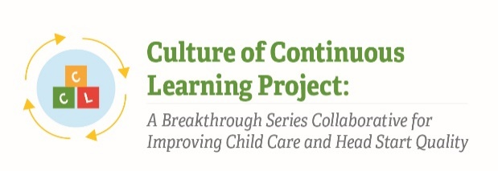

Instrument 19: Administrative Data Survey

Culture of Continuous Learning Project: A Breakthrough Series Collaborative for Improving Child Care and Head Start Quality

Respondents | Time of Data Collection
Center Administrators | Baseline (T1)  Mid-Point (T2)  Post-Test (T3)  Follow-Up (T4)

- Please share your most up to date staff roster with us. You can upload a file in any format (Word, Excel, .pdf) or type the list into the text box below.
  - Upload
  - Text box
The Paperwork Reduction Act of 1995 (Pub. L. 104-13) Statement: This collection of information is voluntary and will be used to assess the feasibility of implementing continuous quality improvement methods in ECE programs and systems to support the use and sustainability of evidence-based practices. Public reporting burden for this collection of information is estimated to average 30 minutes per response, including the time for reviewing instructions, gathering and maintaining the data needed, and reviewing the collection of information. An agency may not conduct or sponsor, and a person is not required to respond to, a collection of information unless it displays a currently valid OMB control number. The OMB number and expiration date for this collection are OMB #: 0970-XXXX, Exp: XX/XX/XXXX. Send comments regarding this burden estimate or any other aspect of this collection of information, including suggestions for reducing this burden to Kathryn Tout, ktout@childtrends.org or Child Trends, 708 N 1st Suite #333 Minneapolis, MN 55401 Attention: Kathryn Tout

