CCDF 101: CCDF Fundamentals New Administrators’ Self-Assessment Tool

Purpose
The CCDF 101: CCDF Fundamentals CCDF 101: CCDF Fundamentals New Administrators’ Training Cohort is an intentional effort to offer a gradual learning experience focused on essential requirements, knowledge, and skills for new Tribal CCDF Administrators. The objective of the CCDF 101: CCDF Fundamentals New Administrators’ Training Cohort is to grow and nurture new leadership and management skills through a small-group approach and a peer-supportive network.
The CCDF 101: CCDF Fundamentals New Administrators’ Training Cohort Self-Assessment Tool highlights a key component of the New Administrators’ cohort experience: management systems. This tool was designed to provide New Administrators with a way to reflect upon these components and assess growth over the course of the cohort.
New Administrators will complete the self-assessment at the beginning and at the conclusion of the six-month cohort. The assessment at the beginning of the cohort will serve as a baseline and provide an opportunity for New Administrators to consider their current capacity and areas for development. At the end of the cohort, the self- assessment will provide an opportunity to reflect on progress and help inform next steps for continued growth.
The self-assessment will serve the additional purpose of helping the Tribal Child Care Capacity Building Center (TCBC) understand the impact that the New Administrators’ Training has on nurturing leadership capabilities and management skills over the course of the six-month cohort.
All responses provided on this self-assessment are private. Data may be aggregated to assess growth of the cohort overall, but individual responses will remain private.

Instructions
For each section, review the relevant capabilities and skills and think about your current understanding, experience, and level of comfort with each. Consider your ability to apply the capabilities and skills to lead, manage, and implement your CCDF program and determine which implementation phase you are in:
The purpose of this information collection is to gather feedback from technical assistance recipients to improve future technical assistance efforts and resource development. Public reporting burden for this collection of information is estimated to average 20 minutes per respondent, including the time for reviewing instructions, gathering and maintaining the data needed, and reviewing the collection of information. This is a voluntary collection of information. agency may not conduct or sponsor, and a person is not required to respond to, a collection of information subject to the requirements of the Paperwork Reduction Act of 1995, unless it displays a currently valid OMB control number. The OMB # is 0970-0531 and the expiration date is 09/30/2025. If you have any comments on this collection of information, please contact Melody Redbird-Post mredbird@mn-e.com.
Implementation Phases
- No action: I have not considered this skill or capability as it applies to my role and leading, managing, and implementing my CCDF program.
- Exploring: I have considered this skill or capability as it applies to my role and my CCDF program. I am assessing my readiness to apply this skill and the ways that I can apply it to lead, manage, and implement my CCDF program.
- Developing: I am planning and preparing to use this skill or capability in my role and my CCDF program. I am making arrangements and acquiring resources that I need to apply this skill or capability to lead, manage, and implement my CCDF program.
- Initial Implementation: I have started to apply this skill or capability in my role and am using it to lead, manage, and implement my CCDF program. I am assessing my approach to applying this skill or capability and identifying ways to improve its application.
- Full Implementation: I am consistently applying this skill or capability in my role and my CCDF program. This skill or capability is embedded as part of my ongoing leadership, management, and implementation of the CCDF program.
At the end of the assessment, please use your responses to reflect on your areas of strength, areas for improvement, and leadership and management goals for the New Administrators’ Training.
Name:____________________________________ Date:____________________________

Section I: Management Systems and Skills
Please consider the following management systems and associated skills and select the implementation phase that most accurately represents your current level of capacity for each system.
System and  Associated Skills | No Action | Exploring | Developing | Initial Implementation | Full Implementation
System: Leadership and Governance  Skills Include:  - Planning strategically  - Making informed decisions  - Supporting teams  - Defining roles and responsibilities  - Fostering collective leadership  - Communicating with leadership  - Mobilizing stakeholders | 1 | 2 | 3 | 4 | 5
System: Direct Services  Skills Include:  Planning and making informed decisions  Determining processes to ensure that families have equal access to stable child care financial assistance  Communicating with parents, providers, and families | 1 | 2 | 3 | 4 | 5
System: Provider Settings  Skills Include:  Determining the needs of the community  Supporting each provider type served by their CCDF program  Ensuring appropriate and high quality care  Ensuring the health and safety requirements of providers are met  Providing culturally and linguistically appropriate training and professional development to providers | 1 | 2 | 3 | 4 | 5
System: Health and Safety Monitoring  Skills Include:  Considering if appropriate health and safety standards are in place  Ensuring providers, staff, and monitoring staff are adequately trained  Ensuring compliance with health and safety standards  Utilizing information gathered through monitoring to increase the health and safety of children in case | 1 | 2 | 3 | 4 | 5
System: Disaster Preparedness and Response  Skills Include:  Developing and implementing a disaster preparedness and response plan for the Tribal services area  Consider how the needs of the children, including the need for safe child care, before, during, and after a state of emergency is declared is maintained  Building partnerships through cooperation, coordination, and collaboration  Working with Tribal leaders  Effectively engaging internal and external stakeholders | 1 | 2 | 3 | 4 | 5
System: Program Administration and Data and Evaluation  Skills Include:  Assessing capabilities of current monitoring system and identifying areas of improvement  Incorporating monitoring results into ongoing program operations, planning, and improvement  Ensuring timeliness of ongoing monitoring  Engaging and training staff regarding monitoring requirements and processes  Sharing results of monitoring with staff and leadership  Using data to inform program implementation  Identifying data sources  Selecting data collection methods  Managing and analyzing data  Using data to assess impact and tell your program’s story | 1 | 2 | 3 | 4 | 5
System: Fiscal Management  Skills Include:  Developing and implementing financial management systems  Engaging leadership and stakeholders in fiscal management  Developing and implementing budgeting processes  Identifying areas of strength and improvement in your program’s fiscal management approach | 1 | 2 | 3 | 4 | 5
System: Community Needs Assessment  Skills Include:  - Gathering information about the needs of providers, children, families, and the community  - Engaging partners in the needs assessment process  - Examining information to determine strengths and needs  - Identifying priorities  - Designing services to align with strengths and needs | 1 | 2 | 3 | 4 | 5
System: Training and Professional Development  Skills Include:  Assessing current approaches for orientation, training, and professional development  Creating a coordinated approach to training and professional development  Developing professional development plans and goals for staff  Aligning professional development plans to program goals  Identifying and supporting staff strengths and areas of improvement  Using reflective supervision  Supporting staff to move program from compliance to excellence | 1 | 2 | 3 | 4 | 5
System: Communication and Information Systems  Skills Include:  Communicating with internal and external stakeholders  Designing, implementing, and supporting communications policies and procedures  Utilizing culturally and linguistically responsive communications  Recruiting and engaging partners to improve program functioning  Communicating (internally and externally) regarding the CCDF final rule | 1 | 2 | 3 | 4 | 5
System: Record Keeping and Reporting  Skills Include:  Managing program records  Overseeing program reports  Using technology to support record keeping and reporting  Establishing, implementing, and supporting policies and procedures for record keeping and reporting  Communicating program information to leadership  Generating reports on program progress and services in real-time | 1 | 2 | 3 | 4 | 5
System: Continuous Quality Improvement  Skills Include:  Identify goals for quality improvement  Supporting continuous quality improvement | 1 | 2 | 3 | 4 | 5
System: Human Resources  Skills Include:  Developing an organizational structure to support program staff, goals, and services  Establishing screening, hiring and onboarding processes, including criminal background checks  Utilizing culturally responsive hiring and onboarding practices  Ensuring staff members have appropriate credentials  Coordinating between program staff and human resources | 1 | 2 | 3 | 4 | 5
Notes: Use this area to record your rationale, comments, or questions regarding your responses above.

Reflection
- What management skills or capabilities stand out as areas of strength for you?
- What areas of improvement have you identified?
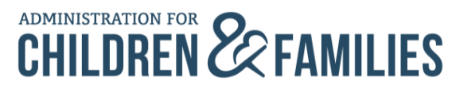
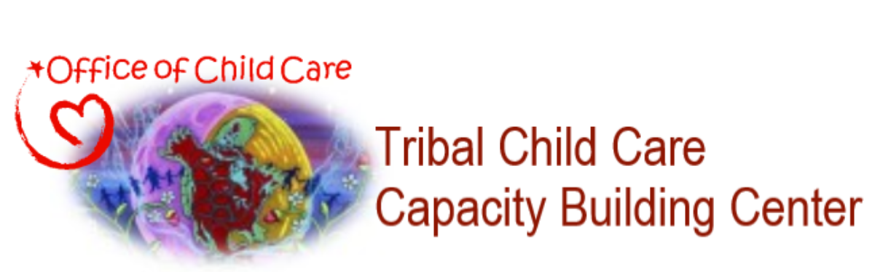
- Based on your self-assessment, what management goals do you have for yourself as a New Administrator?
The Tribal Child Care Capacity Building Center is funded by the U.S. Department of Health and Human Services, Administration for Children and Families, Office of Child Care.
The Tribal Child Care Capacity Building Center,
A Service of the Office of Child Care
Miami Environmental & Energy Solutions, LLC
1950 Roland Clarke Place, Suite 210D
Reston, VA 20191
Phone: 1-844-710-TCBC (8222)
Email: tcbc@mn-e.com

Adapted from Fixsen, D. L., Blase, K. A., Naoom, S. F., & Van Dyke, M. (2010). Stage-based measures of implementation components. Chapel Hill, NC: Authors & National Implementation Research Network.

