## 2025 CJRP/2026 JRFC – Draft Protocol for Round 1 of Cognitive Testing

*Attachment A  
Draft Protocol (10.13.2023)*

10.13.2023

About the Respondent / Warm-Up Questions

* What is your facility’s name(s)? What is your job title or role within the facility?
* Do you recall if you completed the Census of Juveniles in Residential Placement (CJRP) when it was last conducted? How about the or Juvenile Residential Facility Census (JRFC)? [If yes] Could you please tell me about your experience?
  + (Or about how much experience do you have completing the CJRP/JRFC)?
* This is a screenshot of the first pages of the CJRP and JRFC.  
  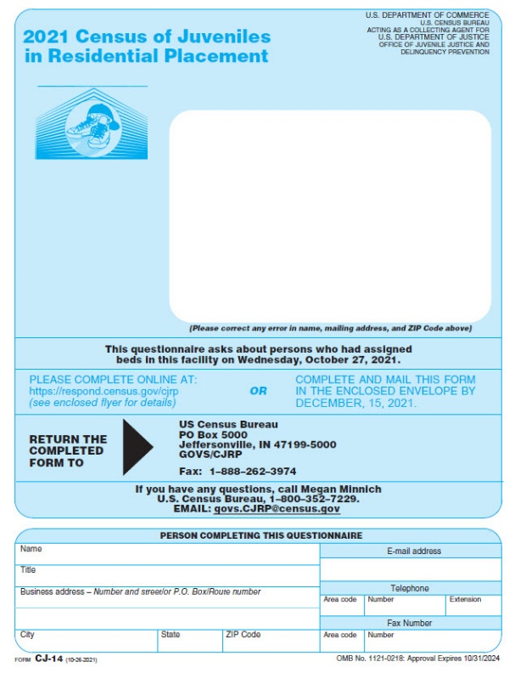 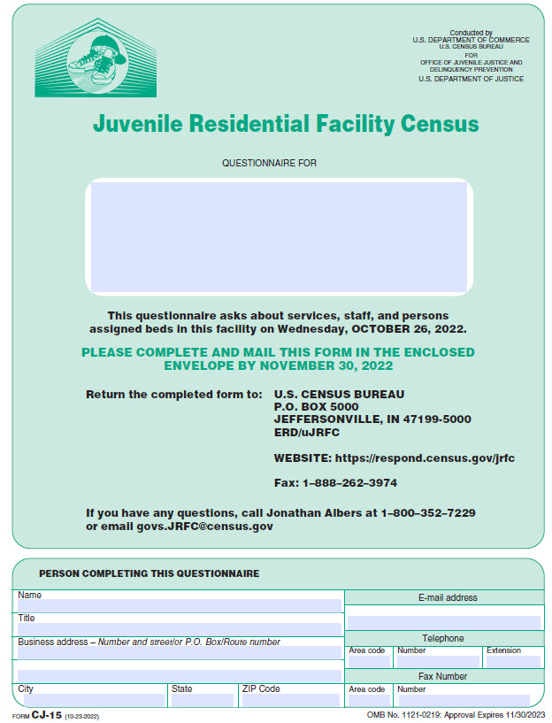
* Can you tell me the difference in your approach to these surveys?
* Do you work with anyone else in your facility to gather data for these surveys?
  + If yes, what are their job titles? And what was their role in gathering/providing data?
* Approximately how much time do you spend completing the CJRP? How about the JRFC? Please include the time spent gathering data, completing the forms, and submitting the data in your estimate. (Note: If respondent answers in terms of the timeframe to complete or number of weeks or months it takes them to complete the survey, please rephrase the question to probe about the approximate number of hours they spend working on the CJRP/JRFC.)
* How do you usually describe your facility? Is this a public or private facility?

What type of residential facility is the one listed on the front cover? (Select that apply)

* **Detention center:** A short-term facility that provides temporary care in a physically restricting environment for juveniles in custody pending court disposition and, often, for juveniles who are adjudicated delinquent and awaiting disposition or placement elsewhere, or are awaiting transfer to another jurisdiction. In some jurisdictions, detention centers may also hold juveniles committed for short periods of time as part of their disposition (e.g., weekend detention).
* **Training school/Long-term secure facility:** A specialized type of facility that provides strict confinement and long-term treatment generally for post-adjudication committed juvenile offenders. Includes training schools, juvenile correctional facilities, youth development centers.
* **Reception or diagnostic center:** A short-term facility that screens juvenile offenders committed by the courts and assigns them to appropriate correctional facilities.
* **Group home/Halfway house:** A long-term facility that is generally non-secure and intended for post-adjudication commitments in which young persons are allowed extensive contact with the community, such as attending school or holding a job.
* **Residential treatment center:** A facility that focuses on providing some type of individually planned treatment program for youth (substance abuse, sex offender, mental health, etc.) in conjunction with residential care. Such facilities generally require specific licensing by the state that may require that treatment provided is Medicaid-reimbursable.
* **Boot camp:** A secure facility that operates like military basic training. It is designed to combine elements of basic military training programs, correctional components and treatment programs. The emphasis is on strict discipline, drills, and work.
* **Ranch, forestry camp, wilderness or marine program or farm:** These are long-term generally non-secure residential facilities often located in a relatively remote area. The juveniles participate in a structured program that emphasizes outdoor work, including conservation and related activities.
* **Runaway and homeless shelter:** A short-term facility that provides temporary care in a physically unrestricted environment. It can also provide longer-term care under a juvenile court disposition order.
* **Other type of shelter:** This includes emergency non-secure shelters where juveniles are housed short-term until another placement can be found.
* **Other:** This includes independent living programs and anything that cannot be classified above. (*Please describe*) [textbox]

Length of Stay

Census of Juveniles in Residential Placement

Now we are going to review some potential questions. This is not the whole survey. We will look at parts of the survey we would like your feedback on.

Releases over a Specific Time Period

How many young persons were released from your facility in the 28 days between Thursday September 14, 2023 and Wednesday, October 11, 2023? *Please do not include any young persons who were only temporarily released from this facility, such as those released for medical care at a hospital.*

* How did/would you obtain this information?
* In your own words, how would you describe what the question means by “young person”?
* What does “released from your facility” mean to you? Are you including those released back into the community as well as those transferred to another facility? Are there any other types of releases?
* How do you think about temporary releases? Are you including those?
* Is there anything about the wording of this question that is confusing or unclear?

They are currently looking at two options for collecting Length of Stay information – average length of stay or roster information.

Average Length of Stay

What was the average length of stay for the young persons who were released from your facility in the 28 days between Thursday, September 14, 2023 and Wednesday, October 11, 2023 (in days)?

_____ days

* How did/would you obtain the information to answer this question?
* How did/would you determine which young people would be included?
* In your own words, what does “average length of stay” mean to you?
* How did/would you calculate the average length of stay?
* Would you like to see a definition of “average length of stay”? What would you like to know?

Roster Information for Length of Stay: Excel Spreadsheet

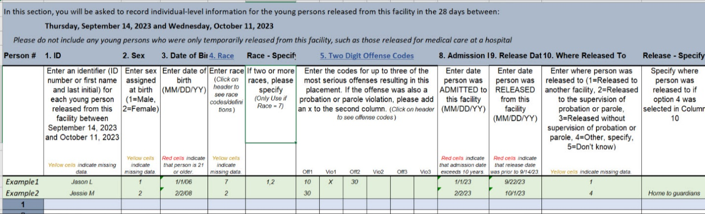

Here is a screenshot of a draft Excel spreadsheet with the Length of Stay information we are considering collecting for recently released young people.

* What is your first impression?
* Looking at each of the columns, would you be able to provide the data requested? Are any of the columns more difficult to provide data for?
* Given the following options, would you be most likely to fill out this roster information using
  1. An excel template,
  2. The online survey, filling each individual’s information separately,
  3. A printed form, or
  4. A fillable pdf form?
* Looking at this spreadsheet, how would you like to be notified of missing cells or errors?

Enter date person was ADMITTED to this facility (MM/DD/YY)

Enter date person was RELEASED from this facility (MM/DD/YY)

* How did/would you obtain this information?
* Approximately how much time will it take to provide this information for length of stay for released individuals in the past 28 days?
* Are there any additional comments you would like to provide regarding collecting information on the length of stay for recently released young persons?
* Do you have any suggestions on how to collect length of stay information?

Enter where person was released to:

1=Released to another facility

2=Released to the supervision of probation or parole

3=Released without supervision of probation or parole

4=Other, describe

5=Do not know

* How did/would you obtain this information?
* In your own words, what would you say this question is asking for?
* What is available in your records?
* What might you write in for an “other” answer?
* Do you have any suggestions on how to collect length of stay information?

Enter the codes for up to three of the most serious offenses resulting in this placement. If the offense was also a probation or parole violation, please add an x to the second column.

* How would you determine the three most serious offenses?
* What is available in your records?
* Would you know if an offense is a probation or parole violation?

Facility Classification

Juvenile Residential Facility Census

Now, let’s talk about the green Juvenile Residential Facility Census. The JRFC is looking to collect additional information about a facility’s attributes.

Let’s look at the first of the proposed questions.

Does this facility screen young persons to assign them to any of the following? *(Select all that apply.)*

* The appropriate program within this facility
* The appropriate living arrangements within this facility
* Another facility
* A community-based program
* None of the above
* How would you answer this question?
* What do each of the response options mean to you?
* Is any part of this question unclear?
* Do you have multiple programs on the same campus? What about multiple buildings?
  + Does that impact your approach to these questions?
* How easy or difficult would you say this question is to answer?

Here is the second question we would like you to review.

Does this facility provide any of the following to young persons INSIDE this facility? *(Select all that apply.)*

* A structured program for young persons emphasizing outdoor experiences, such as outdoor work or conservation training
* An individually planned treatment program for young persons in conjunction with residential care
* A vocation training program, workforce development services, or job training
* None of the above
* How would you answer this question?
* What do each of the response options mean to you?
* What do you think is meant by “inside this facility”?
* Is any part of this question unclear?
* How easy or difficult would you say this question is to answer?

Demographics

Sex

Roster/individual sex:  
  
Please enter this person's sex assigned at birth.

* *Male*
* *Female*
* How would you answer this question? What records are available?

Do you record in your records if a youth is intersex?

*Intersex: a person whose sexual or reproductive anatomy or chromosomal pattern does not seem to fit typical definitions of male or female. Intersex medical conditions are sometimes referred to as differences in sex development.*

* + Yes
  + No
  + Unknown
* Do you have “Intersex” in your records?
* Have you had experience with youth that fall into this category?

Aggregate sex:  
  
How many of the youth currently in your facility are the following sexes as assigned at birth?

*Male __________*

*Female __________*

* How would you answer this question? What records are available?
* Do you have a preference between providing this at the individual/roster level or providing it at the aggregate level?

Gender Identity

Roster/individual gender identity:  
  
Please enter this person's gender identity.  
*Gender identity is a person's core internal understanding of who they are regardless of sex assigned at birth.*

* *Male*
* *Female*
* *Transgender*
* *Nonbinary*
* *They use a different term, describe: _______________*
* *Unknown*
* How do/would you answer this question? What records are available?
* Are you familiar with each of the answer categories? Do you have each of these in your records?
* Are you able to answer this question for all young persons in your facility?

Aggregate gender identity 1:  
  
How many of the youth currently in your facility identify as the following gender identities? *(Please select one category per youth.)*  
*Gender identity is a person's core internal understanding of who they are regardless of sex assigned at birth.*

*Male __________*

*Female __________*

*Transgender __________*

*Nonbinary __________*

*They use a different term __________*

*Unknown __________*

* How would you answer this question? What records are available?
* Are you familiar with each of the answer categories?
* Do you have a preference between providing this at the individual/roster level or providing it at the aggregate level?
* Would you want to write something in for “They use a different term”?
* Are there any complications for only selecting one category per youth?
* How would you categorize transgender girls/boys or men/women?

Sexual Orientation

Roster/individual sexual orientation:  
  
Please enter this person's sexual orientation.  
*Sexual orientation is a person’s emotional or physical attraction to others.*

* *Straight*
* *Gay*
* *Lesbian*
* *Bisexual*
* *They use a different term, describe: _______________*
* *Unknown*
* How do/would you answer this question? What records are available?
* Are you familiar with each of the answer categories? Do you have each of these in your records?
* Are you able to answer this question for all young persons in your facility?

Aggregate sexual orientation:  
  
How many of the youth currently in this facility identify as the following sexual orientations? *(Please select one category per youth.)*  
*Sexual orientation is a person’s emotional or physical attraction to others.*

*Straight __________*

*Gay __________*

*Lesbian __________*

*Bisexual __________*

*They use a different term __________*

*Unknown __________*

* How would you answer this question? What records are available?
* Are you familiar with each of the answer categories? Do you have each of these in your records?
* Do you have a preference between providing this at the individual/roster level or providing it at the aggregate level?
* Would you want to write anything for “they use a different term”?
* Are there any complications to only selecting on category per youth?

Race

Roster/individual Race 1:  
  
Please enter this person’s race.

* *White*
* *Black or African American*
* *Hispanic or Latino*
* *American Indian or Alaska Native*
* *Asian*
* *Native Hawaiian or Other Pacific Islander*
* *Middle Eastern or North African*
* *Two or more races, describe: ____________________*
* *Unknown*
* How do/would you answer this question? What records are available?
* What would you do if you didn’t know a youth’s race?
* Are you familiar with each of the answer categories? Do you have each of these in your records?
* Is “Middle Eastern or North African” broken out in your records?
  + If yes, how do you report “Middle Eastern or North African” now?
  + If no, how would you approach this question?

Form

Privacy

* Do you ever leave certain items blank?
* Is it because you don’t have the data, or do you have concerns about confidentiality?
* When you log into the survey, have you ever clicked on the link to the privacy information (the blue link in the box on the bottom of this screen)?

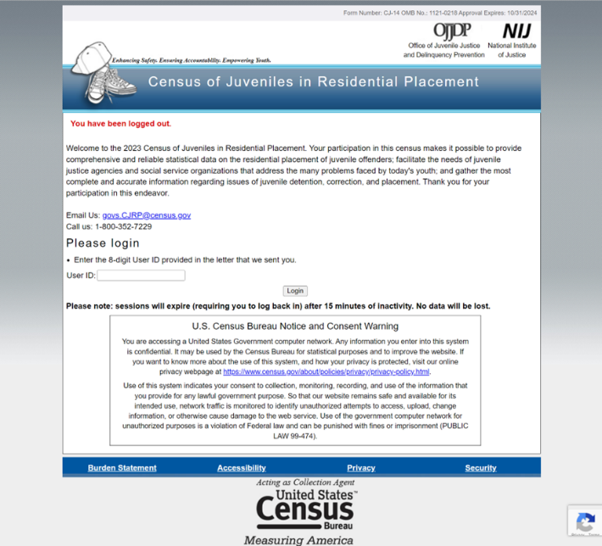

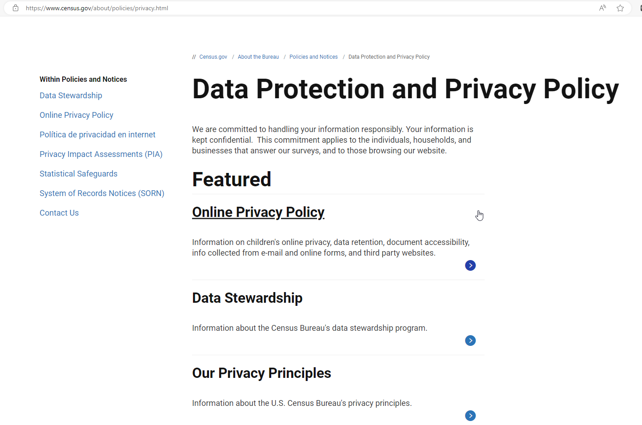

* Here is the linked privacy statement. Could you take a moment to read it over? What is your reaction?
* Would seeing this information impact your confidence about the privacy and security of the information you provide to this survey?

This screen shows the privacy information included in the current paper mailout package: “The confidentiality of the information you provide is protected by federal law (Title 34, Section 10231 of the United States Code) and will only be revealed or used for research purposes (see reverse side for more details).”

* Do you remember seeing this privacy statement the last time you responded to the survey?
* Would seeing this statement impact your confidence about the privacy and security of the information you provide to this survey?
* What additional information, if any, would be useful and encourage providing individual level information?

Web Collection Only

* How do you currently respond to the two surveys (online? by paper form?)?
  + Do you utilize the paper forms to gather information prior to responding online?
* Are there any challenges that could arise from eliminating the paper form?
* If a pdf version of the form were provided online, could you use that to gather information?

Wrap Up

Our session is almost complete. Is there any additional information that you would like to share about any of the items we have looked at today or about the CJRP or JRFC in general?

**Thank you so much for your time and assistance!**