## 2025 CJRP/2026 JRFC – Draft Instrument for Round 1 of Cognitive Testing

*Attachment B  
Draft Instrument (10.13.2023)*

10.13.2023

About the Respondent / Warm-Up Questions

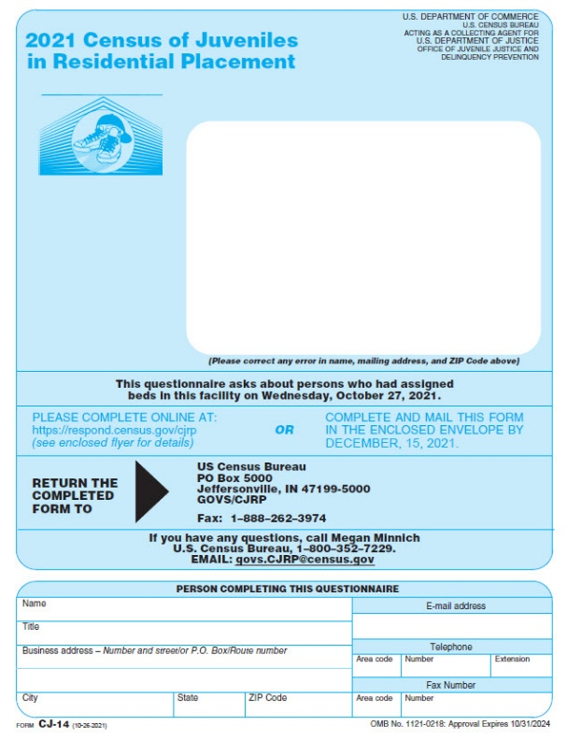 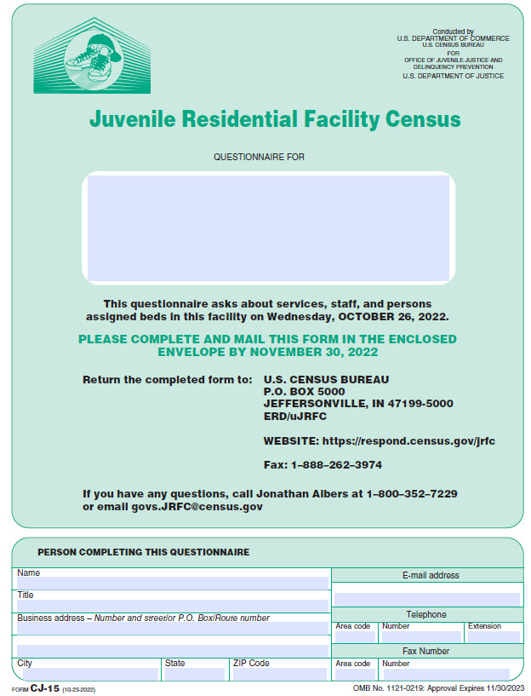

What type of residential facility is the one listed on the front cover? (Select that apply)

* **Detention center:** A short-term facility that provides temporary care in a physically restricting environment for juveniles in custody pending court disposition and, often, for juveniles who are adjudicated delinquent and awaiting disposition or placement elsewhere, or are awaiting transfer to another jurisdiction. In some jurisdictions, detention centers may also hold juveniles committed for short periods of time as part of their disposition (e.g., weekend detention).
* **Training school/Long-term secure facility:** A specialized type of facility that provides strict confinement and long-term treatment generally for post-adjudication committed juvenile offenders. Includes training schools, juvenile correctional facilities, youth development centers.
* **Reception or diagnostic center:** A short-term facility that screens juvenile offenders committed by the courts and assigns them to appropriate correctional facilities.
* **Group home/Halfway house:** A long-term facility that is generally non-secure and intended for post-adjudication commitments in which young persons are allowed extensive contact with the community, such as attending school or holding a job.
* **Residential treatment center:** A facility that focuses on providing some type of individually planned treatment program for youth (substance abuse, sex offender, mental health, etc.) in conjunction with residential care. Such facilities generally require specific licensing by the state that may require that treatment provided is Medicaid-reimbursable.
* **Boot camp:** A secure facility that operates like military basic training. It is designed to combine elements of basic military training programs, correctional components and treatment programs. The emphasis is on strict discipline, drills, and work.
* **Ranch, forestry camp, wilderness or marine program or farm:** These are long-term generally non-secure residential facilities often located in a relatively remote area. The juveniles participate in a structured program that emphasizes outdoor work, including conservation and related activities.
* **Runaway and homeless shelter:** A short-term facility that provides temporary care in a physically unrestricted environment. It can also provide longer-term care under a juvenile court disposition order.
* **Other type of shelter:** This includes emergency non-secure shelters where juveniles are housed short-term until another placement can be found.
* **Other:** This includes independent living programs and anything that cannot be classified above. (*Please describe*) [textbox]

Length of Stay

Census of Juveniles in Residential Placement

Releases over a Specific Time Period

How many young persons were released from your facility in the 28 days between Thursday September 14, 2023 and Wednesday, October 11, 2023? *Please do not include any young persons who were only temporarily released from this facility, such as those released for medical care at a hospital.*

Average Length of Stay

What was the average length of stay for the young persons who were released from your facility in the 28 days between Thursday, September 14, 2023 and Wednesday, October 11, 2023?

_____ days

Roster Information for Length of Stay: Excel Spreadsheet

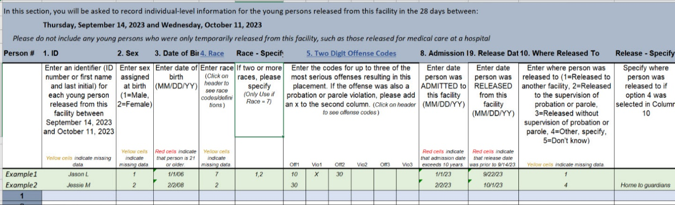

Enter date person was ADMITTED to this facility (MM/DD/YY)

Enter date person was RELEASED from this facility (MM/DD/YY)

Enter where person was released to:

1=Released to another facility

2=Released to the supervision of probation or parole

3=Released without supervision of probation or parole

4=Other, describe

5=Do not know

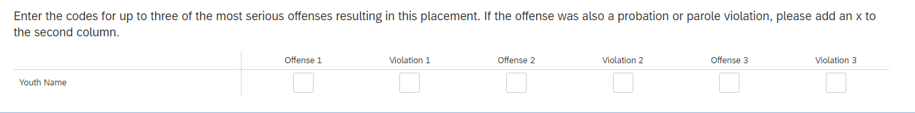

Facility Classification

Juvenile Residential Facility Census

Does this facility screen young persons to assign them to any of the following? *(Select all that apply.)*

* The appropriate program within this facility
* The appropriate living arrangements within this facility
* Another facility
* A community-based program
* None of the above

Does this facility provide any of the following to young persons INSIDE this facility? *(Select all that apply.)*

* A structured program for young persons emphasizing outdoor experiences, such as outdoor work or conservation training
* An individually planned treatment program for young persons in conjunction with residential care
* A vocation training program, workforce development services, or job training
* None of the above

Demographics

Sex

Roster/individual sex:  
  
Please enter this person's sex as assigned at birth.

* *Male*
* *Female*

Do you record in your records if a youth is intersex?

*Intersex: a person whose sexual or reproductive anatomy or chromosomal pattern does not seem to fit typical definitions of male or female. Intersex medical conditions are sometimes referred to as differences in sex development.*

* + Yes
  + No
  + Unknown

Aggregate sex:  
  
How many of the youth currently in your facility are the following sexes?

*Male __________*

*Female __________*

Gender Identity

Roster/individual gender identity:  
  
Please enter this person's gender identity.   
*Gender identity is a person's core internal understanding of who they are regardless of sex assigned at birth.*

* *Male*
* *Female*
* *Transgender*
* *Nonbinary*
* *They use a different term, describe: _______________*
* *Unknown*

Aggregate gender identity:  
  
How many of the youth currently in your facility identify as the following gender identities? *(Please select one category per youth.)*  
*Gender identity is a person's core internal understanding of who they are regardless of sex assigned at birth.*

*Male __________*

*Female __________*

*Transgender __________*

*Nonbinary __________*

*They use a different term __________*

*Unknown __________*

Sexual Orientation

Roster/individual sexual orientation:  
  
Please enter this person's sexual orientation.  
*Sexual orientation is a person’s emotional or physical attraction to others.*

* *Straight*
* *Gay*
* *Lesbian*
* *Bisexual*
* *They use a different term, describe: _______________*
* *Unknown*

Aggregate sexual orientation:  
  
How many of the youth currently in your facility identify as the following sexual orientations? *(Please select one category per youth.)*  
*Sexual orientation is a person’s emotional or physical attraction to others.*

*Straight __________*

*Gay __________*

*Lesbian __________*

*Bisexual __________*

*They use a different term __________*

*Unknown __________*

Race

Please enter this person’s race.

* *White*
* *Black or African American*
* *Hispanic or Latino*
* *American Indian or Alaska Native*
* *Asian*
* *Native Hawaiian or Other Pacific Islander*
* *Middle Eastern or North African*
* *Two or more races, describe: ____________________*
* *Unknown*

Form

Privacy

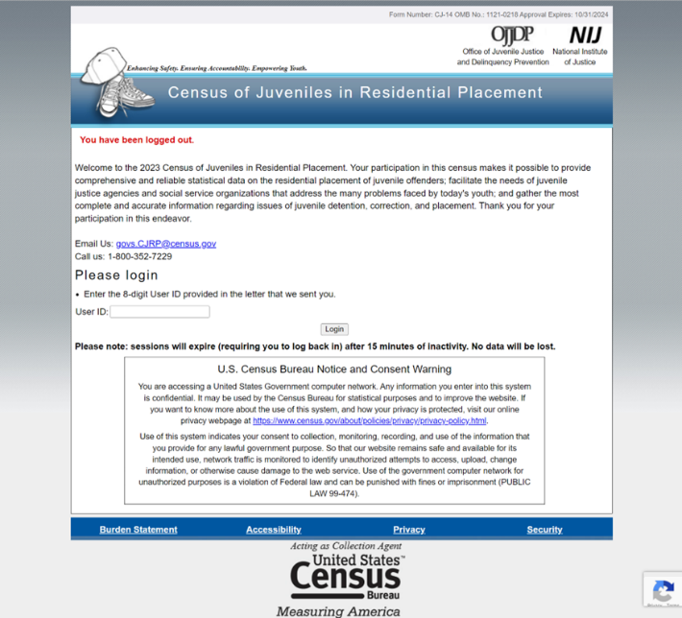

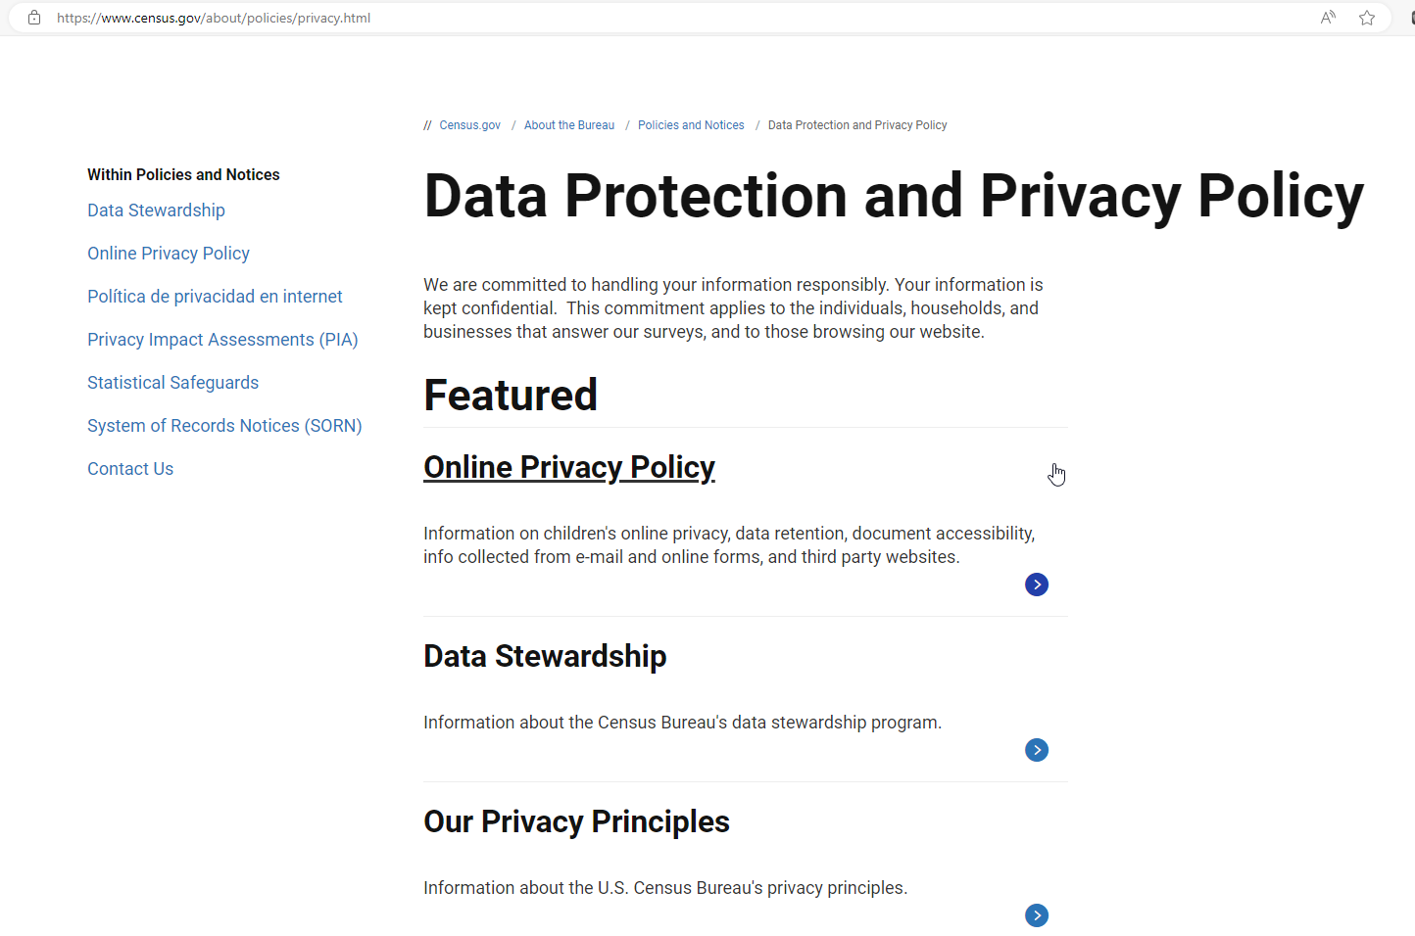

The confidentiality of the information you provide is protected by federal law (Title 34, Section 10231 of the United States Code) and will only be revealed or used for research purposes (see reverse side for more details).

Wrap Up

We thank you for your time spent taking this survey.

Your response has been recorded.