NATIONAL CENTER FOR EDUCATION STATISTICS NATIONAL ASSESSMENT OF EDUCATIONAL PROGRESS

National Assessment of Educational Progress (NAEP) 2024

Appendix J-S
2024 Spanish Questionnaires

OMB# 1850-0928 v.31



August 2023

Appendix J-S provides Spanish student, teacher, and school survey questionnaires that will be administered in 2024. Grades 4 and 8 Core, Math, and Reading questionnaires were previously approved in 2022 (OMB# 1850-0928 v.28), and any changes to the items from the 2022 administration are reflected in summary tables. Additionally, grade 8 Science was previously approved in 2019 (OMB# 1850-0928 v.15), and any changes to the items from the 2019 administration are reflected in summary tables. Please note, some of the numbers of the items may be missing or out of order in these printed versions. This will be corrected in the platform view.

Table of Contents
Student Login Screen 4
Appendix J-1-s: Spanish Translations of Student Questionnaires 5
Appendix J-1a-s-BL: Summary of Changes Operational Grade 4 CORE 6
Appendix J-1a-s-BL: Operational Grade 4 CORE 9
Appendix J-1b-s-PR: Summary of Changes Operational Grade 4 CORE 15
Appendix J-1b-s-PR: Operational Grade 4 CORE 18
Appendix J-1c-s-BL: Summary of Changes Operational Grade 8 CORE 22
Appendix J-1c-s-BL: Operational Grade 8 CORE 25
Appendix J-1d-s-PR: Summary of Changes Operational Grade 8 CORE 34
Appendix J-1d-s-PR: Operational Grade 8 CORE 37
Appendix J-1e-s-BL: Summary of Changes Operational Grade 4 Mathematics 45
Appendix J-1e-s-BL: Operational Grade 4 Mathematics 46
Appendix J-1f-s-PR: Summary of Changes Operational Grade 4 Mathematics 50
Appendix J-1f-s-PR: Operational Grade 4 Mathematics 51
Appendix J-1g-s-BL: Summary of Changes Operational Grade 8 Mathematics 55
Appendix J-1g-s-BL: Operational Grade 8 Mathematics 56
Appendix J-1h-s-PR: Summary of Changes Operational Grade 8 Mathematics 61
Appendix J-1h-s-PR: Operational Grade 8 Mathematics 63
Appendix J-1i-s-BL: Summary of Changes Operational Grade 4 Reading 69
Appendix J-1i-s-BL: Operational Grade 4 Reading 70
Appendix J-1j-s-BL: Summary of Changes Operational Grade 8 Reading 75
Appendix J-1j-s-BL: Operational Grade 8 Reading 77
Appendix J-1k-s-BL: Operational Grade 8 Science 81
Appendix J-1l-s-BL: Operational Grade 4 Debrief 90
Appendix J-1m-s-PR: Operational Grade 4 Debrief 91
Appendix J-1n-s-BL: Operational Grade 8 Debrief 92
Appendix J-1n-s-PR: Operational Grade 8 Debrief 93
Appendix J-1o-s-PR: Pilot Grade 4 Core 94
Appendix J-1p-s-PR: Pilot Grade 8 Core 97
Appendix J-1q-s-PR: Pilot Grade 4 Mathematics 101
Appendix J-1r-s-PR: Pilot Grade 8 Mathematics 106
Appendix J-1s-s-PR: Pilot Grade 4 Debrief 112
Appendix J-1t-s-PR: Pilot Grade 8 Debrief 113
Sample Teacher Login Screen 114
Sample Teacher Questionnaire Booklet Cover 115
Appendix J-2-s: Spanish Translations of Teacher Questionnaires 116
Appendix J-2a-s-PR: Summary of Changes Operational Grade 4 CORE 117
Appendix J-2a-s-PR: Operational Grade 4 CORE 120
Appendix J-2b-s-PR: Summary of Changes Operational Grade 8 CORE 132
Appendix J-2b-s-PR: Operational Grade 8 CORE 135
Appendix J-2c-s-PR: Operational Grade 4 Mathematics 148
Appendix J-2d-s-PR: Operational Grade 8 Mathematics 157
Appendix J-3-s: Spanish Translations of School Questionnaires 167
Sample School Administrator Login Screen 168
Sample School Questionnaire Booklet Covers 169
Appendix J-3a-s-PR: Summary of Changes Operational Grade 4 CORE 170
Appendix J-3a-s-PR: Operational Grade 4 CORE 173
Appendix J-3b-s-PR: Summary of Changes Operational Grade 8 CORE 185
Appendix J-3b-s-PR: Operational Grade 8 CORE 188
Appendix J-3c-s-PR: Operational Grade 4 Mathematics 201
Appendix J-3d-s-PR: Summary of Changes Operational Grade 8 Mathematics 205
Appendix J-3d-s-PR: Operational Grade 8 Mathematics 206

Student Login Screen

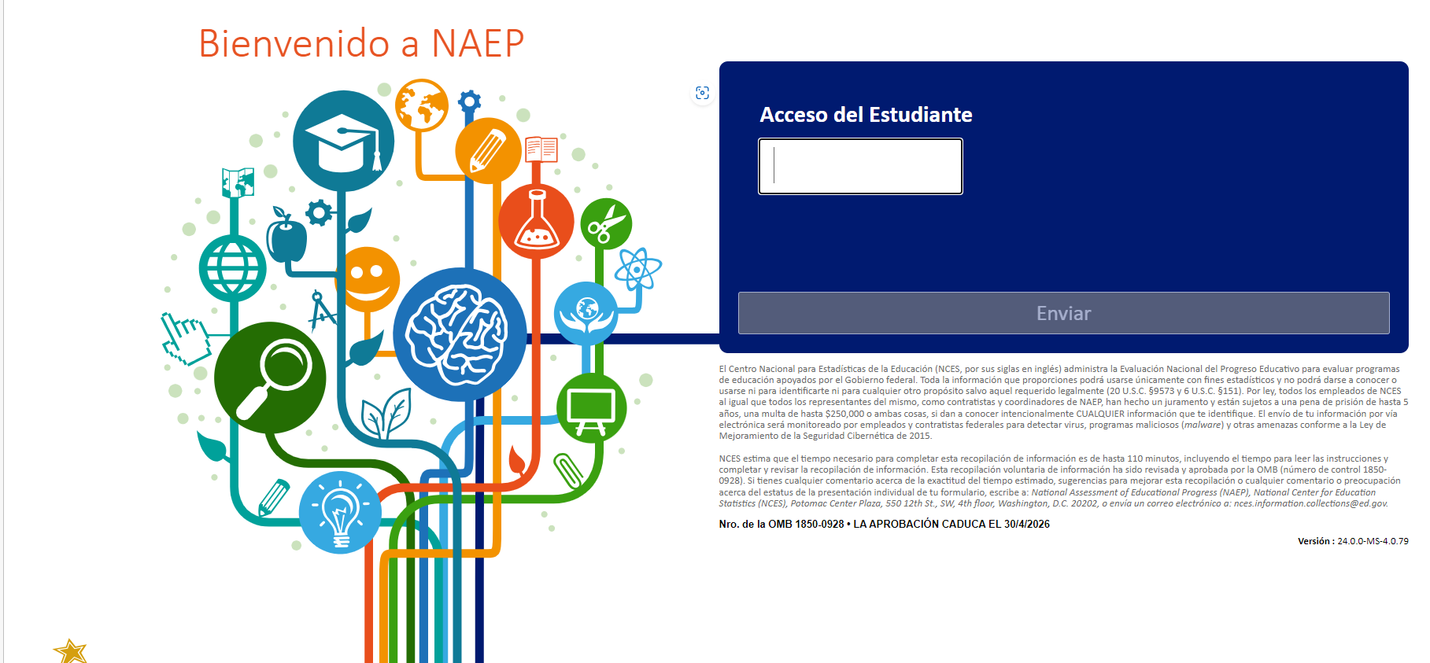

Appendix J-1-s: Spanish Translations of Student Questionnaires

Appendix J-1a-s-BL: Summary of Changes Operational Grade 4 CORE
2024 Operational Grade 4 Core Student – Bilingual
Previous item |  | 2024 item | D/A/R/NC+ |  |  | Rationale
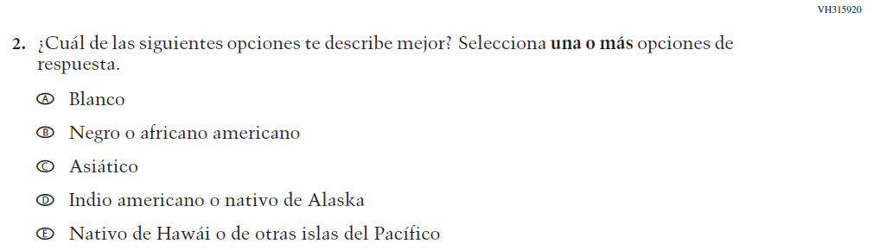  (2022 Operational Grade 4 Student Core - Bilingual) |  | VH315920  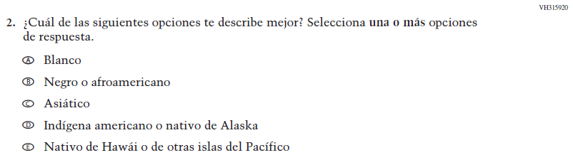  Issue: Race/Ethnicity | R |  |  | Revised options b and d to align with categories used by the 2020 Census Bureau.
N/A  (2022 Operational Grade 4 Student Core - Bilingual) |  | VR741842  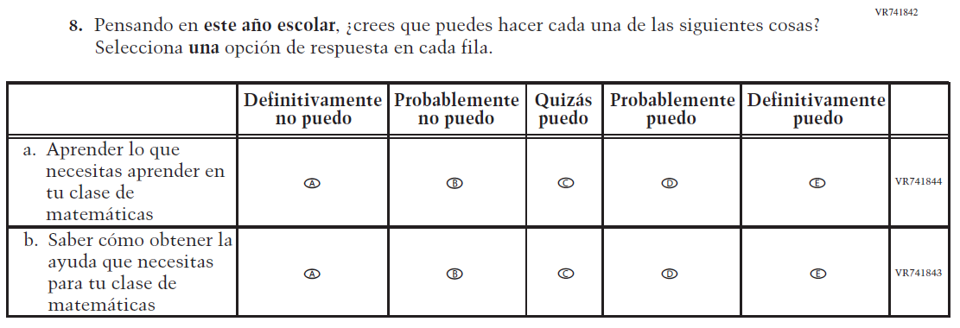  Issue: Learning Recovery | A |  |  | To address gaps in learning that have been developed due to the extended period of remote and hybrid learning that took place during the pandemic.
2024 Operational Grade 4 Core Student – Bilingual
Previous item |  | 2024 item | D/A/R/NC+ |  |  | Rationale
VH580725  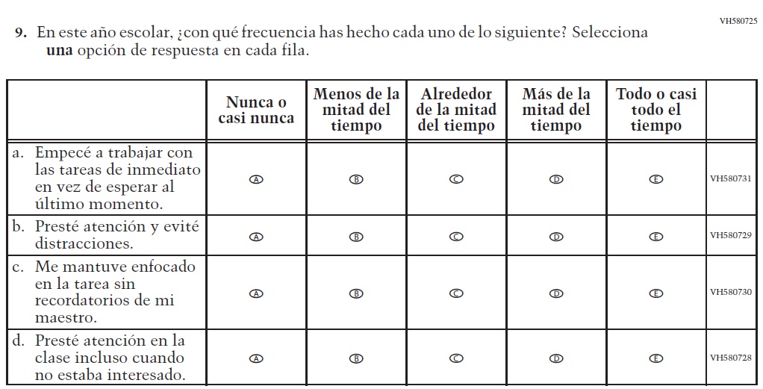  (2022 Operational Grade 4 Student Core - Bilingual) |  | N/A | D |  |  | To keep student burden low, this item was dropped.
N/A  (2022 Operational Grade 4 Student Core - Bilingual) |  | VR741856  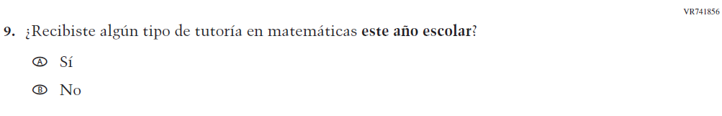  Issue: Learning Recovery | A |  |  | To address gaps in learning that have been developed due to the extended period of remote and hybrid learning that took place during the pandemic.
N/A  (2022 Operational Grade 4 Student Core - Bilingual) |  | VR741955  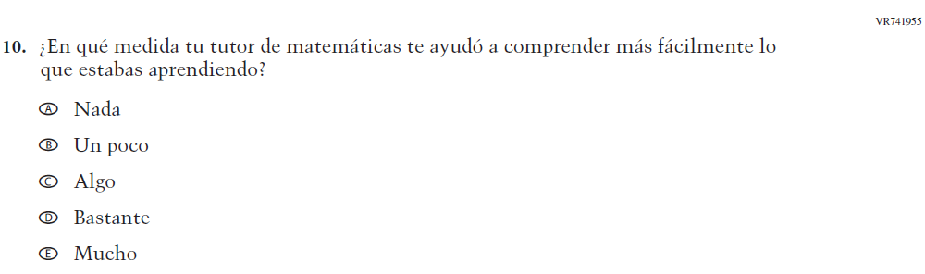  Issue: Learning Recovery | A |  |  | To address gaps in learning that have been developed due to the extended period of remote and hybrid learning that took place during the pandemic.
2024 Operational Grade 4 Core Student – Bilingual
Previous item | 2024 item |  |  | D/A/R/NC+ | Rationale
N/A  (2022 Operational Grade 4 Student Core - Bilingual) | VR741959  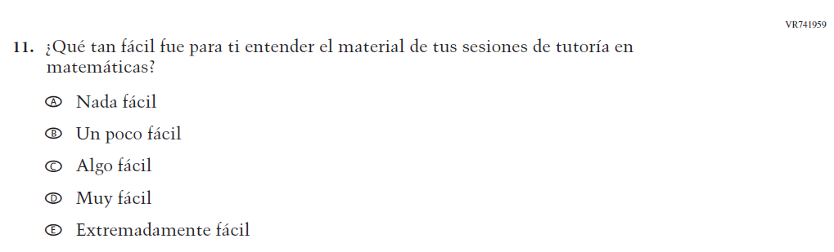  Issue: Learning Recovery |  |  | A | To address gaps in learning that have been developed due to the extended period of remote and hybrid learning that took place during the pandemic.
N/A  (2022 Operational Grade 4 Student Core - Bilingual) | VR741976  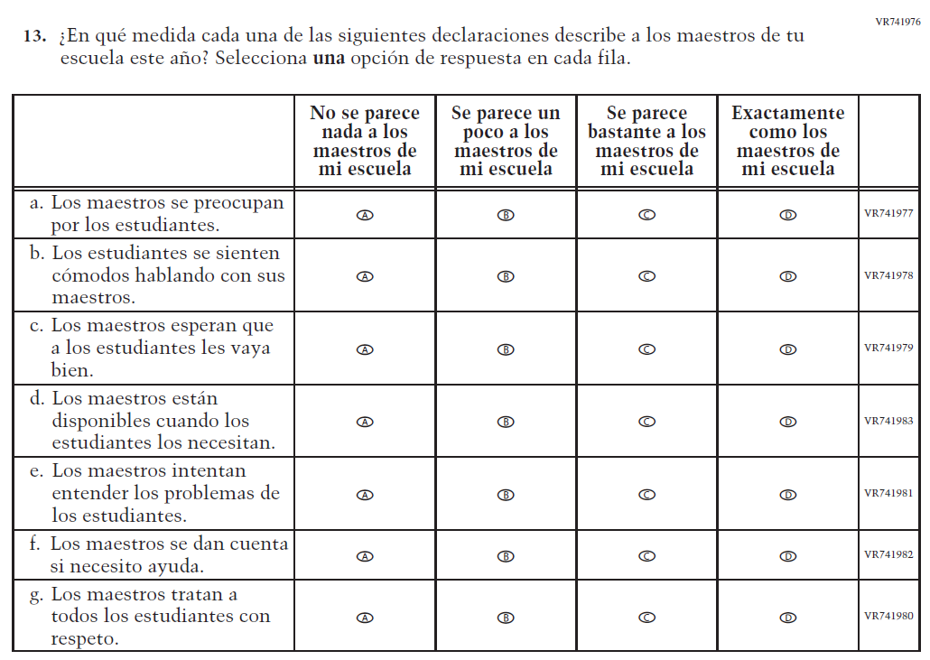  Issue: Learning Recovery |  |  | A | To address gaps in learning that have been developed due to the extended period of remote and hybrid learning that took place during the pandemic.

Appendix J-1a-s-BL: Operational Grade 4 CORE
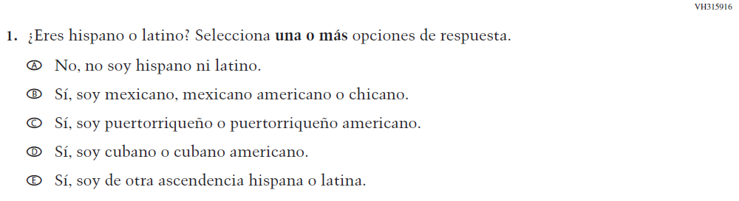

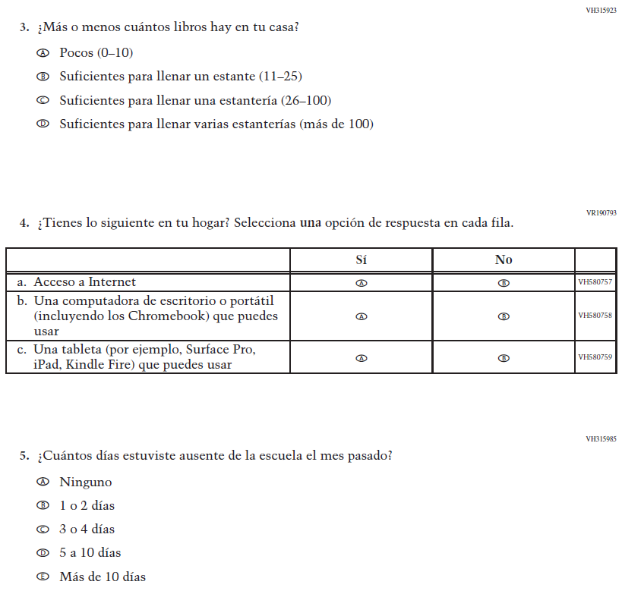

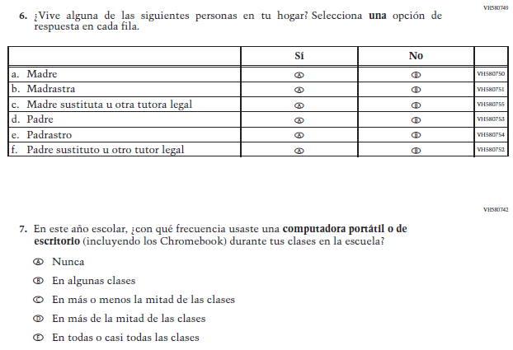

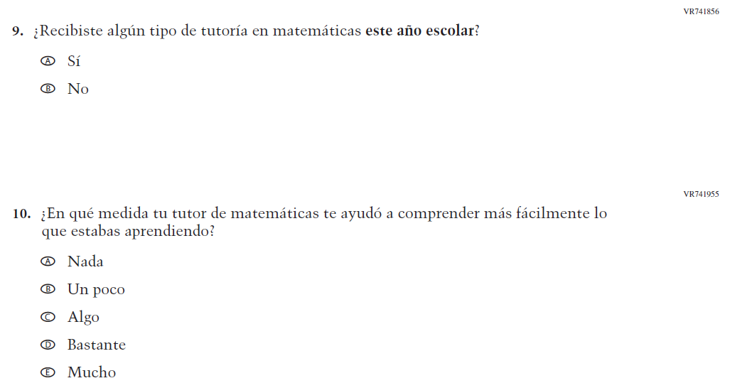

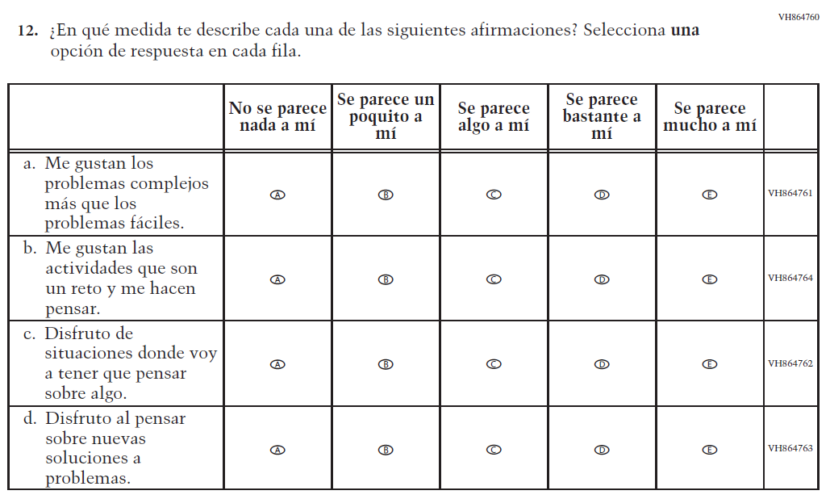

Appendix J-1b-s-PR: Summary of Changes Operational Grade 4 CORE
2024 Operational Grade 4 Core Student – Puerto Rico

Previous item | 2024 item | D/A/R/NC+ | Rationale
VH315774  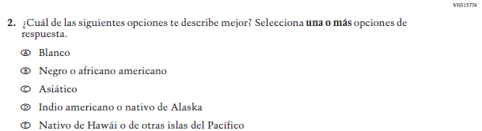  (2022 Operational Grade 4 Student Core – Puerto Rico) | VH315774  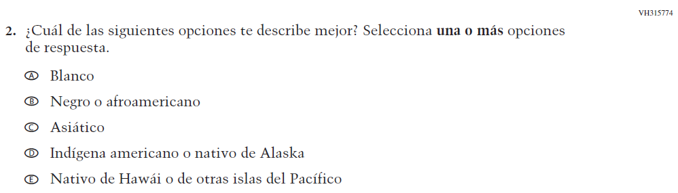  Issue: Race/Ethnicity | R | Revised options b and d to align with categories used by the 2020 Census Bureau.
N/A  (2022 Operational Grade 4 Student Core – Puerto Rico) | VR741839  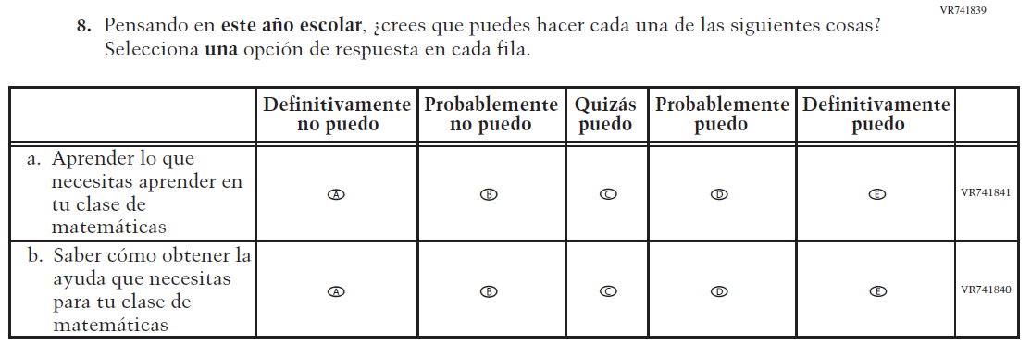  Issue: Learning Recovery | A | To address gaps in learning that have been developed due to the extended period of remote and hybrid learning that took place during the pandemic.
N/A  (2022 Operational Grade 4 Student Core – Puerto Rico) | VR741854  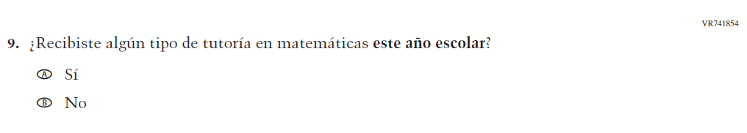  Issue: Learning Recovery | A | To address gaps in learning that have been developed due to the extended period of remote and hybrid learning that took place during the pandemic.
2024 Operational Grade 4 Core Student – Puerto Rico

Previous item | 2024 item | D/A/R/NC+ | Rationale
VH580061  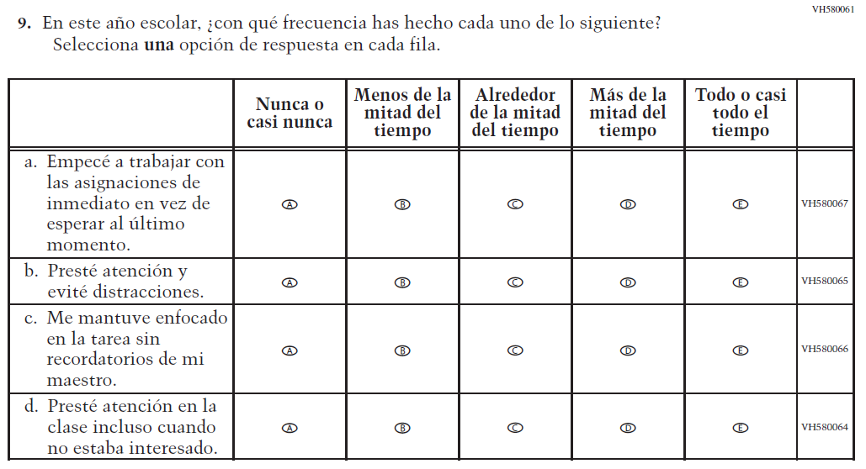  (2022 Operational Grade 4 Student Core – Puerto Rico) | N/A | D | To keep student burden low, this item was dropped.
N/A  (2022 Operational Grade 4 Student Core – Puerto Rico) | VR741954  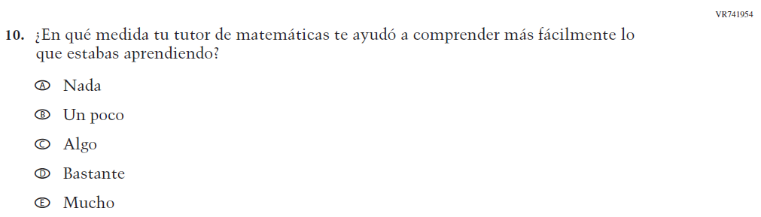  Issue: Learning Recovery | A | To address gaps in learning that have been developed due to the extended period of remote and hybrid learning that took place during the pandemic.
2024 Operational Grade 4 Core Student – Puerto Rico

Previous item | 2024 item | D/A/R/NC+ | Rationale
N/A  (2022 Operational Grade 4 Student Core – Puerto Rico) | VR741958  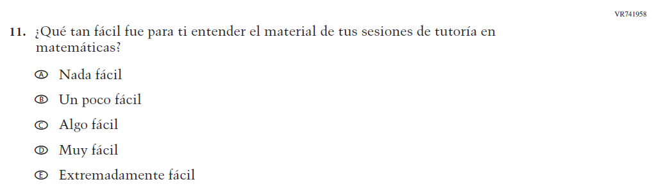  Issue: Learning Recovery | A | To address gaps in learning that have been developed due to the extended period of remote and hybrid learning that took place during the pandemic.
N/A  (2022 Operational Grade 4 Student Core – Puerto Rico) | VR741960  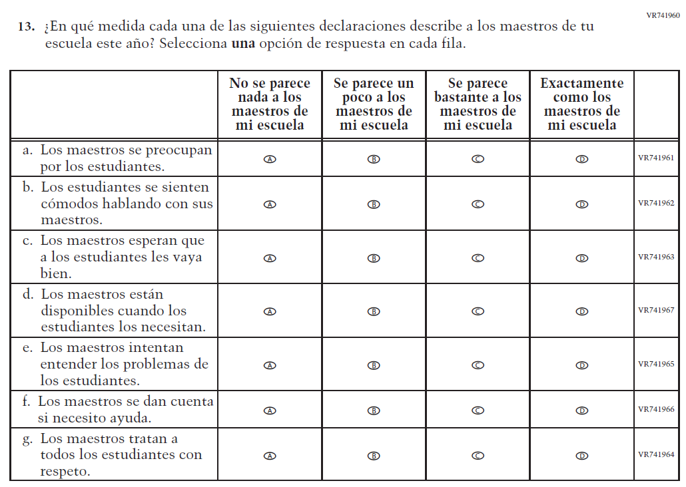  Issue: Learning Recovery |  | To address gaps in learning that have been developed due to the extended period of remote and hybrid learning that took place during the pandemic.

Appendix J-1b-s-PR: Operational Grade 4 CORE
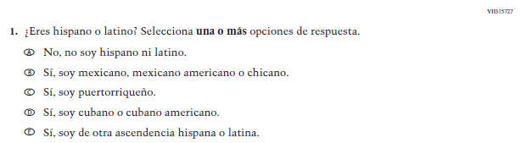

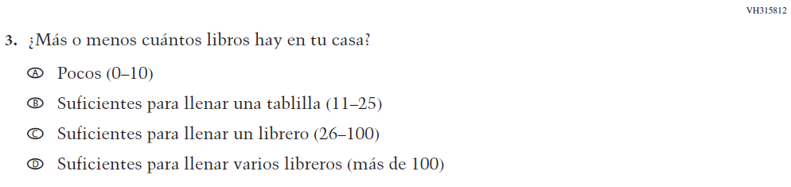

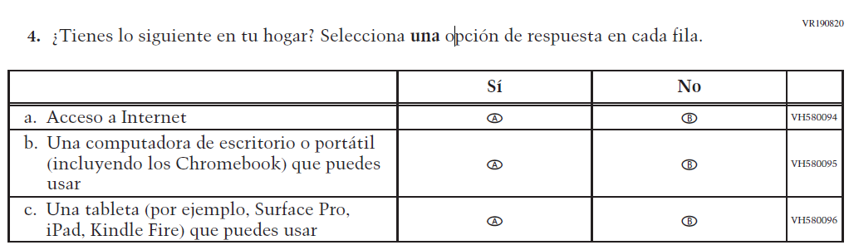
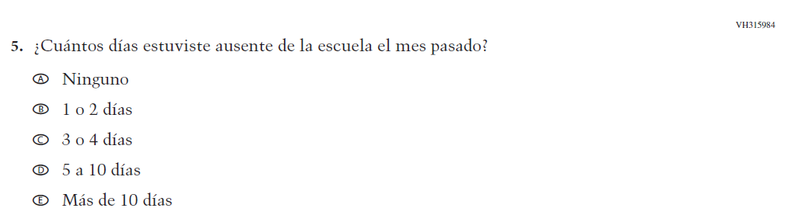

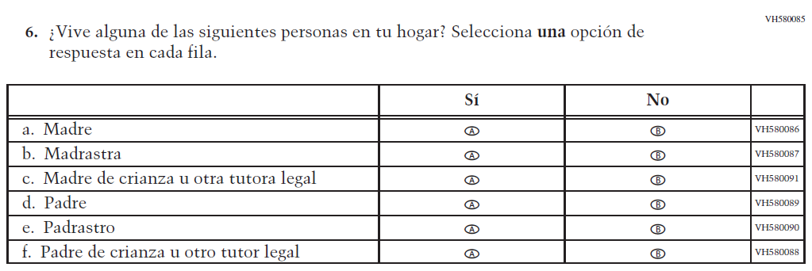

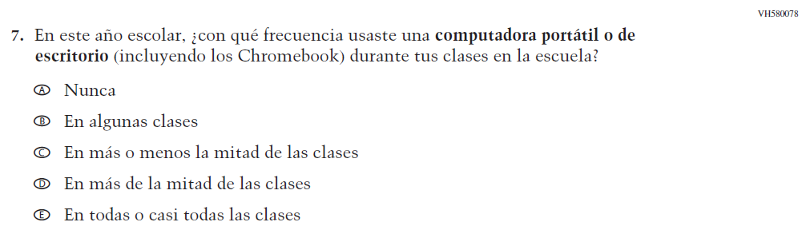

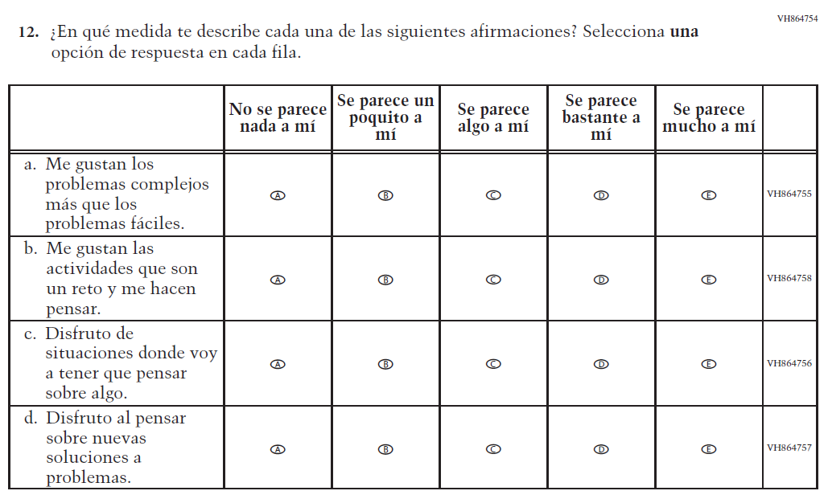

Appendix J-1c-s-BL: Summary of Changes Operational Grade 8 CORE

2024 Operational Grade 8 Core Student – Bilingual
Previous item | 2024 item | D/A/R/A+ | Rationale
VH315920  (2022 Operational Grade 8 Student Core - Bilingual) | VH315920  Issue: Race/Ethnicity | R | Revised options b and d to align with categories used by the 2020 Census Bureau,
N/A  (2022 Operational Grade 8 Student Core - Bilingual) | VR741842  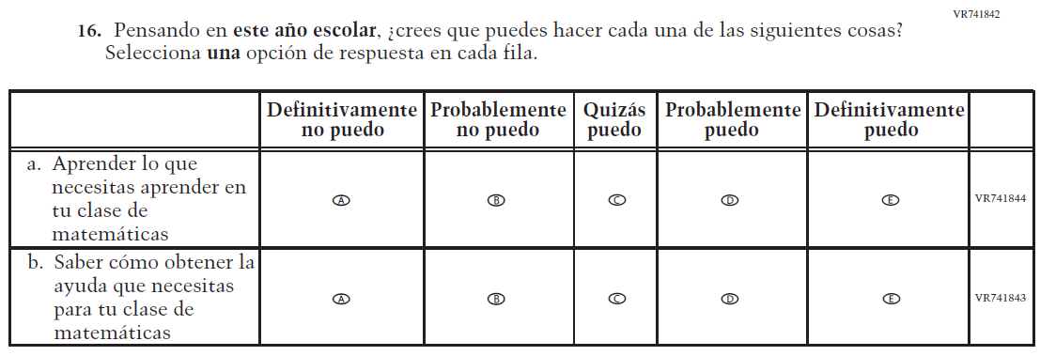  Issue: Learning Recovery | A | To address gaps in learning that have been developed due to the extended period of remote and hybrid learning that took place during the pandemic.
2024 Operational Grade 8 Core Student – Bilingual
Previous item | 2024 item | D/A/R/A+ | Rationale
N/A  (2022 Operational Grade 8 Student Core - Bilingual) | VR741856  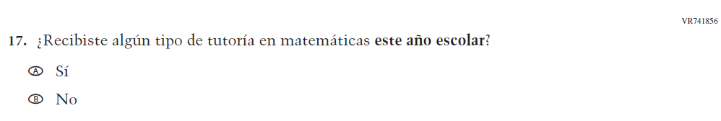  Issue: Learning Recovery | A | To address gaps in learning that have been developed due to the extended period of remote and hybrid learning that took place during the pandemic.
VH580725  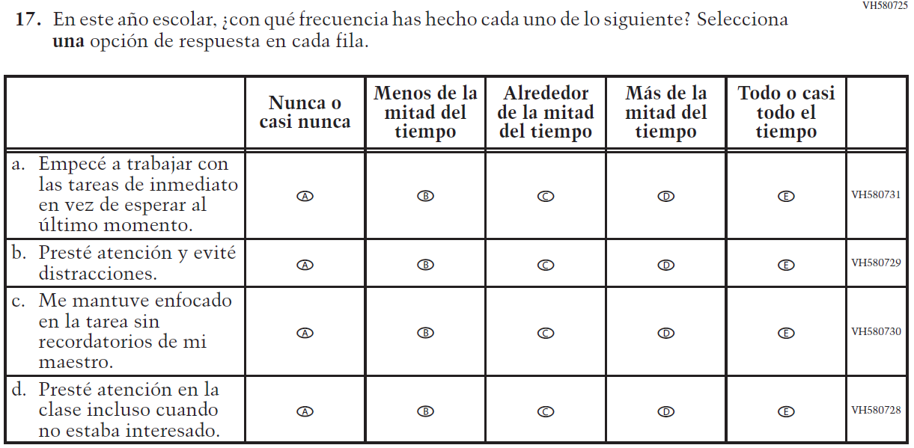  (2022 Operational Grade 8 Student Core - Bilingual) | N/A | D | To keep student burden low, this item was dropped.
N/A  (2022 Operational Grade 8 Student Core - Bilingual) | VR741955  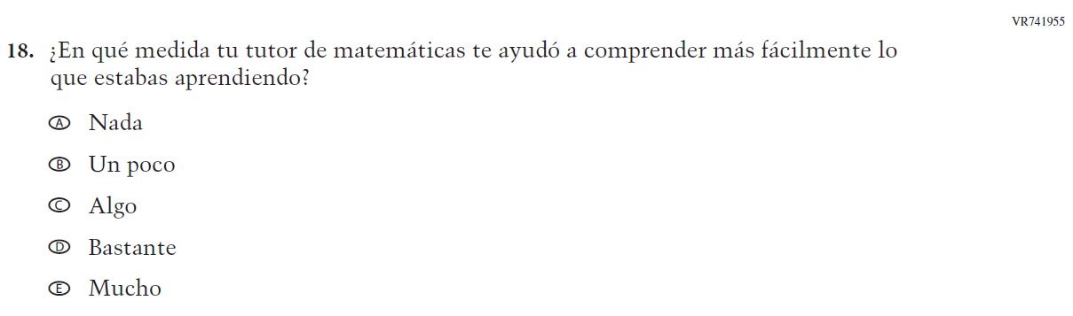  Issue: Learning Recovery | A | To address gaps in learning that have been developed due to the extended period of remote and hybrid learning that took place during the pandemic.
2024 Operational Grade 8 Core Student – Bilingual
Previous item | 2024 item | D/A/R/A+ | Rationale
N/A  (2022 Operational Grade 8 Student Core - Bilingual) | VR741959  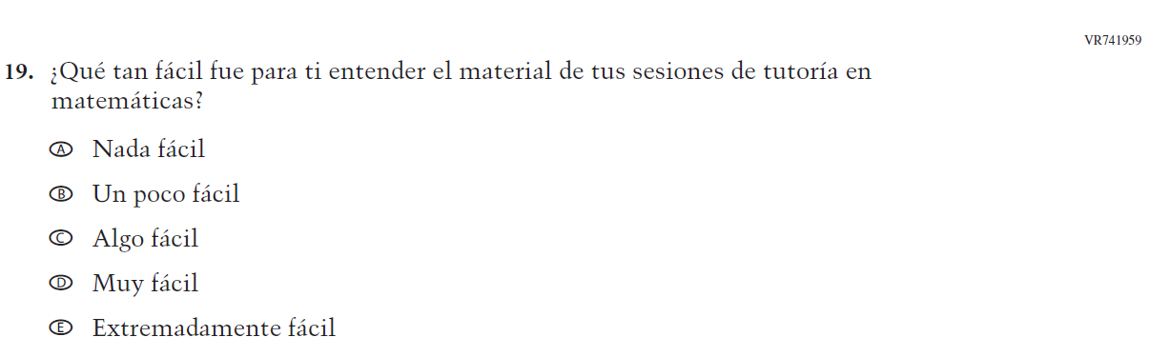  Issue: Learning Recovery | A | To address gaps in learning that have been developed due to the extended period of remote and hybrid learning that took place during the pandemic.
N/A  (2022 Operational Grade 8 Student Core - Bilingual) | VR741976  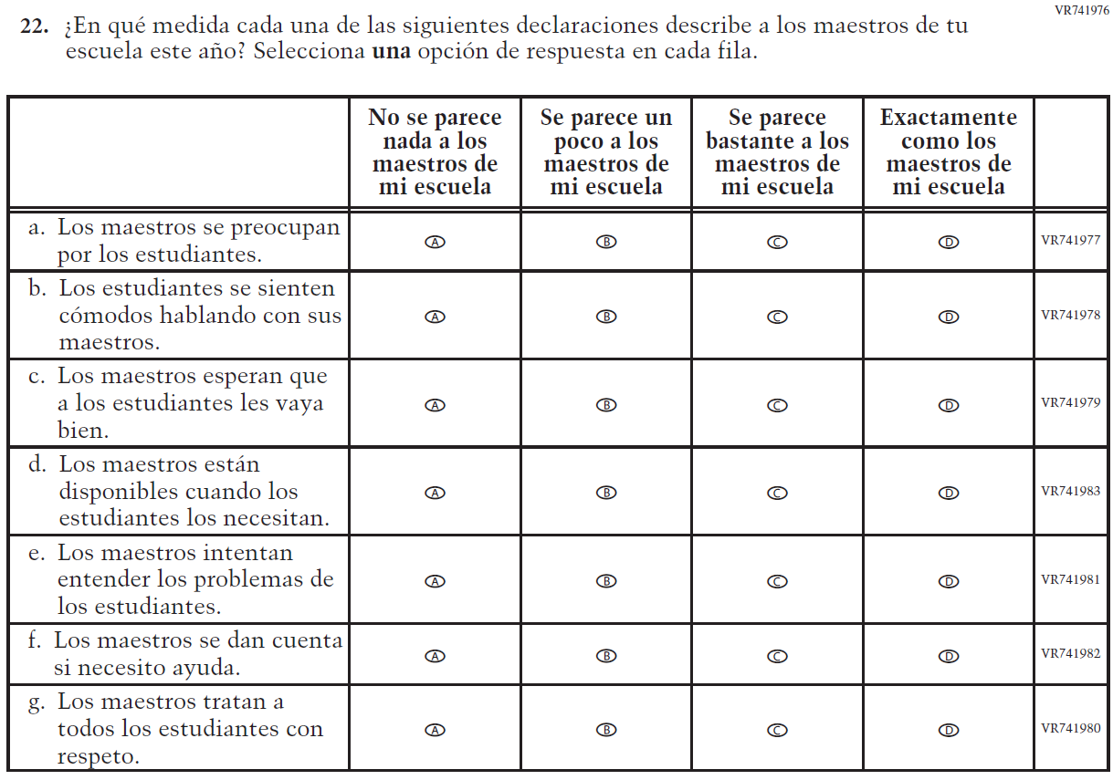  Issue: Learning Recovery | A | To address gaps in learning that have been developed due to the extended period of remote and hybrid learning that took place during the pandemic.

Appendix J-1c-s-BL: Operational Grade 8 CORE
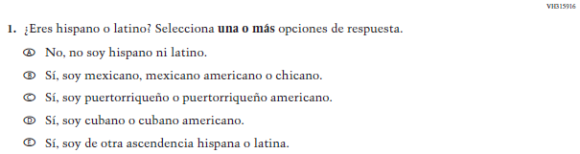

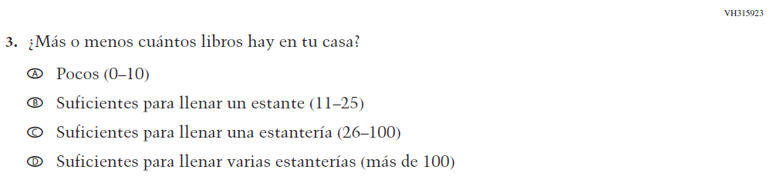

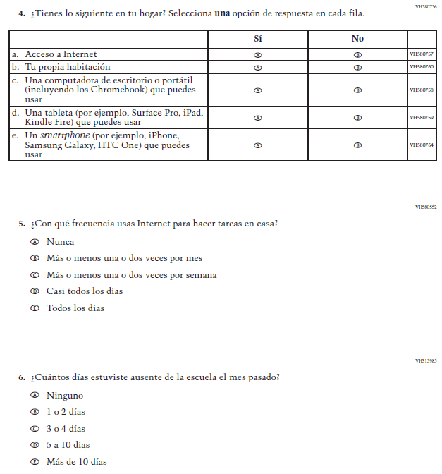

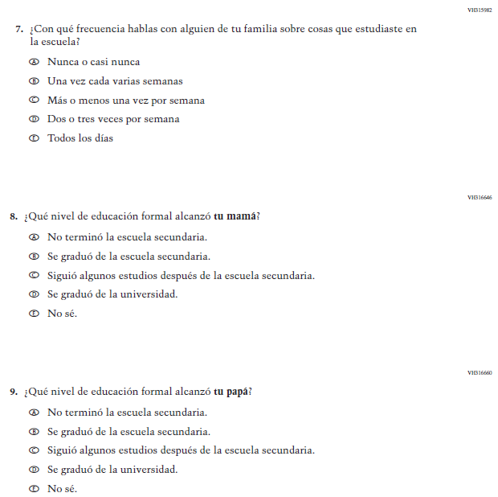

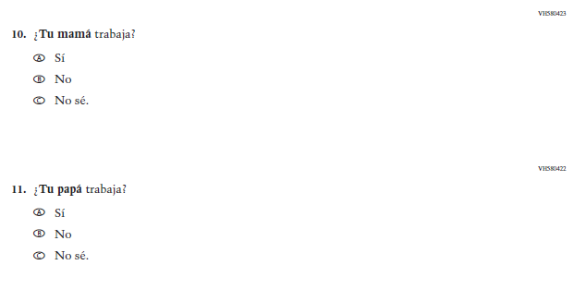

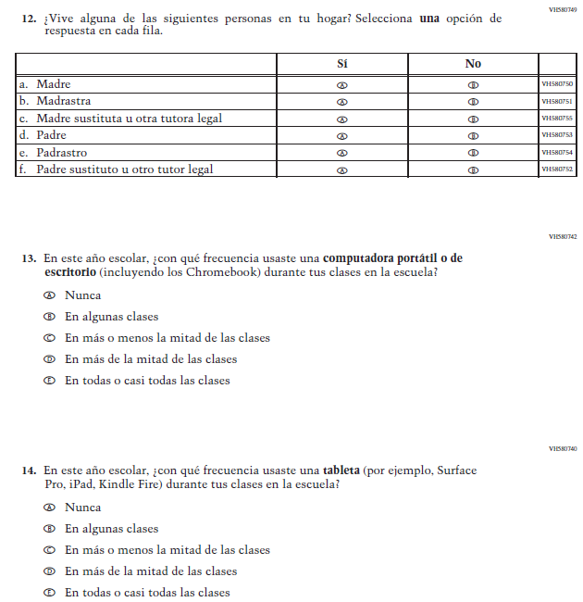

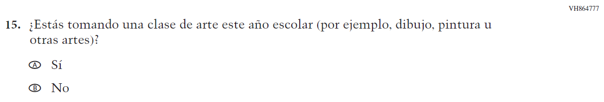

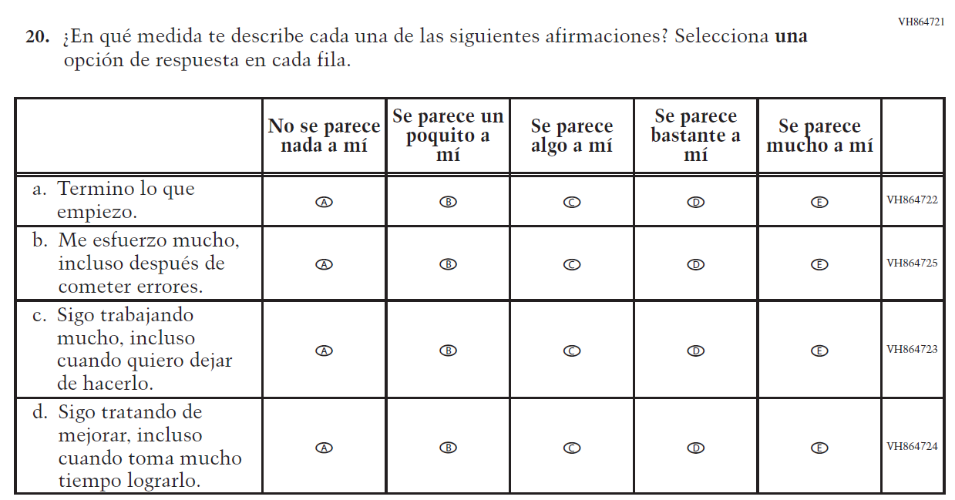

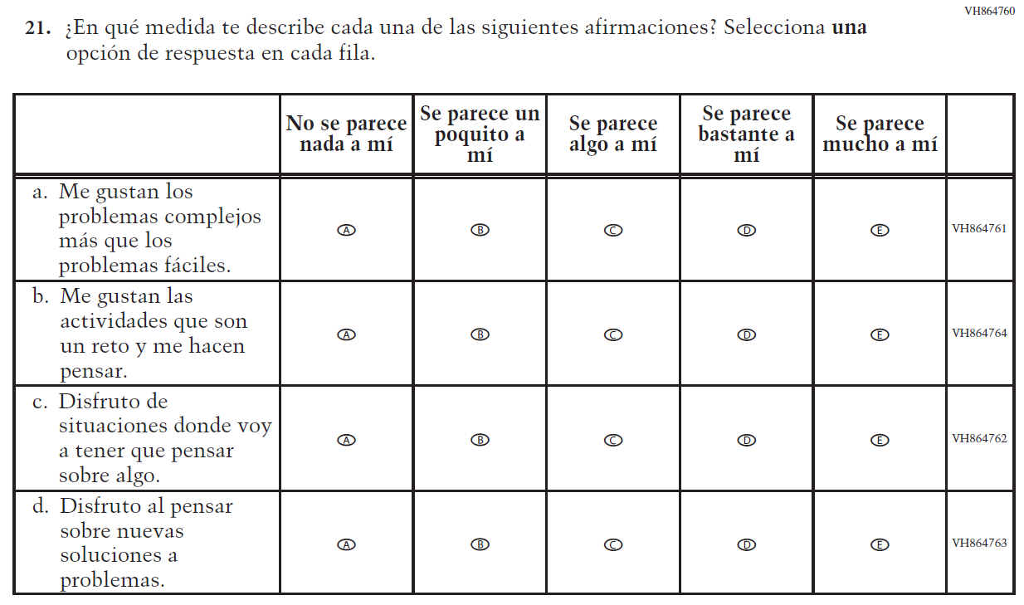

Appendix J-1d-s-PR: Summary of Changes Operational Grade 8 CORE

2024 Operational Grade 8 Core Student – Puerto Rico

Previous item | 2024 item | D/A/R/NC+ | Rationale
VH315774  (2022 Operational Grade 8 Student Core – Puerto Rico) | VH315774  Issue: Race/Ethnicity | R | Revised options b and d to align with categories used by the 2020 Census Bureau.
N/A  (2022 Operational Grade 8 Student Core – Puerto Rico) | VR741839  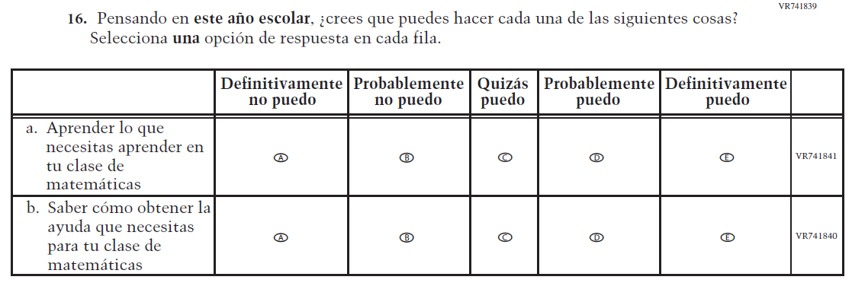  Issue: Learning Recovery | A | To address gaps in learning that have been developed due to the extended period of remote and hybrid learning that took place during the pandemic.
N/A  (2022 Operational Grade 8 Student Core – Puerto Rico) | VR741854  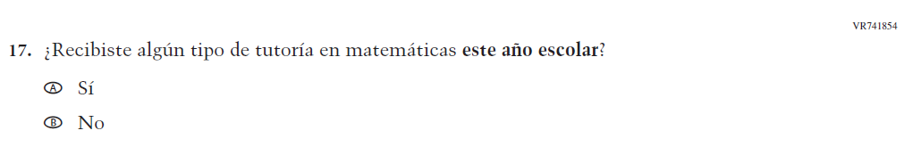  Issue: Learning Recovery | A | To address gaps in learning that have been developed due to the extended period of remote and hybrid learning that took place during the pandemic.

2024 Operational Grade 8 Core Student – Puerto Rico

Previous item | 2024 item | D/A/R/NC+ | Rationale
VH580061  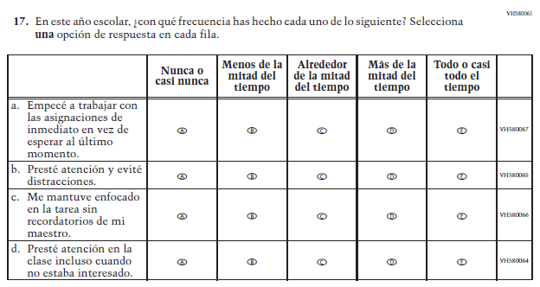  (2022 Operational Grade 8 Student Core – Puerto Rico) | N/A  Issue: Grit | D | To keep student burden low, this item was dropped.
N/A  (2022 Operational Grade 8 Student Core – Puerto Rico) | VR741954  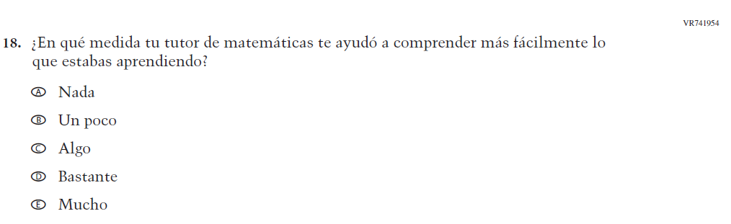  Issue: Learning Recovery | A | To address gaps in learning that have been developed due to the extended period of remote and hybrid learning that took place during the pandemic.

2024 Operational Grade 8 Core Student – Puerto Rico

Previous item | 2024 item | D/A/R/NC+ | Rationale
N/A  (2022 Operational Grade 8 Student Core – Puerto Rico) | VR741958  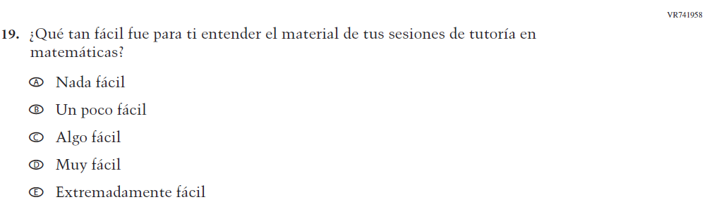  Issue: Learning Recovery | A | To address gaps in learning that have been developed due to the extended period of remote and hybrid learning that took place during the pandemic.
N/A  (2022 Operational Grade 8 Student Core – Puerto Rico) | VR741960  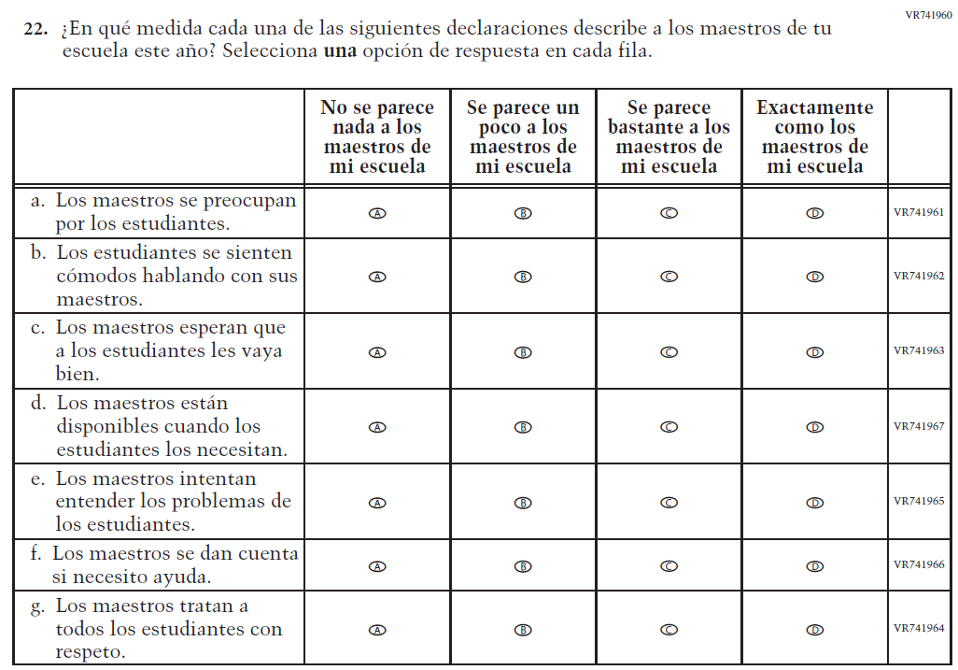  Issue: Learning Recovery |  | To address gaps in learning that have been developed due to the extended period of remote and hybrid learning that took place during the pandemic.

Appendix J-1d-s-PR: Operational Grade 8 CORE

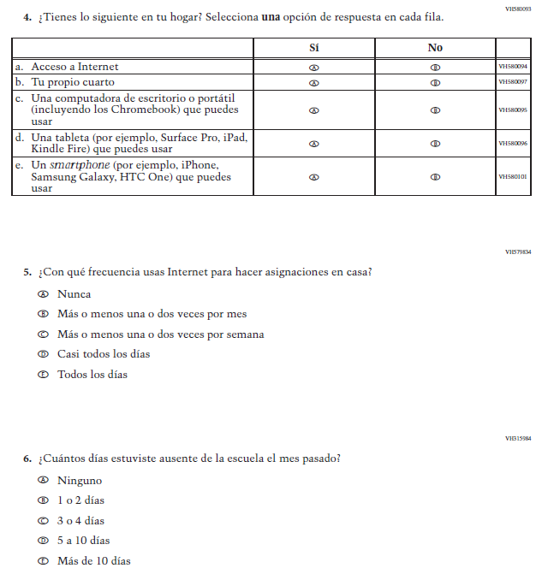

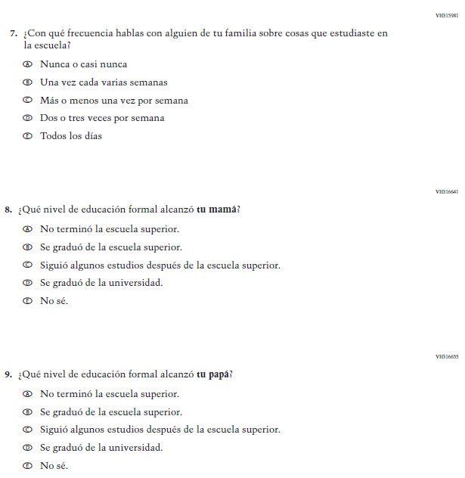

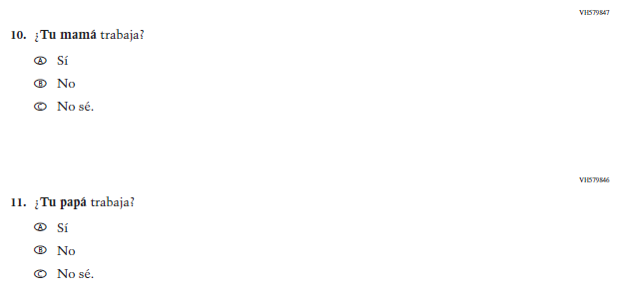

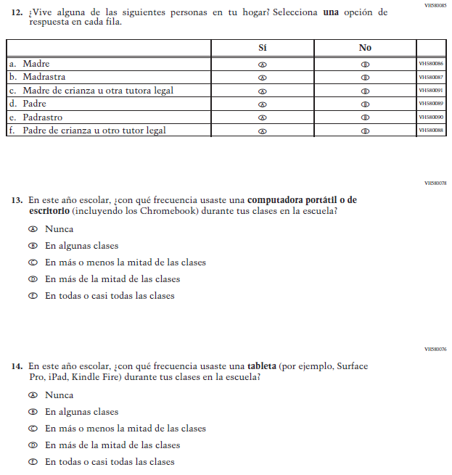

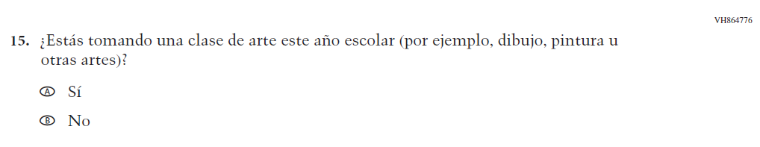

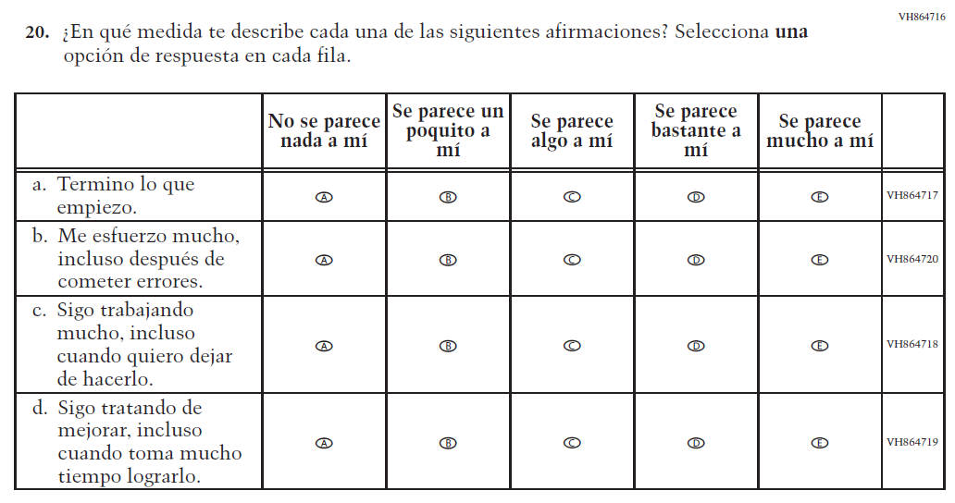

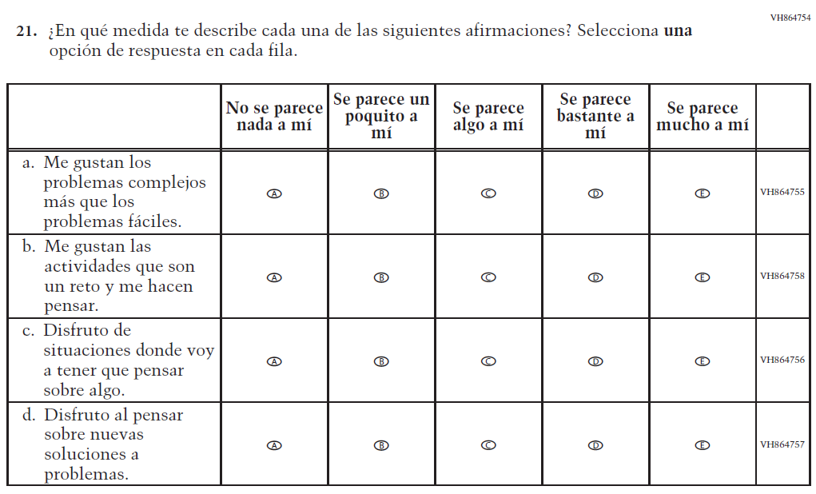

Appendix J-1e-s-BL: Summary of Changes Operational Grade 4 Mathematics

2024 Operational Grade 4 Mathematics Student – Bilingual

Previous item | 2024 item | D/A/ R/NC+ | Rationale
VH580426  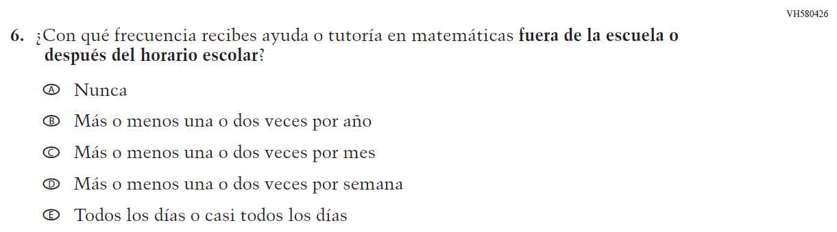  (2022 Operational Grade 4 Student Mathematics – Puerto Rico) | N/A | D | To keep student burden low, this item was dropped.

Appendix J-1e-s-BL: Operational Grade 4 Mathematics

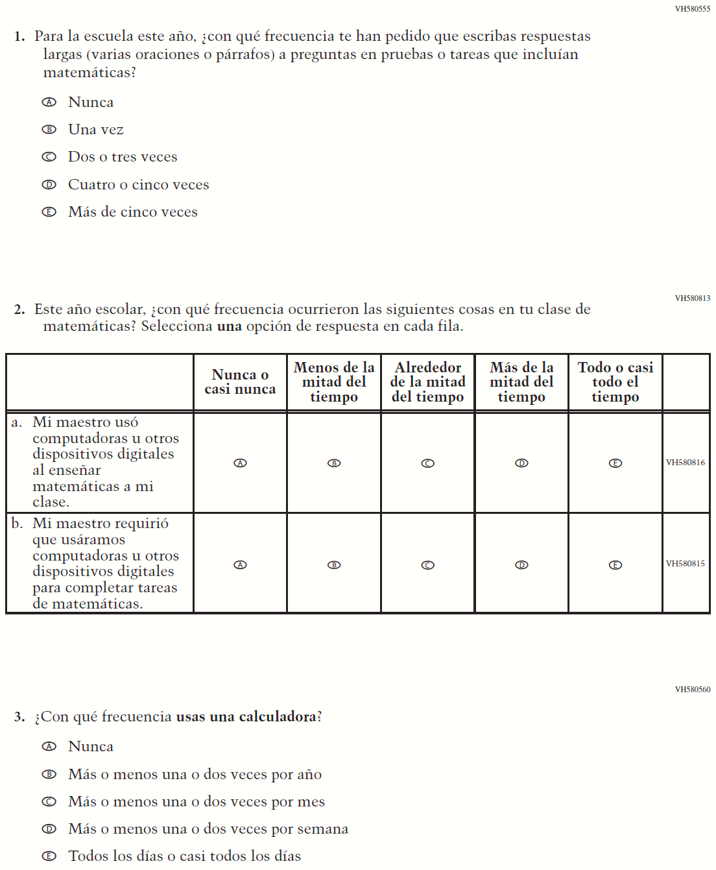

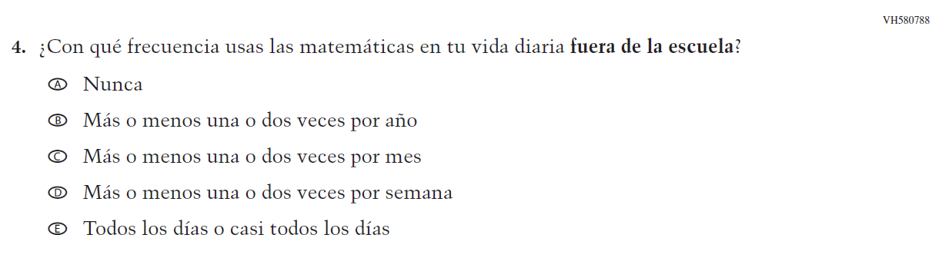

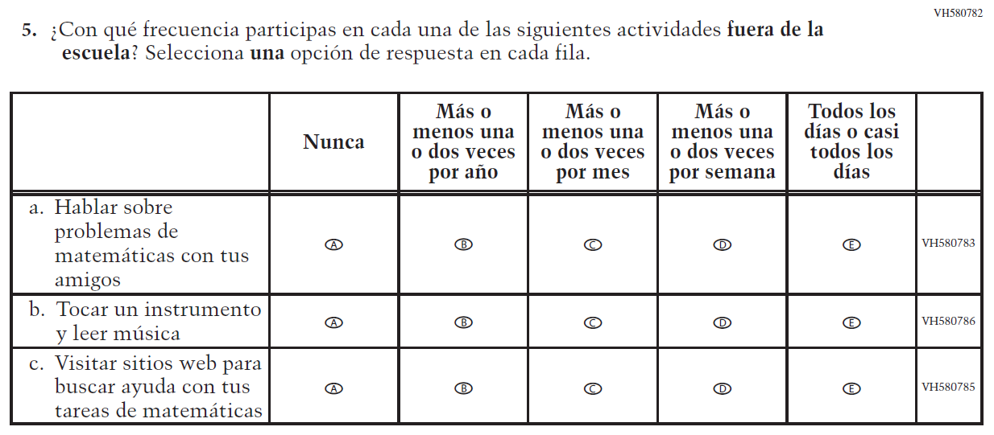

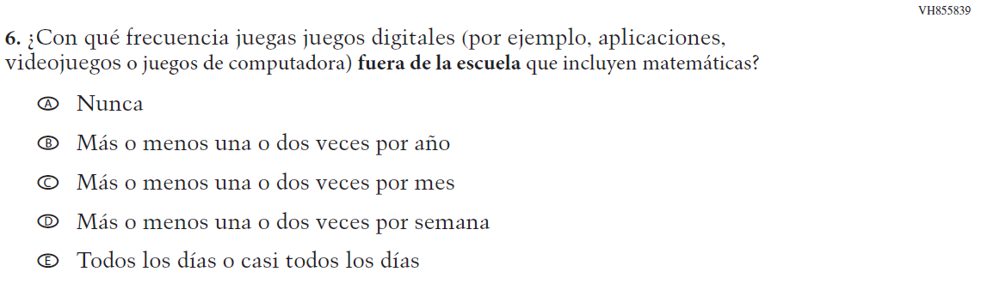

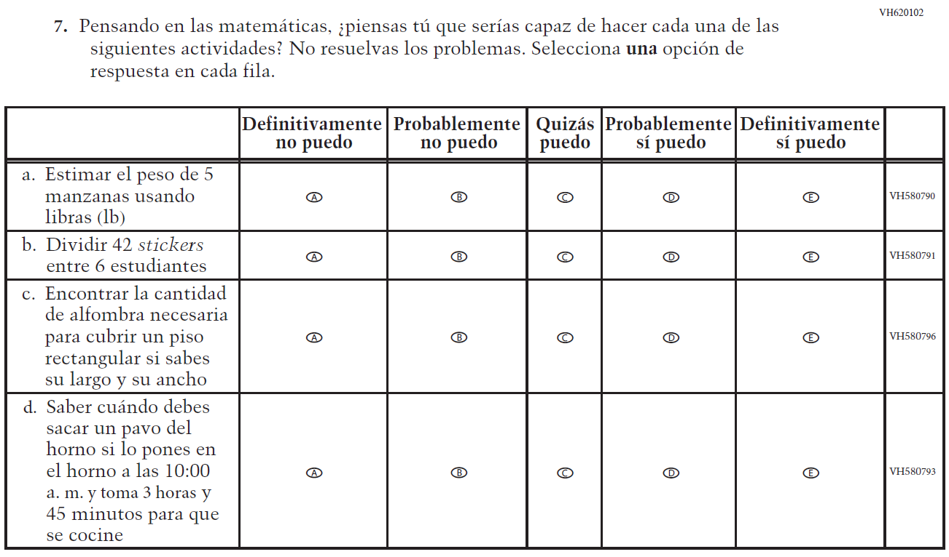

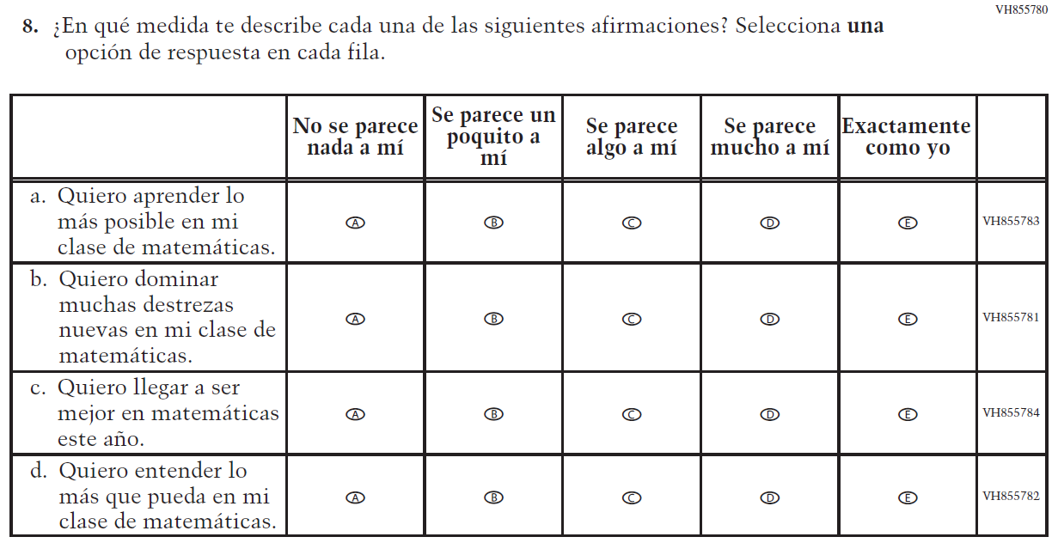

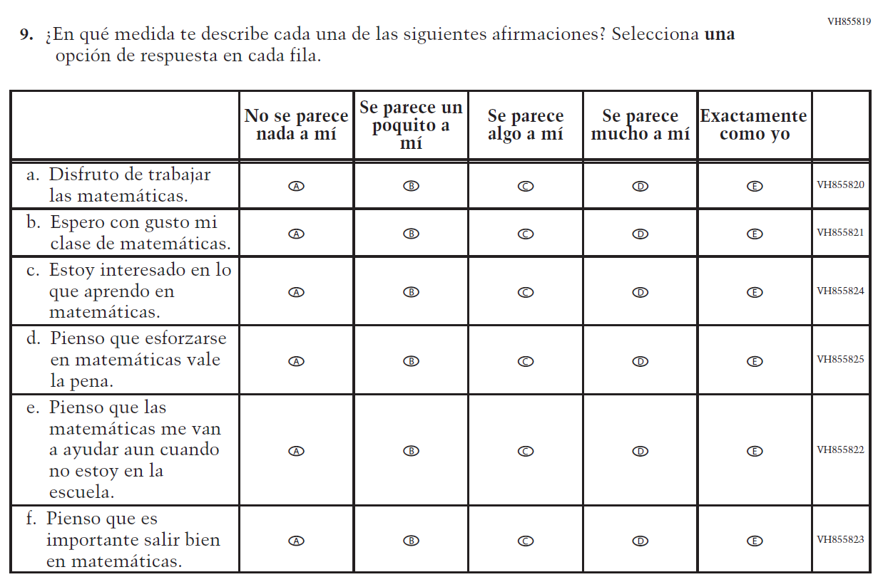

Appendix J-1f-s-PR: Summary of Changes Operational Grade 4 Mathematics

2024 Operational Grade 4 Mathematics Student – Puerto Rico

Previous item | 2024 item | D/A/ R/NC+ | Rationale
VR579850  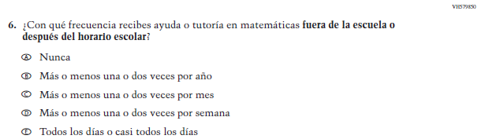  (2022 Operational Grade 4 Student Mathematics – Puerto Rico) | N/A | D | To keep student burden low, this item was dropped.

Appendix J-1f-s-PR: Operational Grade 4 Mathematics

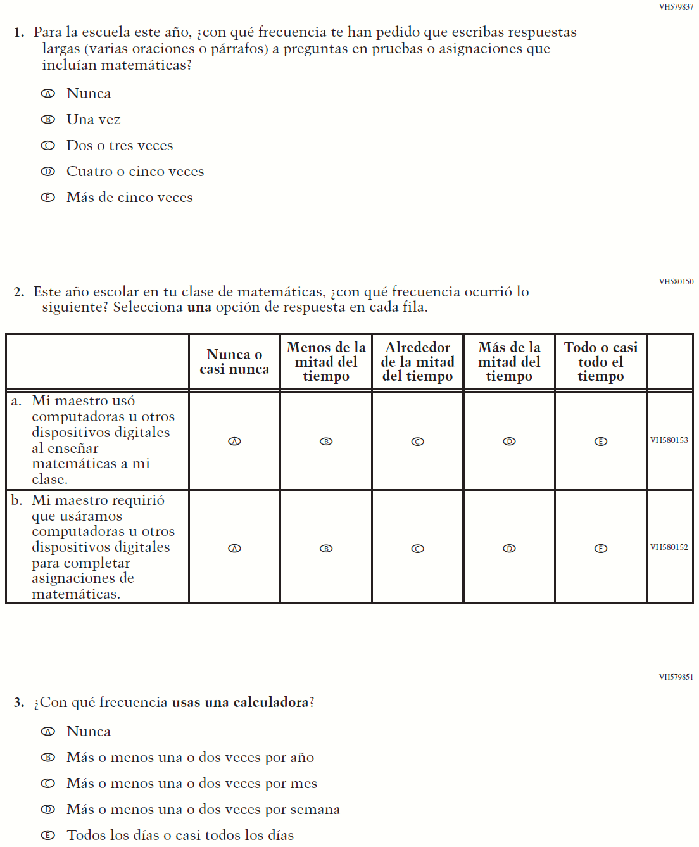

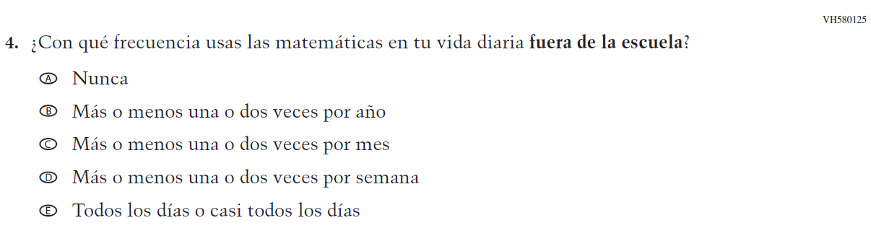

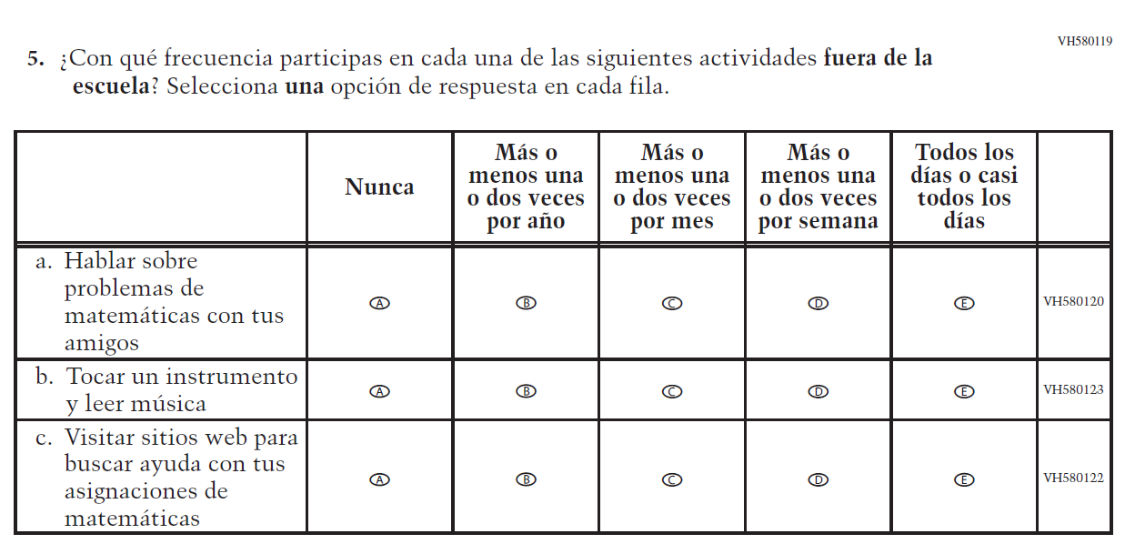

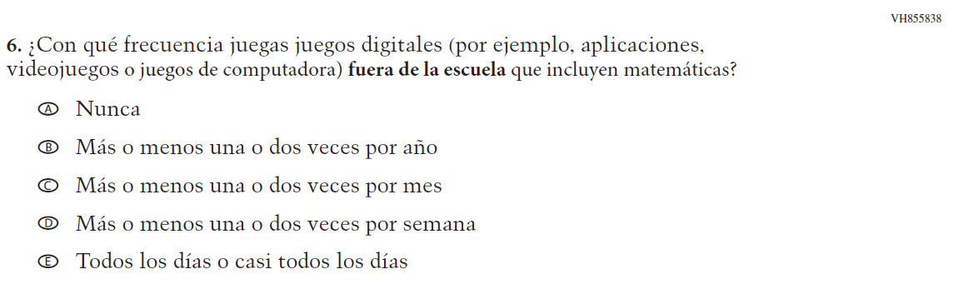

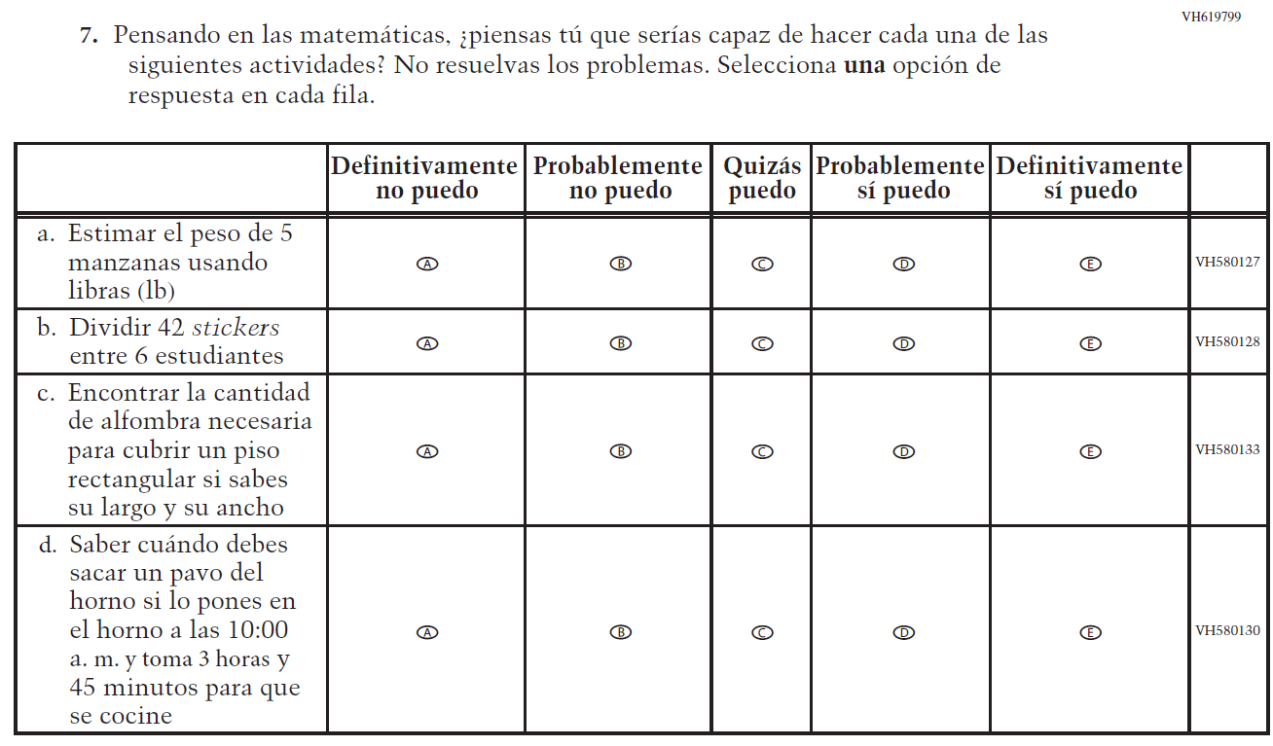

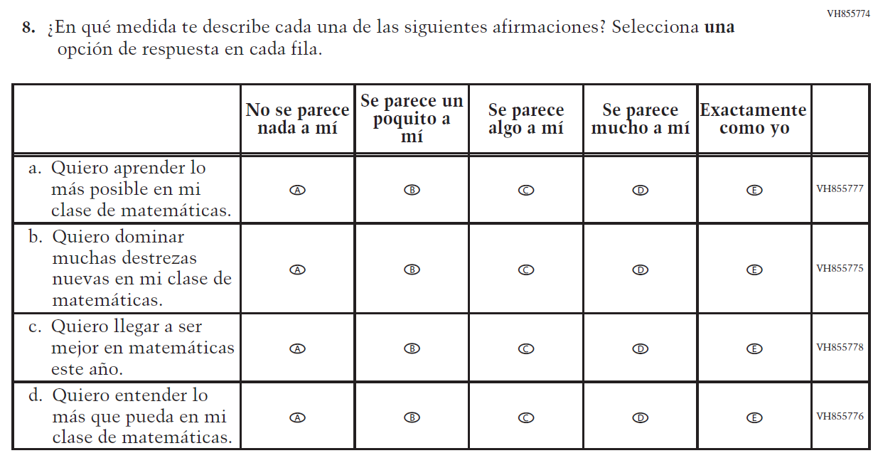

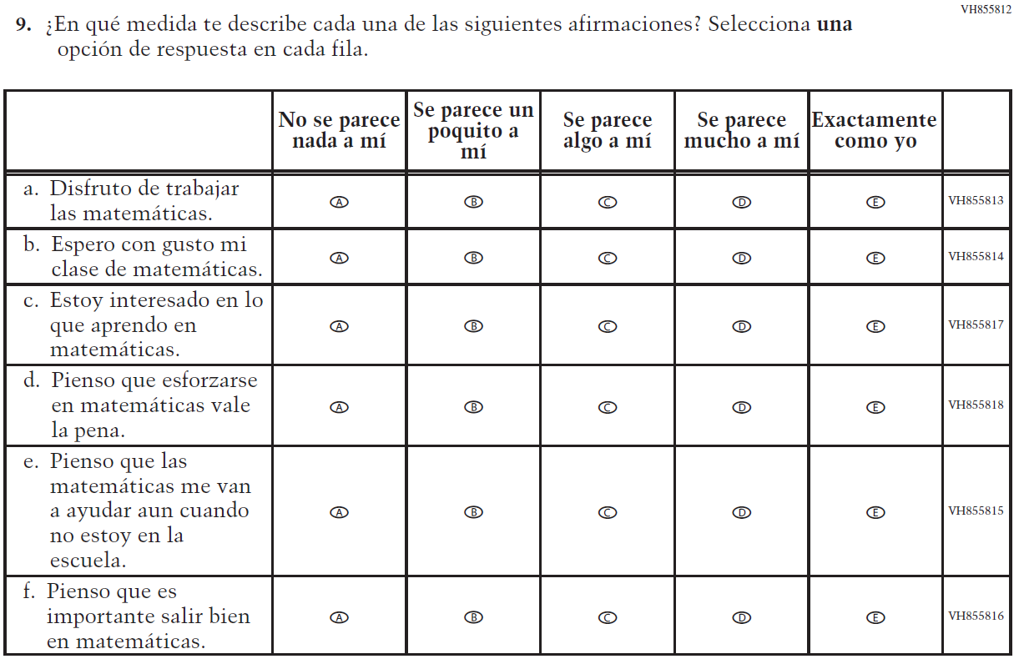

Appendix J-1g-s-BL: Summary of Changes Operational Grade 8 Mathematics
2024 Operational Grade 8 Mathematics Student – Bilingual

Previous item | 2024 item | D/A/R/NC+ | Rationale
VH606092  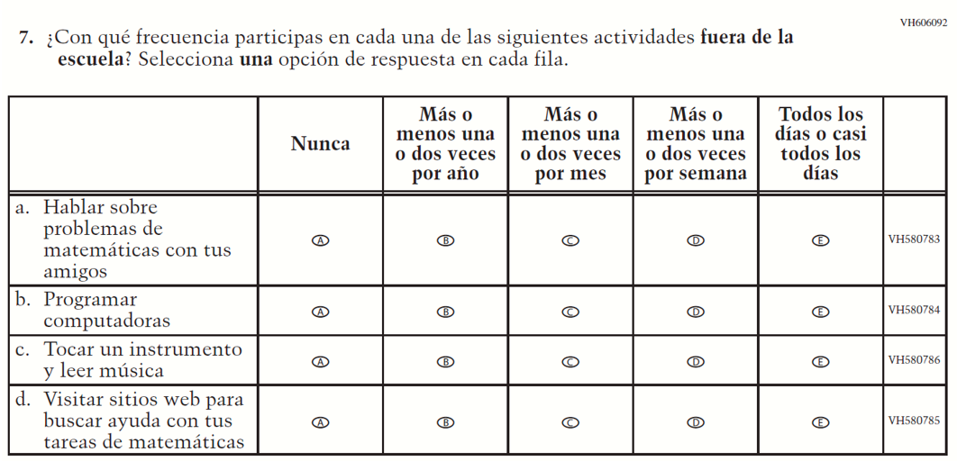  (2022 Operational Grade 8 Student Core - Bilingual) | VH606092  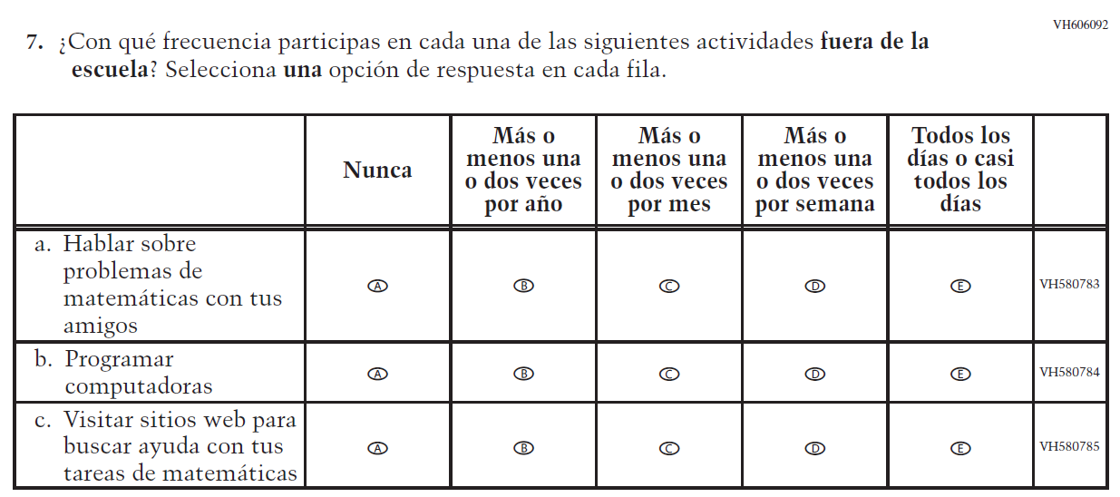  Issue: Resources for Learning and Instruction | D | To keep student burden low, sub item c was dropped.
VH580426  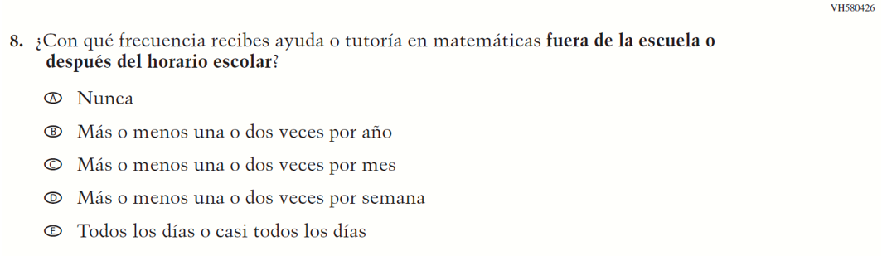  (2022 Operational Grade 8 Student Core - Bilingual) | N/A | D | To keep student burden low, this item was dropped.

2024 Operational Grade 8 Mathematics Student – Bilingual
Previous item | 2024 item | D/A/R/NC+ | Rationale
VH856109  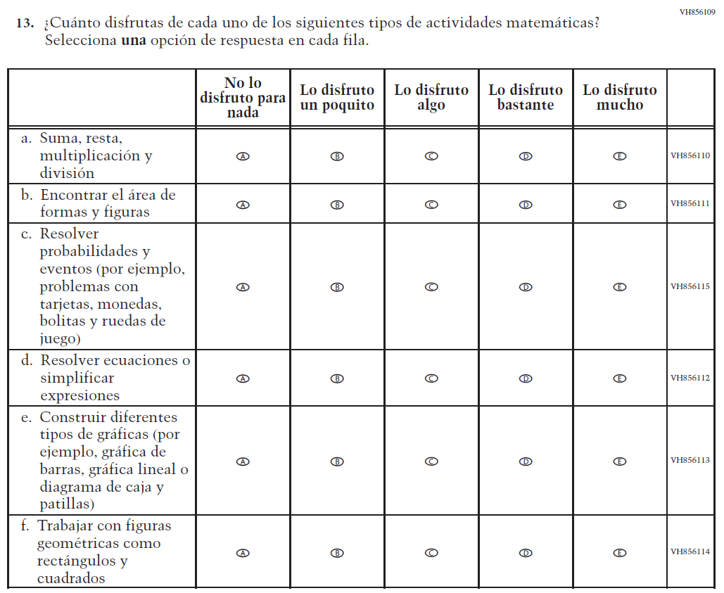  (2022 Operational Grade 8 Student Core - Bilingual) | N/A | D | To keep student burden low, this item was dropped.

Appendix J-1g-s-BL: Operational Grade 8 Mathematics
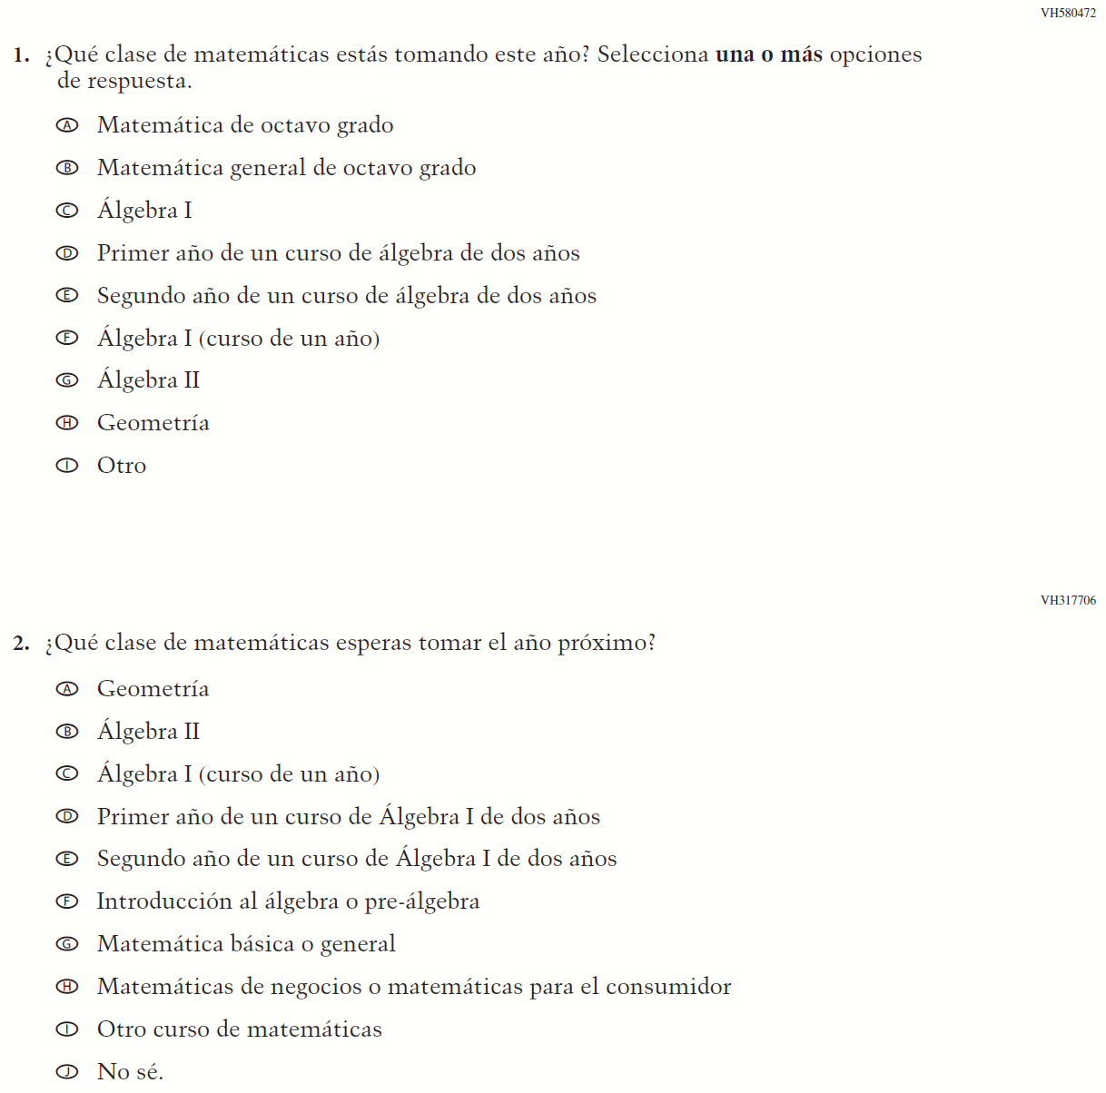

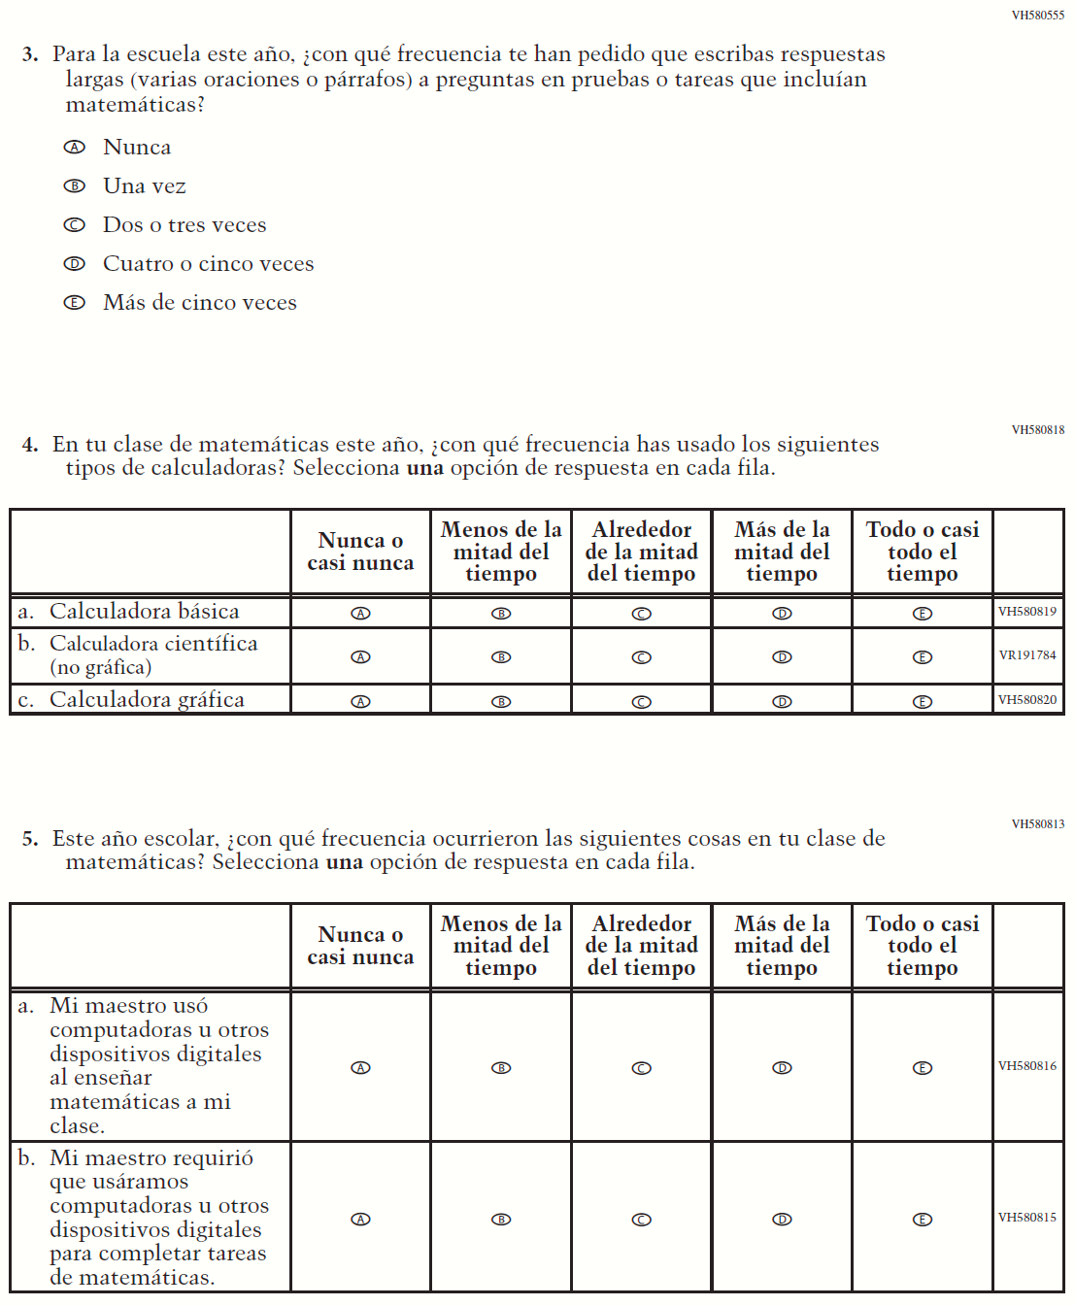

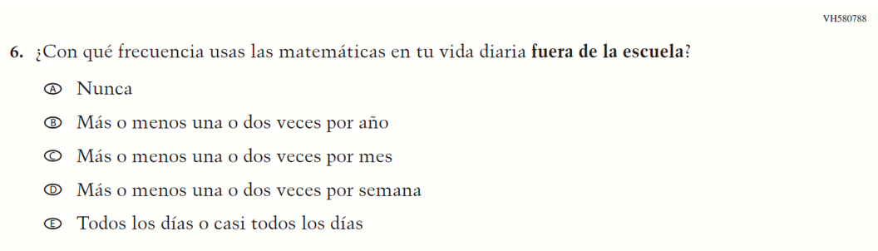

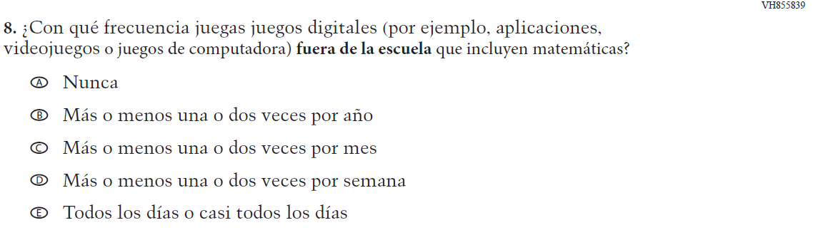

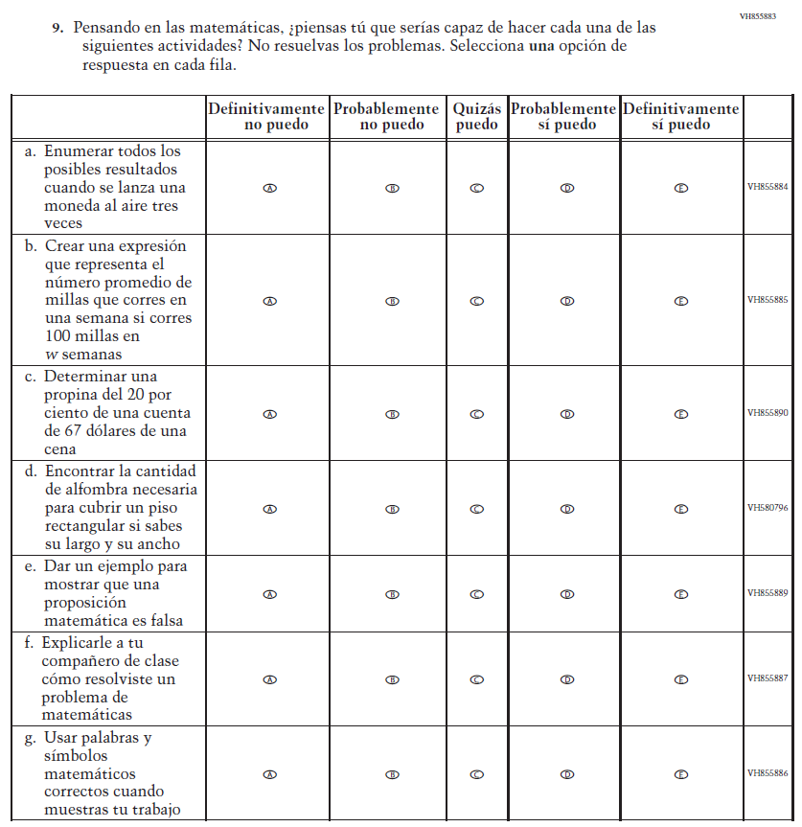

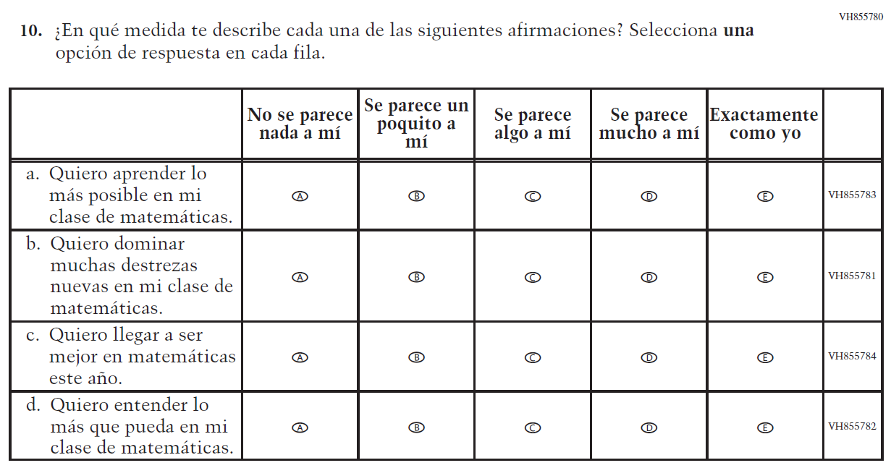

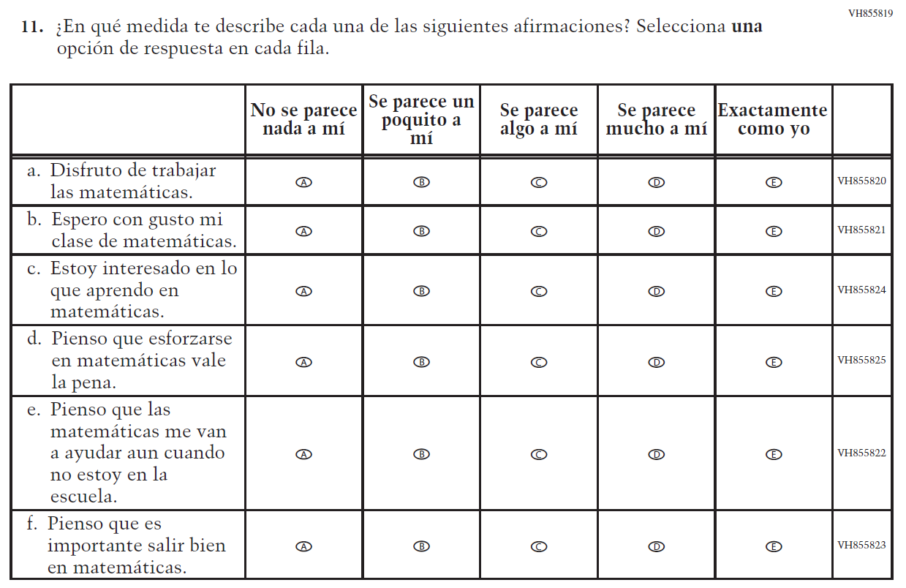

Appendix J-1h-s-PR: Summary of Changes Operational Grade 8 Mathematics
2024 Operational Grade 8 Mathematics Student – Puerto Rico

Previous item | 2024 item | D/A/ R/NC+ | Rationale
VH606084  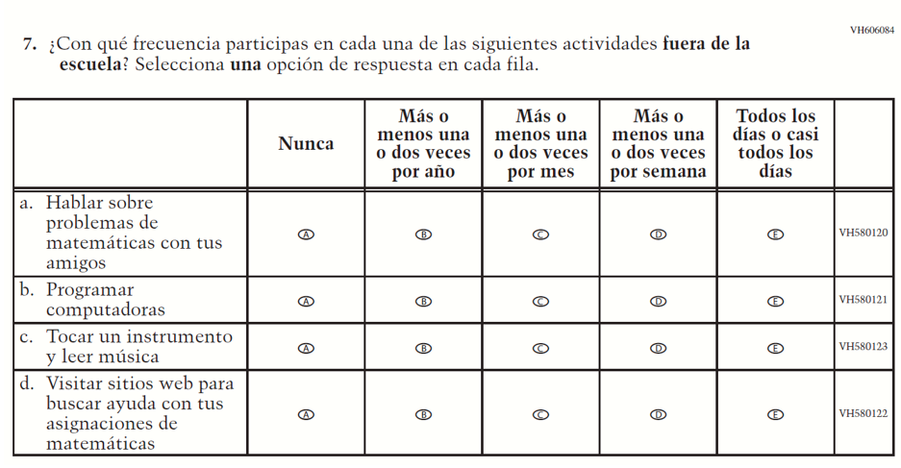  (2022 Operational Grade 8 Student Core – Puerto Rico) | VH606084  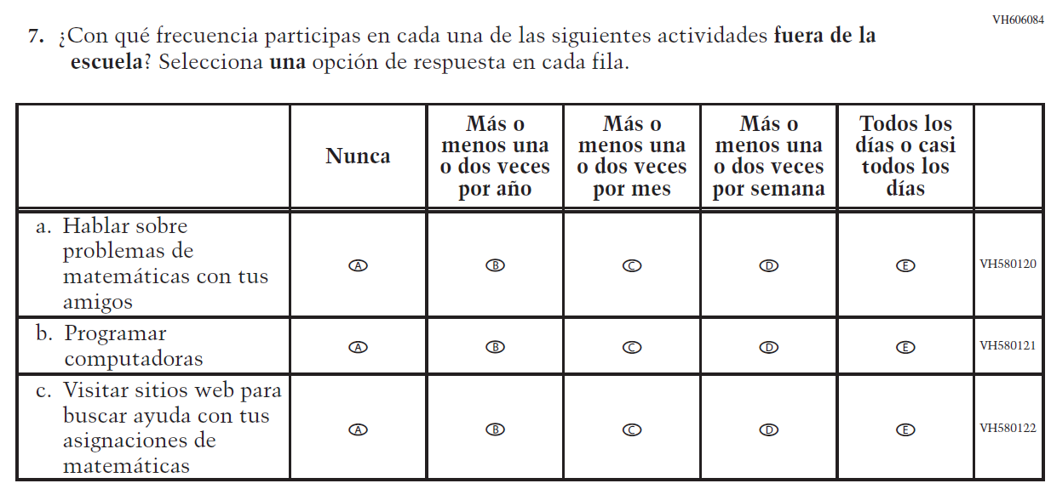  Issue: Resources for Learning and Instruction | D | To keep student burden low, sub item c was dropped.
VH579850  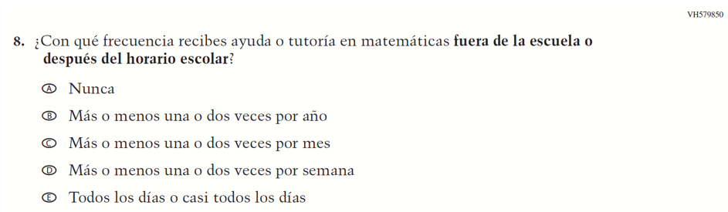  (2022 Operational Grade 8 Student Core – Puerto Rico) | N/A | D | To keep student burden low, this item was dropped.
2024 Operational Grade 8 Mathematics Student – Puerto Rico

Previous item | 2024 item | D/A/ R/NC+ | Rationale
VH856102  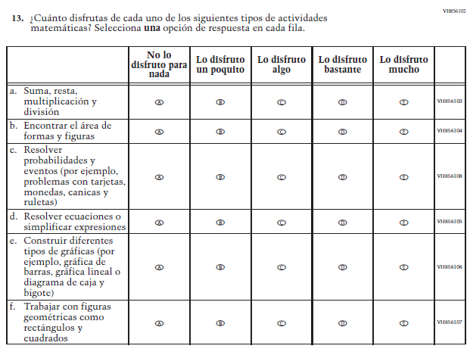  (2022 Operational Grade 8 Student Core – Puerto Rico) | N/A | D | To keep student burden low, this item was dropped.

Appendix J-1h-s-PR: Operational Grade 8 Mathematics
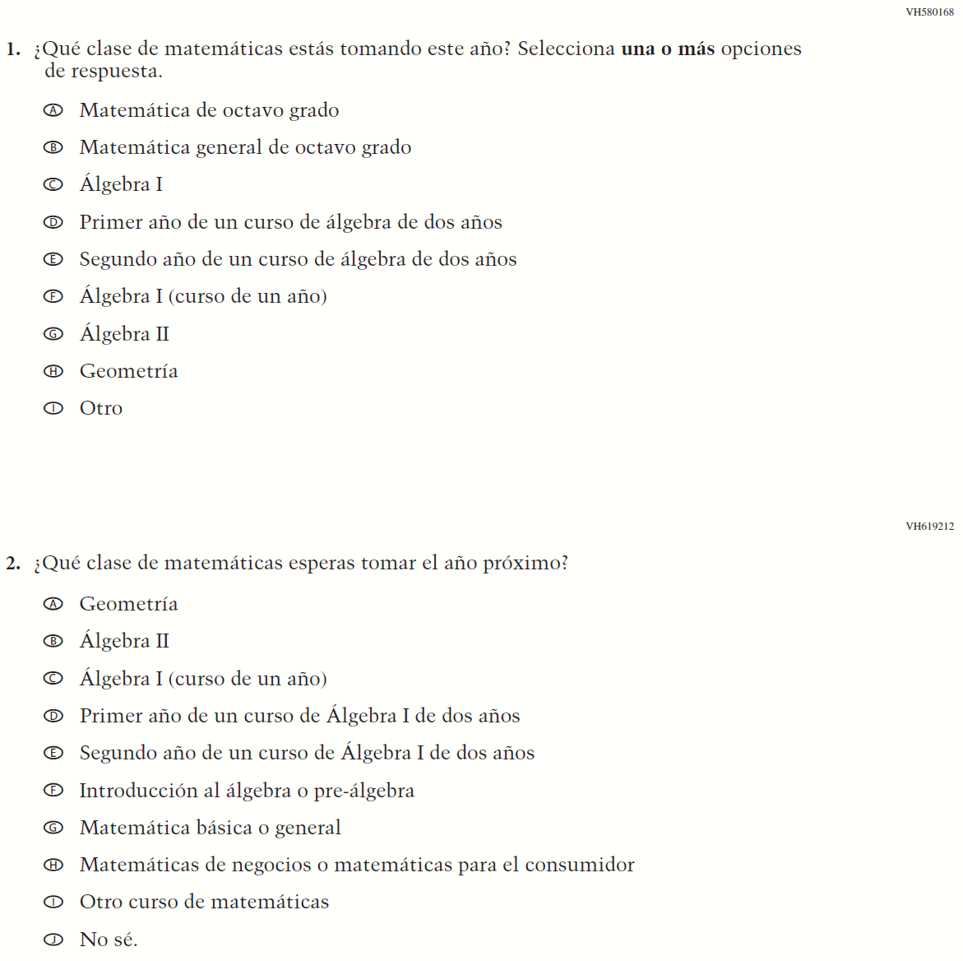

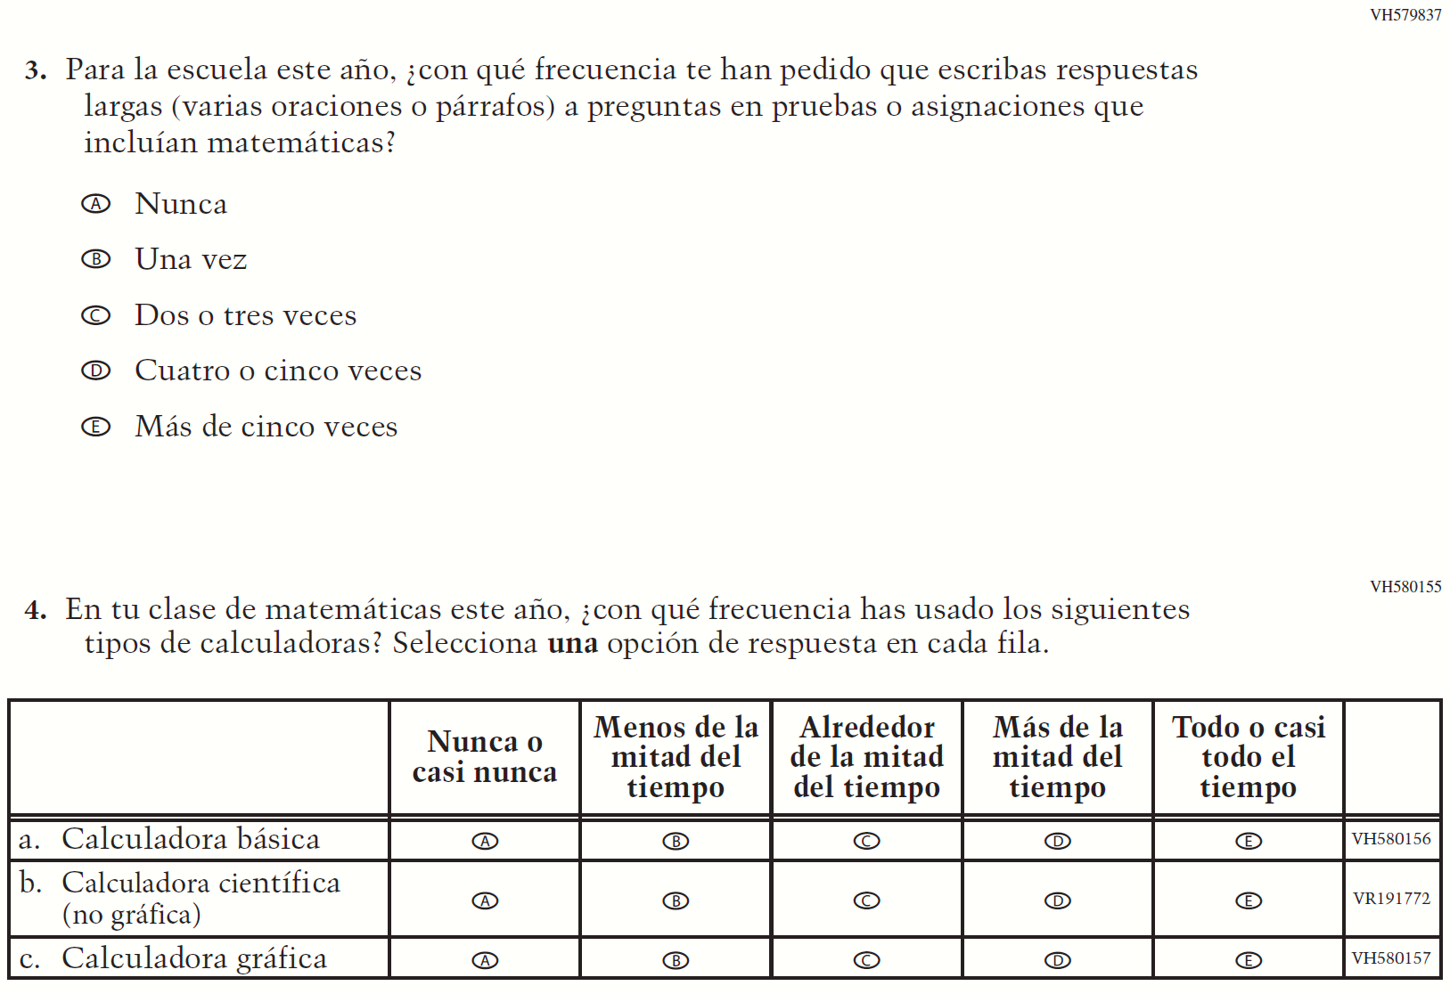

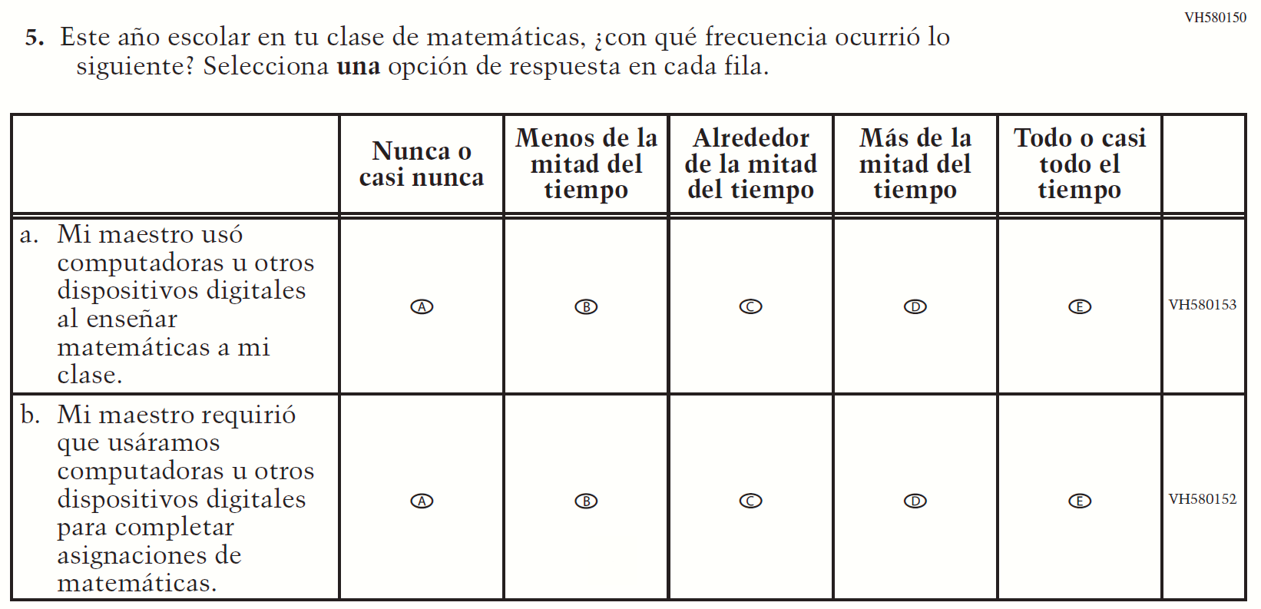

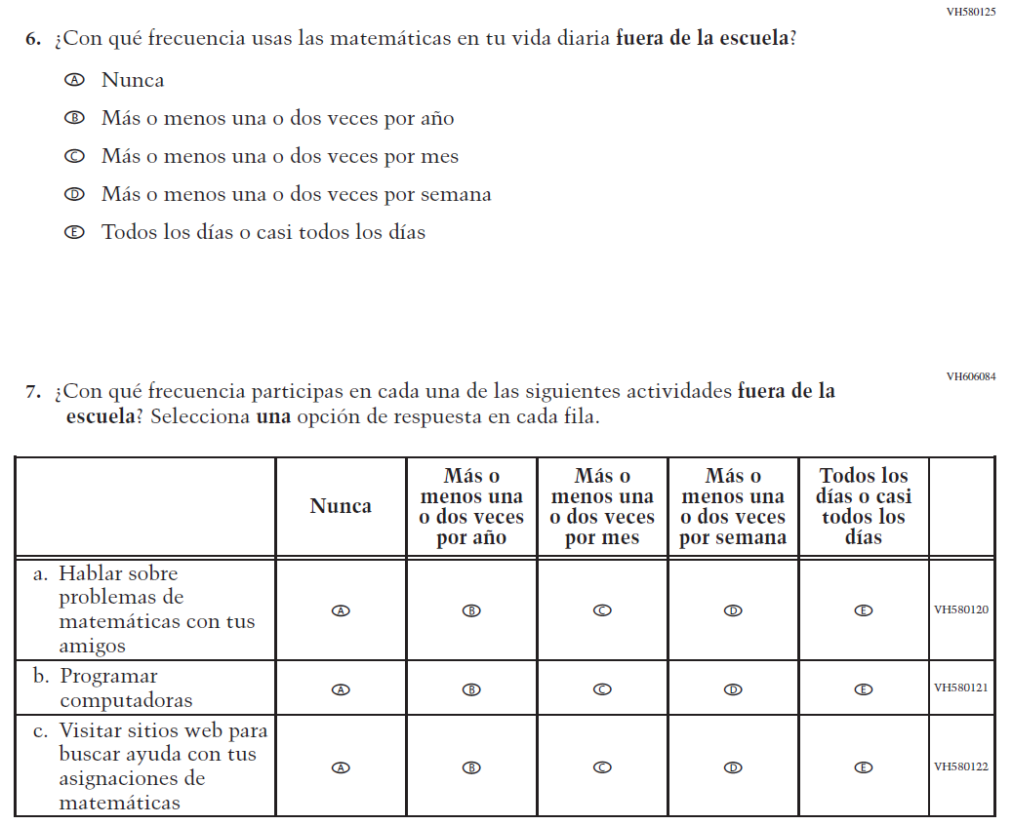

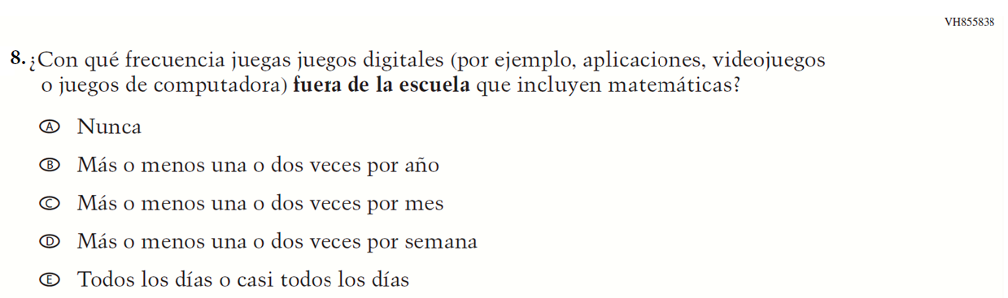

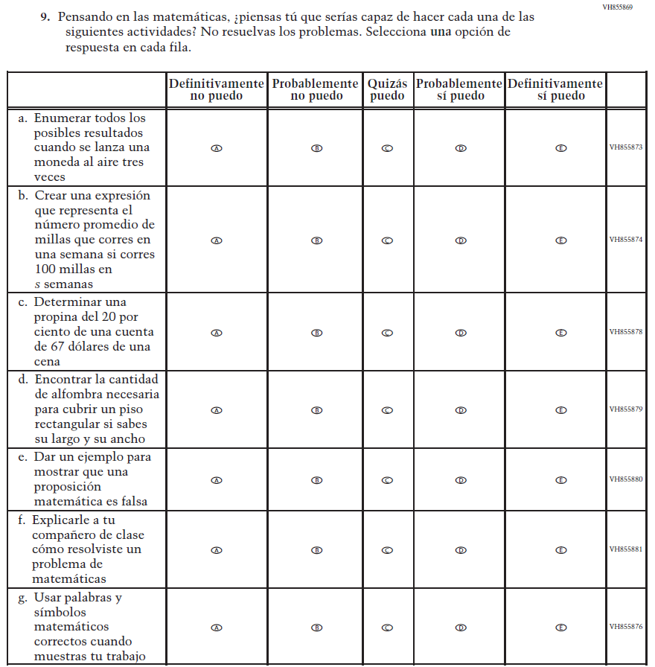

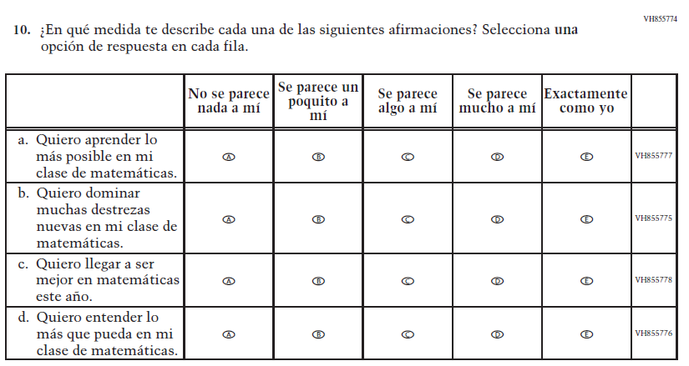

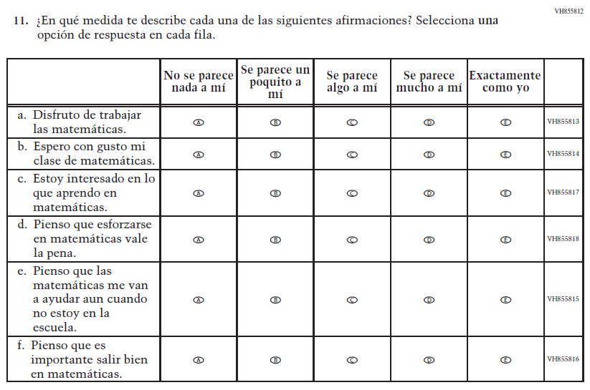

Appendix J-1i-s-BL: Summary of Changes Operational Grade 4 Reading
2024 Operational Grade 4 Reading Student – Bilingual
Previous item | 2024 item | D/A/R/NC+ | Rationale
VH579911  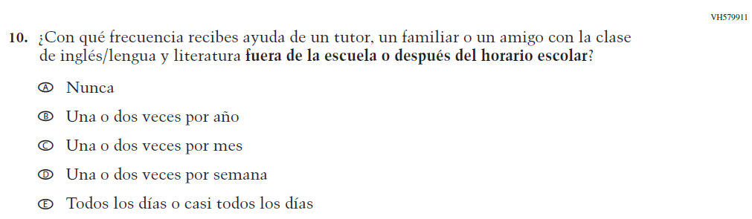  (2022 Operational Grade 8 Student Reading – Bilingual) | N/A | D | To keep student burden low, this item was dropped.

Appendix J-1i-s-BL: Operational Grade 4 Reading

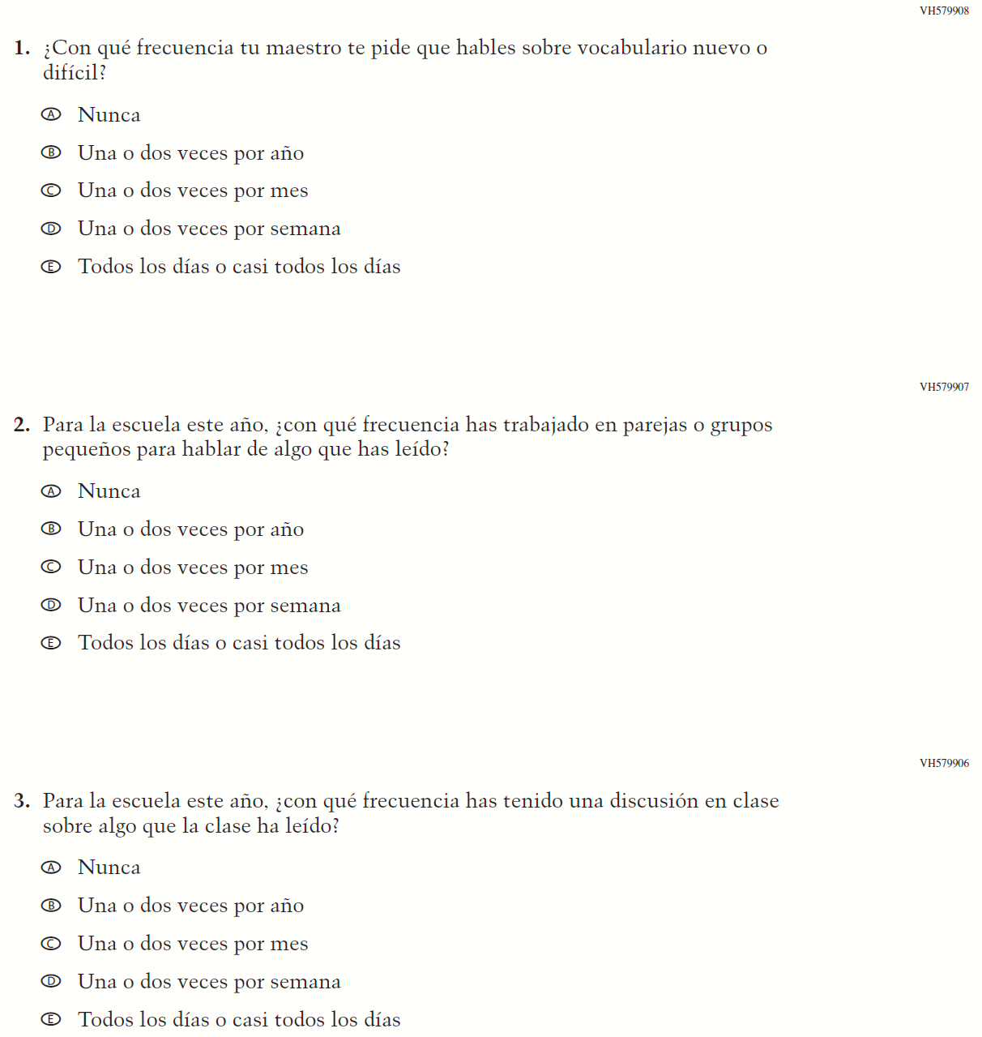

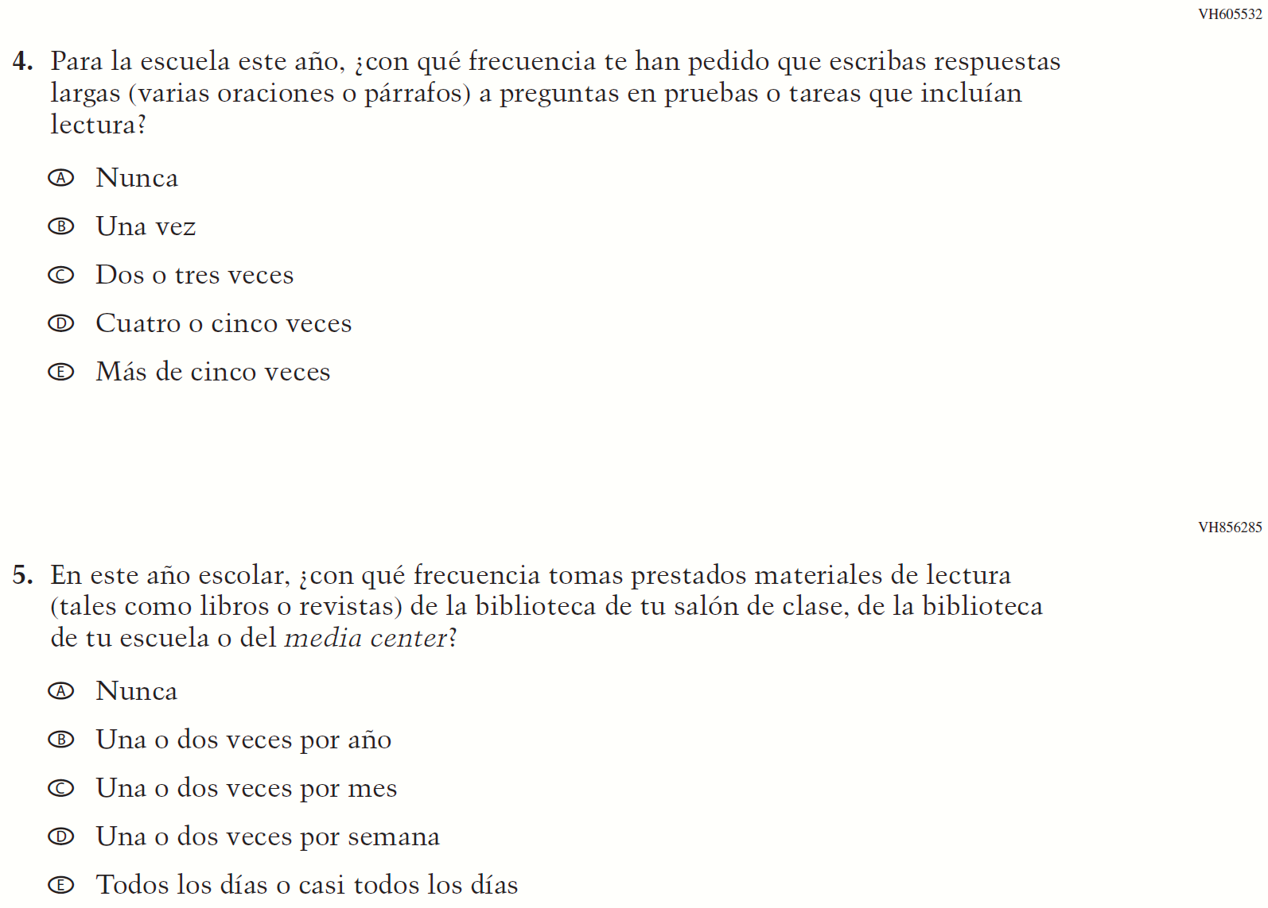

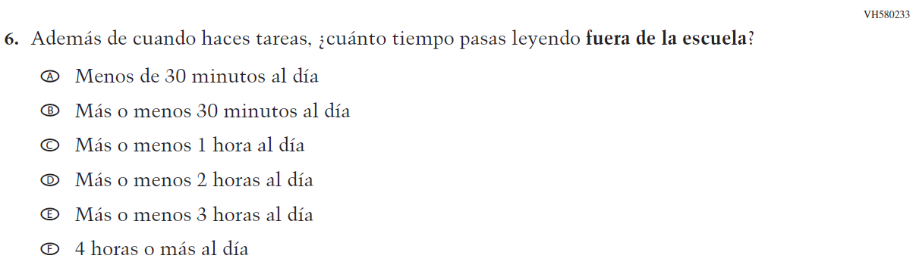

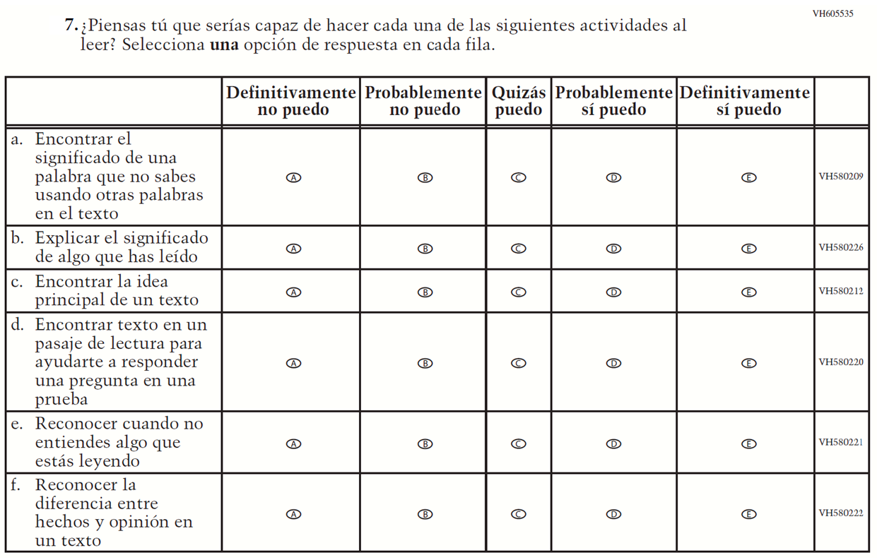

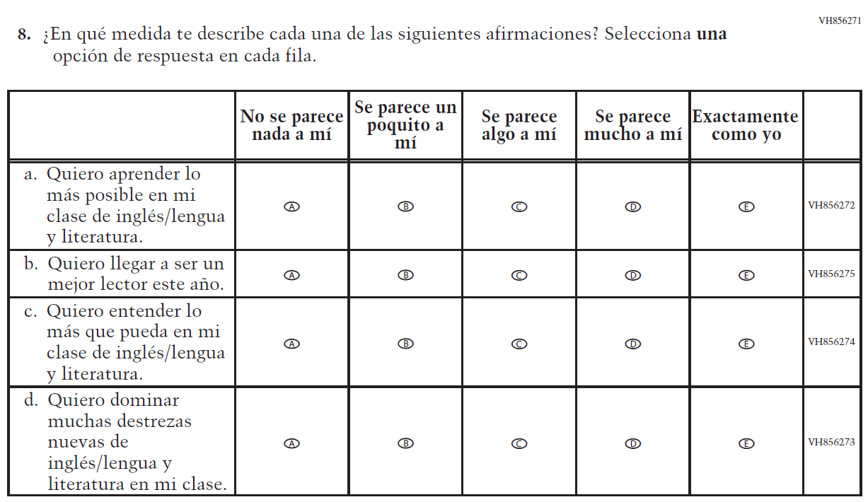

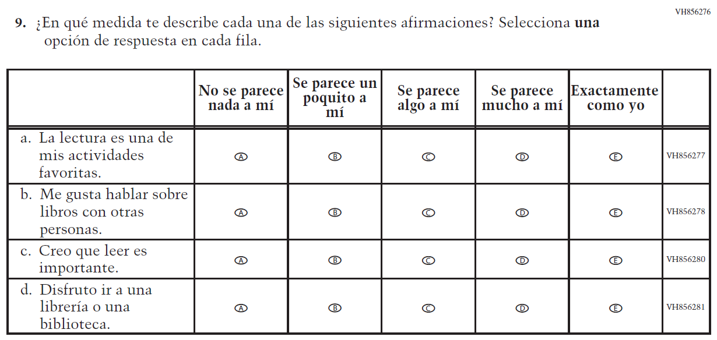

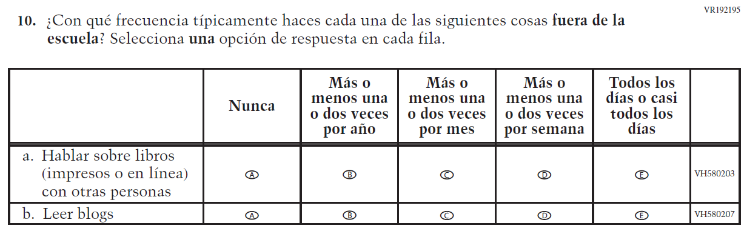

Appendix J-1j-s-BL: Summary of Changes Operational Grade 8 Reading
2024 Operational Grade 8 Reading Student – Bilingual
Previous item | 2024 item | D/A/R/NC+ | Rationale
VH580170  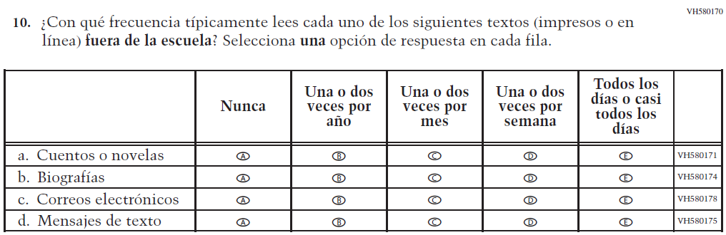  (2022 Operational Grade 8 Student Reading – Bilingual) | N/A | D | To keep student burden low, this item was dropped.
VH579911  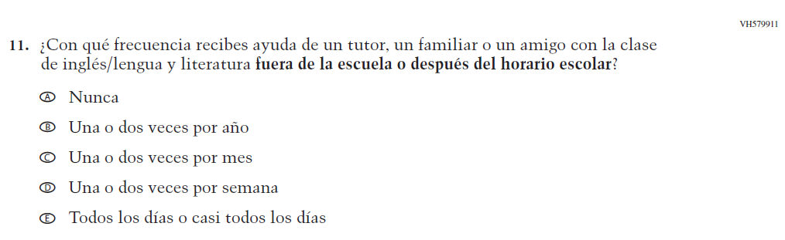  (2022 Operational Grade 8 Student Reading – Bilingual) | N/A | D | To keep student burden low, this item was dropped.

2024 Operational Grade 8 Reading Student – Bilingual
Previous item | 2024 item | D/A/R/NC+ | Rationale
VH580202  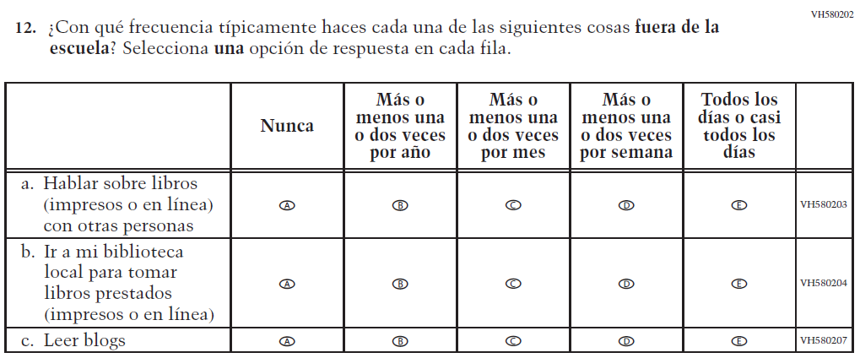  (2022 Operational Grade 8 Student Reading – Bilingual) | N/A  Issue: Student Factors | D | To keep student burden low, this item was dropped.

Appendix J-1j-s-BL: Operational Grade 8 Reading
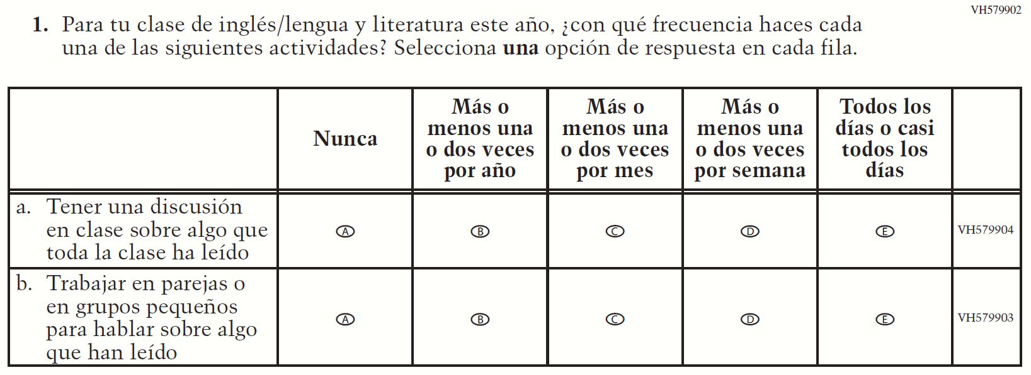

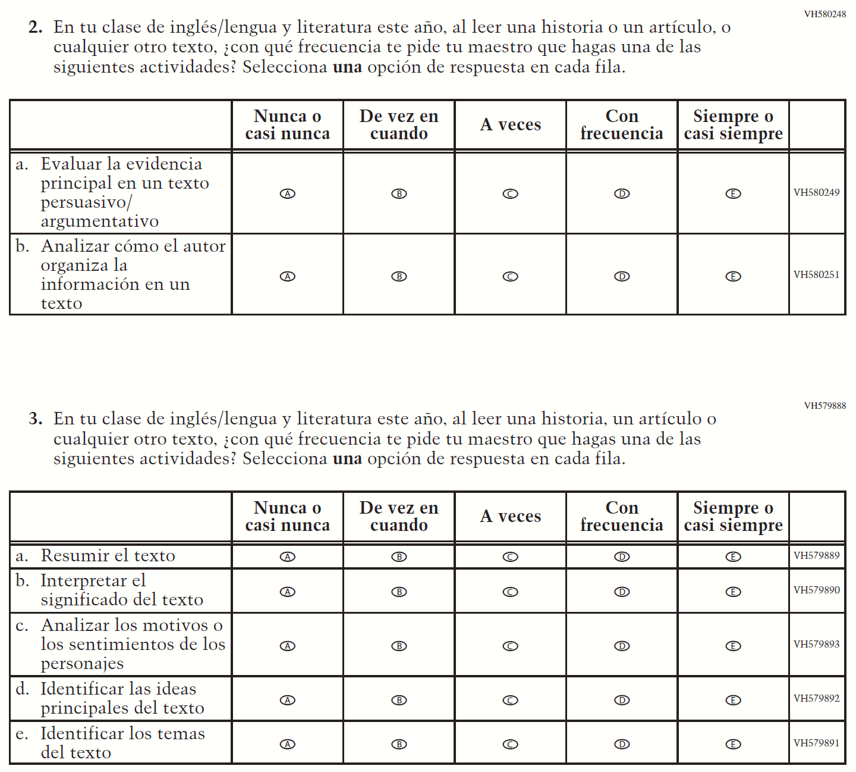

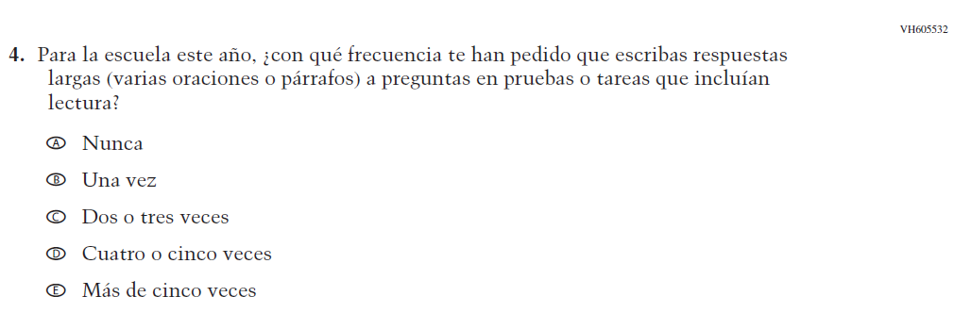

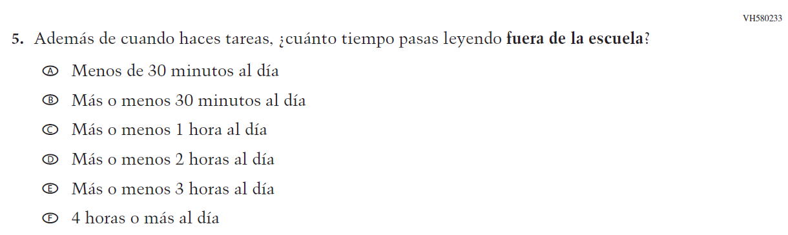
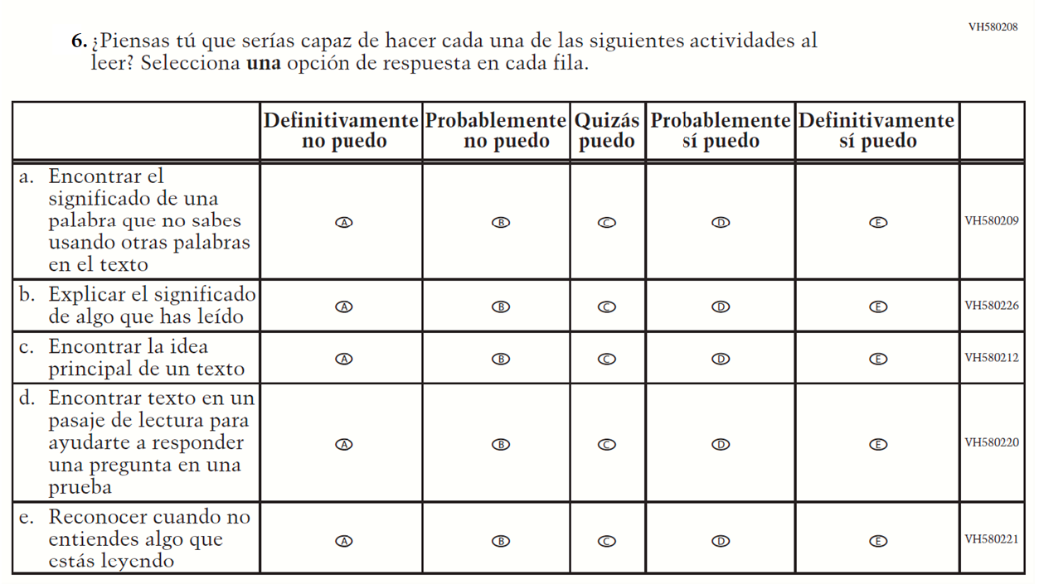

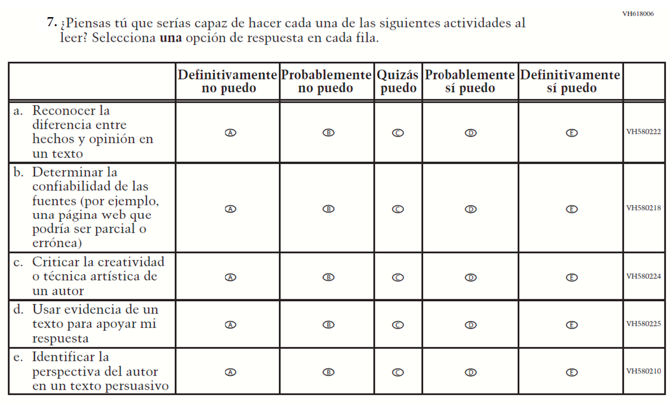

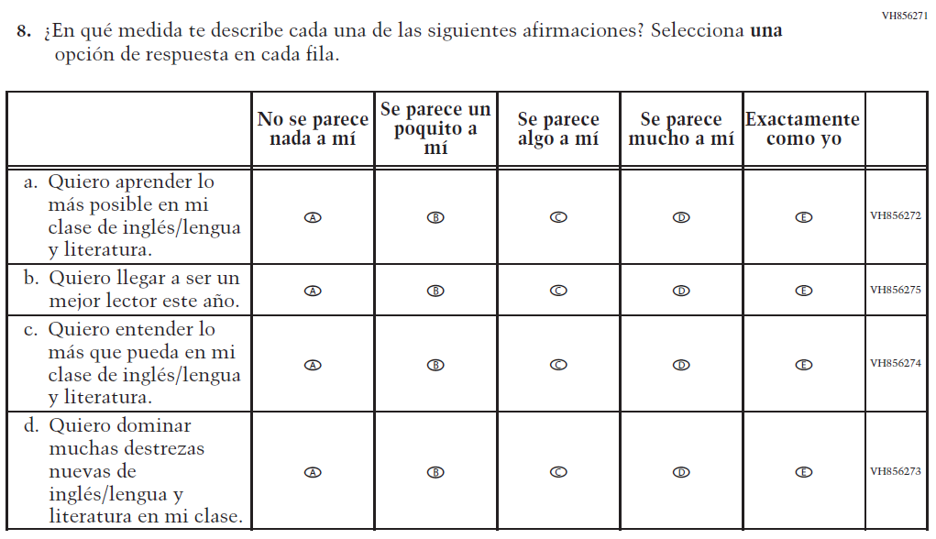

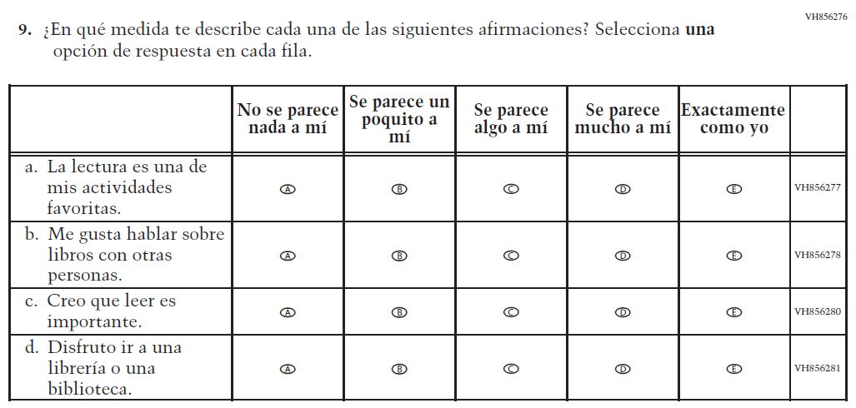

Appendix J-1k-s-BL: Operational Grade 8 Science
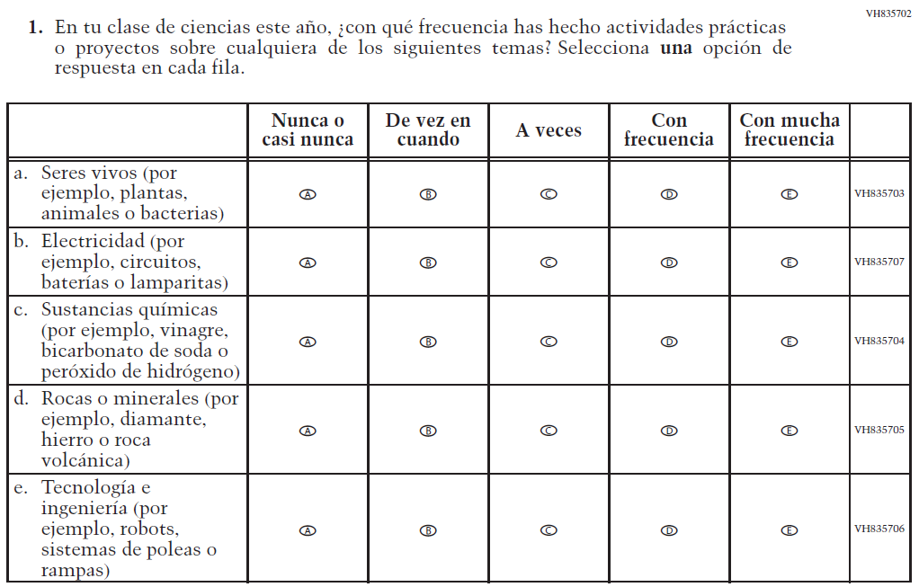

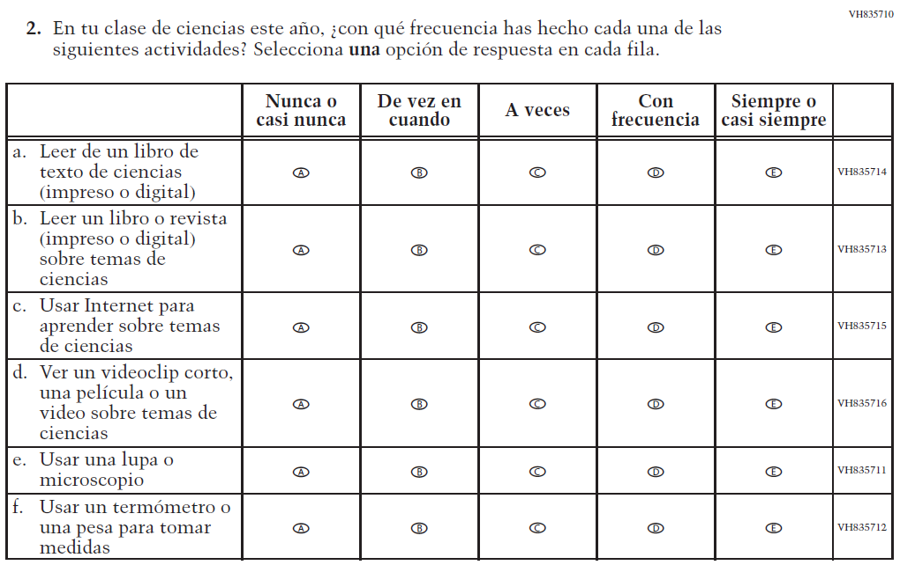

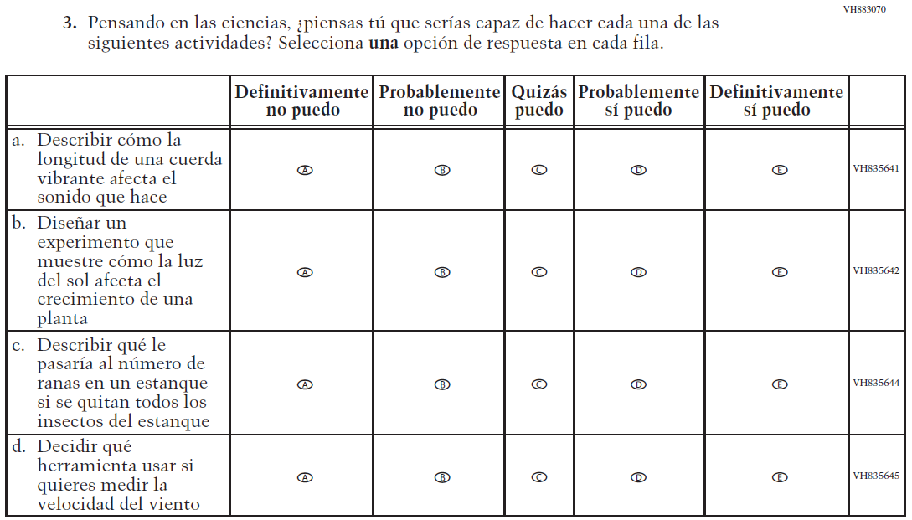

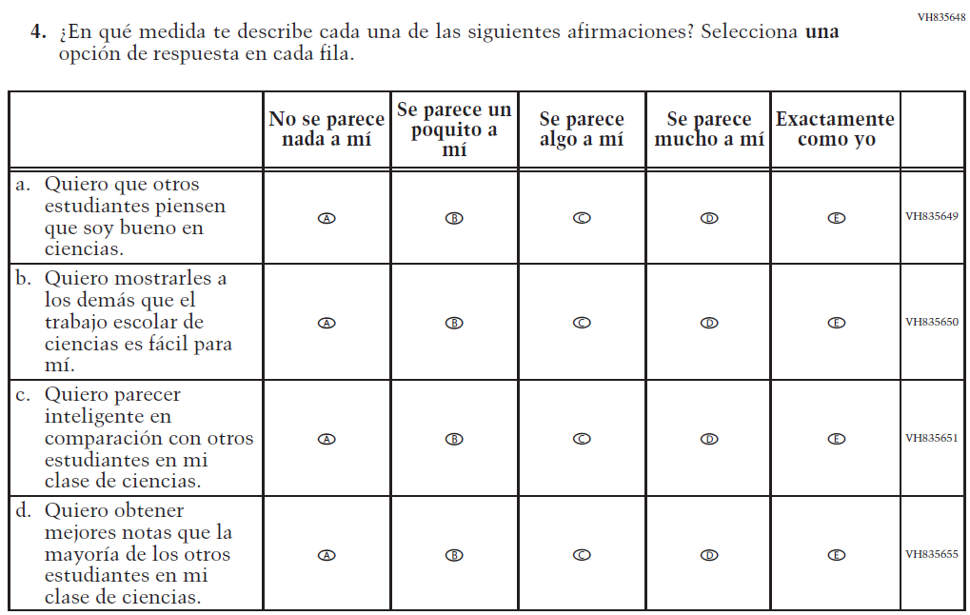

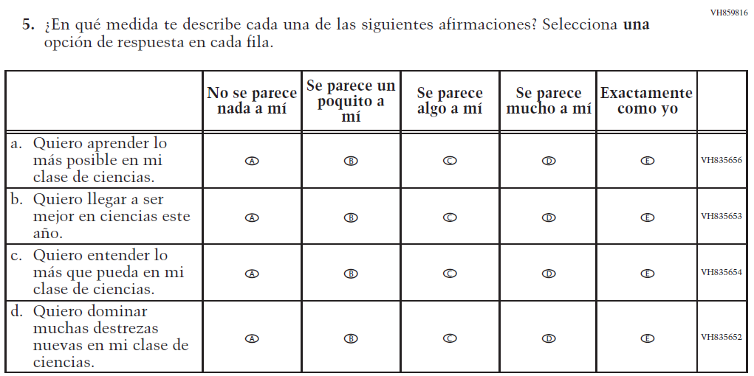

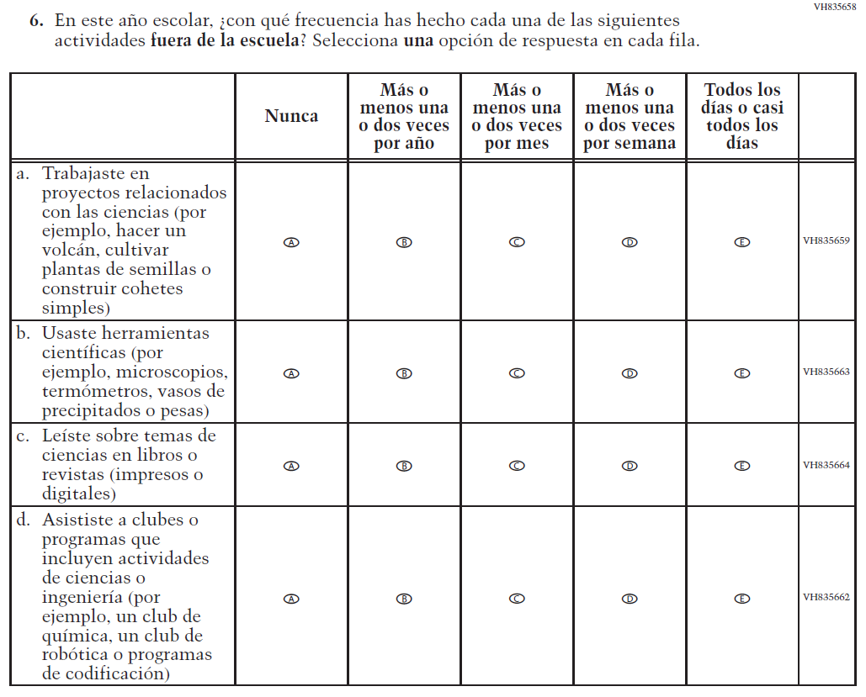

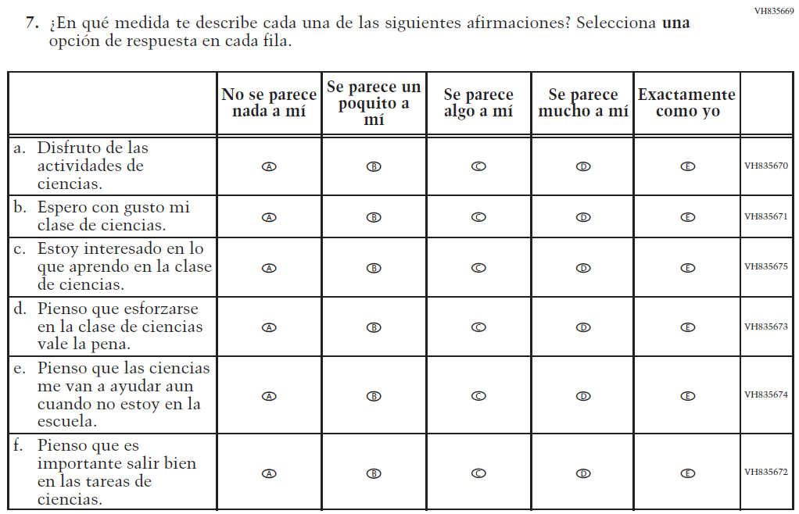

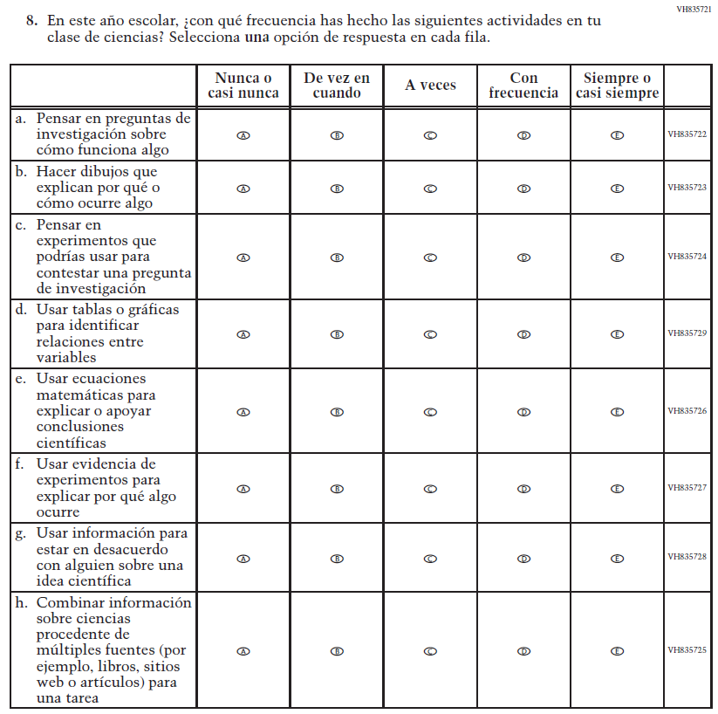

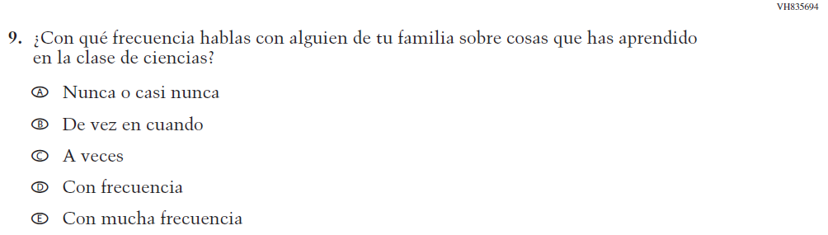

Appendix J-1l-s-BL: Operational Grade 4 Debrief
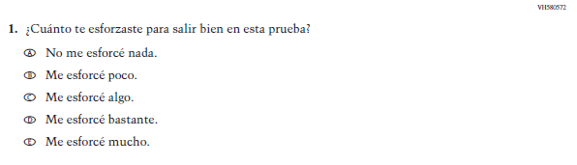

Appendix J-1m-s-PR: Operational Grade 4 Debrief
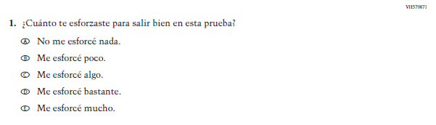

Appendix J-1n-s-BL: Operational Grade 8 Debrief
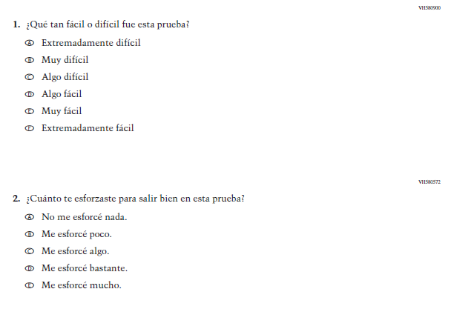

Appendix J-1n-s-PR: Operational Grade 8 Debrief
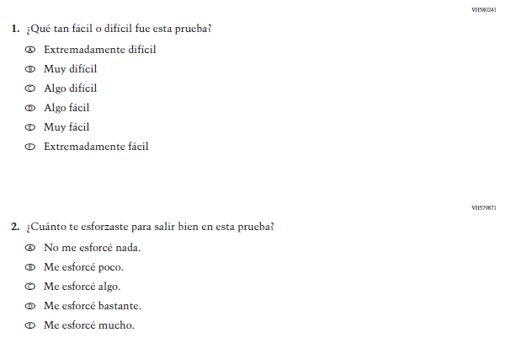

Appendix J-1o-s-PR: Pilot Grade 4 Core
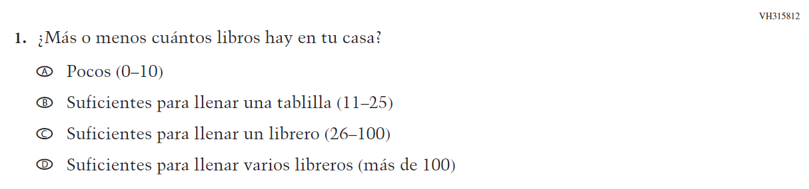

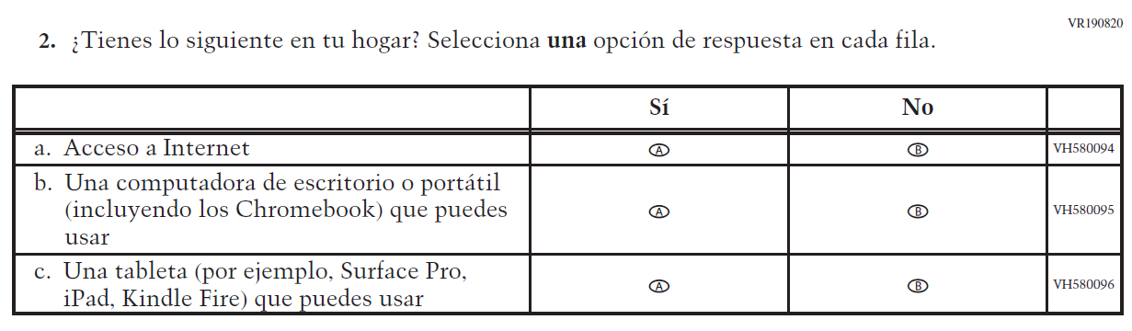

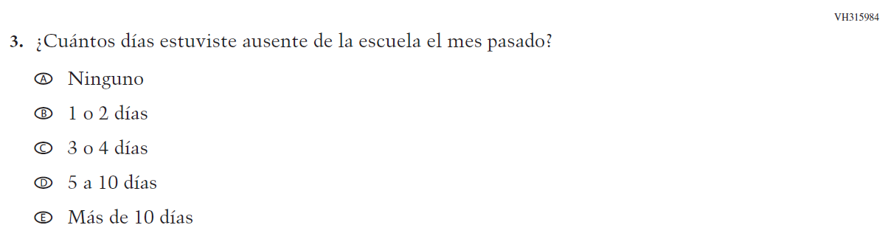

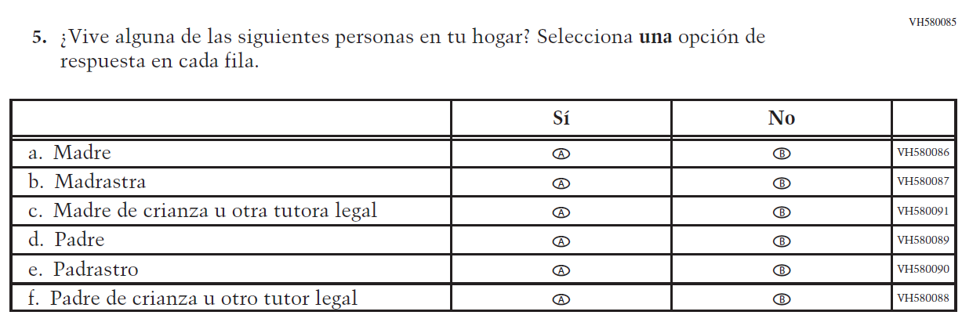

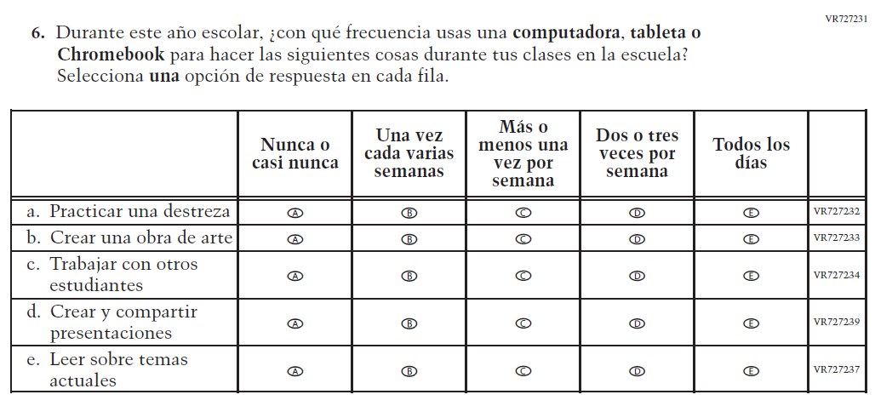

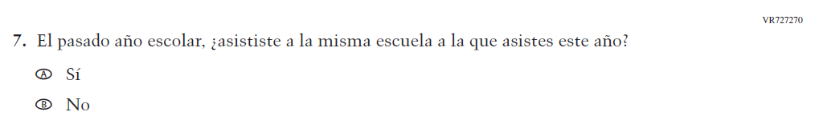

Appendix J-1p-s-PR: Pilot Grade 8 Core

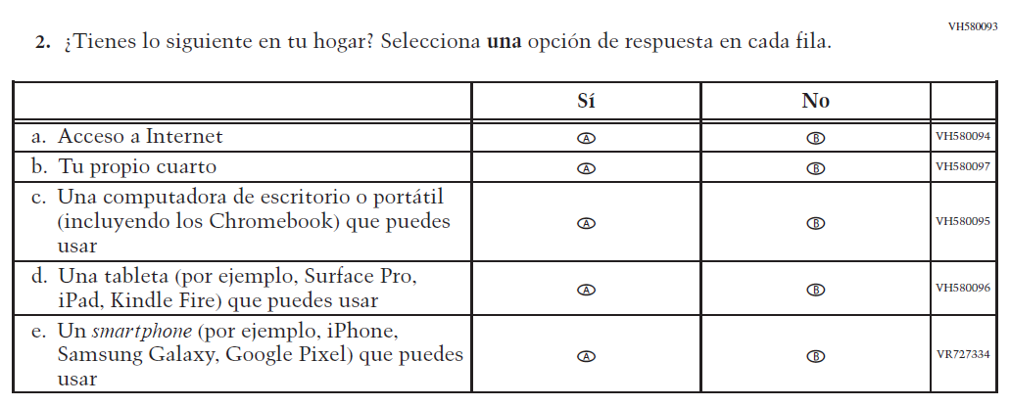
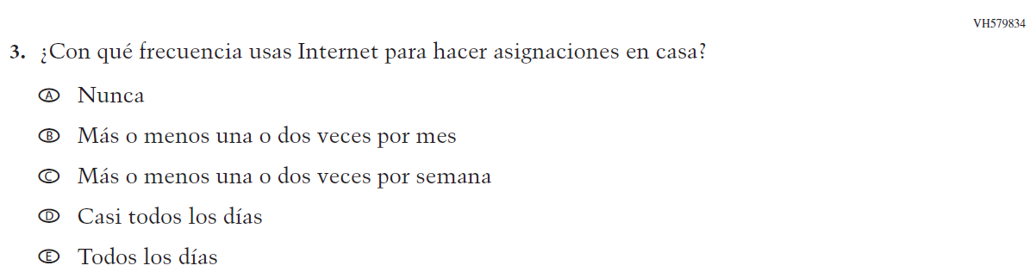
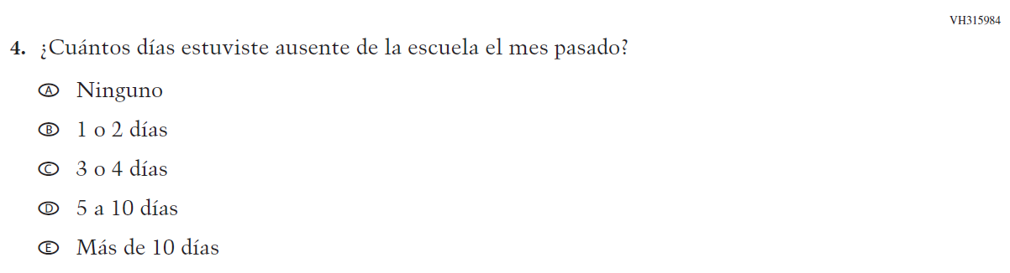

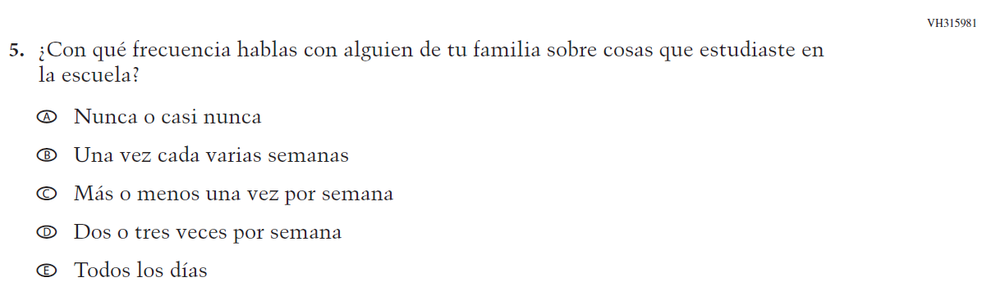

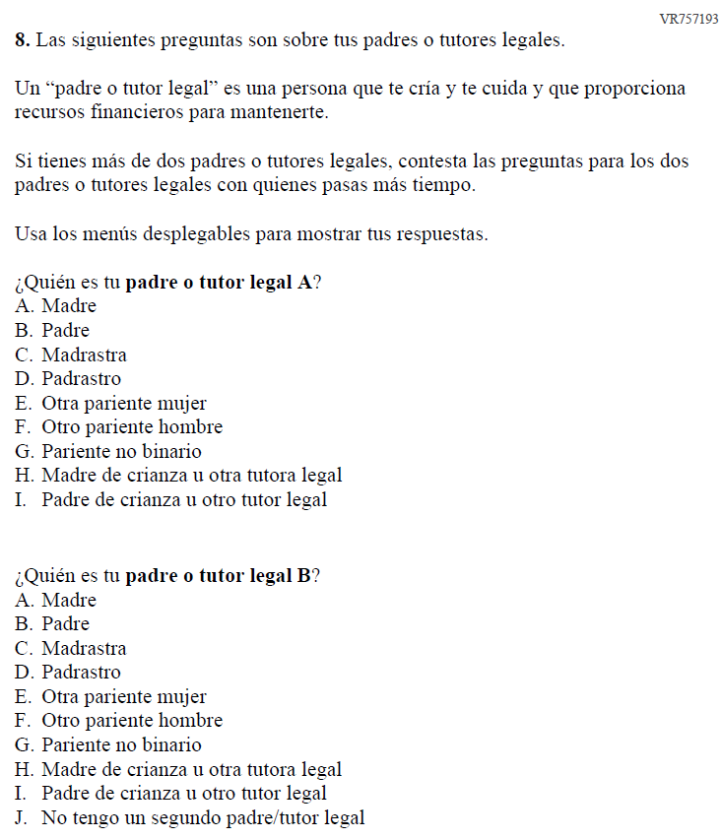
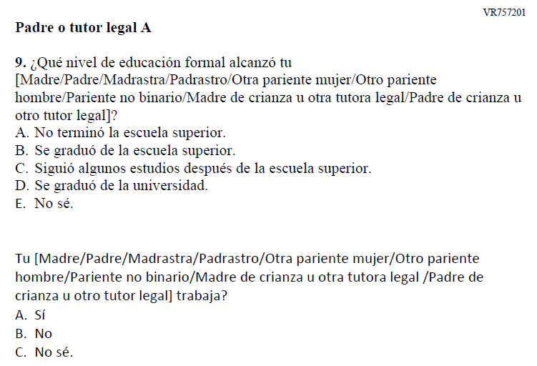

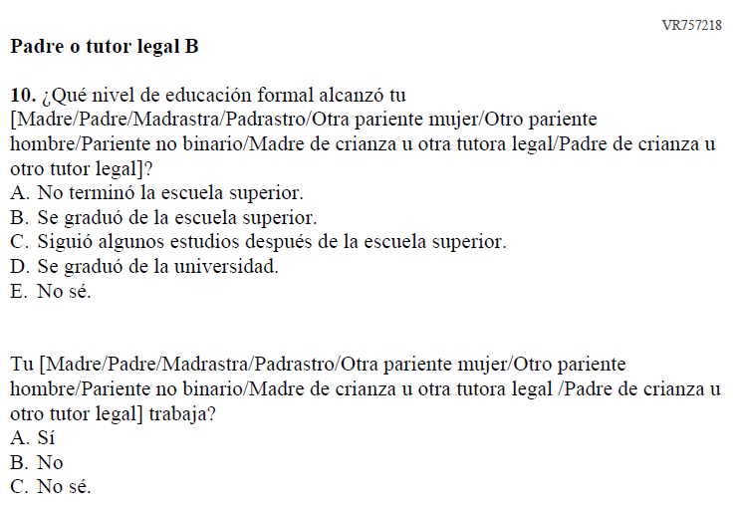

Appendix J-1q-s-PR: Pilot Grade 4 Mathematics
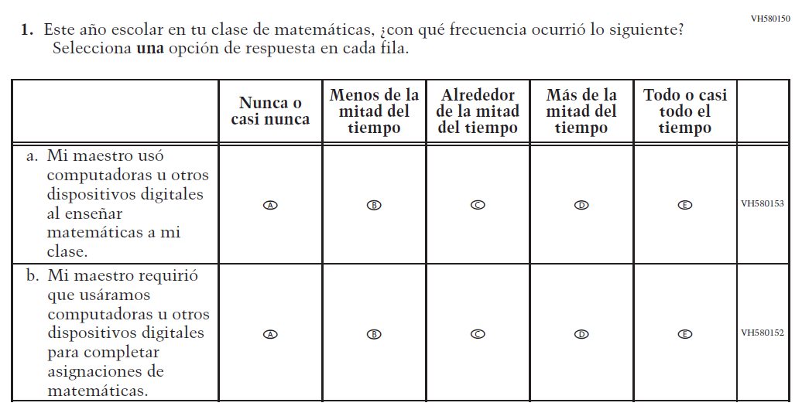

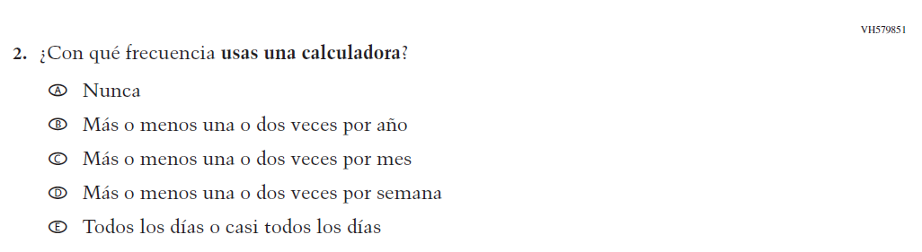

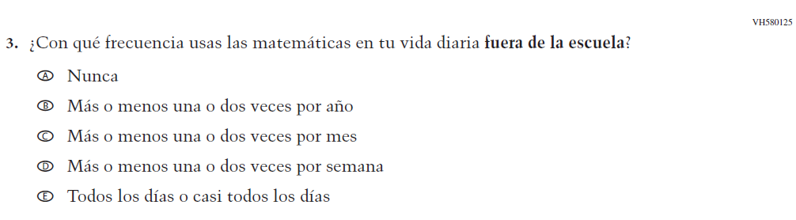

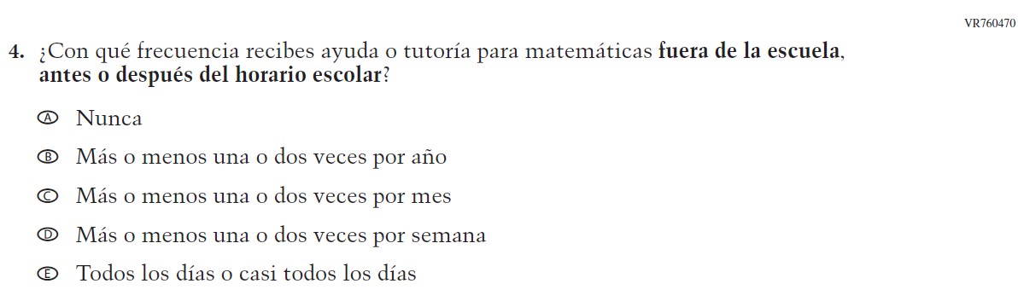

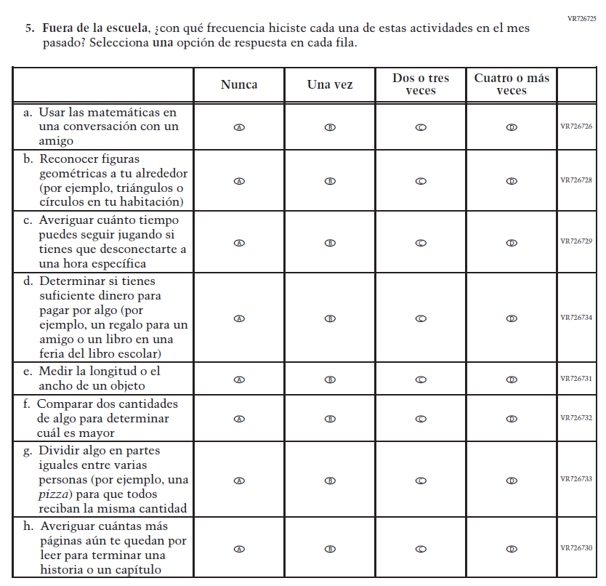

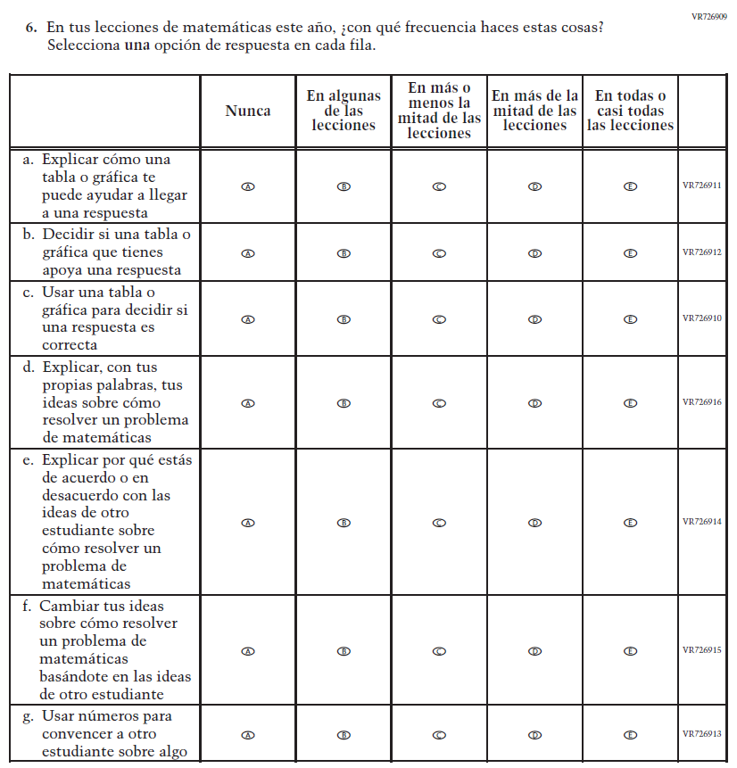

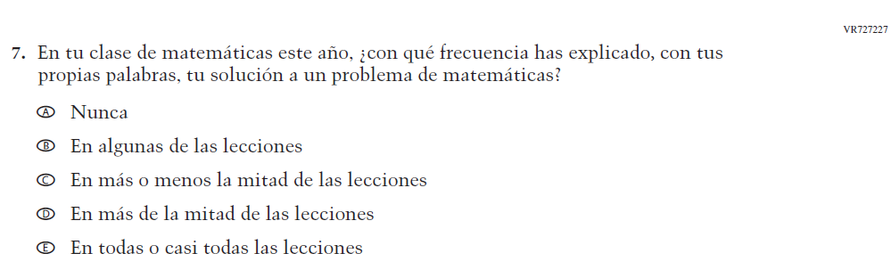

Appendix J-1r-s-PR: Pilot Grade 8 Mathematics
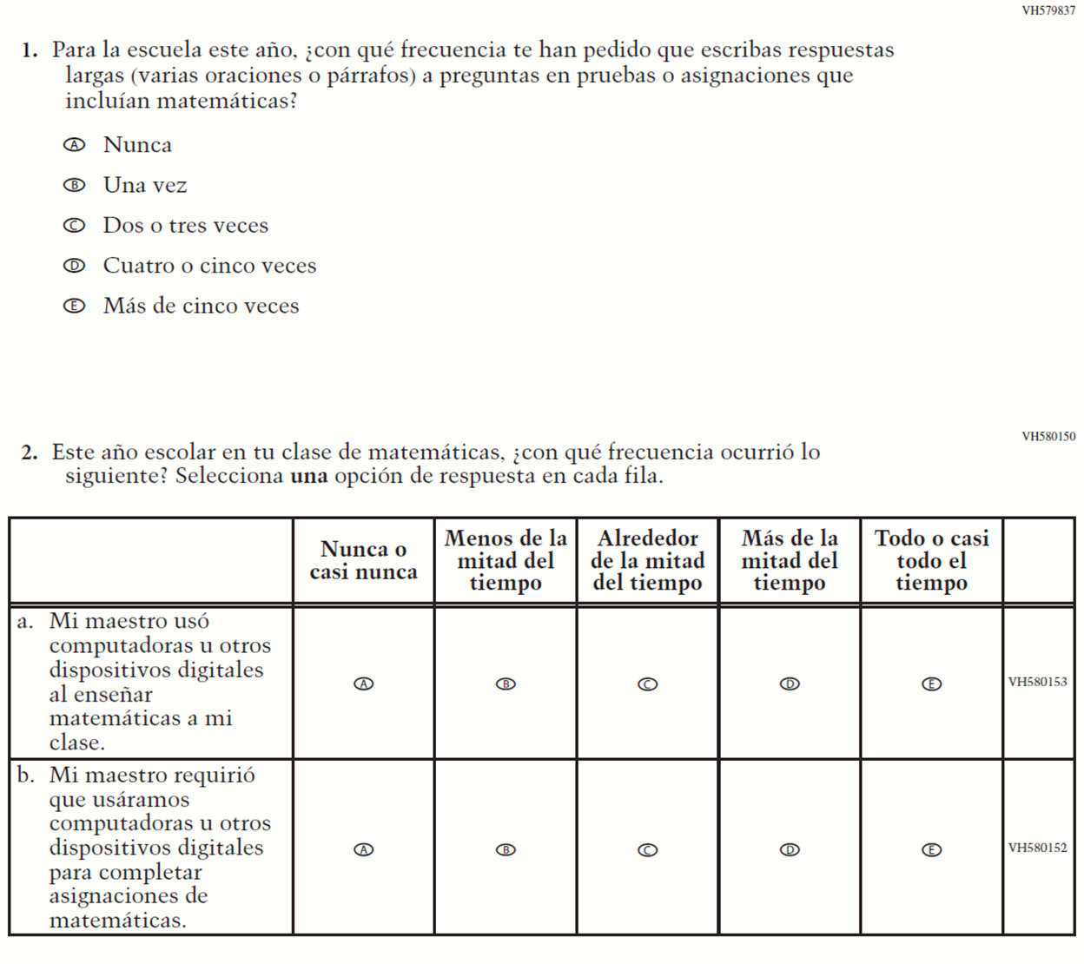

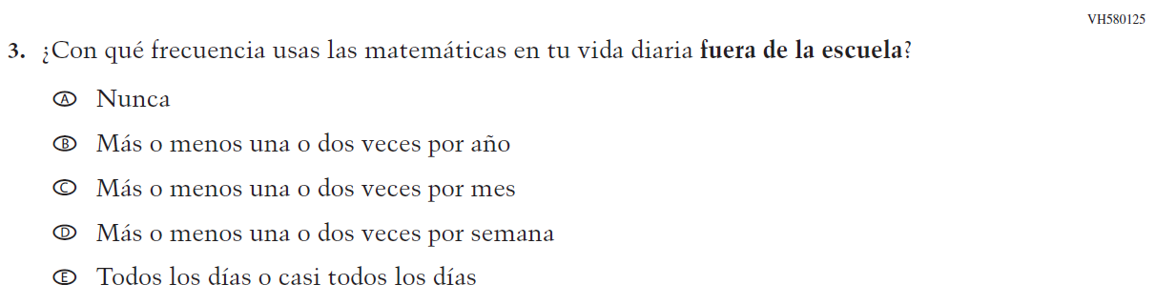

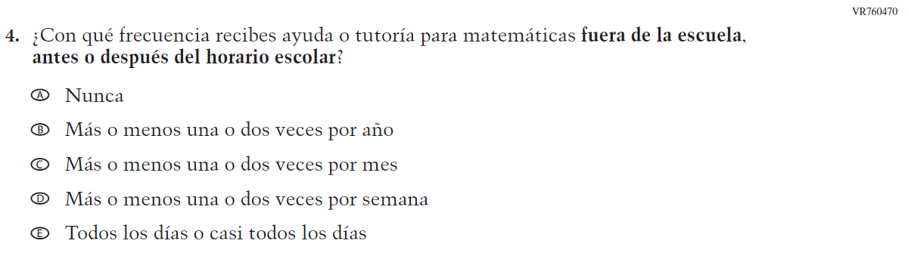

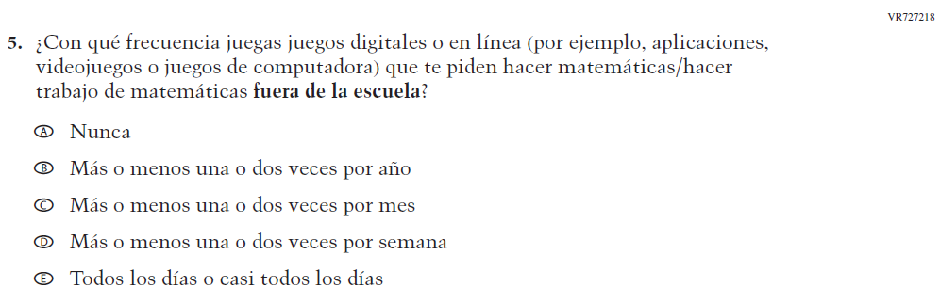

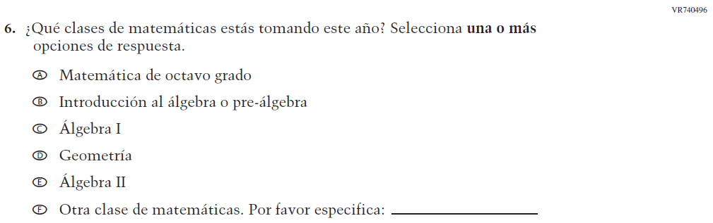

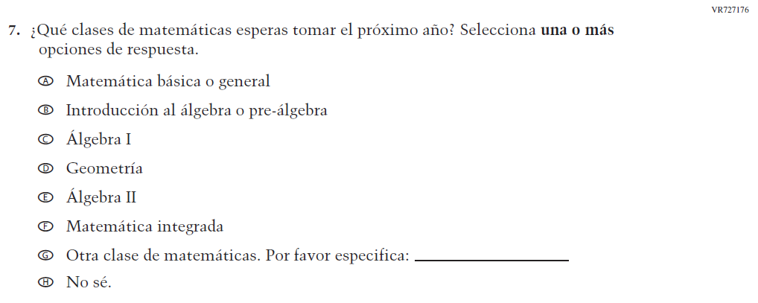

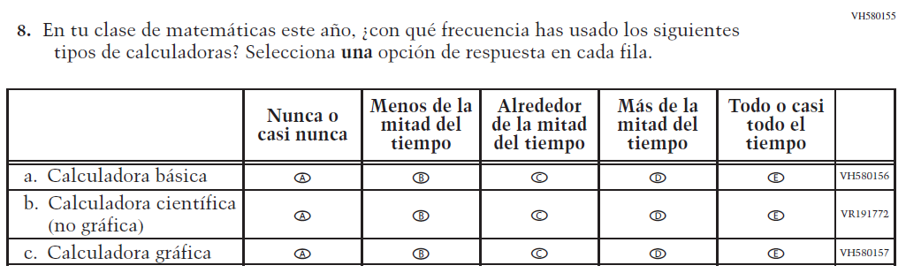

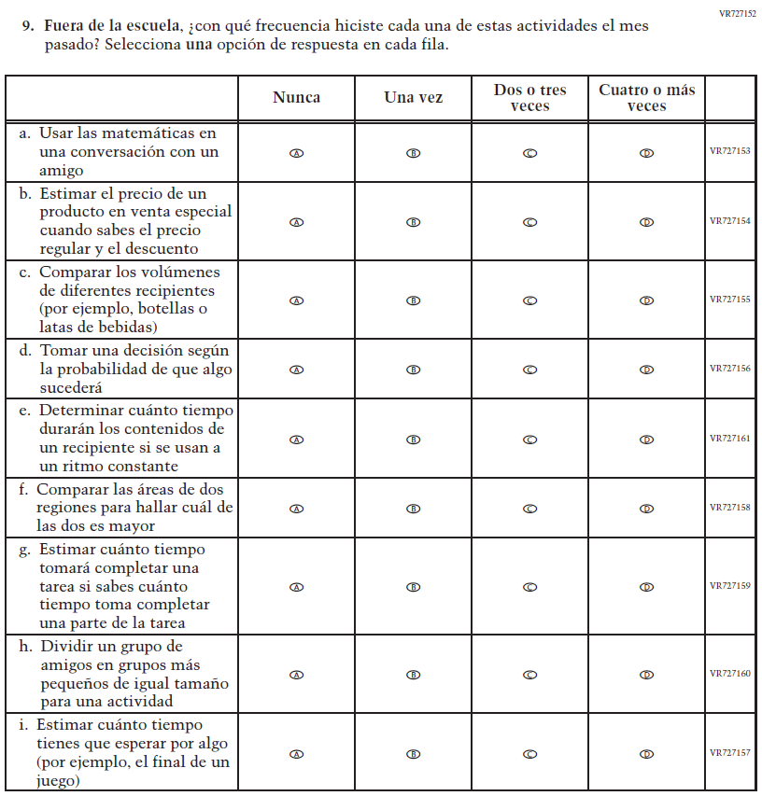

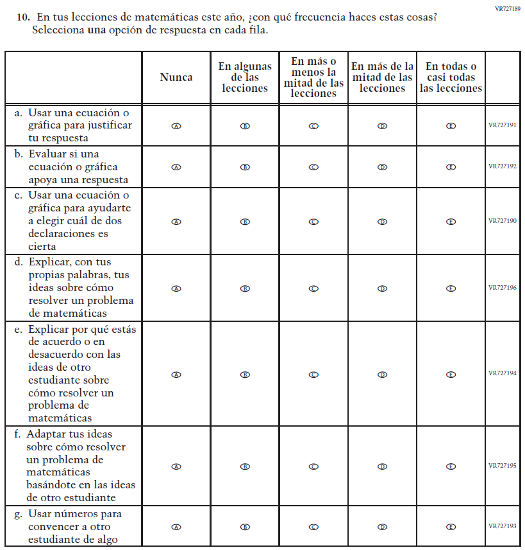

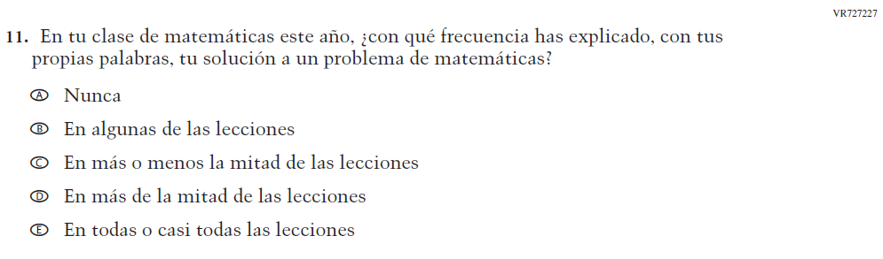

Appendix J-1s-s-PR: Pilot Grade 4 Debrief

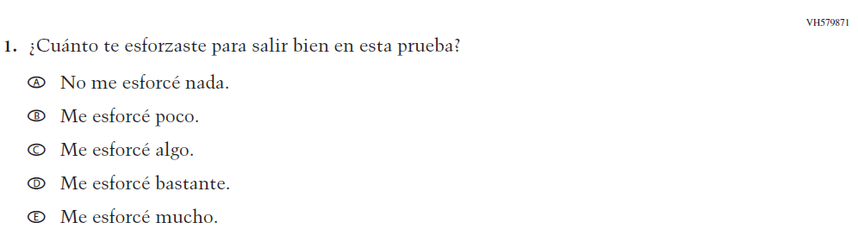

Appendix J-1t-s-PR: Pilot Grade 8 Debrief

Sample Teacher Login Screen

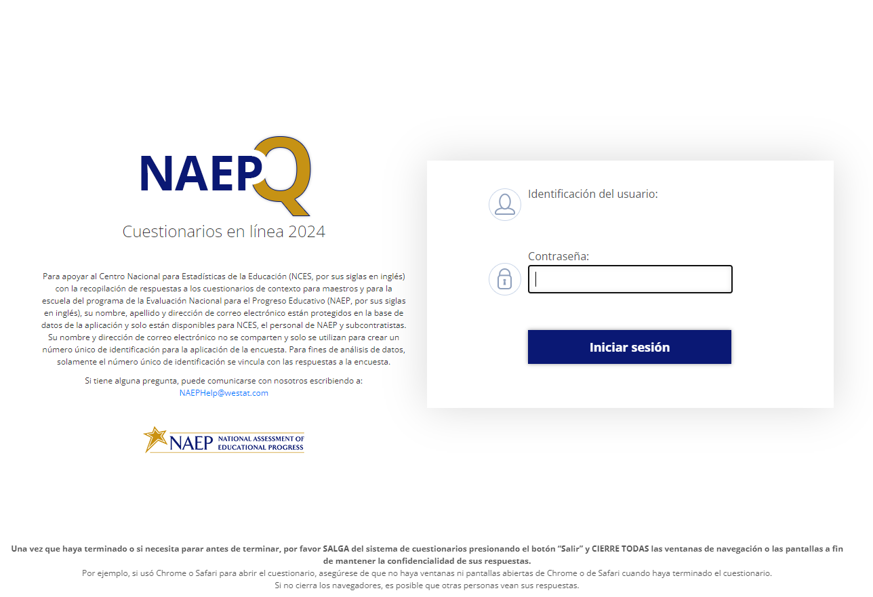

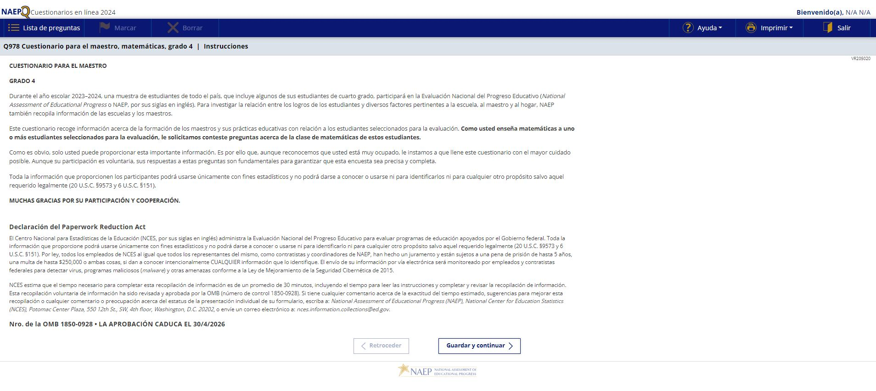

Sample Teacher Questionnaire Booklet Cover

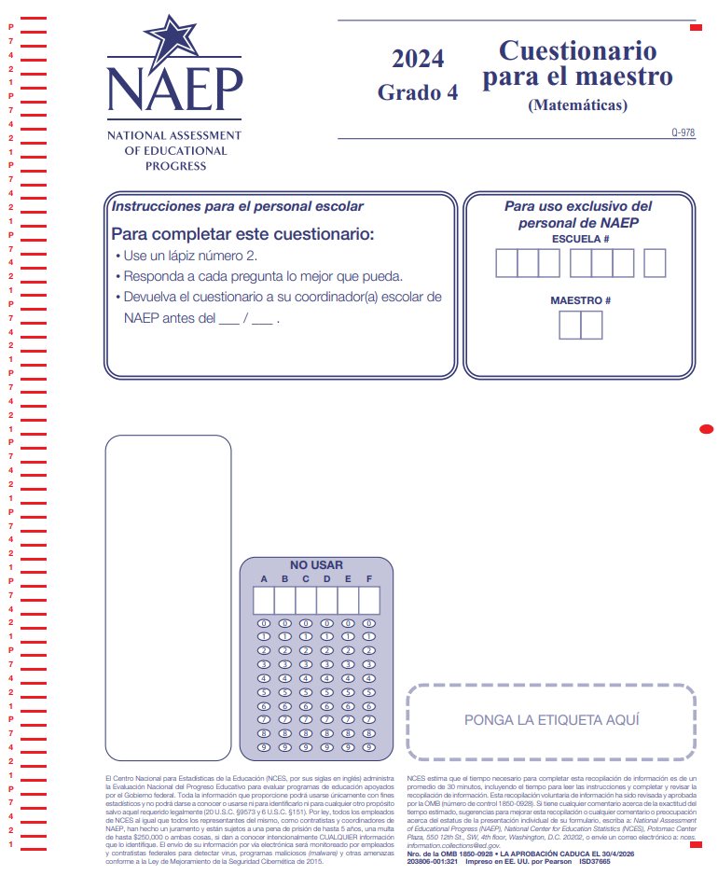

Appendix J-2-s: Spanish Translations of Teacher Questionnaires

Appendix J-2a-s-PR: Summary of Changes Operational Grade 4 CORE
2024 Operational Grade 4 Core Teacher – Puerto Rico
Previous item | 2024 item | D/A/R/NC+ | Rationale
VH835832  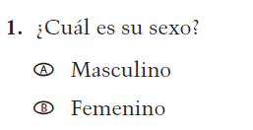  (2022 Operational Grade 4 Teacher Core – Puerto Rico) | VR734663  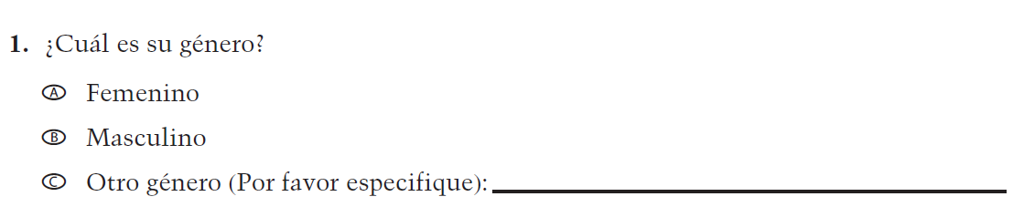  Issue: Gender | R | This Item was revised to be more inclusive and is now in line with an NCES-wide change.
N/A | VR742171  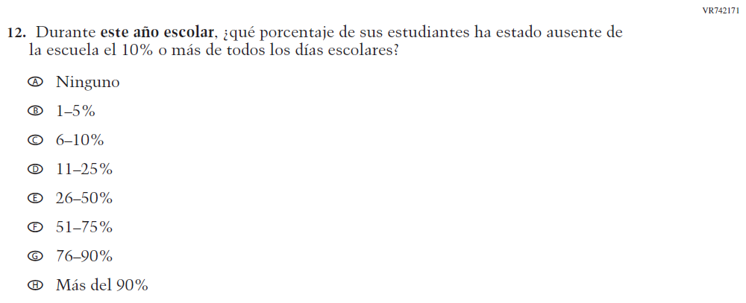  Issue: Learning Recovery | A | To address gaps in learning that have been developed due to the extended period of remote and hybrid learning that took place during the pandemic.

2024 Operational Grade 4 Core Teacher – Puerto Rico
Previous item | 2024 item | D/A/R/NC+ | Rationale
N/A | VR742173  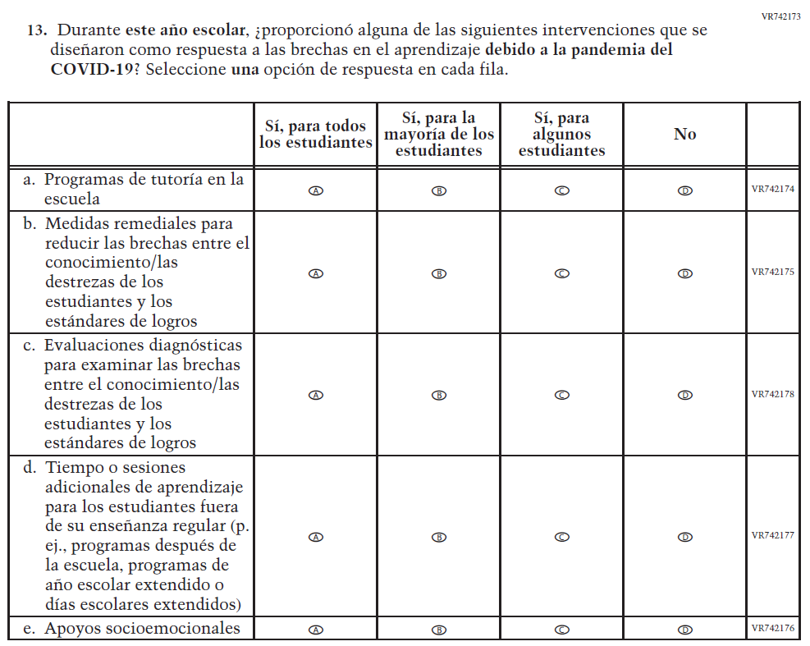  Issue: Learning Recovery | A | To address gaps in learning that have been developed due to the extended period of remote and hybrid learning that took place during the pandemic.

2024 Operational Grade 4 Core Teacher – Puerto Rico
Previous item | 2024 item | D/A/R/NC+ | Rationale
N/A | VR742192  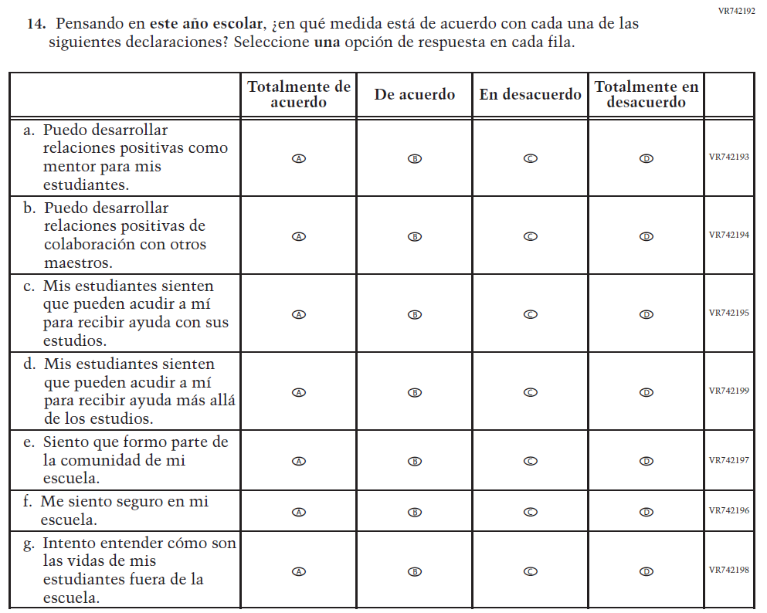  Issue: Learning Recovery | A | To address gaps in learning that have been developed due to the extended period of remote and hybrid learning that took place during the pandemic.

2024 Operational Grade 4 Core Teacher – Puerto Rico
Previous item | 2024 item | D/A/R/NC+ | Rationale
N/A | VR742184  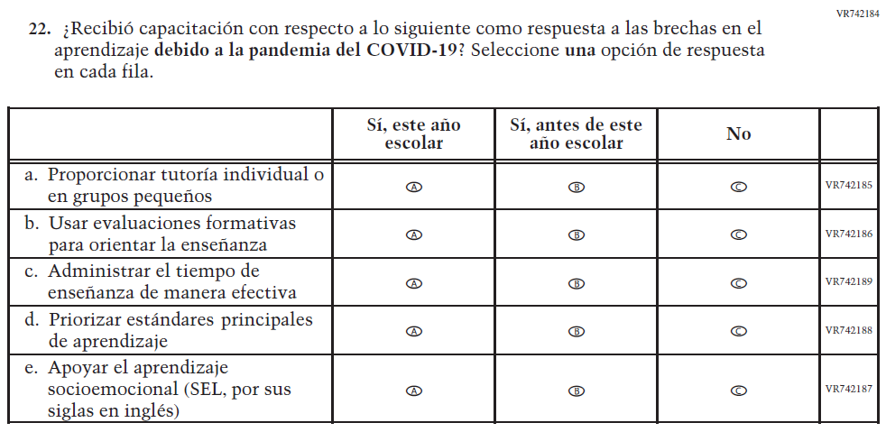  Issue: Learning Recovery | A | To address gaps in learning that have been developed due to the extended period of remote and hybrid learning that took place during the pandemic.

Appendix J-2a-s-PR: Operational Grade 4 CORE
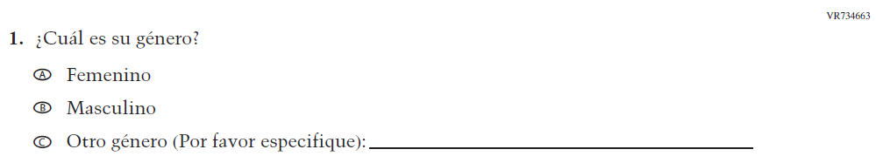

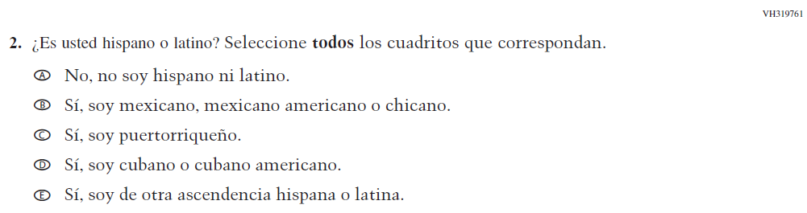

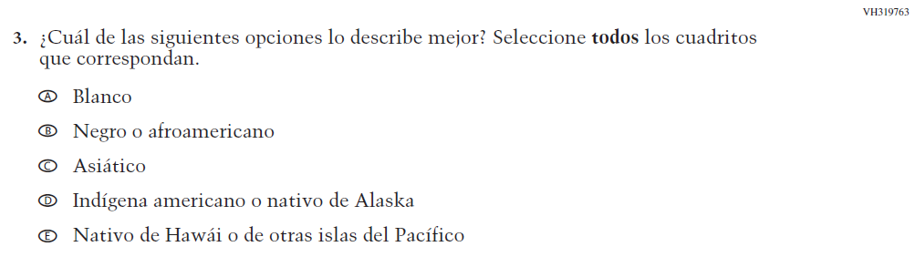

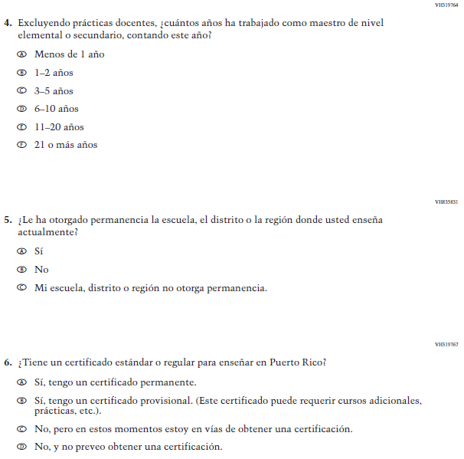

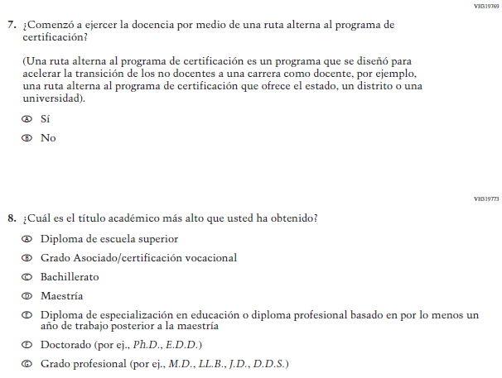

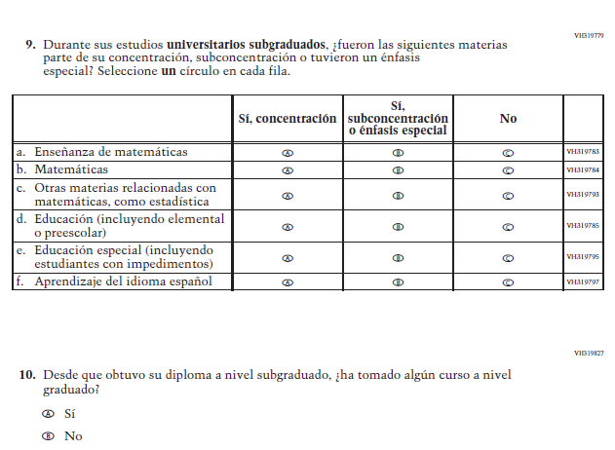

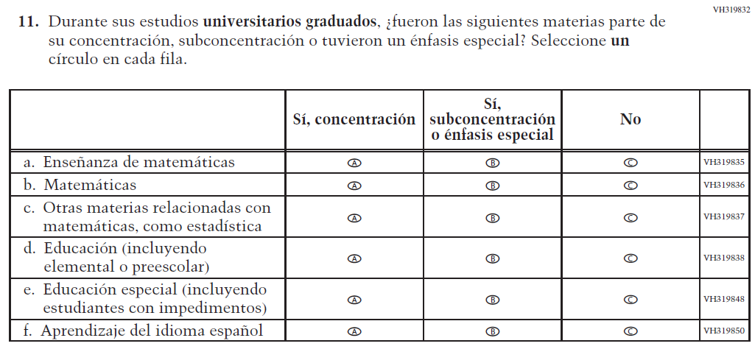

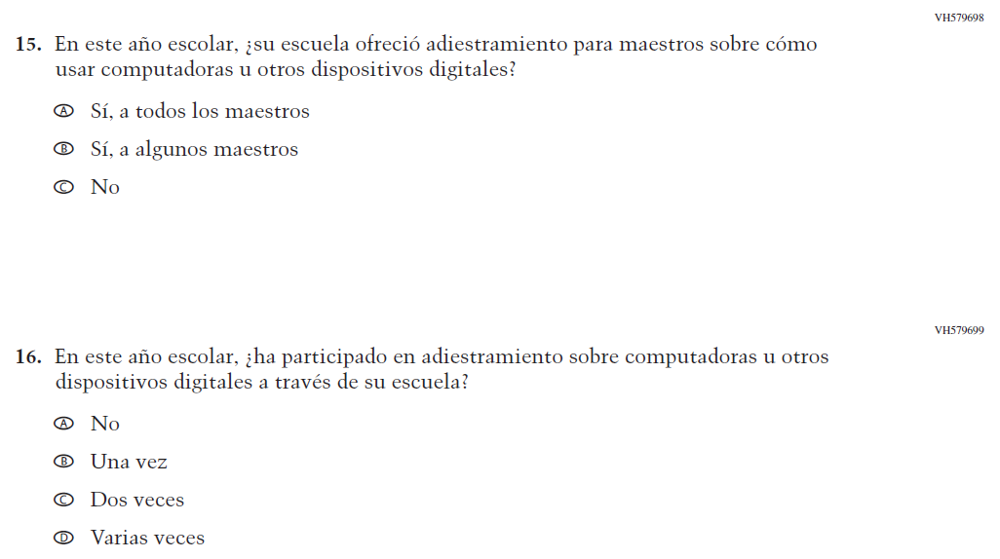

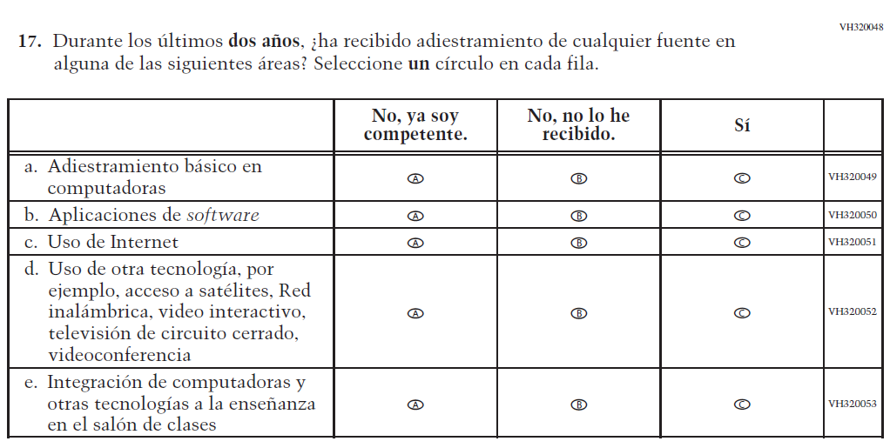
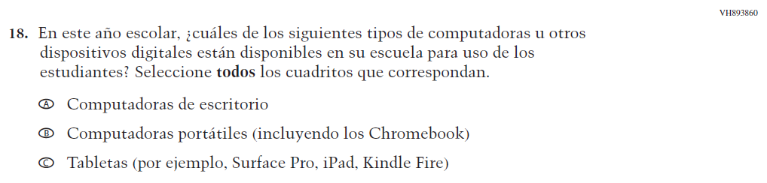

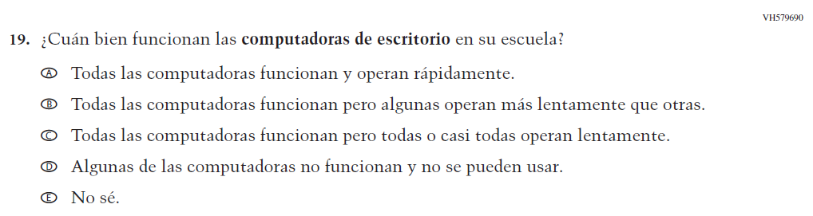

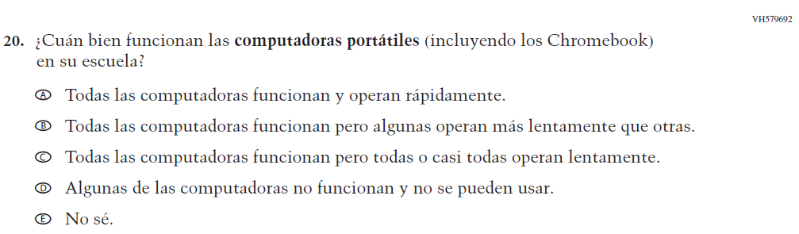

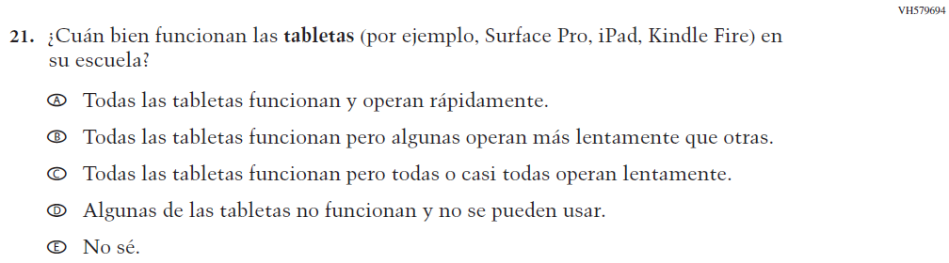

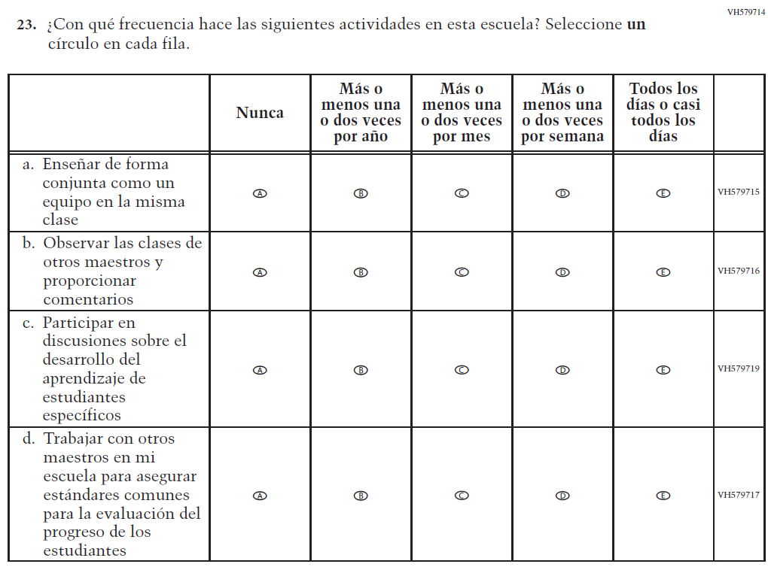

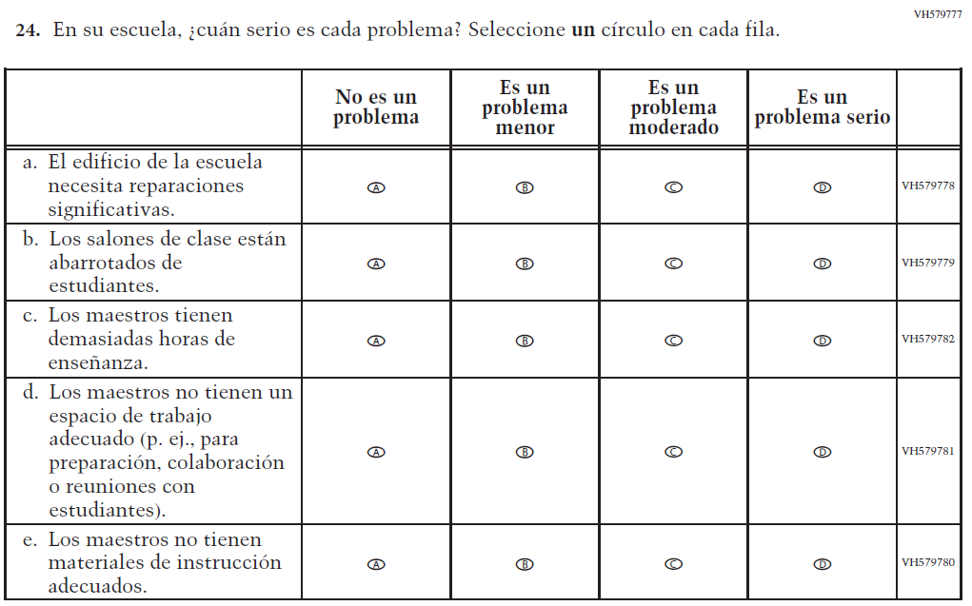

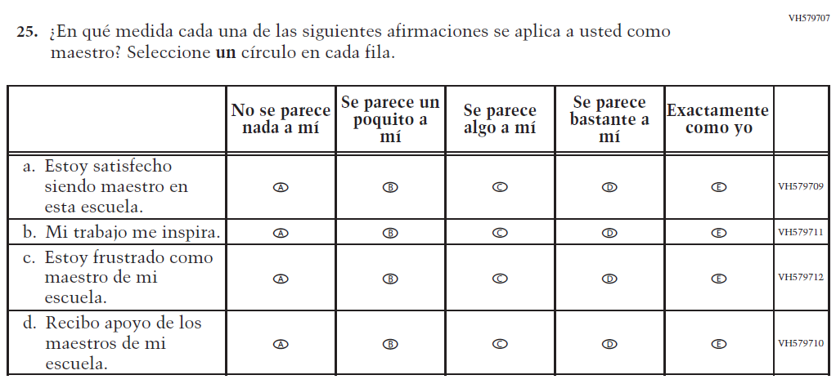
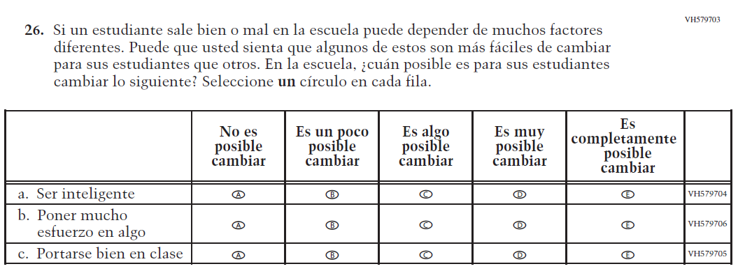

Appendix J-2b-s-PR: Summary of Changes Operational Grade 8 CORE
2024 Operational Grade 8 Core Teacher – Puerto Rico
Previous item | 2024 item | D/A/R/NC+ | Rationale
VH835832  (2022 Operational Grade 4 Teacher Core – Puerto Rico) | VR734663  Issue: Gender | R | This Item was revised to be more inclusive and is now in line with an NCES-wide change.
N/A | VR742171  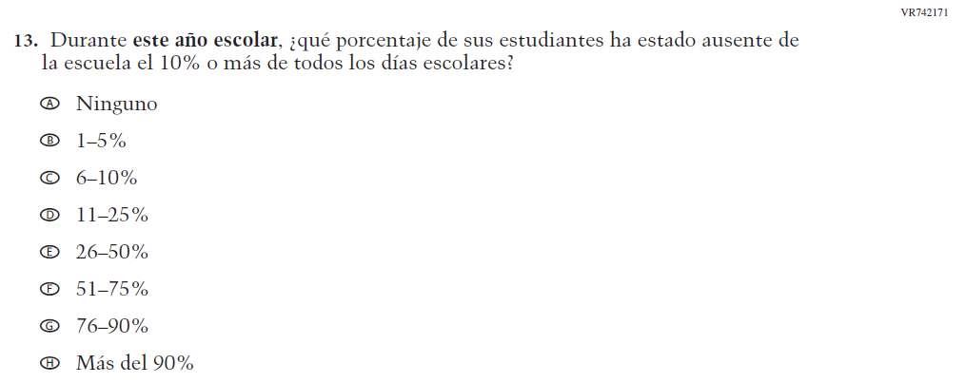  Issue: Learning Recovery | A | To address gaps in learning that have been developed due to the extended period of remote and hybrid learning that took place during the pandemic.

2024 Operational Grade 8 Core Teacher – Puerto Rico
Previous item | 2024 item | D/A/R/NC+ | Rationale
N/A | VR742173  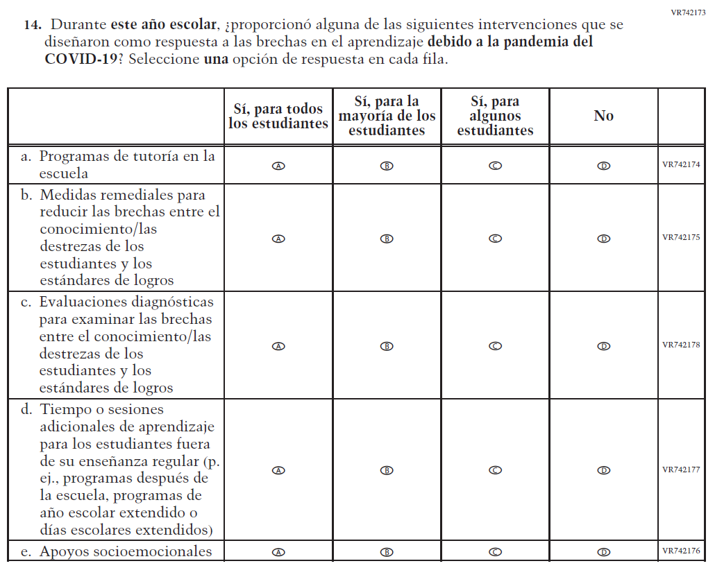  Issue: Learning Recovery | A | To address gaps in learning that have been developed due to the extended period of remote and hybrid learning that took place during the pandemic.

2024 Operational Grade 8 Core Teacher – Puerto Rico
Previous item | 2024 item | D/A/R/NC+ | Rationale
N/A | VR742192  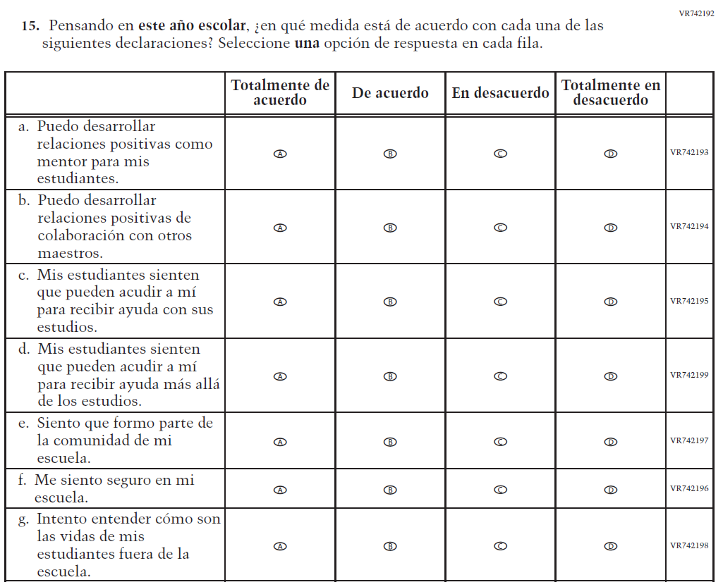  Issue: Learning Recovery | A | To address gaps in learning that have been developed due to the extended period of remote and hybrid learning that took place during the pandemic.

2024 Operational Grade 8 Core Teacher – Puerto Rico
Previous item | 2024 item | D/A/R/NC+ | Rationale
N/A | VR742184  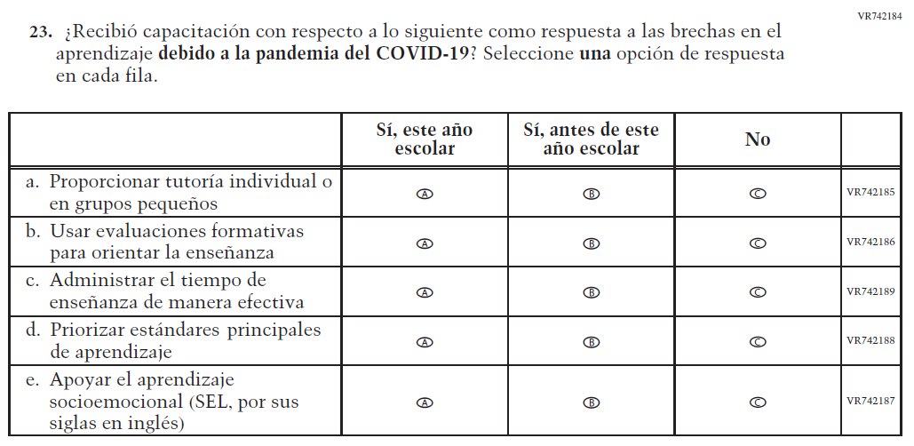  Issue: Learning Recovery | A | To address gaps in learning that have been developed due to the extended period of remote and hybrid learning that took place during the pandemic.

Appendix J-2b-s-PR: Operational Grade 8 CORE

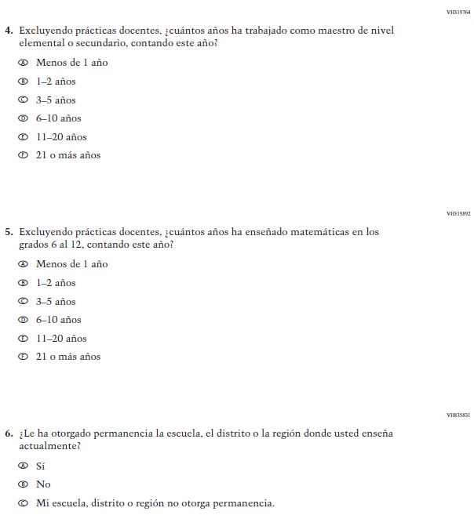

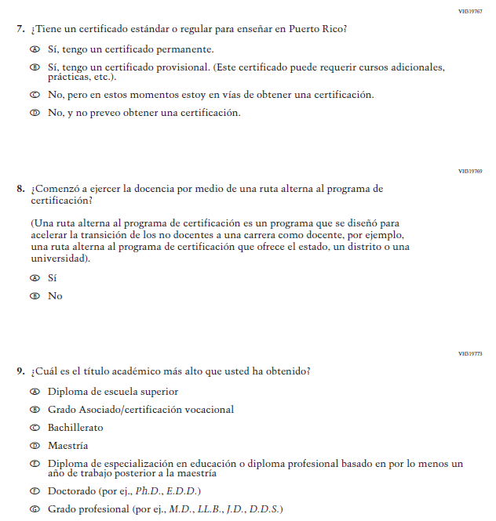

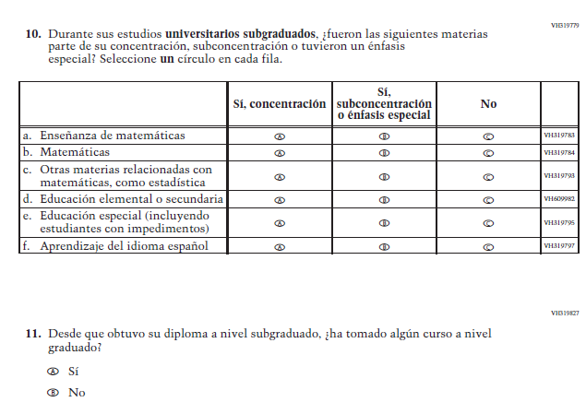

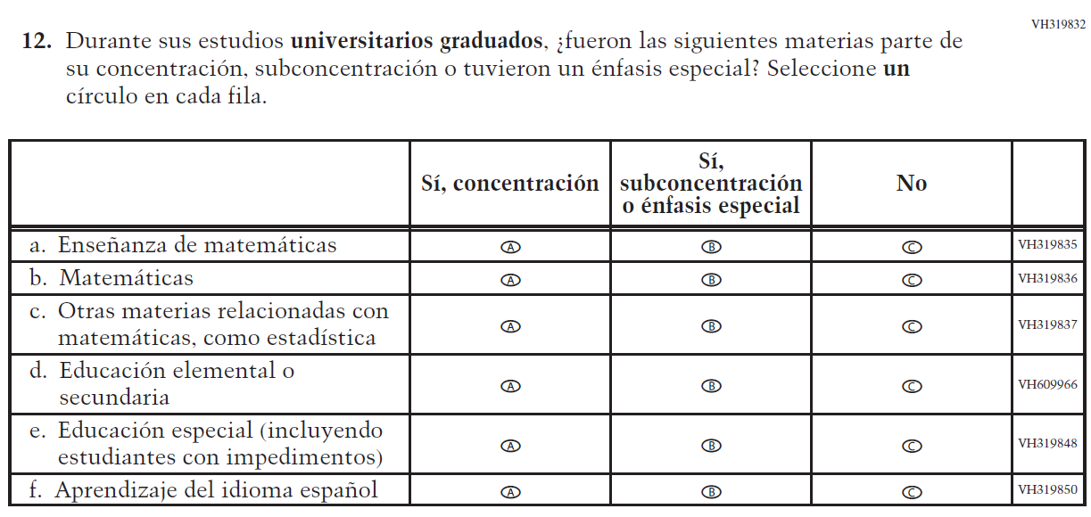

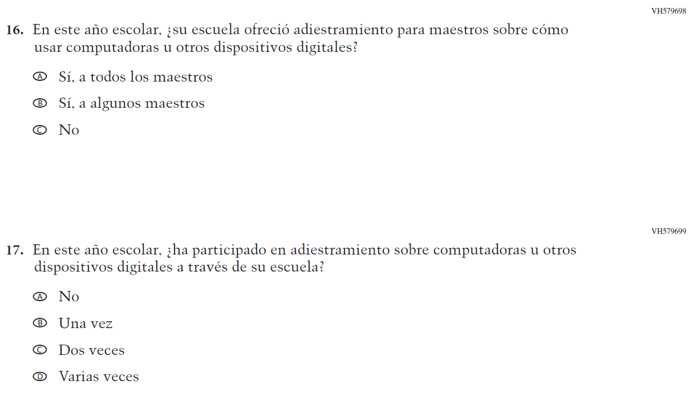

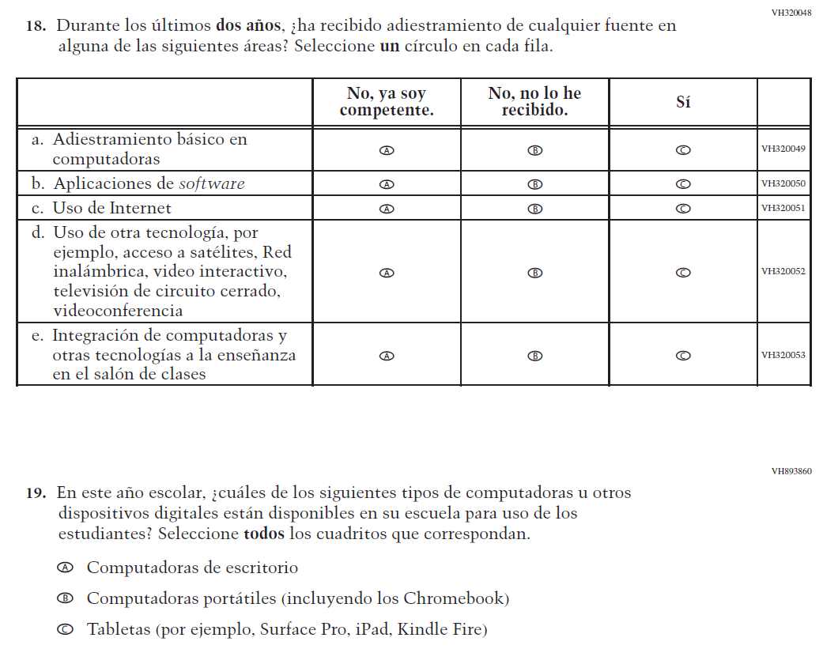

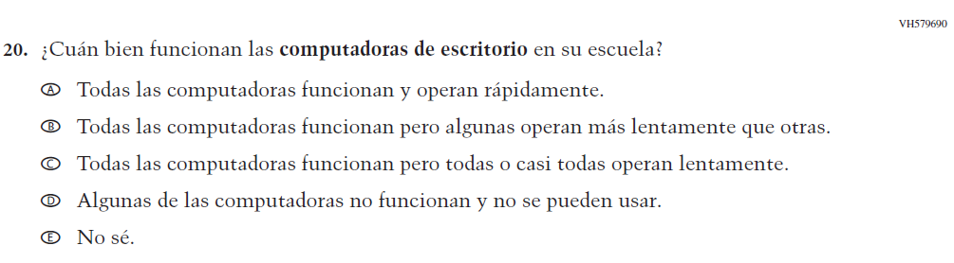

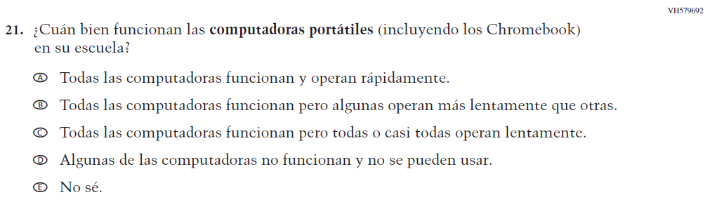

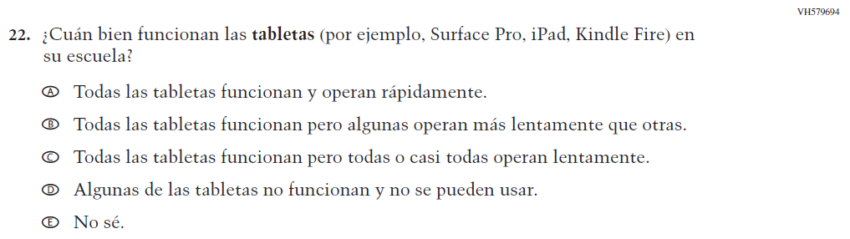

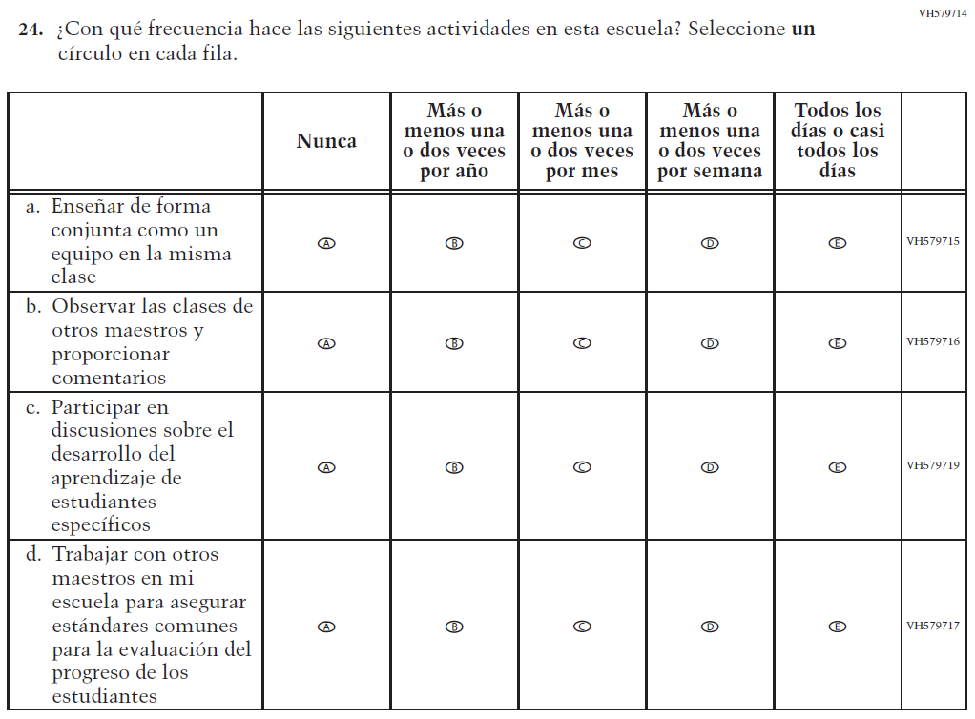

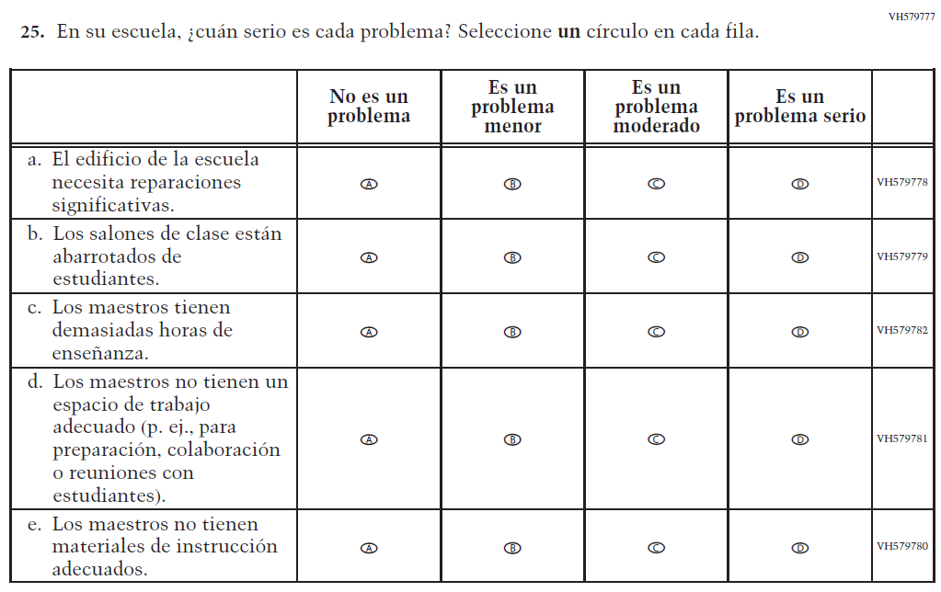

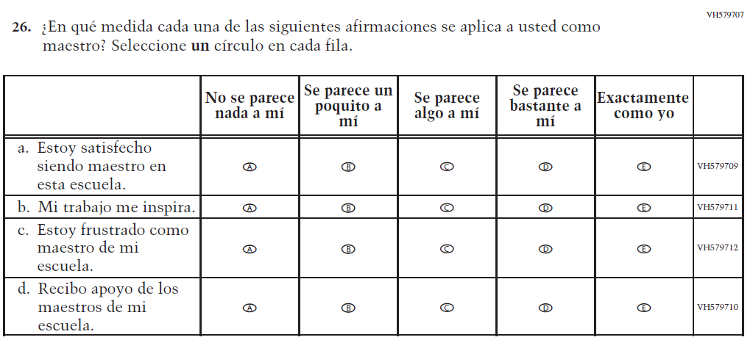

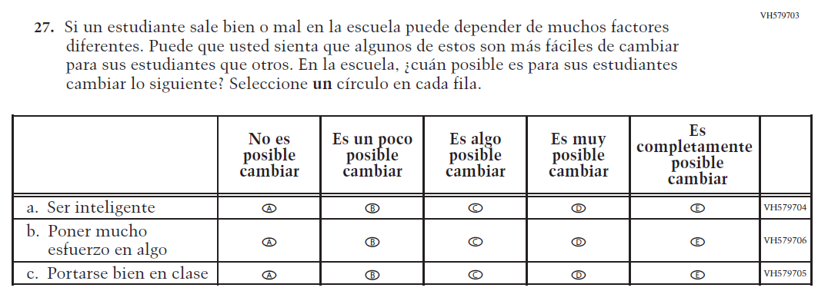

Appendix J-2c-s-PR: Operational Grade 4 Mathematics
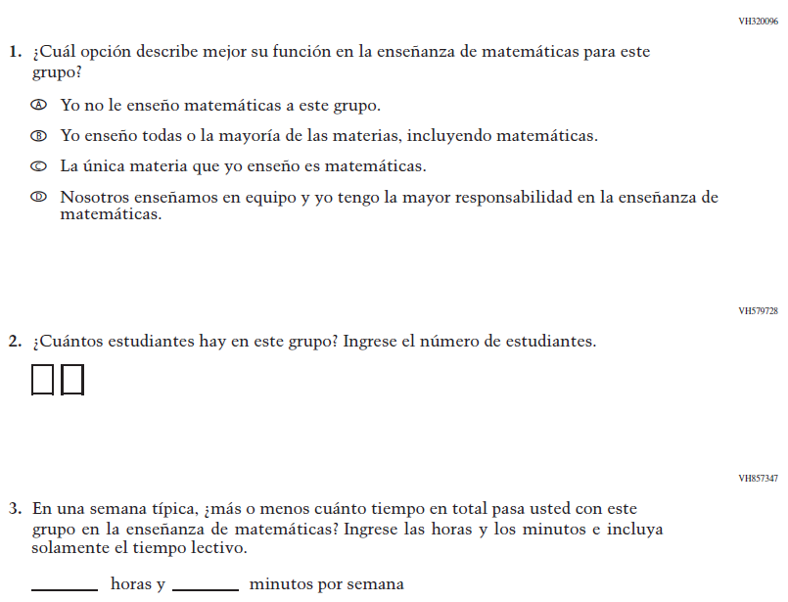
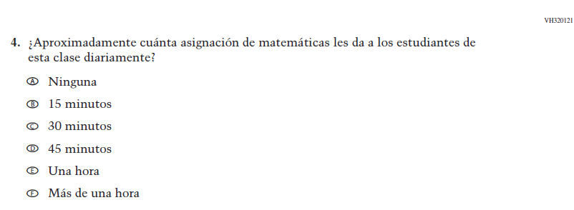

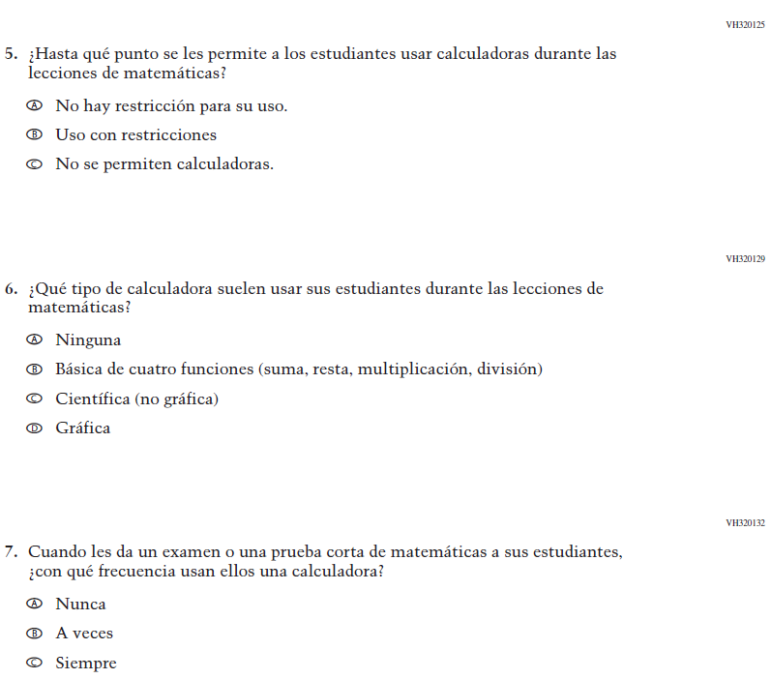

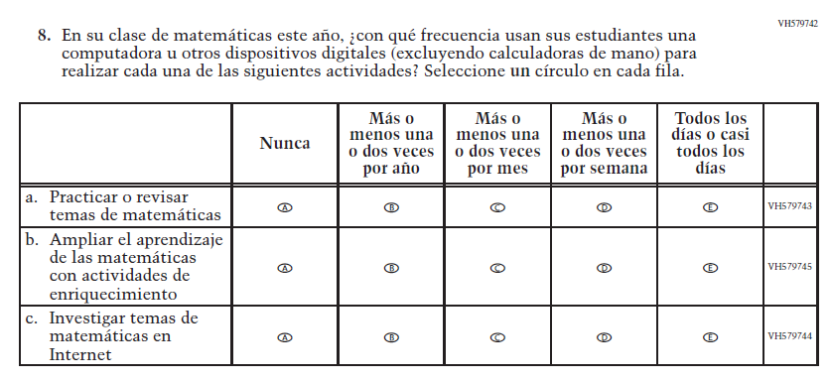

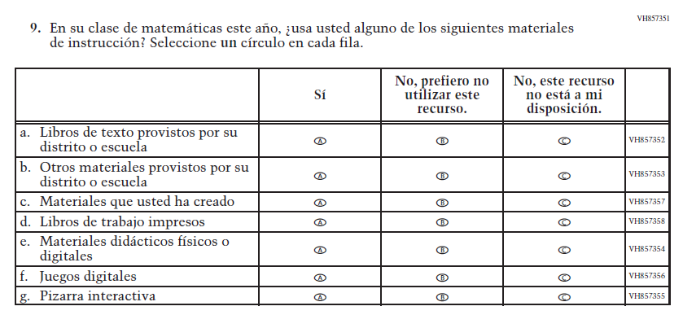

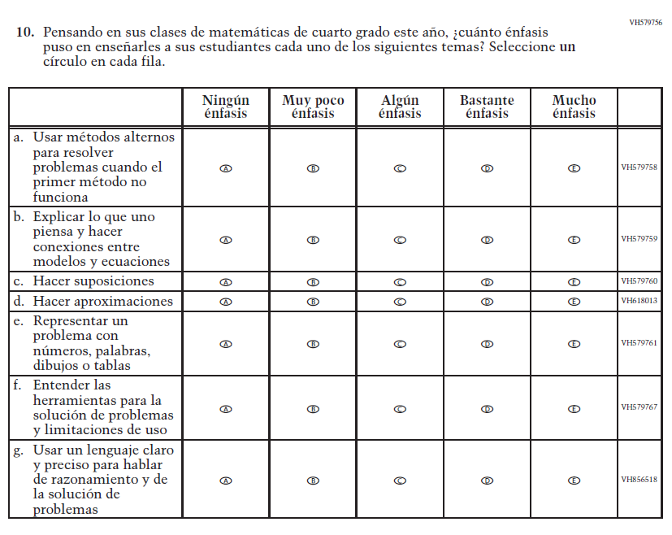

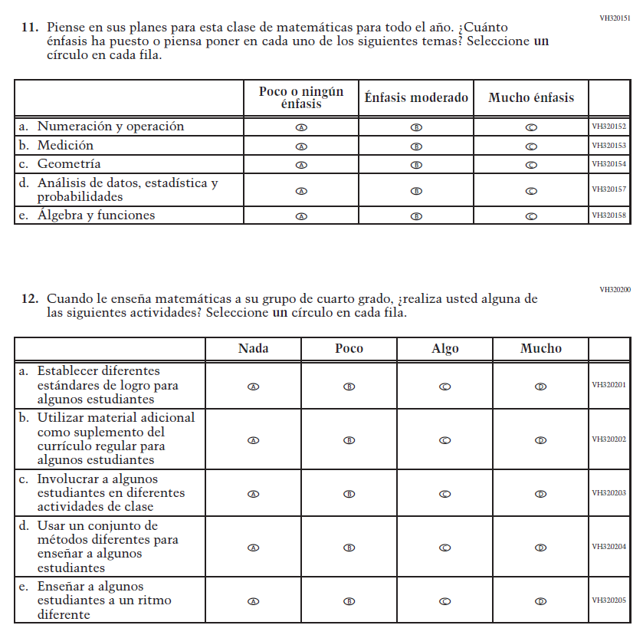

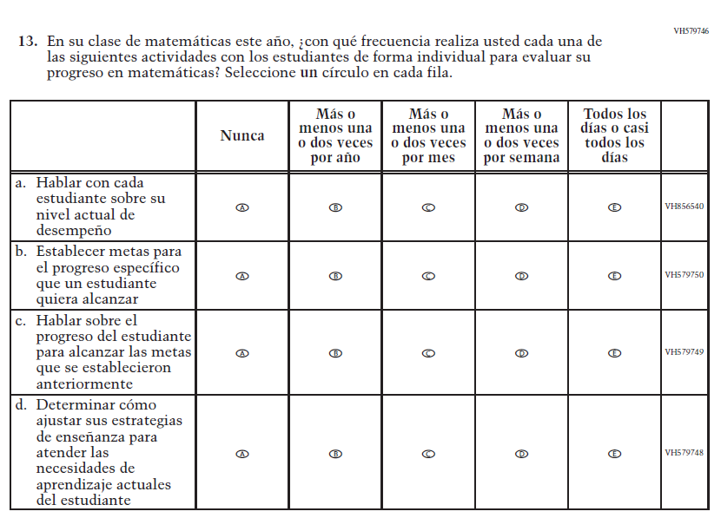

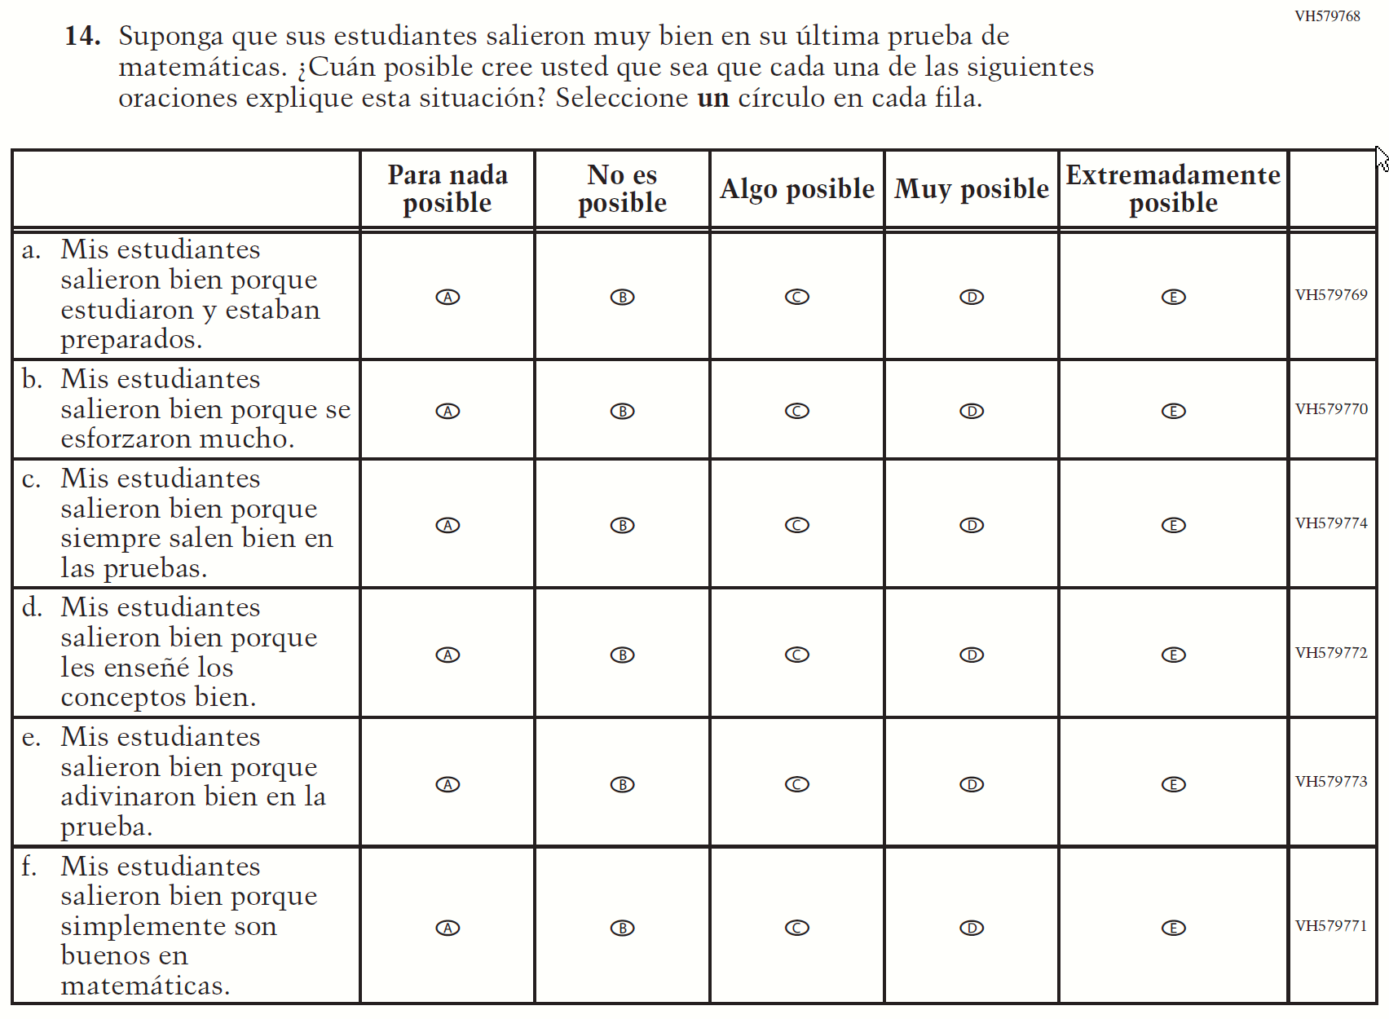
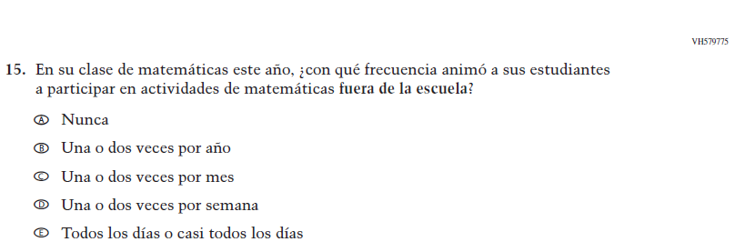

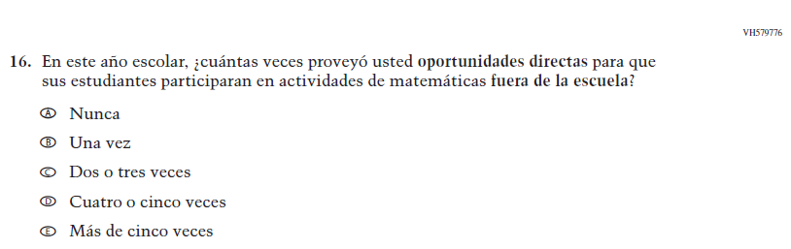

Appendix J-2d-s-PR: Operational Grade 8 Mathematics
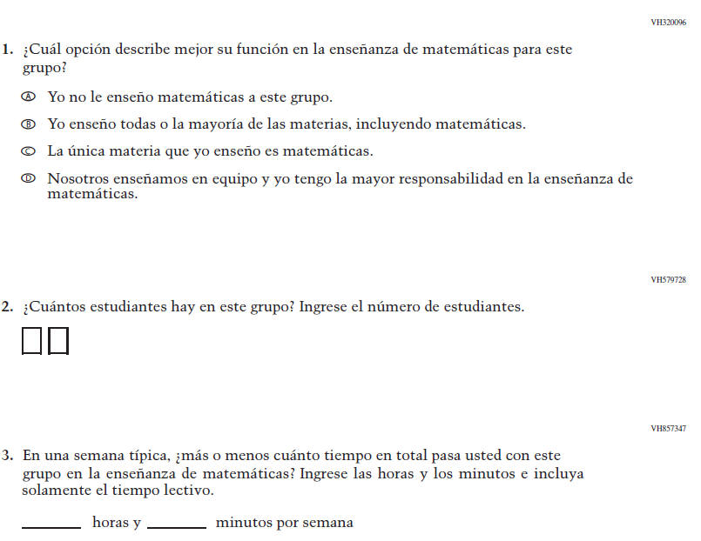
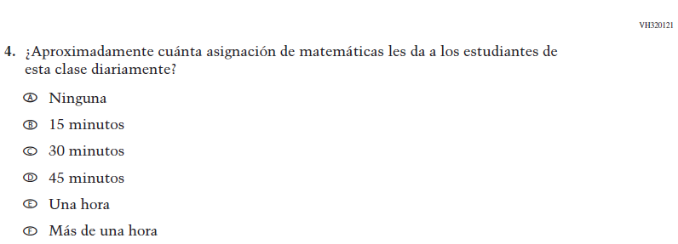
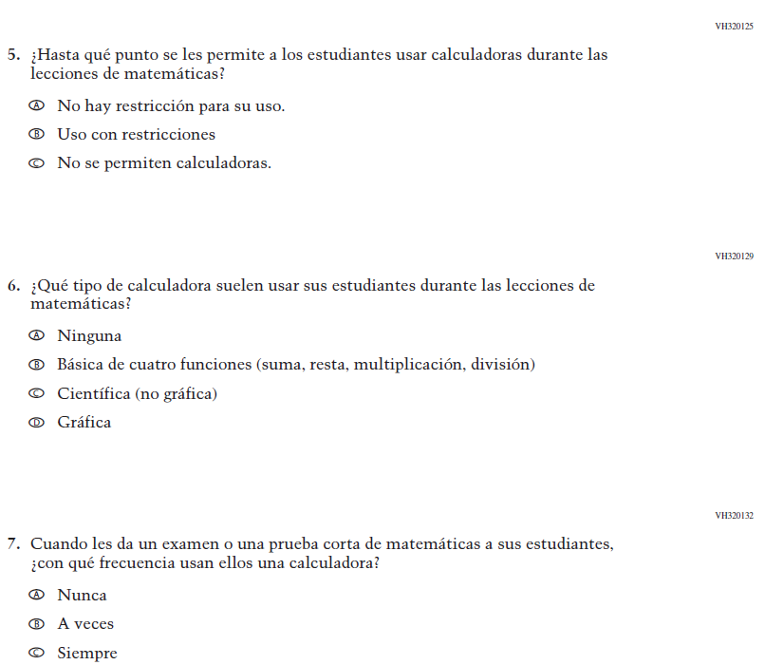

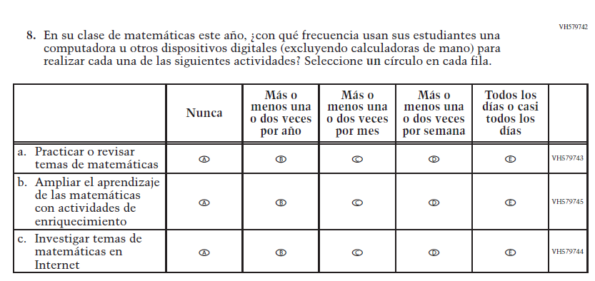

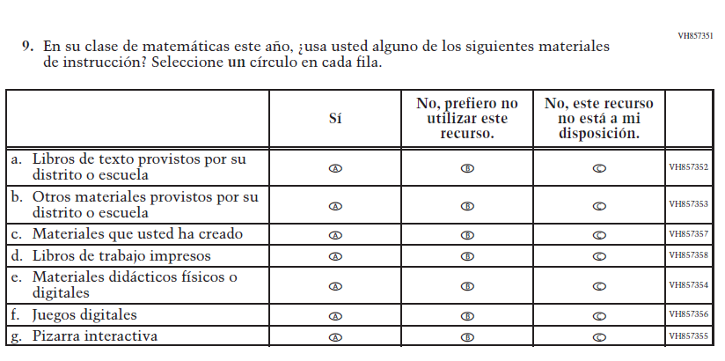

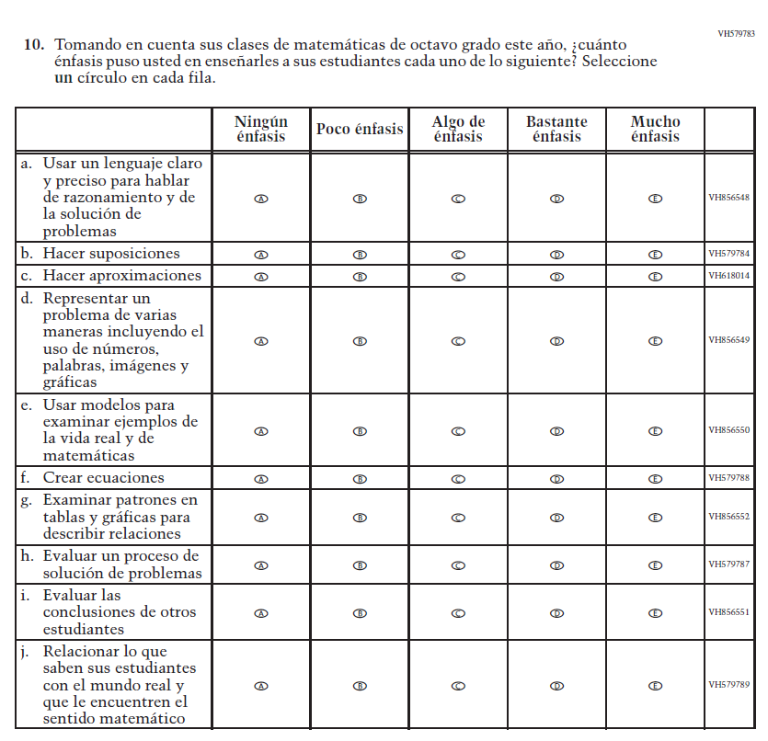

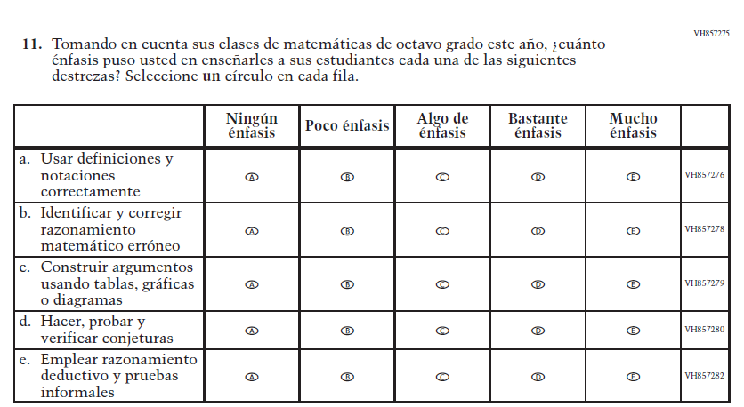

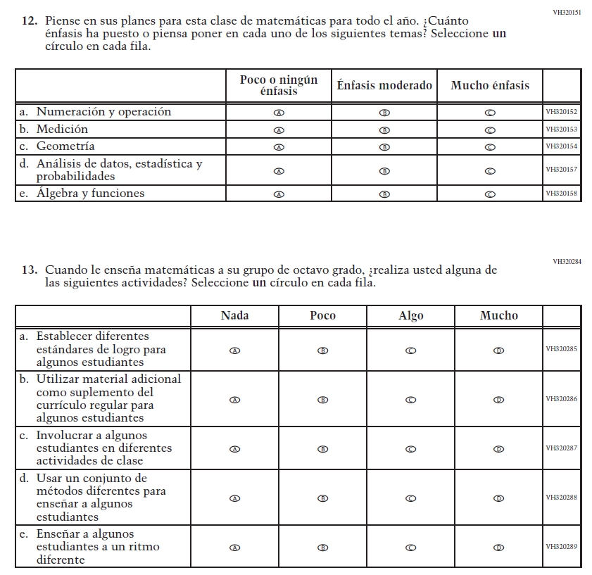

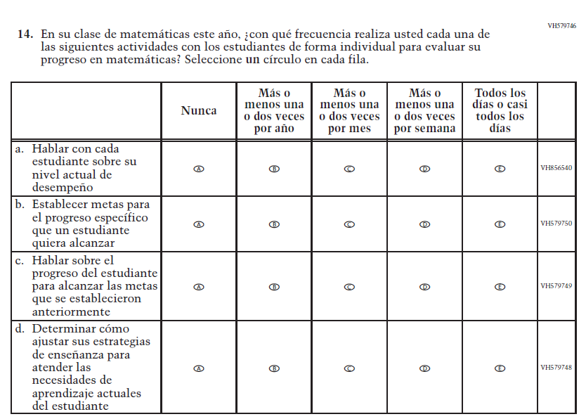

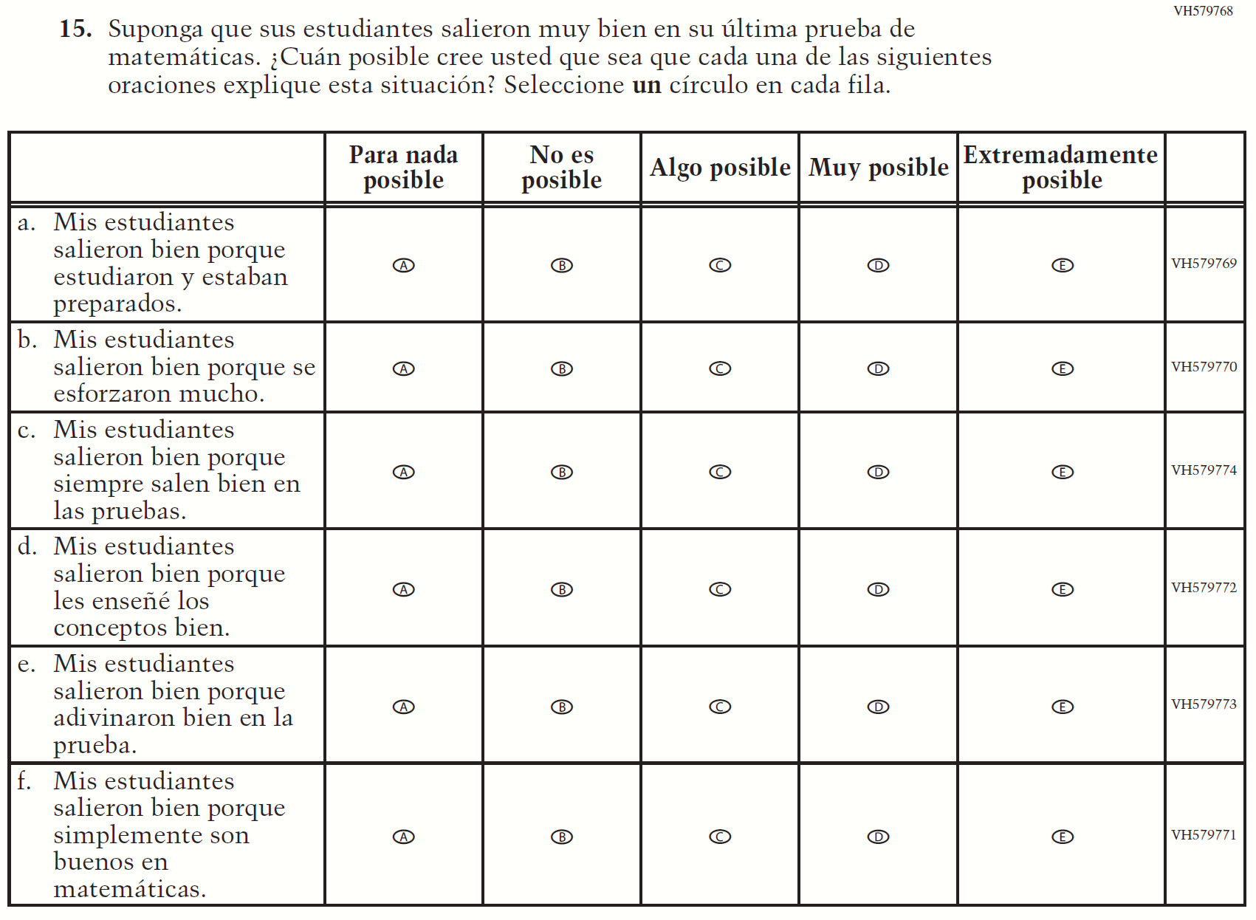

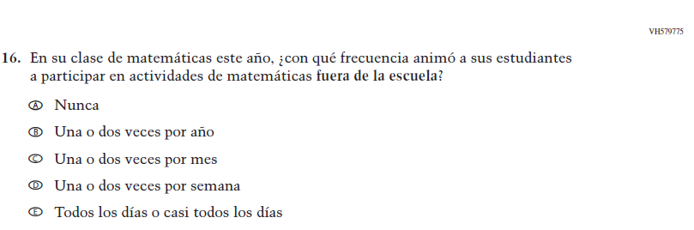

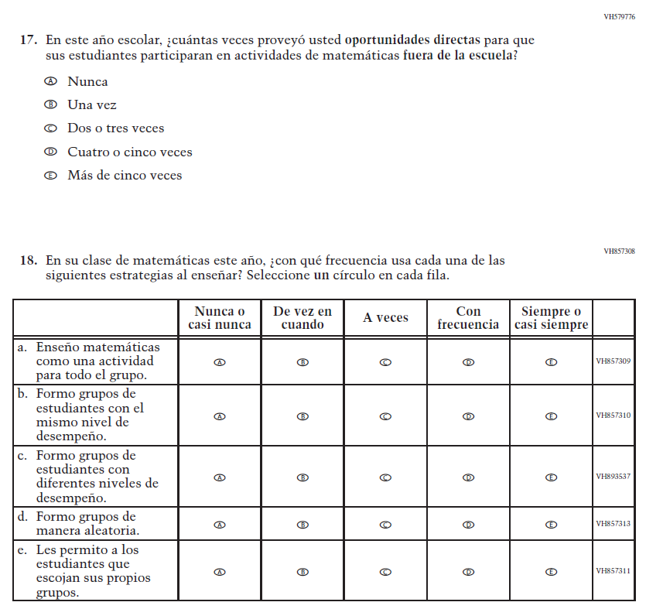

Appendix J-3-s: Spanish Translations of School Questionnaires

Sample School Administrator Login Screen

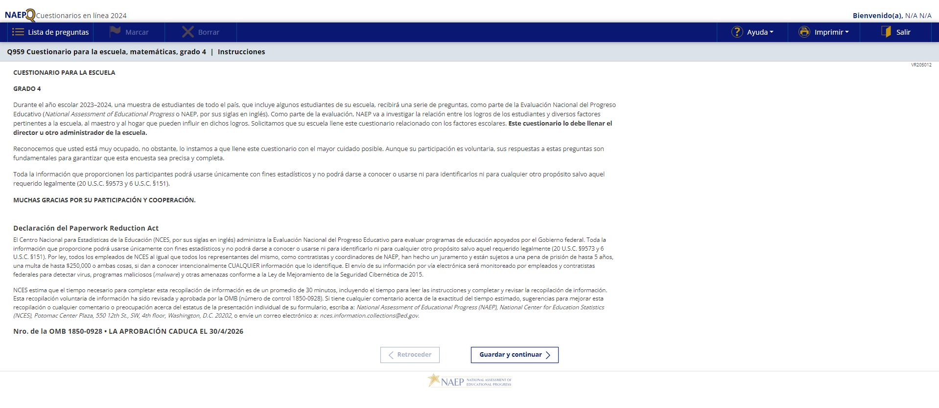

Sample School Questionnaire Booklet Covers

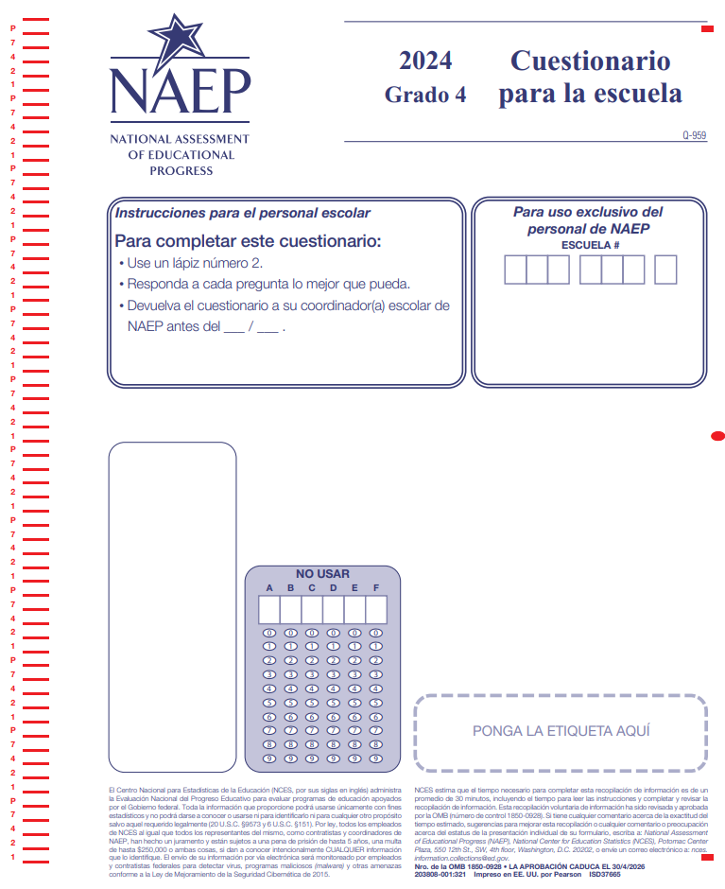

Appendix J-3a-s-PR: Summary of Changes Operational Grade 4 CORE
2024 Operational Grade 4 Core School – Puerto Rico

Previous item | 2024 item | D/A/R/NC+ | Rationale
VH318317  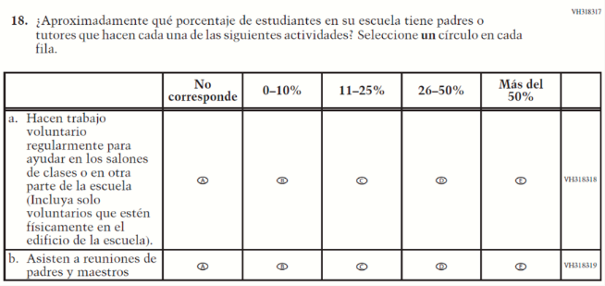  (2022 Operational Grade 4 School Core – Puerto Rico) | N/A | D | To keep school burden low, this item was dropped.
N/A | VR742209  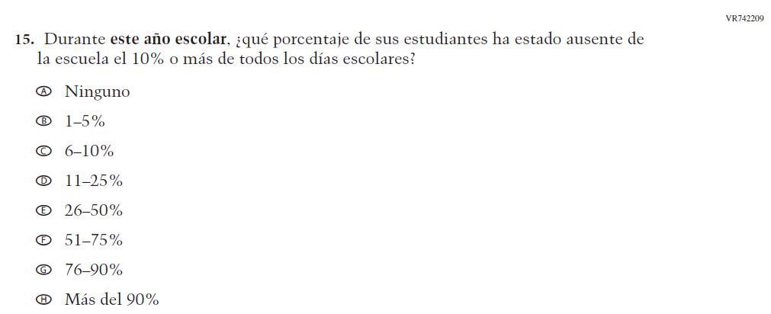  Issue: Learning Recovery | A | To address gaps in learning that have been developed due to the extended period of remote and hybrid learning that took place during the pandemic.

2024 Operational Grade 4 Core School – Puerto Rico

Previous item | 2024 item | D/A/R/NC+ | Rationale
N/A | VR742211  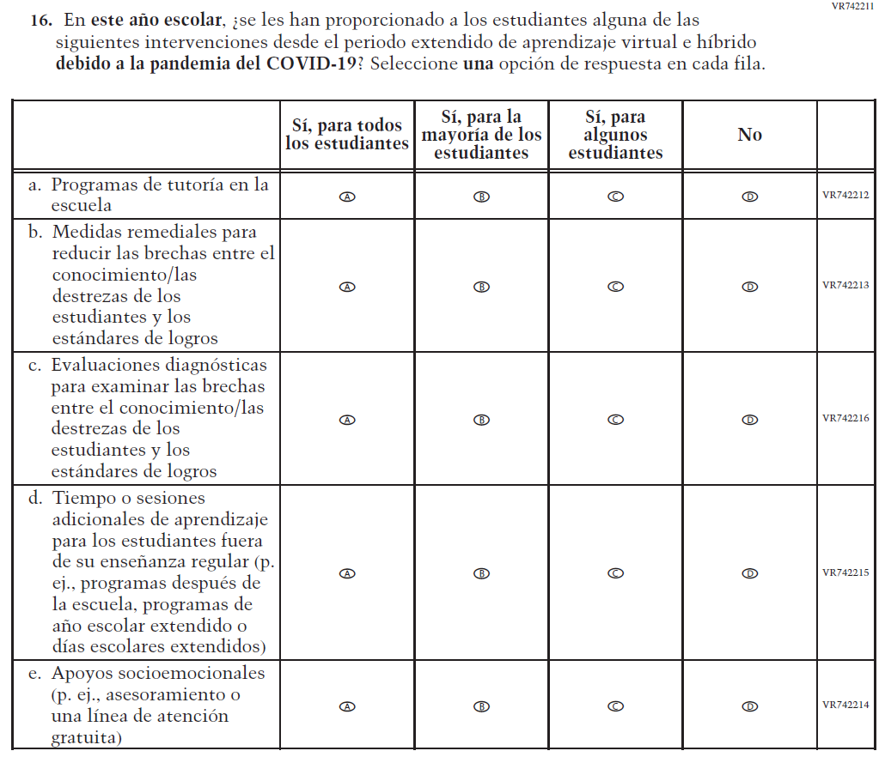  Issue: Learning Recovery | A | To address gaps in learning that have been developed due to the extended period of remote and hybrid learning that took place during the pandemic.

2024 Operational Grade 4 Core School – Puerto Rico

Previous item | 2024 item | D/A/R/NC+ | Rationale
N/A | VR742278  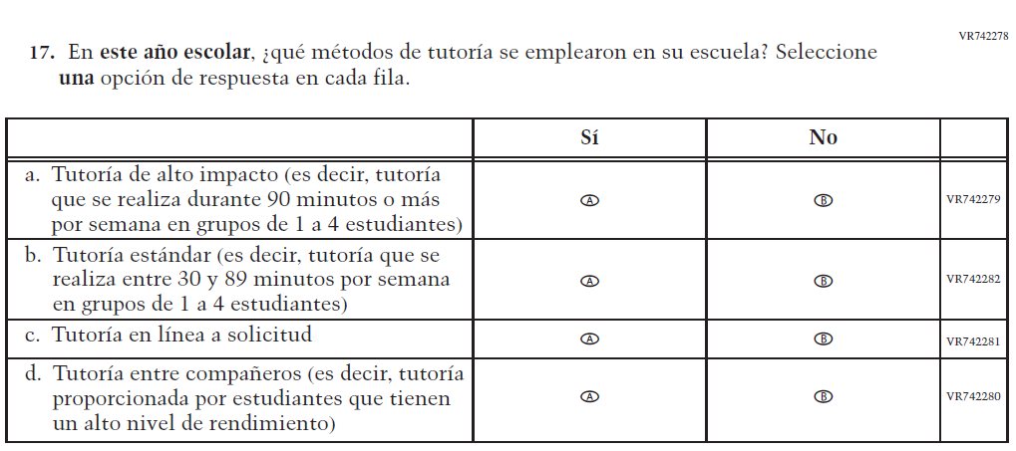  Issue: Learning Recovery | A | To address gaps in learning that have been developed due to the extended period of remote and hybrid learning that took place during the pandemic.
N/A | VR742305  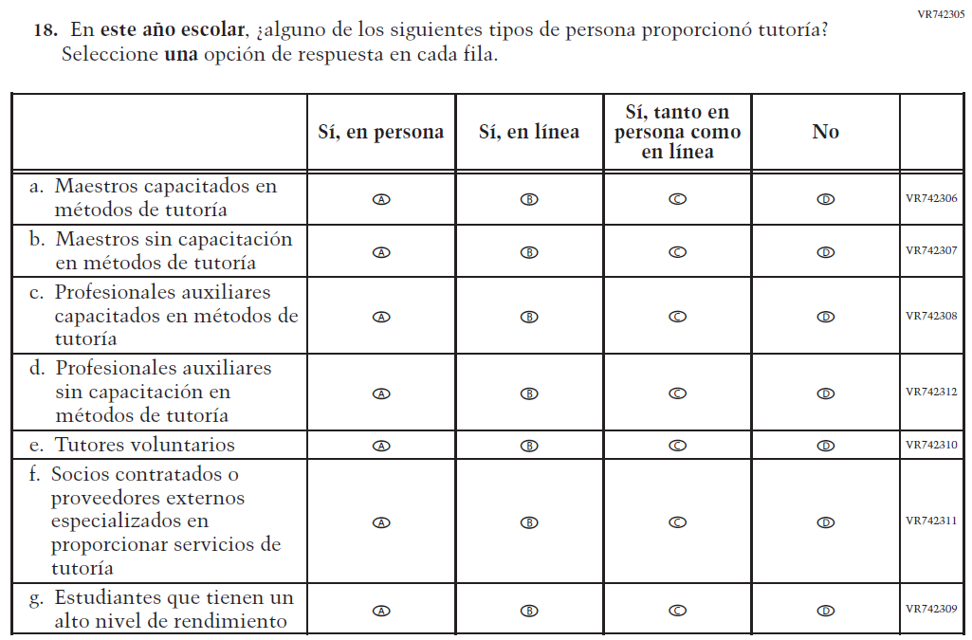  Issue: Learning Recovery | A | To address gaps in learning that have been developed due to the extended period of remote and hybrid learning that took place during the pandemic.

2024 Operational Grade 4 Core School – Puerto Rico

Previous item | 2024 item | D/A/R/NC+ | Rationale
N/A | VR742320  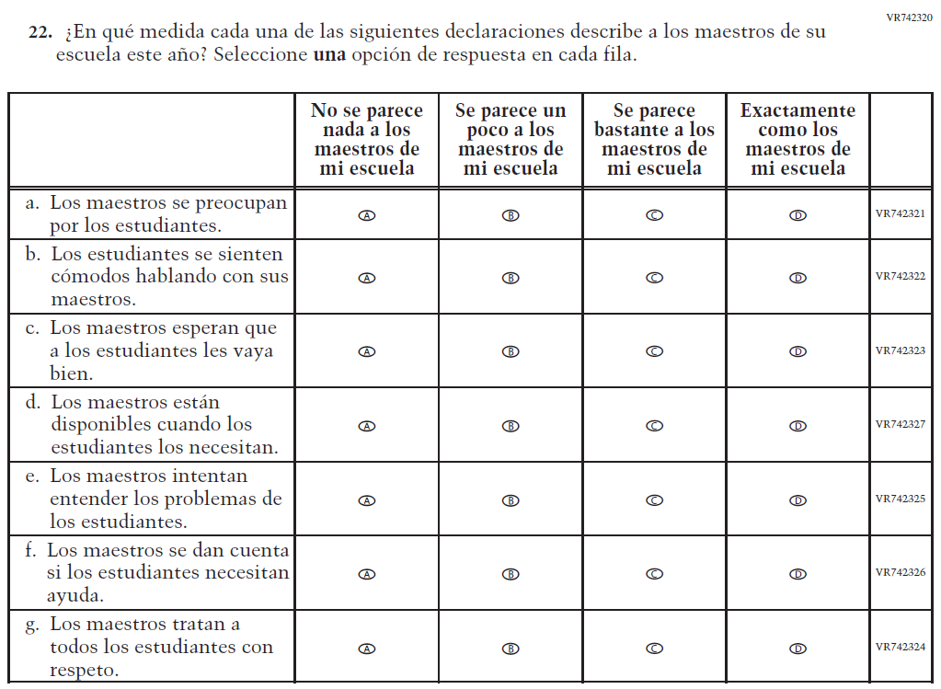  Issue: Learning Recovery | A | To address gaps in learning that have been developed due to the extended period of remote and hybrid learning that took place during the pandemic.

Appendix J-3a-s-PR: Operational Grade 4 CORE
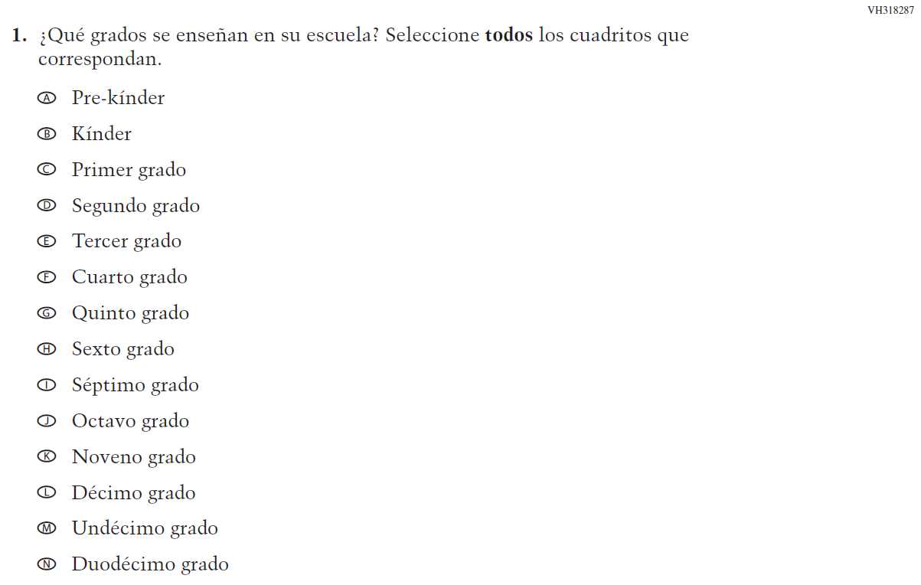

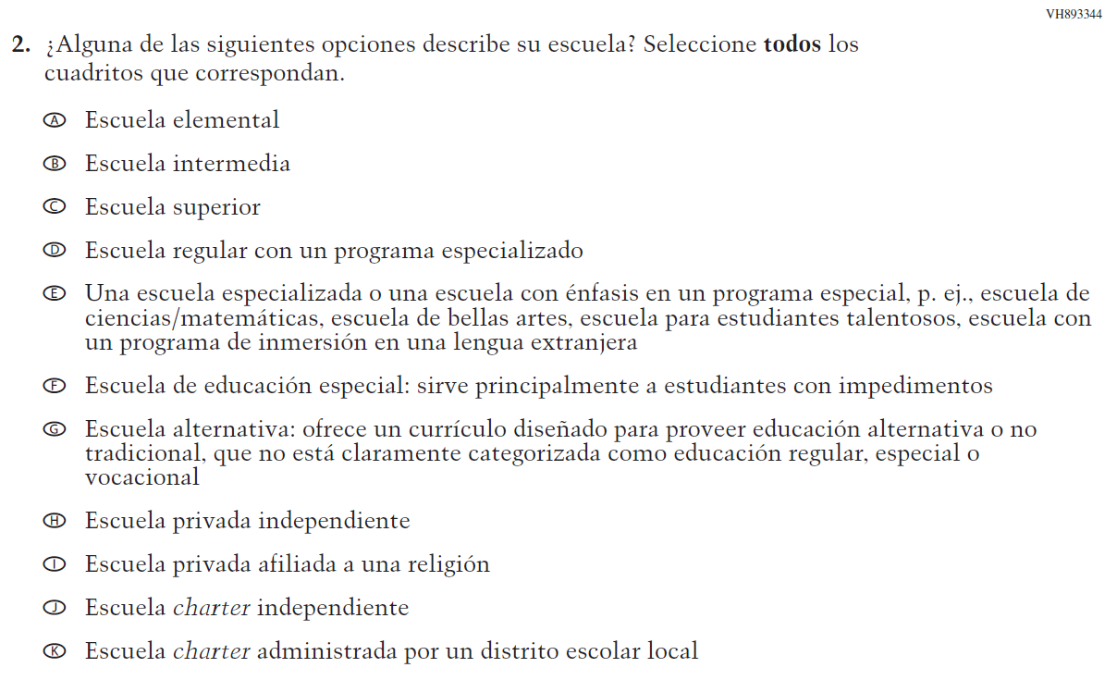

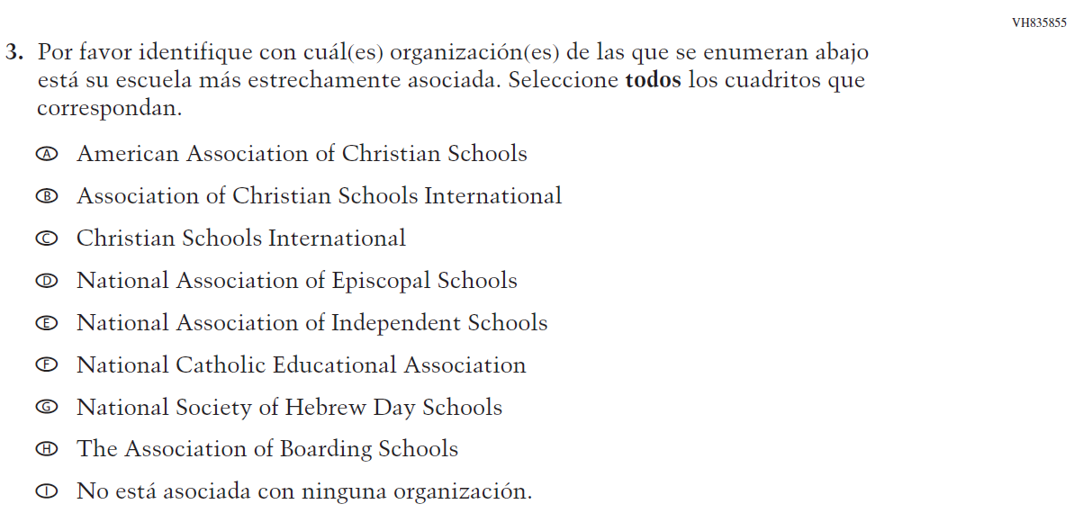

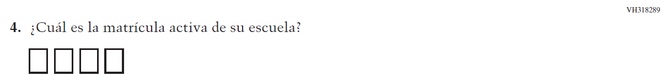

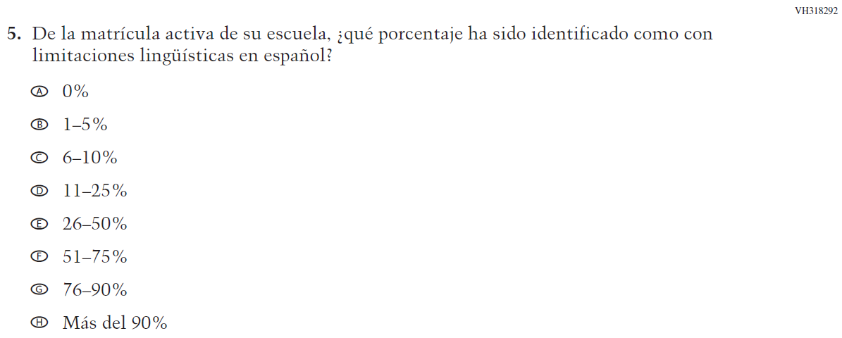

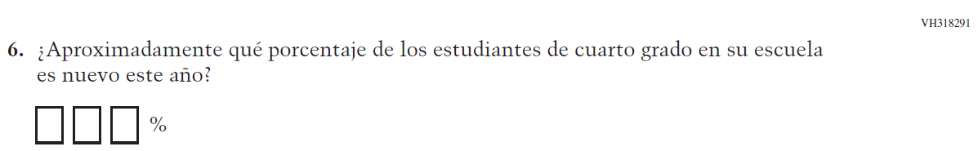

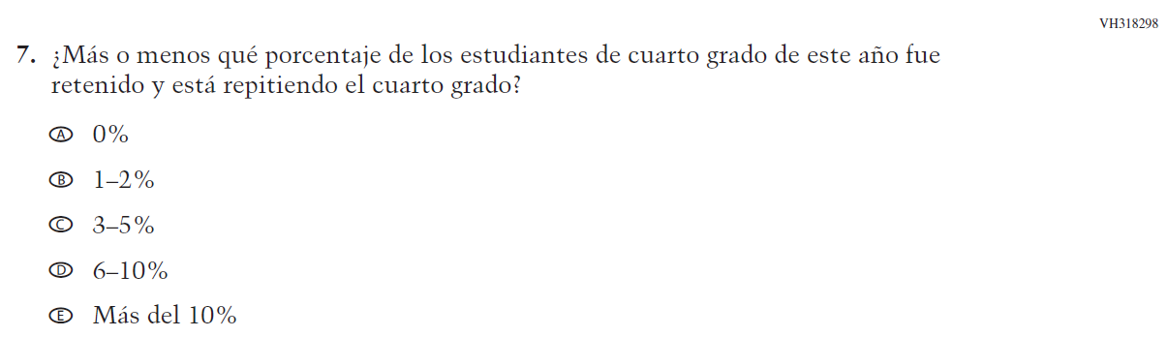

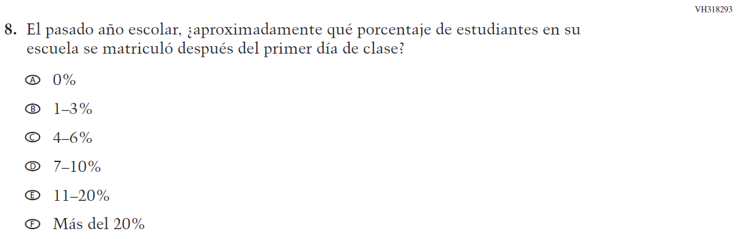

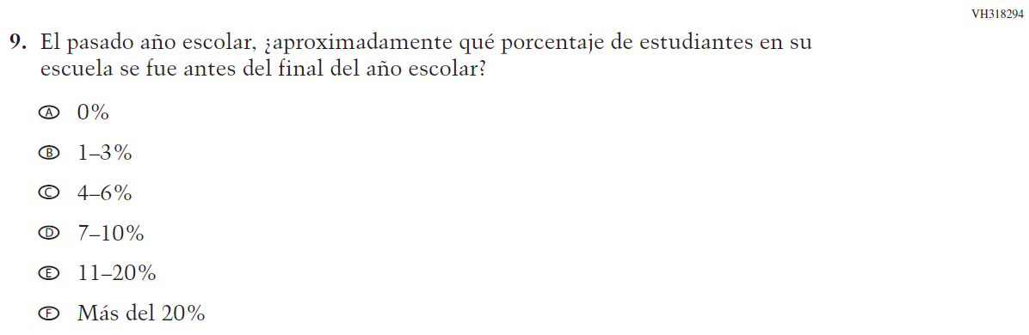

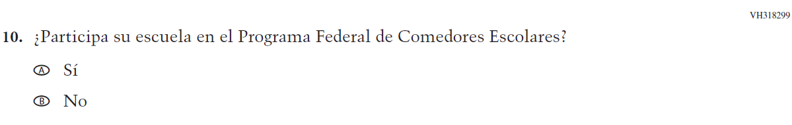

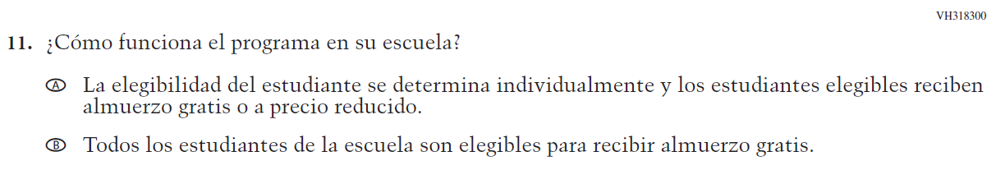

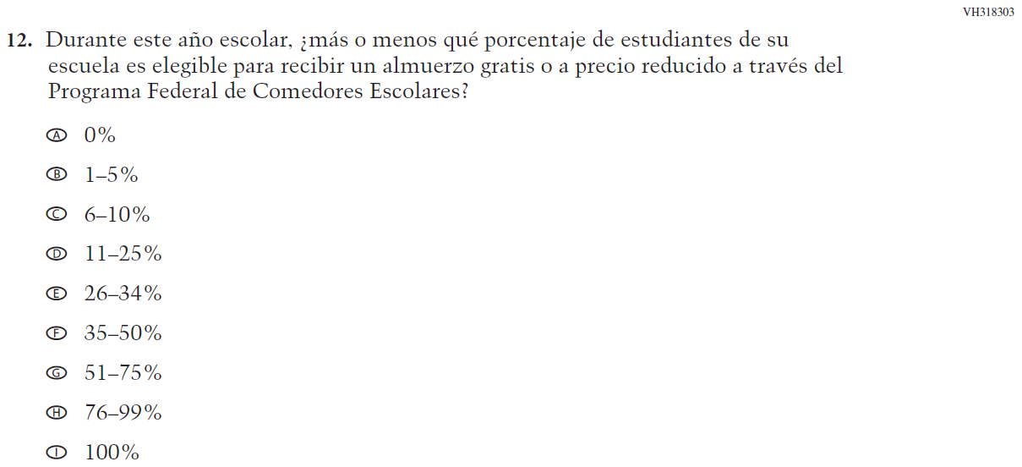

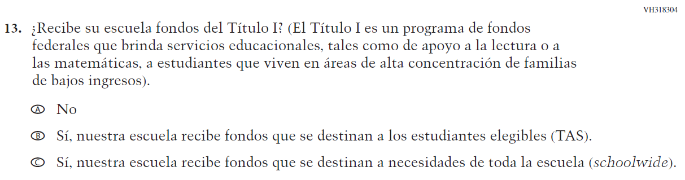
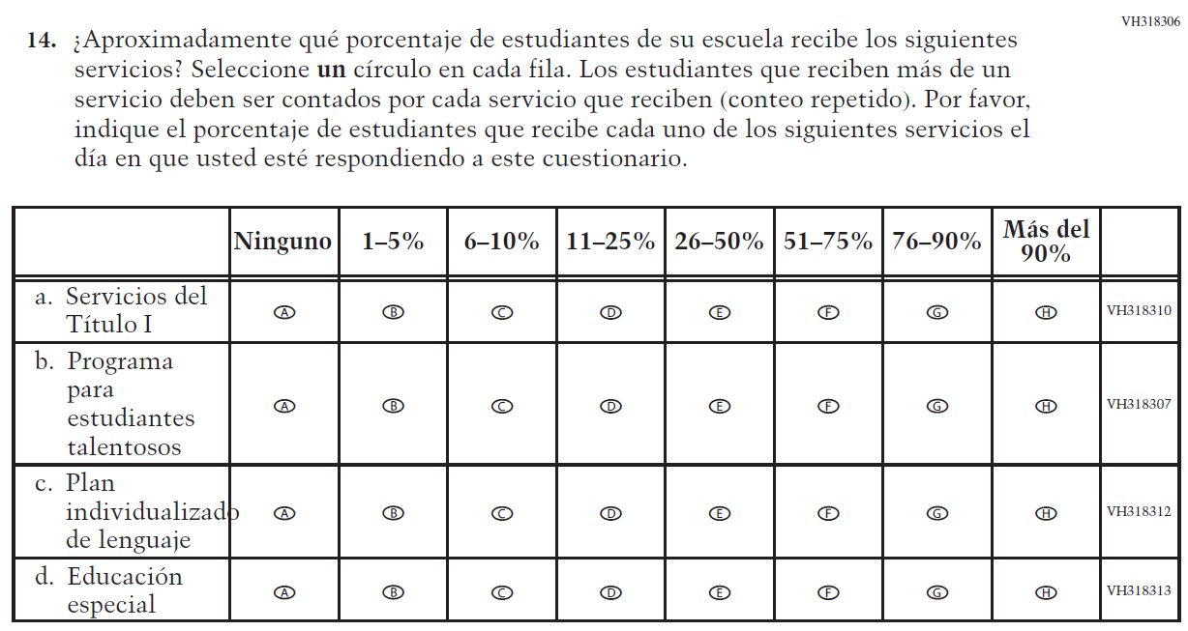

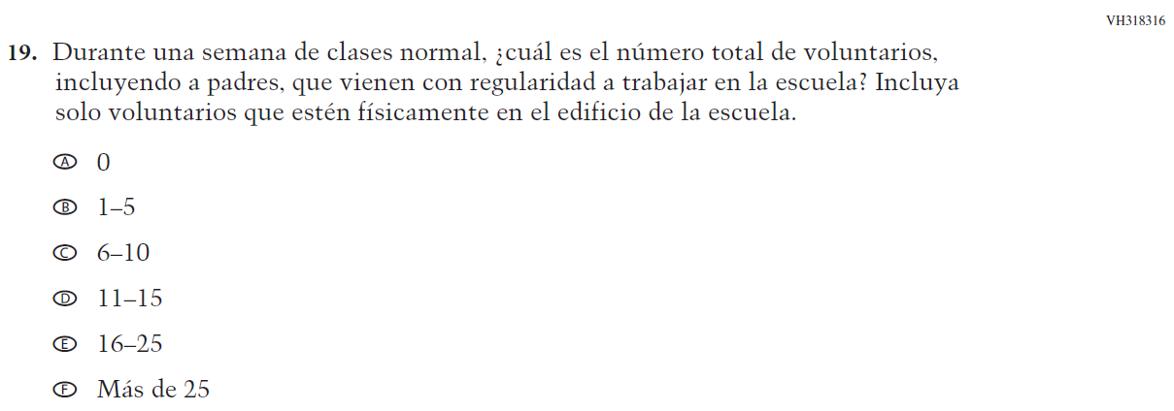

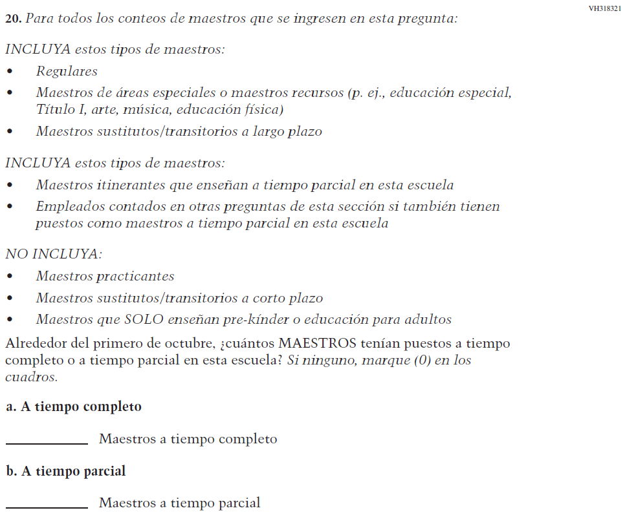

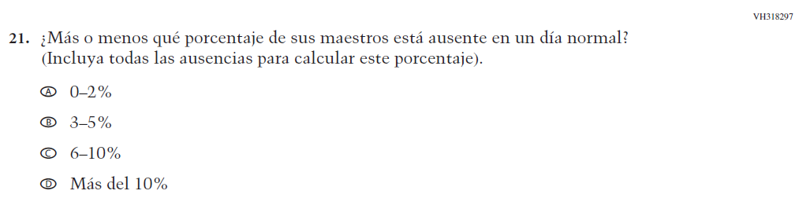

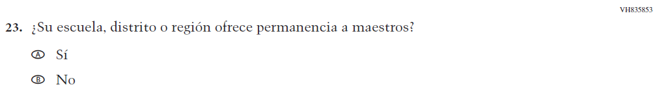

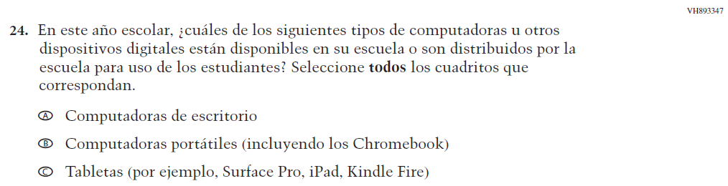

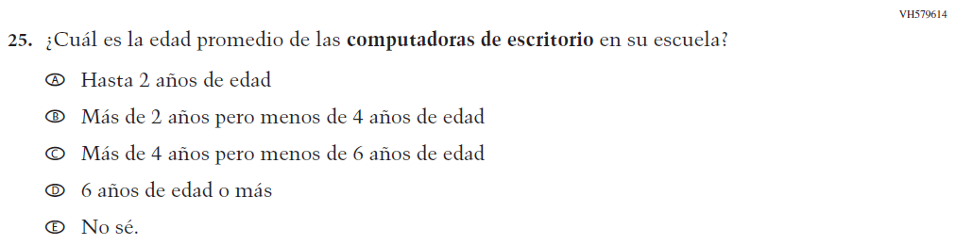

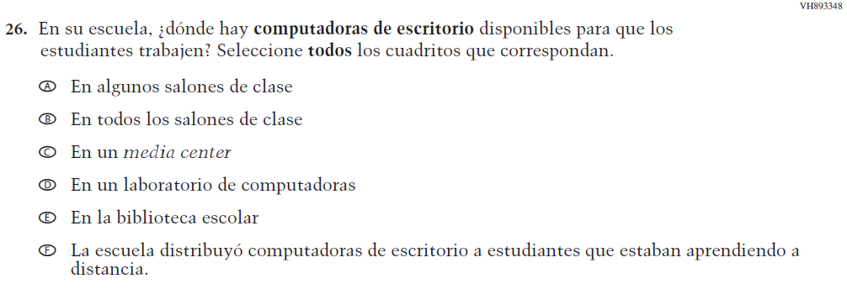

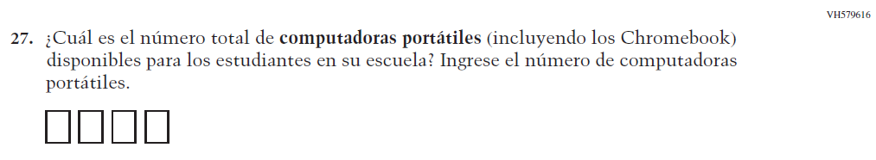

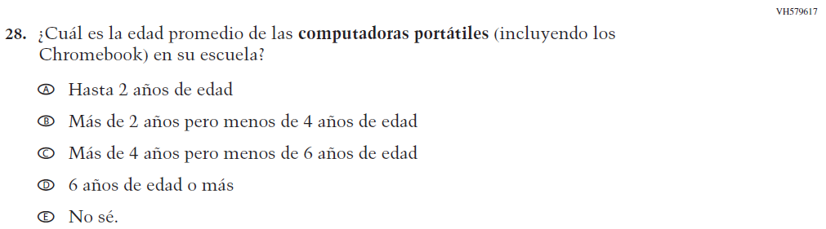

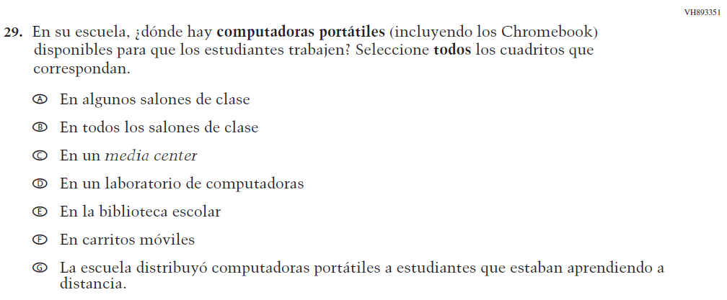

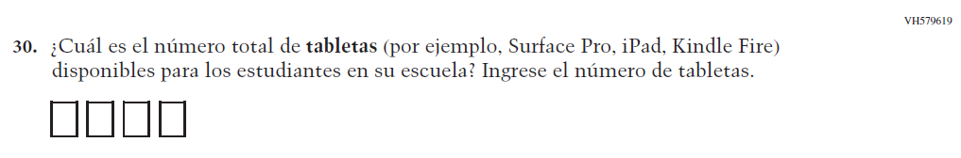

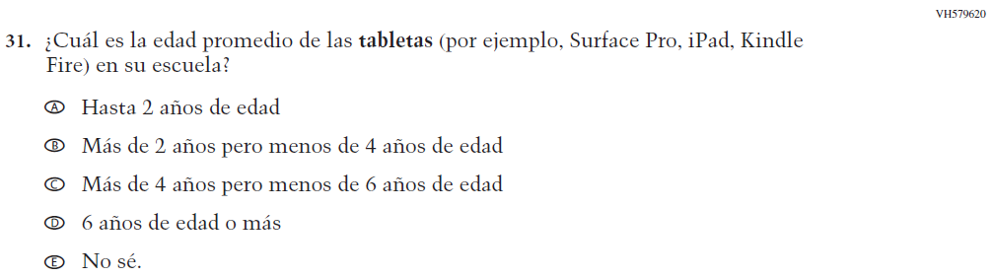

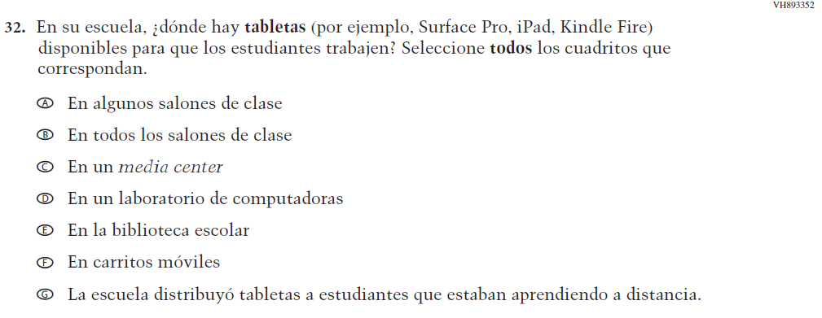

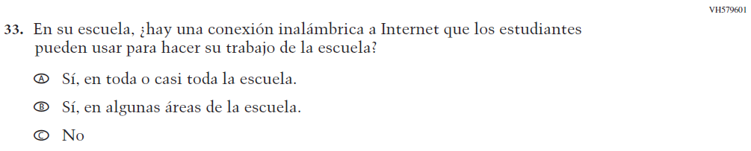

Appendix J-3b-s-PR: Summary of Changes Operational Grade 8 CORE
2024 Operational Grade 8 Core School – Puerto Rico

Previous item | 2024 item | D/A/R/NC+ | Rationale
VH318317  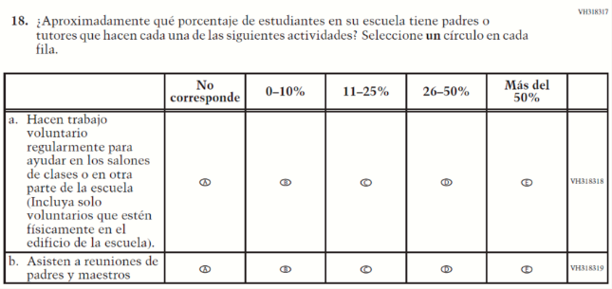  (2022 Operational Grade 4 School Core – Puerto Rico) | N/A  Issue: School Climate | D | To keep school burden low, this item was dropped.
N/A | VR742209  Issue: Learning Recovery | A | To address gaps in learning that have been developed due to the extended period of remote and hybrid learning that took place during the pandemic.

2024 Operational Grade 8 Core School – Puerto Rico
Previous item | 2024 item | D/A/R/NC+ | Rationale
N/A | VR742211  Issue: Learning Recovery | A | To address gaps in learning that have been developed due to the extended period of remote and hybrid learning that took place during the pandemic.

2024 Operational Grade 8 Core School – Puerto Rico

Previous item | 2024 item | D/A/R/NC+ | Rationale
N/A | VR742278  Issue: Learning Recovery | A | To address gaps in learning that have been developed due to the extended period of remote and hybrid learning that took place during the pandemic.
N/A | VR742305  Issue: Learning Recovery | A | To address gaps in learning that have been developed due to the extended period of remote and hybrid learning that took place during the pandemic.

2024 Operational Grade 8 Core School – Puerto Rico

Previous item | 2024 item | D/A/R/NC+ | Rationale
N/A | VR742320  Issue: Learning Recovery | A | To address gaps in learning that have been developed due to the extended period of remote and hybrid learning that took place during the pandemic.

Appendix J-3b-s-PR: Operational Grade 8 CORE

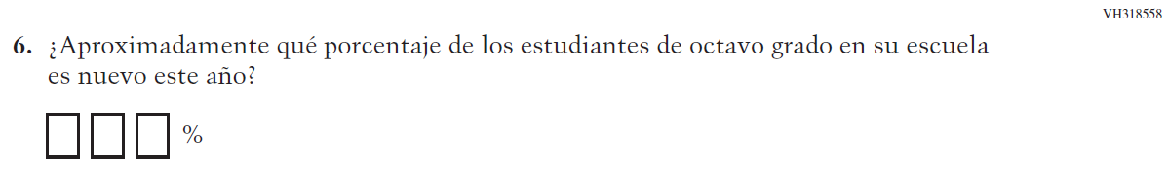

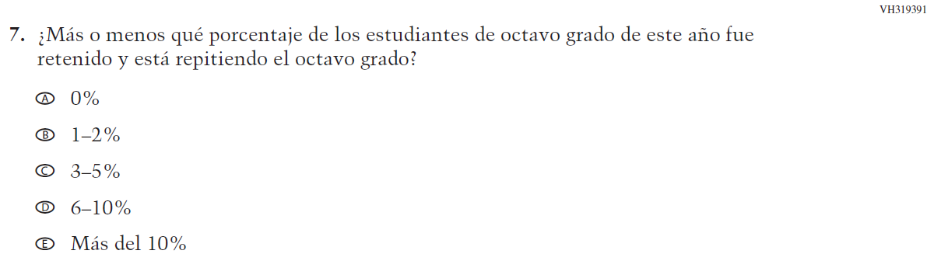

Appendix J-3c-s-PR: Operational Grade 4 Mathematics
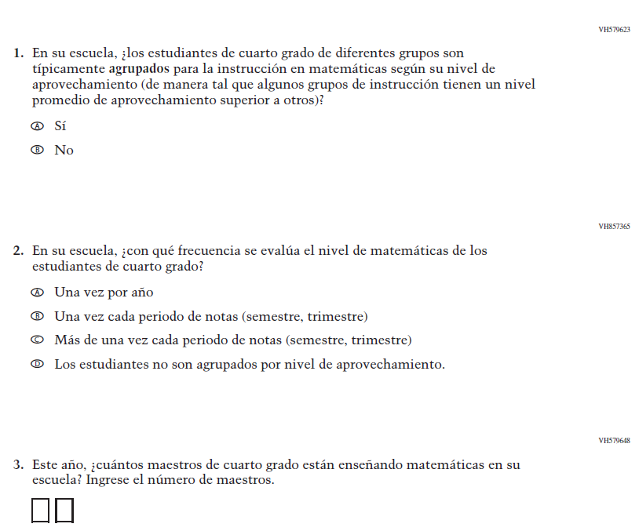

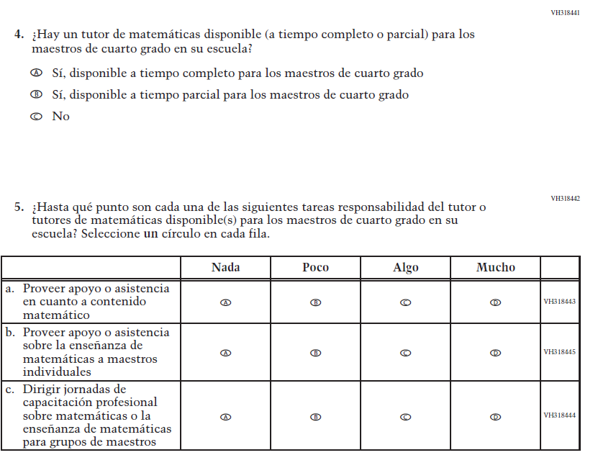
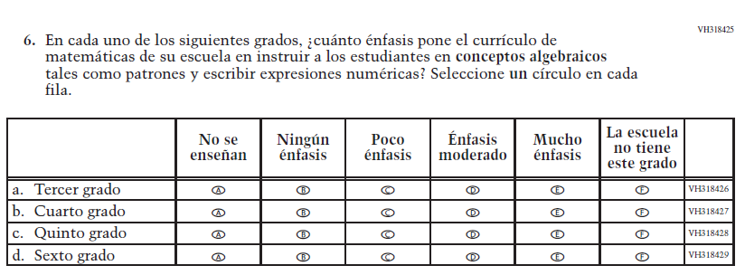

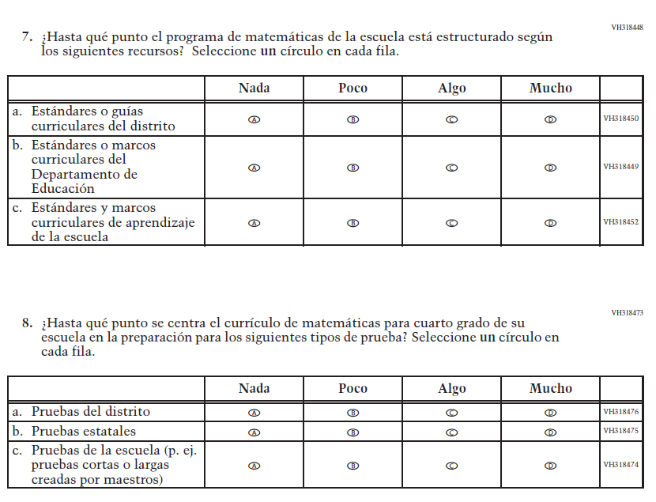

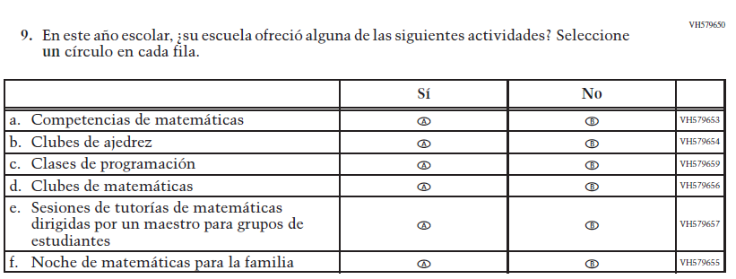

Appendix J-3d-s-PR: Summary of Changes Operational Grade 8 Mathematics
2024 Operational Grade 8 Mathematics School – Puerto Rico

Previous item | 2024 item | D/A/R/NC+ | Rationale
VH318640  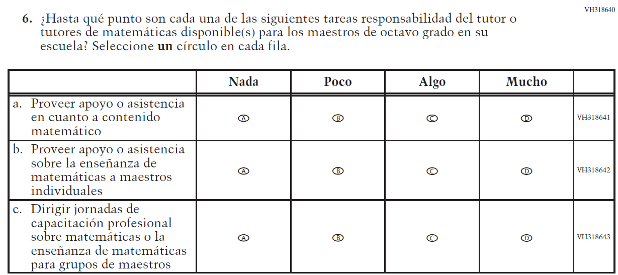  (2022 Operational Grade 4 School Core – Puerto Rico) | N/A | D | To keep school burden low, this item was dropped.

Appendix J-3d-s-PR: Operational Grade 8 Mathematics
