Early Childhood Longitudinal Study, Kindergarten Class of 2023-24 (ECLS-K:2024)

Kindergarten and First-Grade National Data Collection and Transfer School Recruitment

OMB# 1850-0750 v.26

Attachment A-5
Infographics

National Center for Education Statistics
U.S. Department of Education

October 2022

Table of Contents
Section Page
Plan for Distributing Infographics A5-1
Fall Kindergarten and Spring Kindergarten A5-1
Fall First Grade (MyECLS Landing Page only) and Spring First Grade A5-2
Social and Academic Skills A5-3
Activities with Children A5-5
Use of Technology A5-6
School Support of Families A5-7
Materials Sent Home A5-8
Barriers to Participation A5-9
Children Going to School A5-10
Common Activities for Families A5-11
Sense of Belonging A5-12
Positive Learning Behaviors A5-13
Participation in Summer Activities A5-14
School Programs and Services Available to Parents and Families A5-15
Language-Minority Students A5-16
School Safety Measures A5-17
School Neighborhood Problems A5-18

Plan for Distributing Infographics

There have been no changes to the infographics that were used for the K-1 field test, and which are proposed for use in the national kindergarten and first-grade rounds, since previous approved revision (OMB# 1850-0750 v.24). New infographics for this submission are denoted below.
Some of the infographics have been or will be translated into Spanish and the translated text will be included in this attachment with a future OMB revision request. Materials that will include translated infographics are denoted with an asterisk (“*”).

Fall Kindergarten and Spring Kindergarten

 | Social/ Academic skills | Activities with children | Use of technology | School support of families | Materials sent home | Barriers to participation | Children going to school | Common activities for families | Sense of belonging (NEW)
*MyECLS log in screen (Attachment F) | X |  |  | X | X |  | X
ECLS study overview (Attachment A-1 and A-2) | X  (selected) |  |  | X
Teacher fact sheet (Attachment A-1) |  |  |  |  |  | X  (selected) |  |  | X  (selected)
Teacher web portal (Attachment F) |  |  |  |  |  | X
Teacher/School administrator survey reminder letters/ emails (Attachment A-1) |  |  | X | X | X |  | X
*Parent fact sheet (Attachment A-1) | X  (selected) | X  (selected)
*Parent web portal (Attachment F) |  |  |  |  |  | X |  | X
*Parent consent/ survey reminder letters/emails (Attachment A-1) |  |  | X | X | X | X | X | X

Fall First Grade (MyECLS Landing Page only) and Spring First Grade

 | Positive learning  behaviors  (NEW) | Participation in summer  activities  (NEW) | School  programs and services  available to  parents and  families  (NEW) | Language-minority students  (NEW) | School safety measures  (NEW) | School neighborhood  problems  (NEW) | Sense of belonging  (NEW) | Use of technology | Barriers to participation
*MyECLS log in screen (Attachment F) | X | X | X
ECLS study overview (Attachment A-1 and A-2)
Teacher fact sheet (Attachment A-1) |  |  |  |  |  |  | X  (selected) |  | X
Teacher web portal (Attachment F) |  |  |  |  |  |  |  |  | X
Teacher/School administrator survey reminder letters/ emails (Attachment A-1) |  |  |  | X | X | X |  | X
*Parent fact sheet (Attachment A-1) |  | X  (selected)
*Parent web portal (Attachment F) |  |  | X |  |  |  |  |  | X
*Parent consent/ survey reminder letters/emails (Attachment A-1) |  |  |  | X | X | X |  | X | X

Social and Academic Skills

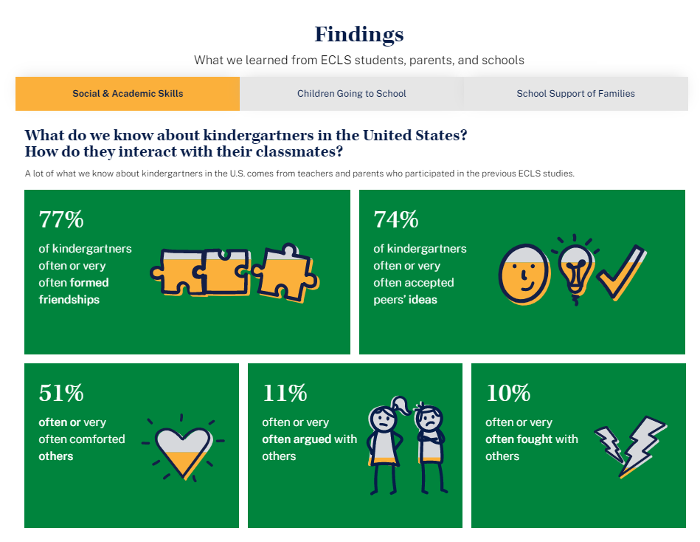
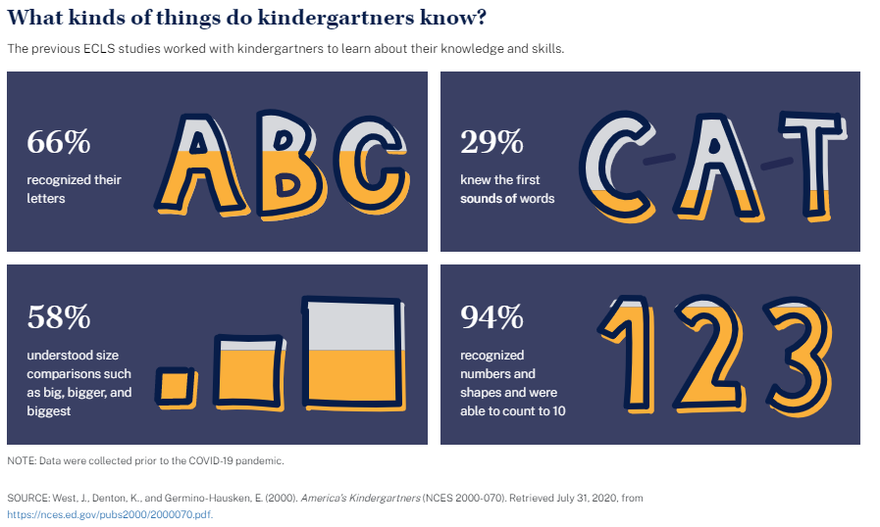
Activities with Children

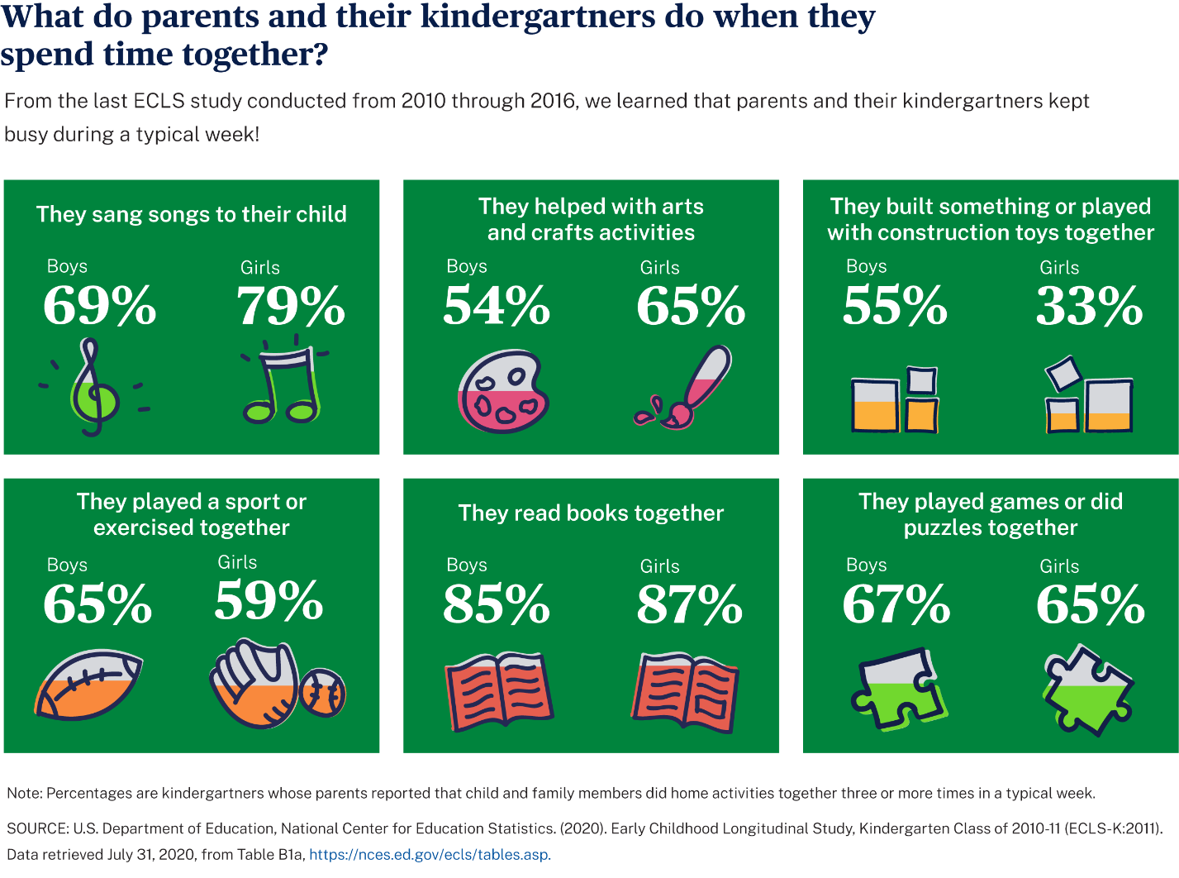

¿Qué hacen los padres y los niños de kindergarten cuando pasan tiempo juntos?
¡Del último estudio de ECLS realizado desde 2010 hasta 2016, aprendimos que los padres y sus niños(as) de kindergarten se mantenían muy ocupados durante una semana normal!
Ayudaban con las actividades de arte y manualidades
Niños 54% Niñas 65%
Jugaban un deporte o hacían ejercicio juntos
Niños 65% Niñas 59%
Jugaban juegos o armaban rompecabezas juntos
Niños 67% Niñas 65%

Nota: Los porcentajes se refieren a los niños y niñas de kindergarten cuyos padres respondieron que el niño(a) y miembros de la familia hacían juntos actividades en el hogar tres o más veces en una semana normal.
Los datos fueron recopilados antes de la pandemia de COVID-19.
FUENTE: Departamento de Educación de los Estados Unidos, Centro Nacional para Estadísticas de Educación (2020). Estudio Longitudinal de la Primera Infancia, Clase de Kindergarten de 2010-11 (ECLS-K:2011). Datos extraídos el 31 de julio de 2020 de la tabla B1a, https://nces.ed.gov/ecls/tables.asp.

Use of Technology

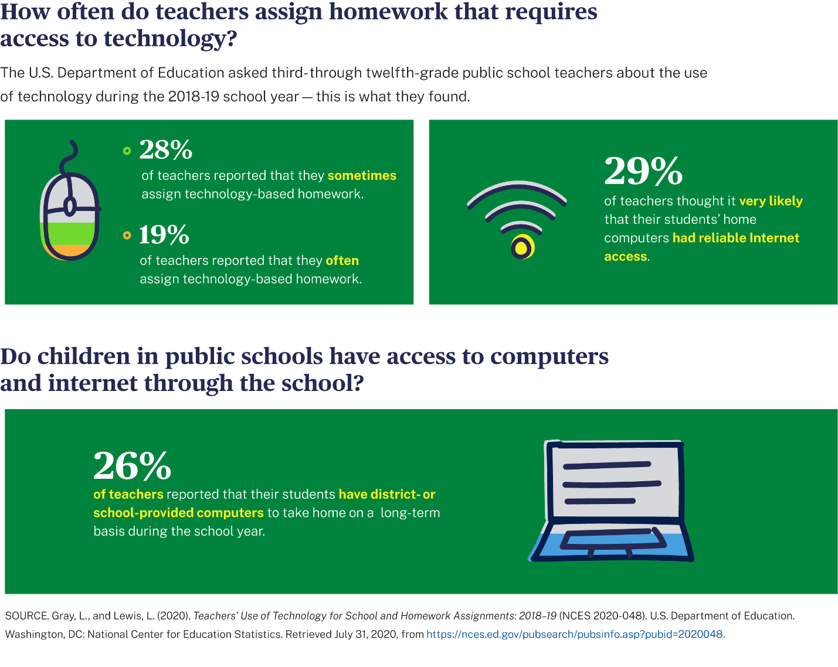

Resultados de estudios anteriores del Departamento de Educación de los Estados Unidos
¿Con qué frecuencia los maestros asignan tarea para el hogar que requiere acceso a tecnología?
El Departamento de Educación de los Estados Unidos preguntó a maestros y maestras de 3º a 12º grado en escuelas públicas sobre el uso de tecnología durante el año escolar 2018-19 y esto es lo que se encontró:
· 28% de los maestros respondió que algunas veces asignan tarea que requiere acceso a tecnología.
· 19% de los maestros respondió que a menudo asignan tarea que requiere acceso a tecnología.
· 29% de los maestros consideraba muy probable que las computadoras en los hogares de sus estudiantes tuvieran acceso estable a Internet.
¿Los niños de escuelas públicas tienen acceso a computadoras y a Internet a través de sus escuelas?
· 26% de los maestros respondió que sus estudiantes tienen computadoras proporcionadas por el distrito escolar o por la escuela para llevarse a casa por periodos prolongados durante el año escolar.

NOTA: Los datos fueron recopilados antes de la pandemia de COVID-19.

FUENTE: Use of Technology for School and Homework Assignments: 2018–19 (NCES 2020-048). U.S. Department of Education. Washington, DC: National Center for Education Statistics. Datos extraídos el 31 de julio de 2020, de https://nces.ed.gov/pubsearch/pubsinfo.asp?pubid=2020048.

School Support of Families

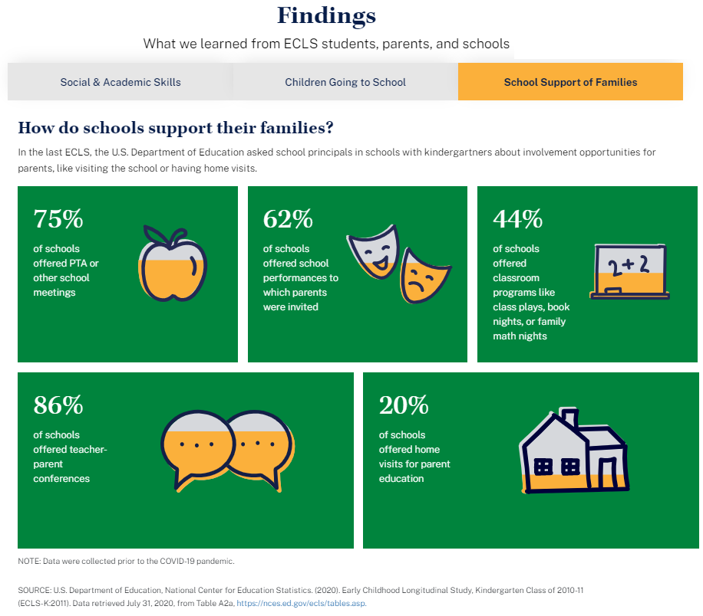

Materials Sent Home

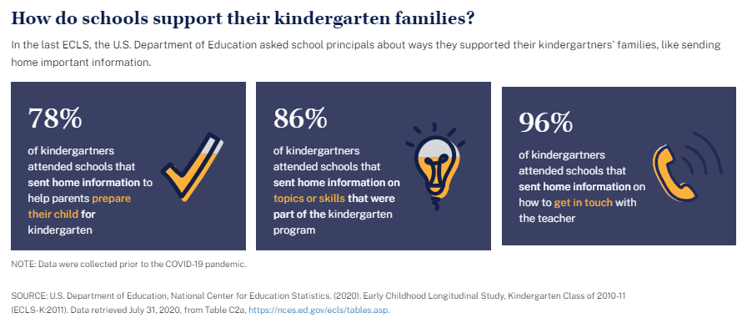

Barriers to Participation

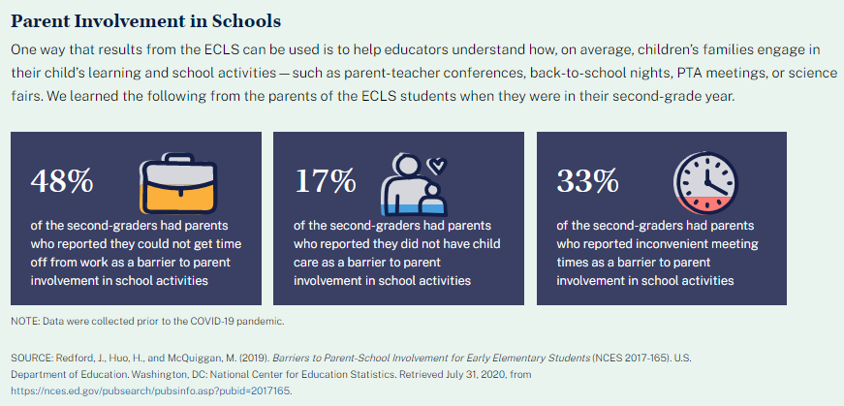

Children Going to School

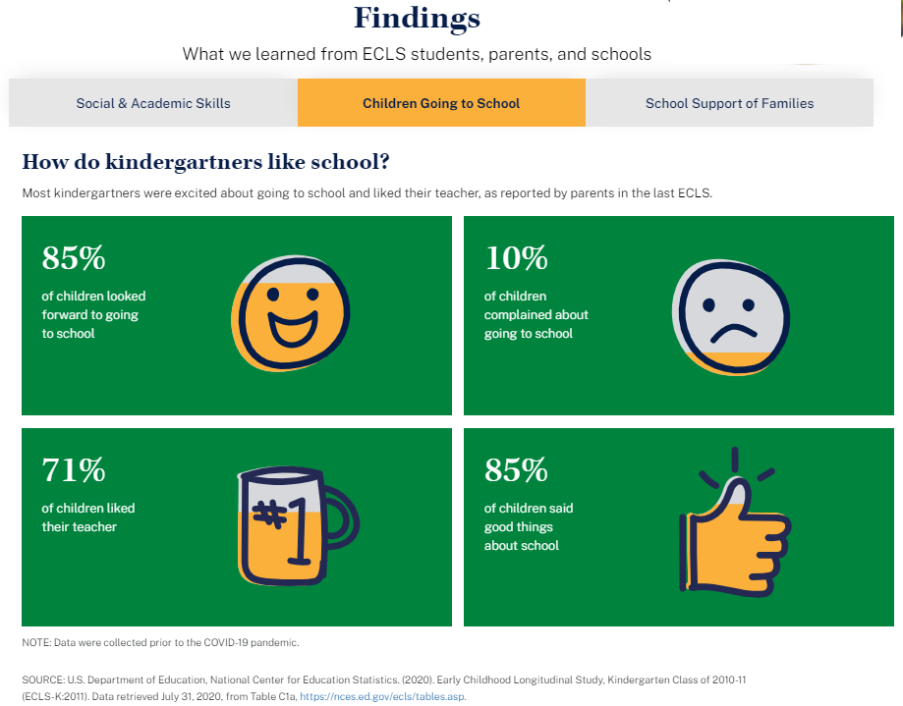

Common Activities for Families

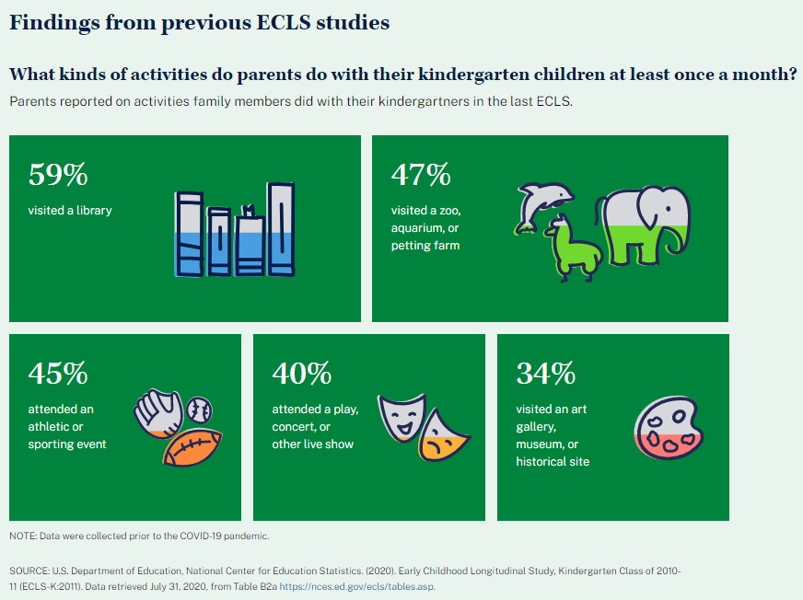

Sense of Belonging

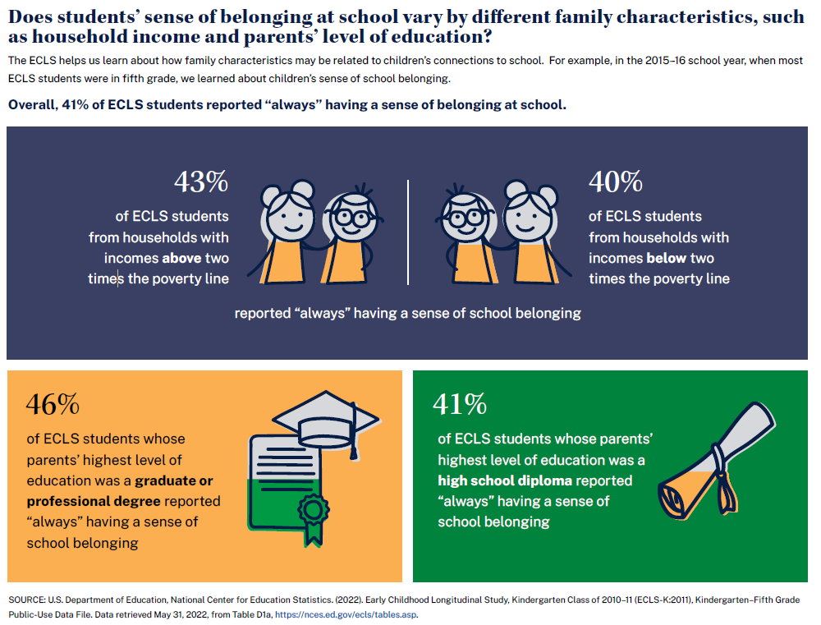

Positive Learning Behaviors

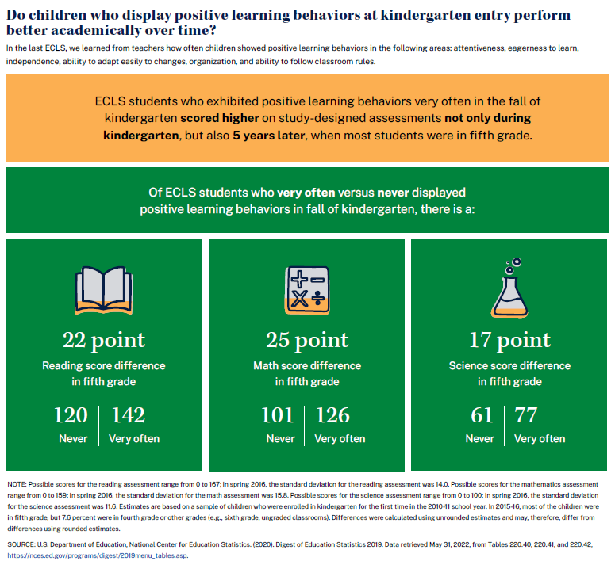

Participation in Summer Activities

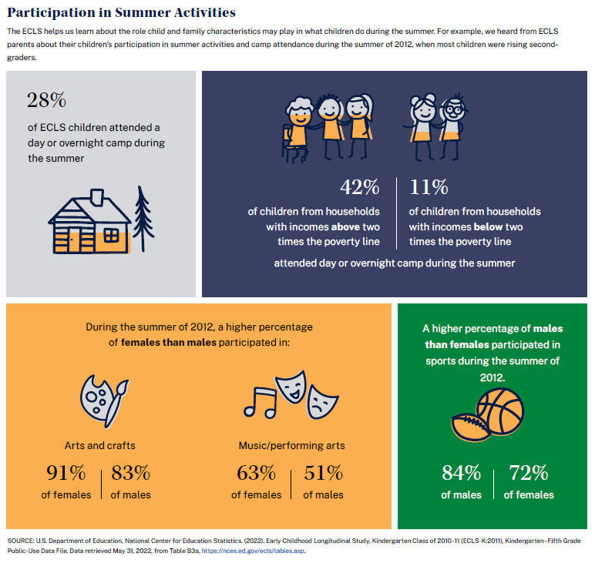

School Programs and Services Available to Parents and Families

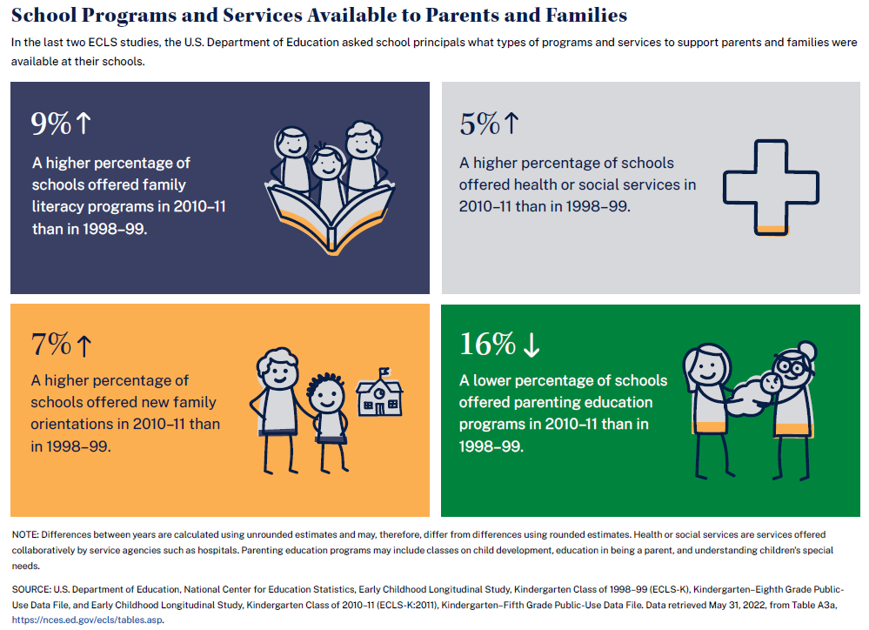

Language-Minority Students

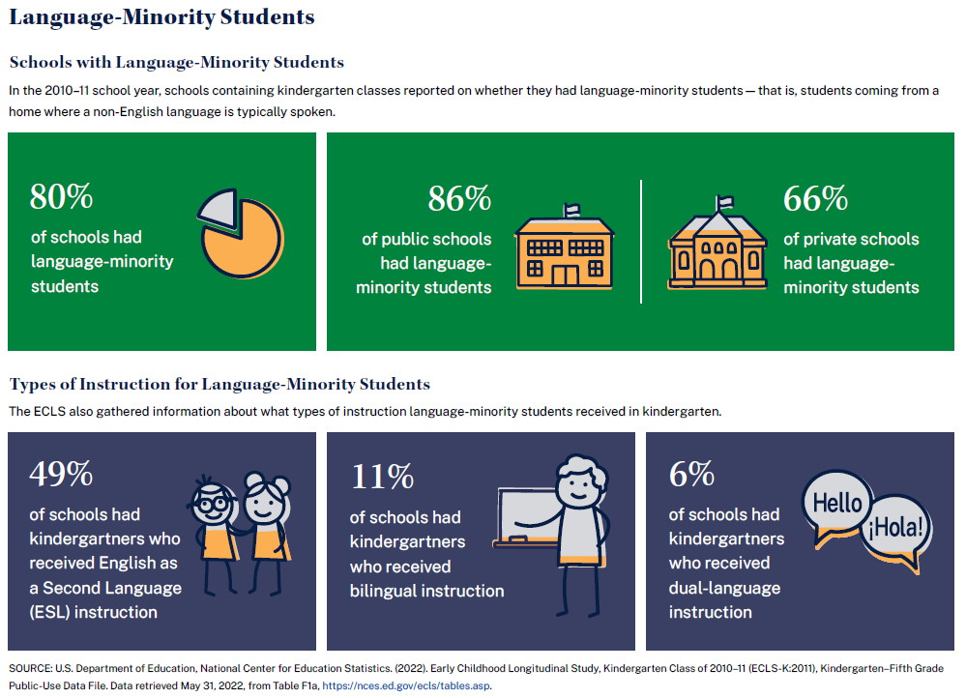

School Safety Measures

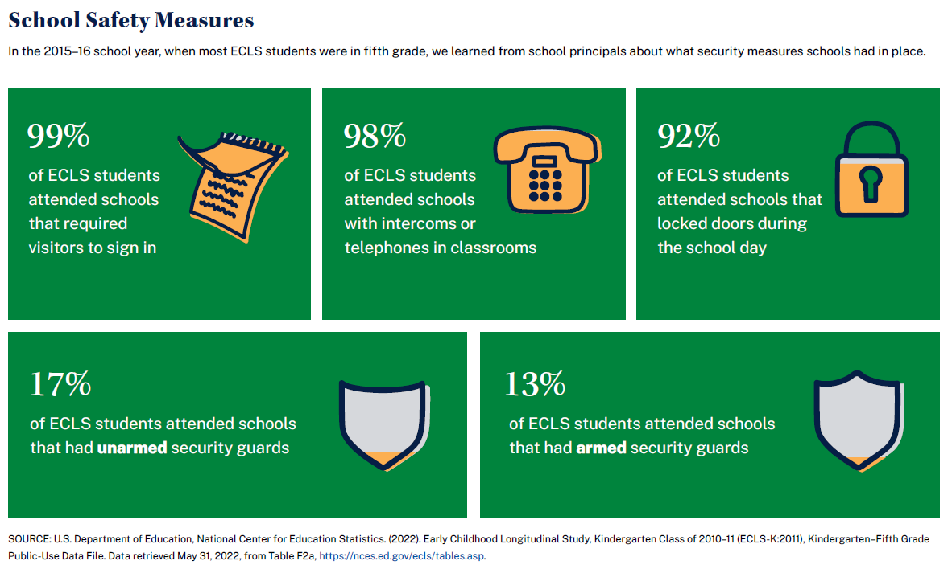

School Neighborhood Problems

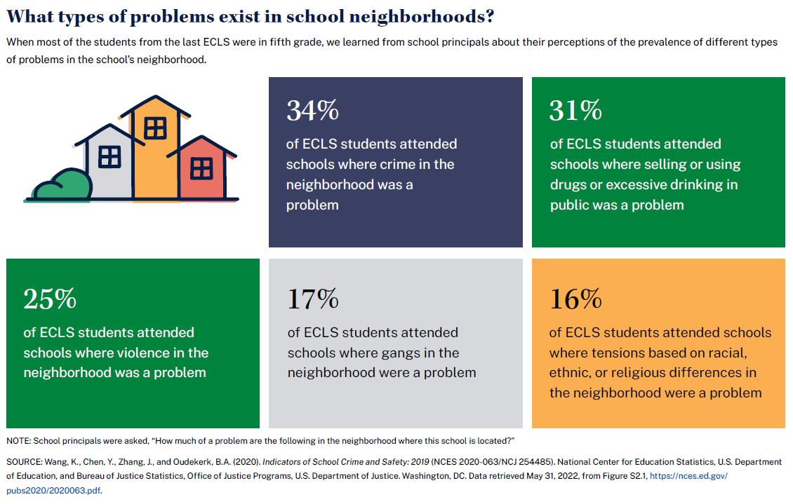

Only the selected statistics from the Activities with Children infographic that will appear on the Parent Fact Sheet have been translated.
Only a selection of the “Activities with Children” graphics appear on the parent fact sheet and thus require Spanish translations. The remainder of the graphics do not need Spanish translation.

