NIFA Reporting System (NRS) Screenshots of Forms & Planned Revisions
Contents
NRS System Header & Footer Present on all System Pages (No Revisions) 2
Header on All Pages 2
Footer with PRA & OMB Control Number on All Pages 2
Add/Edit Project/Program Initiation (No Revisions) 2
Add Result/Edit Result (Revision) 6
Revisions to the Result Form 8
Final Result (Revision) 9
Revisions to the Final Result Form 11
Annual Report of Accomplishments and Results (No Revisions) 12
Overview: Executive Summary & Critical Issues Additional Information 12
Merit and Scientific Peer Review Process 15
Stakeholder Input 16
All Results by Project or Program 18
Research Project Results 18
Extension Program Results 19
Other Projects/Programs Results 20
Plan of Work (No Revisions) 21
Merit and Scientific Peer Review Process 21
Stakeholder Input 22
Manage Critical Issues 24
Add New Critical Issue/Update Issue 25
Executive Summary and Critical Issues Additional Information 26
Financial Report (New, Mockup) 28
OGFM Supplemental Form (New, Mockup) 30

NRS System Header & Footer Present on all System Pages (No Revisions)

Header on All Pages
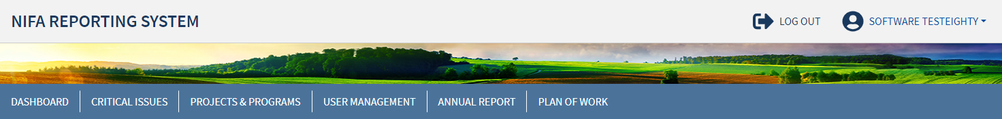

Footer with PRA & OMB Control Number on All Pages

Add/Edit Project/Program Initiation (No Revisions)
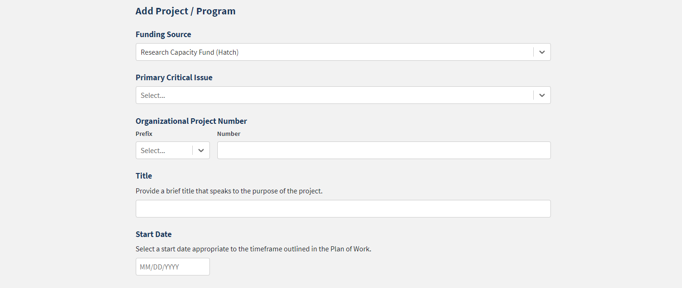
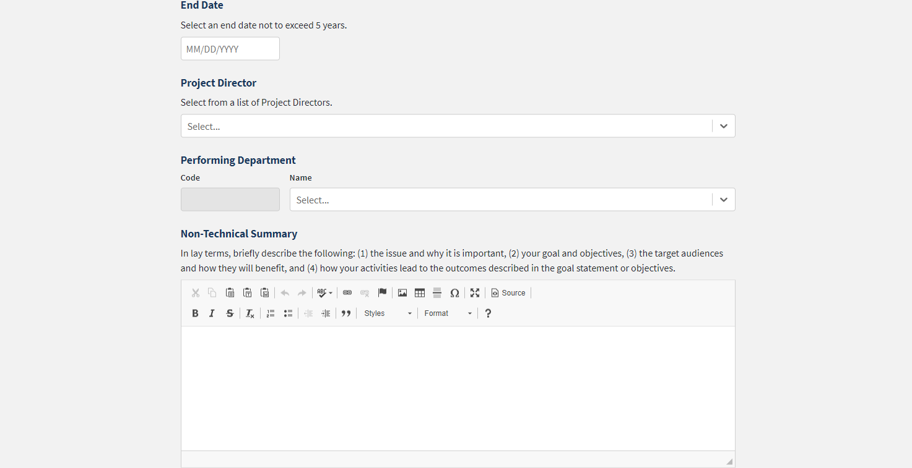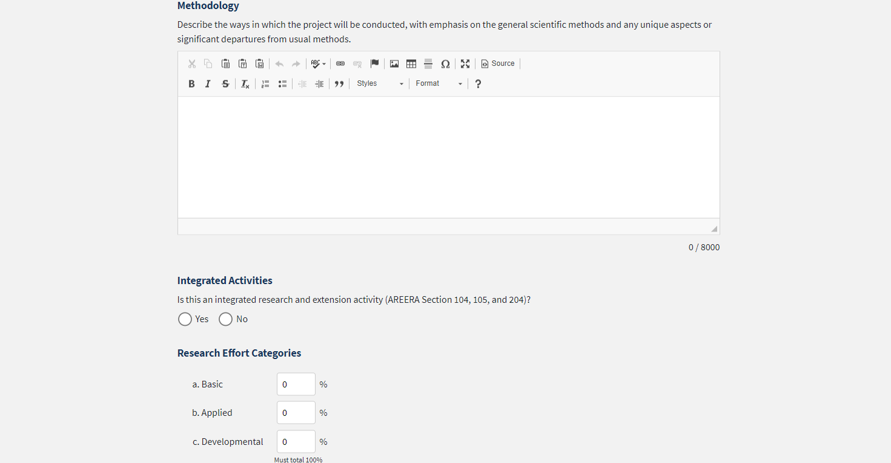
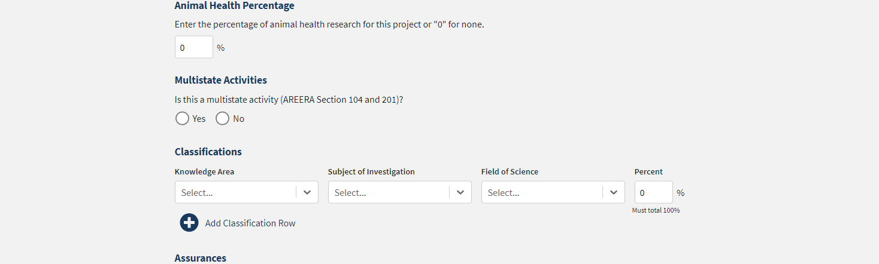
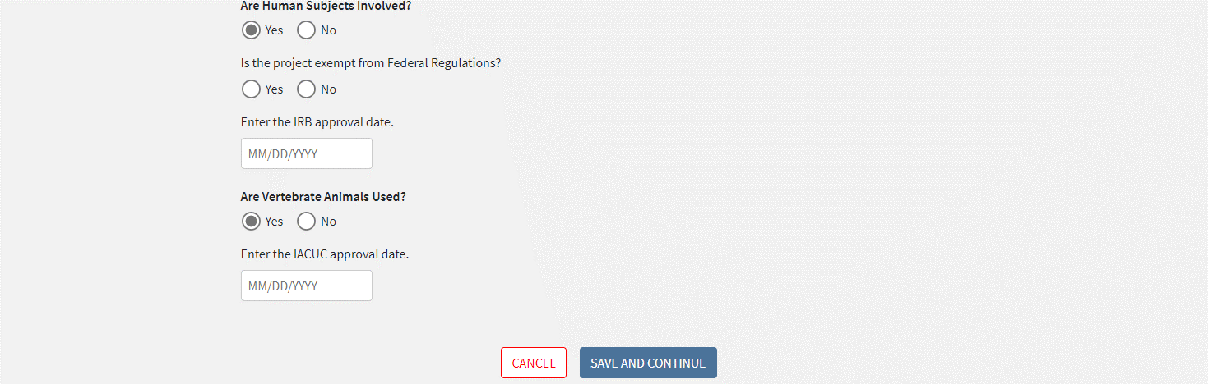

Add Result/Edit Result (Revision)
Note: The Final Result form in the next section is identical to the regular Result form and is grouped together for estimate of burden with the regular Result form for the purpose of this Supporting Statement.
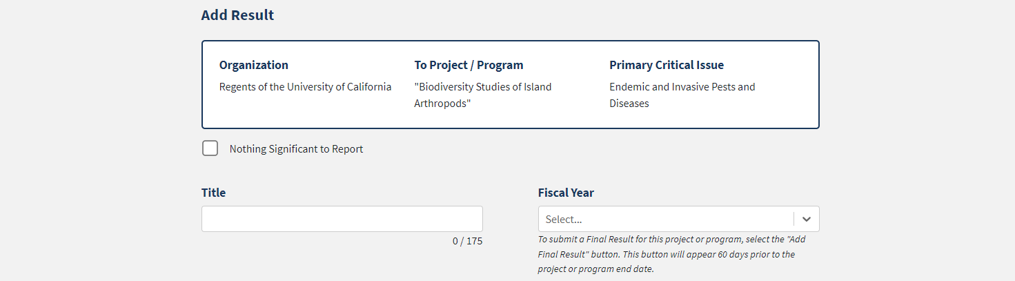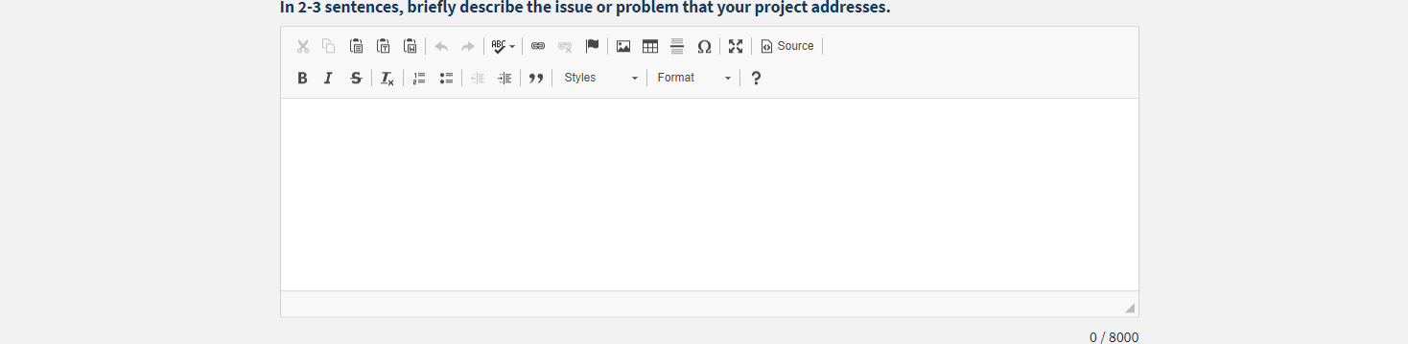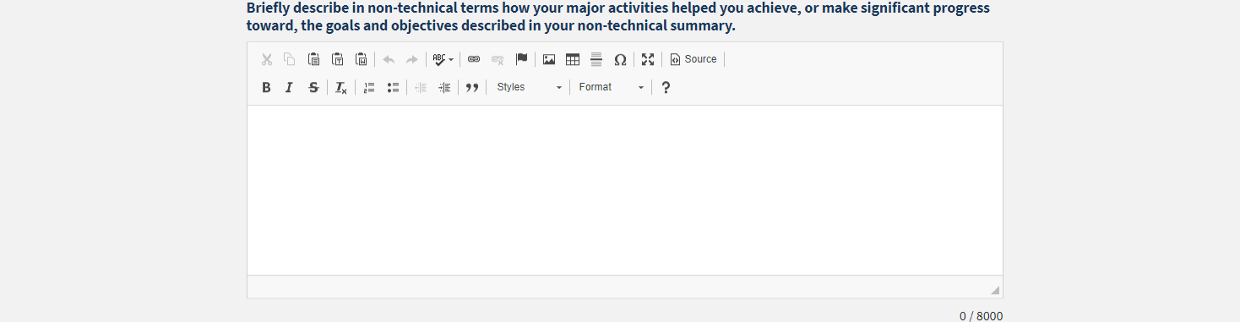
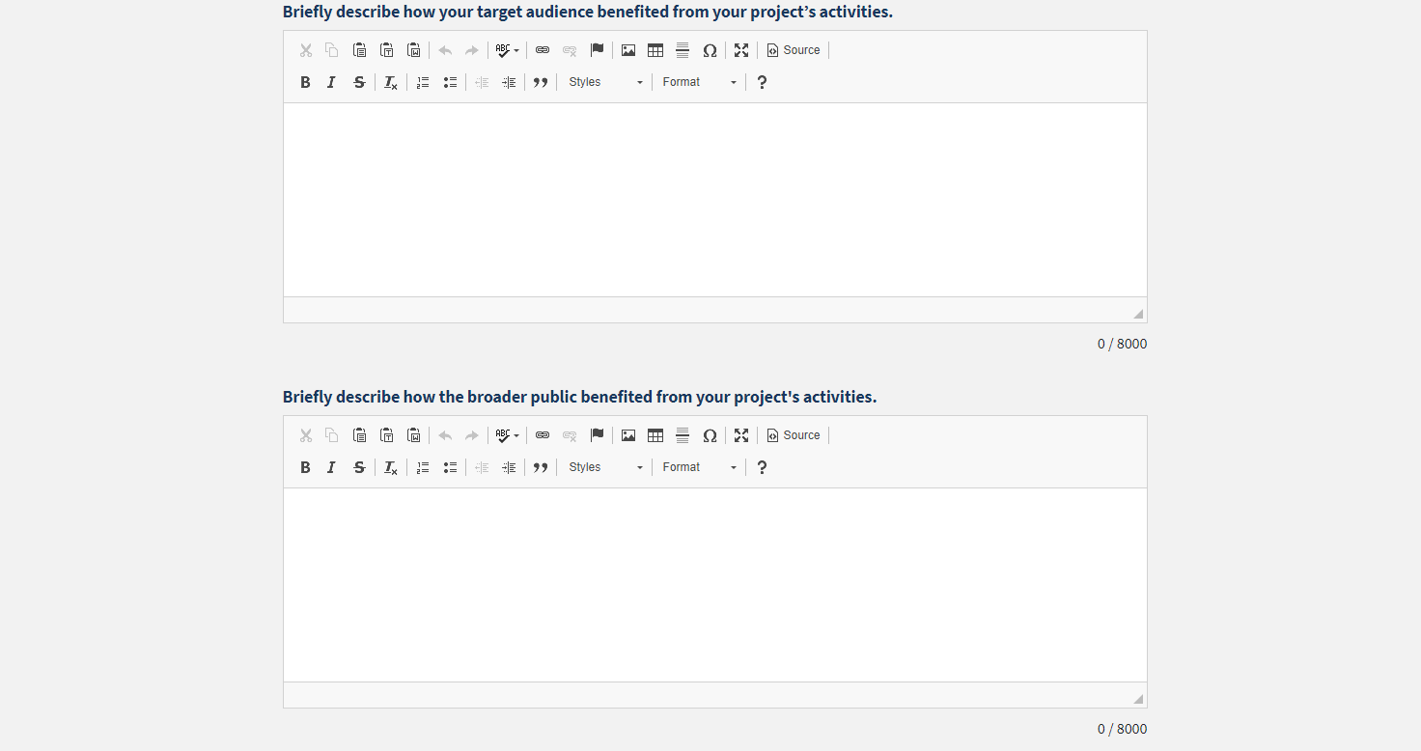
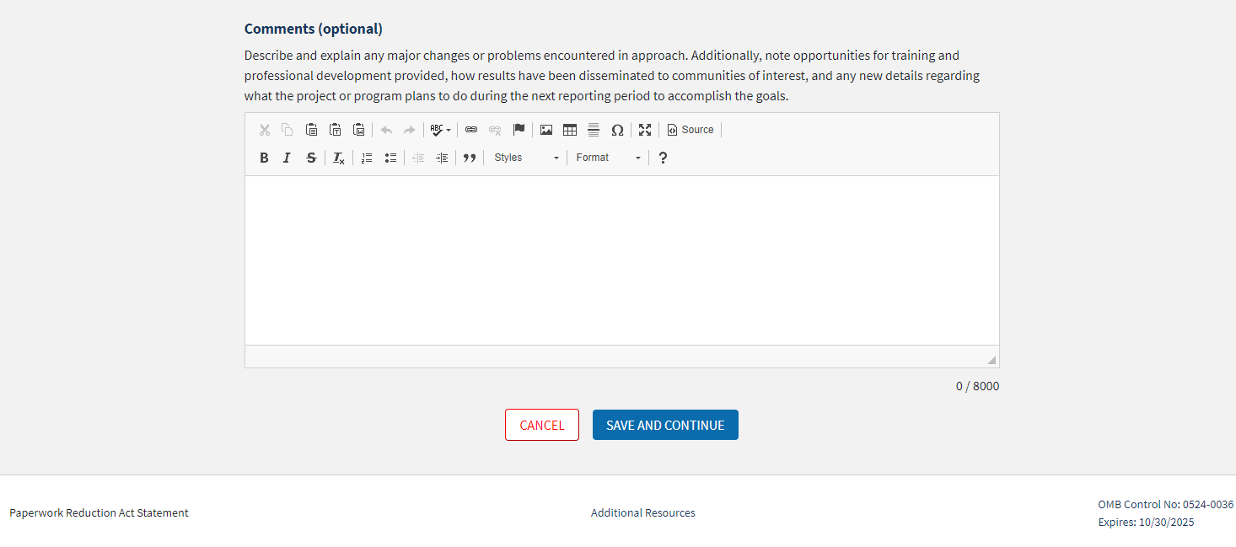

Revisions to the Result Form
NIFA plans to add the following fields to this form to have specific fields for items that respondents add to Comments or other fields currently:
Product Type ___________________ | Description/Citation _______________________________________________________________________________
Author(s) _______________________________________________________ |  | ORCID(s) ________________________________________________________
DOI ____________________________________________________________ |  | Other Digital Persistent Identifier ____________________________________

Additionally, a multiple-choice certification statement will be added as follows:
I certify reporting for this project/program is in compliance with USDA Departmental Regulation (DR) 1020-006 concerning scholarly publications and data assets produced from extramural research supported wholly or in part by NIFA, for the current reporting period.
- Yes, any applicable scholarly publications have been submitted to the National Agricultural Library’s (NAL) PubAg and any applicable data assets have been submitted to NAL’s Ag Data Commons. These submissions included the NIFA grant or accession number and digital persistent identifiers for the publication or data asset (such as DOI) and the authors (such as ORCID).
- Yes, this project/program did not produce any scholarly publications during the reporting period and all data assets produced are exempt from DR 1020-006.
- N/A, this project/program did not produce any scholarly publications and data assets as defined by DR 1020-006 during the reporting period.

Final Result (Revision)
Note: The Final Result form is identical to the regular Result form and is grouped together for estimate of burden with the regular Result form for the purpose of this Supporting Statement.
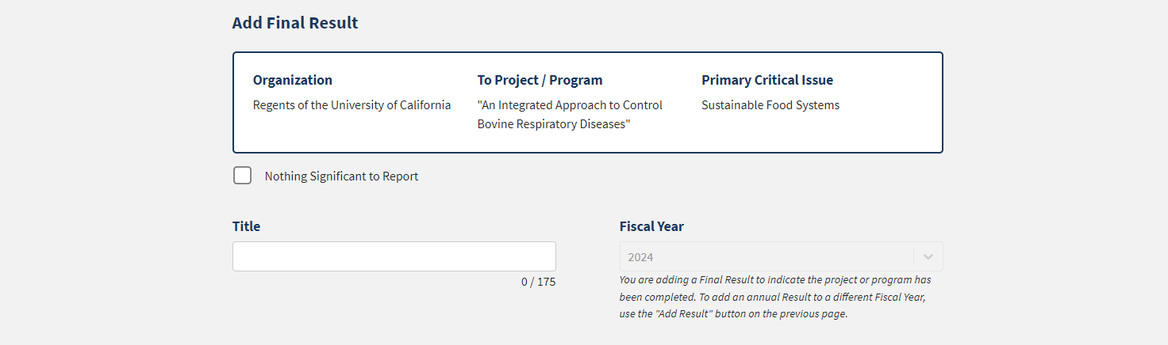
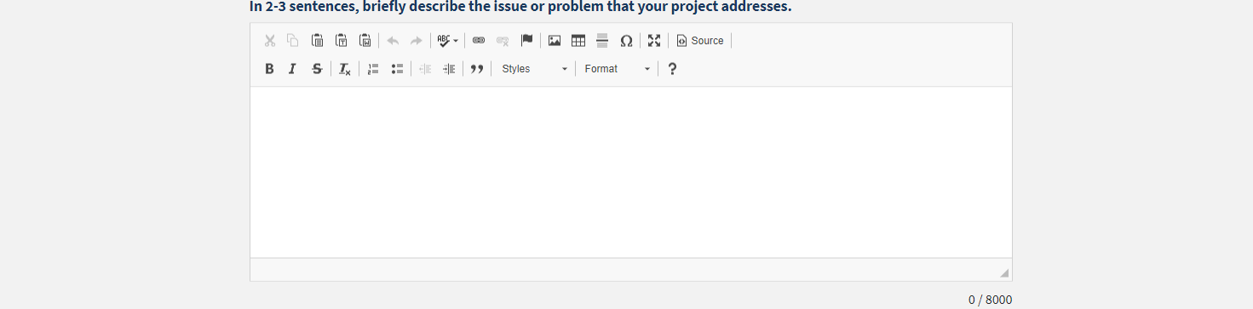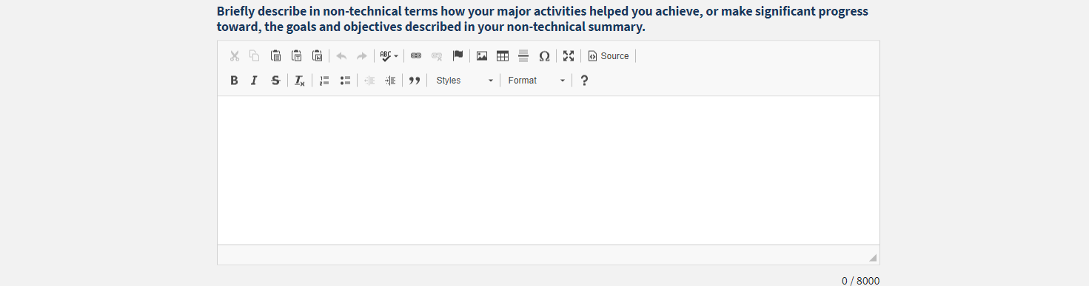
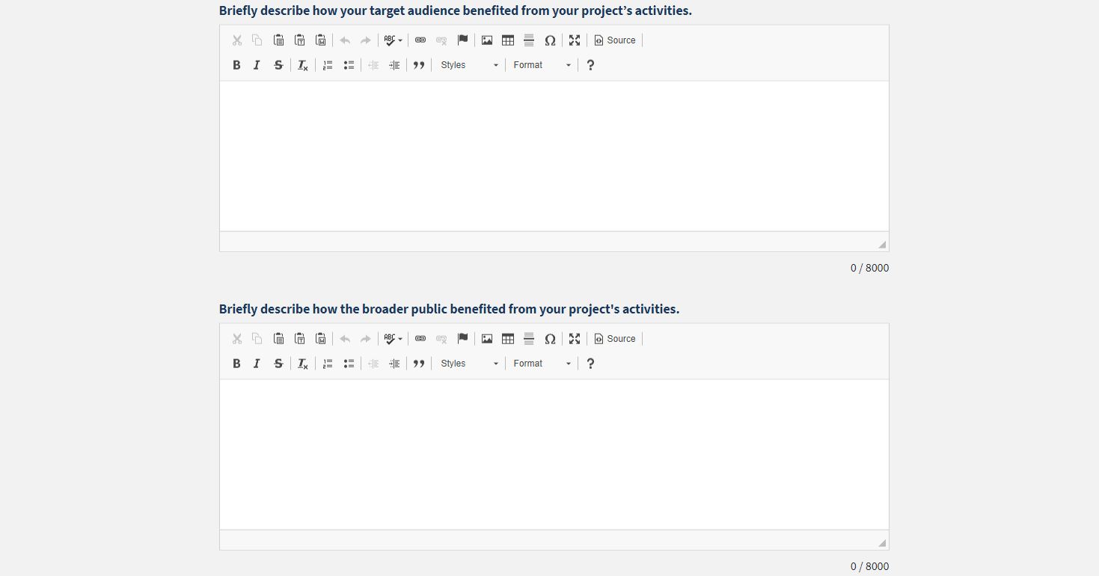
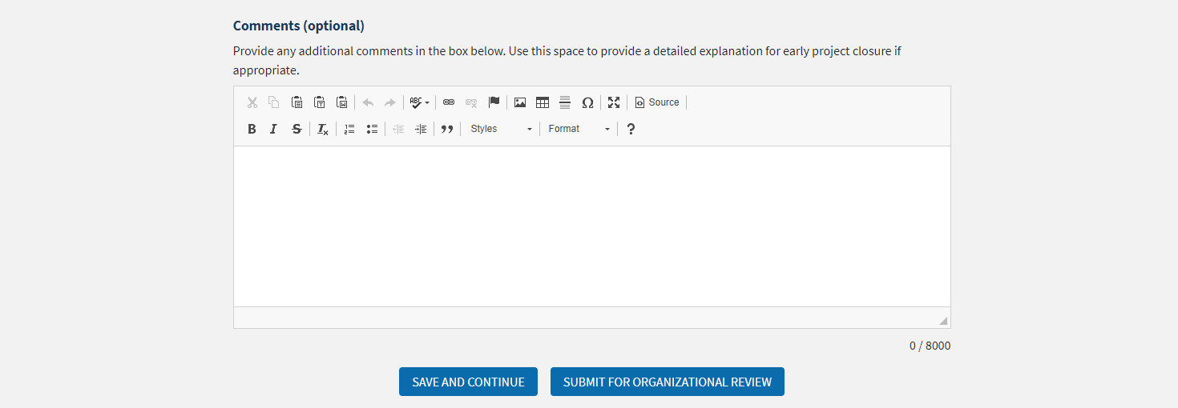

Revisions to the Final Result Form
NIFA plans to add the following fields to this form to have specific fields for items that respondents add to Comments or other fields currently (matching the regular Result form revisions):
Product Type ___________________ | Description/Citation _______________________________________________________________________________
Author(s) _______________________________________________________ |  | ORCID(s) ________________________________________________________
DOI ____________________________________________________________ |  | Other Digital Persistent Identifier ____________________________________

Additionally, a multiple-choice certification statement will be added as follows:
I certify reporting for this project/program is in compliance with USDA Departmental Regulation (DR) 1020-006 concerning scholarly publications and data assets produced from extramural research supported wholly or in part by NIFA, for the current reporting period.
- Yes, any applicable scholarly publications have been submitted to the National Agricultural Library’s (NAL) PubAg and any applicable data assets have been submitted to NAL’s Ag Data Commons. These submissions included the NIFA grant or accession number and digital persistent identifiers for the publication or data asset (such as DOI) and the authors (such as ORCID).
- Yes, this project/program did not produce any scholarly publications during the reporting period and all data assets produced are exempt from DR 1020-006.
- N/A, this project/program did not produce any scholarly publications and data assets as defined by DR 1020-006 during the reporting period.

Annual Report of Accomplishments and Results (No Revisions)

Overview: Executive Summary & Critical Issues Additional Information
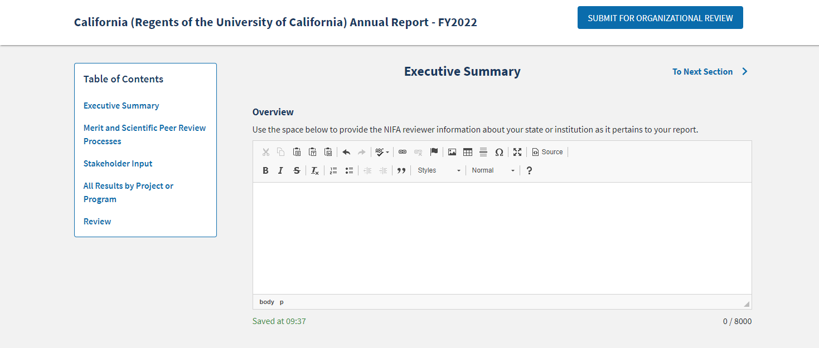
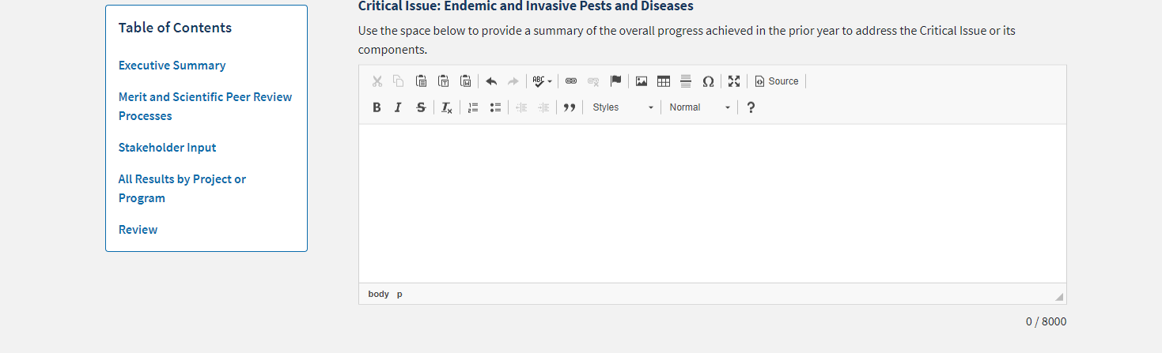
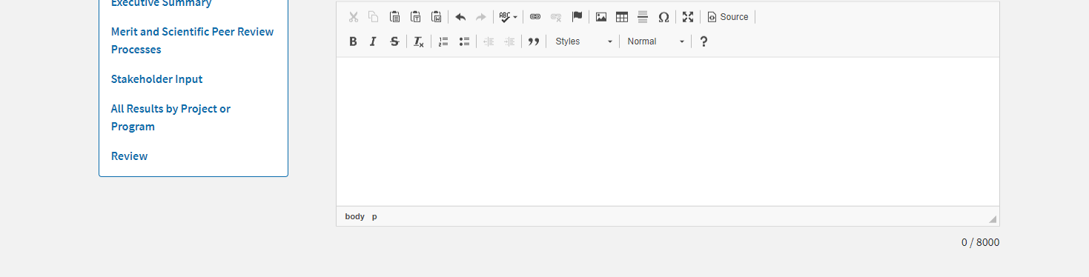
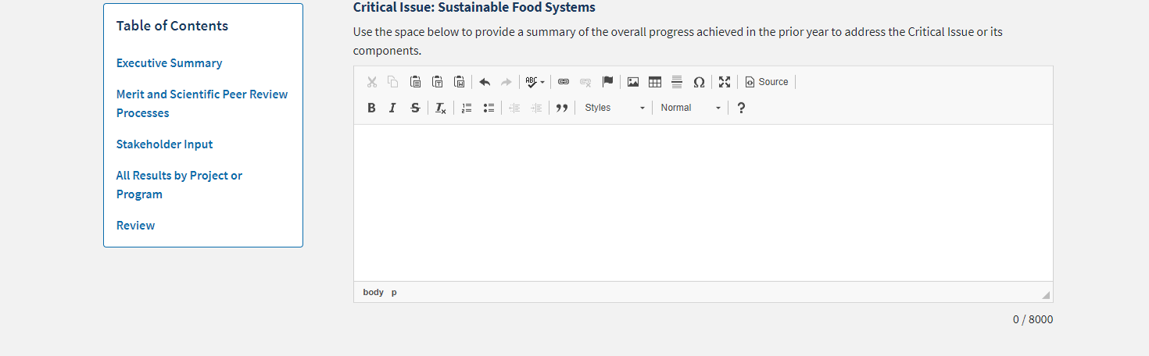
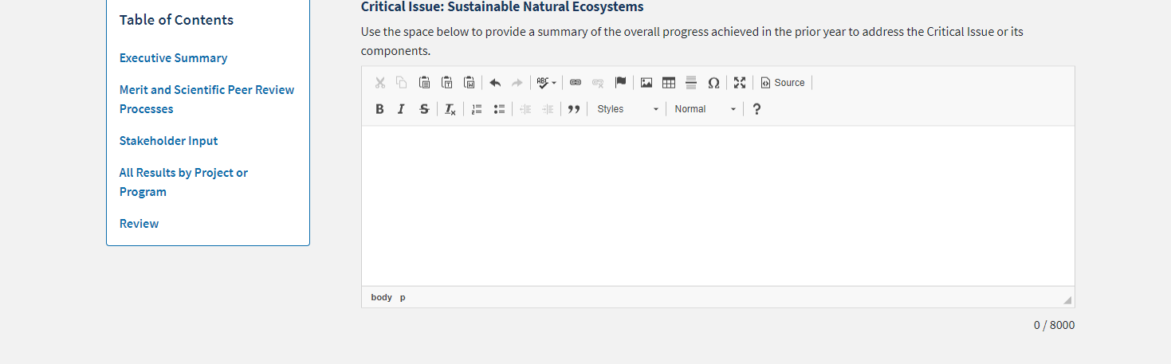
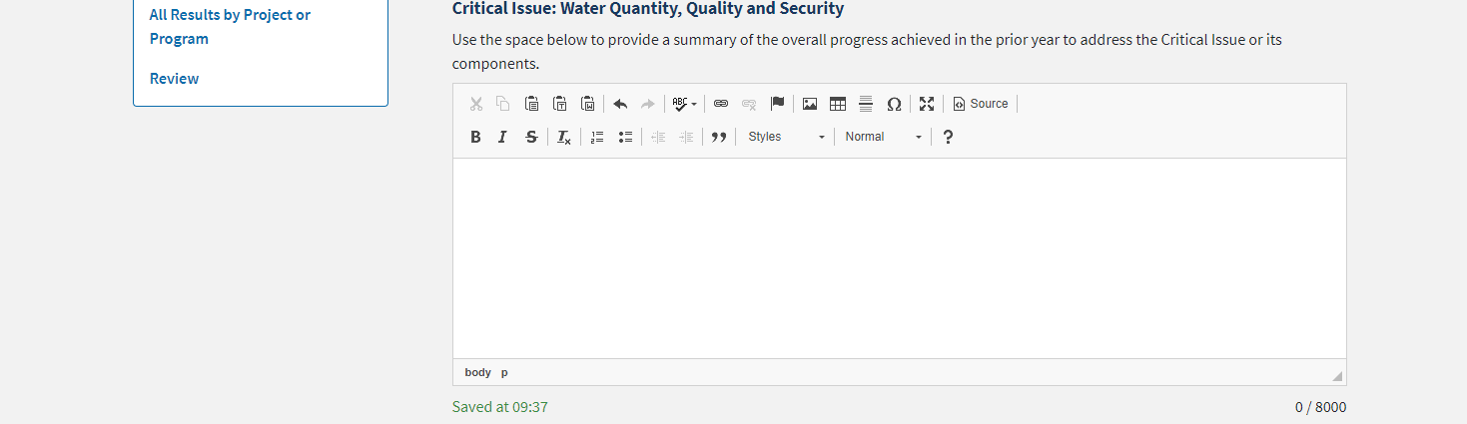

Merit and Scientific Peer Review Process
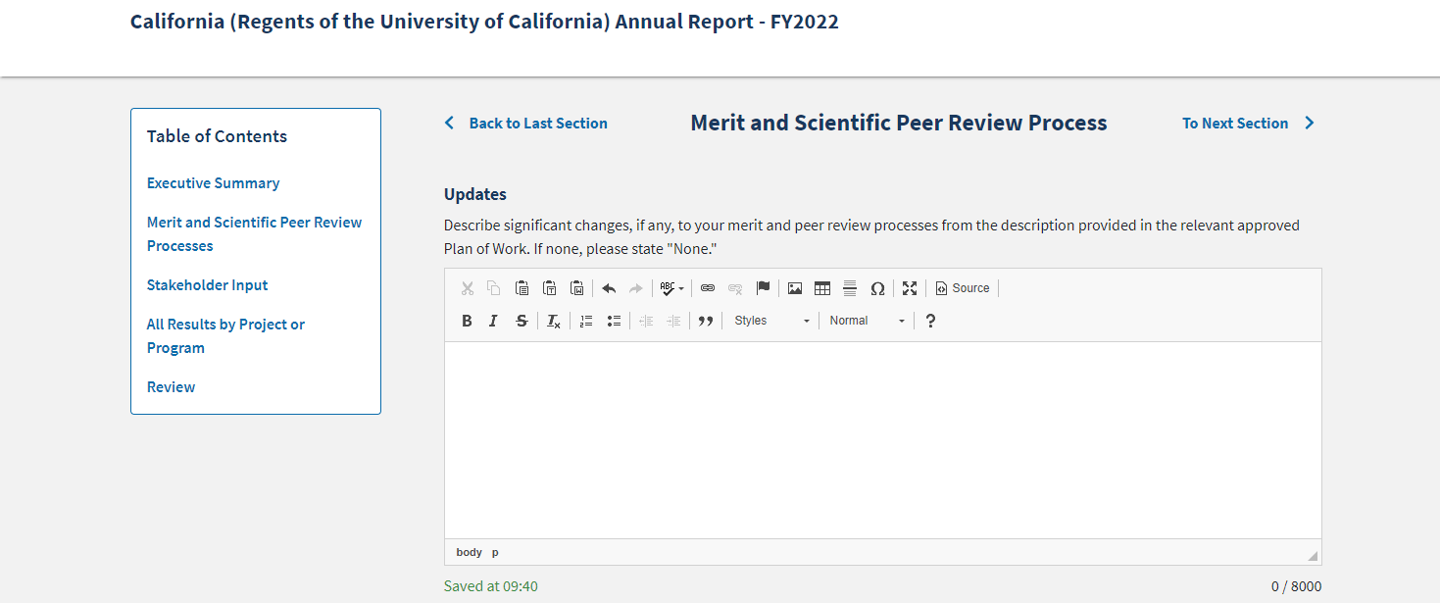

Stakeholder Input
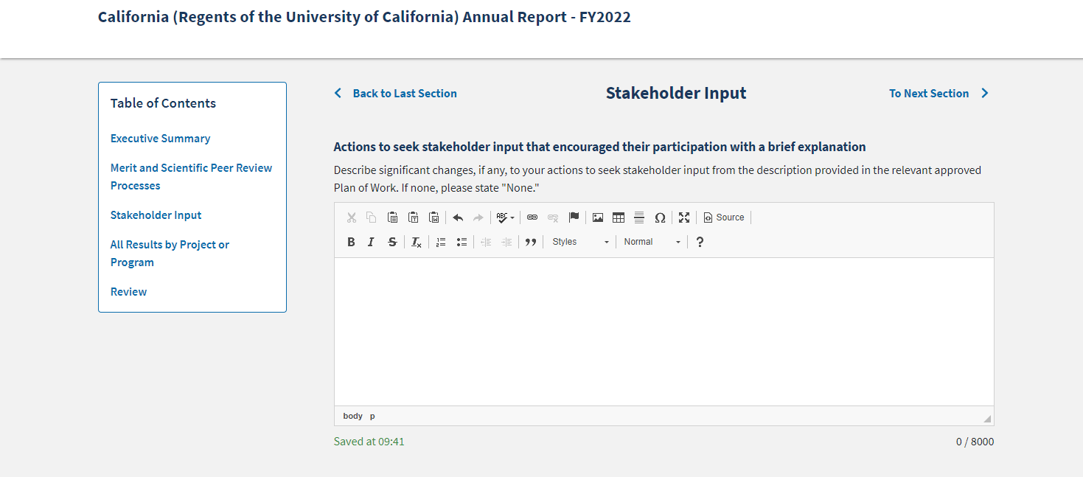
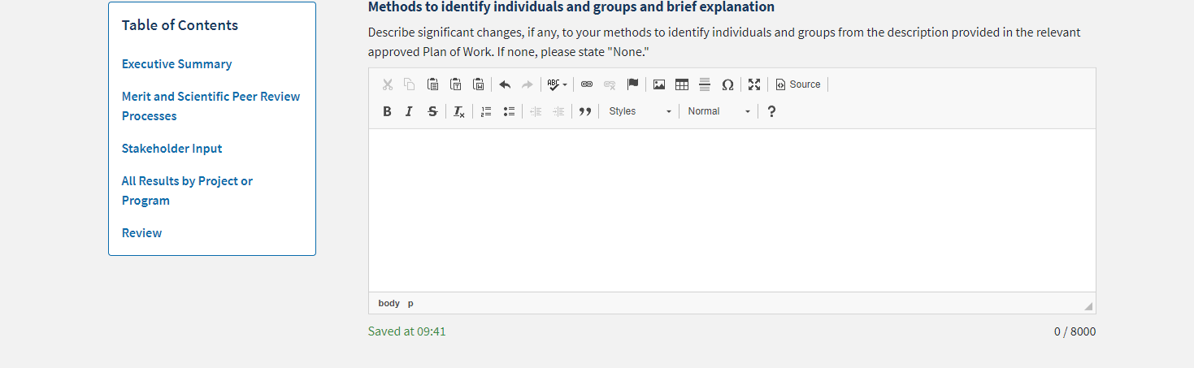
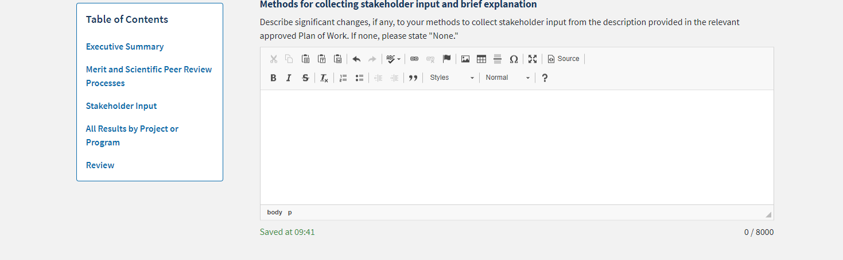
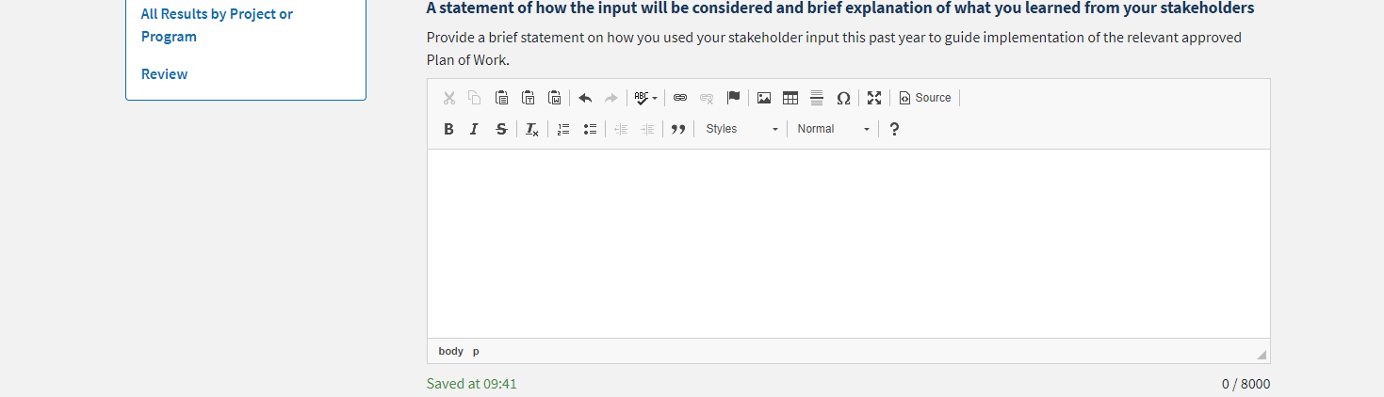

All Results by Project or Program
This list is automatically generated by the system when the user marks previously entered Results as highlighted.

Research Project Results
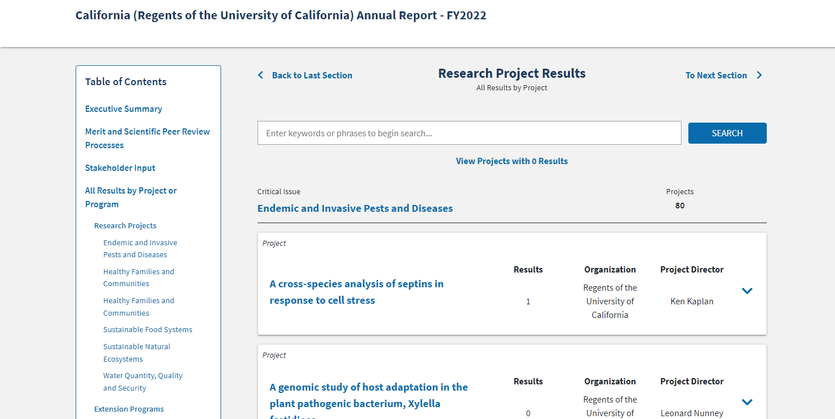

Extension Program Results
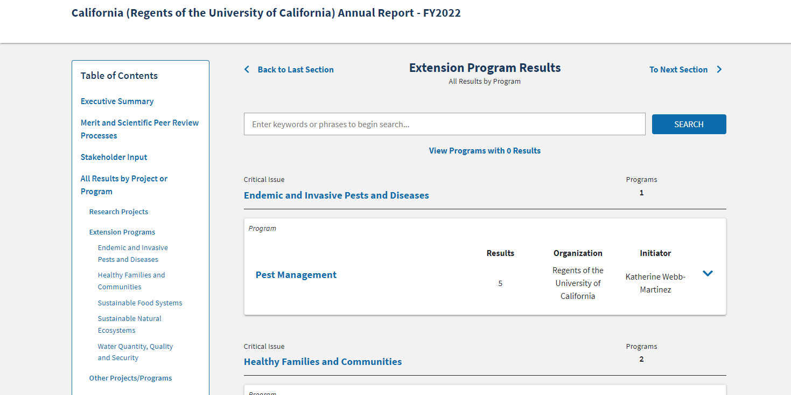

Other Projects/Programs Results
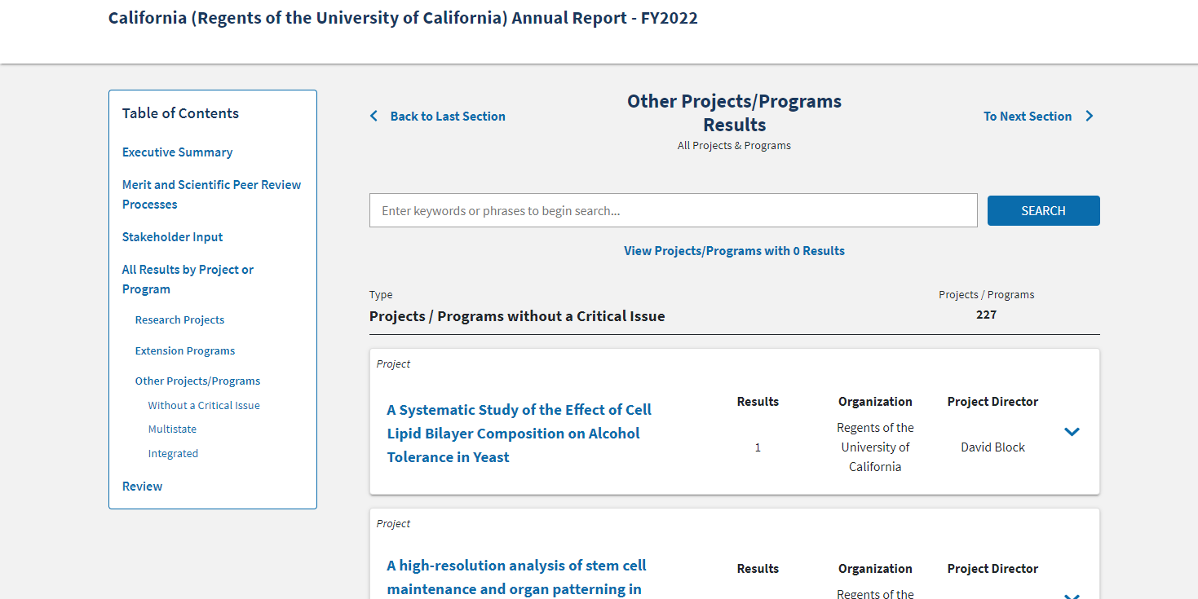

Plan of Work (No Revisions)

Merit and Scientific Peer Review Process
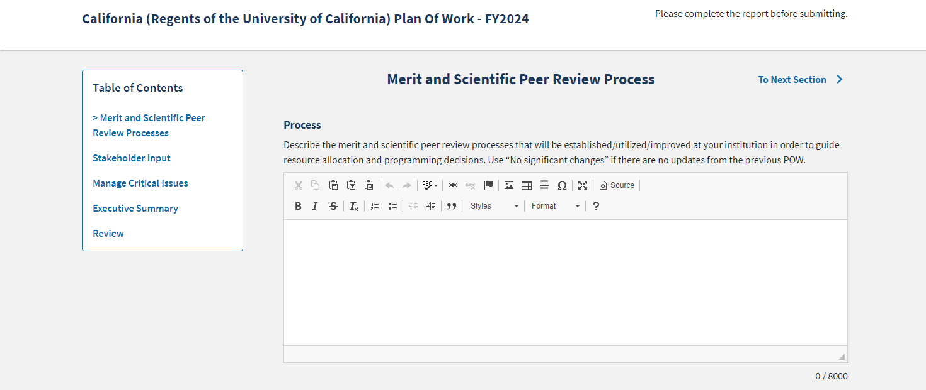

Stakeholder Input
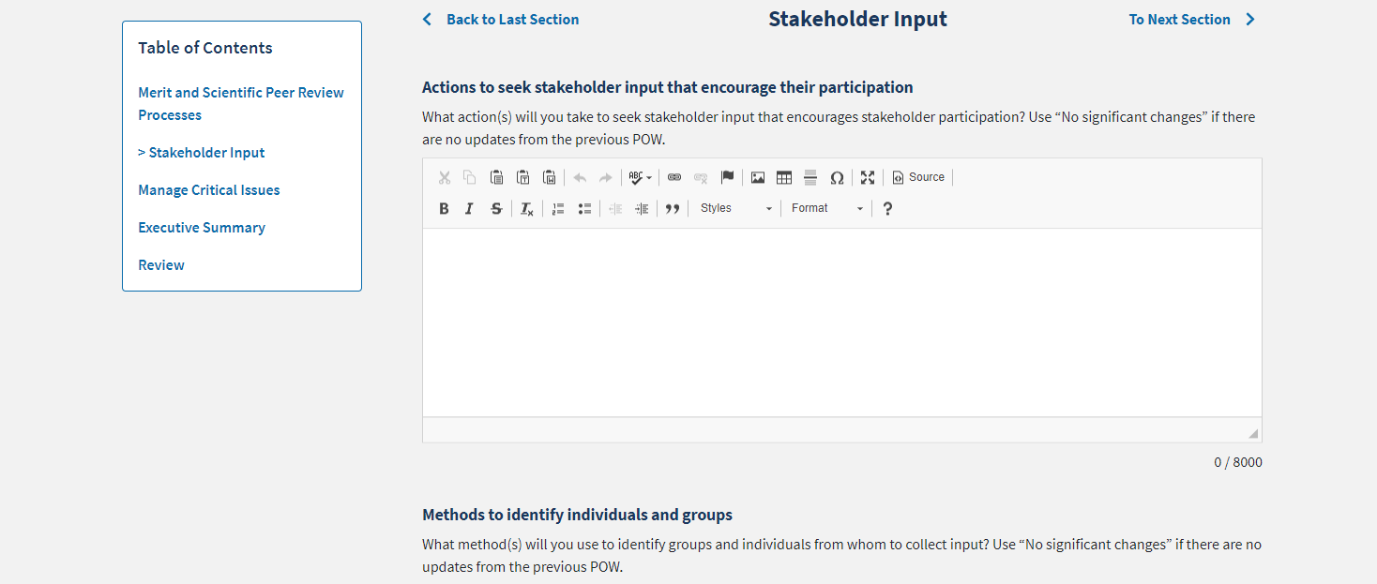
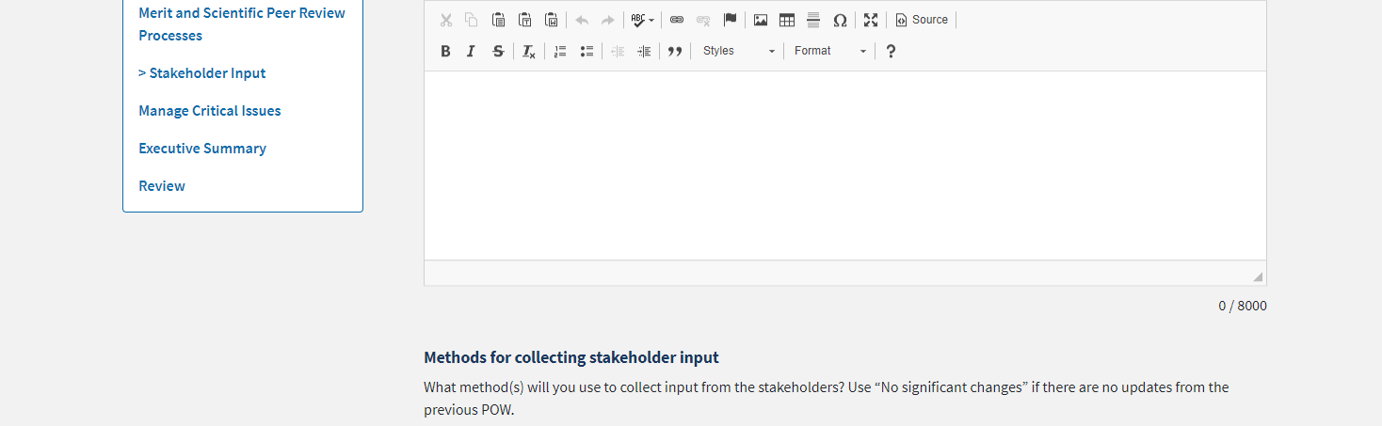
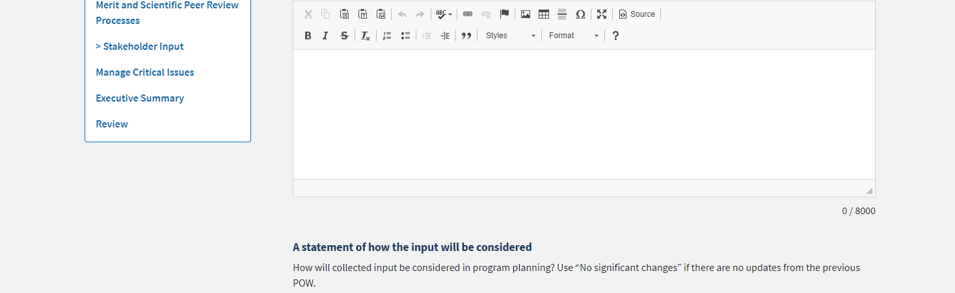
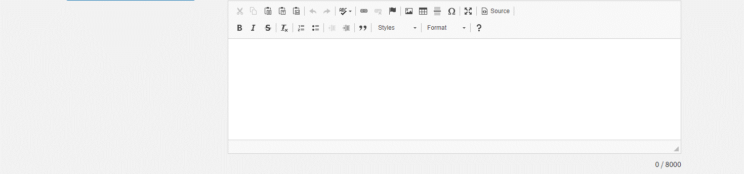

Manage Critical Issues
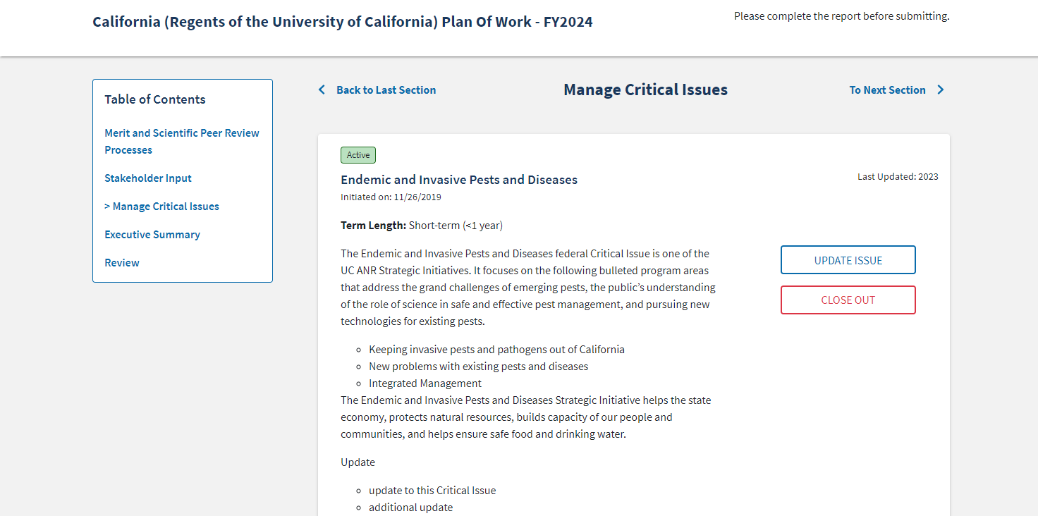


Add New Critical Issue/Update Issue
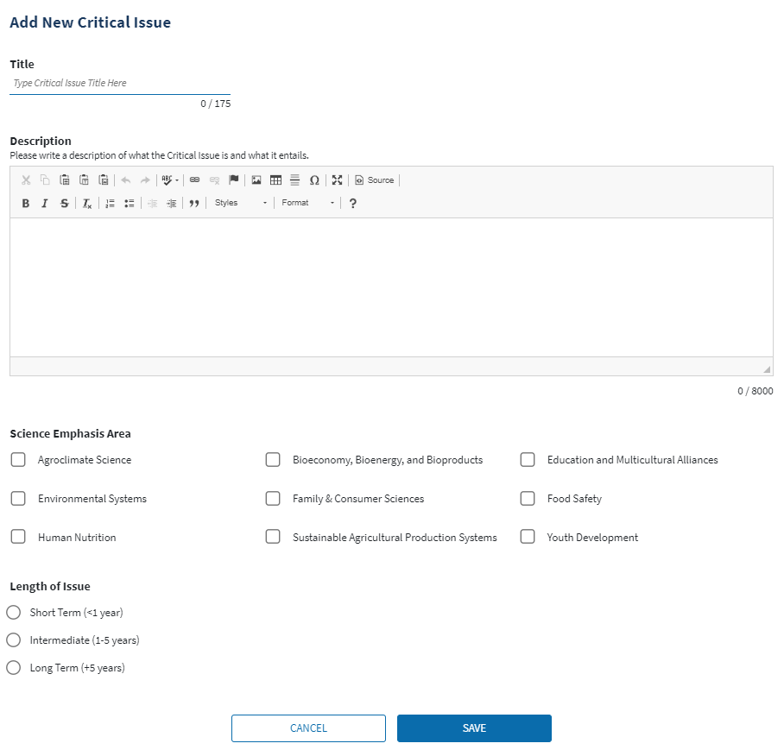

Executive Summary and Critical Issues Additional Information
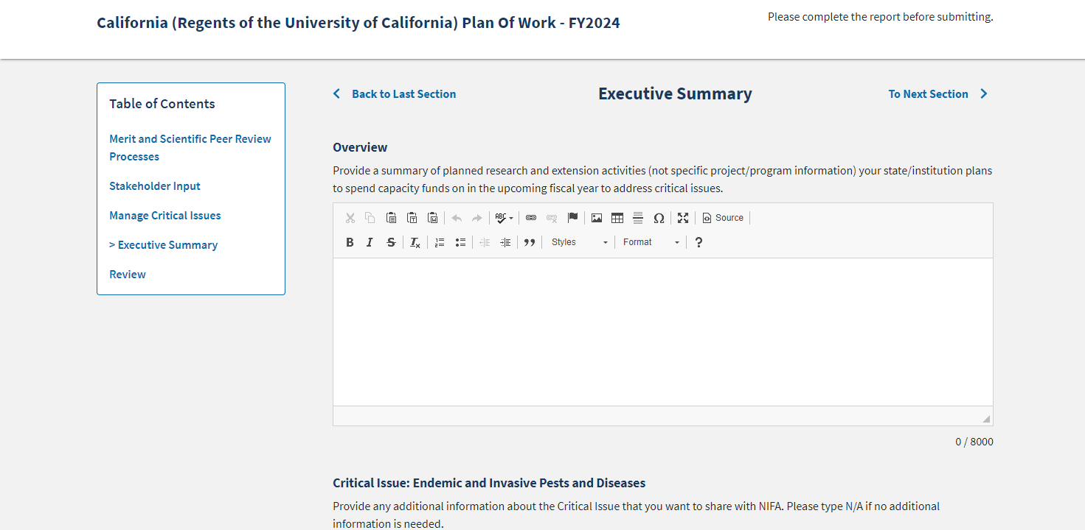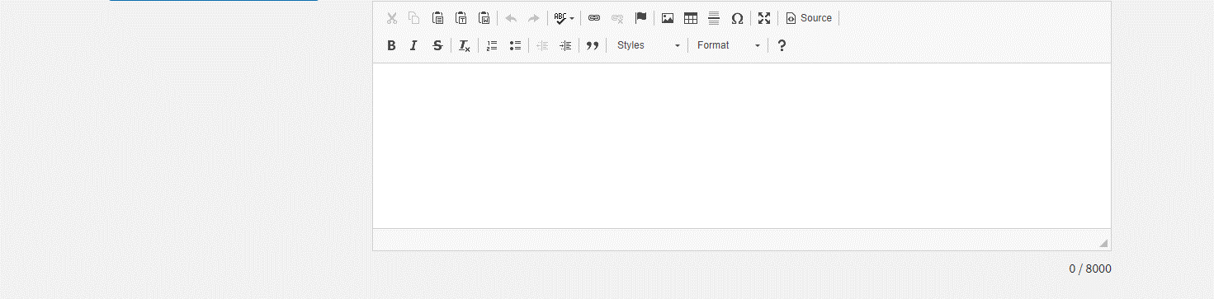
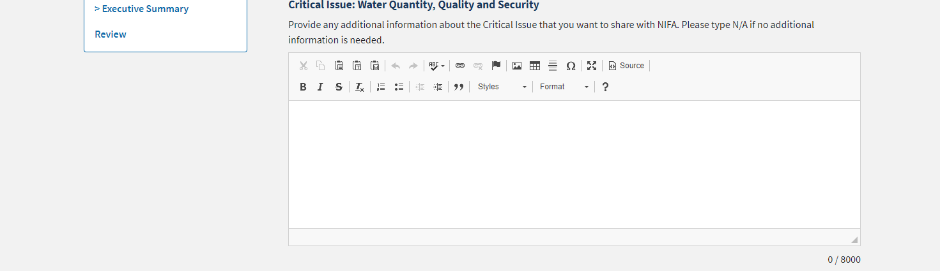

Financial Report (New, Mockup)
The following Financial Report form will be new in NRS, previously the data was collected in REEport or manually on an interim basis. The Project #/Accession # and Funding Type will be prefilled, and the percentages and totals/subtotals will be calculated by NRS, the fillable fields are the funding types and the FTE types.
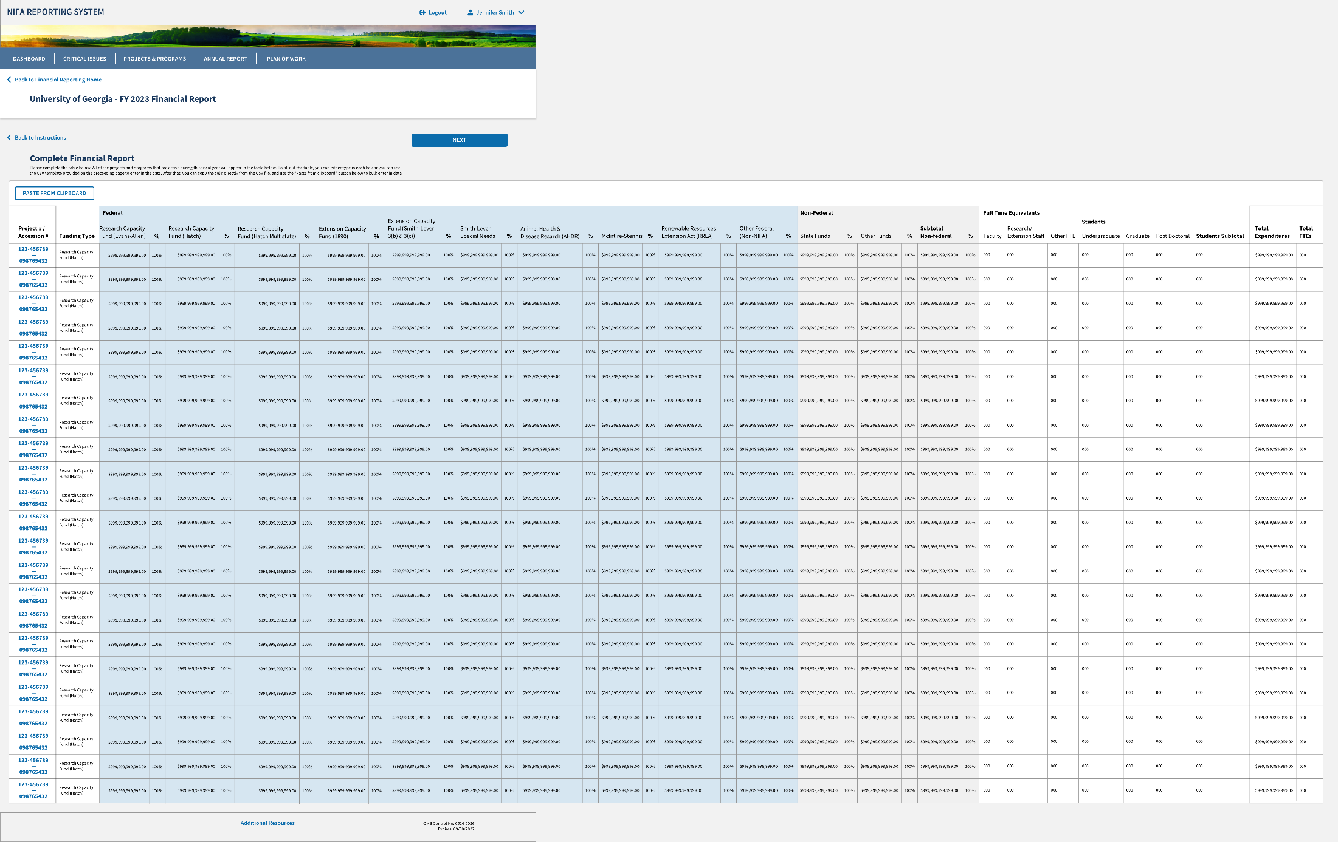

The fillable fields in the Financial Report image above are:
- Research Capacity Fund (Evans-Allen)
- Research Capacity Fund (Hatch)
- Research Capacity Fund (Hatch Multistate)
- Extension Capacity Fund (1890)
- Extension Capacity Fund (Smith-Lever 3(b) and 3(c))
- Smith-Lever Special Needs
- Animal Health & Disease Research (AHDR)
- McIntire-Stennis
- Renewable Resources Extension Act (RREA)
- Other Federal (Non-NIFA)
- State Funds
- Other Non-Federal Funds
- FTE Faculty Count
- FTE Research and Extension
- Other FTE Count
- Undergraduate Student Count
- Graduate Student Count
- Post Doctoral Student Count

OGFM Supplemental Form (New, Mockup)
The following OGFM Supplemental form will be new in NRS. The Project #/Accession # and Funding Type will be prefilled, and the percentages and totals/subtotals will be calculated by NRS, the fillable fields are the funding types and the FTE types.
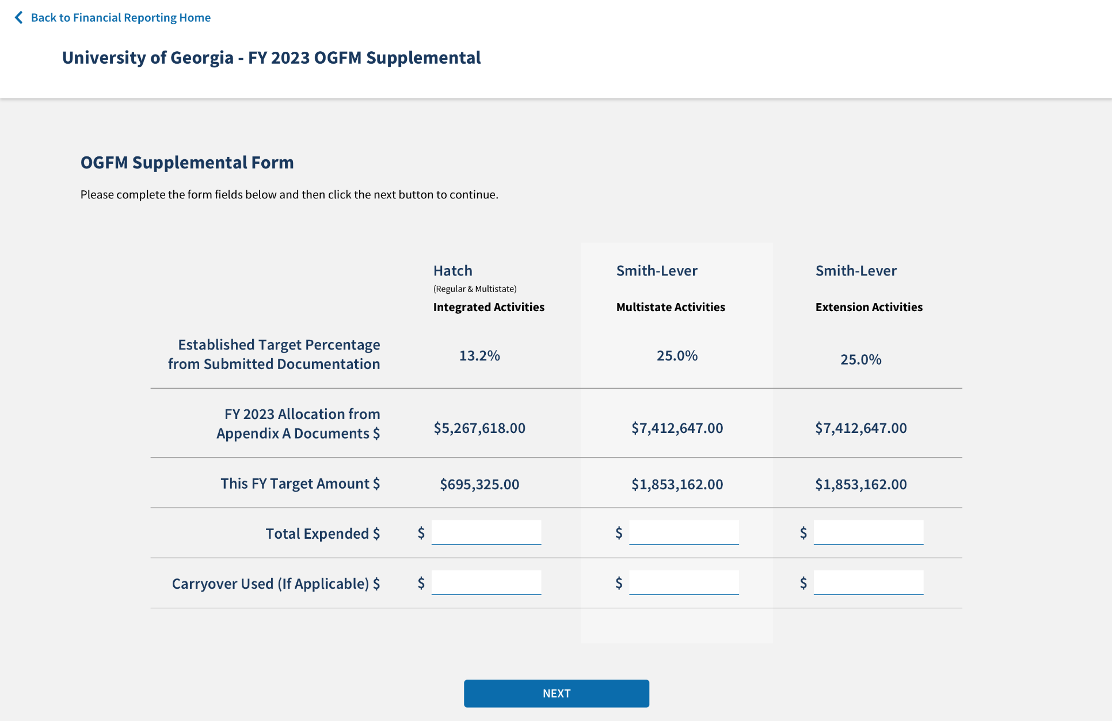
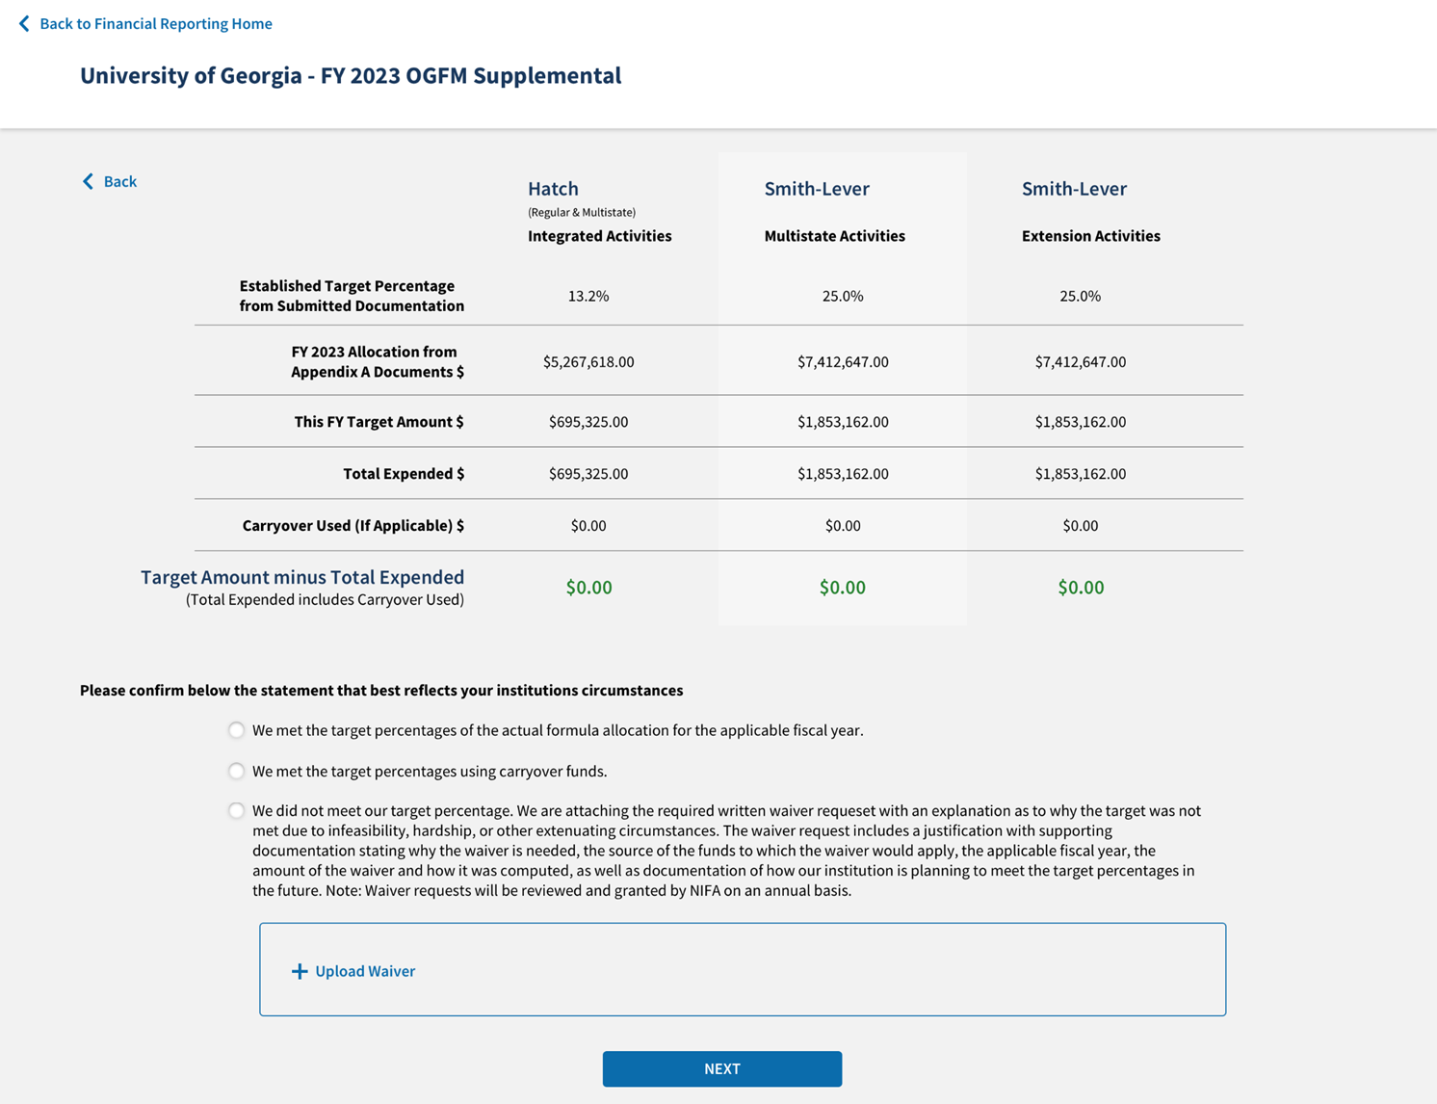

The fillable fields in the OGFM Supplemental image above are:
- Hatch Integrated Activities Total Expended
- Hatch Integrated Activities Carryover Used (If Applicable)
- Smith-Lever Multistate Activities Total Expended
- Smith-Lever Multistate Activities Carryover Used (If Applicable)
- Smith-Lever Extension Activities Total Expended
- Smith-Lever Extension Activities Carryover Used (If Applicable)
- Selection of one statement:
  - We met the target percentages of the actual formula allocation for the applicable fiscal year.
  - We met the target percentages using carryover funds.
  - We did not meet our target percentage. We are attaching the required written waiver request with an explanation as to why the target was not met due to infeasibility, hardship, or other extenuating circumstances. The waiver request includes a justification with supporting documentation stating why the waiver is needed, the source of the funds to which the waiver would apply, the applicable fiscal year, the amount of the waiver and how it was computed, as well as documentation of how our institution is planning to meet the larger percentages in the future. Note: Waiver requests will be reviewed and granted by NIFA on an annual basis.
    - Upload of PDF waiver request require if selecting the last statement.

In addition to the forms above, NRS will automatically generate a list of accession with integrated activities and multistate activities as marked during Project/Program Initiation for the institution. This list will be added to the bottom of the form after the selected statement listed above.
