Non-substantive Change Request
0535-0273 – Cooperator Funded Chemical Use Surveys
Minnesota Best Management Practices Survey

The Minnesota Department of Agriculture requested the Minnesota Best Management Practices Survey for corn and soybeans conducted in 2023 be for the 2023 crop year instead of the 2022 crop year. The revised schedule with changes is now:
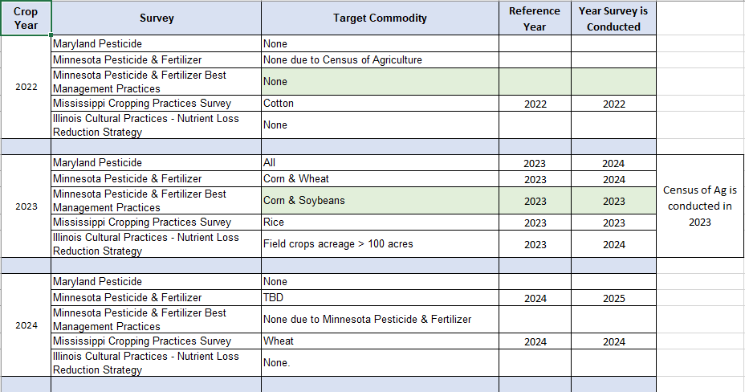
This change will not impact the current sample size or respondent burden.

