**Non-substantive Change Request**

**0535-0273 – Cooperator Funded Chemical Use Surveys**

MINNESOTA BEST MANAGEMENT PRACTICES SURVEY - 2023

The Minnesota Best Management Practices Survey, scheduled for August-September, 2023 was postponed per a request by the client, the Minnesota Department of Agriculture (MDA). MDA staff are responsible for the content of the survey instrument and prior to the start of the data collection for this survey, a review of data from another project they conduct suggested that the question wording for this project needed to be clarified to avoid misreporting problems that could reduce the value of the data.

With that new and last minute information, the MDA staff asked us to postpone the data collection and they went back through the questionnaire to clarify the wording of questions, removed a few particularly troublesome questions and replaced those with more direct and understandable questions to collect the data they need.

The purpose, desired goals, and content theme of the Minnesota Best Management Practices Survey have not changed from the original OMB review request. However, a number of the questions have been re-worded, clarified or replaced with others to improve the expected quality of the reported data.

**New Questions**: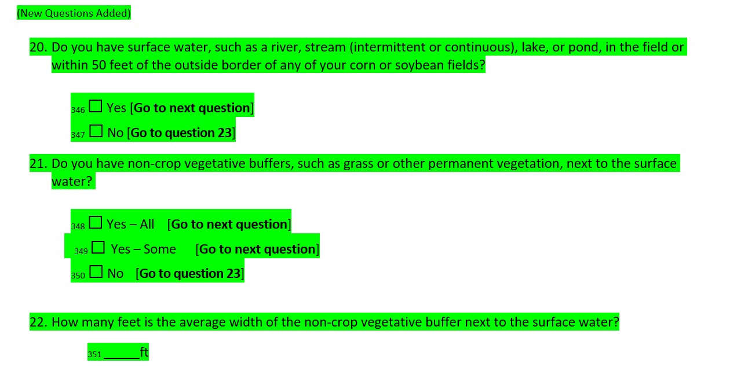

**Revised wording in existing Questions**:

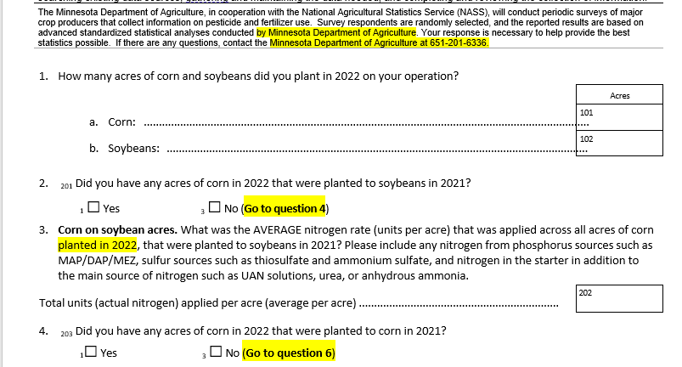

**Deletion of Questions**:

The questionnaire has been loaded to ROCIS.

This change will not impact the requested annual sample size and respondent burden.