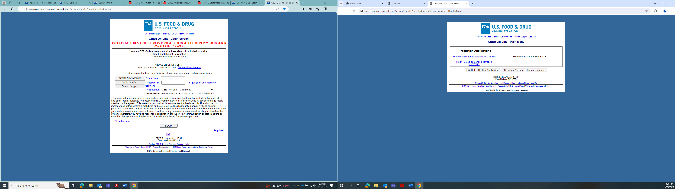

**After user has logged in using username and password**

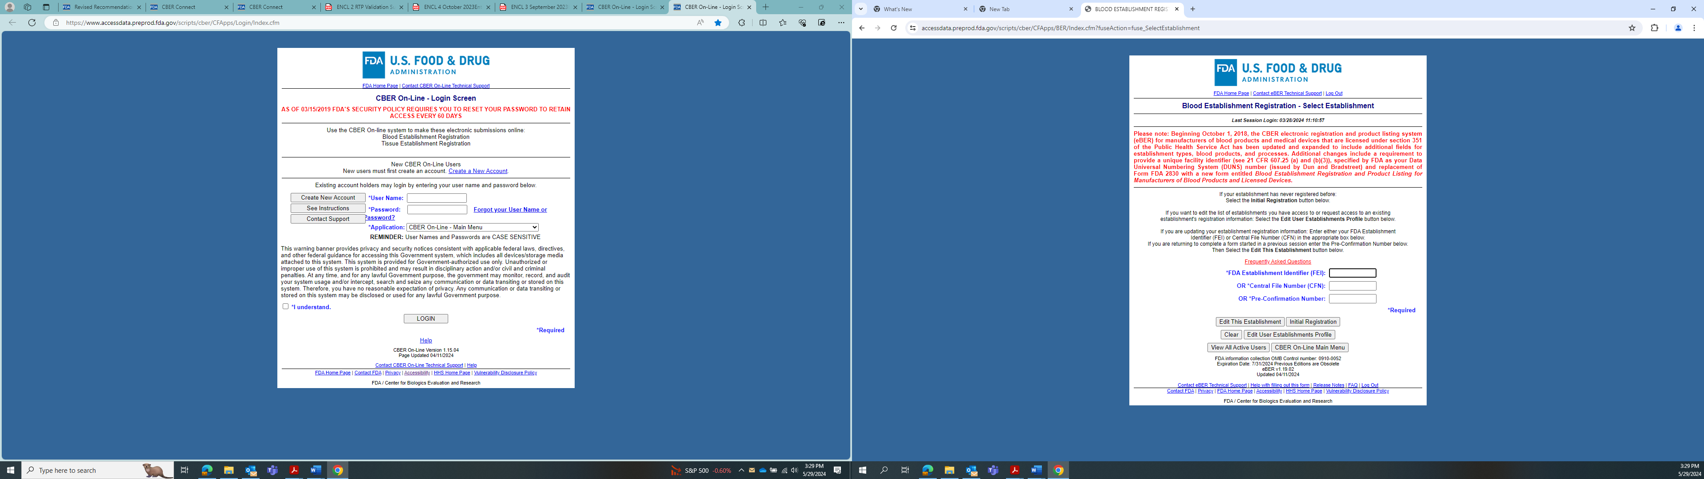



**OMB Control Number and expiration date visible on page prior to user entering FEI Number associated with their establishment.**