ORGANDONOR.GOV ONLINE SURVEY QUESTIONNAIRE
Thank you for your interest in taking this survey. Please read the following information.
Public Burden Statement: This survey is designed to gain feedback on a website, and will be used to improve the site to make it better. An agency may not conduct or sponsor, and a person is not required to respond to, a collection of information unless it displays a currently valid OMB control number. The OMB control number for this information collection is 0915-0212 and it is valid until 04/30/2024. This information collection is voluntary. Public reporting burden for this collection of information is estimated to average 10 minutes per response, including the time for reviewing instructions, searching existing data sources, and completing and reviewing the collection of information. Send comments regarding this burden estimate or any other aspect of this collection of information, including suggestions for reducing this burden, to HRSA Reports Clearance Officer, 5600 Fishers Lane, Room 14N136B, Rockville, Maryland, 20857 or paperwork@hrsa.gov.
Please note participation in this survey is voluntary. Your feedback will be kept private to the extent allowed by law. Thank you for your feedback.
Please indicate if you consent to participate:
- I understand this information and agree to participate.
- I would not like to participate in this survey. [terminate]

- What is your age group?
- 17 or younger [terminate]
- 18-29
- 30-49
- 50-64
- 65 or over

- Please indicate which of the following most closely applies to you as it relates to being a registered organ donor.
- I am not currently registered as an organ donor, but would like to register
- I am not currently registered as an organ donor, but am interested in learning more so I can decide whether to register
- I am currently registered as an organ donor [terminate]
- I am not a registered organ donor and do not have an interest or cannot register at this time [terminate]
- I’m not sure/don’t remember if I am registered or not

- Please indicate which of the following websites you have visited to research organ donation. (Select all that apply)
- organdonor.gov/donaciondeorganos.gov
- donatelife.net
- mayoclinic.org
- americantransplantfoundation.org
- I don’t know
- Other (please specify)

- And, when researching organ donation online, please indicate how likely you are to use the following devices:

 | Not likely at all  1 | Not likely  2 | Not sure  3 | Likely  4 | Very likely  5 | Do not own
Laptop/desktop computer
Tablet
Smartphone
Other (please specify)

- Now, please take a couple of minutes and carefully review this screenshot of the organdonor.gov website homepage:
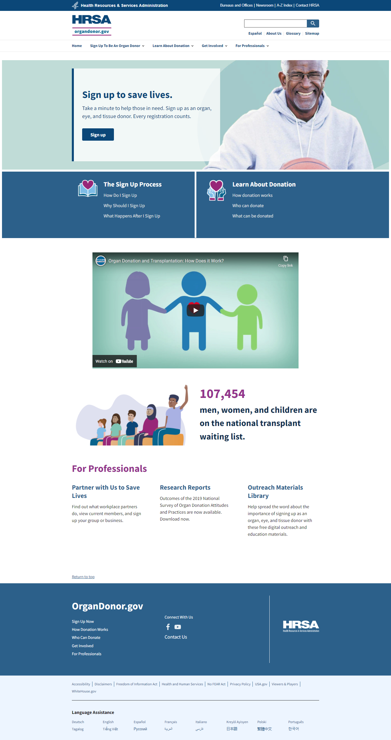

What are your initial impressions of this page?

 | Do not agree at all  1 | Disagree  2 | Not sure  3 | Agree  4 | Completely agree  5
It is visually appealing
It’s laid out well/nicely organized
Top navigation bar contains relevant menu selections
Page content is clear and understandable
The labels on the page clearly define associated content
I can easily tell what is clickable

- When you land on a homepage like this, what are you inclined to do first?
- Scroll the entire page
- Explore the top navigation drop-down menus and browse resulting content
- Go straight to the search box and enter what I’m looking for

- And, when you navigate a webpage like this, what best resonates with you when content is clickable?
- It is underlined
- It is in a different color than surrounding text and bolded
- It is presented in a button or bar

- [Display if ‘organdonor.gov’ is selected in Q3] You indicated earlier that you have visited this site before. How did you first become aware of or learn about the organdonor.gov website?
- Internet search engine (Google, Bing, etc.)
- Information/advertisement on another website
- Ad on Facebook, Twitter or other social media site
- Advertisement on TV or radio
- Advertisement in a newspaper or magazine
- Conversation with a friend, family member or colleague
- Content in a blog
- Other (please specify)

Please look at this page again.

- Where would you go on this page to sign up to be an organ donor?
- I’d click the “Sign Up To Be An Organ Donor” link on the top navigation bar
- I’d click the blue “Sign up” button next to the picture of the man holding a basketball
- I’d click on one of the pages in the “Sign Up Process” section to learn more about the process
- I’d want to learn more about organ donation before I sign up

- Now, please take a couple of minutes and carefully review this screenshot of the organdonor.gov website “Sign Up To Be An Organ Donor” page:

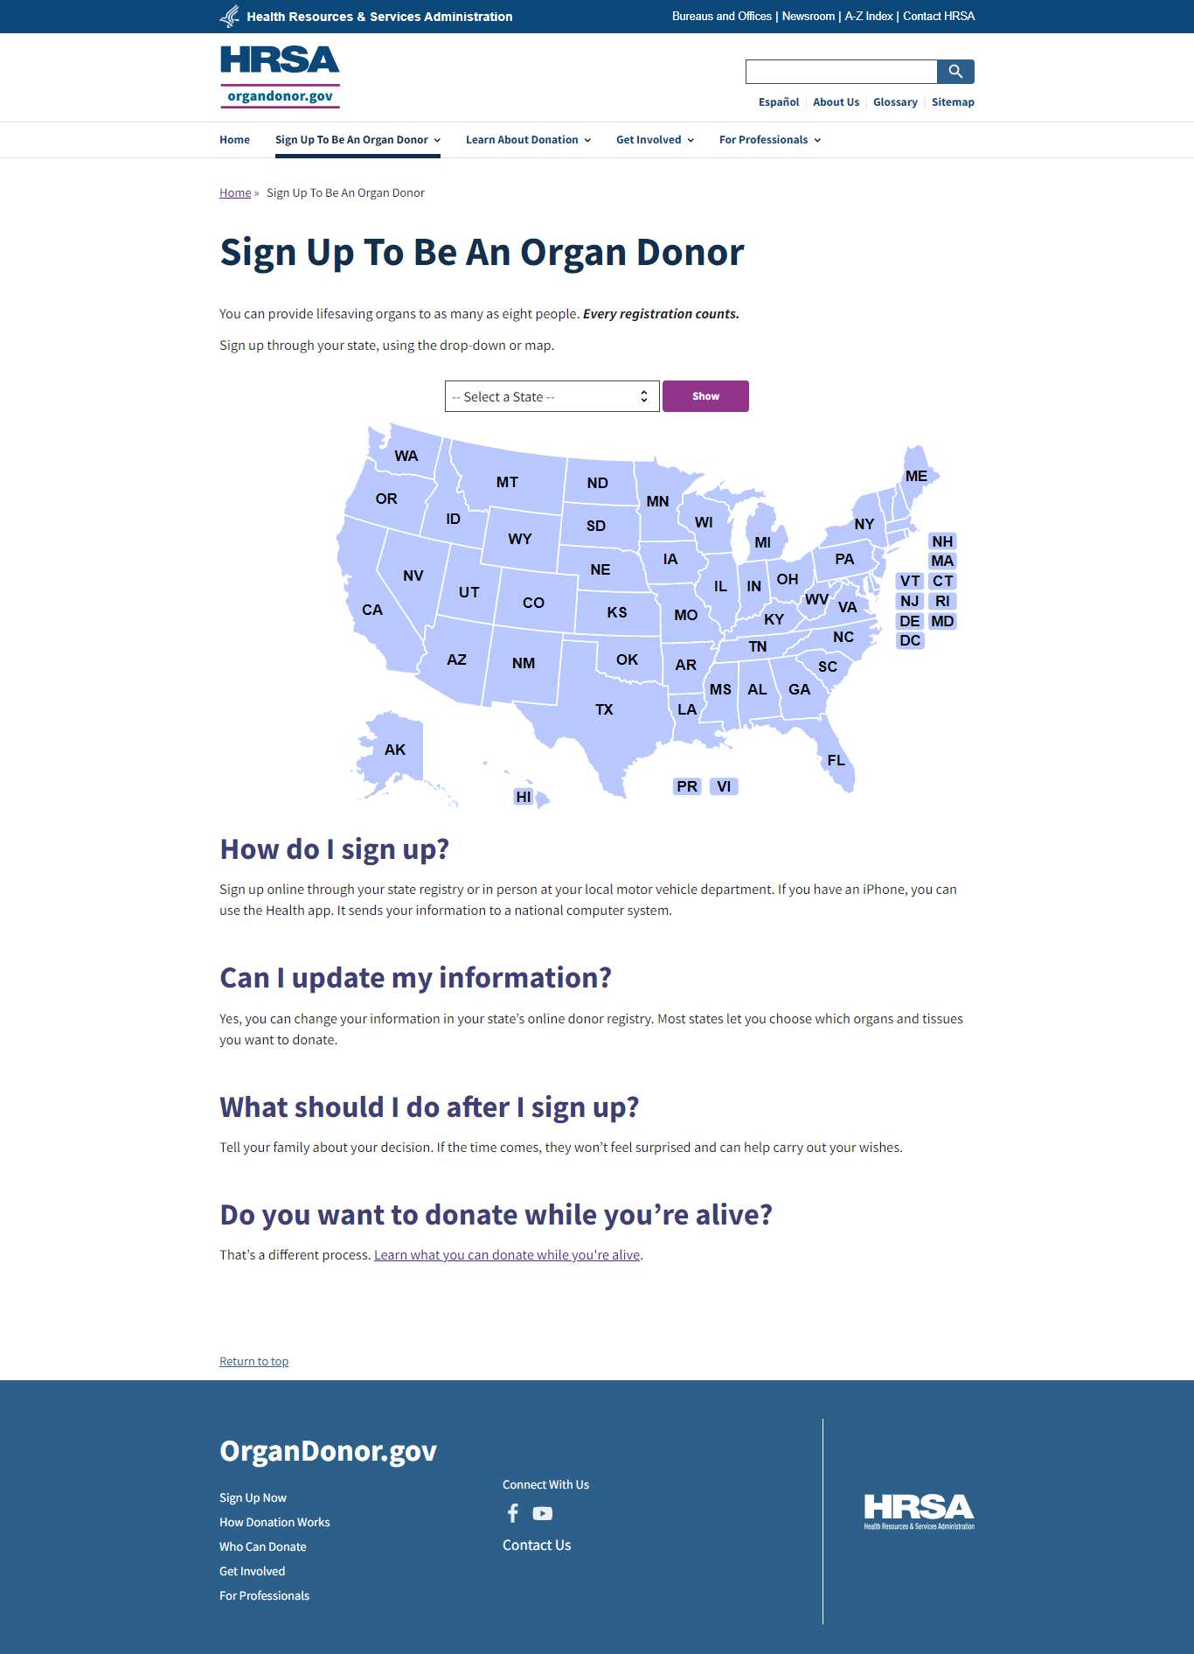

- Where would you go on this page to sign up to be an organ donor?
- I’d click the “Select a State” dropdown to find my state
- I’d click on my state on the map
- I’d read the information below the map first
- I’d want to learn more about organ donation before I sign up

[Display only if ‘I’d want to learn more about organ donation before I sign up’ is selected in Q9] Please look at this page again.

- Where would you most likely go first on this page to find out more information?
- I’d click the “Learn About Donation” link on the top navigation bar
- I’d watch the video content in the middle of the page
- I’d explore the “How Do I Sign Up” section in the middle of the page
- Other (please specify)

- Now, if you were still researching organ donation, please rate how influential you feel each of the following topics would be in helping you make the decision to sign up.

 | Not at all influential  1 | Not influential  2 | Neutral  3 | Influential  4 | Very influential  5
Who can donate
What can be donated
How donation works – Donation while alive
How donation works—Donation after death
Life Stories (stories of donors, recipients, advocates)
Ways to get involved
Organ donation statistics
Organ donation history
FAQs
Educational videos

- Please tell us any other information you would like to see that would help you make a decision to sign up as an organ donor.

SURVEY TERMINATION
Thank you for sharing your thoughts today. Your feedback is very valuable.
https://www.usabilitysciences.com/privacy-policy

