**Water Fluoridation Reporting System (WFRS) – Data Entry Screenshots from System**

#### **OMB No. 0920-1319 Expiration date: 2/29/2024**

**FLUORIDATION STATUS AND POPULATION**

**Water System Data Entry**

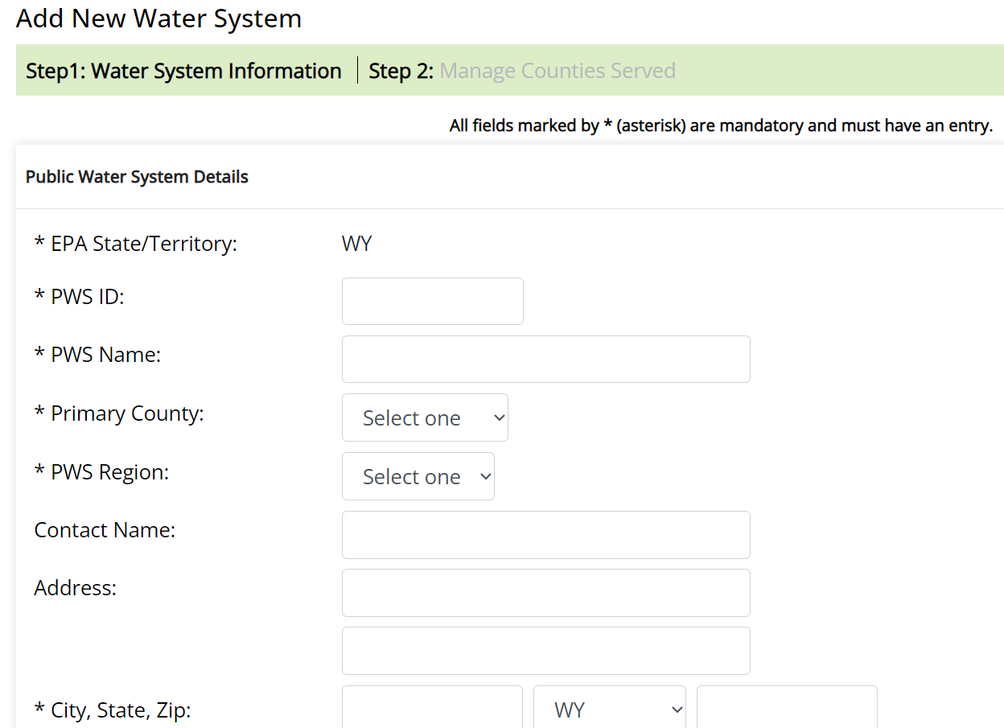

**Water System Data Entry (Continued)**

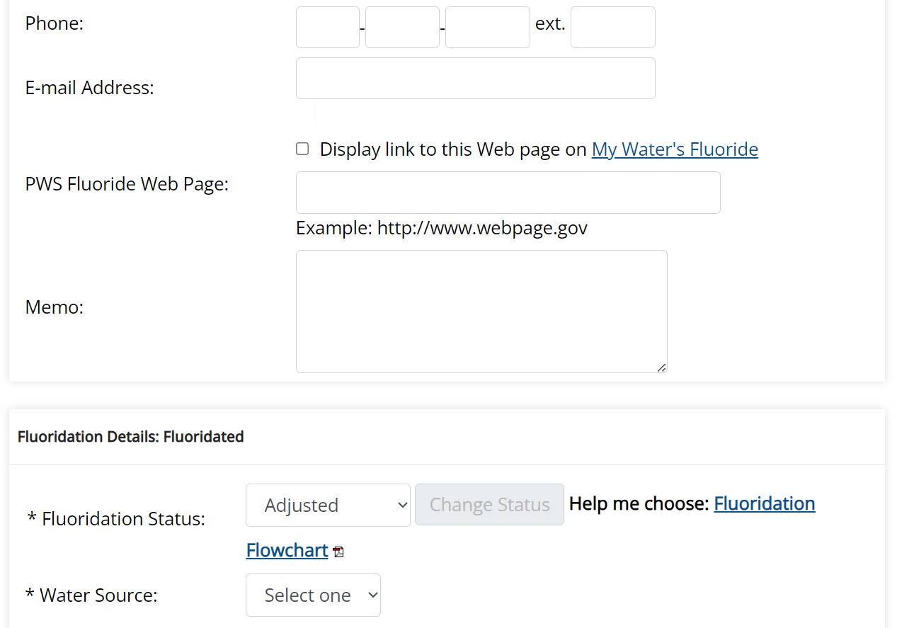

**Water System Data Entry (Continued)**

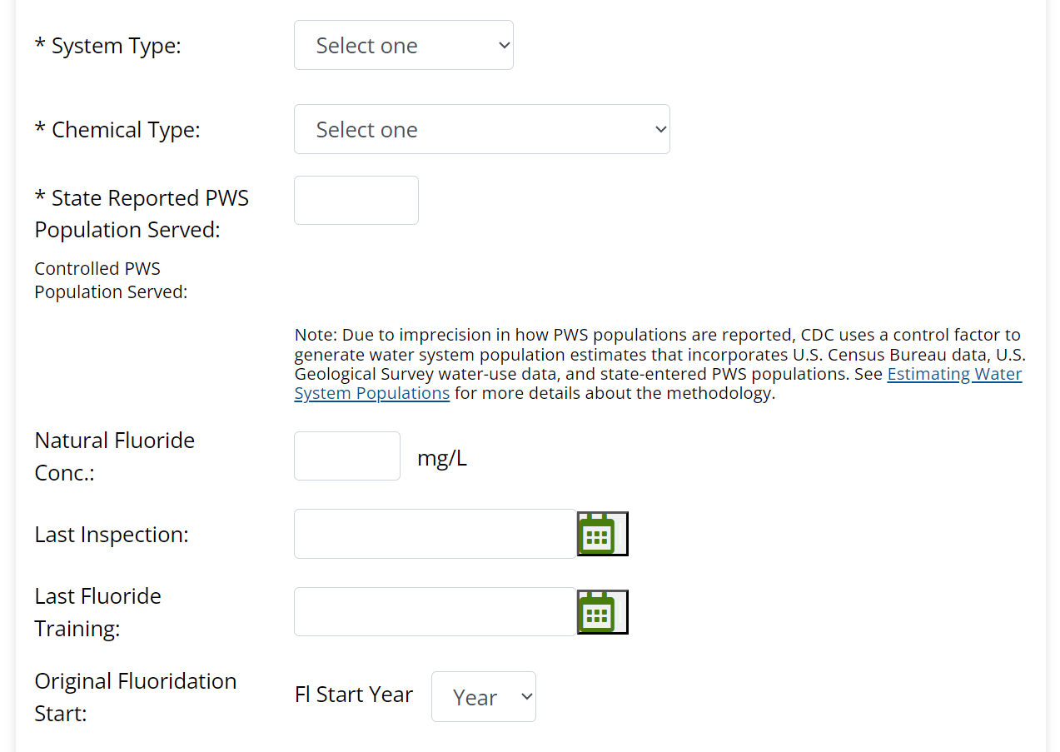

**Water System Data Entry (Continued)**

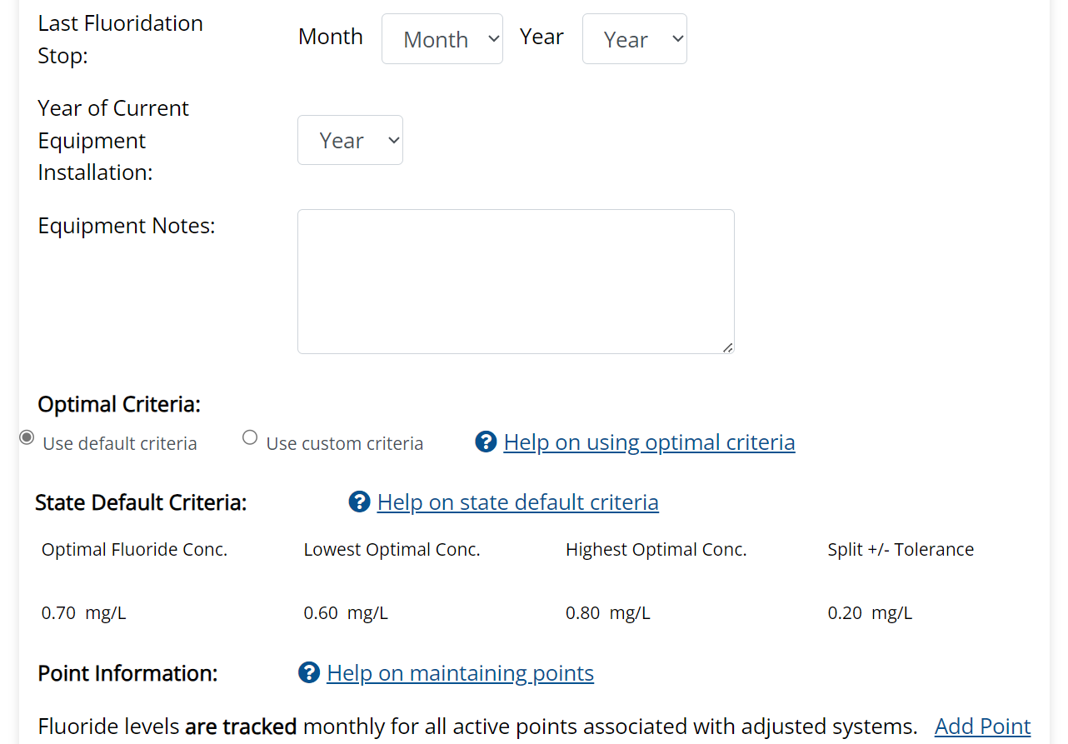

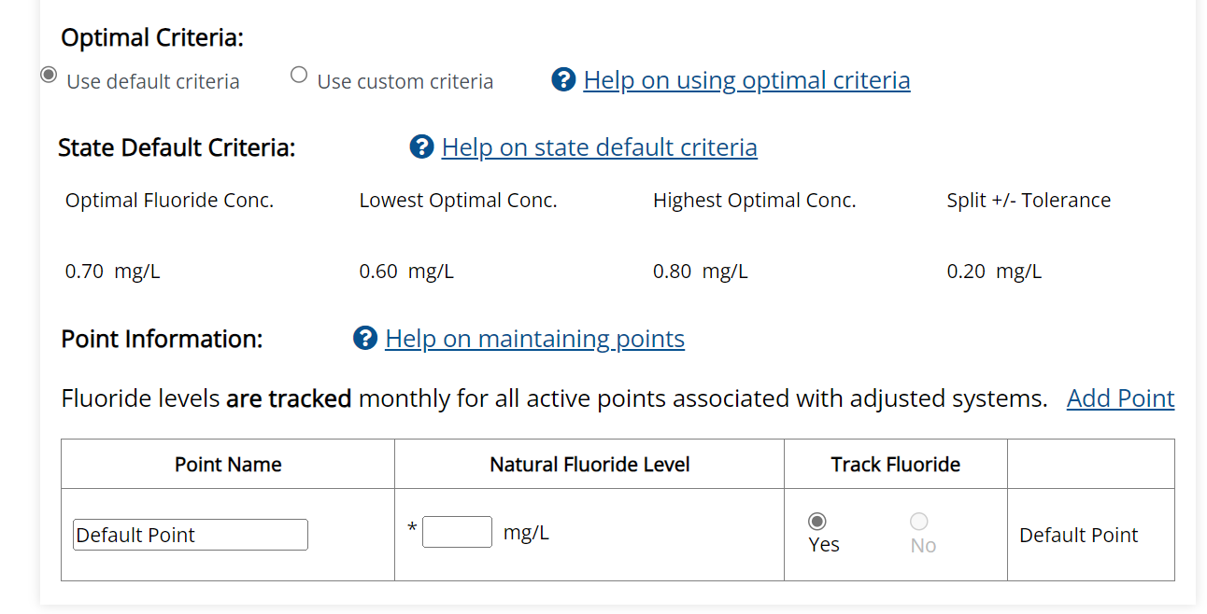

**Primary and Secondary County Data Entry**

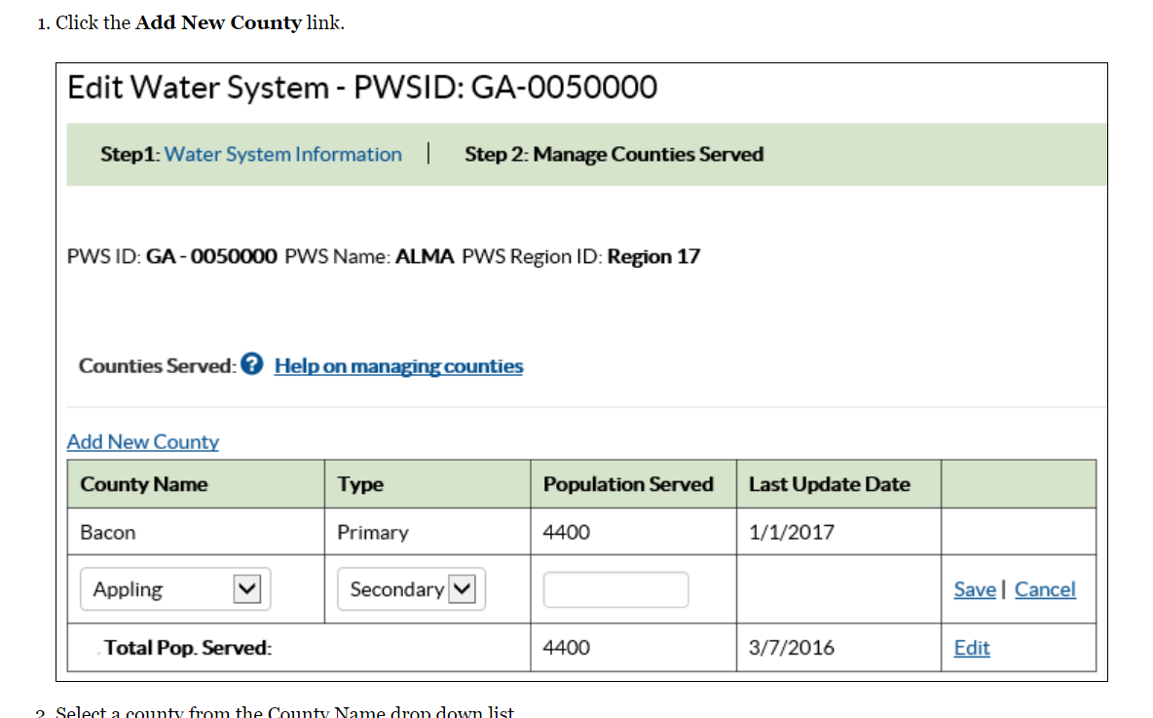

**FLUORIDE TESTING DATA**

**Fluoride Data Entry (by month)**

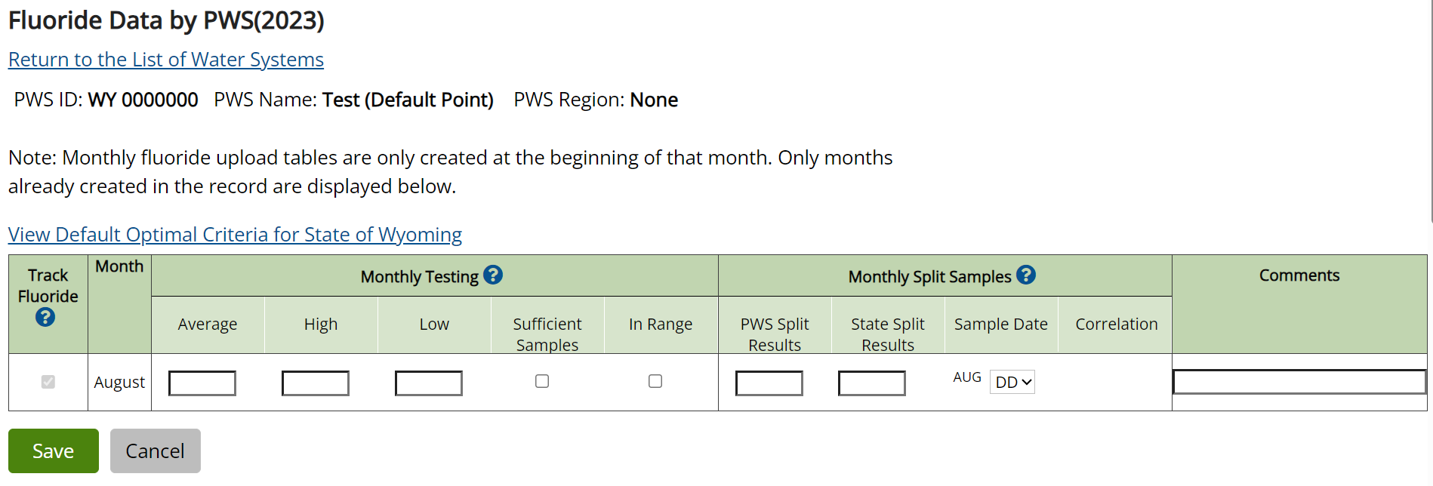

**Public Reporting Burden Statement – Fluoride Testing Data**

Public reporting burden of this collection of information is estimated to average annual **65** **hours** per response, including the time for reviewing instructions, searching existing data sources, gathering, and maintaining the data needed, and completing and reviewing the collection of information. An agency may not conduct or sponsor, and a person is not required to respond to a collection of information unless it displays a currently valid OMB control number. Send comments regarding this burden estimate or any other aspect of this collection of information, including suggestions for reducing this burden to CDC/ATSDR Information Collection Review Office, 1600 Clifton Road NE, MS D-74, Atlanta, Georgia 30333; ATTN: PRA (09200572)