Cross walk - 2024 form changes

ABCs

- ABCs Case Report Form - Attachment #3
 | 2023 Form | 2024 Form (Changes in yellow highlight)
a) |  | Appended to County (Patient Residence):  6a. Planning Region  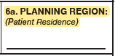

- ABCs Invasive Pneumococcal Disease (IPD) Report Form - Attachment #4
 | 2023 Form | 2024 Form (Changes in yellow highlight)
a) | 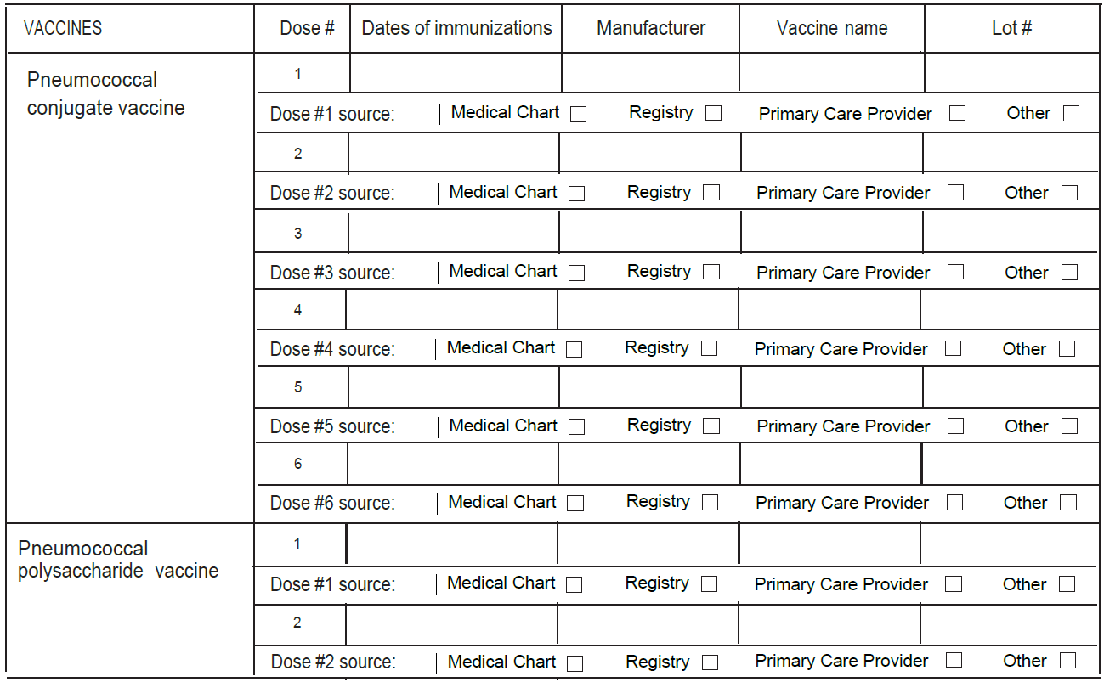 | Updated overall design of the form to show available all data value sets.  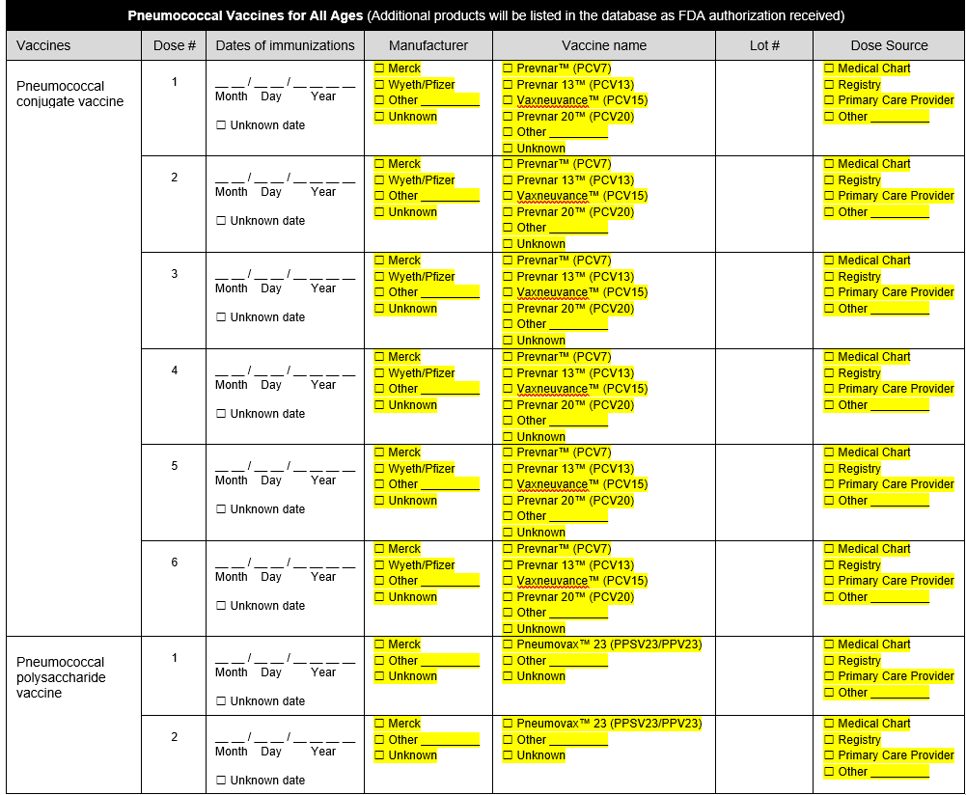
b) | 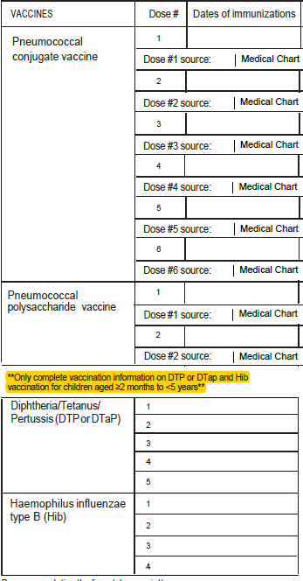 | Addition of unknown checkboxes for all vaccination date variables.  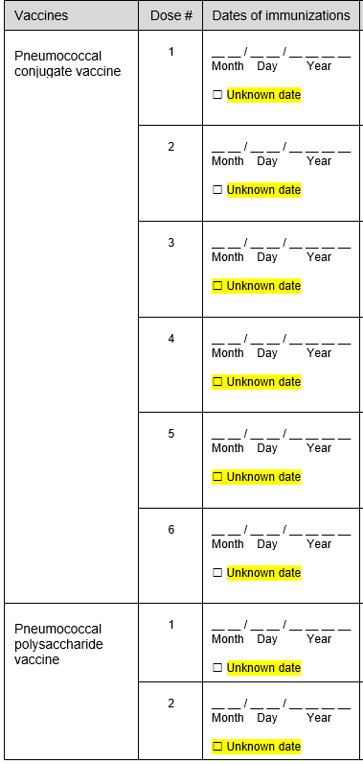  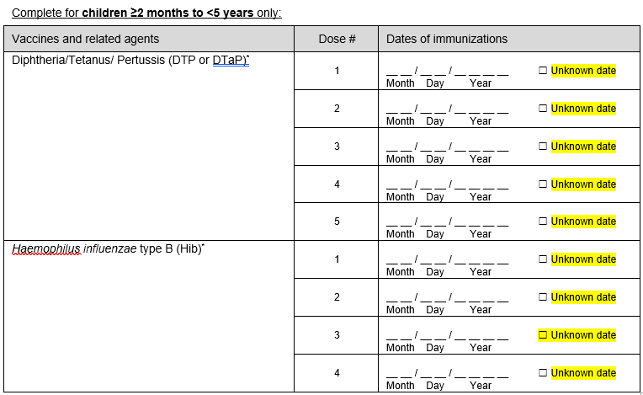
c) | 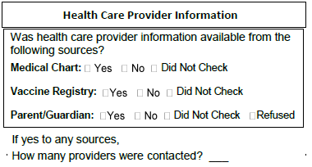 | Removed questions.

FoodNET
- FoodNet Active Surveillance Data Elements List – Attachment #5

Variable #2 AgClinicTestType – Added Meridian Curian Campy to Value Set. See highlighted in Yellow.

Variable #6 AgSphlTestType – Added Meridian Curian Campy to Value Set. See highlighted in Yellow.

The following 3 data elements questions the word “isolate” was inserted for better clarification highlighted in Yellow below:
- StecHAg – Variable #121
  - If E. coli, what was the H-antigen number for the isolate?
- StecOAg – Variable #122
  - If E. coli, what was the O-antigen number for the isolate?
- StecStx – Variable #123
  - Was E. coli isolate Shiga toxin-producing?

FluSurv-Net

- FluSurv-NET Influenza Surveillance Project Case Report Form– Attachment #6

Question on 2022-23 Form | Questions on 2023-24 Form
Case Classification  □ Prospective  □ Surveillance Discharge Audit | Case Classification  □ Surveillance Discharge Audit
C15. Where did the patient reside at the time of hospitalization (Indicate type of residence)  - Private residence  - Private residence with services  - Homeless/Shelter  - Nursing home/Skilled nursing facility  - Alcohol/Drug Abuse Treatment  - Hospitalized at birth  - Rehabilitation facility  - Corrections facility  - Hospice  - Assisted living/Residential care  - LTACH  - Group/Retirement home  - Psychiatric facility  - Other long term care facility  - Other, specify:_______  - Unknown | C15. Where did the patient reside at the time of hospitalization (Indicate type of residence)  - Private residence  - Private residence with services  - Homeless/Shelter/Temporary housing  - Nursing home/Skilled nursing facility  - Substance abuse treatment center  - Hospitalized at birth  - Rehabilitation facility  - Corrections facility  - Hospice  - Assisted living/Residential care  - LTACH  - Group/Retirement home  - Psychiatric facility  - Other long term care facility  - Other, specify:_______  - Unknown
F2. If patient discharged alive, please indicate to where:  - Private residence  - Private residence with services  - Homeless/Shelter  - Nursing home/Skilled nursing facility  - Alcohol/Drug Abuse Treatment  - Hospitalized at birth  - Rehabilitation facility  - Corrections facility  - Hospice  - Assisted living/Residential care  - LTACH  - Group/Retirement home  - Psychiatric facility  - Other long term care facility  - Against medical advice (AMA)  - Discharged to another hospital  - Other, specify:_______  - Unknown | F2. If patient discharged alive, please indicate to where:  - Private residence  - Private residence with services  - Homeless/Shelter/Temporary housing  - Nursing home/Skilled nursing facility  - Substance abuse treatment center  - Hospitalized at birth  - Rehabilitation facility  - Corrections facility  - Hospice  - Assisted living/Residential care  - LTACH  - Group/Retirement home  - Psychiatric facility  - Other long term care facility  - Against medical advice (AMA)  - Discharged to another hospital  - Other, specify:_______  - Unknown
G1. Reason for admission:  - “Influenza/COVID/RSV-related illness”  - OB/Labor and delivery admission  - Inpatient surgery procedures  - Psychiatric admission needing acute medical care  - Trauma  - Unknown  - Other, specify: _________ | G1. Reason for admission:  - “Influenza/COVID/RSV-related illness”  - OB/Labor and delivery admission  - Inpatient surgery procedures  - Psychiatric admission needing acute medical care  - Trauma  - Newborn/Hospitalized at birth  - Unknown  - Other, specify: _________
G2. Acute signs/symptoms present at admission (began or worsened within 2 weeks prior to admission) (Select all that apply)  Non respiratory symptoms  - Abdominal pain  - Altered mental status/confusion  - Anosmia/decreased smell  - Chest pain  - Conjunctivitis  - Diarrhea  - Dysgeusia/decreased taste  - Fatigue  - Fever/chills  - Headache  - Muscle aches/myalgias  - Nausea/vomiting  - Rash  - Seizures | G2. Acute signs/symptoms present at admission (began or worsened within 2 weeks prior to admission) (Select all that apply)  Non respiratory symptoms  - Abdominal pain  - Altered mental status/confusion  - Anosmia/decreased smell  - Chest pain/tightness  - Conjunctivitis  - Diarrhea  - Dysgeusia/decreased taste  - Fatigue  - Fever/chills  - Headache  - Muscle aches/myalgias  - Nausea/vomiting  - Rash  - Seizures
G2. Acute signs/symptoms present at admission (began or worsened within 2 weeks prior to admission) (Select all that apply)  Respiratory symptoms  - Congested/runny nose  - Cough  - Hemoptysis/bloody sputum  - Shortness of breath/respiratory distress  - Sore throat  - URI/ILI  - Wheezing | G2. Acute signs/symptoms present at admission (began or worsened within 2 weeks prior to admission) (Select all that apply)  Respiratory symptoms  - Congested/runny nose  - Chest congestion  - Cough  - Hemoptysis/bloody sputum  - Shortness of breath/respiratory distress  - Sore throat  - URI/ILI  - Wheezing
G2. Acute signs/symptoms present at admission (began or worsened within 2 weeks prior to admission) (Select all that apply)  For cases <2 years  - Apnea  - Cyanosis  - Decreased vocalization/stridor  - Dehydration  - Hypothermia  - Inability to eat/poor feeding  - Lethargy | G2. Acute signs/symptoms present at admission (began or worsened within 2 weeks prior to admission) (Select all that apply)  For cases <12 years  - Apnea  - Cyanosis  - Stridor/decreased vocalization  - Dehydration/decreased urine output  - Hypothermia  - Inability to eat/poor feeding  - Irritability/fussiness/excess crying  - Lethargy/decreased activity  - Nasal flaring/grunting/retractions  - Tachypnea/increased work of breathing
I1a. If yes, what is the specimen source?  - Blood  - Bronchoalveolar lavage (BAL)  - Pleural fluid  - Cerebrospinal fluid (CSF)  - Sputum  - Endotrache aspirate  - Other, specify: ___________ | I1a. If yes, what is the specimen source?  - Blood  - Bone/joint aspirate  - Bronchoalveolar lavage (BAL), bronchial aspirate/wash  - Cerebrospinal fluid (CSF)  - Endotracheal/tracheal aspirate  - Peritoneal or abdominal fluid/ascites  - Pleural fluid  - Sputum  - Wound- Group A Streptococcus (only)  - Other, specify: ___________
J1. Was patient tested for any of the following viral respiratory pathogens within 14 days prior to admission or ≤3 days after admission?  - RSV  - Adenovirus  - Parainfluenza 1  - Parainfluenza 2  - Parainfluenza 3  - Parainfluenza 4  - Human metapneumovirus  - Rhinovirus/Enterovirus  - Coronavirus SARS-CoV-2  - Coronavirus, other | J1. Was patient tested for any of the following viral respiratory pathogens within 14 days prior to admission or ≤3 days after admission?  - RSV  - Adenovirus  - Parainfluenza 1  - Parainfluenza 2  - Parainfluenza 3  - Parainfluenza 4  - Human metapneumovirus  - Rhinovirus/Enterovirus  - Coronavirus 229E  - Coronavirus HKU1  - Coronavirus NL63  - Coronavirus OC43  - Coronavirus SARS-CoV-2  - Coronavirus (not further specified)
L. Chest Imaging – Based on radiology report only  2b. For the first abnormal chest x-ray, please check all that apply  - Report not available  - Air space density  - Air space opacity  - Bronchopneumonia/pneumonia  - Cannot rule out pneumonia  - Consolidation  - Cavitation  - ARDS (acute respiratory distress syndrome)  - Lung Infiltrate  - Interstitial infiltrate  - Lobar infiltrate  - Pleural Effusion  - Empyema  - Other | L. Chest X-ray – Based on radiology report only  2b. For the first abnormal chest x-ray, please check all that apply  - Report not available  - Air space density  - Air space opacity  - Bronchopneumonia/pneumonia  - Cannot rule out pneumonia  - Consolidation  - Cavitation  - ARDS (acute respiratory distress syndrome)  - Infiltrate (lung, interstitial, other)  - Lobar infiltrate  - Pleural Effusion  - Empyema  - Other
M1. Did the patient have any of the following new diagnoses at discharge? (Select all that apply)  - Acute encephalopathy/encephalitis  - Acute liver failure  - Acute myocardial infarction  - Acute myocarditis  - Acute renal failure/acute kidney injury  - Acute respiratory distress syndrome (ARDS)  - Acute respiratory failure  - Asthma exacerbation  - Bacteremia  - Bronchiolitis  - Bronchitis  - Chronic lung disease of prematurity/BPD  - Congestive heart failure  - COPD exacerbation  - Deep vein thrombosis (DVT)  - Diabetic ketoacidosis  - Disseminated intravascular coagulation (DIC)  - Guillain-Barre syndrome  - Hemophagocytic syndrome  - Invasive pulmonary aspergillosis  - Kawasaki disease  - Mucormycosis  - Multisystem inflammatory syndrome in children (MIS-C) or adults (MIS-A)  - Other thrombosis/embolism/coagulopathy  - Pneumonia  - Pulmonary embolism (PE)  - Reye’s syndrome  - Rhabdomyolysis  - Sepsis  - Seizures  - Stroke (CVA)  - Toxic shock syndrome (TSS) | M1. Did the patient have any of the following new diagnoses at discharge? (Select all that apply)  - Acute complication of sickle cell  - Acute encephalopathy/encephalitis  - Acute liver failure  - Acute myocardial infarction  - Acute myocarditis  - Acute renal failure/acute kidney injury  - Acute respiratory distress syndrome (ARDS)  - Acute respiratory failure  - Asthma exacerbation  - Atrial fibrillation (Afib) new-onset or paroxysmal/chronic  - Bacteremia  - Bronchiolitis  - Bronchitis  - Cardiac arrest  - Chronic lung disease of prematurity/BPD  - Congestive heart failure exacerbation  - COPD exacerbation  - Deep vein thrombosis (DVT)  - Diabetic ketoacidosis  - Disseminated intravascular coagulation (DIC)  - Guillain-Barre syndrome  - Hemophagocytic syndrome  - Invasive pulmonary aspergillosis  - Kawasaki disease  - Mucormycosis  - Multisystem inflammatory syndrome in children (MIS-C) or adults (MIS-A)  - Other thrombosis/embolism/coagulopathy  - Pneumonia  - Pulmonary embolism (PE)  - Reye’s syndrome  - Rhabdomyolysis  - Sepsis  - Seizures  - Stroke (CVA)  - Supraventricular tachycardia (SVT)  - Toxic shock syndrome (TSS)  - Ventricular fibrillation (Vfib)  - Ventricular tachycardia (V-tach)
O6a. If patient was pregnant on admission but no longer pregnant at discharge, indicate pregnancy outcome at discharge. | O6a. If patient was pregnant on admission but no longer pregnant at discharge, indicate pregnancy outcome at discharge. (If multiple fetuses, indicate outcome at discharge for each fetus in the database separately.)

- FluSurv-NET/RSV Laboratory Survey– Attachment #7

Question on 2022-23 form | Question on 2023-24 form
4A. Select the kit name(s) (manufacturer) for the rapid influenza antigen diagnostic test performed or planned to be used at the laboratory: (Check all that apply)  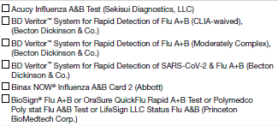  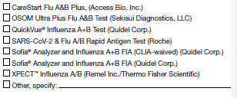 | 5A. Select the kit name(s) (manufacturer) for the rapid influenza antigen diagnostic test performed or planned to be used at the laboratory: (Check all that apply)  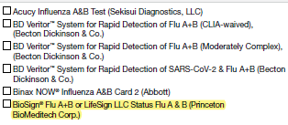  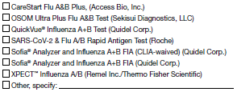
5a. Select the kit name(s) (manufacturer) for all molecular assays performed or planned to be used at the laboratory: (Check all that apply)  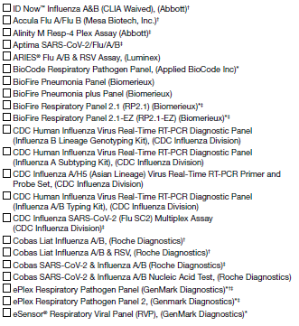  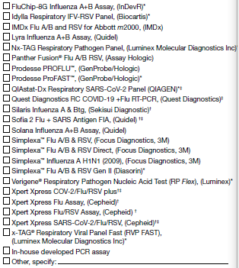 | 6a. Select the kit name(s) (manufacturer) for all molecular assays performed or planned to be used at the laboratory: (Check all that apply)  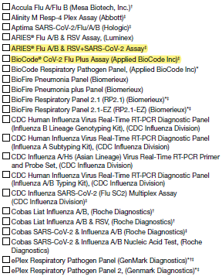  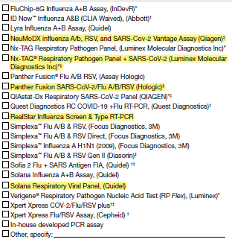
5b. If more than one kit is selected above, please select the one kit name that is (or will be) used most frequently for molecular assay at the laboratory during the current influenza season:  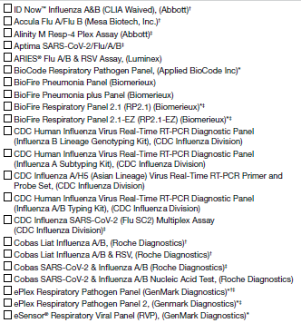  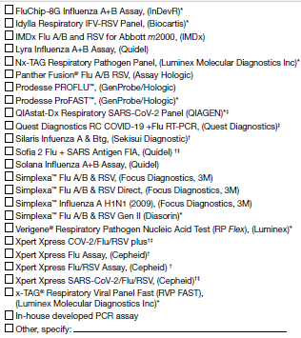 | 6b. If more than one kit is selected above, please select the one kit name that is (or will be) used most frequently for molecular assay at the laboratory during the current influenza season:  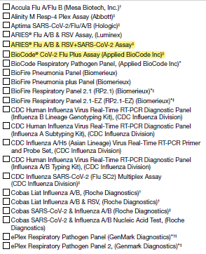  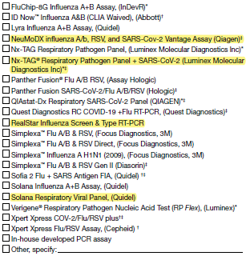

HAIC

  - Multi-site Gram-Negative Surveillance Initiative (MuGSI) Case Report Form (CRF) Attachment #8

Question on original 2023 form | Question on 2024 form | Description of change
2023 Carbapenem Resistant Enterobacteriaceae (CRE)/ Carbapenem Resistant A. baumannii  (CRAB) Multi-site Gram-Negative Surveillance Initiative (MuGSI)  Healthcare-Associated Infections Community Interface (HAIC) Case Report | 2024 Multi-site Gram-Negative Surveillance Initiative (MuGSI)  Healthcare-Associated Infections Community Interface (HAIC) Case Report | Language Modification  I. Updated year to 2024  II. Removed the pathogens from the updated form title since one form is used for all of MuGSI surveillance pathogens
10. Organism:  CRE CRAB  If CRE, select one of the following:  Escherichia coli Klebsiella aerogenes Klebsiella oxytoca  Enterobacter cloacae Klebsiella pneumoniae | 10. Organism:  Carbapenem-Resistant Enterobacterales (CRE)  Escherichia coli  Klebsiella pneumoniae  Klebsiella oxytoca  Klebsiella aerogenes  Enterobacter cloacae  Extended-spectrum beta-lactamase-producing Enterobacterales (ESBL-E)  Escherichia coli  Klebsiella pneumoniae  Klebsiella oxytoca  Carbapenem-Resistant A. baumannii (CRAB)  Invasive Escherichia coli (iEC)  (not CRE or ESBL-E) | Language Modification  I. This is updated language to clearly delineate MuGSI pathogens and phenotypes under surveillance with the use of a one form.  II. Includes the organisms/phenotypes for ESBL and iEC (from approved 2023 ESBL/iEC MuGSI CRF)
11. Incident Specimen Collection Site  Blood  Bone  Bronchoalveolar lavage (CRAB only, complete Q23c)  CSF  Internal body site (specify):______________  Muscle  Peritoneal fluid  Pericardial fluid  Joint/synovial fluid  Sputum (CRAB only, complete Q23c)  Urine  Wound (CRAB only) (specify):______________  Other LRT site (CRAB only, complete Q23c) (specify):______________  Other normally sterile site (specify):______________ | 11. Specimen Collection Site(s)  Blood  Bone  Bronchoalveolar lavage (CRAB only, complete Q23c)  CSF  Internal body site (specify):______________  Muscle  Peritoneal fluid  Pericardial fluid  Joint/synovial fluid  Sputum (CRAB only, complete Q23c)  Urine (complete 22a–22c)  Wound (CRAB only) (specify):______________  Other LRT site (CRAB only, complete Q23c) (specify):______________  Other normally sterile site (specify):______________ | Language Modification  I. Update to respondent instructions (i.e., when “Urine” is recorded, provide responses to Q22a–22c)
16. Patient Outcome:  On the day of or in the 6 calendar days before death, was the pathogen of interest isolated from a site that meets the case definition?  Yes  No  Unknown | 16. Patient Outcome  [Removed] | Administrative Change  I. Removed the specified question from “16. Patient Outcome:” on the 2024 form. A response for this question can be calculated by CDC.
17a. Types of infection associated with culture(s):  (Check all that apply) None Colonized Unknown  Abscess, not skin  AV fistula/graft infection  Bacteremia  Bursitis  Catheter site infection (CVC)  Cellulitis  Chronic Ulcer/wound (not decubitus)  Decubitus/pressure ulcer  Empyema  Endocarditis  Epidural abscess  Meningitis  Osteomyelitis  Peritonitis  Pneumonia (CRAB cases, complete Q23c)  Pyelonephritis  Septic arthritis  Septic emboli  Septic shock  Skin abscess  Surgical incision infection  Surgical site infection (internal)  Traumatic wound  Urinary tract infection  Other (specify):______________ | 17a. Types of infection associated with culture(s):  (Check all that apply) None Colonized Unknown  Abscess, not skin  AV fistula/graft infection  Bacteremia  Bursitis  Catheter site infection (CVC)  Cellulitis  Chronic Ulcer/wound (not decubitus)  Decubitus/pressure ulcer  Empyema  Endocarditis  Epidural abscess  Meningitis  Osteomyelitis  Peritonitis  Pneumonia (CRAB cases, complete Q23c)  Pyelonephritis (complete 22a–22c)  Sepsis  Urosepsis  Septic arthritis  Septic emboli  Septic shock  Skin abscess  Surgical incision infection  Surgical site infection (internal)  Traumatic wound  Urinary tract infection (complete 22a–22c)  Other (specify):______________ | Administrative Change & Language Modification  I. Provided a checkbox for “Sepsis” as an infection type, including a sub-choice for “Urosepsis”  II. Respondents previously entered these responses under Bacteremia or as additional notes in the comments section of the form.  III. Update respondent instructions (i.e., when “Pyelonephritis” or “Urinary tract infection” are recorded, provide responses to Q22a–22c)
URINE CULTURES ONLY:  [Instruction preceding Q22a–22c] | Complete questions 22a–22c for all MuGSI cases from urine cultures or where UTI or pyelonephritis is marked in question 17a: | Administrative Change & Language Modification  I. This is revised language to clarify form instructions to respondents.
23b. Risk factors in the 7 days before the DISC:  Non-invasive positive pressure ventilation (CPAP or BiPAP) at any time in the  7 calendar days before the DISC  Nebulizer treatment at any time in the 7 calendar days before the DISC  Mechanical ventilation at any time in the 7 calendar days before the DISC  None | 23b. Risk factors prior to CRAB DISC:  Non-invasive positive pressure ventilation (CPAP or BiPAP) at any time in the  7 calendar days before the DISC  Nebulizer treatment at any time in the 7 calendar days before the DISC  Mechanical ventilation at any time in the 7 calendar days before the DISC  None | Language Modification  I. Revised and clarified the text for of the question.
Question 24 a & b come from the OMB-approved 2023 ESBL/iEC MuGSI CRF. | 24a. Is antimicrobial use (IV or Oral) in the 30 days before the DISC documented?  Yes No Unknown | Administrative Change  I. This question from the OMB-approved 2023 ESBL/iEC MuGSI is consolidated to the single 2024 MuGSI CRF
Question 24 a & B come from the OMB-approved 2023 ESBL/iEC MuGSI CRF. | 24b. If yes, check all antimicrobials used in the 30 days before the DISC:  (Check all that apply)  Amikacin  Amoxicillin  Amoxicillin/clavulanic acid  Ampicillin  Ampicillin/sulbactam  Azithromycin  Aztreonam  Cefadroxil  Cefazolin  Cefdinir  Cefepime  Cefiderocol  Ceixime  Cefotaxime  Cefoxitin  Cefpodoxime  Ceftaroline  Ceftazidime  Ceftazidime/avibactam  Ceftizoxime  Ceftolozane/tazobactam  Ceftriaxone  Cefuroxime  Cephalexin  Ciprofloxacin  Clarithromycin  Clindamycin  Dalbavancin  Daptomycin  Delafloxacin  Doripenem  Doxycycline  Eravacycline  Ertapenem  Fidaxomicin  Fosfomycin  Gentamicin  Imipenem/cilastatin  Levofloxacin  Linezolid  Meropenem  Meropenem/vaborbactam  Metronidazole  Moxifloxacin  Nitrofurantoin  Omadacycline  Oritavancin  Penicillin  Piperacillin/tazobactam  Polymyxin B  Polymyxin E (colistin)  Rifaximin  Tedizolid  Telavancin  Tigecycline  Tobramycin  Trimethoprim  Trimethoprim/sulfamethoxazole  Vancomycin  IV  PO  Other (specify):___________  Other (specify):___________  Reminder: Any prior antimicrobial use that is not noted above should be documented in the other (specify) field. | Administrative Change  I. As noted for 24a, this question from the OMB-approved 2023 ESBL/iEC MuGSI is consolidated to the single 2024 MuGSI CRF
24c. COVID-Net Case ID:_________ | 25c. COVID-Net Case ID in the year before or day of DISC:_________  None or N/A | Language Modification & Administrative Change  I. Updated the question number  II. Added language to state the specified timeframe  III. Included a checkbox for “None or N/A” to differentiate from missing data
28. Susceptibility Results  Please complete the table below based on the information found in the indicate data source | 29. Susceptibility Results  Please complete the table below based on the information found in the indicate data source  No susceptibility data from the medical record are available | Administrative Change  I. Updated the question number  II. Included a checkbox for “No susceptibility data form the medical record are available” to differentiate from missing data

- Multi-site Gram-Negative Surveillance Initiative (MuGSI) Community-Associated Carbapenemase-Producing Carbapenem-Resistant Enterobacterales (CA CP-CRE) Health interview - Attachment #9

Original Instruction | Proposed Change to Instruction
[If answer to Q22 = 1, i.e., interviewee lives alone, skip to Section G] | [If answer to Q22 = 1, i.e., interviewee lives alone, skip to Section 9]

- Invasive Staphylococcus aureus Infection Case Report - Attachment #10

2023 CRF Question | Changes to the 2024 CRF Question
15a. Is the isolate MRSA or MSSA?
□ MRSA □ MSSA □ Unknown
[new question]
34a. COVID-NET CASE ID: ________________ | 34a. COVID-NET CASE ID in the year before or day of the DISC: ________________ □ None or N/A  [updated language, added checkbox]

- Clostridiodies difficile Infection (CDI) Case Report and Treatment Form - Attachment #11
2023 CRF | 2024 CRF | Changes
9a. EIA  - Positive  - Negative  - Not tested | 9a. EIA  - Positive  - Negative  - Not tested  - Unknown | Added option for “unknown”
9b. GDH  - Positive  - Negative  - Not tested | 9b. GDH  - Positive  - Negative  - Not tested  - Unknown | Added option for “unknown”
9c. Cytotoxin  - Positive  - Negative  - Not tested | 9c. Cytotoxin  - Positive  - Negative  - Not tested  - Unknown | Added option for “unknown”
9d. NAAT (C. diff only)  - Positive  - Negative  - Not tested | 9d. NAAT (C. diff only)  - Positive  - Negative  - Not tested  - Unknown | Added option for “unknown”
9e. NAAT (GI panel)  - Positive  - Negative  - Not tested | 9e. NAAT (GI panel)  - Positive  - Negative  - Not tested  - Unknown | Added option for “unknown”
9f. Other (specify)  - Positive  - Negative  - Not tested | 9f. Other (specify)  - Positive  - Negative  - Not tested  - Unknown | Added option for “unknown”
21. Underlying conditions  - Transplant, solid organ | 21. Underlying conditions  - Transplant, solid organ:  ____________________ | Added a field to specify organ transplanted
34f.1 If YES, which medication was taken | 34f.1 If YES, which treatment was taken? | Changed “medication” to “treatment”
37. COVID-NET Case IDs: ________ | 37. COVID-NET Case IDs in the year before or day of DISC: _________  - None or N/A | Clarified the time period of the question  Added a checkbox for “none or N/A”

- Clostridiodies difficile Infection (CDI) Annual Surveillance Officers Survey - Attachment #12
Existing question | Modified question
2. In 2022, did any laboratories drop out of participation? | 2. In 2023, did any laboratories drop out of participation?  (changed year to 2023 to reflect change in survey year)
3. In 2022, did you identify any additional laboratories inside or outside of your catchment area which identify C.diff assays from persons who are residents of your catchment area? | 3. In 2023, did you identify any additional laboratories inside or outside of your catchment area which identify C.diff assays from persons who are residents of your catchment area?  (changed year to 2023 to reflect change in survey year)
10. Did your site complete a physician/outpatient provider survey in 2022? | 10. Did your site complete a physician/outpatient provider survey in 2023?  (changed year to 2023 to reflect change in survey year)
13. For each facility that treated a case in 2022, please provide the following | 13. For each facility that treated a case in 2023, please provide the following  (changed year to 2023 to reflect change in survey year)

- Annual Survey of Laboratory Testing Practices for C. difficile Infections - Attachment #13
Existing question | Modified question
Was this a new laboratory in 2022? | Was this a new laboratory in 2023?
How often did you receive line lists from this lab in 2022? | How often did you receive line lists from this lab in 2023?
How did you receive line lists from this lab in 2022? | How did you receive line lists from this lab in 2023?
Did you receive specimens from this lab in 2022? | Did you receive specimens from this lab in 2023?
Was this lab audited in 2022? | Was this lab audited in 2023?
Types of facilities in your catchment area served by this lab in 2022 | Types of facilities in your catchment area served by this lab in 2023
Did your laboratory ever send specimens off-site for Clostridioides difficile testing in 2022? | Did your laboratory ever send specimens off-site for Clostridioides difficile testing in 2023?
2a. Which testing method(s) for Clostridioides difficile (C. difficile) did your laboratory perform in 2022? | 2a. Which testing method(s) for Clostridioides difficile (C. difficile) did your laboratory perform in 2023?
Did your laboratory use this testing method for Clostridioides difficile (C. difficile) in 2022? | Did your laboratory use this testing method for Clostridioides difficile (C. difficile) in 2023?
Did you use this testing method in this way for all of 2022? | Did you use this testing method in this way for all of 2023?
3a. Which EIA test kit was used by your laboratory in 2022? | 3a. Which EIA test kit was used by your laboratory in 2023?
3b. Which Nucleic Acid Amplification test was used by your laboratory in 2022? | 3b. Which Nucleic Acid Amplification test was used by your laboratory in 2023?
4a. If your laboratory used a multiplexed molecular diagnostic (e.g., Biofire Filmarray GI Panel, Luminex xTAG GPP) to test for several GI pathogens in 2022, did your laboratory suppress the C. difficile result so that clinicians could not see it? | 4a. If your laboratory used a multiplexed molecular diagnostic (e.g., Biofire Filmarray GI Panel, Luminex xTAG GPP) to test for several GI pathogens in 2023, did your laboratory suppress the C. difficile result so that clinicians could not see it?
4b. If your laboratory used a multiplexed diagnostic in 2022 and the result was suppressed, where does the suppression occur? | 4b. If your laboratory used a multiplexed diagnostic in 2023 and the result was suppressed, where does the suppression occur?
5a. If your laboratory used a nucleic acid amplification test (NAAT) (e.g., Cepheid Xpert C. difficile) as first line testing followed by a toxin EIA test (whenever NAAT result is positive) in 2022, did your laboratory suppress the positive NAAT result so that clinicians could not see it? | 5a. If your laboratory used a nucleic acid amplification test (NAAT) (e.g., Cepheid Xpert C. difficile) as first line testing followed by a toxin EIA test (whenever NAAT result is positive) in 2023, did your laboratory suppress the positive NAAT result so that clinicians could not see it?
5b. If your laboratory used NAAT as first line testing followed by confirmatory toxin EIA testing in 2022, and both the NAAT and toxin EIA results were released to the clinician, did your laboratory provide any comments to help the clinician interpret the test results (e.g., NAAT-positive only result might represent colonization, etc.)? | 5b. If your laboratory used NAAT as first line testing followed by confirmatory toxin EIA testing in 2023, and both the NAAT and toxin EIA results were released to the clinician, did your laboratory provide any comments to help the clinician interpret the test results (e.g., NAAT-positive only result might represent colonization, etc.)?
6. What are the LOINC or internal testing codes associated with the tests your lab used in 2022 (e.g. LOINC codes 13957-6, 34713-8, or 54067-4)? | 6. What are the LOINC or internal testing codes associated with the tests your lab used in 2023 (e.g. LOINC codes 13957-6, 34713-8, or 54067-4)?
7. Did your lab have a policy to reject stool specimens for C. difficile testing in 2022? | 7. Did your lab have a policy to reject stool specimens for C. difficile testing in 2023?
7a. Did your rejection policy for stool specimens change between January 1, 2022 and December 31, 2022? | 7a. Did your rejection policy for stool specimens change between January 1, 2023 and December 31, 2023?
8. How many stool samples did you test for C. difficile each month in 2022? | 8. How many stool samples did you test for C. difficile each month in 2023?

- HAIC Candidemia Case Report - Attachment #14
2023 CRF Question | 2024 CRF Question
CANDIDEMIA 2023 CASE REPORT FORM (header) | CANDIDEMIA 2024 CASE REPORT FORM (header)  (changed year)
Version: Short Form 2023, Last Updated: 07/29/2022 (footnotes) | Version: Short Form 2024, Last Updated: 07/29/2023 (footnotes)  (changed year and date)
23. Candida species from initial positive blood culture (check all that apply):  Candida albicans (CA)  Candida glabrata (CG)  Candida parapsilosis (CP)  Candida tropicalis (CT)  Candida dubliniensis (CD)  Candida lusitaniae (CL)  Candida krusei (CK)  Candida guilliermondii (CGM)  Candida, other (CO) specify: ______________  Candida, germ tube negative/non albicans (CGN)  Candida species (CS)  Pending | 23. Candida species from initial positive blood culture (check all that apply):  Candida albicans (CA)  Candida auris (CAU)  Candida glabrata (CG)  Candida parapsilosis (CP)  Candida tropicalis (CT)  Candida dubliniensis (CD)  Candida lusitaniae (CL)  Candida krusei (CK)  Candida guilliermondii (CGM)  Candida, other (CO) specify: ______________  Candida, germ tube negative/non albicans (CGN)  Candida species (CS)  Pending  (added new response option)
24. Antifungal susceptibility testing  Species  CA  CG  CP  CT  CD  CL  CK  CGM  CO  CGN  CS  Pending | 24. Antifungal susceptibility testing  Species  CA  CAU  CG  CP  CT  CD  CL  CK  CGM  CO  CGN  CS  Pending  (added new response option)
25. Did the patient have a culture-independent diagnostic test (CIDT) for Candida, (e.g., T2), on the day of or in the 6 days before the DISC?  1 Yes 0 No 9 Unknown | 25. Did the patient have a PCR molecular test for Candida (e.g., T2) in the 6 days before or two days after the DISC?  1 Yes 0 No 9 Unknown  (changed question wording)
26a. If yes, provide dates of all subsequent positive Candida blood cultures and select the species:  Date Drawn (mm-dd-yyyy)  ___ ___ - ___ ___ - ___ ___ ___ ___  Species identified* CA CG CP CT CD CL CK CGM CO:_________ CGN CS Pending | 26a. If yes, provide dates of all subsequent positive Candida blood cultures and select the species:  Date Drawn (mm-dd-yyyy)  ___ ___ - ___ ___ - ___ ___ ___ ___  Species identified* CA CAU CG CP CT CD CL CK CGM  CO:_________ CGN CS Pending  (added new response option)
40. Underlying conditions (Check all that apply):  Chronic Lung Disease  Cystic Fibrosis  Chronic Pulmonary disease  Chronic Metabolic Disease  Diabetes Mellitus  With Chronic Complications  Cardiovascular Disease  CVA/Stroke/TIA  Congenital Heart disease  Congestive Heart Failure  Myocardial infarction  Peripheral Vascular Disease (PVD)  Gastrointestinal Disease  Diverticular disease  Inflammatory Bowel Disease  Peptic Ulcer Disease  Short gut syndrome  Immunocompromised Condition  HIV infection  AIDS/CD4 count <200  Primary Immunodeficiency  Transplant, Hematopoietic Stem Cell  Transplant, Solid Organ | 40. Underlying conditions (Check all that apply):  Chronic Lung Disease  Cystic Fibrosis  Chronic Pulmonary disease  Chronic Metabolic Disease  Diabetes Mellitus  With Chronic Complications  Cardiovascular Disease  CVA/Stroke/TIA  Congenital Heart disease  Congestive Heart Failure  Myocardial infarction  Peripheral Vascular Disease (PVD)  Gastrointestinal Disease  Diverticular disease  Inflammatory Bowel Disease  Peptic Ulcer Disease  Short gut syndrome  Immunocompromised Condition  HIV infection  AIDS/CD4 count <200  Primary Immunodeficiency  Transplant, Hematopoietic Stem Cell  Transplant, Solid Organ (specify): ________  (added new response option)
52. Did the patient have a CVC in the 2 calendar days before, not including the DISC?  1 Yes 2 No 3 Had CVC but can’t find dates 9 Unknown  If yes, check here if central line in place for > 2 calendar days: | 52. Did the patient have a CVC in the 2 calendar days before, not including the DISC?  1 Yes 2 No 3 Had CVC but can’t find dates 9 Unknown  If yes, was the central line in place for > 2 calendar days: 1 Yes 0 No 9 Unknown  (changed question wording, added additional response options)
55b. If yes, EIP COVID-NET Case ID: ____________ 9 Unknown Out of EIP COVID-NET catchment area | 55b. If yes, EIP COVID-NET Case ID: ____________ None or N/A  (added new response option)
AFST results for additional Candida isolates  Species  CA  CG  CP  CT  CD  CL  CK  CGM  CO  CGN  CS  Pending | AFST results for additional Candida isolates  Species  CA  CAU  CG  CP  CT  CD  CL  CK  CGM  CO  CGN  CS  Pending  (added new response option)

- Laboratory Testing Practices for Candidemia Questionnaire - Attachment #15
2023 Lab Survey Question | 2024 Lab Survey Question
2023 LABORATORY TESTING PRACTICES FOR CANDIDEMIA QUESTIONNAIRE (header) | 2024 LABORATORY TESTING PRACTICES FOR CANDIDEMIA QUESTIONNAIRE (header)  (changed year)
2023 Page # of # (footnotes) | 2024 Page # of # (footnotes)  (changed year)
- Does this laboratory employ culture-independent diagnostic tests (CIDTs) to identify Candida from blood specimens?  Yes (got to Q14)  No (got to Q17)  Unknown | - Does this laboratory employ PCR molecular tests to identify Candida from blood specimens?  Yes (go to Q14)  No (go to Q17)  Unknown  (changed question wording)
- Does this laboratory employ any other CIDTs to identify Candida from blood specimens?  Yes (specify) _____________  No  Unknown  Not applicable | - Does this laboratory employ any other PCR molecular tests to identify Candida from blood specimens?  Yes (specify) _____________  No  Unknown  Not applicable  (changed question wording)
17) If No for Question 13, does this laboratory have plans to employ culture independent diagnostics for Candida identification in the near future (e.g., T2Candida Panel, BioFire)?  Yes  No  Unknown  Not applicable | 17) If No for Question 13, does this laboratory have plans to employ PCR molecular tests for Candida identification in the near future (e.g., T2Candida Panel, BioFire)?  Yes  No  Unknown  Not applicable  (changed question wording)

