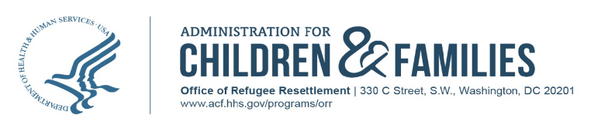

Dear Colleague,
Under your care is an unaccompanied child who is in the custody of the Office of Refugee Resettlement (ORR) in the Department of Health and Human Services (DHHS). As such, ORR must collect specific information on healthcare services received by the child. While in ORR custody, children are placed in government-funded care provider programs that are responsible for providing day-to-day care. The ultimate goals of ORR are to ensure the health and safety of the child while in custody and to unify the child with their sponsor, as soon as possible.
The entire Dental Assessment Form (DAF) must be completed by the evaluating dental provider during every visit, including the initial dental exam and preventative health visits, and returned to the care provider program staff member at the conclusion of the evaluation.
The DAF is comprised of 3 sections - General Information, History and Assessment, and Diagnosis and Plan. Please ensure the Plan section contains detailed information on next steps of care. If a medication is given/prescribed, a corresponding diagnosis must be indicated in the Diagnosis and Plan section. As stated, ORR’s primary objective is the safe and timely unification of children with their sponsors. For children identified with potential acute health conditions, ORR relies on healthcare provider recommendations to determine whether indicated follow-up services must occur prior to a child’s travel to unify with their sponsor or if the services may be addressed after unification. Given this, please clearly identify on the form if a child is cleared to travel with or without restrictions by the conclusion of their evaluation with you.
Please ensure that copies of all health records, including office notes, lab results and imaging reports are forwarded to care provider program staff as soon as they are available. Also, please verify that all information entered on the form is legible and complete as this information will be transcribed and uploaded into a secure electronic data system owned by ORR.
If you have any questions or concerns regarding the information collected on this form or require additional direction, please contact the ORR’s Division of Health for Unaccompanied Children (DHUC) at DCSMedical@acf.hhs.gov.

Thank you,

Director, Division of Health for Unaccompanied Children (DHUC)
Unaccompanied Children Programs
Office of Refugee Resettlement
Administration for Children and Families
U.S. Department of Health and Human Services

