OFFICE OF REFUGEE RESETTLEMENT
Services to Afghan Survivors Impacted by Combat
Program Data Points Form

USER GUIDE

TABLE OF CONTENTS

OVERVIEW 2
PROGRAM INDICATORS 2
01. CLIENT COUNT DURING REPORTING PERIOD 3
02. AGE AT INTAKE 4
03. GENDER IDENTITY 5
04. SEXUAL ORIENTATION (SELF-REPORTED) 6
05. LENGTH OF TIME IN THE U.S. AT INTAKE 7
06a. TYPE OF COMBAT /TRAUMA EXPOSURE PRIMARY 8
06b. TYPE OF COMBAT/TRAUMA EXPOSURE SECONDARY______________________________10
07. PRIOR GOVERNMENT/MILITARY SERVICE 11
08. EDUCATION PRIOR TO ARRIVAL 12
09. IMMIGRATION STATUS AT INTAKE 13
10. EMPLOYMENT IN THE U.S. AT INTAKE 15
11. CLIENTS SERVED BY SERVICE CATEGORY 16
12. SERVICE-RELATED PROGRAM ACTIVITIES 17
12. PROFESSIONAL TRAINING FOR STAFF 19
13. PROFESSIONAL TRAINING FOR COMMUNITY 20

OUTCOME INDICATORS 22
LEVEL OF NEED 24
14. MENTAL HEALTH SERVICES 25
15. MEDICAL HEALTH SERVICES 27
16. SOCIAL SERVICES 29

APPENDIX A: SASIC: PSYCHOSOCIAL WELL-BEING INDEX-SHORT 31
APPENDIX B: VERIFYING ACCURACY OF DATA POINTS 33

OVERVIEW:

ORR requires all grantees funded under its Services to Afghan Survivors Impacted by Combat (SASIC) Program to collect and report aggregate program data for SASIC clients. Recipients implementing programs through multiple funding sources to serve Afghan survivors of combat should report data related only to individuals eligible for and served with ORR funding. Only these individuals should be included in this report and will be referred to hereafter as clients. Using the Services to Afghan Survivors Impacted by Combat – Program Data Points (SASIC -PDP), grantees must report data related to both new and continuing clients, unless instructed otherwise.

Recipients must submit the SASIC-PDP form on an annual basis, along with their second semi-annual Performance Progress Report (PPR) each program year throughout the project period. For the specific purpose of the PDP Form, the reporting period covers the entire program year. SASIC Program grantees must submit annual demographic and outcome data using the SASIC Program Data Points (PDP) tool sent by email to all SASIC grant recipients.
For more information on reporting requirements, please refer to the current SASIC Program Notice of Funding Opportunity.
For each data indicator, please read the corresponding definitions and follow the reporting instructions. ORR will return incorrect or incomplete forms for revision and re-submission.

PROGRAM INDICATORS (Data Points 1–13)

CLIENT COUNT DURING REPORTING PERIOD
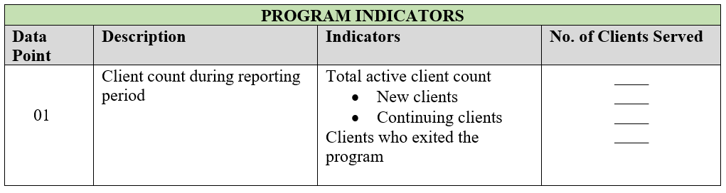

Definitions:
Total active client count: Indicate the total number of clients being served during the current reporting period.

New clients: Indicate the current number of clients who completed intake, were determined to be eligible for services, were accepted into the ORR-funded Services to Afghan Survivors Impacted by Combat program and received service(s) during the reporting period.

Continuing clients: Indicate the number of individuals who entered the program prior to the reporting period and received services during the current annual reporting period, OR the number of individuals who previously exited the program, were found eligible for services through a comprehensive intake assessment and returned for additional services during the current reporting period. As such, ORR defines a continuing client as an individual who received services during the reporting period, regardless of whether that person continuously received services from the previous year or returned to receive services after a break in accessing services, provided that the “inactive” period lasted less than two years.

Clients who exited the program: Indicate the total number of clients known to have left the program during the current reporting period. This count includes clients who were served during the reporting period or earlier. Clients are considered to have exited the program when they have officially been discharged from it, moved out of the service area, or ceased to access any services during the current program year.
A client may be counted as both active and exiting during any given annual reporting period.

Note: The tool used to count the number of clients that existed the program is based on your agency guidelines for termination of client services.

Reporting: Indicate the total active, new, continuing, and exiting clients during the reporting period.

Example

Here is an example of how to consider a client in each of the above categories:

In Program Year (PY) 2023, Grantee X begins serving an individual. That person would be counted as a new client. The client continues to receive services the following PY 2024, and therefore would be counted as a continuing client in PY 2024. The client does not access services in PY 2025 and would therefore be counted as exiting the program.
Note: A continuing client would only be counted if they accessed services in PY 2024 and 2025.

02: AGE AT INTAKE:

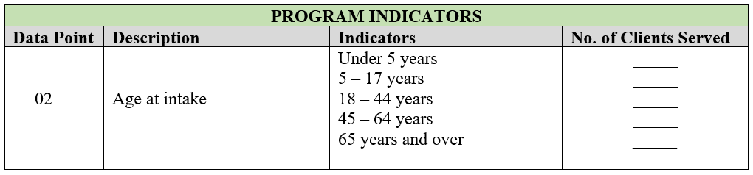

Definitions:
Age at intake: Indicate the number of individuals represented by each age range. This indicator should be the age at which an individual entered the SASIC program and completed the intake assessment. If the individual is a child and is unable to provide this information, the child’s parent or guardian may provide the information.

Reporting:
For each age range, indicate the number of new and continuing clients who enter the SASIC program during the intake assessment. These counts should be unduplicated. Note the definition of a continuing client above.

GENDER IDENTITY:

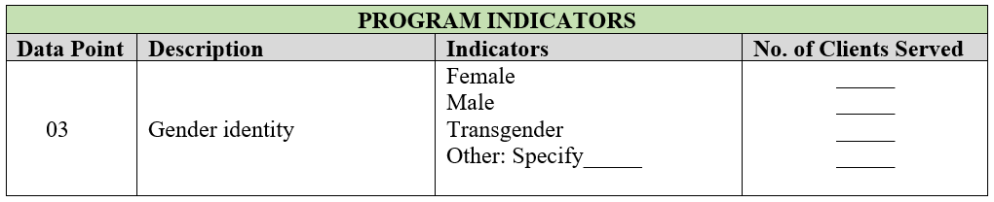

Definitions:
Female: An individual who identifies as female from birth.

Male: An individual who identifies as male from birth.

Transgender: An individual who identifies as transgender.

Other: An individual who identifies as non-binary, any other gender identity not specified above, is unknown, or chooses not to disclose.

Reporting:
Indicate the number of new and continuing clients for each category. These counts should be unduplicated.

04. SEXUAL ORIENTATION (client self-identification):

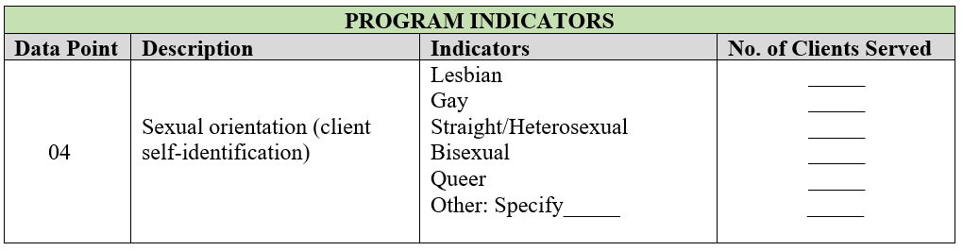

Definitions:
Lesbian: An individual who self-identifies as a lesbian.

Gay: An individual who self-identifies as gay.

Straight/Heterosexual: An individual who self-identifies as straight or heterosexual.

Bisexual: An individual who self-identifies as bisexual.

Queer: An individual who self-identifies as queer.

Other: An individual who self-identifies as a member of another group, is unknown or chooses not to disclose.

Reporting:
Indicate the number of new and continuing clients who self-identify within each category. These counts should be unduplicated.

05. LENGTH OF TIME IN THE U.S. AT INTAKE:

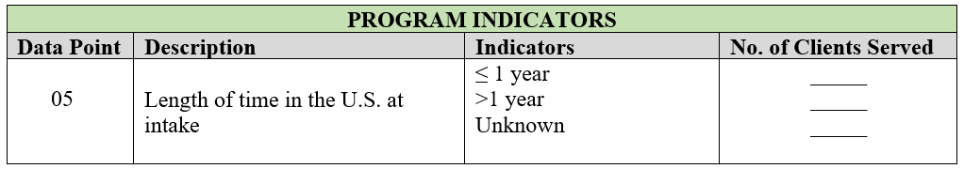

Definitions:
Length of time in the U.S. at intake: The number of days, months, or years the client has lived in the United States up until the time of intake. The duration of time should be counted as ≤ 1 year if the client has lived in the U.S. for less or equal to 365 days and > 1 year if the client has lived in the U.S. for 366 days or more at intake.

Reporting:
For each date range, indicate the total number of clients that have lived in the U.S. for 1 year or less and the total number of clients that have lived in the U.S. for more than 1 year. If a client does not know the timeframe that they have lived in the U.S., select ‘Unknown’.

06. COMBAT EXPOSURE:

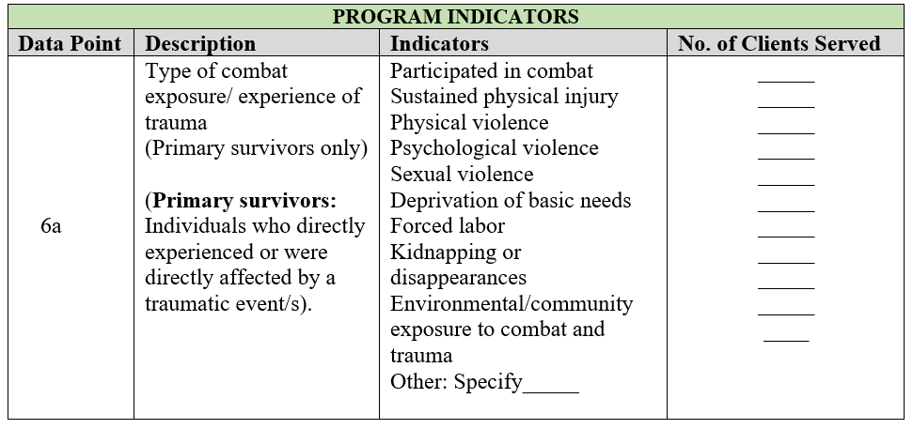

Before completing Data Indicator 06a on the form, please read through the definitions below carefully, as they list many sub-categories under the broad categories listed. For example, forced removal of teeth is listed in the category of physical violence, rape is included under the category of sexual violence, and waterboarding is included under psychological violence.

*Note: The lists below are not all encompassing and provides examples of various types of combat exposure/experiences of trauma.

Definitions:
Primary survivors: An individual who is determined eligible for services based on direct exposure to combat and combat related trauma, including being forced to witness the abuse of another individual or living in a community with exposure to combat and trauma. A primary survivor who also qualifies as a secondary survivor must be reported only as a primary survivor.

Participated in combat: Any act of service during combat, whether voluntary or involuntary.

Sustained physical injury: Any injury sustained due to combat exposure. Injuries can encompass a wide range of conditions, from minor injuries to severe and life altering damage (e.g. marks, scars, bruises, burns, broken bones or traumatic brain injuries).

Physical violence: Any intentional act causing physical harm. Examples include strangulation, hitting, kicking, punching or blows with objects (e.g., rifle butts, whips, straps, or heavy sticks). The act may or may not have resulted in a physical injury.

Psychological violence: The use of psychological tactics to inflict pain and suffering. Examples include simulated execution; attempts to disorient the person; verbal abuse; waterboarding; forcing an individual to kill or torture another; the killing of family or community members; witnessing any physical, mental, or sexual harm to others; the use of humiliation of any kind; or the use of psychotropic or other drugs to force compliance and cause distress or disrupt the senses or personality.

Sexual violence: Forced touching or performance of specific sexual acts with another person or with inanimate or animate objects. Examples include rape by someone of the opposite or same sex; sexual threats and other forms of sexual harassment; touching certain parts of the body as a form of sexual molestation; forced viewing of or exposure to sexual acts or content.

Deprivation of basic needs: Denial of food, water, sleep, medication, shelter, education/school, or personal hygiene; prolonged detention and isolation; or solitary confinement.

Forced labor: Work that is performed involuntarily and under the menace of any penalty with the threat of destitution, detention, violence including death or other forms of extreme hardship to either themselves or members of their families.

Threats: The use of threats (with or without death threats) against the individual, the individual’s family, and/or the individual’s friends and colleagues.

Kidnapping and disappearances: The kidnapping of the individual and/or the kidnapping/disappearances of that individual’s loved ones (family, friends, and others).

Environmental/community exposure to combat and trauma: Living in a setting where combat is taking place, resulting in exposure to violence and trauma in the course of daily life and activities.

Other: Before selecting this category, please be sure that the type of combat trauma you are attempting to report is not described in the above categories, which we have tried to make as broad and inclusive as possible. Select this category only if the type of combat trauma you are attempting to report is not listed above and specify the act of combat trauma.

Reporting:

Indicate only the number of new and continuing primary and secondary clients that self-report being subjected to the type of combat trauma. These counts can be duplicated if a client reports multiple types of combat trauma. If clients report combat trauma that cannot be categorized into any of the types listed, please specify the type(s) under “Other” and provide a count for each type specified.

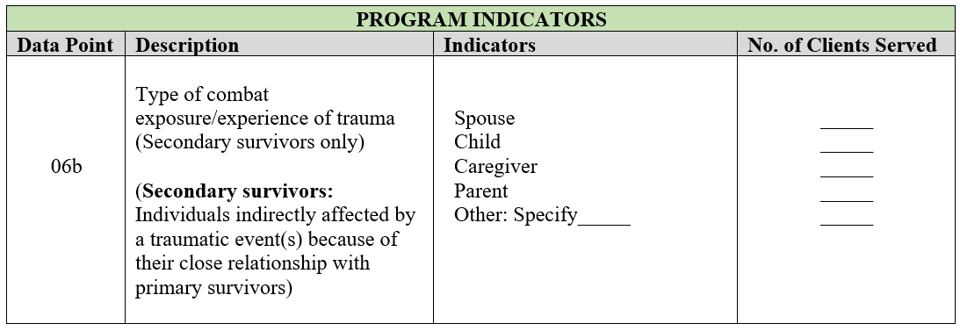

Definitions:
Secondary survivors: An individual who is a family member, spouse/partner, child, parent, or legal guardian of a primary survivor, and has been adversely affected by the combat experience of the primary survivor.

Spouse: An individual considered to be in relationship with the primary survivor through marriage.

Children: A minor individual who is related to the primary survivor by birth or adoption.

Caregiver: An individual who is the caretaker of the primary survivor. The individual may or may not be related by birth.

Parent: A father or mother of the primary survivor.

Other: An individual not listed above but may have a close relationship with the primary survivor, including a partner (that is not a spouse), colleagues, friends, employers, healthcare professionals, teachers, community members, and religious leaders.

Reporting:
Indicate only the number of new and continuing secondary survivors who report being subjected to the type of combat trauma through the primary survivor. If the client reports directly experiencing combat trauma, they should be categorized as primary survivors and not secondary survivors. If the client does not fall into any of the types listed, please specify the type(s) under “Other” and provide a count for each type specified.

Note: If a secondary survivor falls under the “Other” category, review eligibility for services under the SASIC program.

07. PRIOR GOVERNMENT OR MILITARY SERVICE:

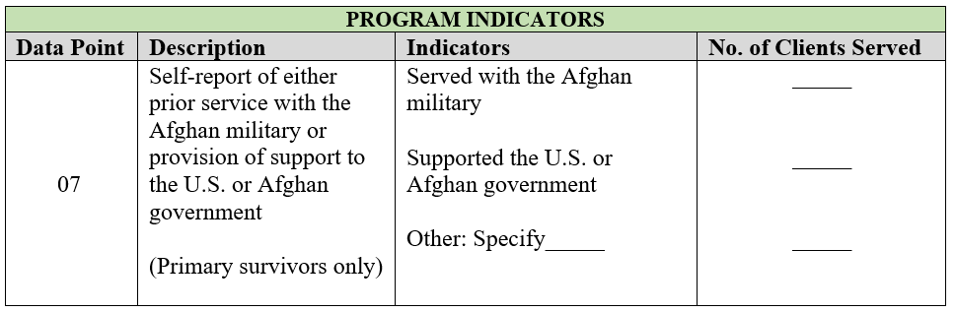

Definitions:
Served with the Afghan military: An individual who is a citizen or national of Afghanistan and served in the Afghan military.

Supported the U.S. or Afghan government: An individual who is a citizen or national of Afghanistan and provided faithful and valuable support to the U.S. or Afghan government. The individual may have been officially hired by U.S. government agencies or provided assistance and support to these agencies in their efforts in Afghanistan. These individuals may have worked as interpreters, advisors, security personnel, or in other roles that contributed to the U.S government’s objectives and operations in Afghanistan.

Other: An individual who does not hold any of the positions/statuses listed above. Specify the category if known.

Reporting:
Indicate the number of new and continuing clients, primary survivors only, who report Afghan military service or support to the Afghan or U.S. government.

08. EDUCATION PRIOR TO ARRIVAL:

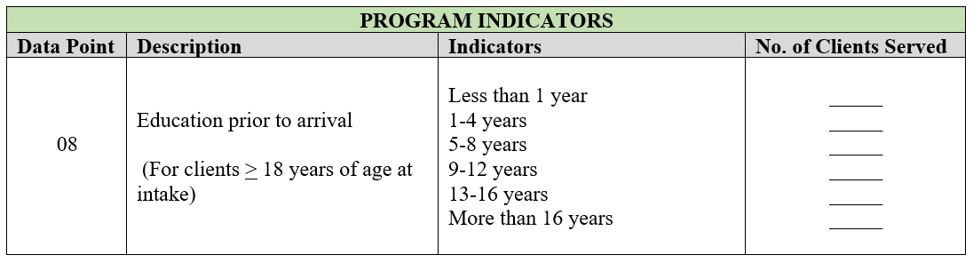

Definition:
Education prior to arrival: Years of education that the individual completed in a formal classroom or on-line education program in the individual’s home country, country of first asylum, or other country prior to arrival in the United States. This term does not include short-term educational programs related to resettlement (e.g., cultural orientation, ESL, etc.), nor does it include technical skills training, intensive language studies, monastic studies, or Qur’anic schools (duksi/madrasah) unless they are programs that lead to a degree.

Reporting:
Indicate the number of years of formal education that new and continuing clients, primary and secondary, ages 18 and older completed prior to arrival in the United States. These counts should be unduplicated.

09. IMMIGRATION CATEGORY/STATUS AT INTAKE:

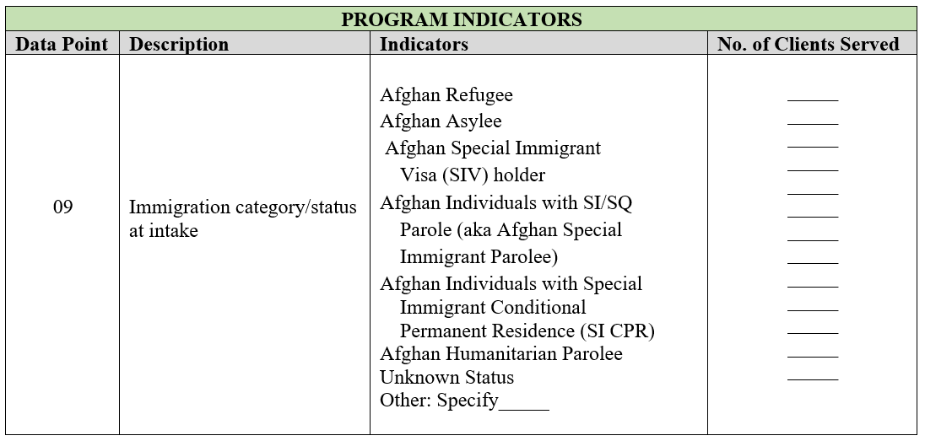

Definitions:
Please carefully read the list of immigration statuses/categories defined below.

Afghan Refugee: An individual who was granted refugee status before entering the U.S. and was admitted to the U.S. as a refugee under sections 207 or 212(d)(5) of the Immigration and Nationality Act.

Afghan Asylee: An individual who filed for asylum at a port of entry in the U.S. or after entering the U.S. and was granted asylum.

Afghan Special Immigrant Visa Holder (SIV): An individual who is a national of Afghanistan, provided faithful and valuable service to the U.S. government and, while employed by or on behalf of the U.S. government, experienced an ongoing serious threat as a consequence of that employment, and was granted an immigrant visa to enter the U.S. While an SIV holder is a Lawful Permanent Resident (LPR) at arrival, for this form, please report that individual as an SIV instead of an LPR.

Afghan Individuals with SI/SQ Parole (aka Afghan Special Immigrant Parolee): An individual who is a national of Afghanistan paroled into the United States for their service to the U.S. government.

Afghan Individuals with Special Immigrant Conditional Permanent Residence (SI CPR): An individual who is a national of Afghanistan who is a conditional permanent resident and will become a SI legal permanent resident once the temporary conditions of immigration status are removed.

Afghan Humanitarian Parolee: Citizens or nationals of Afghanistan paroled into the United States between July 31, 2021, and September 30, 2023. Additionally, a spouse or child of any Afghan humanitarian parolee, who is paroled into the United States after September 30, 2023.

Unknown Status: Afghan national whose immigration status is either not documented or not disclosed by the individuals.

Other at Intake: Any individual who does not hold any of the immigration categories/statuses listed above. Please specify that individual’s category/status if known.

Reporting:
Indicate the number of new and continuing clients, primary and secondary, who fall into each of the immigration categories/statuses at intake. Indicate the most recent category/status for each client at intake. For example, a refugee generally becomes a LPR after one year and would be listed as an LPR if he or she were an LPR at intake. Also, indicate the former immigration categories/statuses for clients who are LPR and U.S. citizens at intake. These counts should be unduplicated. At no point, should you describe a client’s immigration status based on his or her marital status. For example, if the client acquired LPR through marriage to a U.S. citizen, that client’s status should be reported as LPR. Do not report that client as “Other” or describe the client as, “Spouse of U.S. citizen”, which is not an official immigration status.

10. EMPLOYMENT STATUS IN THE U.S. AT INTAKE:

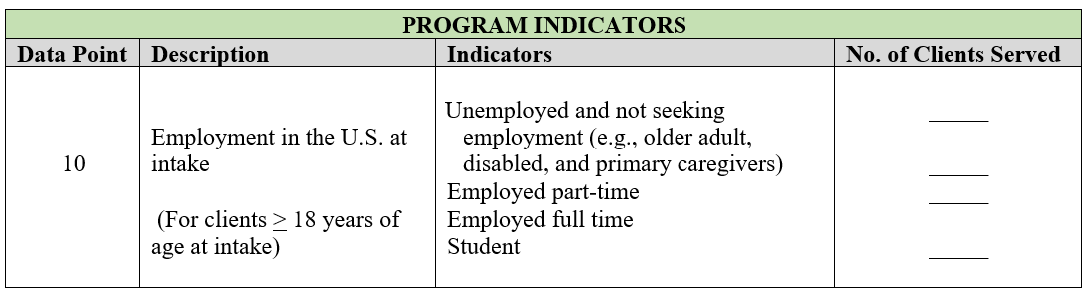

Definitions:

Unemployed and not seeking employment: An individual who is not working on a part-time or full-time basis as an employee or contractor, is not self-employed, and does not receive any income from work. This includes older individuals, primary caregivers, or disabled individuals.

Employed part-time: An individual who is being compensated for work performed on a part-time basis. This includes individuals who are employees, contractors, or self-employed.

Employed full-time: An individual who is being compensated for work performed on a full-time basis. This includes individuals who are employees, contractors, or self-employed.

Student: An individual who is enrolled in secondary or collegiate schooling full-time. This includes individuals enrolled in high school, community college, vocational training, college or university; it does not include those enrolled in short-term educational programs.

Reporting:
Indicate the number of new and continuing clients, primary and secondary, who fall into one of the categories. This count should be unduplicated.

11. CLIENTS SERVED BY SERVICE CATEGORY:

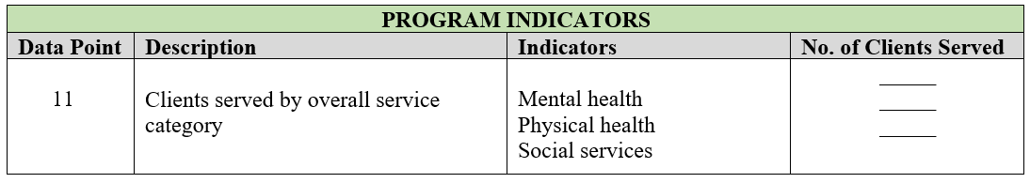

Definitions:
Mental health: Any psychiatric or psychological services received through psychiatric clinical care providers such as psychiatric nurses, psychiatrists, clinical social workers, psychologists, licensed professional counselors, primary care physicians providing explicit mental health treatment or other certified/licensed professionals acting within the scope of their practice according to state law. These services may involve diagnostic, treatment, and preventive care services including psychological testing and evaluation, psychotherapy/counseling, psychopharmacology, and other forms of psychiatric/psychological treatment, and substance use treatment

Physical health: Any medical, dental or other primary or specialty care services provided by a licensed medical practitioner (e.g., medical doctors, optometrists, nurse practitioners, registered nurses, licensed practical nurses, physician assistants, dentists, dental technicians, etc.). This category also includes subspecialty medical services such as neurology, orthopedics, rehabilitation medicine, etc., except for psychiatry.

Social services: Any social service or care coordination provided by a wide range of professional and paraprofessional personnel that address personal, social, and environmental problems. These services include employment, housing, clothing, transportation (including access to health services), case management, interpretation/translation, or other forms of direct assistance.

Reporting:
Report the number of new and continuing primary and secondary clients who received a service in the given service category. A given service may not count toward more than one type of service. However, a client may be represented in multiple service types if that client received multiple different services, so these counts may be duplicated.

12. PROGRAM ACTIVITIES:

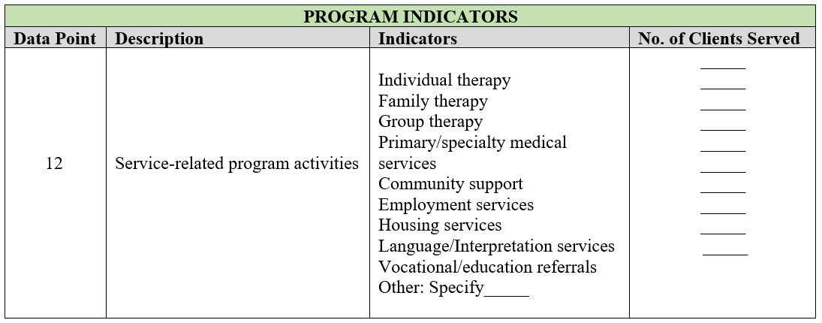

Definitions:
Individual Therapy: This type of support service is designed to help an individual with emotional or behavioral challenges adjust to situations. This includes actions that address both psychological and social needs of individuals, families, and communities. Support may come from mental health professionals such as psychologists, psychiatrists, clinical social workers (providing explicit mental health treatment), therapists, psychiatric nurses, or other qualified mental health professional that address specific mental health, or psychological issues. This can include behavioral health case managers and peer counselors but does not include psychiatrists.

Family Therapy: This type of support service is designed to help a family of individuals with social, emotional, relational or behavioral challenges adjust to situations. This includes actions that address psychological and/or social needs of individuals who are members of the same family. Support may come from various professions depending on the nature of the support such as psychologists, psychiatrists, clinical social workers (providing explicit mental health treatment), therapists, psychiatric nurses, or other qualified mental health professional that address specific mental health, psychiatric, or psychological issues. This can include behavioral health case managers, peer counselors or faith-based leaders.

Group Therapy: This type of support service is designed to help a group of individuals with social, emotional or behavioral challenges adjust to situations. This includes actions that address psychological and/or social needs of individuals and communities. The individuals within the group may connect by belonging to the same community or having a similar emotional or behavioral challenge. Support may come from various professions depending on the nature of the group support such as psychologists, psychiatrists, clinical social workers (providing explicit mental health treatment), therapists, psychiatric nurses, or other qualified mental health professional that address specific mental health, psychiatric, or psychological issues. This can include behavioral health case managers, peer counselors or faith-based leaders.

Primary/Specialty Medical Services: This type of support service is provided by licensed medical professionals. Services can consist of entry into the health care system for basic health care needs, supports and services to include prevention, wellness and treatment for common illnesses or pain and may also be services provided by a medical professional with a unique training or specialty. Examples of primary medical services include dental, vision, internal medicine, pediatrics, and family medicine. Examples of specialty medical services include obstetrics & gynecology and adult or pediatric cardiology, neurology, oncology etc and generally require a referral from a primary care provider. Support may come from medical professionals trained in a particular specialty service, a medical doctor, nurse, physician’s assistant, or nurse practitioner.

Community Support: This type of support service is designed to provide linkages and referrals to any qualified government benefit or any qualified community resources not provided by the grant recipient agency or its contracted partners based on the needs of the individual. This support could include linkage to other ORR funded programs.

Employment Services: This type of support service is provided in procuring and stabilizing client employment or helping the individual become more employable, self-sufficient, and productive. This includes assessing the individual’s ability to secure and retain employment based on individual circumstances and whether they have the skills or resources needed to become financially independent.

Housing Services: This type of support service provides linkage and referrals to obtain safe and secure housing.

Language/Interpretation Services: This type of support service provides language, communication and skill acquisition services that will enable the client to effectively communicate in their community, on the job or in an educational environment and in interpersonal relationships with others. Language skills may include ESOL classes and training. Interpretation services is conversion of spoken or written material from one language (the source language) into a different language (the target language).

Vocational/Education Referrals: This type of support service is designed to link the client with any suitable educational resources. This may include technical skills, certifications or formal educational classes as needed. This includes assessing the individual’s knowledge and ability to access the type of services they qualify for to meet their needs and goals including work-related ESL, vocational or professional skills training, or career or college counseling, assistance with resume writing or completion of job applications. This may also include educational referrals or K-12 school enrollment assistance for children and adolescents.

Other: Any support service not listed above. Specify the category of support provided.

*Note: Program activities are services to the client that increase access to effective, holistic, strengths-based, trauma-informed, culturally and linguistically appropriate care. The agency staff member should assess whether the client has any unresolved needs and, if so, whether the client has the knowledge, skills, and resources to represent themselves or access care and services. Assess the client’s ability to obtain developmentally, cognitively, and culturally and linguistically appropriate services. Program activities can be a direct service performed or administered by the grant recipient or by their partners with whom they hold a memorandum of understanding (MOU) or contract that outlines service provision or a referral service administered or performed by an agency that is not a partner of or contracted with the grant recipient directly.

Reporting:
Report the number of new and continuing primary and secondary clients who received a service in the given service category. A client may be represented in multiple service types if that client received multiple services, so these counts may be duplicated.

13. PROFESSIONAL TRAINING FOR STAFF AND COMMUNITY

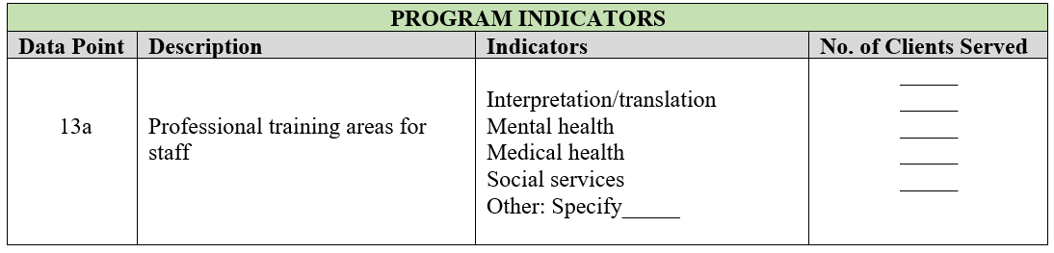

Definitions:
Interpretation /Translation: Training provided to staff that assists in identifying, referring, and serving individuals with interpretation and translation. This includes training to new or currently trained and certified individuals or volunteers who convert spoken or written material from one language (the source language) into a different language (the target language).

Mental Health: Training provided to staff to assist in identifying, referring, and serving individuals in the area of mental health. This includes training to psychologists, psychiatrists, clinical social workers, and primary care physicians providing explicit mental health treatment, therapists, psychiatric nurses, or other qualified mental health professional that address specific mental health, psychiatric, or psychological issues. This can include behavioral health case managers and peer counselors.

Medical Health: Training provided to staff to assist in identifying, referring, and serving individuals in the area of medical care. This includes training to nurses (except for psychiatric nurses), physical therapists, massage therapists, medical doctors (with the exception of psychiatrists), dentists, community health workers, or other medical service providers that specifically address medical or physical issues.

Social services: Training provided to staff to assist in identifying, referring, and serving individuals in the area of social services. This includes training to social workers (except for licensed clinical social workers or equivalent who provide explicit mental health treatment), case managers, or other social service providers that address housing, clothing, employment, transportation, case management, or other specific social service issues.

Other: Training provided to staff to assist in identifying, referring, and serving individuals in any professional service not listed above. Specify the training category.

Reporting:
Indicate the number of staff members trained in some area of identifying, referring, and serving individuals impacted by combat trauma, cultural competency, or additional services delivery during the reporting period. If a profession does not fit into any of the preceding categories, please specify and include a count for each type of profession under “Other.”

Note: ACF does not require tracking of non-ACF funded activities by recipients. Recipients must report only training services pertinent to or related to the ACF-funded SASIC Program.

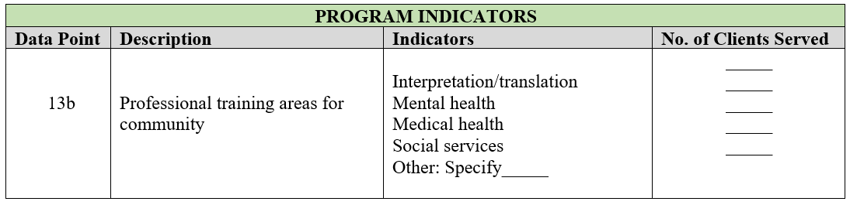

Definitions:
Interpretation/Translation: Training provided to the community or community members and partners that assists in identifying, referring, and serving individuals in the area of interpretation and translation. This includes training to new or currently trained and certified individuals or volunteers who convert spoken or written material from one language (the source language) into a different language (the target language).

Mental Health: Training provided to the community or community members and partners to assist in identifying, referring, and serving individuals in the area of mental health. This includes training to psychologists, psychiatrists, clinical social workers, and primary care physicians providing explicit mental health treatment, therapists, psychiatric nurses, or other qualified mental health professional that address specific mental health, psychiatric, or psychological issues. This can include behavioral health case managers and peer counselors.

Medical Health: Training provided to the community or community members and partners to assist in identifying, referring, and serving individuals in the area of medical care. This includes training to nurses (except for psychiatric nurses), physical therapists, massage therapists, medical doctors (with the exception of psychiatrists), dentists, community health workers, or other medical service providers that specifically address medical or physical issues.

Social Services: Training provided to the community or community members and partners to assist in identifying, referring, and serving individuals in the area of social services. This includes training to social workers (except for licensed clinical social workers or equivalent who provide explicit mental health treatment), case managers, or other social service providers that address housing, clothing, employment, transportation, case management, or other specific social service issues.

Other: Training provided to the community or community members and partners to assist in identifying, referring, and serving individuals in any professional service not listed above. Specify the training category.

Reporting:
Indicate the number of community trainings completed in some area of identifying, referring, and serving individuals impacted by combat trauma, cultural competency, or additional services delivery during the reporting period. If a profession does not fit into any of the preceding categories, please specify and include a count for each type of profession under “Other.”

OUTCOME INDICATOR PREFACE:
Provide the following information regarding client-level data at the top of the Outcome Indicators section.

- If using a specific program tool, please provide the name of the tool.
- Specify the date range for new and continuing clients being served during the current reporting period at the top of the outcome indicators section. A new client being served in the 1st year of admission would be noted within year 1. If the client has been served during the 1st program year and the second program year, the individual would be counted in year 2.
- Indicate the number of new and continuing clients being served in the current program year and the previous program year individually. A new client being served for the 1st time would be counted in the current program year area. If the client has been served during the 1st program year and the 2nd program year, the individual would be counted in the previous program year area due to their initial enrollment during year 1.

Figure 1: CLIENT OUTCOME INDICATORS
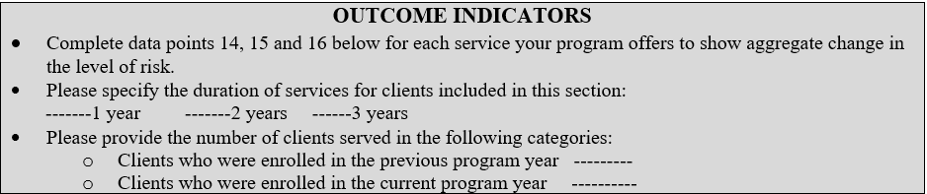

OUTCOME INDICATORS (Data Points 14–16)
Overview:
Reporting these indicators will help to provide important aggregate client outcome data for the SASIC Program. The expectation is that the holistic services provided to combat survivors through self-sufficiency and wellness plans will lead to an increase in psychosocial well-being. However, ORR recognizes that several factors that influence client well-being are not in the control of either combat survivors or service providers, and that levels of need for some clients may increase during the reporting period. These data can be useful for evaluating program effectiveness and will not necessarily have a negative impact on program performance reviews.

Assess the Client:
A staff member conducts quarterly assessments of level of need for new and continuing primary and secondary clients in the three domains of mental health services, medical health services, and social services and then determines a score based on observations and/or case notes from a session with the client.
For new clients, assess the initial level of need for each domain (1) during intake or soon afterwards (before a client begins receiving services), (2) at a second point during the client’s enrollment in the service at least 6 months after the first assessment, and (3) at a third point during the client’s enrollment, preferably when the client reaches 12 months after initial admission or when the client exits the program. Programs should be conducting bi-annual assessments and use the first and last collection points to report Outcome Indicators.

For continuing clients, assess their level of need for each domain at least every 6 and 12 months or more frequently if needed for completion of goals. Programs should be conducting bi-annual assessments and use the first and last collection points to report Outcome Indicators. Clients must be enrolled in the service to be measured in the service. The grantee's primary healthcare, mental health/behavioral health and case management staff are responsible for assessing client needs and appropriately identifying the corresponding magnitude of need.

Record Client Data:
To record client-level outcome data for each domain, use your program tool. Your program tool must measure levels of need in at least the three domains of mental health services, medical health services and social services. Compare the START and END assessments in each domain for each client to determine individual changes in level of need. These collection points should be at least 6 months apart.

Aggregate Client Data:
If using your own program tool, convert its assessment scale to best fit into the four levels of need for SASIC criteria (In Crisis, Vulnerable, Stable, Safe) for each of the three domains (see Appendix A). Using the SASIC level of need scale, aggregate the client-level changes in the level of need for new and continuing clients in each domain to obtain program-level data for the Outcome Indicators. Do not include data for clients with only one collection point. If there are several clients who have been enrolled for more than 6 months but have not had a second assessment, please provide an explanation in the program narrative report to address why this has not been completed.

Report the Aggregated Data:
Transfer the scores from the SASIC level of need scale to the SASIC Program Data Points Form using the corresponding Outcome Indicator for new and continuing clients. Using the matrix for each domain, 1) enter the number of clients (N =) in the START column for each level of need as instructed in the “Assess the Client” section above and 2) enter the number of clients in the END row that reflects their level of need at the last time they were assessed during the program year period, making sure the level of need box in the END row corresponds to level of need box in the START column. Do not include data for clients with only an intake data collection point in a program year.

LEVEL OF NEED

The level of need tables below are not comprehensive and simply provides examples of various types/areas of needs for each client. Grantees should use evidence-based assessment tools of their choice to assess client needs and appropriately identify the corresponding magnitude of need in clients.

Definitions:

In Crisis: Highest level of risk in the scale. It is associated with an extremely high probability of negative outcomes or negative impacts on the individual’s safety, health or wellness. Immediate services and supports are essential to reduce permanent or long-term harm or life-threatening situations.

Vulnerable: Risk of harm to the individual is significantly elevated. Substantial likelihood of negative consequences or negative impact on the individual’s safety, health or wellness that may put them at risk of deteriorating health and wellness. Individuals are not currently in crisis but may exhibit signs that necessitate intervention and resources to prevent their condition from worsening.

Stable: Moderate level risk. Some potential for negative consequences and risk to safety, health or wellness, but it is not highly likely. Some support and resources may still be needed.

Safe: Minimal or very low risk. Likelihood of negative consequences to safety, health or wellness or adverse events occurring is extremely low. Denotes that such individual is independently functioning well in home and school/work settings, exhibits self-agency in decision-making and is able to independently access any resources or supports needed to live comfortably and independently.

14. MENTAL HEALTH SERVICES: Assesses the general mental, emotional, and social well-being of the client. Use your agency program tool’s assessment measure and convert your measures to the SASIC levels of need for this domain. Mental health needs can include issues affecting the client’s mood, thinking behavior or relationships due to combat trauma. This category should assess whether the client has any unresolved mental health or psychiatric needs and, if so, whether the client has the knowledge, skills, and resources to represent themselves or access mental health services and work with a mental health professional to engage in services. Consider the client’s ability to obtain developmentally, cognitively, culturally, and linguistically appropriate services and their ability to adhere to any treatment plans.

14. Enter the total number of clients (N=) receiving the service.

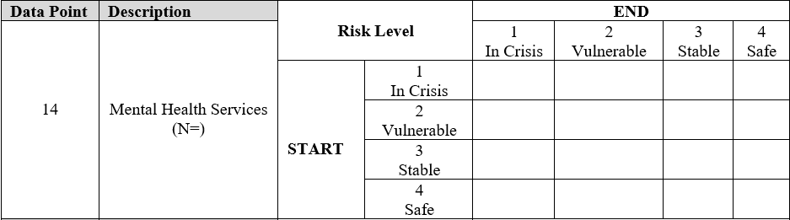

Area of Need | Level of Need
Mental Health Services | 1  In-Crisis | 2  Vulnerable | 3  Stable | 4  Safe
 | Client:  - Has a plan, intent, and/or access to means that present risk of harm to self or others  - Has an untreated mental health condition that interferes with multiple life domains  - Is unable to care for self or family due to current mental health challenges | Client:  - Acknowledges thoughts of harm to self or others but does not have a plan, intent, or means  - Has an inadequately managed mental health condition that interferes with multiple life domains  - Decreased capacity to care for self or family due to current mental health challenges | Client:  - No thoughts of harm to self or others  - Demonstrates some coping skills to manage past or current mental health challenges  - Mental health status does not interfere with any life domains  - Able to care for self or family with minimal mental health support | Client:  - Does not report any active mental health concerns at time of assessment  - Able to cope with life stresses and accomplish personal goals  - Describes regular involvement in activities that bring them purpose and pleasure  - Cares for self and family independently without any barriers due to mental health

EXAMPLE:
Data Point | Description | Level of Need |  | END
 |  |  |  | 1  In Crisis | 2  Vulnerable | 3  Stable | 4  Safe
14 | Mental Health Services  N=100 | S  T  A  R  T | 1  In Crisis  N= 15 |  | 3 | 10 | 2
 |  |  | 2  Vulnerable  N= 30 |  | 5 | 22 | 3
 |  |  | 3  Stable  N= 27 |  |  | 15 | 12
 |  |  | 4  Safe  N= 28 |  |  |  | 28

In this example, the program recorded the mental health services level of need for new and continuing clients (N=).
- At intake (START column), fifteen clients were in-crisis, 30 were vulnerable, 27 were stable, and 4 were safe.
- At the end of the program year (END row), the program reassessed the clients’ level of need. Three clients moved from in crisis to vulnerable, 10 from in crisis to stable, and 2 from in crisis to safe; 5 clients stayed vulnerable, 22 moved from vulnerable to stable, and 3 moved from vulnerable to safe; 15 clients stayed stable and 12 moved from stable to safe; 28 clients stayed at the safe level.
- The total number of new and continuing that moved from in crisis and vulnerable (highlighted oval) to stable and safe was 37 (highlighted rectangle).

15. MEDICAL HEALTH SERVICES: Assesses the general physical health of the client. Physical health needs can include primary, specialty or chronic care from medical professionals. These services include medical assessments to determine preventive, acute, and chronic physical conditions that need medical care. Consider the client’s ability to obtain developmentally, cognitively, culturally, and linguistically appropriate services.

15. Enter the total number of clients (N=) receiving the service.

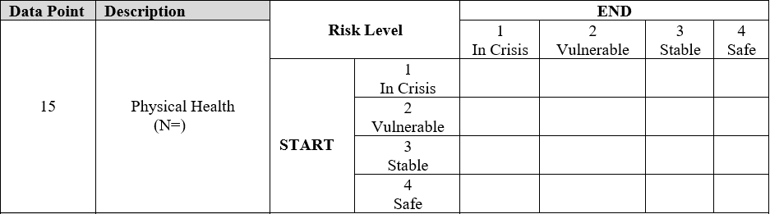

Area of Need | Level of Need
Medical Health Services | 1  In-Crisis | 2  Vulnerable | 3  Stable | 4  Safe
 | Client  - Has urgent and unaddressed medical needs  - Is unable to access routine medical care or doesn’t know how to navigate the health care system  - Is unable to care for self or family due to current medical challenges | Client:  - Has inconsistently managed medical needs  - Has limited access to routine medical care or limited ability to navigate the health care system  - Decreased capacity to care for self or family due to current medical challenges | Client:  - Medical needs are addressed and well managed  - Can access medical care with minimal support  - Receives routine medical care to manage any physical health challenges  - Able to care for self or family with minimal support for medical issues | Client:  - Manages medical needs independently  - Can access routine medical care without any support  - Cares for self and family independently without any barriers due to physical health

EXAMPLE:
Data Point | Description | Level of Need |  | END
 |  |  |  | 1  In crisis | 2  Vulnerable | 3  Stable | 4  Safe
15 | Medical Health  Services  N=100 | S  T  A  R  T | 1  In crisis  N= 15 | 2 | 3 | 7 | 3
 |  |  | 2  Vulnerable  N= 60 | 4 | 10 | 36 | 10
 |  |  | 3  Stable  N= 17 | 2 | 4 | 8 | 3
 |  |  | 4  Safe  N= 8 | 1 | 2 | 5

In this example, the program recorded the medical health services level of need of new and continuing clients using their last assessment from the program year or during the program year (N=).
- At the previous assessment (START column), 15 clients were in-crisis, 60 were vulnerable, 17 were stable and 8 were safe.
- At the end of the reporting period (END row), the program reassessed the clients’ level of need.
- Seven clients moved from in crisis to stable, 3 from in crisis to safe, 36 from vulnerable to stable, and 10 from vulnerable to safe. The total number of new and continuing clients that moved from in crisis and vulnerable to stable and safe was 56.
- However, 9 clients moved from stable or safe to in crisis or vulnerable.

16. SOCIAL SERVICES: Assesses the general social functioning and overall well-being of the client as well as nature of the individual’s interpersonal relationships in the U.S., especially the extent to which these relationships sustain the client during times of crisis. This service provides overall support for the client within the community in areas such as education, employment, language and skill acquisition, housing, linkage to community services and any resources needed to support the client to effectively communicate in their community, on the job or in an educational environment and in interpersonal relationships with others to be successful in their health and overall wellness. These strengths-based, trauma-informed support service includes all areas of social wellbeing that are not already listed above. Consider the client’s ability to obtain developmentally, cognitively, culturally, and linguistically appropriate services.

16. Enter the total number of clients (N=) receiving the service.

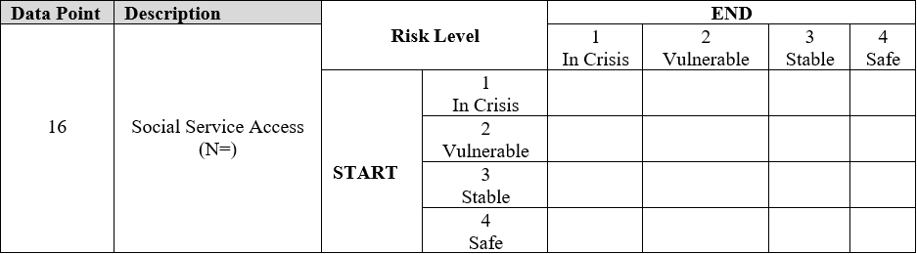

Area of Need | Level of Need
Social Services | 1  In-Crisis | 2  Vulnerable | 3  Stable | 4  Safe
 | Client:  - Is unaware of or unable to access services and benefits.  - Is unable to communicate outside of native language  - Lacks skills needed to advance or gain employment and resources  - Is unable to work due to lack of work authorization  - Has unmet basic needs, such as food or shelter | Client:  - Shows limited awareness of available services and resources but has significant access barriers  - Has limited English skills but is able to communicate with support  - Has insufficient education or technical skills for gainful employment  - Is working without work authorization or is unemployed despite having work authorization  - Basic needs met but resources are not stable | Client:  - Is aware of and has access to some resources and benefits but some barriers still need to be addressed  - Can communicate in English and navigate language barriers with minimal support  - Has some education and vocational skills and is able to gain some employment  - Has work authorization and has irregular employment  - Can meet basic needs but with external supports | Client:  - Independently accesses a full range of services to address any unmet needs.  - Can communicate effectively in English  - Has adequate education or technical skills that enable advancement and gainful employment  - Has authorization and maintains regular employment that offers some benefits and protections  - Independently meets basic needs

EXAMPLE:

Data Point | Description | Level of Need |  | END
 |  |  |  | 1  In crisis | 2  Vulnerable | 3  Stable | 4  Safe
16 | Social Services  N= | S  T  A  R  T | 1  In crisis  N= 20 | 2 | 3 | 10 | 5
 |  |  | 2  Vulnerable  N= 40 | 1 | 4 | 25 | 10
 |  |  | 3  Stable  N= 30 |  |  | 15 | 15
 |  |  | 4  Safe  N= 10 |  |  | 2 | 8

In this example, the program recorded the social services level of need for new and continuing clients (N=).
- At intake (START column), 20 were in-crisis and 40 were vulnerable.
- At the end of the program year (END row), the program reassessed the clients’ level of need. Ten clients moved from in crisis to stable, 5 from in crisis to safe, 25 from vulnerable to stable, and 10 from vulnerable to safe.
- The total number of new and continuing clients that moved from in crisis or vulnerable (highlighted oval) to stable or safe during the reporting period was 50 (highlighted rectangle).

APPENDIX A: SERVICES TO AFGHAN SURVIVORS IMPACTED BY COMBAT
SAMPLE PSYCHOSOCIAL WELL-BEING MATRIX

The level of need tables below are not comprehensive and simply provides examples of various types/areas of needs for each client. Grantees should use evidence-based assessment tools of their choice to assess client needs and appropriately identify the corresponding magnitude of need in clients.

Area of Need | Levels of Need
 | (1) | (2) | (3) | (4)
 | In Crisis | Vulnerable | Stable | Safe
Mental Health Services | Client:  - Has a plan, intent, and/or access to means that present risk of harm to self or others  - Has an untreated mental health condition that interferes with multiple life domains  - Is unable to care for self or family due to current mental health challenges | Client:  - Acknowledges thoughts of harm to self or others but does not have a plan, intent, or means  - Has an inadequately managed mental health condition that interferes with multiple life domains  - Decreased capacity to care for self or family due to current mental health challenges | Client:  - No thoughts of harm to self or others  - Demonstrates some coping skills to manage past or current mental health challenges  - Mental health status does not interfere with any life domains  - Able to care for self or family with minimal mental health support | Client:  - Does not report any active mental health concerns at time of assessment  - Able to cope with life stresses and accomplish personal goals  - Describes regular involvement in activities that bring them purpose and pleasure  - Cares for self and family independently without any barriers due to mental health
Medical Health Services | Client  - Has urgent and unaddressed medical needs  - Is unable to access routine medical care or doesn’t know how to navigate the health care system  - Is unable to care for self or family due to current medical challenges | Client:  - Has inconsistently managed medical needs  - Has limited access to routine medical care or limited ability to navigate the health care system  - Decreased capacity to care for self or family due to current medical challenges | Client:  - Medical needs are addressed and well managed  - Can access medical care with minimal support  - Receives routine medical care to manage any physical health challenges  - Able to care for self or family with minimal support for medical issues | Client:  - Manages medical needs independently  - Can access routine medical care without any support  - Cares for self and family independently without any barriers due to physical health
Social Services | Client:  - Is unaware of or unable to access services and benefits.  - Is unable to communicate outside of native language  - Lacks skills needed to advance or gain employment and resources  - Is unable to work due to lack of work authorization  - Has unmet basic needs, such as food or shelter | Client:  - Shows limited awareness of available services and resources but has significant access barriers  - Has limited English skills but is able to communicate with support  - Has insufficient education or technical skills for gainful employment  - Is working without work authorization or is unemployed despite having work authorization  - Basic needs met but resources are not stable | Client:  - Is aware of and has access to some resources and benefits but some barriers still need to be addressed  - Can communicate in English and navigate language barriers with minimal support  - Has some education and vocational skills and is able to gain some employment  - Has work authorization and has irregular employment  - Can meet basic needs but with external supports | Client:  - Independently accesses a full range of services to address any unmet needs.  - Can communicate effectively in English  - Has adequate education or technical skills that enable advancement and gainful employment  - Has authorization and maintains regular employment that offers some benefits and protections  - Independently meets basic needs

APPENDIX B: VERIFYING ACCURACY OF DATA POINTS

- The table below shows which data points should be equal to, greater than or less than the total active client count.
- Please refer to the table below to make sure your counts match ORR guidelines.
- Reach out to the SASIC Project Officer if there will be known discrepancies in your data due to missing information.

Data Point (DP) 1: New Clients+ Continuing Clients = Total Active Client Count
= | ≤ | ≥
DP2: Age at Intake  DP3: Gender Identity  DP4: Sexual Orientation (Self-Reported)  DP5: Length of Time in the U.S. at Intake  DP7: Prior Government/Military Service  DP9: Immigration category/status at Intake | DP6a: Type of Combat Exposure-Primary Survivor*  DP6b: Type of Combat Exposure- Secondary Survivor*  DP8: Education Prior to Arrival  DP10: Employment in the U.S. at Intake  DP11: Clients Served by Overall Service Category  DP12: Service-Related Program Activities  DP14–16: Outcomes | DP13a: Professional Training Areas for Staff  DP13b: Professional Training Areas for Community
*or could potentially be >

PAPERWORK REDUCTION ACT OF 1995 (Pub. L. 104-13) STATEMENT OF PUBLIC BURDEN: The purpose of this information collection is to monitor SASIC grant recipients activities. Public reporting burden for this collection of information is estimated to average 5 hours per grantee, including the time for reviewing instructions, gathering and maintaining the data needed, and reviewing the collection of information. This is a mandatory collection of information under INA § 412(c)(1)(A), 8 U.S.C. 1522(c)(1)(A). An agency may not conduct or sponsor, and a person is not required to respond to, a collection of information subject to the requirements of the Paperwork Reduction Act of 1995, unless it displays a currently valid OMB control number. The OMB # is 0970-0558 and the expiration date is 11/30/2023. If you have any comments on this collection of information, please contact Francine White at francine.white@acf.hhs.gov.

