Injury Tracking Application 3.0 BETA Test Form

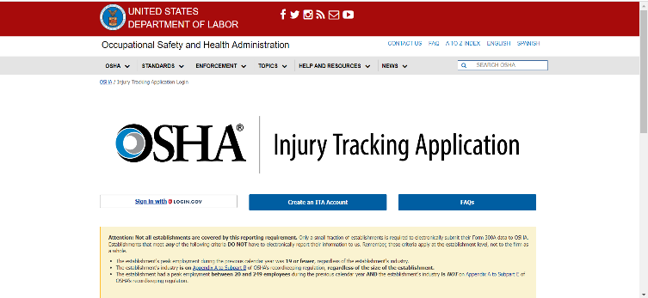
- Access the ITA BETA Test (Preview) Homepage: Navigate to the following link to get started: https://ddp-preview.osha.gov/injuryreporting/ita.
The OSHA Injury Tracking Application (ITA) has transitioned its login procedure to the public’s one account access to government applications, Login.gov. All current and new account holders must connect their ITA account to a Login.gov account with the same email address to access the application.
If you have any questions regarding the creation of a Login.gov account, please review the following guidance: Create a Login.gov Account.
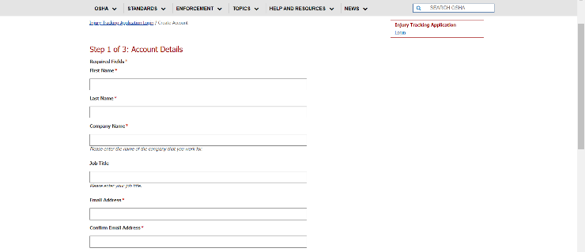
- Create an ITA account: https://www.osha.gov/injuryreporting/ita/create-account
Note: Users who are already registered in ITA Preview may continue to Step 3.
Input all required fields, including full name, company name, email address and username. Check the box to indicate the user is not a robot and select Continue.

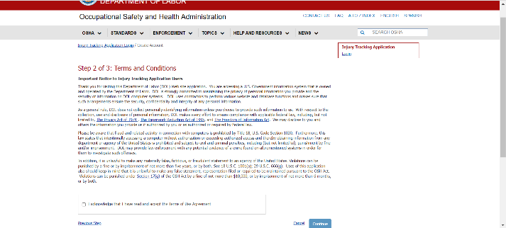
Acknowledge and accept the Terms of Use agreement by checking the box and selecting Continue.

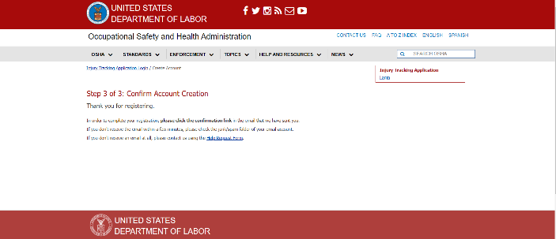
User account registration is confirmed on the next page. User next receives an email with a confirmation link to complete the registration process.

Comments, suggestions, and proposed improvements: | Pass/Fail Status
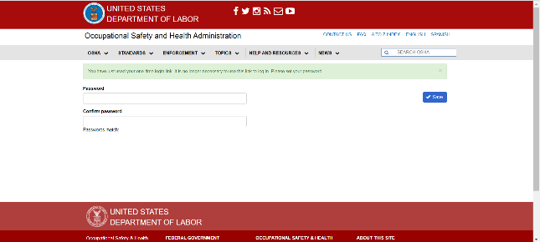
User will be directed to one-time login. Select the Log in button to enter and confirm your password on the following screen.

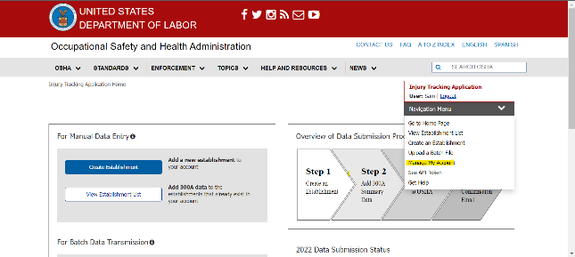
- ITA Account management: Use the following URL to access your user profile: https://preview.osha.gov/injuryreporting/ita/account/profile.
Otherwise, navigate using the dropdown menu in the top right corner of the page.
Test case:
- Confirm ability to edit user profile details
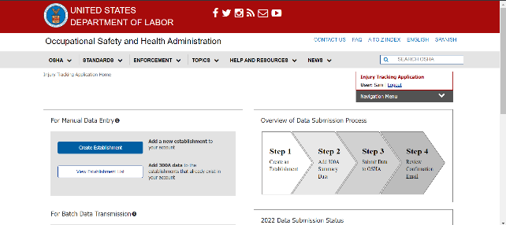
- Create an Establishment:
Return to the landing page at: https://ddp-preview.osha.gov/injuryreporting/ita/home

Create a new establishment by selecting the Create Establishment button under the “For Manual Data Entry” label on the landing page, accessing the page via the right-hand navigational dropdown menu, or using this link: https://preview.osha.gov/injuryreporting/ita/establishments/create
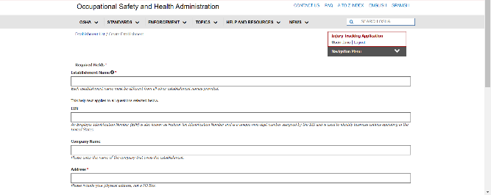
Fill out all required fields, including company name, address, and NACIS code. When finished, select the Save button in the bottom right corner.

Test cases:
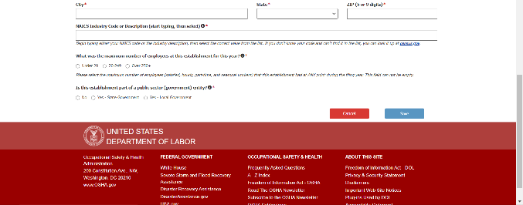
- Validate new establishment cannot be created using the name of an existing establishment
- Ensure NAICS code dropdown is populating expected codes

Comments, suggestions, and proposed improvements: | Pass/Fail Status

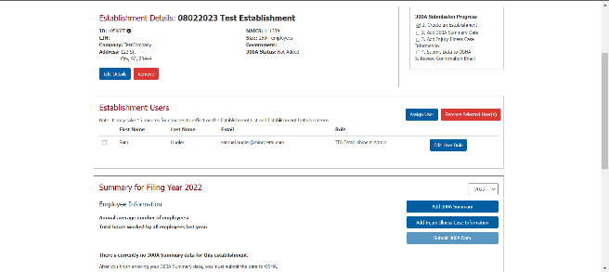
- Submit Form 300A Data:
On the right-hand side of the Establishment Details screen, select the Add 300A Summary button.

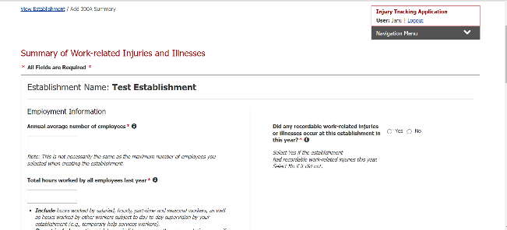
The following screen presents fields for manual entry of Form 300A data. Fill out all required fields and select Save button in the bottom right corner of the screen when done.

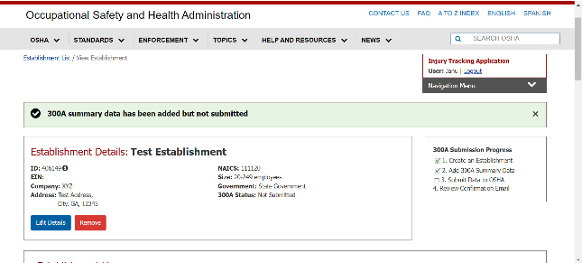
After submitting 300A data, users are returned to the Establishment Details page and a light green banner notifies users that 300A summary data has been added but not submitted.

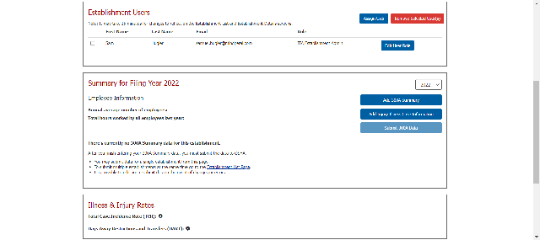
Scroll down on the Establishment Details page and select the Submit 300A Data button to complete the process.

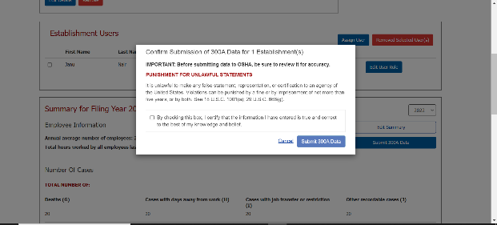
A pop-up notification appears. Confirm submission by checking the box and selecting the Submit 300A Data button. Next, check for an email notification detailing a successful submission.

Comments, suggestions, and proposed improvements: | Pass/Fail Status

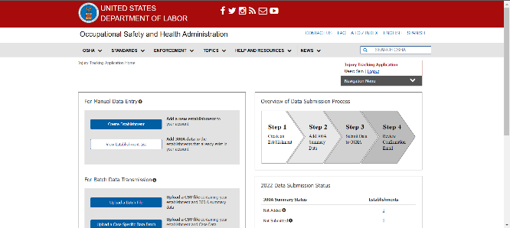
- Web Submission of Form 300/301 Data
From the landing page (https://ddp-dev.ita.osha.gov/injuryreporting/ita/home), select the View Establishment List button.

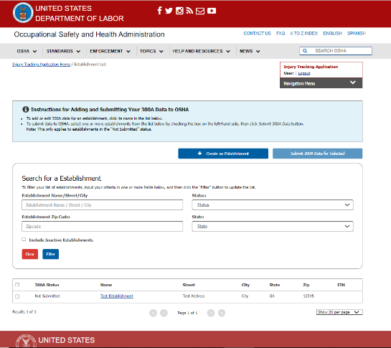
All establishments registered under an employer are displayed. Select an establishment name to submit data against to continue.

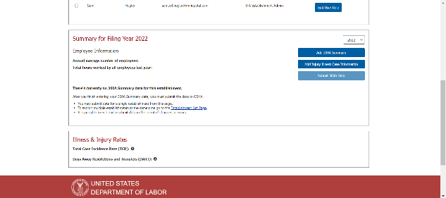
Select the Add Injury Illness Case Information button to view all Form 300/301 case data entries for a given establishment. Prior to submitting case details this table will be blank.

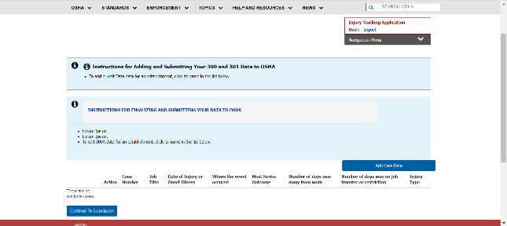
Select the Add Case button to populate a row in the table.

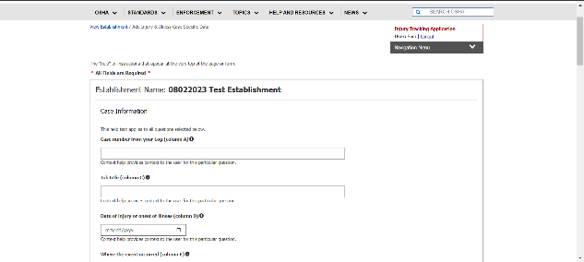
Fill out case detail information, including case number, details about the nature of the injury, and where it took place. Please complete all required fields prior to selecting the Save button in the bottom right corner when done.

Comments, suggestions, and proposed improvements: | Pass/Fail Status
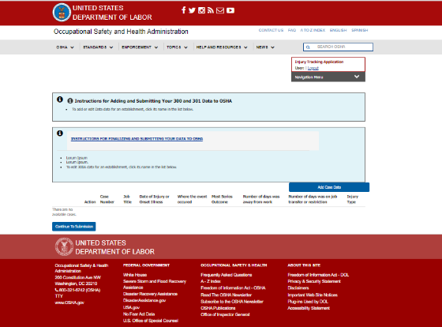
After saving, select Continue to Submission on the next page to proceed.

A pop-up notification appears. Confirm submission by checking the box and selecting the Submit 300/301 Data button. Next, check for an email notification detailing a successful submission.

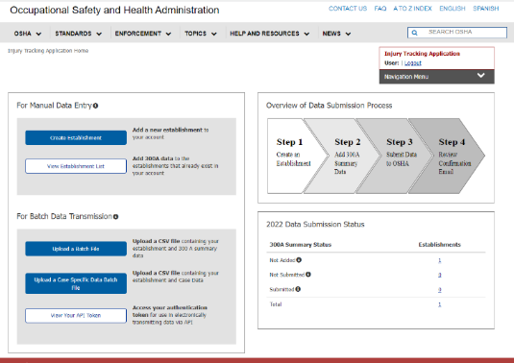
- CSV Submission of Form 300/301 Data

From the landing page (https://ddp-preview.osha.gov/injuryreporting/ita/home), select the Upload a Specific Data Batch File button under Batch Data Transmission.

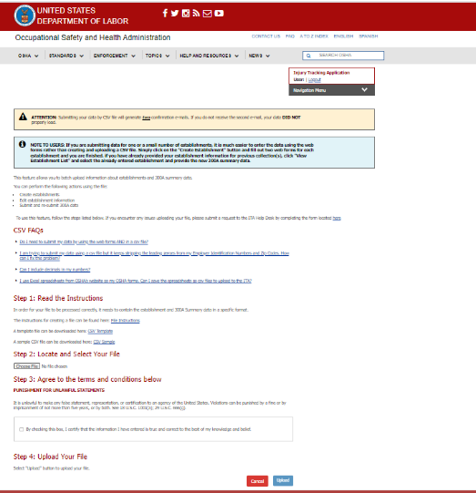
Select the Choose CSV file button to bring up a file explorer. Specify the CSV file to be uploaded and select Open.

Next check the box to certify the information entered is accurate and select the Upload button.

Note: CSV upload generates two confirmation emails - if a second email is not received, upload was unsuccessful.

Comments, suggestions, and proposed improvements: | Pass/Fail Status
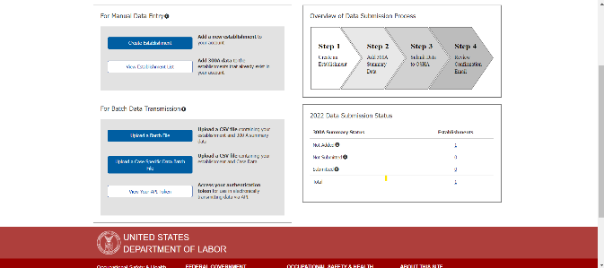
- View API Token for Form 300/301 Submission
From the landing page (https://ddp-preview.osha.gov/injuryreporting/ita/home), navigate to the “For Batch Data Transmission” header and select the View Your API Token button.

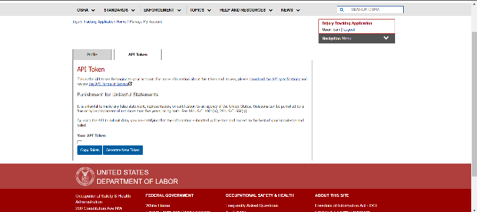
On the following screen (https://preview.osha.gov/injuryreporting/ita/account/api-token), select the button to Generate New Token.

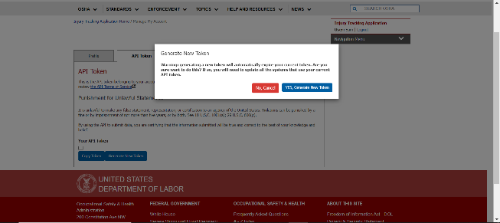
A pop-up notification appears confirming generation of a new token will invalidate previously issued API tokens. Select the YES, Generate New Token to proceed.

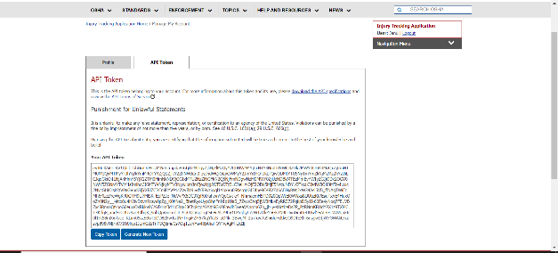
API token is displayed. The Copy Token button can be used to assign a token to the clipboard.

Comments, suggestions, and proposed improvements: | Pass/Fail Status

