OWCP Medical Bill Processing Questionnaire
https://forms.office.com/r/QETPjc43mu

Dear Provider,
Our records indicate you are successfully billing for services provided to Office of Workers’ Compensation Programs (OWCP) injured and ill workers. Our interest is to capture your experience interacting with the Workers’ Compensation Medical Bill Processing (WCMBP) system and services. We kindly request your time to answer a few questions. Your feedback will serve to benefit all OWCP providers.
Please be sure to click Submit at the end of the form to ensure we have received your responses. If you have any questions or need further assistance, please email amy.harris@acentra.com or call (240) 243-2782.
Thank you,
OWCP Medical Bill Processing Outreach Team

- Please select the OWCP Program(s) you provide services for:
☐ DFEC (Division of Federal Employees' Compensation)
☐ DEEOIC (Division of Energy Employees Occupational Illness Compensation)
☐ DCMWC (Division of Coal Mine Workers' Compensation)

- How long have you provided services for OWCP claimants?
☐ 0-2 Years
☐ 3-5 Years
☐ 5+ Years

- My interactions with WCMBP system and services this past year increased my trust in OWCP.
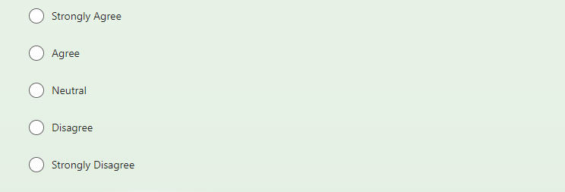

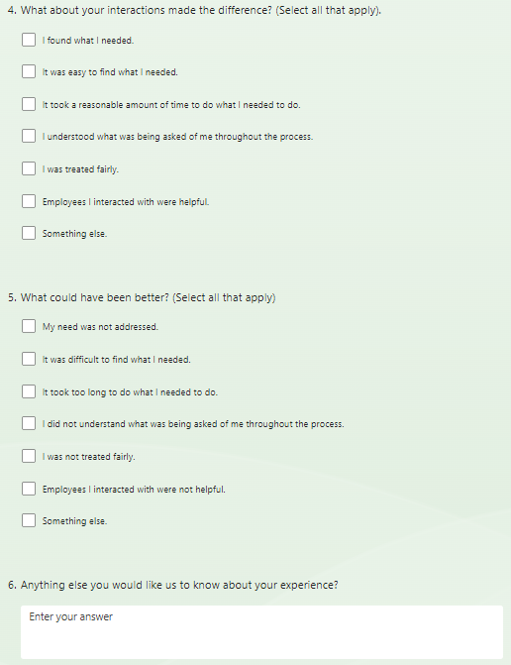
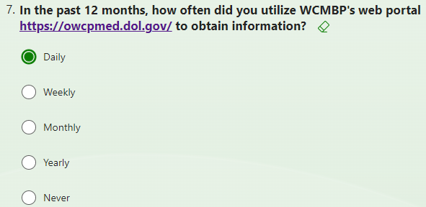
8. If you use WCMBP web portal, which links do you use most frequently?
(Check all that apply)
☐ Provider Home
☐ News
☐ Provider Enrollment
☐ Training &Tutorials
☐ Authorizations
☐ Forms & References
☐ Billing
☐ FAQs
☐ Payments
☐ Other

9. What features of the WCMBP system or services are helpful in scheduling appointments for OWCP claimants?
☐ Eligibility Inquiry
☐ Authorizations
☐ Call Center/IVR
☐ Other
Please provide any additional comments here.

10. What features of the WCMBP system or services are helpful in billing for services provided to OWCP claimants?
☐ Electronic Billing (EDI/HIPAA)
☐ On-line Billing via Portal
☐ Remittance Vouchers (RVs)
☐ Bill Inquiry
☐ Other
Please provide any additional comments here.

For the next few questions, consider your most recent experience with the WCMBP Call Center:
11. Did you contact at least one of the call center numbers below for assistance with bill processing and or prior authorizations within the last three (3) months?
Division of Federal Employees’ Compensation (DFEC): 1-844-493-1966
Division of Energy Employees Occupational Illness Compensation (DEEOIC): 1-866-272-2682
Division of Coal Mine Workers’ Compensation (DCMWC): 1-800-638-7072
☐Yes ☐No
If Yes selected for #11, the following question appears:
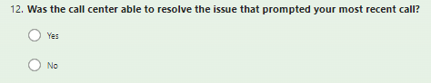
If Yes selected for #12, the following question appears:
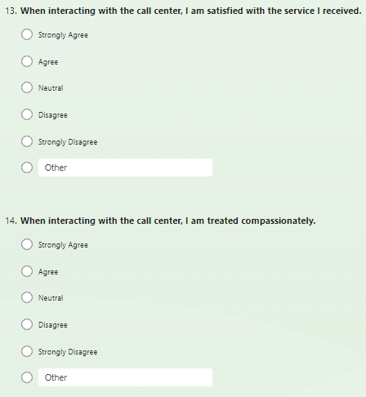
If NO selected #12, the following question appears:
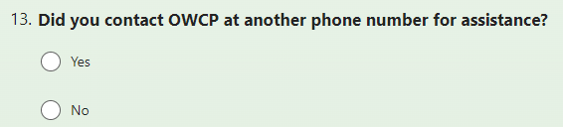
If Yes selected #13, the following question appears:
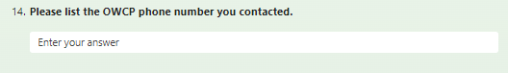
If No selected #13, the following question appears:
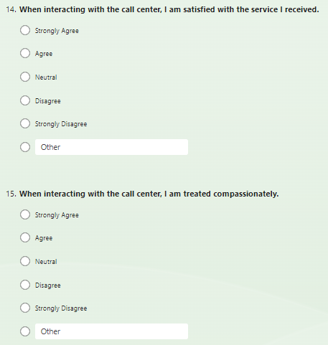

If NO selected for #11, respondent skips#12-15 from above and proceeds to the following questions. The Question # will be dependent on previous responses:
12. or 16. To what extent do you agree that working with us on bills, authorizations, and enrollment is easier than it was 12 months ago?
☐ Strongly Agree
☐ Agree
☐ Neutral
☐ Disagree
☐ Strongly Disagree
Please provide the reason for your response.

13. or 17. Overall, I am satisfied with the systems and processes for billing and prior authorizations.
☐ Strongly Agree
☐ Agree
☐ Neutral
☐ Disagree
☐ Strongly Disagree
Please provide the reason for your response.

14. or 18. What is one helpful hint that you would suggest to other providers when using the WCMBP system or services?
Please provide your response here.

15. or 19. Are you aware of the provider manual that is now available at [insert link]?
☐Yes ☐No
If yes is selected, the following question appears:
20.
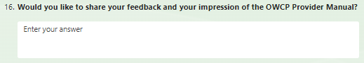

Thank you for your time and feedback.

