Appendix A.   
Evaluation of Full-Service Community Schools

State and District Administrative Data Request Form

**To**: [STATE/DISTRICT]

**From**: [DATA LIAISON]

**Date**: [DATE]

**Subject**: School-level Administrative Data Request for the Evaluation of Full-Service Community Schools

The U.S. Department of Education is conducting an implementation study of the **Full-Service Community Schools (FSCS)** grant program through the National Center for Education Evaluation and Regional Assistance within the Institute of Education Sciences (IES). The study’s aims are to understand how grantees and their partner schools are planning and implementing activities and how implementation is related to student outcomes. IES is requesting that all fiscal year 2023 grantees and their partner schools complete short surveys for this study. In addition, the study is requesting administrative data from [states / school districts] about the grantee’s partner schools. Mathematica, along with its partners Social Policy Research Associates and the Learning Policy Institute, are conducting the study for IES.

This memo outlines our request for **school-level** administrative data to address the study’s requirements; specifically, the student chronic absenteeism rate, the out-of-school suspension rate, and the four-year adjusted cohort graduation rate (ACGR). At the end of this memo in Part E, we provide instructions for using the study’s secure file transfer site to download and upload all data under this study.

1. School-level Student Data Requested

Table 1 lists the school-level student data elements requested for the school years 2021–2022 through 2025–2026, as available. Please provide the requested rates by:

* school overall
* each grade level served by the school
* the following student subgroups:
  + race (White, Black/African American, Asian, Native Hawaiian or Other Pacific Islander, American Indian or Alaska Native) and ethnicity (Hispanic or Latino, Not Hispanic or Latino)
  + English learner (EL) status
  + Individualized Education Program (IEP) status
  + free- and reduced-priced lunch (FRPL) status
  + economically disadvantaged (ED) status.

**Table 1. School-level Student Data Elements Requested**

| **Data Element** | **Description** | **Notesa** |
| --- | --- | --- |
| School year | School year to which the record pertains (for example, 2021-2022) |  |
| District ID | Number that uniquely identifies the district across all years of data |  |
| District name | Name of district corresponding to District ID |  |
| School ID | Number, such as federal ID, that uniquely identifies the school across all years of data |  |
| School name | Name of school corresponding to School ID |  |
| Chronic absenteeism rate | Percentage of students who were chronically absent for each school year requested. As available, please provide these rates by school, each grade served, and student subgroups (race and ethnicity, EL status, IEP status, and FRPL/ED status). |  |
| Average attendance rate | Average attendance rate of students for each school year requested. As available, please provide these rates by school, each grade served, and student subgroups (race, ethnicity, EL status, IEP status, and FRPL/ED status). |  |
| Out-of-school suspension rate | The percentage of students who had an out-of-school suspension for at least one day (or time) for each school year requested. As available, please provide these rates by school, each grade served, and student subgroups (race, ethnicity, EL status, IEP status, and FRPL/ED status). |  |
| In-school suspension rate | The percentage of students who had an in-school suspension for at least one day (or time) for each school year requested. As available, please provide these rates by school, each grade served, and student subgroups (race, ethnicity, EL status, IEP status, and FRPL/ED status). |  |
| Four-year adjusted cohort graduation rate (ACGR) | The percentage of 9th grade students who graduated with a regular high school diploma within four years or less, for each of the school years requested. As available, please provide the ACGR by overall school and student subgroups (race, ethnicity, EL status, and FRPL/ED status). |  |

**a** The Notes column will be completed by study staff using information provided during the initial call to discuss the data request.

B. Justification for Requested Data

We will use the school-level student data to measure changes over time in attendance, student behavior, and graduation among FSCS partner schools. We selected these outcomes because research has shown that they are “leading indicators” that are associated with improved student learning.[1]. The evaluation team and the U.S. Department of Education carefully considered this request to ensure it includes only the data necessary to conduct a high-quality evaluation. We appreciate your assistance with this data request.

C. Data Confidentiality

Mathematica follows the confidentiality and data protection requirements of The Education Sciences Reform Act of 2002, Title I, Part E, Section 183. We will use the data provided in response to this request for research purposes only. The reports prepared for the study will summarize findings across the sample and will not associate responses with a specific state, district, or school. We will not provide information that identifies respondents to anyone outside the study team, except as required by law.

D. File Format

You may provide the data in a single file or multiple files, whichever you prefer. We can work with almost any file format, including Excel, comma delimited or fixed-width text files, SAS, SPSS, Stata, and Access. Please also provide documentation of the data, including definitions of variables/fields, any codes used, and contact information for someone who can answer questions about the data.

E. Using Mathematica’s Secure File Transfer Site to Share Data

Mathematica has established and manages a secure file transfer site [URL] that includes a confidential folder for each participating state or district on this site. Each state or district can access only its own data that staff have uploaded or data made available by Mathematica for download. No other entities will have access to the data you upload or download.

On the study’s file transfer site we have provided an Excel file that lists the FSCS partner schools in your [state/district] (we refer to these schools as “study schools”) for which we are requesting data. If easier, you may provide the requested data for all schools in your state, and we can extract the study schools ourselves.

Please review the instructions below for how to request an account, create your unique password, and upload and download data files using the site.

**Step 1: Registering to Use the Site**

**New users**: Please provide the full name and email of each staff member who needs access to the site to your liaison at Mathematica. Each staff member will receive a registration email from “FX-Welcome” (please check Junk/Spam folder as well as Inbox for this email).

* The registration email will contain a temporary password. Each staff’s username is their work email.
* Each staff must click on the link in the email, enter their username and temporary password, and select “Sign in.”
* Each staff will then be prompted to change their temporary password to one they create. This step must be completed within 14 days from receipt of the registration email or a new temporary password must be provided.
* Once the password has been changed, each staff will have full access to the site to download and upload files.

**Existing users**: If staff have already registered to use this study’s file transfer site, they may enter their username and password to log-in at <https://XXX.mathematica.org>.

* If staff forgot their password, they may click on “Forgot Password” on the site’s log-in page to reset it.

**Step 2. Review List of FSCS Partner Schools**

On the transfer site, please review the provided Excel file that lists the FSCS partner schools in your [state/district] (we refer to these schools as “study schools”) for which we are requesting data. If easier, you may provide the requested data for all schools in your state, and we can extract the study schools ourselves.

**Step 3. Uploading Files**

* To upload a file(s), select **Choose Files**.

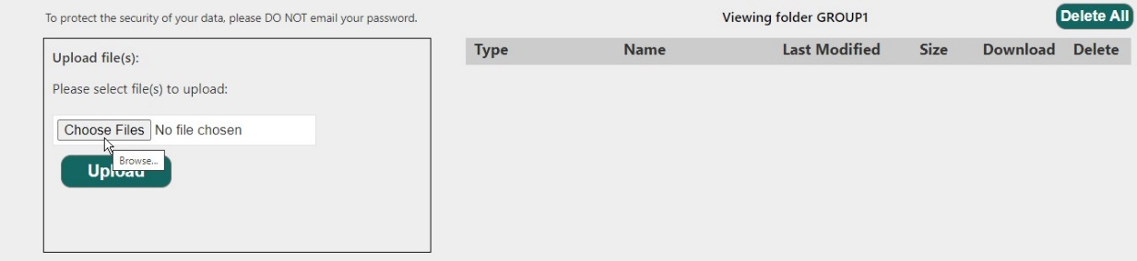

* Select a file(s) holding down the **Ctrl** key and then choose **Open**.

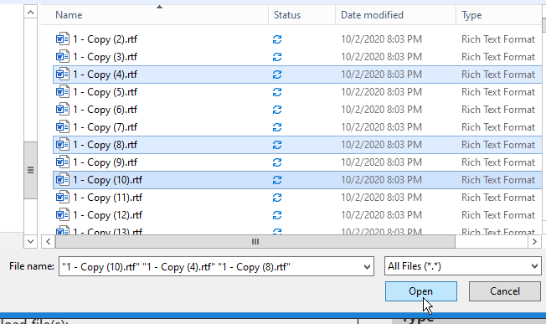

* Depending on whether one file or multiple files selected, the file name or the number of files will appear in the pop-up. Select **Upload** to start the upload process.

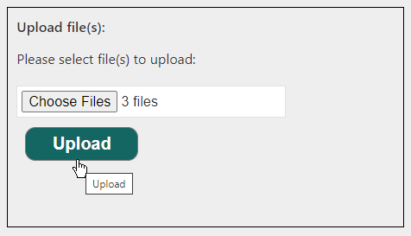

* If the upload was successful, a confirmation message will appear, and the uploaded file(s) will be listed to the right. The site will automatically add the date and a code to the beginning of each file name.

**Step 4: Downloading Files**

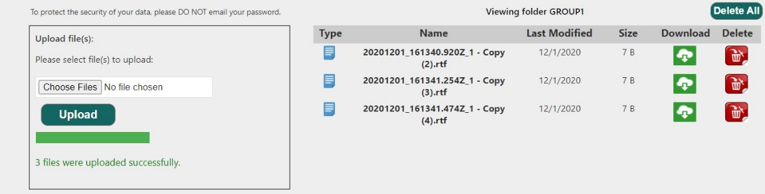

* Select the **Download** icon for the file to download.

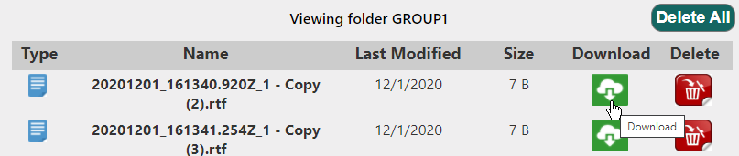

* The download should start immediately. If staff are using Microsoft Windows, the file should be saved in their **Downloads** folder. If not, they may be asked to specify a folder location before downloading.

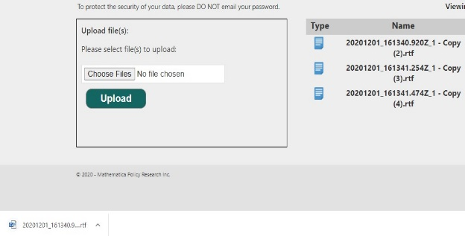

**Thank you very much for your assistance with this data request! We greatly appreciate your assistance. Please do not hesitate to contact me with any questions or concerns at [liaison phone] or [liaison email].**

|  |
| --- |
| An agency may not conduct or sponsor, and a person is not required to respond to, a collection of information unless it displays a currently valid OMB control number. The OMB number and expiration date for the described collection are OMB #: XXXX-XXXX, Exp: XX/XX/XXXX. The time required to complete this voluntary information collection is estimated to average 5 hours, including the time to review instructions, gather the data needed, and complete and review the information collected. Send comments regarding the burden estimate or any other aspect of this collection of information, including suggestions for reducing this burden to Mathematica; P.O. Box 2393, Princeton, NJ 08543, Attention: Mathematica.  Notice of Confidentiality  Information collected for this study comes under the confidentiality and data protection requirements of the Institute of Education Sciences (IES) (The Education Sciences Reform Act of 2002, Title I, Part E, Section 183). Responses to this data collection will be used only for statistical purposes. Study findings will be summarized across the sample and will not associate responses with a specific grantee, organization, full-service community school, or person. All of the information you provide may be used only for statistical purposes and may not be disclosed, or used, in identifiable form for any other purpose except as required by law (20 U.S.C. §9573 and 6 U.S.C. §151). |

1. Johnston, William R., John Engberg, Isaac M. Opper, Lisa Sontag-Padilla, and Lea Xenakis. “Illustrating the Promise of Community Schools: An Assessment of the Impact of the New York City Community Schools Initiative.” Sponsored by the New York Mayor’s Office of Economic Opportunity. Santa Monica, CA: RAND Corporation, 2020. Available at <https://www.rand.org/pubs/research_reports/RR3245.html>. Maier, A., J. Daniel, J. Oakes, and L. Lam. “Community Schools as an Effective School Improvement Strategy: A Review of the Evidence.” Palo Alto, CA: Learning Policy Institute, 2017.