REQUEST FOR APPROVAL under the Generic Clearance for NASA STEM Engagement Performance Measurement and Evaluation, OMB Control Number 2700-0159, expiration 09/30/2024
_____________________________________________________________________________________

- TITLE OF INFORMATION COLLECTION:
NASA K-12 Student Outcome Surveys (NASA Elementary School Survey, NASA Middle School Survey, and NASA High School Survey)

- TYPE OF COLLECTION:
Attitude/Behavior Scale
Baseline Survey
Cognitive Interview Protocol
Consent Form
Focus Group Protocol
Follow-up Survey
Instructions
Satisfaction Survey
Usability Protocol

GENERAL OVERVIEW: NASA Science, Technology, Engineering, and Mathematics (STEM) Engagement is comprised of a broad and diverse set of programs, projects, activities and products developed and implemented by HQ functional Offices, Mission Directorates and Centers. These investments are designed to attract, engage, and educate students, and to support educators, and educational institutions. NASA’s Office of STEM Engagement (OSTEM) delivers participatory, experiential learning and STEM challenge activities for young Americans and educators to learn and succeed. NASA STEM Engagement seeks to:

- Create unique opportunities for students and the public to contribute to NASA’s work in exploration and discovery.
- Build a diverse future STEM workforce by engaging students in authentic learning experiences with NASA people, content, and facilities.
- Strengthen public understanding by enabling powerful connections to NASA’s mission and work.

To achieve these goals, NASA STEM Engagement strives to increase K-12 involvement in NASA projects, enhance higher education, support underrepresented communities, strengthen online education, and boost NASA's contribution to informal education. The intended outcome is a generation prepared to code, calculate, design, and discover its way to a new era of American innovation.

The focus of this study is to develop and pilot three grade-level appropriate instruments (same instrument, language level varies) for measuring student outcomes of participation in NASA K-12 STEM Engagement programming in grades 4-12. The three grade-level appropriate surveys for this information collection are specific to determining the impact of the NASA STEM Engagement K-12 projects and activities on students (upper elementary grades 4 and 5; middle school grades 6 through 8; and high school grades 9-12). STEM Identity, STEM Self-Efficacy, STEM Interest and 21st Century skills development are also measures of interest.

- INTRODUCTION AND PURPOSE: The FY 2021 NASA STEM Engagement K-12 Comprehensive Evaluation study identified the current state of K-12 activities across NASA and proposed a common vision, goals, and objectives for K-12 projects and activities – grounded in a logic model and theory of change. Building upon this work, the NASA K-12 Student Outcome Assessment will examine the impact of NASA STEM Engagement K-12 activities on relevant student outcomes. The evaluation study process consists of 1) instrument development, 2) strategic briefings, 3) pilot testing and 4) instrument utilization. Three surveys were developed for each of the following grade bands: upper elementary (grades 4-5); middle school (grades 6-8); and high school (grades 9-12) to be piloted and validated. This study will provide evidence that can be used to: Explore, Describe, Classify and establish associations among variables (constructs) and the population of interest (NASA K-12 STEM engagement program participants in grades 4-12).

Our interest is to measure students’ immediate outcomes of participating in a NASA STEM Engagement K-12 project or activity and to assess what are the psychometric properties of the new constructs developed to measure students’ STEM Identity, Self-Efficacy, Interest, and 21st Century Skills. Thus, the purpose for pilot testing is to develop valid instruments that reliably explain the ways in which participants in grades 4-5, 6-8 and 9-12 are impacted by participation in these activities. Guided by current STEM education and measurement methodologies, it is the goal of this rigorous instrument development and testing procedure to provide information that becomes part of the iterative outcome assessment and feedback process for the portfolio of NASA STEM Engagement K-12 projects and activities.

Hence, the goals of this cycle of pilot testing are to 1) determine clarity, comprehensibility, and preliminary psychometric properties (e.g., validity, reliability) of these instruments. And, to explore individual item functioning, and to make any necessary adjustments in preparation for large-scale testing as the basis for more sophisticated statistical testing and 2) determine an accurate response burden for these instruments.

- RESEARCH DESIGN OVERVIEW: NASA’s work in STEM Engagement is focused on serving students. It is recognized that providing support and resources to educators and educational institutions is vital to effectively engage students. The specific aims of this study are to develop and pilot three grade-level appropriate instruments (same instrument, language level varies) for measuring student outcomes of participation in NASA K-12 STEM Engagement programming. The resulting instrument will be used in ongoing program evaluation by NASA. This study is program evaluation and will be guided by five evaluation questions for the approach and design of this study. Evaluation questions are presented in Figure 1 below. Evaluation Question 1 is related to the piloting of new instruments, while Evaluation Questions 2-5 are related to an outcome evaluation after the instrumentation pilot.
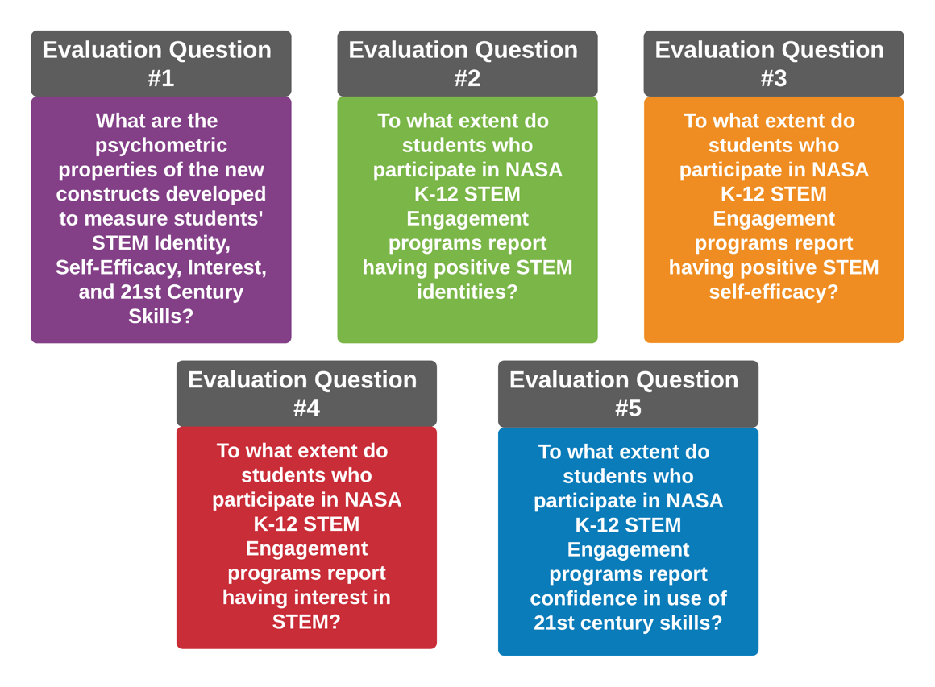
Figure 1. Evaluation Questions

The three develop items will be placed into Survey Monkey online software, and a survey link will be distributed through email to ~2500 NASA Intern participants. Quantitative and qualitative methods will be used to analyze survey data. Quantitative data will be summarized using descriptive statistics such as numbers of respondents, frequencies and proportions of responses, average response when responses categories are assigned to a Likert scale (e.g., 1 = “Never Used” to 4 = “Used Every day”), and standard deviations. Emergent coding will be used for the qualitative data to identify the most common themes in responses.

Construct survey item analysis. Rasch (1960, 1980) measurement was previously employed to assess the construct sections of the NASA Intern Survey in the Spring of 2021 (Sondergeld & Johnson, 2021). Pilot results showed all construct sections functioned well and could be used to form respective scales, or composite measures. Thus, items in different survey construct sections will be analyzed and an average scale score computed for the purpose of looking for significant differences in each construct (STEM Identity, STEM Self-Efficacy, STEM Interest, and 21st Century Skills) by student participants.

- TIMELINE: Testing of the three grade-level appropriate instruments (NASA Elementary School Survey, NASA Middle School Survey, and NASA High School Survey) will take place in June 2022 – December 2022 with student participants (grades 4-12) from NASA STEM Engagement K-12 projects and activities in coordination with project management.

- SAMPLING STRATEGY: The universe of NASA K-12 participants (grades 4-12) for pilot testing is 600 or below. Items for the three grade-level appropriate instruments (NASA Elementary School Survey, NASA Middle School Survey, and NASA High School Survey) will be placed into Survey Monkey online software, and a survey link will be distributed through email to ~600 NASA K-12 participants (grades 4-12) and/or to the educator in the NASA STEM Engagement program to administer.

Table 1. Calculation chart to determine statistically relevant number of respondents
Data Collection Source | (N)  Population Estimate | (A)  Sampling Error +/-  5% (.05) | (Z) Confidence Level 95%/ Alpha 0.05 | (P) *Variability (based on consistency of intervention administration) 50% | Base Sample Size | Response Rate | (n) Number of Respondents
NASA Elementary School Participants (grades 4-5) | 200 | N/A | N/A | N/A | 200 | N/A | 200
NASA Middle School Participants (grades 6-8) | 200 | N/A | N/A | N/A | 200 | N/A | 200
NASA High School Participants (grades 9-12) | 200 | N/A | N/A | N/A | 200 | N/A | 200
TOTAL |  |  |  |  |  |  | 600

- BURDEN HOURS: Burden calculation is based on a respondent pool of individuals as follows:

Data Collection Source | Number of Respondents | Frequency of Response | Total minutes per Response | Total Response Burden in Hours
NASA K-12 Participants (grade 4-12) | 600 | 1 | 20 | 200
TOTAL |  |  |  | 200

- DATA CONFIDENTIALITY MEASURES: Any information collected under the purview of this clearance will be maintained in accordance with the Privacy Act of 1974, the e-Government Act of 2002, the Federal Records Act, and as applicable, the Freedom of Information Act in order to protect respondents’ privacy and the confidentiality of the data collected.

- PERSONALLY IDENTIFIABLE INFORMATION:
  - Is personally identifiable information (PII) collected? Yes No

  - If yes, will any information that is collected by included in records that are subject to the Privacy Act of 1974? Yes No

  - If yes, has an up-to-date System of Records Notice (SORN) been published?
Yes No
Published March 17, 2015, the Applicable System of Records Notice is NASA 10EDUA, NASA STEM Engagement Program Evaluation System - http://www.nasa.gov/privacy/nasa_sorn_10EDUA.html.

APPLICABLE RECORDS:

  - Applicable System of Records Notice: SORN: NASA 10EDUA, NASA STEM Engagement Program Evaluation System - http://www.nasa.gov/privacy/nasa_sorn_10EDUA.html

  - Completed surveys will be retained in accordance with NASA Records Retention Schedule 1,
Item 68D. Records will be destroyed or deleted when ten years old, or no longer needed, whichever is longer.

- PARTICIPANT SELECTION APPROACH:

- Does NASA STEM Engagement have a respondent sampling plan? Yes No

If yes, please define the universe of potential respondents. If a sampling plan exists, please describe? The universe of NASA K-12 participants (grades 4-12) for pilot testing is 600 or below. Items for the three grade-level appropriate instruments (NASA Elementary School Survey, NASA Middle School Survey, and NASA High School Survey) will be placed into Survey Monkey online software, and a survey link will be distributed through email to ~600 NASA K-12 participants (grades 4-12) and/or to the educator in the NASA STEM Engagement program to administer.

If no, how will NASA STEM Engagement identify the potential group of respondents and how will they be selected? Not applicable.

- INSTRUMENT ADMINISTRATION STRATEGY
Describe the type of Consent: Active Passive

  - How will the information be collected:
Web-based or other forms of Social Media
Telephone
In-person
Mail
Other

If multiple approaches are used for a single instrument, state the projected percent of responses per approach.

  - Will interviewers or facilitators be used? Yes No

- DOCUMENTS/INSTRUMENTS ACCOMPANYING THIS REQUEST:
Consent form
Instrument (attitude & behavior scales, and surveys)
Protocol script (Specify type: Script)
Instructions NOTE: Instructions are included in the instrument
Other (Specify ________________)

- GIFTS OR PAYMENT: Yes No If you answer yes to this question, please describe and provide a justification for amount.

- ANNUAL FEDERAL COST: The estimated annual cost to the Federal government is $5,925. The cost is based on an annualized effort of 75 person-hours at the evaluator’s rate of $79/hour for administering the survey instrument, collecting and analyzing responses, and editing the survey instrument for ultimate approval through the methodological testing generic clearance with OMB Control Number 2700-0159, exp. exp. 09/30/2024.

- CERTIFICATION STATEMENT:

I certify the following to be true:
- The collection is voluntary.
- The collection is low burden for respondents and low cost for the Federal Government.
- The collection is non-controversial and does raise issues of concern to other federal agencies.
- The results will be made available to other federal agencies upon request, while maintaining confidentiality of the respondents.
- The collection is targeted to the solicitation of information from respondents who have experience with the program or may have experience with the program in the future.

Name of Sponsor: Richard Gilmore
Title: Performance Assessment and Evaluation Program Manager, NASA
Office of STEM Engagement (OSTEM)
Email address or Phone number: richard.l.gilmore@nasa.gov
Date: 5/20/2022

References
Rasch, G. (1960/1980). Probabilistic models for some intelligence and attainment tests. (Copenhagen, Danish Institute for Educational Research), with foreward and afterword by B.D. Wright. The University of Chicago Press.
Sondergeld, T. A., & Johnson, C. C. (2021). NASA intern study: Quantitative field study of intern survey. 1-
18.

