NASA MUREP OUTCOME ASSESSMENT

NASA MUREP-Funded Activity: Student Survey - Draft

Intro

- As a participant (i.e., student) in a NASA MUREP-Funded Activity, you have been selected to take part in a brief questionnaire about your experiences. If you wish to participate in this survey, please select next page to continue. Thank you for your time and perspective.

Privacy Act Notiﬁcation:

The information you provide via this form is protected from unauthorized disclosure in accordance with the Privacy Act of 1974. It will be used by NASA for the speciﬁc purpose of managing registrants, selecting applicants, implementing and evaluating STEM engagement investments. Collection of the information is authorized by the National Aeronautics and Space Act of 1958 § 403(a)(b), 42 U.S.C. § 2473 (c)(1). Provision of the requested information is strictly voluntary; however, failure to provide the information may result in NASA's inability to provide you with the information or STEM services you desire. NASA may disclose information to NASA administrators and managers, Oﬀice of Management and Budget oﬀicials, and members of Congress for the purposes of accountability and tracking of program and project eﬀiciency and eﬀectiveness. Elaboration and conditions of
information disclosure may be found under “Routine Uses” of the full System of Records Notice at https://www.govinfo.gov/content/pkg/PAI-2013-NASA/xml/PAI-2013- NASA.xml#10euda and in Appendix B at https://www.govinfo.gov/content/pkg/PAI-2013- NASA/xml/PAI-2013-NASA.xml#appb.

Paperwork Reduction Act Statement:

This information collection meets the requirements of 44 U.S.C. §3507, as amended by section 2 of the Paperwork Reduction Act of 1995. You do not need to answer these questions unless we display a valid Oﬀice of Management and Budget (OMB) control number. The OMB control number for this collection is 2700-0159 and expires 09/30/2024.
Next page End survey

Background - NASA MUREP-funded Activity

NASA MUREP-Funded Activity: Student Survey - Draft

- Please select the MUREP-Funded Activity you participate in from the list below.
MUREP Institutional Research Opportunity (MIRO)
MUREP Aerospace High Volume Manufacturing and Supply Chain Management (High Volume) MUREP-SMD Research Ocean Biology and Biogeochemistry (OCEAN)
MUREP Innovations in Space Technology Curriculum (MISTC) NASA Community College Aerospace Scholars (NCAS)
MUREP for American Indian and Alaska Native Science, Technology, Engineering, and Math (STEM) Engagement (MAIANSE)

MUREP Innovation Tech Transfer Idea Competition (MITTIC) MUREP INCLUDES

Introduction - Institution type

NASA MUREP-Funded Activity: Student Survey - Draft

- Please provide your institution.

- Please select your institution type.
Asian American Native American Paciﬁc Islander-Serving Institutions (AANAPISI) Native Hawaiian-Serving Institutions (ANNH)
Historically Black Colleges & Universities (HBCU) Hispanic Serving Institutions (HSI)
Minority Serving Institutions (MSI)
Native American-Serving Non-Tribal Institutions (NASNTI) Predominantly Black Institutions (PBI)
Private (Pri) Public (Pub)
Tribal Colleges and Universities (TCU)

Background - Activity

NASA MUREP-Funded Activity: Student Survey - Draft

- Please brieﬂy describe how you engage with NASA's MUREP-funded activity that you selected at your institution.

- How long have you participated in the NASA's MUREP-funded activity at your institution?

1 - 2 semesters
3 - 4 semesters
5+ semesters

Recruitment

NASA MUREP-Funded Activity: Student Survey - Draft

- Please select from the list below how you found out about NASA's MUREP-funded activity at your institution. Select all that apply.
Emails Referrals Events Websites
Other (please specify)

Sense of Belonging (1 of 3)

NASA MUREP-Funded Activity: Student Survey - Draft

Below is a list of statements that may or may not be true about your experience at college. Please indicate your level of agreement with each statement using the responses provided. Think carefully and respond honestly as there is no “wrong” answer.”
Please rate your agreement with the following statements based on how you feel about your involvement in NASA's MUREP-funded activity at your school.
- Faculty and staﬀ members who are part of NASA's MUREP-funded activity notice when I am good at something.
Strongly Disagree Disagree
Slightly disagree Slightly agree Agree
Strongly Agree
Prefer not to respond

- Faculty and staﬀ members who are part of NASA's MUREP-funded activity value my opinions
Strongly Disagree Disagree
Slightly disagree Slightly agree Agree
Strongly Agree
Prefer not to respond

- Faculty and staﬀ members who are part of NASA's MUREP-funded activity know I can do good work.
Strongly Disagree Disagree
Slightly disagree Slightly agree Agree
Strongly Agree Prefer not to respond

- I can really be myself in NASA's MUREP-funded Activity community.
Strongly Disagree Disagree
Slightly disagree Slightly agree Agree
Strongly Agree
Prefer not to respond

- Other students who are part of NASA's MUREP-funded activity at my school like me the way I am.
Strongly Disagree Disagree
Slightly disagree Slightly agree Agree
Strongly Agree Prefer not to respond

Sense of Belonging (2 of 3)

NASA MUREP-Funded Activity: Student Survey - Draft

During this academic year, it is likely that I will...

- Read research papers from a faculty member who is a member of NASA's MUREP-funded activity at my school.
Strongly Disagree Disagree
Slightly disagree Slightly agree Agree
Strongly Agree
Prefer not to respond

- Attend a seminar hosted by NASA's MUREP-funded activity at my school.
Strongly Disagree Disagree
Slightly disagree Slightly agree Agree
Strongly Agree
Prefer not to respond

- Visit the lab of a faculty who is a member of NASA's MUREP-funded activity at my school.

Strongly Disagree Disagree
Slightly disagree Slightly agree Agree
Strongly Agree Prefer not to respond

Sense of Belonging (3 or 3)

NASA MUREP-Funded Activity: Student Survey - Draft

- Please rank order the levels at which you have the highest sense of belonging in the STEM ﬁeld:
My NASA MUREP-Funded Activity community My program of study (major) community
My college or university community

STEM Identity

NASA MUREP-Funded Activity: Student Survey - Draft

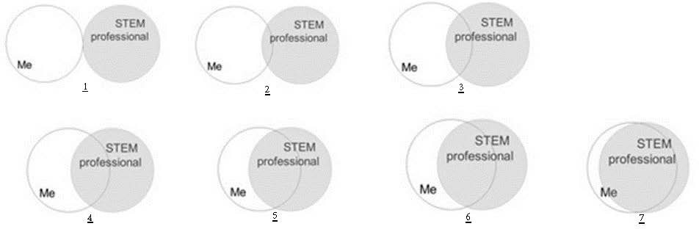

- STEM professionals are individuals whose professional activities relate to the STEM ﬁelds (Science, Technology, Engineering, or Mathematics). Select number that best describes the current overlap of the image you have of yourself and your image of what a STEM professional is.
1
7

- Because of my participation in NASA's MUREP-funded activity at my school, I am more likely to continue along a STEM pathway.
Strongly disagree Somewhat disagree Agree
Somewhat agree Strongly agree

Academic Self-eﬀicacy

NASA MUREP-Funded Activity: Student Survey - Draft

Please answer how conﬁdent you are that you can successfully complete the task from 0 = Not at all conﬁdent to 10 = Extremely conﬁdent.
- Getting the grades, I want
0
10

- Taking good class notes
0
10

- Studying to perform well on tests
0
10

- Getting papers done on time
0
10

- Preparing for exams
0
10

- Researching term papers
0
10

- Doing well in my toughest class
0
10

- Talking to my professors
0
10

- Getting help and information at school
0
10

- Talking to college staﬀ
0
10

- Participating in class discussions
0
10

- Asking questions in class
0
10

Demographics

NASA MUREP-Funded Activity: Student Survey - Draft

- Please select your gender
Female Male
Choose not to report

- Please select your race
American Indian or Alaska Native Asian
Black or African American
Native Hawaiian or Other Paciﬁc Islander White
Choose not to report Other (please specify)

- Are you of Hispanic, Latino, or Spanish origin?
No, not of Hispanic, Latino, or Spanish origin Yes, Mexican, Mexican American, Chicano Yes, Puerto Rican
Yes, Cuban
Yes, another Hispanic, Latino, or Spanish origin Choose not to report
Other (please specify)

- Please select your grade-level
Freshmen Sophomore Junior
Senior
Graduate student Choose not to report
Other (please specify)

- Have you ever served on active duty in the United States Armed Forces, either in the regular military or in National Guard or military reserve unit?
Yes No
Choose not to report

- Have you declared a STEM (Science, Technology, Engineering, Mathematics) major? If yes, please provide your major.

- On a scale 0 to 10, how likely are you to recommend NASA's MUREP-funded activity at your school to your peers?
0
10

- Would you be willing to participate in a follow-up focus group related to these questions? If Yes, please provide your email below.

