MUREP Outcome Assessment Focus Group Protocol (Principal Investigators)

Thank you for agreeing to participate in our MUREP-Funded Activity Outcome Assessment Focus Group. Please know that all responses are voluntary. Individual responses will not be shared and only aggregated; anonymous results will be reported. Please answer each question regarding the MUREP-Funded Activity you are involved with.

Informed Consent Information Sheet:
Purpose of this Research/Project: The purpose of the evaluation study is to measure, interpret, and evaluate the outcomes that MUREP addresses. The findings of this investigation are intended to be used by NASA (the Minority University Research and Education Project (MUREP) specifically) to inform prioritization of MUREP investments, activity design, and associated efforts related to sustainability and lowering of barriers to entry for learners, especially those from groups historically underrepresented and underserved in STEM.
Targeted MUREP Activities: MUREP activities that have been active for at least one year are the targeted sample for this study.
Procedures: The research will include a document analysis, surveys, and focus group data collection.
Risks: Participation in this research does not place you at more than minimal risk of harm.
Benefits: While there may be no direct benefit to you as a participant, results from this study will assist in ensuring that MUREP activities are aligned to federal mandates for Minority Serving Institutions (MSIs), NASA’s goals and priorities, MUREP program goals and objectives, and evidence-based and promising practices for STEM Engagement.
Extent of Anonymity and Confidentiality: All the results of this study will be kept confidential. The study participants names and contact information will be disassociated from responses gathered through the study’s data collection processes (including from this focus group). All data will be presented in aggregate. It is possible that the NASA Institutional Review Board (IRB) may view this study’s collected data for auditing purposes. The IRB is responsible for the oversight of the protection of human subjects involved in research.
Compensation: None
Freedom to Withdraw: As a participant, you are free to withdraw from a study at any time without penalty and you may choose to not answer any questions you deem unnecessary.
Subject's Responsibilities: I voluntarily agree to participate in this study. I have the following responsibilities: Participation in a focus group, participation in an interview, and submit project documents for analysis by the evaluator.
Contact Information: Should you have any questions about this research or its procedures, you may contact the principal investigator of this project, Dr. Aime Black, at aime.t.black@nasa.gov.

Introduction Script:
Guardians of Honor was contracted by NASA to conduct an evaluation of Minority University Research and Education Project (MUREP) portfolio. The purpose of the evaluation study is to measure, interpret, and evaluate the outcomes that MUREP addresses. The findings of this investigation are intended to be used by NASA (the Minority University Research and Education Project (MUREP) specifically) to inform prioritization of MUREP investments, activity design, and associated efforts related to sustainability and lowering of barriers to entry for learners, especially those from groups historically underrepresented and underserved in STEM. MUREP-Funded activities that have been active for at least one full year were selected by NASA for the evaluation. This evaluation will examine both quantitative and qualitative data to examine outcomes from MUREP-Funded activities to help guide decision-making.
This evaluation is not an assessment of you. In addition, participation in this focus group is voluntary. You can skip any questions you do not want to answer. This focus group will last approximately 45-60 minutes.
At the end of this evaluation study, we will be writing a report for NASA. We will be summarizing all of the focus group responses; however, we will not disclose any names or connect your responses to your specific site. Today, we will be taking notes during our conversation. To ensure accuracy, we would like to record this conversation. The recording will be deleted after we have summarized your responses. Are you okay with us recording the interview? Do you have any questions?
Student Recruitment
- Did you face challenges implementing recruitment activities as planned? Please describe.
  - Has anything been done to address these challenges?
- Has your recruitment strategy changed since the inception of the program?
- In regard to recruiting URM students into your program, what has worked well and what has not worked well?

Student Retention
- Did you face challenges implementing retention activities as planned? Please describe.
  - Has anything been done to address these challenges?
- Has your student retention strategy changed since the inception of the program?
- In regard to retaining URM students into your program, what has worked well and what has not worked well?

Partnerships
- What role did strategic partnerships play in the development/implementation/success of your activity?
- Did you face challenges implementing strategic partnerships as planned? Please explain.
  - Has anything been done to address these challenges?
- What do you think would have made strategic partnerships more successful?
- Are you satisfied with the quality of your partnerships?

Cross-cutting
- What supports, resources, etc. are provided to students to help ensure students are able to engage with the activity?
- If allowed, would you apply for funding for this activity again? Why or why not?

Thank you for participating in the focus group. We greatly appreciate your time and feedback.

MUREP Outcome Assessment: Focus Group Protocol (Students)

Thank you for agreeing to participate in our MUREP-Funded Activity Outcome Assessment Focus Group. Please know that all responses are voluntary. Individual responses will not be shared and only aggregated; anonymous results will be reported. Please answer each question regarding the MUREP-Funded Activity you are involved with.

Informed Consent Information Sheet:
Purpose of this Research/Project: The purpose of the evaluation study is to measure, interpret, and evaluate the outcomes that MUREP addresses. The findings of this investigation are intended to be used NASA (the Minority University Research and Education Project (MUREP) specifically) to inform prioritization of MUREP investments, activity design, and associated efforts related to sustainability and lowering of barriers to entry for learners, especially those from groups historically underrepresented and underserved in STEM.
Targeted MUREP Activities: MUREP activities that have been active for at least one year are the targeted sample for this study.
Procedures: The research will include a document analysis, surveys, and focus group data collection.
Risks: Participation in this research does not place you at more than minimal risk of harm.
Benefits: While there may be no direct benefit to you as a participant, results from this study will assist in ensuring that MUREP activities are aligned to federal mandates for Minority Serving Institutions (MSIs), NASA’s goals and priorities, MUREP program goals and objectives, and evidence-based and promising practices for STEM Engagement.
Extent of Anonymity and Confidentiality: All the results of this study will be kept confidential. The study participants names and contact information will be disassociated from responses to questionnaires, interviews, and focus groups. All data will be presented in aggregate. It is possible that the NASA Institutional Review Board (IRB) may view this study’s collected data for auditing purposes. The IRB is responsible for the oversight of the protection of human subjects involved in research.
Compensation: None
Freedom to Withdraw: As a participant, you are free to withdraw from a study at any time without penalty and you may choose to not answer any questions you deem unnecessary.
Subject's Responsibilities: I voluntarily agree to participate in this study. I have the following responsibilities: Participation in a focus group, participation in an interview, and submit project documents for analysis by the evaluator.
Contact Information: Should you have any questions about this research or its procedures, you may contact the principal investigator of this project, Dr. Aime Black, at aime.t.black@nasa.gov.

Introduction Script:
Guardians of Honor was contracted by NASA to conduct an evaluation of Minority University Research and Education Project (MUREP) portfolio. The purpose of the evaluation study is to measure, interpret, and evaluate the outcomes that MUREP addresses. The findings of this investigation are intended to be used by NASA (the Minority University Research and Education Project (MUREP) specifically) to inform prioritization of MUREP investments, activity design, and associated efforts related to sustainability and lowering of barriers to entry for learners, especially those from groups historically underrepresented and underserved in STEM. MUREP-Funded activities that have been active for at least one full year were selected by NASA for the evaluation. This evaluation will examine both quantitative and qualitative data to examine outcomes from MUREP-Funded activities to help guide decision-making.
This evaluation is not an assessment of you. In addition, participation in this focus group is voluntary. You can skip any questions you do not want to answer. This focus group will last approximately 45-60 minutes.
At the end of this evaluation study, we will be writing a report for NASA. We will be summarizing all of the focus group responses; however, we will not disclose any names or connect your responses to your specific site. Today, we will be taking notes during our conversation. To ensure accuracy, we would like to record this conversation. The recording will be deleted after we have summarized your responses. Are you okay with us recording the interview? Do you have any questions?
Sense of Belonging
- In what other ways has your sense of belonging been shaped?
- Did the activity make you feel like your competence was valued, if so, how?
- Did the activity make you feel socially accepted, if so, how?
- Did the activity make you feel involved, if so, how?
- Can you relate to the role models involved with the [MUREP-funded activity]? Why or why not?

STEM Identity
- Thinking back to this picture from the survey, please describe why you selected the option you did.
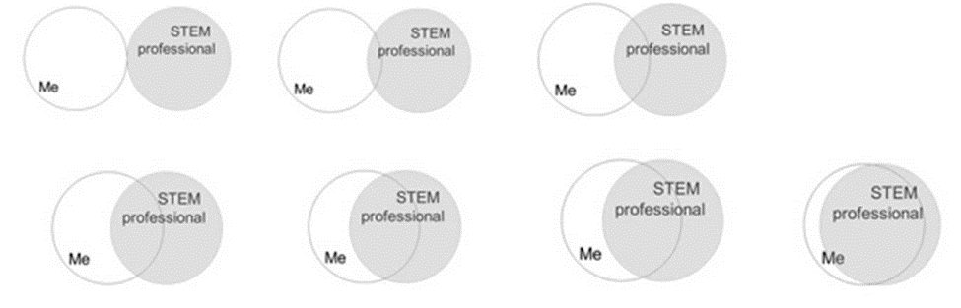
Student Recruitment
- What led you to apply to participate in the MUREP-Funded Activity?
- What recommendations do you have for improving recruitment?

Student Retention
- Do plan to stay in a STEM major, if so, why?
- Do you see yourself pursuing a STEM career, if so, why?
Overall
- What did you find most beneficial from participating in the MUREP-Funded Activity?
- Would recommend this activity to your peers, why? Please explain.

Thank you for participating in the focus group. We greatly appreciate your time and feedback.

