Internship Experience Survey

The purpose of this Internship Experience Survey is to understand NASA OSTEM Intern' sense of belonging and STEM identity. Findings from the survey will inform the NASA OSTEM Internship Program about the impacts that Interns experience after completing at least one NASA OSTEM Internship Program Internship.

This study is conﬁdential. The beneﬁt of completing this survey is the potential for improving future Intern experiences.

This survey contains ﬁve items and should take less than 10 minutes to complete. This survey includes multiple choice, Likert scale, image selection, and rating type questions. You will receive no compensation for completing this survey. Your honest responses will shape future internship experiences for your peers who come after you.

Privacy Act Notiﬁcation: The information you provide via this form is protected from unauthorized disclosure in accordance with the Privacy Act of 1974. It will be used by NASA for the speciﬁc purpose of managing registrants, selecting applicants, implementing and evaluating STEM engagement investments. Collection of the information is authorized by the National Aeronautics and Space Act of 1958 § 403(a)(b), 42 U.S.C. § 2473 (c)(1). Provision of the requested information is strictly voluntary; however, failure to provide the information may result in NASA's inability to provide you with the information or STEM services you desire. NASA may disclose information to NASA administrators and managers, Oﬀice of Management and Budget oﬀicials, and members of Congress for the purposes of accountability and tracking of program and project eﬀiciency and eﬀectiveness. Elaboration and conditions of information disclosure may be found under “Routine Uses” of the full System of Records Notice at https://www.govinfo.gov/content/pkg/PAI-2013-NASA/xml/PAI-2013-NASA.xml#10euda and in Appendix B at https://www.govinfo.gov/content/pkg/PAI-2013-NASA/xml/PAI-2013-NASA.xml#appb.

Paperwork Reduction Act Statement: This information collection meets the requirements of 44 U.S.C. §3507, as amended by section 2 of the Paperwork Reduction Act of 1995. You do not need to answer these questions unless we display a valid Oﬀice of Management and Budget (OMB) control number. The OMB control number for this collection is 2700-0159 and expires 09/30/2024.

Sense of Belonging

Below is a list of statements about how people can experience a college-related activity. Sense of belonging refers to the extent to which you feel connected with and a part of a speciﬁc community.

think about your sense of belonging in the speciﬁc community referenced in each question, such as your university/college at large, a speciﬁc organization, program, class, or NASA OSTEM Internship. There is no “wrong” answer, please oﬀer your honest feedback.

Of the three items below, where do you have the strongest feeling of belonging, or feel most accepted and part of a community? Please rank the items from highest to lowest:
My NASA OSTEM Internship community/team/cohort
My program of study (major community), or classes if no major declared My college or university community

I see examples of people like me in my classes.
Strongly disagree Disagree
Slightly disagree Slightly agree Agree
Strongly agree

Please rate your level of agreement with the following statements based on how you feel about your involvement in the NASA OSTEM Internship Program.

Please note the term NASA OSTEM Internship Representative, implies any faculty, staﬀ, consultant, mentor, supervisor, or representative that is active or a part of the NASA OSTEM Internship Program of which you participate(d) in.

Strongly
Slightly
Slightly
Strongly

disagree Disagree disagree
agree Agree
agree

I see examples of people like me in the NASA OSTEM Internship Program.
Representatives who are part of the NASA OSTEM Internship Program notice when I am good at something.
Representatives who are part of the NASA OSTEM Internship Program value my opinions.
Representatives who are part of the NASA OSTEM Internship Program know I can do good work.
I can really be myself in the NASA OSTEM Internship Program community.

Please rate your level of agreement with the following statements based on how you feel about your involvement in the NASA OSTEM Internship Program.

Please note the term NASA OSTEM Internship Representative, implies any faculty, staﬀ, consultant, mentor, supervisor, or representative that is active or a part of the NASA OSTEM Internship Program of which you participate(d) in.

Strongly
Slightly
Slightly
Strongly

disagree Disagree disagree
agree Agree
agree

Other interns who are part of the NASA OSTEM Internship Program like me the way I am.
During this internship, it is likely that I will ﬁnd opportunities to connect and learn more from the professional representatives within the NASA OSTEM Internship Program.
During this internship, it is likely that I will attend a seminar, workshop, or professional learning opportunity as part of the NASA OSTEM Internship Program.
During this internship, it is likely that I will visit the lab of
a representative who is a member of the NASA OSTEM Internship Program.

- STEM Identity

STEM identity refers to what degree you see yourself as a “STEM person.” STEM professionals are individuals whose professional activities relate to the STEM ﬁelds (Science, Technology, Engineering, or Mathematics).

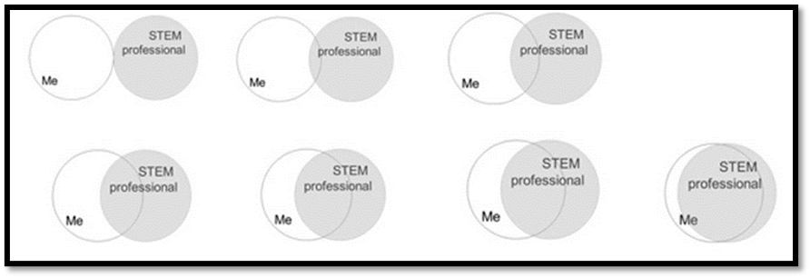
(12). STEM professionals are individuals whose professional activities relate to the STEM ﬁelds (Science, Technology, Engineering, or Mathematics). Select the picture that best describes the current overlap of the image you have of yourself and your image of what a STEM professional is.

