****



**Secure and Trusted Communications Networks Reimbursement Program**

**FCC Form 5640 Part G and Modifications of FCC Form 5640 Part C User Guide**

A step-by-step guide for completing FCC Form 5640: *Reimbursement Claim Request* and Modifying Cost Estimates

OMB Control No. 3060-1270

**Table of Contents**

[Background 3](#_Toc147494573)

[Purpose and Scope of this User Guide 4](#_Toc147494574)

[Instructions for Submitting Modification Requests 6](#_Toc147494575)

[Instructions for Submitting FCC Form 5640 Part G: Reimbursement Claim Request 11](#_Toc147494576)

[Responding to Requests for Information in the SCRP Online Portal 14](#_Toc147494577)

# Background

The Secure and Trusted Communications Networks Act of 2019 (Secure Networks Act), as amended, directed the Federal Communications Commission (FCC or Commission) to establish the Secure and Trusted Communications Networks Reimbursement Program (Reimbursement Program or SCRP).[[1]](#footnote-3) The purpose of the Reimbursement Program is to reimburse providers of advanced communications services with ten million or fewer customers for costs reasonably incurred in the removal, replacement, and disposal of communications equipment or services produced or provided by Huawei Technologies Company (Huawei) or ZTE Corporation (ZTE) (or their parents, subsidiaries, or affiliates) and obtained on or before June 30, 2020 (Covered Communications Equipment or Services).[[2]](#footnote-4)

In the *2020 Supply Chain Order*, the Commission adopted rules for the Reimbursement Program, which are codified in section 1.50004 of its rules.[[3]](#footnote-5) The Commission revised these rules in the *2021 Supply Chain Order* and provided additional guidance on the application and reimbursement process in the *Finalized Reimbursement Process Public Notice*, including FCC Form 5640 Part C: Application Request for Funding Allocation (FCC Form 5640 Part C) and a Catalog of Eligible Expenses and Estimated Costs (Cost Catalog), and separately on the disposal process.[[4]](#footnote-6)

On July 15, 2022, the Wireline Competition Bureau (Bureau) issued decisions approving and denying applications submitted for Reimbursement Program support. Applicants that were approved to receive an allocation (Recipients)[[5]](#footnote-7) received an approval email from the Bureau and the Bureau announced these allocations in a July 18, 2022 Public Notice.[[6]](#footnote-8)

# Purpose and Scope of this User Guide

This document is a guide for Recipients to consult when submitting an FCC Form 5640 Part G: Reimbursement Claim Request (FCC Form 5640 Part G or Reimbursement Claim Request) or when modifying their cost estimates in FCC Form 5640 Part C. Recipients must file at least one Reimbursement Claim Request within one year of the approval of their FCC Form 5640 Part C application or their allocations will revert back to the Reimbursement Program.[[7]](#footnote-9) In some cases, Recipients may need to submit a request to modify information submitted with their Application Request for Funding Allocation prior to submitting a Reimbursement Claim Request.

This User Guide provides informal guidance intended to assist Recipients as they proceed with these Reimbursement Program processes and does not constitute legal advice. Recipients remain solely responsible for reviewing and complying with all statutory provisions, rules, FCC precedent, and program procedures.

***Mandatory and Permissible Modifications***

Recipients that have not yet provided a vendor or supplier quote associated with an invoice because they relied on the Cost Catalog estimates when completing their Application Request for Funding Allocation *must* file a modification before submitting the Reimbursement Claim Request to provide the required vendor or supplier quote.[[8]](#footnote-10) Recipients may also submit modification filings to:

* Update certain aspects of line items and itemized expenses, such as providing required details about replacement equipment and services;[[9]](#footnote-11)
* Update the removal, replacement, and disposal timeline and plan submitted with the Recipient’s application; and
* Update location information for covered equipment and replacement equipment.[[10]](#footnote-12)

Requests to modify line items and itemized expenses and other material changes will be reviewed by the Fund Administrator[[11]](#footnote-13) and the Bureau to determine if they comply with program requirements.[[12]](#footnote-14) While such modification requests may provide updated cost information for a Recipient’s project, the funding allocation issued to the Recipient will not be altered.[[13]](#footnote-15)

In addition, timelines submitted with a Recipient’s application[[14]](#footnote-16) must comply with the Recipient’s deadline to complete the permanent removal, replacement, and disposal (RRD) of Covered Communications Equipment and Services, which is one year from its initial distribution of a reimbursement.[[15]](#footnote-17) The submission or approval of a modification request, including but not limited to an update to a timeline, does not extend the deadline by which Recipients must complete the permanent removal, replacement, and disposal of all Covered Communications Equipment or Services.

Per the Secure and Trusted Networks Communications Act, Recipients will be required to certify in their Final Certifications that they have “permanently removed from the communications network of the recipient, replaced, and disposed of . . . all covered communications equipment or services that were in the network of the recipient as of the date of the submission of the application of the recipient for the reimbursement[.]”[[16]](#footnote-18) Accordingly, Recipients are required to remove, replace, and dispose of all Covered Communications Equipment and Services in their networks as of the date of the submission of the application and may not now modify their plans to reduce that scope.[[17]](#footnote-19)

Specific instructions on how to submit a modification request via the SCRP Online Portal are provided below. If you have questions about whether a particular type of modification request is permissible before you file, please contact the Fund Administrator at [scrpfundadmin@fcc.gov](mailto:scrpfundadmin@fcc.gov).

***Review of Reimbursement Claim Requests***

A Recipient’s Reimbursement Claim Request will be evaluated by the Fund Administrator and the Bureau based on information provided by the Recipient in its FCC Form 5640 Part G filing. To determine whether the expense was “reasonably incurred,” the Fund Administrator and the Bureau will consider whether the cost is typically incurred when transitioning from Covered Communications Equipment or Services to a replacement, the cost relative to alternative equipment and services, and the capabilities and functions performed by the replacement equipment and services as compared to the equipment and services removed.[[18]](#footnote-20) The Fund Administrator and the Bureau will compare the request to the price ranges in the Cost Catalog, review supporting invoice documentation, and consider any additional justification or explanation submitted by the Recipient in their review of Reimbursement Claim Requests.[[19]](#footnote-21)

The review process is designed to allow reasonably incurred expenses to be paid while guarding the Reimbursement Program against waste, fraud, and abuse.

Specific instructions on how to submit Reimbursement Claim Requests via the SCRP Online Portal are provided below.

***Deadline for Submission of All Reimbursement Claim Requests***

Recipients have one year from their initial disbursement of a reimbursement to complete the permanent Removal, Replacement, and Disposal (RRD) of all Covered Communications Equipment or Services unless that deadline is extended by the FCC (RRD Term).[[20]](#footnote-22) Recipients can file Reimbursement Claim Requests during the RRD Term and up until 120 days following the end of that term (Reimbursement Claim Request Deadline).[[21]](#footnote-23) Recipients may also submit modifications during the 120 days following the expiration of their RRD term to the extent they are necessary to process related reimbursement claims. Recipients may not submit Reimbursement Claim Requests for costs that are incurred after the end of their RRD Term. When the Recipient notifies the FCC and Fund Administrator that it has finished all removal, replacement, and disposal activities and has submitted all invoices, the FCC and Fund Administrator will commence closing out the Recipient’s reimbursement account.[[22]](#footnote-24) During the process of closing out the account, the FCC and Fund Administrator may require invoice proof of payment from Recipients.

# Instructions for Submitting Modification Requests

As noted above, Recipients may make certain modifications to their Application Request for Funding Allocation and in some cases, must do so before submitting a Reimbursement Claim Request. In addition, the Fund Administrator may notify Recipients through a Request for Information (RFI) via the SCRP Online Portal if a modification is required before it can process a Reimbursement Claim Request. Regardless of any modified cost estimates, reimbursements will not be made in excess of a Recipient’s available allocation amount.

***Getting Started***

To begin filing a modification, Recipients will log into the Supply Chain Reimbursement Program Online Portal, open their *Program Participant File*, then navigate to *SCRP Filings* and locate the appropriate Application Request for Funding Allocation that was either Completed Granted or Completed Granted in Part (Figure 1).

Figure 1: SCRP Filings

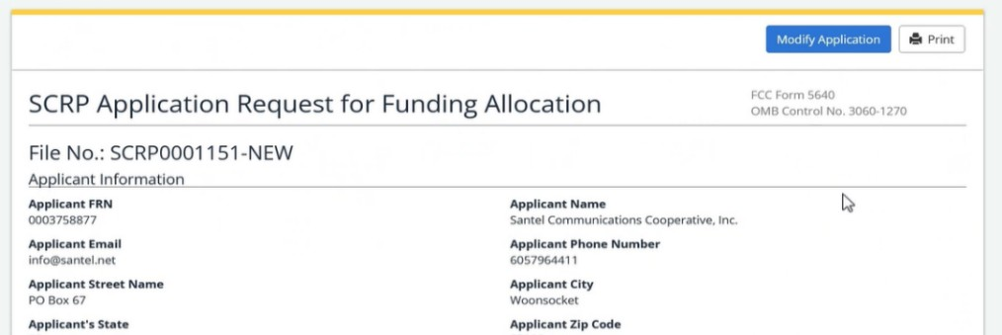

Mala Geoscience

987-654-3210

Washington

123 Water Street

info@mala.net

123456789

SCRP0000000

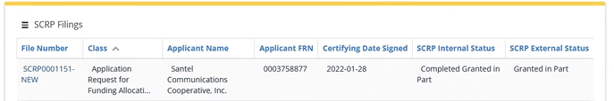

Mala Geoscience

123456789

SCRP0000000

SCRP0000000-NEW

After opening their FCC Form 5640 filing, Recipients will select the blue ‘Modify Application’ button, which will allow them to submit the requested modifications to their filing (Figure 2).

Figure 2: Modify Application

Once the modification opens, Recipients will fill out the Filing Contact Information for the individual who will handle any communications related to this modification. They will also provide a description of the modification and its purpose (Figure 3).

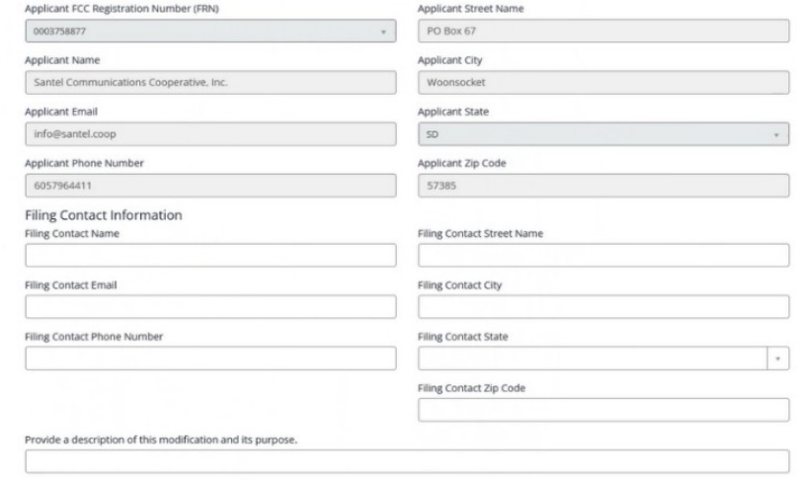

Figure 3: Applicant Information

Machine generated alternative text:
Timeline and Plan Information 
Provide a sxißc timeline for the permanent remmml. replacement. and 
Prm•ide descriøtion of Applicants plan for the permanent remm•al. 
diSsBSal Of the communications or service. 
replacement and diSJXISal Of or 
app" G nt æq u tt»t 
appliGnt all of of the be 
all of of the 
Numb« & 
be kept 
kept con 
ID 
SCLM33S7a 
SCLlI"S3'6 
t i tude of 
'O. 1234 
"362261 
service disrupt i Or'S to the process Of 
nd replKin8 —ed equi;mt mices? 
O Yes @ No 
Lo ngitude of 
.60.1234 
nge Next, if there are changes to the timeline and plan, Recipients may upload their modified information in the Timeline and Plan Information section (Figure 4).

Figure 4: Timeline and Plan Information

Machine generated alternative text:
ID 
SCLM33S7a 
SCLMOS316 
SCLI Ø05320 
SCLMOS3ta 
SCLM33S22 
SCLM33S70 
SC" 0005318 
SCL10033S76 
Witch el 
Mitchel b H a mar 
Poet 
Pinal Test 
t i tude of 
'O. 1234 
% 362261 
7047-97 
43.638139 
22.1422 
121234 
Q 1234 
Lo ngitude of 
.60_1234 
.98_051025 
-98047 s 
1401234 
.98.'02 SS 
.60.'23. 
nge 
1900 w. Cedar Ave. 
40797 257th St 
40509 247th St 
test If there are changes to Location information, Recipients will add and edit the information in the Locations section (Figure 5). Similarly, if there are changes to Equipment or Service information, Recipients will add or edit the information in the Equipment or Service section (Figure 6). All changes to Location and Equipment or Service information should be linked to a specific cost estimate.

Figure 5: Locations Information

Machine generated alternative text:
Equi%nent or * Nice 
Actio NS 
Equipment Or Service ID 
scEQON9733 
scEQDN%86 
scEQ0015276 
scEQ0015301 
SCEQMIS299 
SCEQØ15297 
SCE0001S309 
IS the existing equipment Or a replacement Service? IS 
Existing Equi*nent 
Replacemen t E quipme n t 
Existing Equgnent 
Replacem t Equipme n t 
Existing Equipment 
Existing equi%nent 
t EquiJmt 
Existing Equi%nent 

Figure 6: Equipment or Service Information

Next, Recipients will navigate to the Cost Estimate Modification section. As in the initial application filing, Recipients will utilize the batch upload feature by downloading the Excel template within the blue hyperlink (‘*download this excel template for cost estimates modification’*), as shown in Figure 7.

Figure 7: Download Cost Estimate CSV and Choose File

Refer to the sections below for instructions on how to add, edit, and remove cost estimates. Please note that only cost estimates that need to be added, modified, or removed should be included in the Cost Estimate Modification Template. Do not include cost estimates that do not need to be added, modified, or removed in the Cost Estimate Modification Template.

***Adding or Editing Cost Estimates***

Recipients will use the Cost Estimate ID to identify the cost estimate being modified, which may be copied from a request for information (RFI), if applicable, into Column A of the Cost Estimate Template (Figure 8). Alternatively, Recipients may find all of their cost estimate IDs by navigating to the Cost Estimates section within the SCRP Online Portal (Figure 9), which will include all cost estimates and IDs previously submitted. If the Recipient is entering new cost estimate information that does not have an existing Cost Estimate ID, then it will enter “NEW” in this column of the template. If the Recipient would like to export this information, they may do so by clicking the three horizontal lines above the table (Figure 10).

Recipients should not resubmit cost estimates that are not being modified.



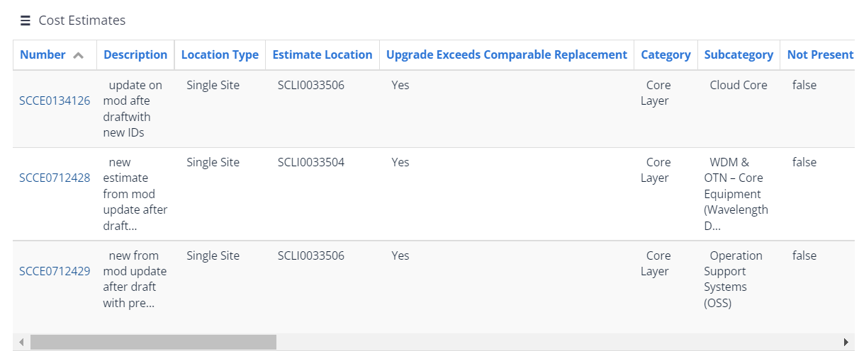

*Figure 9: Cost Estimates Dashboard*

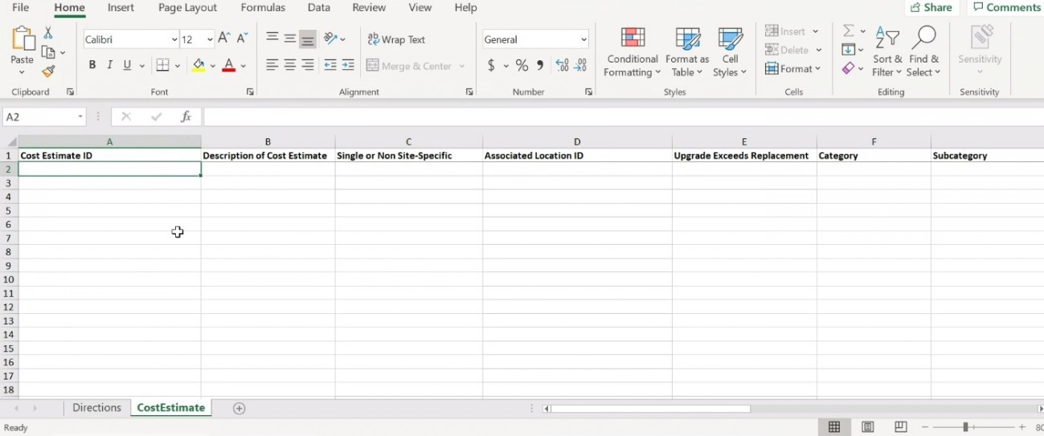

*Figure 8: SCRP Excel Upload Cost Estimate Modification Template*

*Figure 4: Cost Estimates Dashboard*

***Removing Cost Estimates***

If the Recipient would like to remove a particular cost estimate because it is no longer necessary, it will need to include the Cost Estimate ID in the Cost Estimate Modification Batch Excel template and enter a cost estimate of $0 in Column K (Provide Estimate of Costs (in USD).

***Completing Additional Columns and Submitting***

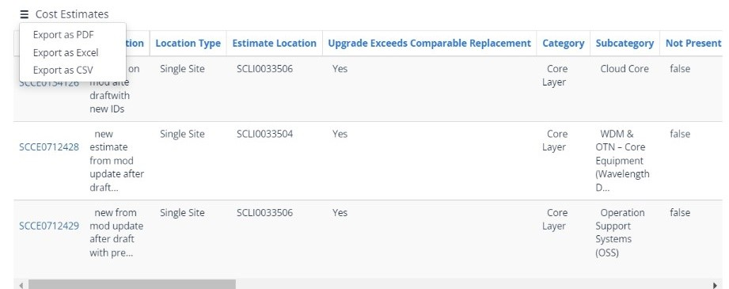After populating the Cost Estimate ID, the Recipient will complete all remaining columns of the Cost Estimate Modification Template for each cost estimate being modified. All of the columns of the Cost Estimate Modification Template, not only the information being modified, must berepopulated and modified as needed. The following describes each data category that must be re-entered into the Modification Template:

*Figure 10: Cost Estimates Pending Review Export Option*

* Describe the Cost Estimate.
* Identify if the cost estimate is associated with a Single Site or is Non-site-specific (from the drop-down menu); or
  + All cost estimates for existing or replacement Equipment should be tied to a location (Location ID);

If the Recipient seeks to remove, replace, and dispose of equipment at multiple customer premises locations, the Recipient should create one Location ID for all customer premises locations in a given service area. For more information on how to do this, please refer to the Secure and Trusted Communications Networks Reimbursement Program FCC Form 5640 User Guide.



* + If Recipients pick ‘Single Site,’ they will be required to identify the Location ID associated with the cost estimate. For Covered Equipment on a customer's premise, Recipients should choose 'single site'. Recipients will then input the location ID for the Equipment Location that was input in the location section;
  + If Recipients identify a cost estimate as ‘Non-site-specific’, they will not be required to identify the Location ID.
* Indicate whether the cost estimate is associated with a technology upgrade that exceeds a comparable replacement (‘yes’ or ‘no’).
  + If Recipients are requesting reimbursement up to the amount of the comparable replacement for the technology upgrade, they will need to complete the following steps:
    - Indicate that the ‘Upgrade Exceeds Replacement’ in column E.
    - Indicate the Cost Catalog category and subcategory (from the drop-down menu) of the comparable replacement equipment in columns F and G, respectively.
    - Indicate the Cost Catalog item (from the drop-down menu) of the comparable replacement equipment in column H (if applicable).
      * If the Cost Catalog item is not identified in the Cost Catalog, Recipients should choose 'true' in column I.
      * If the comparable replacement equipment is identified in the Cost Catalog, Recipients should confirm that the average cost is automatically populated in column J.
    - Enter the cost estimate for the amount of the comparable replacement equipment in column K.
    - Enter the actual ‘Replacement Equipment’ being purchased using the Equipment ID associated with the technology upgrade equipment in column O.
* Indicate to which category the cost estimate is related (choose ‘Access Layer’, ‘Distribution Layer’, ‘Core Layer’, ‘Software’, or ‘Services’ from the drop-down menu). For additional information on the Cost Estimate categories, please refer to the [Cost Catalog (pages 8, 9, 18, 21 & 23)](https://www.fcc.gov/document/fcc-announces-final-supply-chain-reimbursement-program-procedures/appendix-c).
* Indicate the related Cost Catalog subcategory (from the drop-down menu) based on the Category chosen above.
* Indicate the related Cost Catalog item (from the drop-down menu).
* Indicate if the cost estimate average is not identified in the Cost Catalog (if applicable).

Recipients will no longer be using the Cost Catalog Average when modifying their cost estimates. Column K is where Recipients should enter the new cost estimate value from their vendor quote or actual expense incurred.



* Confirm that the average cost from Cost Catalog is automatically populated.
* Provide the actual expense or new quote of costs reasonably incurred.
* Populate the ‘Cost Estimate Justification and Supporting Quote Information.’ In this field, Recipients should provide the file name(s) of the quote(s) that support this cost estimate, in addition to any other justification that the Recipient chooses to provide to support the cost estimate. Quotes that support the cost estimate should be uploaded in the **Attachments** section later in the application.
* Identify the Equipment ID for Existing Equipment or Service Being Removed, Replaced, and/or Disposed.
* Indicate the Quantity of Existing Equipment.
* Identify the Equipment ID for Replacement Equipment or Service.
* Identify the Quantity of Replacement Equipment.

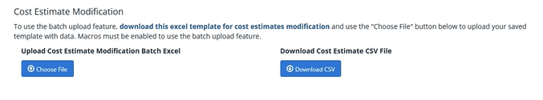

*Figure 11: Upload Cost Estimate Modification Batch Excel*

Once the Recipient has completed the Cost Estimate Modification Template, it will need to select the ‘Choose File’button within the application beneath the **Upload Cost Estimate Modification Batch Excel** section on the left-hand side of the screen (Figure 11). When the template has been uploaded to the application, the Recipient should see a link to the document appear beneath the ‘Choose File’button. The blue ‘Download CSV’ button under ‘Download Cost Estimate CSV File’ provides Recipients with the opportunity to download their completed file, inclusive of their changes.

Once all the necessary changes have been made, the Certifying Official must re-certify their FCC Form 5640 Part C by ticking the box in the Certifications section and complete the Certifier Information section. The Date Signed will automatically populate. This section is the equivalent of electronically signing the submission. Recipients will then submit their modified FCC Form 5640 Part C by clicking on the blue ‘Submit’ button on the bottom right of the page. If a Recipient is not ready to submit, it can save its modified FCC Form 5640 Part C as a draft by clicking on the blue ‘Save as Draft’ button on the bottom left of the page.

Recipients can revise their modified FCC Form 5640 Part C by logging into the SCRP Online Portal and navigating to the relevant ‘Program Participant File’ and ‘SCRP Filing’. Once they have selected the correct filing, they may select the blue “Open Modified Draft” button in the top right of the page to continue working. Once revisions have been made, Recipients will have the option to save as draft or submit.

Once ready to submit, Recipients will submit their modified FCC Form 5640 Part C by clicking on the blue ‘Submit’ button on the bottom right of the page.

Instructions for Submitting FCC Form 5640 Part G: Reimbursement Claim Request

After receiving an allocation and once any required modifications are made, Recipients can return to the SCRP Online Portal and complete an FCC Form 5640 Part G to submit invoices as part of a Reimbursement Claim Request. Please note that some data will need to be input again, e.g., contact information.

Mala Geoscience

To begin the Reimbursement Claim Request process, the Recipient will log into the SCRP Online Portal and navigate to its *Program Participant File*. After opening its file, the Recipient will click ‘Create New Filing’ then click **Reimbursement Claim Request (Part G)** (Figure 12).

Figure 12: Part G- Reimbursement Claim Request

**Applicant Information**

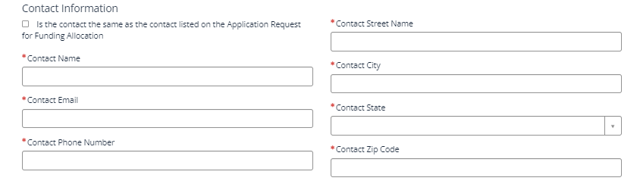The Recipient will begin this section by ensuring that its ‘Applicant Information’ is accurate, including FRN, Applicant Name, Email, Phone Number, Street Name, City, State, and Zip Code. This information will be automatically populated from the FCC Form 5640 Part C filing.

Figure 13: Part G- Applicant Information

**Contact Information**

Figure 14: Part G- Contact Information

In this section, the Recipient will ensure that its ‘Contact Information’ is accurate. This information may be automatically populated from Part C by clicking the “Is the contact the same as the contact listed on the Application Request for Funding Allocation” checkbox, but Recipients will have the ability to edit the information, if necessary. If the Recipient needs to manually input its contact information, it will complete the following fields: Contact Name, Email, Phone Number, Street Name, City, State (utilizing the drop-down menu), and Zip Code.

These fields will identify the contact representative if it is different from the Recipient. Please ensure that the **point of contact listed is easily contactable** through the information provided.



**Invoice Information**

In this section, the Recipient will input information about the invoice(s) to be reimbursed. Recipients will need to provide a vendor or supplier quote associated with the invoice in this section. Recipients will be required to link actual costs incurred and the supporting invoice documentation to their itemized cost estimates.

Additionally, Recipients will need to upload supporting documentation for the costs for which they are seeking reimbursement demonstrating the costs were actually incurred. Such supporting documentation must include a valid invoice, receipt, or other form of documentation that explains the nature, date, and cost of the expense. This attachment must be a pdf.

Invoices submitted by Recipients for reimbursement must include the following information:

* Description of Invoice to be reimbursed

Previously entered Invoice Vendor names will display in a drop-down menu. If the Invoice Vendor does not appear in the drop-down menu, Recipients should check the ‘Other Vendor’ box, then enter the Vendor Name and Vendor EIN/TIN.



* Invoice Vendor
  + Vendor Name
  + Vendor Identification Number (EIN) or Taxpayer Identification Number (TIN)
* Invoice Number (assigned by the vendor)
* Total Invoice Amount
* Invoice Date
* Invoice Due Date (Recipients should use the payment terms to calculate and document the payment due date on the invoice if this information is not originally included)
* Recipient FRN
* Location ID (if costs are associated with a specific site location)

Recipients will answer ‘yes’ or ‘no’ to the questions outlined below:

* Does the attached invoice contain costs ineligible for reimbursement?
* Does the invoice contain expense(s) related to technology upgrades that are not eligible for reimbursement as a comparable replacement?

*Figure 15: Part G Invoice Upload*

Recipients will then upload a copy of the invoice by clicking the blue ‘Required Upload’ button (Figure 15).

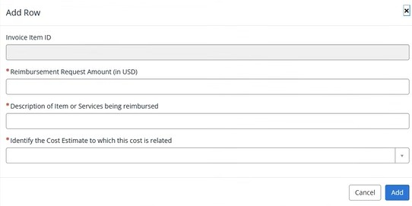The Recipient will add details of each invoice item by clicking the blue ‘Add’ button. After clicking the blue ‘Add’ button, the ‘Add Row’ pop-up box will appear to add specific details of the invoice item(s) (Figure 16). The Recipient will need to manually input the Reimbursement Request Amount, Description of Item or Services Being Reimbursed, and Identify the Cost Estimate to Which This Cost Is Related. The Recipient may follow this process to add multiple invoice items. After each invoice item is added, it will be reflected in a row. Please note that the Invoice Item ID may populate as null, however this does not mean there is an error, and the ID will populate once the reimbursement claim is submitted.

*Figure 16: Part G- Invoice Pop-up*

**Certifier Information**

The Recipient Certifying Official must certify to the accuracy of the Recipient’s Reimbursement Claim Request by ticking the box in the Certifications section and completing the Certifier Information section. The Date Signed will automatically populate. This section is the equivalent of electronically signing the Reimbursement Claim Request. If Recipients are not ready to submit, they can save their reimbursement claim as a draft by clicking on the blue ‘Save as Draft’ button on the bottom left of the page.

Recipients can revise their invoice draft by logging into the SCRP Online Portal and navigating to the relevant ‘Program Participant File’ and ‘SCRP Filing’. Once they have selected the correct Reimbursement Claim file, they may select the “Open Draft” button to continue working. Once revisions have been made, Recipients will have the option to save as draft or submit.

Once ready to submit, Recipients will then submit their reimbursement claim by clicking on the blue ‘Submit’ button on the bottom right of the page.

**Attachments**

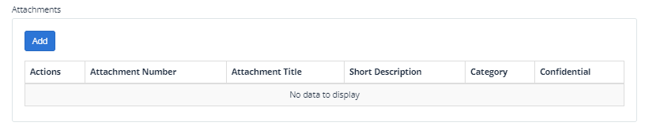In this section, Recipients can upload additional documentation that they believe may be beneficial to the review of their Reimbursement Claim Request filing, such as a cover letter or other explanation.

*Figure 17: Part G- Attachments*

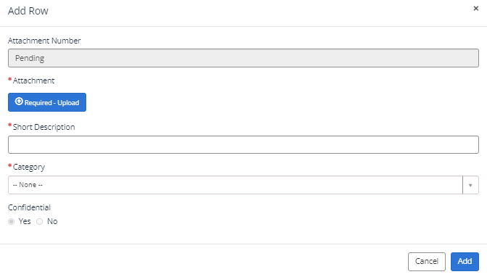If uploading additional attachments here, Recipients will need to include a short description, the category of the attachment (from the drop-down menu), and indicate if it is to remain confidential (Figure 18). When seeking confidential treatment for attachments categorized as “Other”, the Recipient must also upload a request for confidentiality providing the justification as to why the information is entitled to confidential treatment.[[23]](#footnote-25) That request for confidentiality will be made publicly available. Attachments for which confidential treatment is sought will be withheld from routine public inspection. Redacted versions of these attachments and attachments not indicated as containing confidential information will be subject to routine public inspection. Multiple attachments can be added. After an attachment is added, it will be reflected in a row.

*Figure 18: Part G- Attachments Pop-Up*

Responding to Requests for Information in the SCRP Online Portal

The Fund Administrator may ask a Recipient to respond to a RFI about a submitted Reimbursement Claim Request or a requested modification to its Application Request for Funding Allocation. Recipients will receive a RFI notification via email and should respond to the RFI request within the SCRP Online Portal. If the RFI pertains to a submitted Reimbursement Claim Request, the RFI notification will unlock the associated Reimbursement Claim Request to allow revisions. If the RFI pertains to a submitted modification request, the RFI notification will unlock the associated SCRP Modification of Application for Funding Request to allow revisions. Failure to respond to an RFI could potentially result in a delay in, or denial of, funding.

When an application has an active modification that is under review or has been issued an RFI, the reimbursement claim request review process will be paused, regardless of whether the claim submissions are related to the modification, until the modification is approved or approved in part. Providers are encouraged to limit cost estimate modifications to the line items for which they will be submitting reimbursement claim requests in order to facilitate timely processing.

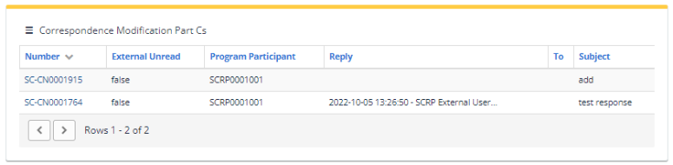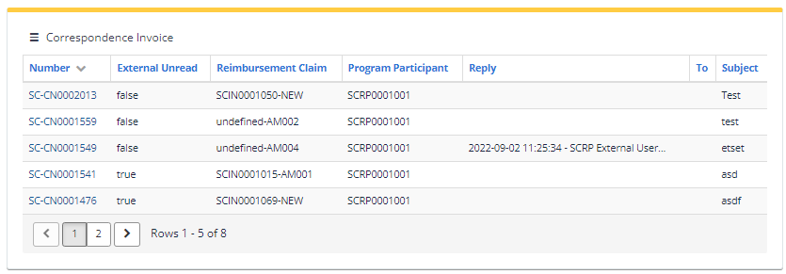

Figure 19: Correspondence Tables

After logging into the SCRP Online Portal, Recipients will click on their Program Participant File. Recipients will see multiple ‘Correspondence’ tables. If the RFI pertains to an invoice, select the corresponding row with the RFI communication in the ‘Correspondence Invoice’ table (Figure 19) to view specific details of the RFI. If the RFI pertains to a submitted modification request, select the corresponding row with the RFI communication in the ‘Correspondence Modification Part Cs’ table (Figure 19) to view specific details of the RFI. By clicking on the row containing the RFI communication, the specific details of the RFI will open, such as the Program Participant number, Status, Correspondence Type, and more. These greyed boxes cannot be edited by the Recipient. After scrolling down, Recipients will see the body of the correspondence and all communications history related to the RFI. Recipients may reply to the RFI if they have a question regarding the correspondence and/or requested information. Please note that submitted Reimbursement Claim Requests or requested modifications to an Application Request for Funding Allocation will lock again once Recipients recertify and submit, or if they do not make the requested changes in a timely manner..

**Amending Part G Reimbursement Claim Request Submissions**

If the RFI requires updates to be made to a Reimbursement Claim Request, Recipients will need to amend the claim and resubmit. To amend a claim, Recipients will log into the SCRP Online Portal, navigate to the relevant ‘Program Participant File,’ then scroll down to ‘SCRP Filings’ (Figure 20) to select the correct Reimbursement Claim by clicking on the appropriate ‘File Number’ (note: ‘SCRP Internal Status’ will be ‘Needs More Information’). Once the Recipient has selected the correct Reimbursement Claim file, they should select the blue ‘Amend’ button (Figure 21) to make the requested changes. Once the requested changes have been made, Recipients will have the option to save as draft or submit. Once ready to submit, Recipients will then submit their reimbursement claim by clicking on the blue ‘Submit’ button on the bottom right of the page. Recipients may refer to the instructions above beginning on page 12 on how to submit their reimbursement claim via Part G.

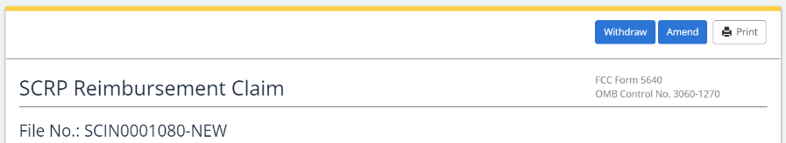

Figure 21: Amending Part G Reimbursement Claim

Figure 20: SCRP Filings

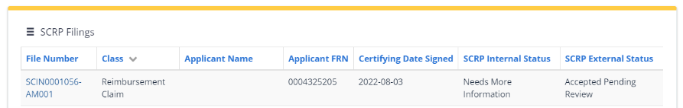

Please note, Recipients have 15 days to respond to the RFI and/or make the requested updates. If a response is not received and/or the requested updates are not made within 15 days, Recipients will receive a follow up email with an additional 10 days to respond and/or make the requested updates before the invoice is denied.

**Modifying Form 5640 Part C Application Request for Funding Allocation**

If the RFI requires updates to be made to a submitted modification request, Recipients will log into the SCRP Online Portal, open their *Program Participant File*, then navigate to *SCRP Filings* (Figure 22) to select the correct Application Request for Funding Allocation by clicking on the appropriate ‘File Number’ (note: ‘SCRP Internal Status’ will be ‘Needs More Information’). Once the Recipient has selected the correct modification request, they should select the blue ‘Update button (Figure 23) to make the requested modifications to their filing. Recipients may refer to the instructions above beginning on page 8 on how to modify their Form 5640 Part C.

Figure 22: SCRP Filings

SC-MOD-AR00000000

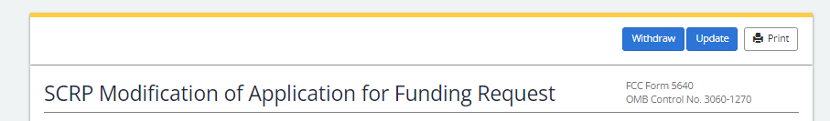

Figure 23: Modifying Form 5640 Part C

1. *Secure and Trusted Communications Act of 2019*, Pub. L. No. 116-124, 134 Stat. 158 (2020) (codified as amended at 47 U.S.C. § 1601-1609) (Secure and Trusted Communications Networks Act); *Consolidated Appropriations Act, 2021*, Pub. L. No. 116-260, § 901, 134 Stat. 1182 (2020) (CAA). [↑](#footnote-ref-3)
2. *Protecting Against National Security Threats to the Communications Supply Chain Through FCC Programs*, WC Docket No. 18-89, Third Report and Order, 36 FCC Rcd 11958, 11965-78, 11992-96, paras. 18-46, 85-94 (2021) (*2021 Supply Chain Order*); *see also Protecting Against National Security Threats to the Communications Supply Chain Through FCC Programs*, WC Docket No. 18-89, Second Report and Order, 35 FCC Rcd 14284, 14309-10, paras. 51-54 (2020) (*2020 Supply Chain Order*) (interpreting “communications equipment or service”). [↑](#footnote-ref-4)
3. 47 CFR § 1.50004; *2020 Supply Chain Order*, 35 FCC Rcd at 14374-83, Appx. A. [↑](#footnote-ref-5)
4. *2021 Supply Chain Order*, at Appx. A; *Wireline Competition Bureau Finalizes Application Filings, Procedures, Cost Catalog, and Replacement List for the Secure and Trusted Communications Networks Reimbursement Program*, WC Docket No. 18-89, Public Notice, 36 FCC Rcd 12190 (WCB Aug. 3, 2021) (*Finalized Reimbursement Process Public Notice*); *Wireline Competition Bureau Announces Best Practices for Equipment Disposal and Revises FCC Form 5640 Certifications for the Secure and Trusted Communications Networks Reimbursement Program*, WC Docket No. 18-89, Public Notice, 36 FCC Rcd 14061 (WCB Sept. 30, 2021). [↑](#footnote-ref-6)
5. The Secure Networks Act defines “recipient” as “any provider of advanced communications service the application of which for a reimbursement under the [Reimbursement] Program has been approved by the Commission, regardless of whether the provider has received reimbursement funds.” 47 U.S.C. § 1608(11); *see also* 47 CFR § 1.50001 (“The term ‘Reimbursement Program recipient’ or ‘recipient’ means any eligible advanced communications service provider that has requested via application and been approved for funding in the Reimbursement Program, regardless of whether the provider has received reimbursement funds.”). [↑](#footnote-ref-7)
6. *Wireline Competition Bureau Announces the Grant of Applications for the Secure and Trusted Communications Networks Reimbursement Program*, WC Docket No. 18-89, Public Notice, DA 22-774 (WCB July 18, 2022). [↑](#footnote-ref-8)
7. 47 CFR § 1.50004(g)(1). [↑](#footnote-ref-9)
8. *Finalized Reimbursement Process Public Notice*, 36 FCC Rcd at 12206, para. 46. Recipients may not rely on the Cost Catalog as the basis for a modified cost estimate. [↑](#footnote-ref-10)
9. *Id*. at 12208, para. 54. Permissible modifications to existing line items and itemized expenses include, but are not limited to, adding vendor and supplier quotes as well as new auxiliary equipment if it is required as part of the replacement of the covered equipment. [↑](#footnote-ref-11)
10. *Finalized Reimbursement Process Public Notice*, 36 FCC Rcd at 12208, para. 54. [↑](#footnote-ref-12)
11. *Id*. [↑](#footnote-ref-13)
12. 47 CFR § 1.50004(d). [↑](#footnote-ref-14)
13. *Finalized Reimbursement Process Public Notice*, 36 FCC Rcd at 12208, para. 54. [↑](#footnote-ref-15)
14. Applicants were required to submit specific timelines for the permanent removal, replacement, and disposal of the Covered Communications Equipment or Services in their networks with their applications, 47 U.S.C. § 1.50004(d)(4)(A)(ii), and will be required to certify that they complied with those timelines in their Final Certifications. 47 U.S.C. § 1.50004(e)(4)(A)(iv). [↑](#footnote-ref-16)
15. 47 U.S.C. § 1603(d)(6)(A). [↑](#footnote-ref-17)
16. 47 U.S.C. § 1603(e)(4)(A)(iii); 47 CFR § 1.50004(m)(1). [↑](#footnote-ref-18)
17. Recipients are encouraged to carefully review modification requests to ensure they are consistent with all applicable provisions of the Secure and Trusted Networks Communications Act, the Commission’s rules, and/or program procedures. [↑](#footnote-ref-19)
18. *Id.* at 14334-36, paras. 118-20, *2021 Supply Chain Order* at 36 FCC Rcd 11992-96. [↑](#footnote-ref-20)
19. While the Fund Administrator and the Bureau may refer to the Cost Catalog in evaluating a Reimbursement Claim Request, the Recipient may not rely on the Cost Catalog as the basis for a modified cost estimate and must instead have previously submitted a cost estimate modification request supported by an actual vendor quote or invoice. If the modified cost estimate exceeds the original estimated cost submitted for a particular line item, the Recipient must note the nature of the variation when submitting its cost estimate modification request. The Recipient must then submit an actual vendor invoice to support its Reimbursement Claim Request. [↑](#footnote-ref-21)
20. 47 CFR § 1.50004(h); *2020 Supply Chain Order*, 35 FCC Rcd at 14291-92, para. 20. The Commission may extend the Removal, Replacement, and Disposal term for all recipients by six months if it “finds that the supply of replacement equipment or services needed by the recipients to achieve the purposes of the Program is inadequate to meet the needs of the recipients.” 47 U.S.C. § 1603(d)(6)(B)(i); 47 CFR § 1.50004(h)(1). The Bureau may also grant a petition filed by a Recipient for an individual extension of up to six months “if the Bureau finds that, due to no fault of such recipient, such recipient is unable to complete the permanent removal, replacement, and disposal” of covered communications equipment and services within one year from their initial disbursement of reimbursement funds. 47 U.S.C. § 1603(d)(6)(C); 47 CFR § 1.50004(h)(2). [↑](#footnote-ref-22)
21. 47 CFR § 1.50004(g)(2). A Recipient may request a single extension of their Reimbursement Claim Deadline, not to exceed 120 days. *See* 47 CFR § 1.50004(g)(3). A request for an extension of the Reimbursement Claim Deadline must be submitted before the Reimbursement Claim Deadline passes, or the request will not be deemed timely. *Id*. [↑](#footnote-ref-23)
22. Recipients must file a final certification to the Commission within 10 days following the expiration of the Removal, Replacement, and Disposal process. 47 CFR § 1.50004(m). [↑](#footnote-ref-24)
23. *See Finalized Reimbursement Process Public Notice*, 36 FCC Rcd at 12214, para. 70. [↑](#footnote-ref-25)