York River Outdoor Recreation Survey:

Understanding Visitor Experiences, Motivations, and Barriers

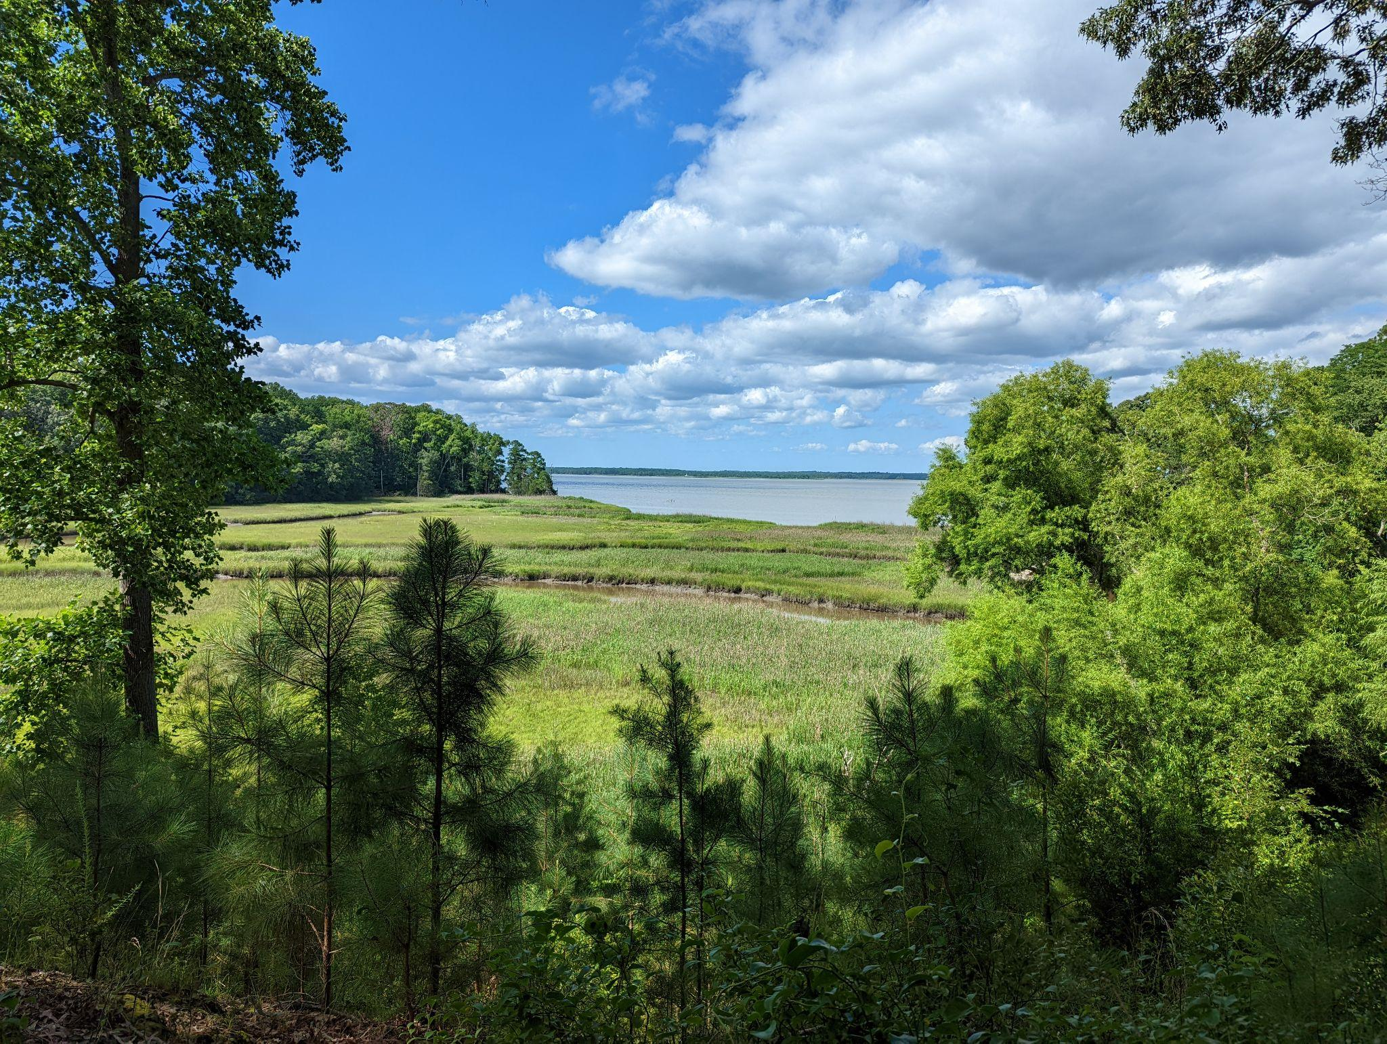

We are interested in learning about your outdoor experiences in and around the York River (see map on next page). This survey will ask about what motivates you to engage in outdoor recreation, any challenges you might have encountered, and details about your most recent trip to the York River and surrounding areas. Your responses will help local policy makers, including park managers and municipalities, improve outdoor recreation experiences in and around the York River.

By completing the survey, you are consenting to participate in this research. Although we hope that you will answer every question, you are free to skip any questions. Your participation is voluntary, and you may withdraw your consent and discontinue participation at any time. The survey will take approximately 10 minutes to complete. You will not be individually identified, and your responses will be used for statistical purposes only.

**Public Burden Statement**

A Federal agency may not conduct or sponsor, and a person is not required to respond to, nor shall a person be subject to a penalty for failure to comply with an information collection subject to the requirements of the Paperwork Reduction Act of 1995 unless the information collection has a currently valid OMB Control Number. The approved OMB Control Number for this information collection is 0648-XXXX. Without this approval, we could not conduct this survey/information collection. Public reporting for this information collection is estimated to be approximately 1 hour per response, including the time for reviewing instructions, searching existing data sources, gathering and maintaining the data needed, and completing and reviewing the information collection. All responses to this information collection are voluntary. Send comments regarding this burden estimate or any other aspect of this information collection, including suggestions for reducing this burden to the BUREAU Name at: address, Attn: NOS/NCCOS, 1305 East West Highway, Bldg. SSMC4, Rm 9320, Silver Spring, MD, 20910, sarah.gonyo@noaa.gov, 240-621-1999.

**Privacy Act Statement**

**Authority:** The collection of this information is authorized under 5 U.S.C. § 301, Departmental regulations which authorizes the operations of an executive agency, including the creation, custodianship, maintenance and distribution of records, and 15 U.S.C. 1512, Powers and duties of Department.

**Purpose:** NOAA collects limited information, such as name, address, phone number, or email address for a variety of purposes. This information will be used to respond to user inquiries or provide services requested by the user.

**Routine Uses:**  Disclosure of this information is permitted under the Privacy Act of 1974 (5 U.S.C. Section 552a**)** to be shared among Department staff for work-related purposes. Disclosure of this information is also subject to all of the published routine uses as identified in the Privacy Act System of Records Notice COMMERCE/NOAA-11, Contact Information for Members of the Public Requesting or Providing Information Related to NOAA’s Mission.

**Disclosure:**  Furnishing this information is voluntary. By providing this information, you are consenting to the use of that information only for the purpose for which it is submitted.

**This is a map of the York River and surrounding parks and natural areas.**

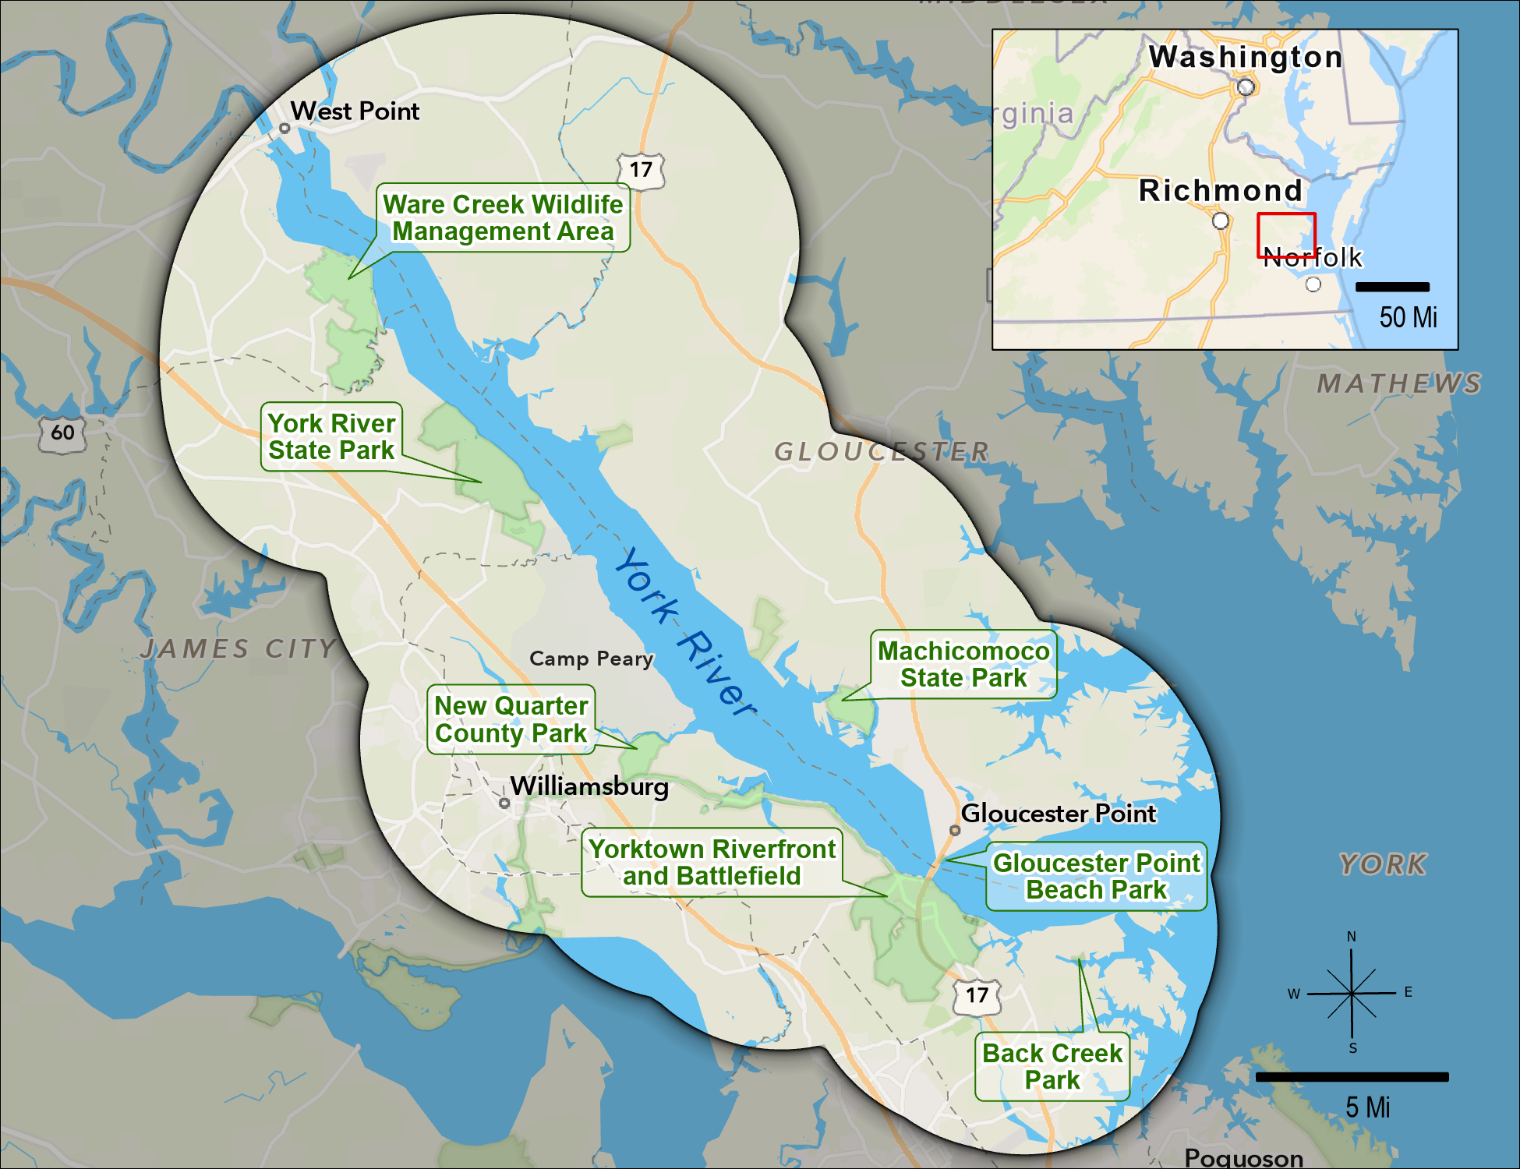

1. **Looking at the map above, did you take any trips to the York River or any surrounding park or natural area for outdoor recreation within the last 12 months?**

*A trip is defined as an intentional visit where at least 10 minutes are spent on-site. Same-day reentries are considered to be a single trip. Trips may include overnight stays.*

* Yes
* No → SKIP to PAGE 6

1. **Approximately, how many trips did you take to the York River or any surrounding park or natural area for outdoor recreation within the last 12 months?** ____ number of trips
2. **When was the last time you took a trip to the York River or any surrounding park or natural area for outdoor recreation?** __/___ (MM/YYYY)
3. **Including yourself, how many people were in your personal group on this trip?** ____ number of people
4. **Including yourself, how many of these people were at least 18 years old?** ____ number of people

Please only consider the **last time** you took a trip to the York River or any surrounding park or natural area for outdoor recreation when answering questions on this page.

1. **How important was visiting the York River or any surrounding park or natural area when deciding to take this trip?**
   * Not at all important
   * Somewhat important
   * Very important
   * Extremely important
2. **Approximately, how much time did you spend specifically within the York River or any surrounding park or natural area during this trip?**

_____ Number of hours if a day trip

_____ Number of days if longer than 1 day

1. **Did you or your personal group visit any of the following locations on this trip?**

|  |  |  |  |
| --- | --- | --- | --- |
|  | Yes | No | Unsure |
| Ware Creek Wildlife Management Area |  |  |  |
| York River State Park |  |  |  |
| New Quarter Park |  |  |  |
| Yorktown Riverfront/Battlefield |  |  |  |
| Back Creek Park |  |  |  |
| Gloucester Point Beach Park |  |  |  |
| Machicomoco State Park |  |  |  |

1. **Did you participate in any of the following activities within the York River or any surrounding park or natural area during this trip?**

|  |  |  |
| --- | --- | --- |
|  | Yes | No |
| Walking, hiking, or running |  |  |
| Nature photography |  |  |
| Biking |  |  |
| Horseback riding |  |  |
| Viewing wildlife, including birdwatching |  |  |
| Camping |  |  |
| Hunting |  |  |
| Swimming or wading |  |  |
| Fishing |  |  |
| Motorized boating |  |  |
| Paddlesports (for example, canoeing and kayaking) |  |  |
| Educational/interpretive program |  |  |
| Other, please specify |  |  |

1. **Did you or your personal group use any of the following forms of transportation to reach your primary destination on this trip?**

|  |  |  |
| --- | --- | --- |
|  | Yes | No |
| Personal vehicle, including watercraft |  |  |
| Bicycle |  |  |
| Public transportation (for example, bus, rail, or ferry) |  |  |
| Rental car |  |  |
| Taxi or rideshare (for example, Uber or Lyft) |  |  |

Please only consider the **last time** you took a trip to the York River or any surrounding park or natural area for outdoor recreation when answering questions on this page.

1. **Did you purchase a Virginia State Park annual pass in the last 12 months?**
   * Yes
   * No → SKIP to Q13
2. **How much did you spend on your Virginia State Park annual pass in the last 12 months?** $____
3. **Did you purchase a Virginia hunting or fishing license in the last 12 months?**
   * Yes
   * No → SKIP to Q15
4. **How much did you spend on your Virginia hunting or fishing license(s) in the last 12 months?** $____
5. **How much did your personal group spend on the following items on this trip? Please mark $0 if no money was spent on an item.**

|  |  |
| --- | --- |
|  | Amount |
| Gas | $_________ |
| Tolls | $_________ |
| Public transportation, taxi, or rideshare fare | $_________ |
| Entrance fees (excluding annual passes) | $_________ |
| Parking fees (excluding annual passes) | $_________ |
| Bait and tackle | $_________ |
| Equipment rental fees | $_________ |
| Tour or guide fees | $_________ |
| Lodging (for example, hotel or campground) fees | $_________ |

1. **When participating in water-based activities, such as swimming, kayaking, or boating, did you bring a mobile device, such as a smartphone, tablet, or smartwatch, with you?**
   * Yes, and I kept it on
   * Yes, but I turned it off
   * No
   * I did not participate in water-based activities on this trip
2. **When participating in land-based activities, did you bring a mobile device, such as a smartphone, tablet, or smartwatch, with you?**
   * Yes, and I kept it on
   * Yes, but I turned it off
   * No
   * I did not participate in land-based activities on this trip
3. **If you brought a mobile device and kept it on, did you use it for any of the following reasons?**

|  |  |  |
| --- | --- | --- |
|  | Yes | No |
| Safety/In case of emergency |  |  |
| Navigation |  |  |
| Social media |  |  |
| Photography |  |  |
| Learn about the park |  |  |
| Other, please specify |  |  |

* + I didn’t bring a mobile device and/or keep it on

Please only consider the **last time** you took a trip to the York River or any surrounding park or natural area for outdoor recreation when answering questions on this page.

1. **How important to you were the following features when deciding to take this trip?**

|  |  |  |  |  |
| --- | --- | --- | --- | --- |
|  | Not at all  important | Somewhat  important | Very  important | Extremely  important |
| Designated walking/hiking trails |  |  |  |  |
| Designated blueways/kayak trails |  |  |  |  |
| Access to water |  |  |  |  |
| Restrooms |  |  |  |  |
| Picnic areas |  |  |  |  |
| Fishing areas |  |  |  |  |
| Parking areas |  |  |  |  |
| Internet or cell service |  |  |  |  |
| Educational/interpretive program |  |  |  |  |
| Interpretive signage |  |  |  |  |
| Directional signage |  |  |  |  |
| Other, please specify |  |  |  |  |

1. **Looking at this same list of features, how satisfied were you with the quality of each of the following features on this trip?**

|  |  |  |  |  |  |
| --- | --- | --- | --- | --- | --- |
|  | Not at all  satisfied | Somewhat  satisfied | Very  satisfied | Extremely  satisfied | Not applicable |
| Designated walking/hiking trails |  |  |  |  |  |
| Designated blueways/kayak trails |  |  |  |  |  |
| Access to water |  |  |  |  |  |
| Restrooms |  |  |  |  |  |
| Picnic areas |  |  |  |  |  |
| Fishing areas |  |  |  |  |  |
| Parking areas |  |  |  |  |  |
| Internet or cell service |  |  |  |  |  |
| Educational/interpretive program |  |  |  |  |  |
| Interpretive signage |  |  |  |  |  |
| Directional signage |  |  |  |  |  |
| Other, please specify |  |  |  |  |  |

1. **Do you intend to visit the York River or any surrounding parks or natural areas for outdoor recreation in the future?**

* Yes, within the next 12 months
* Yes, but not within the next 12 months
* No
* Unsure

1. **Regardless of how you answered the question above, which of the following are reasons why you may not visit the York River or surrounding areas for outdoor recreation in the next 12 months?**

|  |  |  |  |
| --- | --- | --- | --- |
|  | Not a reason | Minor reason | Major reason |
| Concerns about safety or security |  |  |  |
| Discrimination/do not feel welcome |  |  |  |
| Too crowded |  |  |  |
| Trails poorly maintained |  |  |  |
| Limited/no available parking |  |  |  |
| Limited/no clean restrooms |  |  |  |
| Limited/no picnic areas |  |  |  |
| Limited/no access for people with disabilities |  |  |  |
| Limited/no water access |  |  |  |
| Limited/no available fishing |  |  |  |
| Limited/no nature programs |  |  |  |
| Limited/no equipment/gear |  |  |  |
| Limited/no information on available facilities, amenities, or activities |  |  |  |
| Information is/was often not in my preferred language |  |  |  |
| Not enough time |  |  |  |
| Too expensive |  |  |  |
| Too far to travel |  |  |  |
| Limited/no public transportation |  |  |  |
| No one to go with |  |  |  |
| Limited/no internet or cell service |  |  |  |
| Not interested in outdoor recreation |  |  |  |
| Other, please specify |  |  |  |

*This is the final section of the survey. The following questions ensure that all groups are fairly represented.*

***All answers are confidential.***

1. **Are you…?**
   * Male
   * Female
   * Transgender, non-binary, or another gender
   * Prefer not to answer
2. **Are you of Hispanic, Latino, or Spanish origin?**
   * Yes
   * No
   * Prefer not to answer
3. **What is your race?** *Please select all that apply.*

* American Indian or Alaska Native
* Asian
* Black or African American
* Native Hawaiian or other Pacific Islander
* White or Caucasian
* Other (please specify) _____
* Prefer not to answer

1. **In what year were you born?** _____ YYYY
2. **How well do you read and speak English?**

|  |  |  |  |  |
| --- | --- | --- | --- | --- |
|  | Not at all | Not well | Well | Very well |
| read English |  |  |  |  |
| speak English |  |  |  |  |

1. **What is the highest degree or level of school you have completed?** *Please check only one.*
   * Some high school, no diploma
   * High school graduate/GED
   * Vocational/trade school certificate
   * Some college, no diploma
   * Two-year college degree
   * Four-year college degree
   * Graduate or professional degree
   * Prefer not to answer
2. **Do you own or rent this residence (where this survey was mailed to)?**

* Own
* Rent
* Other

1. **Is this your primary residence?**
   * Yes
   * No
2. **How long have you been a resident of your current town?** _____ number of years
3. **How long have you been a resident of your current state?** _____ number of years
4. **How many people, including yourself, live in your household?** ____ number of people
5. **How many of these people are at least 18 years old?** ____ number of people at least 18
6. **Which best describes your current employment status?** *Please check only one.*

* Unemployed
* Employed full-time
* Employed part-time
* Retired
* Student
* Homemaker
* Prefer not to answer

1. **What was your annual household income in 2023, before taxes?** *Please check only one.*

* Less than $25,000
* $25,000 to $49,999
* $50,000 to $74,999
* $75,000 to $99,999
* $100,000 to $149,999
* $150,000 to $199,999
* $200,000 or more
* Prefer not to answer

**Thank you very much for taking the time to complete our survey. If you have any additional comments, please feel free to include them in the space provided below.**

*Thank you! That’s our last question. Please place this completed questionnaire in the* ***postage-paid*** *envelope provided and drop it off in the mail.*