Public Perceptions of Prescribed Fires
in Coastal Alabama and Mississippi

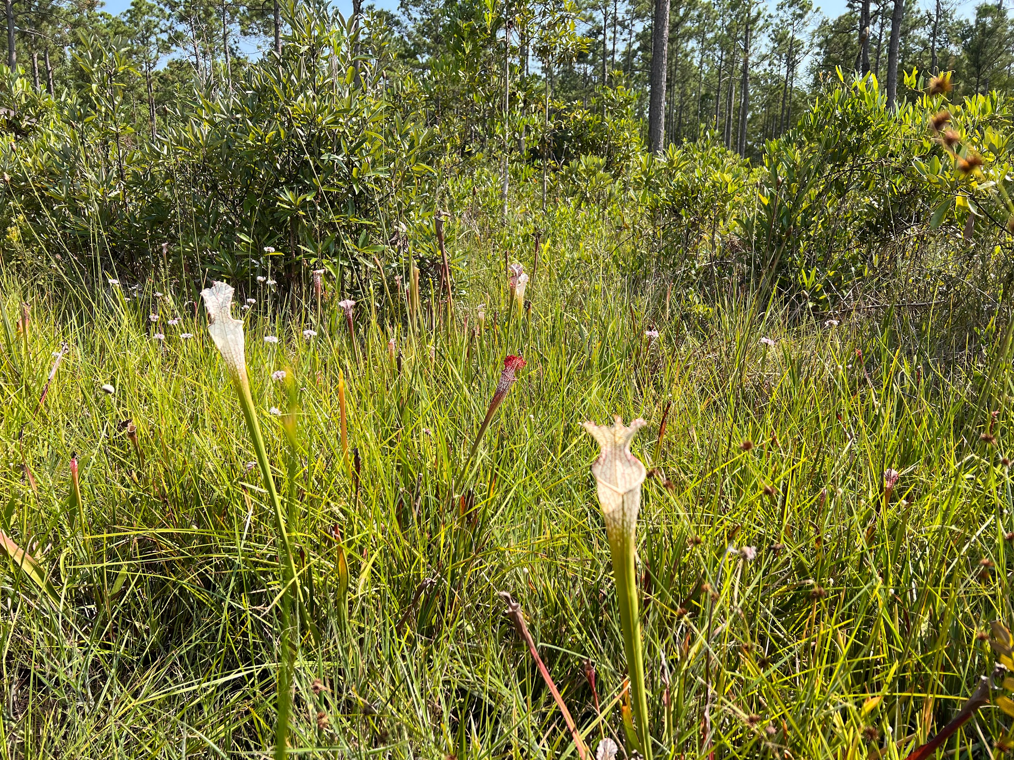

To be completed by the adult (age 18 and over) in your
household who has the next upcoming birthday.

Prescribed fires - a land conservation and management technique - are used in many locations. We are interested in learning about your perceptions and opinions related to prescribed fires in the public lands within the Gulf Coast region of Alabama and Mississippi. Even if you are not familiar with prescribed fires, your responses will help local policy makers improve community awareness and understanding of prescribed fires.

By completing the survey, you are consenting to participate in this research. Although we hope that you will answer every question, you are free to skip any questions. Your participation is voluntary, and you may withdraw your consent and discontinue participation at any time. The survey will take approximately 10 minutes to complete. You will not be individually identified, and your responses will be used for statistical purposes only.

Public Burden Statement
A Federal agency may not conduct or sponsor, and a person is not required to respond to, nor shall a person be subject to a penalty for failure to comply with an information collection subject to the requirements of the Paperwork Reduction Act of 1995 unless the information collection has a currently valid OMB Control Number. The approved OMB Control Number for this information collection is 0648-XXXX. Without this approval, we could not conduct this survey/information collection. Public reporting for this information collection is estimated to be approximately 1 hour per response, including the time for reviewing instructions, searching existing data sources, gathering and maintaining the data needed, and completing and reviewing the information collection. All responses to this information collection are voluntary. Send comments regarding this burden estimate or any other aspect of this information collection, including suggestions for reducing this burden to the BUREAU Name at: address, Attn: NOS/NCCOS, 1305 East West Highway, Bldg. SSMC4, Rm 9320, Silver Spring, MD, 20910, sarah.gonyo@noaa.gov, 240-621-1999.

Privacy Act Statement
Authority: The collection of this information is authorized under 5 U.S.C. § 301, Departmental regulations which authorizes the operations of an executive agency, including the creation, custodianship, maintenance and distribution of records, and 15 U.S.C. 1512, Powers and duties of Department.
Purpose: NOAA collects limited information, such as name, address, phone number, or email address for a variety of purposes. This information will be used to respond to user inquiries or provide services requested by the user.
Routine Uses: Disclosure of this information is permitted under the Privacy Act of 1974 (5 U.S.C. Section 552a) to be shared among Department staff for work-related purposes. Disclosure of this information is also subject to all of the published routine uses as identified in the Privacy Act System of Records Notice COMMERCE/NOAA-11, Contact Information for Members of the Public Requesting or Providing Information Related to NOAA’s Mission.
Disclosure: Furnishing this information is voluntary. By providing this information, you are consenting to the use of that information only for the purpose for which it is submitted.

- Before today, had you heard about prescribed fires within the Gulf Coast region of Alabama and Mississippi?
- Yes
- No, but I had heard of prescribed fire, in general → SKIP to Q5
- No, I hadn’t heard about prescribed fires before today → SKIP to Q6
- Have you had any of the following experiences with prescribed fires within the Gulf Coast region of Alabama and Mississippi within the last five years?
 | Yes | No
Worked with prescribed fire programs at my job
Private property of myself or someone I know was affected by a prescribed fire
Saw the flames of a prescribed fire
Saw the smoke of a prescribed fire
Experienced discomfort from the smoke of prescribed fire
Saw parts of a forest or grassland that had recently been burned
Saw the regrowth of plants and trees after a prescribed fire
Changed my recreation plans because of a prescribed fire
Had family/friends tell me about prescribed fires
Other, please specify
- Do you believe enough information is provided to residents about prescribed fires within the Gulf Coast region of Alabama and Mississippi?
- Too little information
- The right amount of information
- Too much information
- Don't know
- How timely do you believe information is provided to residents about prescribed fires within the Gulf Coast region of Alabama and Mississippi?
  - Not at all timely
  - Slightly timely
  - Moderately timely
  - Extremely timely
  - Don’t know
- In general, how knowledgeable do you feel about prescribed fires?
  - Not at all knowledgeable
  - Slightly knowledgeable
  - Moderately knowledgeable
  - Extremely knowledgeable
- Given what you currently know about prescribed fires, what best describes your opinion about prescribed fires within the Gulf Coast region of Alabama and Mississippi?
  - I support prescribed fires within the Gulf Coast region of Alabama and Mississippi → SKIP to Q8
  - I oppose prescribed fires within the Gulf Coast region of Alabama and Mississippi → SKIP to Q8
  - I have not made up my mind
- Even if you have not made up your mind, which way are you leaning?
  - To support prescribed fires within the Gulf Coast region of Alabama and Mississippi
  - To oppose prescribed fires within the Gulf Coast region of Alabama and Mississippi
  - I don’t know

- Prescribed fires are one strategy to achieve management outcomes on public lands. How important are the following management outcomes to you?
 | Not at all important | Slightly important | Moderately important | Extremely important
Lower wildfire risk
Control invasive species
Minimize spread of pest insects and disease
Improve wildlife habitat
Improve plant diversity
Improve forage for grazing
Improve forest appearance
- Thinking about the same list and given what you currently know about prescribed fires, how effective do you think prescribed fires are at achieving these management outcomes?
 | Not at all effective | Slightly effective | Moderately effective | Extremely effective | Don’t know
Lower wildfire risk
Control invasive species
Minimize spread of pest insects and disease
Improve wildlife habitat
Improve plant diversity
Improve forage for grazing
Improve forest appearance
- Thinking about the same list again, how much do you trust that managers within the Gulf Coast region of Alabama and Mississippi are doing their best to achieve these management outcomes?
  - Don’t trust at all
  - Slightly trust
  - Moderately trust
  - Completely trust
  - Don’t know
- Given what you currently know about prescribed fires, how would you rate your concern about the following potential effects?
 | Not at all concerned | Slightly concerned | Moderately concerned | Extremely concerned
Smoke and associated health issues
Wildlife mortality during burns
Possible escape to private property
Decreased forest aesthetics shortly after burns
Limited recreational access during/shortly after burns
Cost of conducting burns
- Thinking about the same list, how much do you trust that managers within the Gulf Coast region of Alabama and Mississippi are doing their best to minimize the potential effects of prescribed fires?
  - Don’t trust at all
  - Slightly trust
  - Moderately trust
  - Completely trust
  - Don’t know

This is the final section of the survey. The following questions ensure that all groups are fairly represented.
All answers are confidential.

- Are you…?
  - Male
  - Female
  - Transgender, non-binary, or another gender
  - Prefer not to answer
- Are you of Hispanic, Latino, or Spanish origin?
  - Yes
  - No
  - Prefer not to answer
- What is your race? Please select all that apply.
- American Indian or Alaska Native
- Asian
- Black or African American
- Native Hawaiian or other Pacific Islander
- White or Caucasian
- Other (please specify) _____
- Prefer not to answer
- In what year were you born? _____ YYYY
- How well do you read and speak English?
 | Not at all | Not well | Well | Very well
read English
speak English
- What is the highest degree or level of school you have completed? Please check only one.
  - Some high school, no diploma
  - High school graduate/GED
  - Vocational/trade school certificate
  - Some college, no diploma
  - Two-year college degree
  - Four-year college degree
  - Graduate or professional degree
  - Prefer not to answer
- Do you own or rent this residence (where this survey was mailed to)?
- Own
- Rent
- Other
- Is this your primary residence?
  - Yes
  - No
- How long have you been a resident of your current town? _____ number of years
- How long have you been a resident of your current state? _____ number of years
- How many people, including yourself, live in your household? ____ number of people
- How many of these people are at least 18 years old? ____ number of people at least 18
- Which best describes your current employment status? Please check only one.
- Unemployed
- Employed full-time
- Employed part-time
- Retired
- Student
- Homemaker
- Prefer not to answer
- What was your annual household income in 2023, before taxes? Please check only one.
- Less than $25,000
- $25,000 to $49,999
- $50,000 to $74,999
- $75,000 to $99,999
- $100,000 to $149,999
- $150,000 to $199,999
- $200,000 or more
- Prefer not to answer
Thank you very much for taking the time to complete our survey. If you have any additional comments, please feel free to include them in the space provided below.

Thank you! That’s our last question. Please place this completed questionnaire in the postage-paid envelope provided and drop it off in the mail.
[FRONT COVER WRAP AROUND]

Thank you!

Please place in enclosed postage paid envelope
and return as soon as possible.

