[TITLE]

[Introduction text that explains purpose of survey]

- Have you ever visited a coastal or marine area for outdoor recreation?
- Yes
- No → SKIP TO PAGE X

- How important to you are the following reasons for participating in outdoor recreation in a coastal and marine area? [CBNERR-VA ONLY]
 | Not at all  important | Somewhat  important | Very  important | Extremely  important
Spending time with friends or family | ⃞ | ⃞ | ⃞ | ⃞
Learning something new | ⃞ | ⃞ | ⃞ | ⃞
Relaxing | ⃞ | ⃞ | ⃞ | ⃞
Experiencing solitude | ⃞ | ⃞ | ⃞ | ⃞
Experiencing nature | ⃞ | ⃞ | ⃞ | ⃞
Exercising | ⃞ | ⃞ | ⃞ | ⃞
Experiencing excitement or adventure | ⃞ | ⃞ | ⃞ | ⃞
Doing competitive events | ⃞ | ⃞ | ⃞ | ⃞

- How important to you are the following features when visiting a coastal or marine area for outdoor recreation?
 | Not at all  important | Somewhat  important | Very  important | Extremely  important
Designated walking/hiking trails | ⃞ | ⃞ | ⃞ | ⃞
Designated blueways/kayak trails | ⃞ | ⃞ | ⃞ | ⃞
Access to water (for example, boat ramps) | ⃞ | ⃞ | ⃞ | ⃞
Available parking | ⃞ | ⃞ | ⃞ | ⃞
Internet or cell service | ⃞ | ⃞ | ⃞ | ⃞
Nature programs | ⃞ | ⃞ | ⃞ | ⃞
Interpretive signs | ⃞ | ⃞ | ⃞ | ⃞
Directional maps | ⃞ | ⃞ | ⃞ | ⃞
Access to level ground  (less than 5% grade) | ⃞ | ⃞ | ⃞ | ⃞
Access to moderate to steep slopes  (more than 10% grade) | ⃞ | ⃞ | ⃞ | ⃞

We are interested in understanding technology use during outdoor recreation in marine and coastal areas.

- When participating in land-based outdoor recreation in coastal or marine areas, do you typically bring a mobile device, such as a smartphone, tablet, or smartwatch, with you?
  - Yes
  - No
  - I don’t participate in land-based outdoor recreation in coastal or marine areas
- When participating in water-based outdoor recreation in coastal or marine areas, do you typically bring a mobile device, such as a smartphone, tablet, or smartwatch, with you?
    - Yes
    - No
    - I don’t participate in water-based outdoor recreation in coastal or marine areas
- If you typically bring a mobile device with you when participating in either land-based or water-based outdoor recreation, do you typically leave it on or off?
- Typically on
- Typically off
- I don’t normally bring a mobile device with me

We would like to learn more about your outdoor recreation experiences in and around [study area] (see map below).
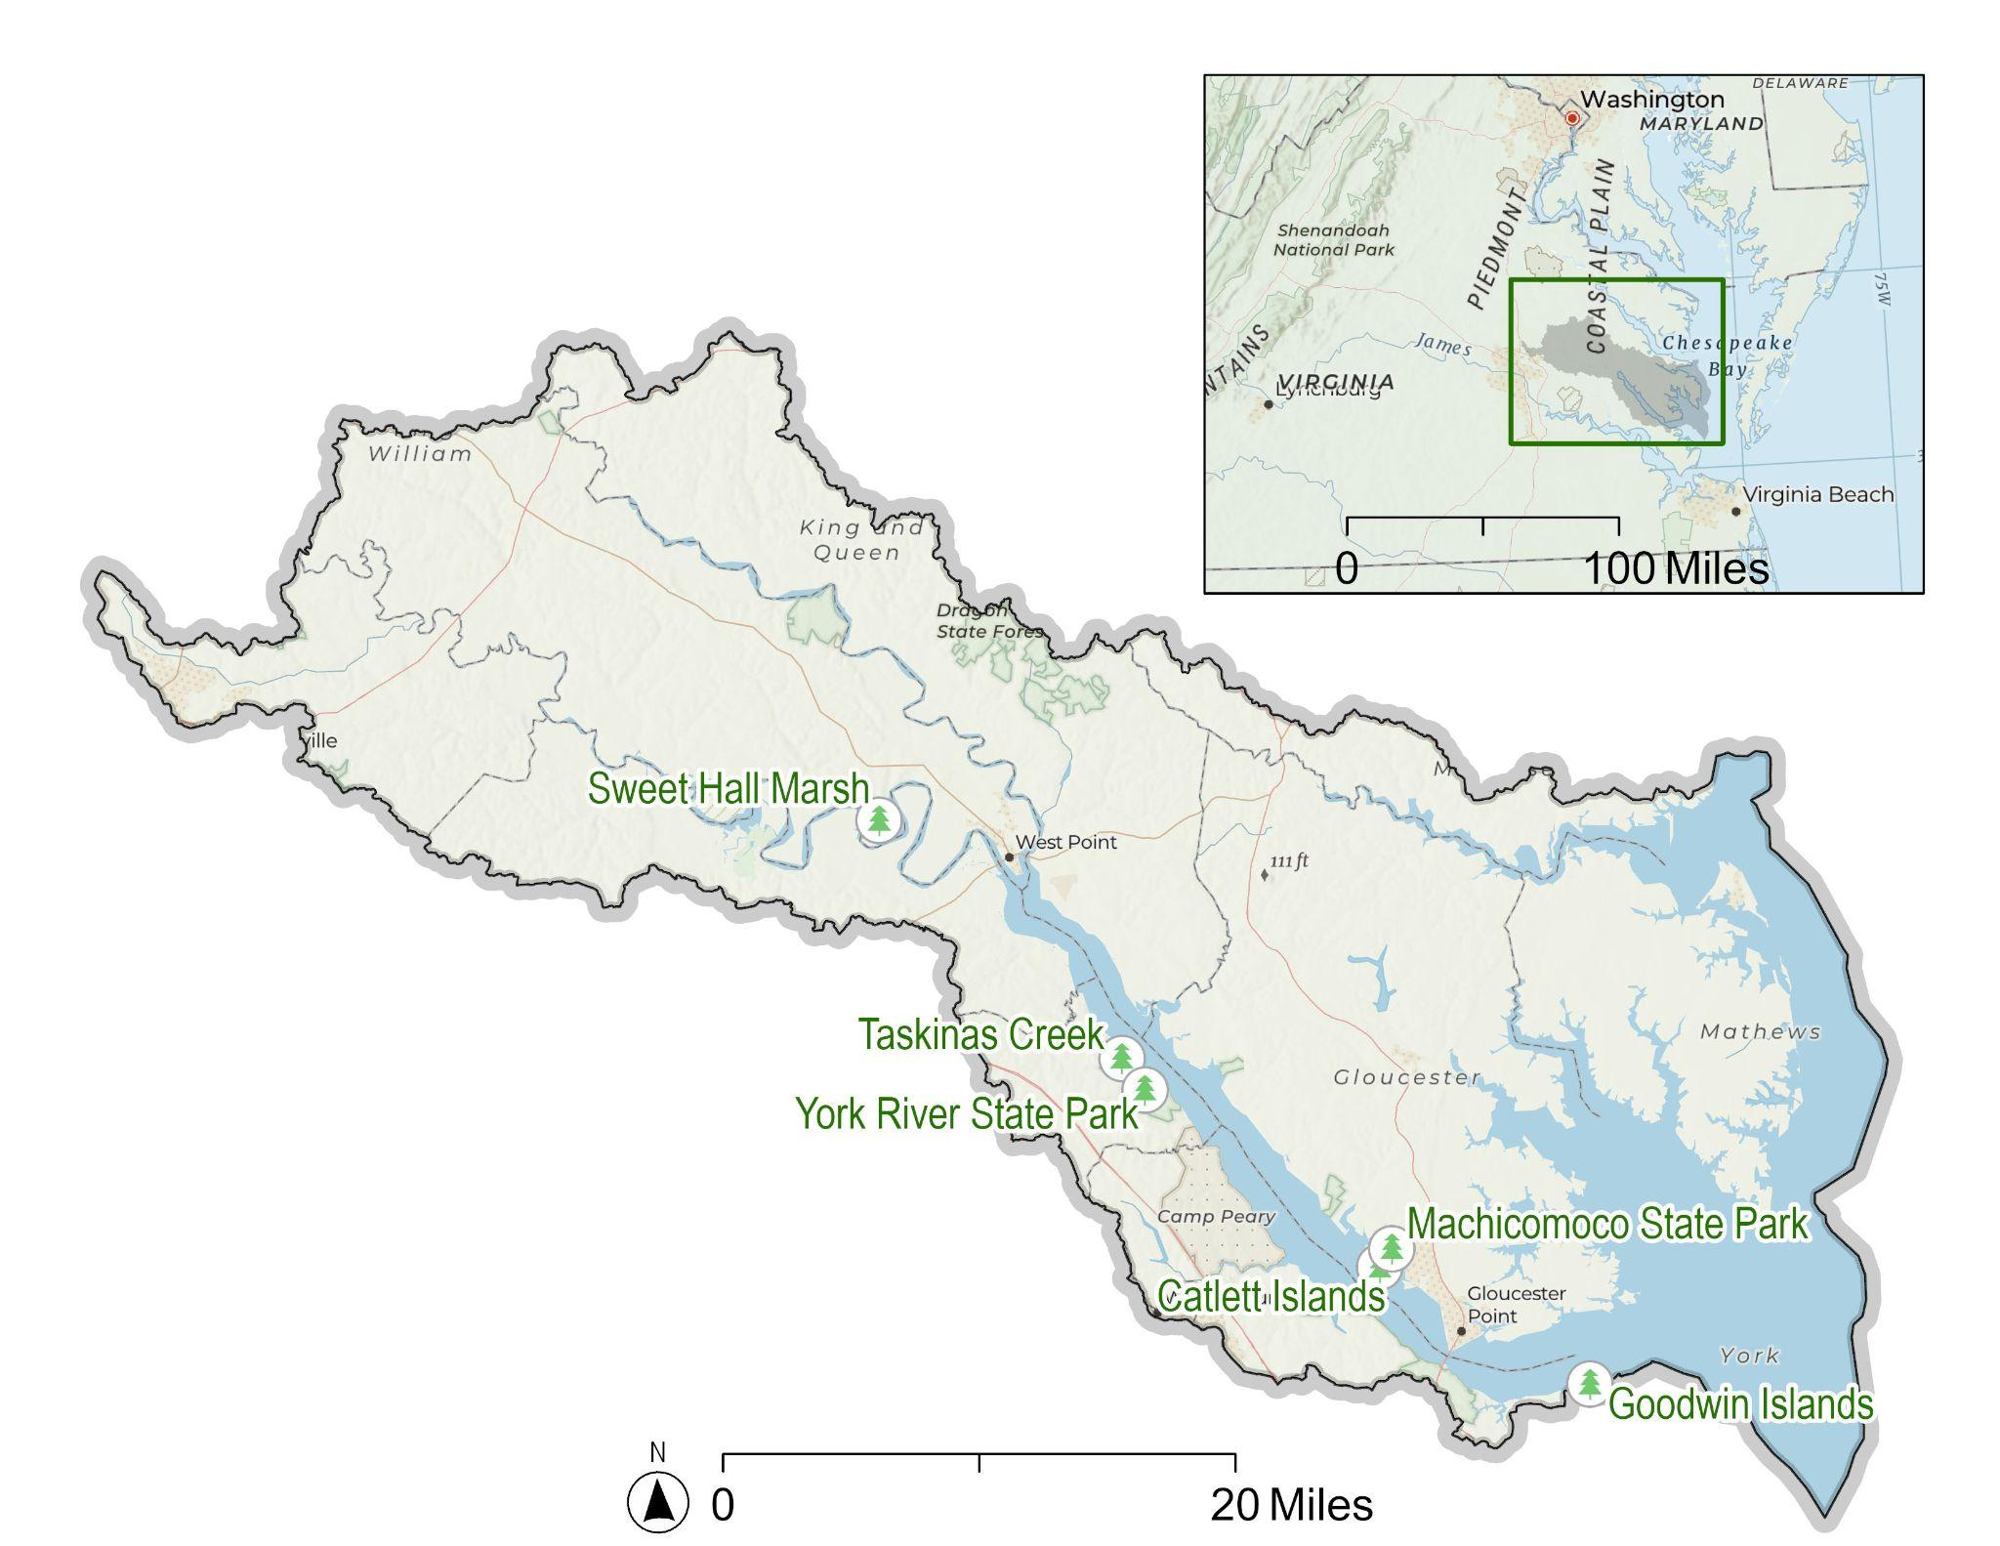

- Have you visited [study area] for outdoor recreation in the last 12 months?
- Yes
- No → SKIP to PAGE X
- How many trips have you taken to [study area] for outdoor recreation in the last 12 months?
_____trips

- When was the last time you took a trip to [study area] for outdoor recreation? __/___ (month/year)

Please only consider the last time you took a trip to [study area] for outdoor recreation when answering the following questions.

- Including yourself, how many people were in your personal group? _____ people

- How many of these people, including yourself, were at least 18 years old? ___ people

- Was visiting [study area] the sole purpose of this trip?
  - Yes → SKIP to Q14
  - No
- How important was visiting [study area] when deciding to take this trip?
  - Not at all important
  - Somewhat important
  - Very important
  - Extremely important
- Approximately how long was this trip? Please include total travel time and time spent within [study area] as well as other places you may have visited.
_____ If a day trip, number of hours
_____ If greater than 1 day, number of days
- Approximately, how much time did you spend within [study area]?
_____ If a day trip, number of hours
_____ If greater than 1 day, number of days

Please only consider the last time you took a trip to [study area] for outdoor recreation when answering the following questions.

- Did you or your personal group use any of the following forms of transportation on this trip?
 | Yes | No
Automobile (for example, car, van, or truck)
Personal watercraft
Motorcycle
Bicycle
On-foot
Public transportation (for example, bus, rail, or ferry)

- How much did you spend on the following items on this trip, and how many people did these expenses cover?
 | Expenses | Number of People
Gas | $_________
Tolls | $_________
Rental car fees | $_________
Taxi or rideshare (for example, Uber or Lyft) fares | $_________
Public transportation (for example, bus, rail, or ferry) fares | $_________
Entrance fees | $_________
Parking fees | $_________
Equipment rental fees | $_________
Lodging (for example, hotel or campground) fees | $_________

Please only consider the last time you took a trip to [study area] for outdoor recreation when answering the following questions.

- Did you or your personal group participate in the following activities? [CBNERR-VA ONLY]
Activity | Yes | No
Scenic viewing | ⃞ | ⃞
Wildlife watching | ⃞ | ⃞
Hiking, walking, or jogging | ⃞ | ⃞
Bicycling - all types | ⃞ | ⃞
Horseback riding | ⃞ | ⃞
Picnicking | ⃞ | ⃞
Visiting playgrounds | ⃞ | ⃞
Visiting historical areas | ⃞ | ⃞
Stargazing/astronomy | ⃞ | ⃞
Driving or motorcycling for pleasure | ⃞ | ⃞
Off-road driving or motorcycling | ⃞ | ⃞
Camping in developed sites | ⃞ | ⃞
Primitive camping | ⃞ | ⃞
Fishing - all types | ⃞ | ⃞
Hunting - all types | ⃞ | ⃞
Beach activities | ⃞ | ⃞
Sailing | ⃞ | ⃞
Paddle sports (for example, canoeing and kayaking) | ⃞ | ⃞
Motorized water-based activities (for example, power boating and water skiing) | ⃞ | ⃞
Snowmobiling | ⃞ | ⃞
Non-motorized snow activities (for example, skiing and snowboarding) | ⃞ | ⃞

Please only consider the last time you took a trip to [study area] for outdoor recreation when answering the following questions.

- How satisfied were you with each of the following features in [study area]?
 | Not at all  satisfied | Somewhat  satisfied | Very  satisfied | Extremely  satisfied | Not applicable
Designated walking/hiking trails
Designated blueways/kayak trails
Access to water (for example, boat ramps)
Available parking
Internet or cell service
Nature programs
Interpretive signs
Directional maps
Access to level ground
(less than 5% grade)
Access to moderate to steep slopes
(more than 10% grade)

Please only consider the last time you took a trip to [study area] for outdoor recreation when answering the following questions.

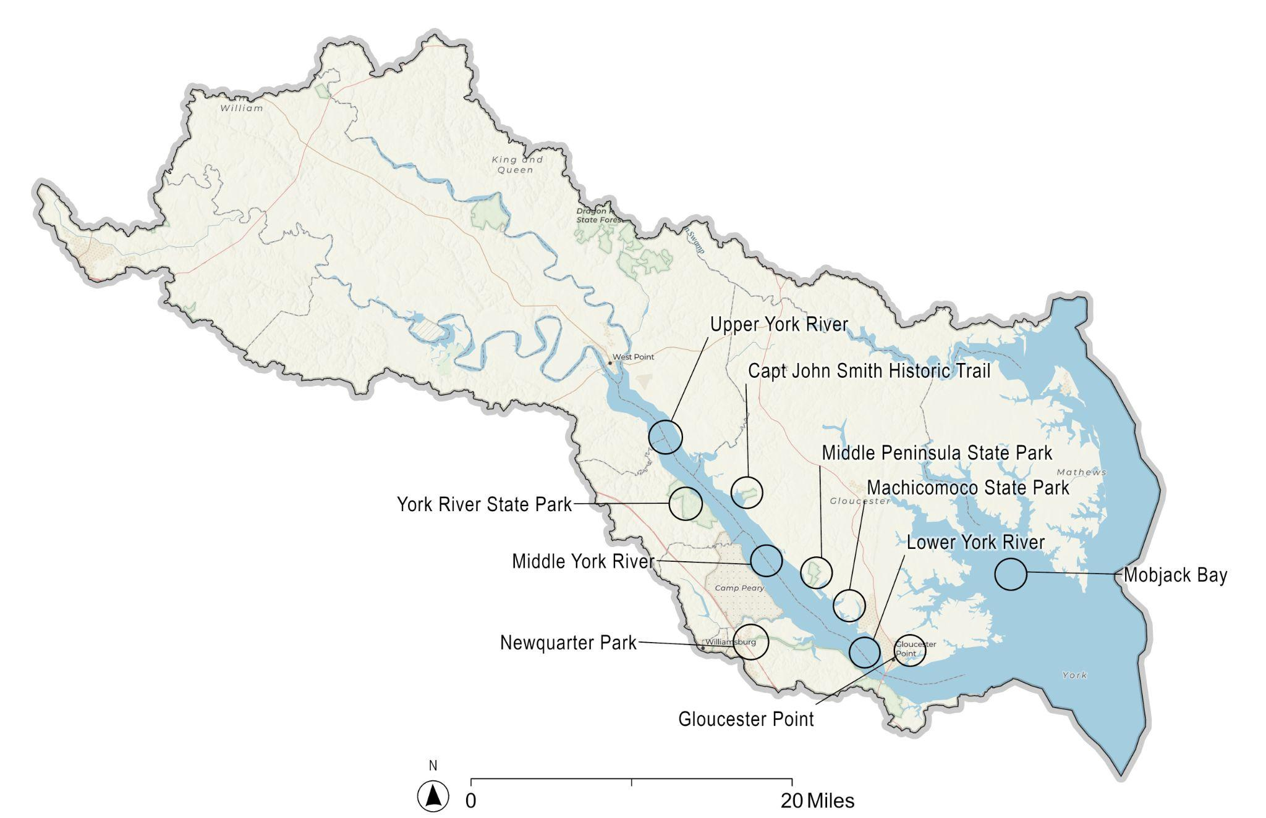

- Looking at the map on the opposite page, did you visit any of the following areas in and around the [study area]? [CBNERR-VA ONLY] {Available options will be specific to study area}
 | Yes | No | Unsure
Upper York River
Middle York River
Lower York River
York River State Park
Capt John Smith Historic Trail
New Quarter Park
Middle Peninsula State Park
Machicomoco State Park
Gloucester Point
Mobjack Bay

SKIP TO THIS PAGE IF YOU HAVE NOT VISITED [STUDY AREA] IN THE LAST 12 MONTHS
- Do you intend to visit [study area] for outdoor recreation in the future?
- Yes, within the next 12 months
- Yes, but not within the next 12 months
- No
- Unsure
- Which of the following are reasons why you may not visit [study area] for outdoor recreation in the next 12 months?
 | Not a reason | Minor reason | Major reason

Concerns about safety or security
Discrimination/do not feel welcome
Too crowded
Facilities are not well-maintained
Limited/no desired facilities
Limited/no desired activities
Too expensive
Too far to travel
Limited/no public transportation
Not enough time
Limited/no access for people with disabilities
Limited/no information on available facilities and activities
Not interested in outdoor recreation
No one to go with
Limited/no equipment/gear
Information (such as staff, signs, and programs) was often not in my preferred language
Limited/no internet or cell service
- Coastal and marine environments offer various benefits to people. Please rate the extent to which you believe [study area] provides the following benefits to nearby communities?
 | Not at all provided | Provided to a limited extent | Provided moderately | Provided to a great extent | Unsure
Seafood production
Protection from storms and flooding
Erosion control
Water purification
Climate change mitigation
Recreation
Environmental education
Mental health
Aesthetic value
Cultural and spiritual values

This next section will ask questions about prescribed fires in and around [Weeks Bay/Grand Bay]. Prescribed fires refer to the controlled application of low-intensity fires to a forest stand. [WBNERR/GBNERR only]
- Before today, had you heard about prescribed fires in and around [Weeks Bay/Grand Bay]?
- Yes
- Yes, but not in and around [Weeks Bay/Grand Bay]
- No, I have never heard about prescribed fires → SKIP to Q27
- How have you heard about prescribed fires? (select all that apply)
- From the media
- From other members of my community
- From visiting [Weeks Bay/Grand Bay]
- I have personally seen prescribed burning
- How knowledgeable do you feel about prescribed fires?
- Not at all knowledgeable
- Somewhat knowledgeable
- Very knowledgeable
- Extremely knowledgeable
- Given what you currently know about prescribed fires, have you formed an opinion about prescribed fires in and around [Weeks Bay/Grand Bay]?
    - I support prescribed fires in and around [Weeks Bay/Grand Bay]
    - I oppose prescribed fires in and around [Weeks Bay/Grand Bay]
    - I have not made up my mind
- Even if you have not made up your mind, which way are you leaning?
    - To support prescribed fires in and around [Weeks Bay/Grand Bay]
    - To oppose prescribed fires in and around [Weeks Bay/Grand Bay]

- There are different management goals for prescribed fires. How important to you are the following management goals?
 | Not at all important | Somewhat important | Very important | Extremely important
Reduce the risk of severe wildfires
Improve forest health
Improve wildlife habitat
Reduce invasive species
Reduce pests
Improve forest appearance

- Looking at the same list and given what you currently know about prescribed fires, how effective do you think is it at meeting these management goals?
 | Not at all effective | Somewhat effective | Very effective | Extremely effective | Unsure
Reduce the risk of severe wildfires
Improve forest health
Improve wildlife habitat
Reduce invasive species
Reduce pests
Improve forest appearance

- There are also potential risks associated with prescribed fires. How concerned are you about the following risks?
 | Not at all concerned | Somewhat concerned | Very concerned | Extremely concerned
Damage to nearby property
Safety of nearby residents
Safety of wildlife
Reduced air quality
Reduced access to outdoor recreation
Reduced forest appearance

Please answer a few more questions so we can better understand who is coming to the parks. You are almost finished! All answers are confidential.
- Are you (select all that apply)
  - Male
  - Female
  - Transgender, non-binary, or another gender
- In what year were you born? _____
- Are you Hispanic or Latino?
  - Yes
  - No
- What is your race? Select all that apply.
- American Indian or Alaska Native
- Asian
- Black or African American
- Native Hawaiian or other Pacific Islander
- White or Caucasian
- Other (please specify) _____
- Do you speak a language other than English at home?
  - Yes
  - No → SKIP to Q39
- What is that language? (select all that apply)
  - Spanish
  - Chinese (Mandarin or Cantonese)
  - Korean
  - Vietnamese
  - Japanese
  - Filipino
  - German
  - French (including Cajun)
  - Arabic
  - Other, please specify_______
- How well do you speak English?
  - Not at all
  - Not well
  - Well
  - Very well

- What is the highest degree or level of school you have completed?
  - Some high school, no diploma
  - High school graduate/GED
  - Vocational/trade school certificate
  - Some college, no diploma
  - Two-year college degree
  - Four-year college degree
  - Graduate or professional degree
- Do you own or rent this residence (where this survey was mailed to)?
- Own
- Rent
- Other
- Is this your primary residence?
  - Yes
  - No
- How many people, including yourself, live in your household? __________
- How many of these people are at least 18 years old? __________
- How long have you been a resident of your current town? _____ years
- How long have you been a resident of your current state? _____ years
- Which best describes your current employment status? (select all that apply)
- Unemployed
- Employed full-time
- Employed part-time
- Retired
- Student
- Homemaker
- Which category best represents your annual household income (before taxes) in 20XX?
- Less than $25,000
- $25,000 to $49,999
- $50,000 to $74,999
- $75,000 to $99,999
- $100,000 to $149,999
- $150,000 to $199,999
- $200,000 or more

Thank you for your participation in this important survey! Please use the space on this page for additional comments.

